**Software Requirements Specification**

**for**

Internship Management System

**Version 2.1 approved**

**Prepared by:**

**Yash Butala 17CS30038**

**Yogesh Kumar 17CS30040**

**IIT Kharagpur**

**Date: 5th March, 2019**

**Table of Contents**

**Table of Contents 3**

**Revision History 4**

**1. Introduction 5**

1.1 Purpose

1.2 Document Conventions

1.3 Intended Audience and Reading Suggestions

1.4 Product Scope

1.5 References

**2. Overall Description 6**

2.1 Product Perspective

2.2 Product Functions

2.3 User Classes and Characteristics

2.4 Operating Environment

2.5 Design and Implementation Constraints

2.6 User Documentation

2.7 Assumptions and Dependencies

**3. External Interface Requirements 9**

3.1 User Interfaces

3.2 Hardware Interfaces

3.3 Software Interfaces

3.4 Communications Interfaces

**4. System Features 11**

4.1 Login/Signup

4.2 Projects Management

4.3 Communication System

**5. Other Nonfunctional Requirements 13**

5.1 Performance Requirements

5.2 Safety Requirements

5.3 Security Requirements

5.4 Software Quality Attributes

5.5 Business Rules

**6. Other Requirements 16**

**Appendix A: Glossary 17**

**Appendix B: Analysis Models 18**

**Appendix C: To Be Determined List 24**

**Revision History**

|  |  |  |  |
| --- | --- | --- | --- |
| **Name** | **Date** | **Reason For Changes** | **Version** |
| Yogesh Kumar  Yash Butala | 13th March, 2019 | Faculty should have a homepage for students to view. | 1.1 |
| Yogesh Kumar  Yash Butala | 15th March, 2019 | Booking confirmation functionality was added to the administration. | 1.2 |
| Yogesh Kumar  Yash Butala | 17th March, 2019 | Add searchable categories to the portal for convenient search. | 2.0 |
| Yogesh Kumar  Yash Butala | 19th March, 2019 | The administration issues Working Permit that allows the student to access the basic facilities in campus like library,labs and canteen. | 2.1 |

# **Introduction**

## **Purpose**

The purpose of this document is to build an online portal for faculties to manage applications for internships as well as for students ( external or internal ) to apply for the particular project that they are interested in, from a list of projects listed under the common portal.

## **Document Conventions**

Standard Documentation Conventions have been used throughout the document.

## **Intended Audience and Reading Suggestions**

The primary target of this portal is to reach students of different universities including those from IIT Kharagpur. Also, the portal will be used by the professors of the Department of Computer Science and Engineering at IIT Kharagpur to enlist the various projects that they are willing to give out to the students.

## **Product Scope**

In this decade, extensive research is going in various fields of Computer Science. There are many students who want to work on a project in their summer break but often it is difficult for them to approach the concerned faculty correctly. Also, faculties find it tough to manage all the applications of students due to lack of proper application system. So we aim to update the conventional method of mailing the professor.

The portal will enable deserving students to undertake quality projects under the esteemed faculty of the Dept. of Computer Science and Engineering, IIT Kharagpur. It will help professors to get the best students that excel in the requires skills. This project will also facilitate a student exchange between the students of various universities and IIT Kharagpur.

## **References**

<http://cse.iitkgp.ac.in/>

<https://www.internshala.com/>

# **Overall Description**

## **Product Perspective**

*The portal will be used by faculties as well as students. The portal will have the following subsystems.*

Project List: It will list the projects under the professors and the prerequisites to apply for it. It will also include the deadline to apply as well as software to shortlist the entries received after the deadline is over.

Communication Software: It will be used by the faculties as well as students to communicate between one another, it will contain functions to video chat for interview sessions as well.

Booking Management: It will look after the vacancies in the hall of residences and guests houses, the student can select over a list of available options for accommodation with the specified rate and book either online or while check-in.

## **Product Functions**

Major functionalities:

* Professors and students get secured login accounts.
* Professors can post ongoing projects and pre-requisites for the same.
* Students submit the required application forms into the portal.
* The first level of shortlisting, which is based on prerequisites, is done by the System. The shortlisted applications are handed to professors.
* After further shortlisting by professors the students are finalized. Some exceptional students are eligible for scholarship and notified accordingly.
* The selected students are prompted to submit legal documents.
* The administrative division verifies the documents and sends Letter of Invitations through the portal.
* Students book accommodation through the portal.

## **User Classes and Characteristics**

The user of the portal should be able to receive the information of all the projects listed under various professors along with their prerequisites and deadlines. The system will support three user privileges, Student, Administration, and Faculty.

The Student should have access to Student functions, whereas the Faculty and Administration can access their own functions as well as Student functions.

**Student Functions:**

* Account Creation
  + New Account (Sign Up)
  + Login (if Already a User)
* Search for Projects
  + Check the field of interest
  + Look for pre requisites set by the professor
* Apply for Projects
  + A student can apply for any number of projects
* Upload Documents
  + Mandatory for application
    - CV upload
    - SoP Upload
    - LoR upload (at least 1)
  + For Selected Students
    - College Identity Card
    - Nationality Proof
    - All major boards transcripts
    - Scholarship form (if applicable)

* Contacting Faculty
  + Mail
    - Students should have a Gmail account which will serve as primary mode of communication.
  + Contact Number.
    - Professor’s office numbers will be made available only after the student is selected.
  + Video Chat
    - It will be done through Skype.Hence, it is expected that students have Skype accounts.
* Booking Accomodation
  + Book Room
  + Change Room
  + Payment
* Update daily progress

**Faculty Functions:**

* Account Creation
  + New Account
  + Login (if Already a User)
  + Create home page
* Add/Remove Project
  + Add/Remove Constraints/Prerequisites
  + Change Prerequisites
* List of Students applied
  + Names of Student
  + University they are studying
* Final Shortlisting
* Contacting Student
  + Mail
    - Gmail account will serve as primary mode of communication.
  + Contact Number.
    - Professor’s office numbers will be made available only after the student is selected.
  + Video Chat
    - It will be done through Skype.

* Send Documents to Administrative Division for Verification/LOI
* Get Scholarship sanctioned.

**Administration Functions:**

* Document verification
  + Documents sent by the selected students are to be verified.
* Disbursement of Scholarship
  + To the students whose scholarships have been sanctioned.
* Booking confirmation.

## **Operating Environment**

Operating environment for the online portal is as listed below.

* Database Management System: MySQL Community
* Operating System: Windows 10 /Ubuntu (16 and above)
* Platform: Java/JSP

## **Design and Implementation Constraints**

* SQL commands for above queries/applications.
* Securely store the data.
* No criteria for fulfilling failure.
* No application before deadline failure.
* Implement the database at least using a centralized database management system.
* Apache Tomcat is used as web server for hosting the intern portal.

## **User Documentation**

The portal will be very much user-friendly. Also to make it even easier ‘Help’ link and ‘FAQ page’ will be provided on the home page of the online portal.

## **Assumptions and Dependencies**

* The students and professors will use the portal for the application instead of the conventional mailing system.
* The room booking facility will be in agreement with the Hall Management Center.
* The portal is able to store and handle large number of applications.
* The change of plan and date due to any unavoidable reason is conveyed to students as well as faculty.
* The students and faculty should have a Gmail and Skype account.

# **External Interface Requirements**

## **User Interfaces**

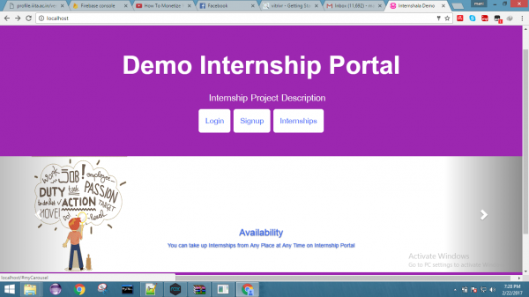

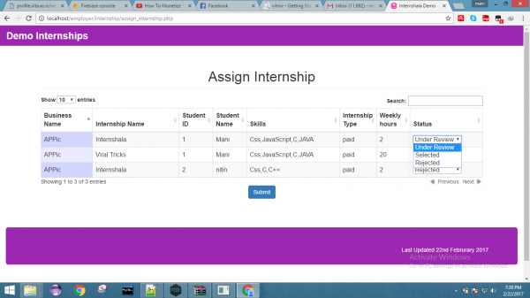

## **Hardware Interfaces**

* Compatible PC
* Internet Connection
* Scanner for Document upload
* Camera for video conferencing

## **Software Interfaces**

* Operating System with based on at least Ubuntu 16.04, Windows 7 or above.
* Browser that supports HTML, JavaScript,CSS.
* Database management system using MySQL.

## **Communications Interfaces**

All the communication is Point to Point and of either type:

* Student-Professor
* Professor-Admin
* Student-Admin

These include

* Video Conferencing
* Electronic Mailing

All these interfaces require an internet connection.

# **System Features**

This online portal serves as an effective means of communication between students of different universities and the faculty of IIT Kharagpur. It helps the faculty by sorting the applicants in various projects offered by him/her and also the student as he/she need not go through the tedious as well as time-consuming process of finding the faculty whose area of research is of interest to the student and then contacting him/her.

## Login / Signup

4.1.1 Description and Priority

* *Priority - High*
  + *Benefit - 10*
  + *Risk -3*
  + *Penalty - 3*
  + *Cost- 4*

4.1.2 Stimulus/Response Sequences

* *Signup - Create an exclusive account for:*
  + *for Students*
  + *for Professors*
* *Login - Login to the account* 
  + *Students - They will apply for the projects*
  + *Prof - Upload ongoing projects*

4.1.3 Functional Requirements

* *Login*
* *SignUp*

## Projects Management

## 4.2.1 Description and Priority

* *Priority - High*
  + *Benefit - 10*
  + *Risk -5*
  + *Penalty - 3*
  + *Cost- 2*

4.2.2 Stimulus/Response Sequences

The professor uploads projects and prerequisites. The portal categorizes it.

The Student applies to a particular project. The selection process follows:

4.2.3 Functional Requirements

* Project Upload and requirements
* Categorize Project
* Consider Student Application
* First Level filter using the system
* Submit the selected students to the professor

**4.3 Communication System**

## 4.3.1 Description and Priority

* *Priority - Medium*
  + *Benefit - 7*
  + *Risk -9*
  + *Penalty - 3*
  + *Cost- 5*

4.3.2 Stimulus/Response Sequences

The students and professors can mail/video chat with each other.

4.3.3 Functional Requirements

* Chat via Gmail
* Video Chat through Skype
* Secure document transfer
* Contact Admin for accommodations/ scholarships.

**4.4 Accommodation**

## 4.4.1 Description and Priority

* *Priority -High*
  + *Benefit - 9*
  + *Risk -3*
  + *Penalty - 5*
  + *Cost- 6*

4.4.2 Stimulus/Response Sequences

The students can select the room of choice and administration will accept the payment and confirm the booking. Incase, the student doesn’t get the room of his choice, alternative options will be given to the student

4.4.3 Functional Requirements

* Payment system
* Room description and prices
* Documents for booking
* Confirmation of booking by the admin.

# **Other Nonfunctional Requirements**

## **Performance Requirements**

The following are the performance requirements for the portal.

* **Scalability**

The portal will need to handle an increasing amount of users, from both faculty as well as students side as the people using the portal is set to increase every year and it can be used by all the faculty of IIT Kharagpur in the future.

* **Work Load**

Since the software is meant to serve many users at a time, there is a need to design software that is capable of handling multiple users without crashing.

* **Response Time**

The portal has various search queries and listing features hence there is a need to efficiently handle the stored data so that there is a minimum delay in the queries.

## **Safety Requirements**

The following safety requirements are necessary.

* An online as well as physical data backup in case of a server failure.
* A Login for faculty and students to protect privacy and sensitive information.
* A secured database so that other people do not access or change any private information.
* Payment system must be encrypted to be safe against hackers.

## **Security Requirements**

The portal exchanges many critical documents between the users hence there is a multitude of safety requirements:

* A secure Login and Password for the users
* A secured database system so that private information cannot be accessed by other people
* Different storage spaces for the users so there is no information exchanged between the users unwillingly.

## **Software Quality Attributes**

The following qualities are attributed to the portal:

Availability*,* Interoperability*,* Maintainability*,* Portability, Reliability, Reusability,Robustness*,* and Usability.

## **Business Rules**

1. The portal can be used by any student looking for an internship at IIT Kharagpur.
2. The portal can be used by the faculty of the Department of Computer science and Engineering, IIT Kharagpur.
3. Any details of the user are kept private, no one would be able to access other’s information.
4. The users are required to login the portal to protect their data.
5. Maintaining more than one account or fake account is illegal.
6. For communication, we are using web services such as Gmail and Skype. All the rights for communication belong to them.

# **Other Requirements**

* Permissions from IIT Kharagpur to host the portal.
* Securely store the data and backup server to prevent any server crashes.
* A server capable of handling heavy workload and queries.

**Appendix A: Glossary**

* IIT - Indian Institute of Technology
* CV - Curriculum Vitae
* SoP - Statement of Purpose
* LoR - Letter of Recommendation (from respective professors)
* LoI - Letter of Invitation
* GMail Link - https://mail.google.com/mail/
* Skype Link - https://www.skype.com/en/

**Appendix B: Analysis Models**

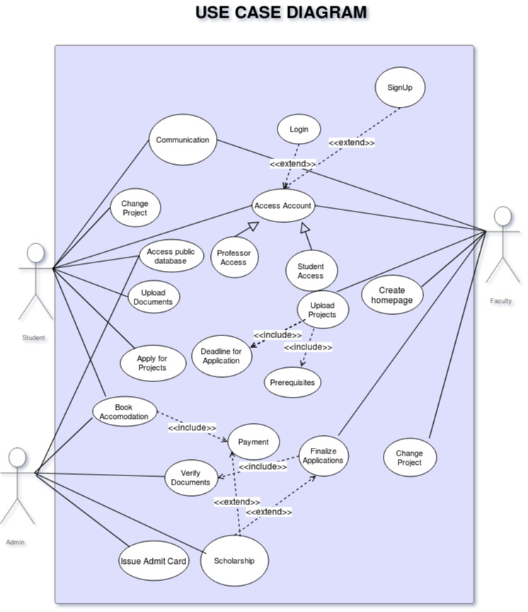

**Class Diagram**

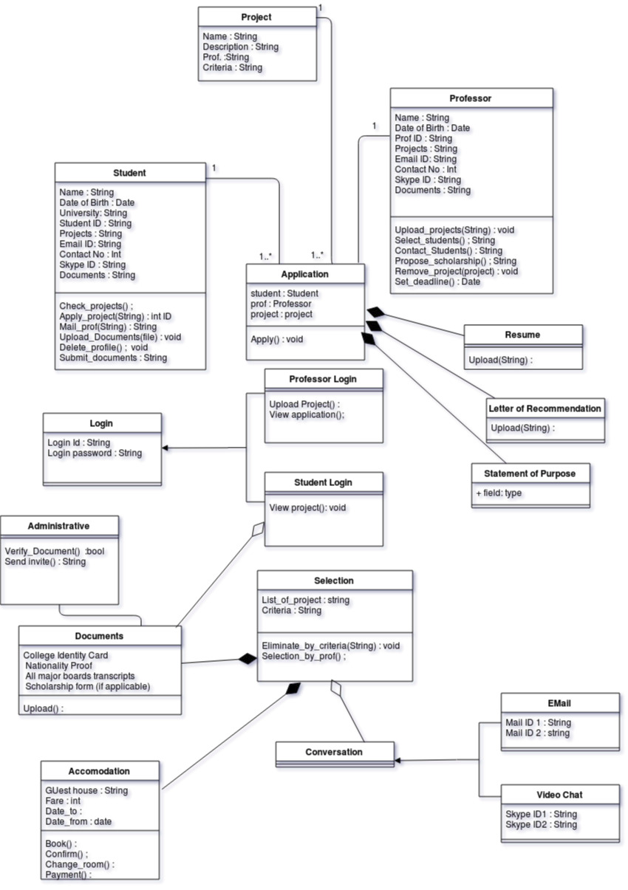

**Sequence Diagrams**

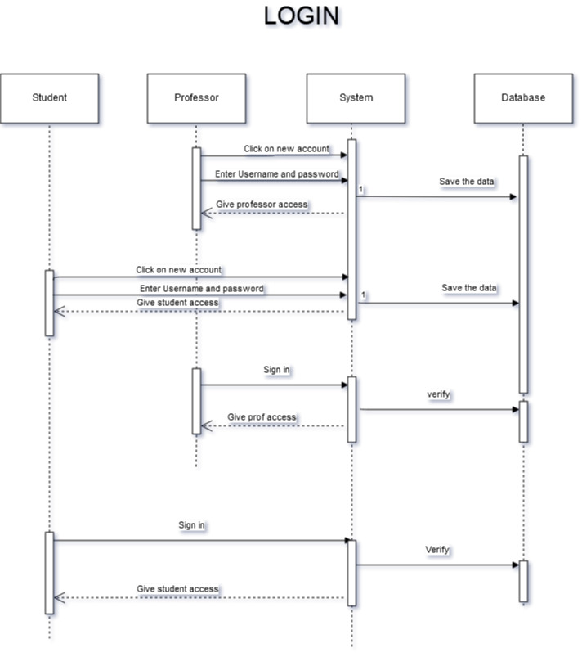

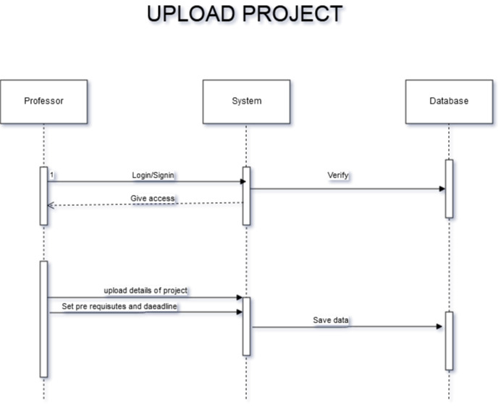

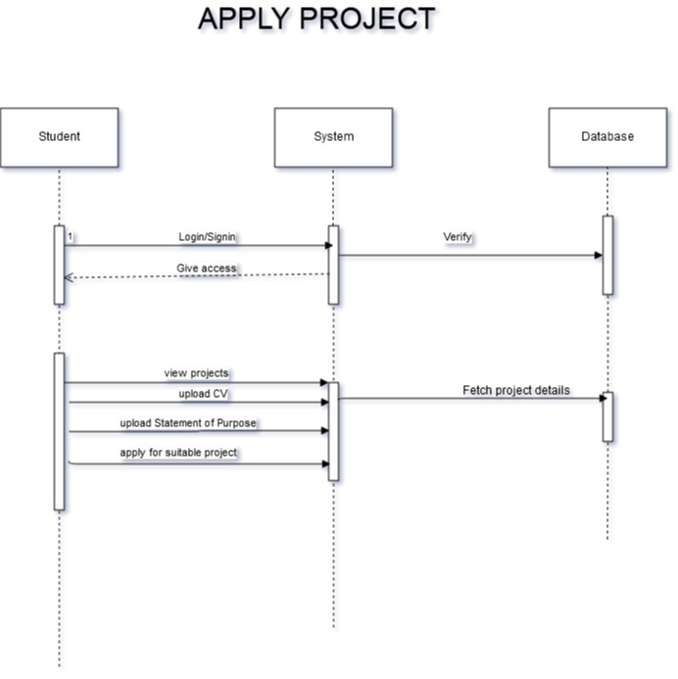

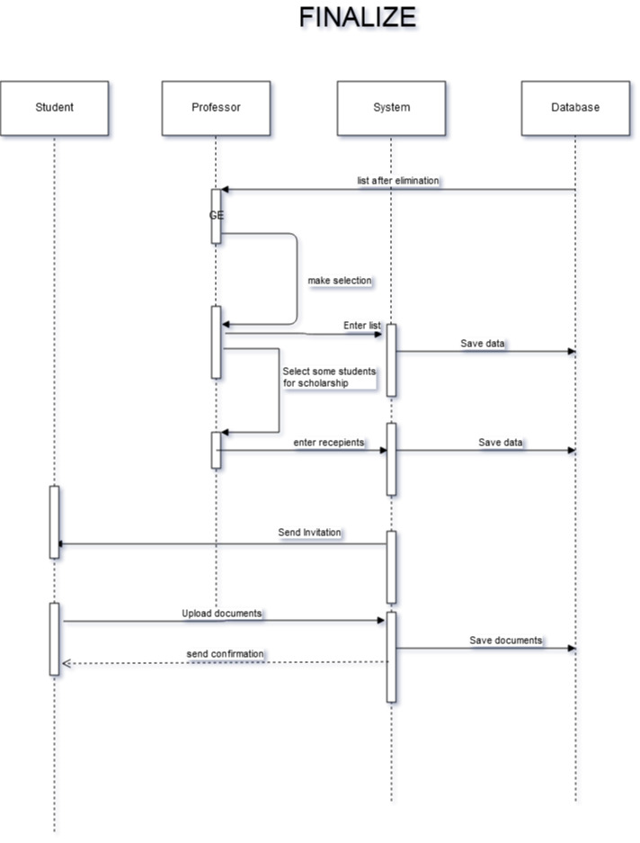

**Appendix C: To Be Determined List**