🛒
POS BILLING SYSTEM
Point of Sale — Full Stack Web Application

Technology Stack | React 18 + Spring Boot 3.2
Database | MySQL 8
Language (Backend) | Java 17
Language (Frontend) | JavaScript (ES6+)
Architecture | REST API + MVC Pattern
Project Type | Mini Project — Academic

1. Project Overview
The POS (Point of Sale) Billing System is a full-stack web application designed for retail shops or kirana stores to manage billing and inventory. Using this system, a shopkeeper can manage products, maintain customer records, and generate bills with printable thermal receipts.

🎯 Project Goals  - Products, Customers aur Bills ka CRUD  - GST-aware billing with auto calculation  - 80mm Thermal receipt printing  - Bill history aur reprint facility | ✅ Key Features  - Real-time GST calculation (0-28%)  - Barcode search support  - Discount field in billing  - Walk-in customer support

1.1 System Architecture
This project uses a 2-tier architecture.

Layer | Technology | Responsibility
Frontend | React 18 (JavaScript) | UI, forms, cart, print
Backend | Spring Boot 3.2 (Java 17) | REST APIs, business logic
Database | MySQL 8 | Data storage (JPA/Hibernate)
Communication | HTTP / JSON (REST) | Frontend ↔ Backend

2. Project Folder Structure
The project is divided into two separate folders — backend (Spring Boot) and frontend (React).

pos-billing-system/
├── backend/ ← Spring Boot Project
│ ├── pom.xml ← Maven dependencies
│ └── src/main/
│ ├── java/com/pos/
│ │ ├── BillingSystemApplication.java ← Main class
│ │ ├── config/
│ │ │ ├── CorsConfig.java ← CORS settings
│ │ │ └── GlobalExceptionHandler.java ← Error handling
│ │ ├── entity/
│ │ │ ├── Product.java ← Product table
│ │ │ ├── Customer.java ← Customer table
│ │ │ ├── Bill.java ← Bill table
│ │ │ └── BillItem.java ← Bill items table
│ │ ├── dto/
│ │ │ ├── BillRequest.java ← Request body
│ │ │ └── ApiResponse.java ← Standard response
│ │ ├── repository/ ← JPA Repositories
│ │ ├── service/ ← Business Logic
│ │ └── controller/ ← REST Controllers
│ └── resources/
│ └── application.properties ← DB config

└── frontend/ ← React Project
├── package.json
└── src/
├── App.js ← Main app + navigation
├── api.js ← All backend API calls
├── components.js ← Reusable UI components
├── printReceipt.js ← 80mm receipt generator
├── ProductModule.js ← Product CRUD screen
├── CustomerModule.js← Customer CRUD screen
├── POSModule.js ← Billing/POS screen
└── BillHistory.js ← Bill history screen

3. Database Design
There are 4 tables in MySQL. Hibernate (JPA) automatically creates these tables when the application starts.

3.1 Products Table
Column | Type | Constraint | Description
id | BIGINT | PRIMARY KEY | Auto-generated ID
name | VARCHAR | NOT NULL | Product name
price | DOUBLE | NOT NULL | Base price (without GST)
gst | DOUBLE | NOT NULL | GST % (0 / 5 / 12 / 18 / 28)
barcode | VARCHAR | NULL | Optional barcode number

3.2 Customers Table
Column | Type | Constraint | Description
id | BIGINT | PRIMARY KEY | Auto-generated ID
name | VARCHAR | NOT NULL | Full name of the customer
mobile | VARCHAR(10) | NOT NULL | 10-digit mobile number
address | VARCHAR | NULL | Customer address

3.3 Bills Table
Column | Type | Constraint | Description
id | BIGINT | PRIMARY KEY | Auto-generated bill number
customer_id | BIGINT | FOREIGN KEY | Customer reference (nullable)
total_amount | DOUBLE | NOT NULL | Grand total including GST
date | DATETIME | NOT NULL | Bill creation timestamp

3.4 Bill Items Table
Column | Type | Constraint | Description
id | BIGINT | PRIMARY KEY | Auto-generated ID
bill_id | BIGINT | FOREIGN KEY | Reference to the bill
product_id | BIGINT | FOREIGN KEY | Reference to the product
qty | INTEGER | NOT NULL | Quantity purchased
price | DOUBLE | NOT NULL | Price at the time of billing
gst | DOUBLE | NOT NULL | GST percentage at the time of billing
total | DOUBLE | NOT NULL | Total = (price × quantity) + GST

4. Backend Modules (Spring Boot)
The backend uses a classic Spring Boot layered architecture. Each layer has a separate responsibility:

Layer | What is the work?
@Entity (Model) | Represents a database table in Java. JPA uses this to create SQL tables automatically.
Repository | Extends JpaRepository. CRUD methods are available automatically (findAll, save, deleteById, etc.).
Service | Business logic is written here. It works as a layer between the Controller and Repository.
Controller | Handles HTTP requests. URLs are mapped using annotations like @GetMapping, @PostMapping, etc.
DTO | Data Transfer Object (DTO) — defines the structure of request and response data.
Config | CORS and global exception handling are configured here.

4.1 Product Module (Backend)
The Product entity stores all items in the store (name, price, GST%, barcode).
- Entity: Product.java — id, name, price, gst, barcode fields
- Repository: ProductRepository — findByNameContainingIgnoreCase(), findByBarcode()
- Service: ProductService — getAllProducts(), create(), update(), delete(), search()
- Controller: ProductController — exposes REST endpoints

4.2 Customer Module (Backend)
The Customer entity stores the customer’s name, mobile number, and address.
- Entity: Customer.java — id, name, mobile, address
- Repository: CustomerRepository — findByMobile(), search by name
- Service: CustomerService — full CRUD operations
- Controller: CustomerController — /customers endpoints

4.3 Billing Module (Backend)
This is the most important module. A bill contains one customer and multiple bill items.
- Bill.java — represents the bill header (customer, totalAmount, date)
- BillItem.java — represents each item (product, quantity, price snapshot, GST, total)
- BillRequest DTO — receives JSON data coming from the frontend
- BillService — saves the bill and its items together within a transaction (@Transactional)
- BillController — handles APIs: POST /bills, GET /bills, GET /bills/{id}

4.4 CORS Configuration
The frontend (localhost:3000) and backend (localhost:8080) run on different ports. CorsConfig.java allows the browser to permit React to send API requests to the Spring Boot backend.

4.5 Global Exception Handler
If any RuntimeException occurs in a service, the GlobalExceptionHandler catches the error and converts it into a clean JSON response. This ensures that the frontend receives a consistent error format.

5. REST API Endpoints

5.1 Product APIs
Endpoint / Method | Description
GET /products | Returns a list of all products
GET /products/{id} | Fetches a specific product by ID
GET /products/search?q=rice | Searches products by name
GET /products/barcode/{barcode} | Finds a product using a barcode
POST /products | Creates a new product (via JSON body)
PUT /products/{id} | Updates an existing product
DELETE /products/{id} | Deletes a product

5.2 Customer APIs
Endpoint / Method | Description
GET /customers | Get a list of all customers
GET /customers/{id} | Get a specific customer by ID
GET /customers/search?q=rahul | Search customers by name
GET /customers/mobile/{mobile} | Get customer by mobile number
POST /customers | Add a new customer
PUT /customers/{id} | Update customer details
DELETE /customers/{id} | Delete a customer

5.3 Bill APIs
Endpoint / Method | Description
POST /bills | Create a new bill (items + customer)
GET /bills | Get all bills (newest first)
GET /bills/{id} | Get a specific bill by ID
GET /bills/customer/{id} | Get all bills for a specific customer

5.4 API Response Format

Each API returns data in a standard ApiResponse<T> format:
{
"success": true,
"message": "Success",
"data": { ... actual data ... }
}
// Error response:
{
"success": false,
"message": "Product not found: 99",
"data": null
}

6. Frontend Modules (React)
The frontend is built using React 18. Functional components and Hooks (useState, useEffect, useCallback) are used. No external UI library has been used — styling is done entirely using CSS-in-JS.

File | Work
App.js | - The main app handles navigation tabs and routing
api.js | - All API calls are managed in one place — productApi, customerApi, billApi
components.js | - Reusable components: Modal, Field, Button, Table, Toast, Spinner
printReceipt.js | - Generates HTML for 80mm thermal receipt printing
ProductModule.js | - Product list with search, add/edit/delete functionality
CustomerModule.js | - Customer list with search, add/edit/delete functionality
POSModule.js | - Main billing screen — cart, calculations, and save bill
BillHistory.js | - View previous bills and reprint receipts

6.1 Product Module (Frontend)
ProductModule.js provides a complete CRUD interface for managing products.
- Uses useEffect to fetch all products when the page loads
- Real-time filtering through the search bar (by name or barcode)
- A modal opens for Add/Edit with form fields
- Clickable GST rate buttons (0%, 5%, 12%, 18%, 28%)
- Price Preview box automatically calculates — Base Price + GST = Customer Pays
- On Save/Update, an API call is made and a success toast is shown
- A confirmation dialog appears before deleting a product

6.2 Customer Module (Frontend)
CustomerModule.js provides a complete CRUD interface for managing customers.
- The customer list displays an avatar (first letter of the name)
- You can search by name or mobile number
- Mobile number validation — only valid Indian numbers are accepted (start with 6–9, 10 digits)
- Add/Edit/Delete — follows the same pattern as the Product module

6.3 POS / Billing Module (Frontend)
POSModule.js is the most important and complex module. This is where the actual billing takes place.
Customer Selection
- Select a customer using the dropdown search (by name or mobile)
- Walk-in customers are also allowed — selecting a customer is optional
Product Addition
- Search for a product by name or scan its barcode
- Once selected, the product is added to the cart
- If the product is already in the cart, its quantity increases by +1
Cart Management
- Use the + / - buttons to change quantity for each item
- You can also type the quantity directly in the input field
- Use the X button to remove an item from the cart
- Use Clear All to empty the entire cart

Automatic Calculations
- Subtotal = Sum of (price × quantity) for all items
- GST = Sum of (price × quantity × GST%) for each item
- Discount = Manual input (optional)
- Grand Total = Subtotal + GST - Discount
- Also shows GST slab breakdown (e.g., how much at 5%, 18%, etc.)

Bill Save & Print
- Click Save Bill to store the bill in the database
- A Bill ID is generated automatically (auto-increment)
- Click Print Receipt to open the 80mm thermal receipt in a new window
- The browser print dialog opens automatically

6.4 Bill History Module (Frontend)
BillHistory.js displays a list of all saved bills.
- Newest bills are shown first
- You can search by bill number or customer name
- Clicking on any bill shows its details in a panel
- The Reprint button allows you to print the receipt of any previous bill again

6.5 Print Receipt (80mm Thermal Format)
printReceipt.js generates an HTML string that is formatted for an 80mm thermal printer.
- Shop name, address, and GSTIN in the header
- Bill number, date, and time
- Customer name and mobile number (if selected)
- Product list — name, quantity, rate, and amount
- GST amount for each item
- Subtotal, total GST, and grand total summary
- “Thank you! Visit again” footer message
- Automatically opens the browser print dialog using window.print()

7. Project Setup & Run Instructions

7.1 Prerequisites (Important Software)
Software | Version | Download
Java JDK | 17 ya upar | adoptium.net
Apache Maven | 3.8+ | maven.apache.org
Node.js | 18+ | nodejs.org
MySQL | 8.0 | dev.mysql.com
VS Code / IntelliJ | Any | code.visualstudio.com

7.2 Steps to Run the Backend

1.Create a database in MySQL:
CREATE DATABASE pos_db;
2.Add your password in the application.properties file:
spring.datasource.password=yourpassword
3.Run the backend:
cd backend
mvn spring-boot:run

# After a successful run, this line will be displayed:
Started BillingSystemApplication in 4.455 seconds

7.3 Steps to Run the Frontend
4.Go to the frontend folder:
cd frontend
5.Install dependencies (for the first time):
npm install
6.Start the React app:
npm start

# The browser will open automatically:
http://localhost:3000

7.4 Insert Sample Data
After starting the backend, run this SQL in MySQL Workbench:
USE pos_db;

INSERT INTO products (name, price, gst, barcode) VALUES
('Basmati Rice 5kg', 320.00, 5.0, '8901234567890'),
('Tata Salt 1kg', 22.00, 0.0, '8902345678901'),
('Amul Butter 500g', 280.00, 12.0, '8903456789012'),
('Parle-G Biscuit', 10.00, 18.0, '8904567890123'),
('Surf Excel 1kg', 185.00, 18.0, '8905678901234');

INSERT INTO customers (name, mobile, address) VALUES
('Rahul Sharma', '9876543210', '123 MG Road Mumbai'),
('Priya Patel', '9765432109', '456 Lal Bagh Pune');

8. How to Use the Application
8.1 Add Product
- Click on the "Products" tab in the app
- Click the "Add Product" button
- Enter the product name, price, and GST rate
- Click "Save Product" — the product will be added to the product list

8.2 Create Bill (POS Screen)
- Go to the "POS / Billing" tab
- Search for the customer and select them (or skip for walk-in customers)
- Search for products — they will be added to the cart
- Adjust quantities and apply a discount (optional)
- Click "Save Bill" — the bill will be saved in the database
- Use "Print Receipt" to print an 80mm thermal receipt

9. Features Checklist

Feature | Frontend | Backend
Product Master — Add, Edit, Delete, View | ✅ | ✅
Customer Master — Add, Edit, Delete, View | ✅ | ✅
POS Billing Screen | ✅ | ✅
Product search in POS (name + barcode) | ✅ | ✅
Auto GST Calculation (per item + total) | ✅ | ✅
GST Slab Breakdown panel | ✅ | —
Discount field in billing | ✅ | —
Cart — Add, Remove, Qty update | ✅ | —
Save Bill to database | ✅ | ✅
Bill number auto generate | — | ✅
80mm Thermal Receipt Print | ✅ | —
Bill History — view all bills | ✅ | ✅
Reprint from Bill History | ✅ | ✅
Walk-in Customer support | ✅ | ✅
Toast notifications | ✅ | —
Form validation | ✅ | ✅
Global Error Handling | — | ✅
CORS Configuration | — | ✅
Standard API Response format | — | ✅

10. Technology Stack Summary

Category | Technology | Version / Notes
Frontend | React | v18.2 — Functional Components + Hooks
Frontend | JavaScript | ES6+ — No TypeScript
Frontend | CSS-in-JS | Inline styles — no external CSS library
Backend | Spring Boot | v3.2.0 — Java 17
Backend | Spring Data JPA | ORM — MySQL pe Hibernate use hota hai
Backend | Spring Validation | Bean validation (@NotBlank etc.)
Backend | Spring Web | REST API (@RestController)
Database | MySQL | v8.0 — Production DB
Build Tool | Maven | pom.xml — backend build
Build Tool | npm | package.json — frontend build
API Style | REST + JSON | HTTP Methods: GET, POST, PUT, DELETE

App Overview
Pos Billing:
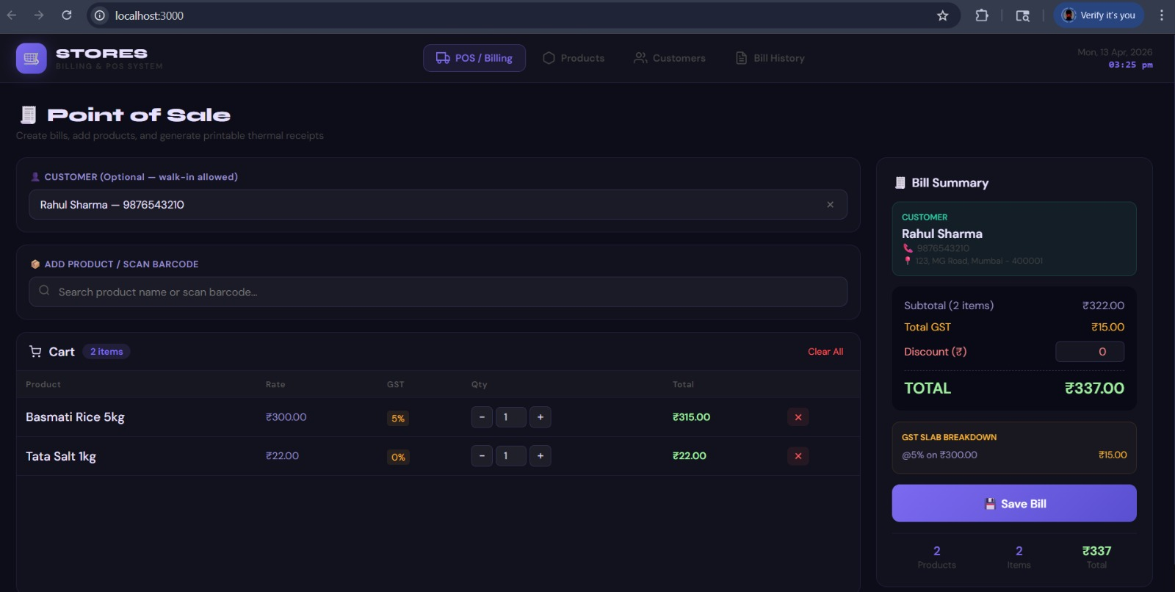
Recipt Report:
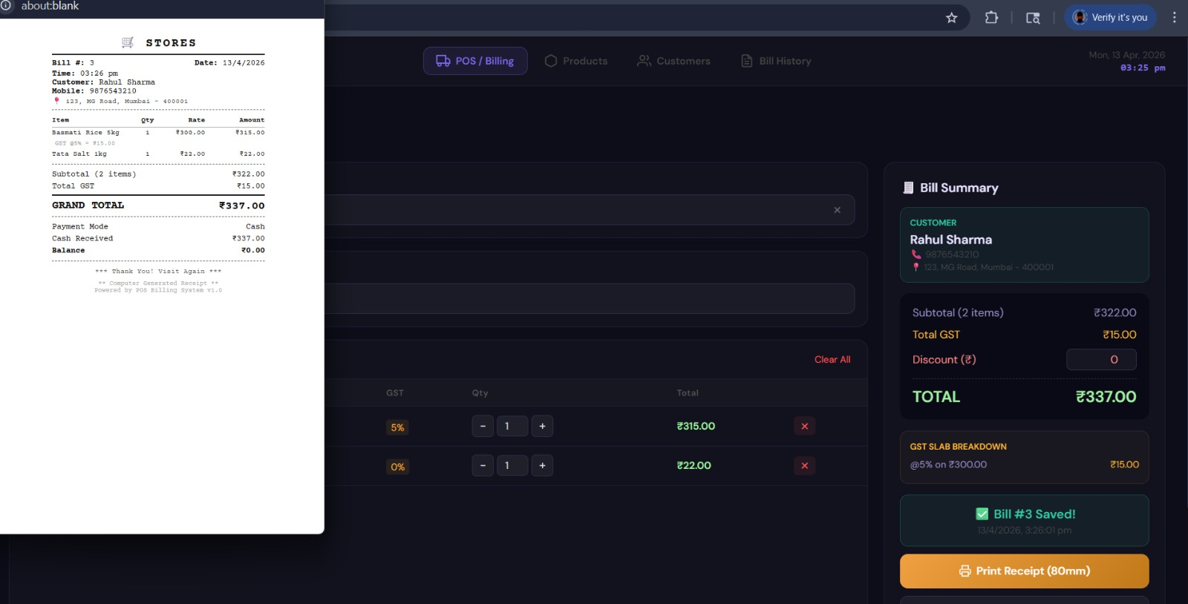

Product’s:
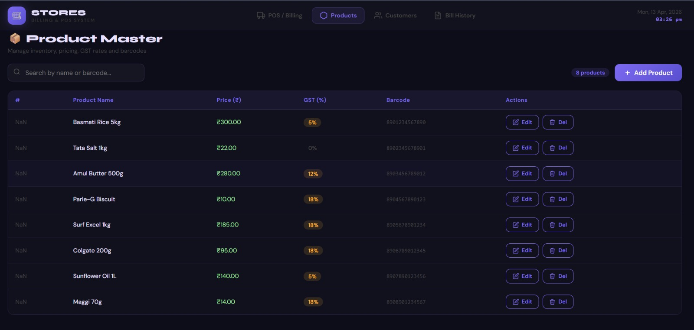AddProducts: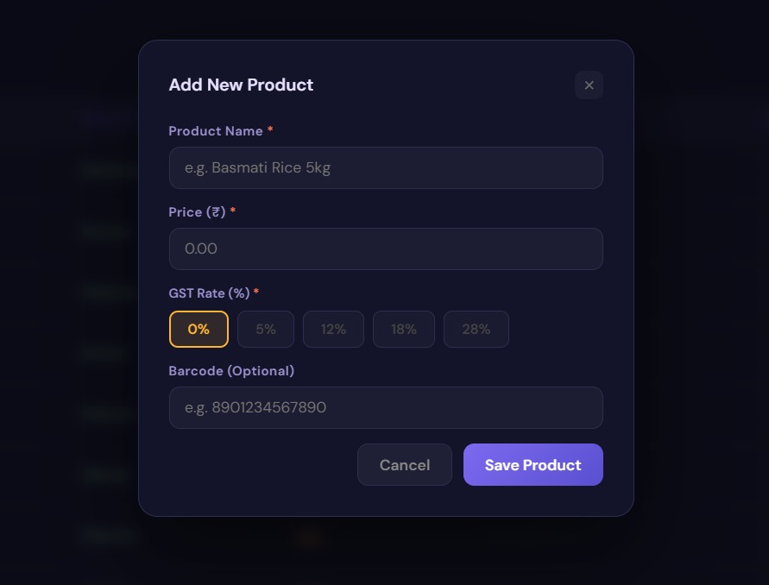

Customer:
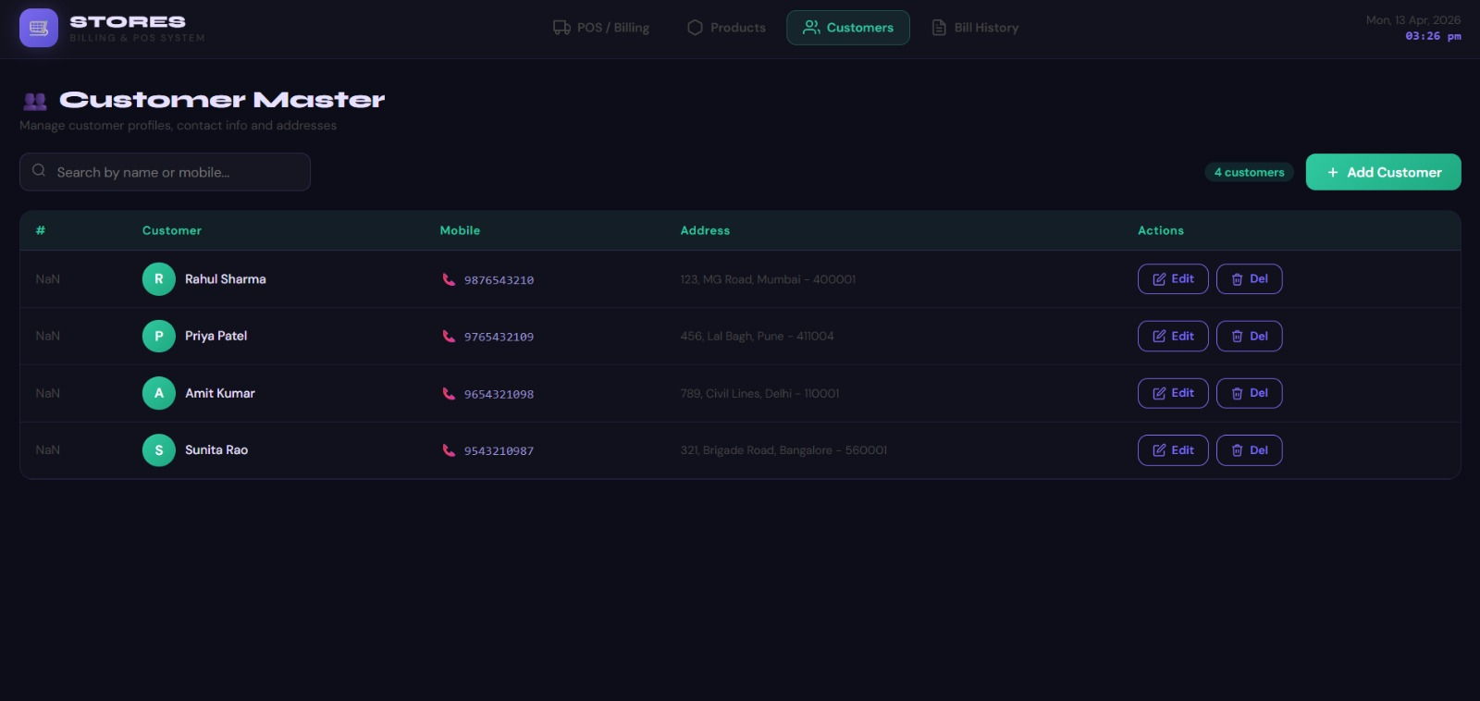

Add Customer:
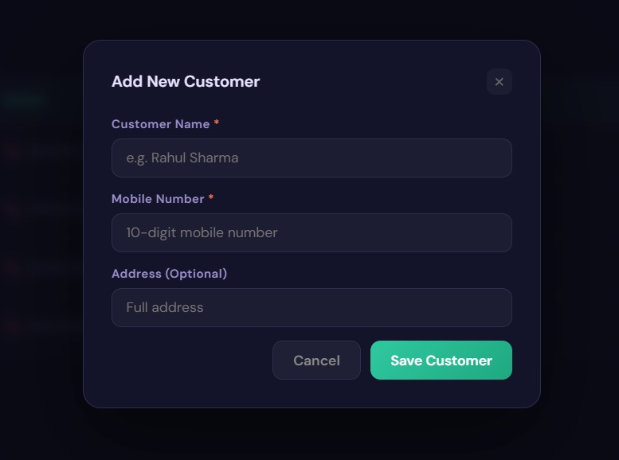

BillHestory:
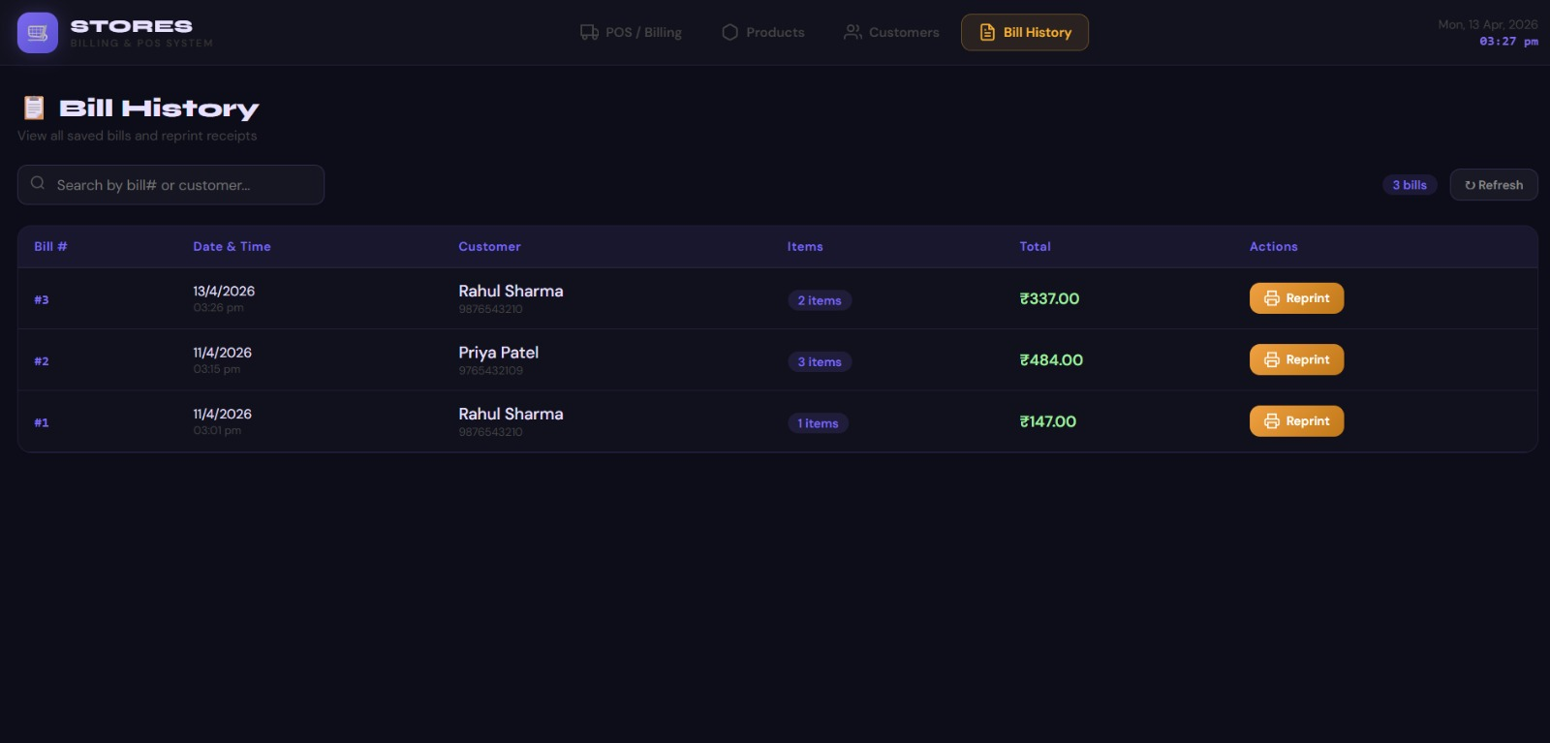

Project Summary

This POS Billing System is a complete full-stack application built using a React frontend and a Spring Boot backend. The system successfully implements all required features, including product management, customer management, real-time GST billing, 80mm thermal receipt printing, and bill history. Data is stored in a MySQL database using JPA/Hibernate, and communication between the frontend and backend is handled through REST APIs

