Name – Yash Chauhan
Roll No. - 28
Registration No. - 230905194
Date – 7/1/26
Sem - 6th
Section – C1

Q1 Ans -
<!DOCTYPE html>
<html lang="en">
<head>
<meta charset="UTF-8">
<title>Whispers of the Day</title>
</head>
<body>
<h1>Whispers of the Day</h1>

<p>
The morning wakes with gentle <b>light</b>,<br>
Birds take wing in cheerful <b>flight</b>.<br>
The sky above so calm and <b>blue</b>,<br>
Holds the dreams we're heading <b>to</b>.
</p>

<p>
As the sun begins to softly <b>rest</b>,<br>
The day feels warm, the heart feels <b>blessed</b>.<br>
Night arrives with stars in <b>sight</b>,<br>
Whispering peace till morning <b>light</b>.
</p>
</body>
</html>

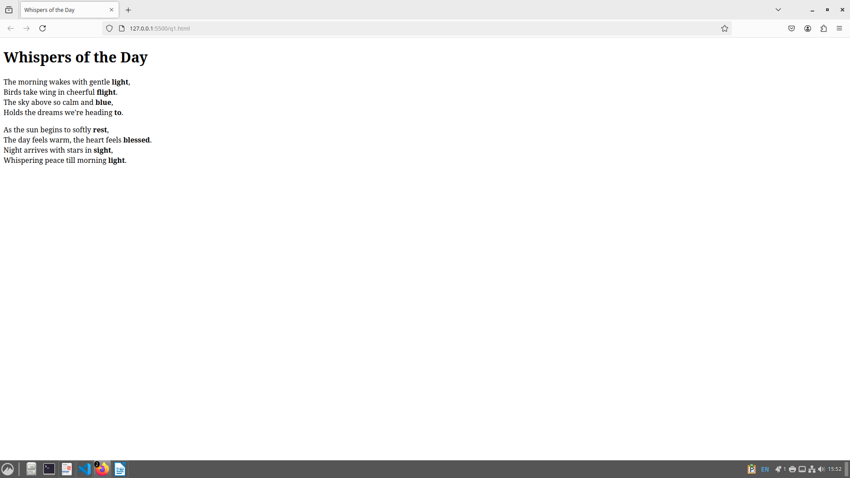

Q2 Ans -

<!DOCTYPE html>
<html lang="en">
<head>
<meta charset="UTF-8">
<title>My New Car Accessories and Travel Plans</title>
</head>
<body>

<h1>My New Car</h1>

<h2>Additional Accessories Needed</h2>
<ul>
<li>Seat covers</li>
<li>Floor mats</li>
<li>Dashboard camera</li>
<li>Car air freshener</li>
<li>Phone holder</li>
<li>First aid kit</li>
</ul>

<h2>Travel Plans Using the Car</h2>
<ol>
<li>Weekend trips</li>
<li>Family vacation to the mountain</li>
<li>Road trip with friends</li>
<li>Daily commute to college</li>
<li>Visit to non-visited places</li>
</ol>

</body>
</html>
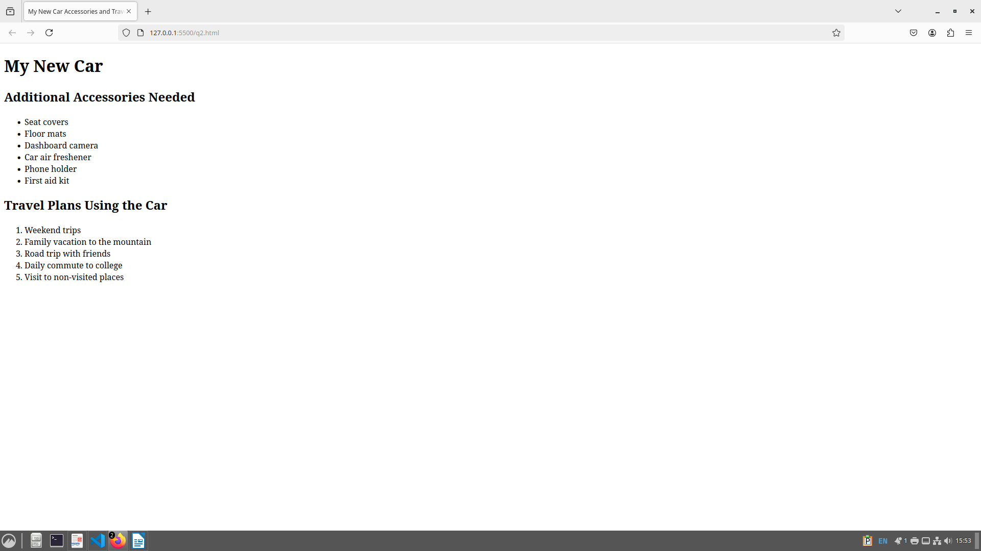

Q3 Ans -

<!DOCTYPE html>
<html lang="en">
<head>
<meta charset="UTF-8">
<title>Share Your Travel</title>

<style>
body {
font-family: Arial, sans-serif;
background: linear-gradient(to right, #74ebd5, #acb6e5);
margin: 0;
padding: 0;
text-align: center;
}

header {
background: linear-gradient(to right, #1e3c72, #2a5298);
color: white;
padding: 40px 20px;
font-size: 32px;
font-weight: bold;
letter-spacing: 2px;
box-shadow: 0 4px 10px rgba(0,0,0,0.3);
}

.content {
padding: 30px 20px;
}

p {
max-width: 800px;
margin: 0 auto 35px;
color: #333;
font-size: 17px;
background: rgba(255, 255, 255, 0.8);
padding: 15px;
border-radius: 10px;
}

.video-container {
display: flex;
flex-wrap: wrap;
justify-content: center;
gap: 25px;
}

.video-card {
width: 420px;
}

video {
width: 100%;
height: 240px;
border-radius: 15px;
box-shadow: 0 8px 16px rgba(0,0,0,0.3);
background-color: #000;
}

.video-desc {
margin-top: 10px;
font-size: 15px;
color: #333;
background: rgba(255,255,255,0.85);
padding: 10px;
border-radius: 8px;
}
</style>
</head>

<body>

<header>
🌍 SHARE YOUR TRAVEL
</header>

<div class="content">
<p>
Traveling allows us to explore new places, cultures, and experiences.
Enjoy the calm beaches, the vibrant beauty of Rajasthan,
and the peaceful curves of mountain roads.
</p>

<div class="video-container">

<div class="video-card">
<video autoplay loop muted playsinline disablePictureInPicture>
<source src="q3/beach.mp4" type="video/mp4">
</video>
<div class="video-desc">
Relax by the serene beaches where the waves meet golden sands.
</div>
</div>

<div class="video-card">
<video autoplay loop muted playsinline disablePictureInPicture>
<source src="q3/rajasthan.mp4" type="video/mp4">
</video>
<div class="video-desc">
Discover the royal heritage and colorful culture of Rajasthan.
</div>
</div>

<div class="video-card">
<video autoplay loop muted playsinline disablePictureInPicture>
<source src="q3/curve_road.mp4" type="video/mp4">
</video>
<div class="video-desc">
Enjoy the peaceful mountain roads winding through nature.
</div>
</div>

</div>
</div>

</body>
</html>

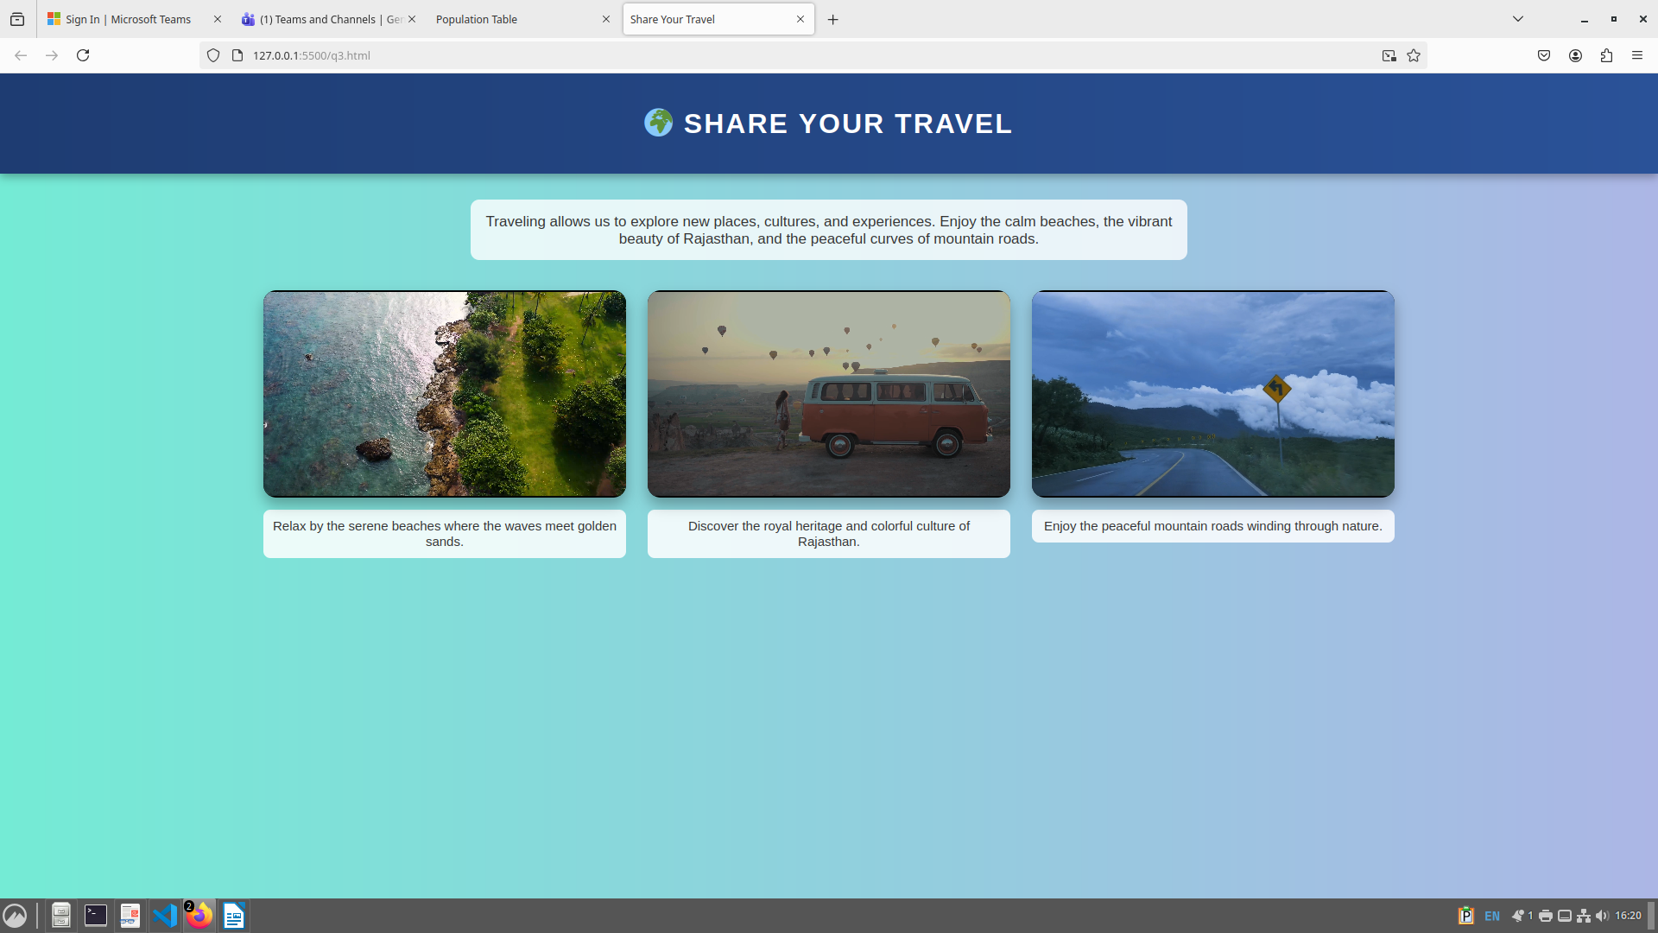

Q1 Additional Ans -

<!DOCTYPE html>
<html>
<head>
<title>Population Table</title>
<style>
table {
border-collapse: collapse;
width: 60%;
margin: 20px auto;
text-align: center;
font-family: Arial;
}
th, td {
border: 1px solid black;
padding: 8px;
}
th {
background-color: red;
color: white;
}
.country {
background-color: #ffe599;
font-weight: bold;
}
.year {
background-color: #9fc5e8;
}
.population {
background-color: #b6d7a8;
}
</style>
</head>
<body>

<table>
<tr>
<th>Country</th>
<th colspan="2">Population (in Crores)</th>
</tr>

<tr>
<td rowspan="3" class="country">INDIA</td>
<td class="year">1998</td>
<td class="population">85</td>
</tr>
<tr>
<td class="year">1999</td>
<td class="population">90</td>
</tr>
<tr>
<td class="year">2000</td>
<td class="population">100</td>
</tr>

<tr>
<td rowspan="3" class="country">USA</td>
<td class="year">1998</td>
<td class="population">30</td>
</tr>
<tr>
<td class="year">1999</td>
<td class="population">35</td>
</tr>
<tr>
<td class="year">2000</td>
<td class="population">40</td>
</tr>

<tr>
<td rowspan="3" class="country">UK</td>
<td class="year">1998</td>
<td class="population">25</td>
</tr>
<tr>
<td class="year">1999</td>
<td class="population">30</td>
</tr>
<tr>
<td class="year">2000</td>
<td class="population">35</td>
</tr>
</table>

</body>
</html>

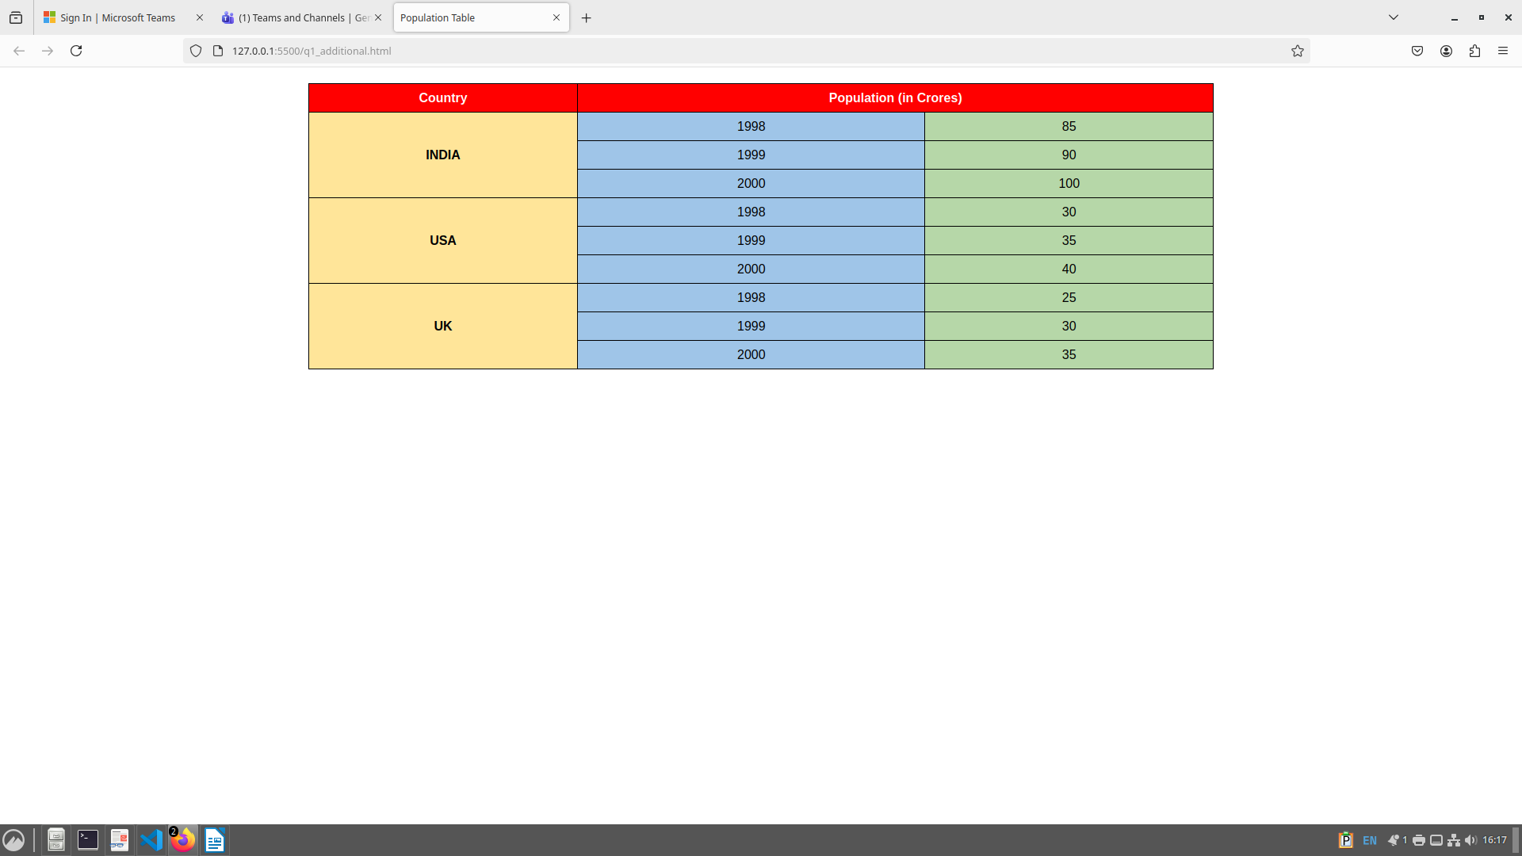

Q2 Additional Ans -

<!DOCTYPE html>
<html>
<head>
<title>Population Table using JavaScript</title>
<style>
table {
border-collapse: collapse;
width: 60%;
margin: 20px auto;
text-align: center;
font-family: Arial;
}
th, td {
border: 1px solid black;
padding: 8px;
}
th {
background-color: red;
color: white;
}
.country {
background-color: #ffe599;
font-weight: bold;
}
.year {
background-color: #9fc5e8;
}
.population {
background-color: #b6d7a8;
}
</style>
</head>
<body>

<table id="populationTable">
<tr>
<th>Country</th>
<th colspan="2">Population (in Crores)</th>
</tr>
</table>

<script>
const data = {
INDIA: [
{ year: 1998, population: 85 },
{ year: 1999, population: 90 },
{ year: 2000, population: 100 }
],
USA: [
{ year: 1998, population: 30 },
{ year: 1999, population: 35 },
{ year: 2000, population: 40 }
],
UK: [
{ year: 1998, population: 25 },
{ year: 1999, population: 30 },
{ year: 2000, population: 35 }
]
};

const table = document.getElementById("populationTable");

for (const country in data) {
data[country].forEach((item, index) => {
const row = document.createElement("tr");

if (index === 0) {
const countryCell = document.createElement("td");
countryCell.textContent = country;
countryCell.rowSpan = data[country].length;
countryCell.className = "country";
row.appendChild(countryCell);
}

const yearCell = document.createElement("td");
yearCell.textContent = item.year;
yearCell.className = "year";

const populationCell = document.createElement("td");
populationCell.textContent = item.population;
populationCell.className = "population";

row.appendChild(yearCell);
row.appendChild(populationCell);
table.appendChild(row);
});
}
</script>

</body>
</html>

