Micro Project Report
On
Technical Skill Development
“ Tasty Restaurant ”
V SEMESTER
INFORMATION TECHNOLOGY

Submitted by

Roll No. Name of Students

Yash Dekate 24010032

Under the guidance of
Prof. Shankar Gadhve

Academic Year 2026-27

Department of Information Technology


ST. VINCENT PALLOTTI COLLEGE OF ENGINEERING AND TECHNOLOGY

CONTENTS

CHAPTER NO. TITLE PAGE NO.

1. INTRODUCTION 01

2. Technology Platform Overview 02

3. CODE IMPLEMENTATION 04
4. OUTPUT 07
5. CONCLUSION 09
6. REFERENCES 10

1. INTRODUCTION

In today's digital world, most customers search for restaurants online before deciding where to dine or order food. A well-designed restaurant website helps attract customers by displaying the menu, restaurant details, and contact information in an attractive and organized manner. Since people access websites using different devices such as smartphones, tablets, and desktop computers, it is important that the website works smoothly on all screen sizes.

The Responsive Restaurant Landing Page is a simple web-based application developed to provide an attractive and user-friendly interface for a restaurant. The website includes a navigation bar, home section, food menu with prices, about section, contact information, and footer. The navigation links allow users to move easily between different sections of the webpage, improving the overall browsing experience.

A major feature of this project is its responsive design, which ensures that the website automatically adjusts its layout according to the screen size of the user's device. Whether viewed on a mobile phone, tablet, or desktop computer, the website remains easy to navigate and visually appealing. This is achieved using CSS Flexbox and Media Queries.

The project is developed using fundamental frontend web technologies such as HTML and CSS. HTML is used to create the structure and content of the webpage, while CSS is used to style the layout, improve the appearance, and implement responsive design. The project demonstrates important web development concepts such as page layout design, navigation using anchor links, responsive design, and user interface development.

Overall, the Responsive Restaurant Landing Page serves as a basic model of a restaurant website that showcases food items, prices, and restaurant information in a clean and professional manner. This project helps in understanding the fundamentals of responsive web design while improving practical skills in frontend web development.

2.TECHNOLOGY PLATFORM OVERVIEW (Detailed)
This project is developed using basic frontend web technologies that help create a responsive, attractive, and user-friendly restaurant website. The website is designed to work efficiently on mobile phones, tablets, and desktop computers. The following technologies and tools were used during the development of the Responsive Restaurant Landing Page.
Frontend Technologies
1. HTML (HyperText Markup Language)
HTML is the standard markup language used to create the structure of web pages. It provides the basic framework of the website by defining elements such as headings, paragraphs, images, navigation links, buttons, and sections.
In this project, HTML is used to:
- Create the overall structure of the restaurant website.
- Design the Header with the restaurant name and navigation menu.
- Build the Home, Menu, About, Contact, and Footer sections.
- Display food images, item names, descriptions, and prices.
- Create navigation links that move users to different sections of the webpage.
HTML ensures that all content is properly organized and displayed in the web browser.
2. CSS (Cascading Style Sheets)
CSS is used to design and style the web pages created using HTML. It improves the visual appearance of the website by controlling colors, fonts, spacing, layouts, and responsiveness.
In this project, CSS is used to:
- Design an attractive and modern restaurant interface.
- Style the navigation bar, buttons, menu cards, and footer.
- Create food item cards with images and prices.
- Apply colors, fonts, borders, spacing, and shadows.
- Implement responsive design using Media Queries for different screen sizes.
- Use Flexbox to arrange menu items in a clean and organized layout.
- Add smooth scrolling for easy navigation between sections.
CSS enhances the overall user experience by making the website visually appealing and responsive.
Responsive Design
Responsive Web Design ensures that the website automatically adjusts its layout according to the screen size of the user's device.
In this project:
- Desktop devices display the full navigation bar and multiple menu cards in a row.
- Tablet devices adjust the layout for medium-sized screens.
- Mobile devices stack the navigation links and menu cards vertically for better readability.
This responsive behavior is achieved using CSS Media Queries and Flexbox.
Platform Used
Visual Studio Code (VS Code)
Visual Studio Code is a lightweight and powerful code editor used for developing web applications.
It is used in this project for:
- Writing HTML and CSS code.
- Organizing project files efficiently.
- Providing syntax highlighting and auto-completion.
- Editing and managing website resources.
- Running and testing the website using the Live Server extension.
VS Code makes web development faster, easier, and more organized.
Browser Used
The website was tested using modern web browsers such as:
- Google Chrome
- Microsoft Edge
- Mozilla Firefox

3. CODE IMPLEMENTATION

Html :-

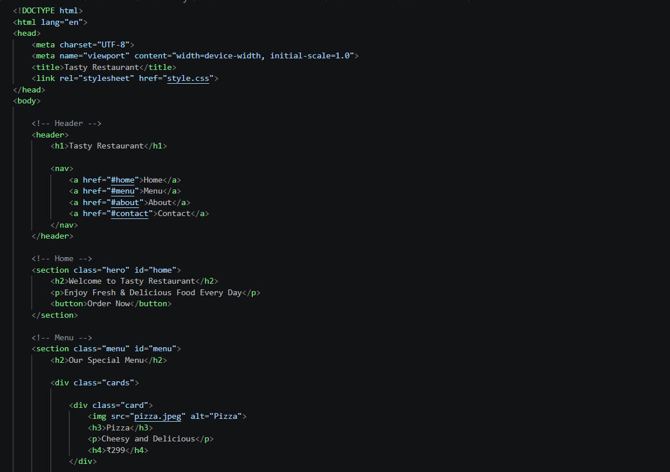

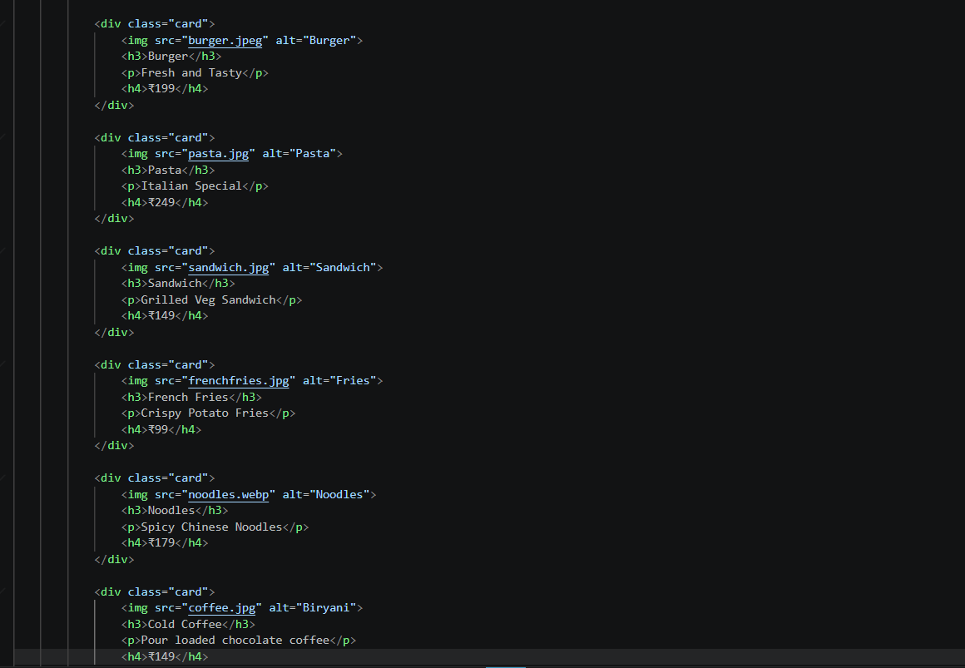

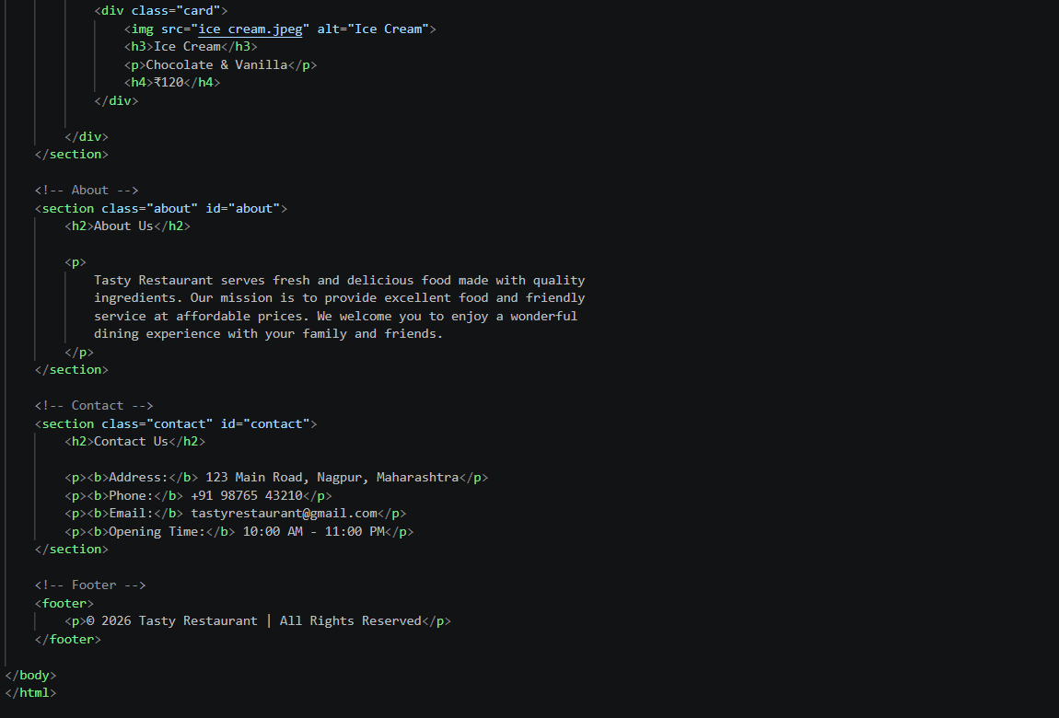

4.OUTPUT

Home Page :-

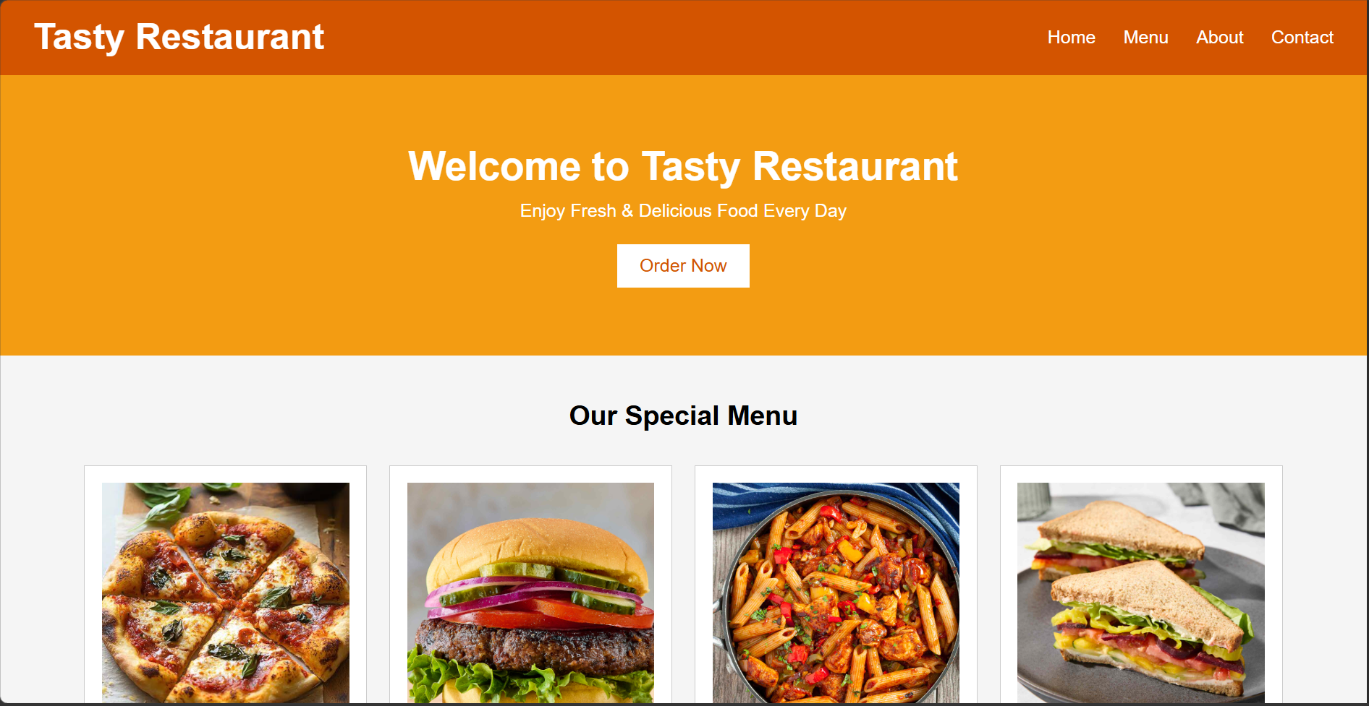

Menu Page :-

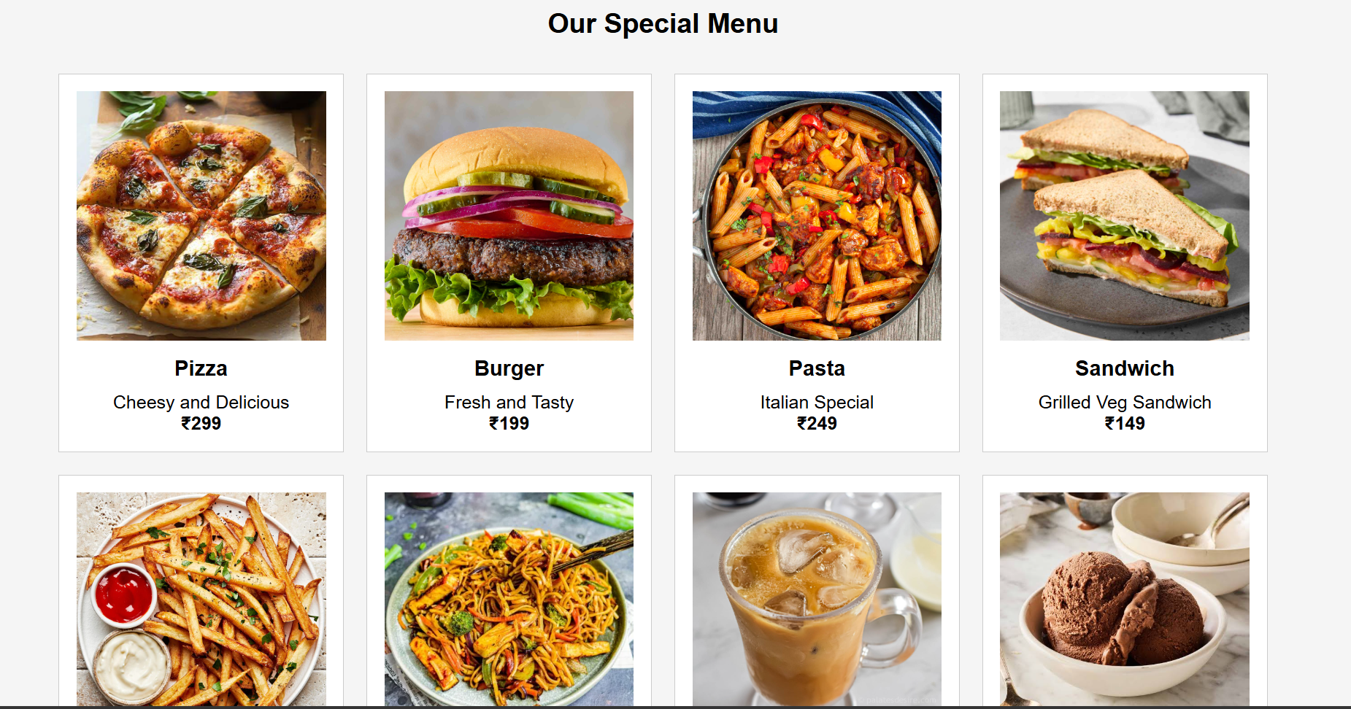

About & Contact Page :-

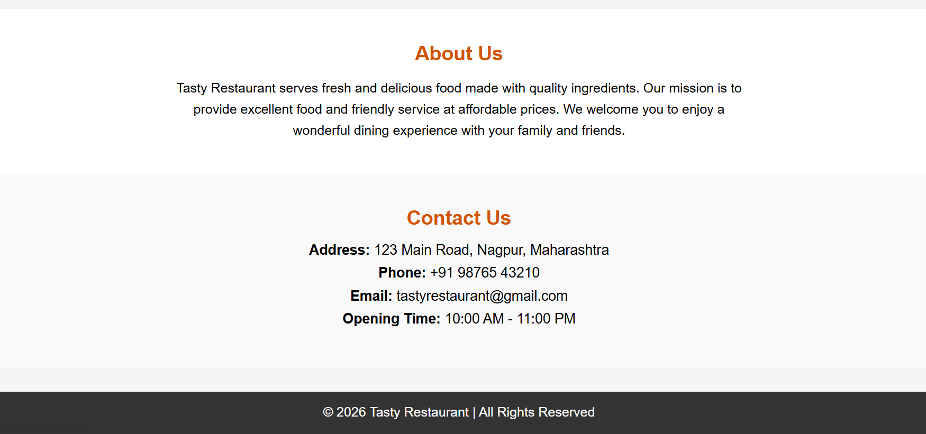

5.CONCLUSION

This project helped in understanding the fundamentals of frontend web development and responsive web design. The Responsive Restaurant Landing Page demonstrates how an attractive and user-friendly restaurant website can be created using HTML and CSS.
The website provides important features such as a navigation bar, home section, food menu with prices, about section, contact information, and a responsive layout that works smoothly on mobile phones, tablets, and desktop computers. It also improves the user experience by allowing easy navigation between different sections of the webpage.
This project enhanced practical knowledge of:
- HTML page structure
- CSS styling and layout design
- Responsive web design using Media Queries
- Flexbox for arranging webpage elements
- Navigation using anchor links
- Creating a clean and user-friendly interface
Overall, this project serves as a basic model of a modern restaurant website and helps in developing practical skills in designing responsive and visually appealing web applications.

6.REFERENCES

W3Schools – HTML & CSS Tutorials
https://www.w3schools.com
MDN Web Docs – HTML and CSS Documentation
https://developer.mozilla.org
GeeksforGeeks – Web Development Tutorials
https://www.geeksforgeeks.org
CSS-Tricks – CSS Flexbox and Responsive Design Guide
https://css-tricks.com
freeCodeCamp – Responsive Web Design Course
https://www.freecodecamp.org

