Micro Project Report
On
Technical Skill Development
“Personal Portfolio ”
V SEMESTER
INFORMATION TECHNOLOGY

Submitted by

Roll No. Name of Students

Yash Dekate 24010032

Under the guidance of
Prof. Shankar Gadhve

Academic Year 2026-27

Department of Information Technology


ST. VINCENT PALLOTTI COLLEGE OF ENGINEERING AND TECHNOLOGY

CONTENTS

CHAPTER NO. TITLE PAGE NO.

1. INTRODUCTION 01

2. Technology Platform Overview 02

3. CODE IMPLEMENTATION 04
4. OUTPUT 07
5. CONCLUSION 09
6. REFERENCES 10

1. INTRODUCTION

In today's digital era, online shopping has become one of the most convenient ways for customers to purchase products from anywhere and at any time. An attractive and user-friendly e-commerce website helps customers easily browse products, view special offers, search for items, and make purchasing decisions. A well-designed product catalog improves the shopping experience by presenting products in a clear, organized, and visually appealing manner. This project, ShopEasy – E-Commerce Product Catalog, is developed to demonstrate the basic concepts of frontend web development using HTML and CSS.

The website includes a header, navigation bar, search box, promotional banner, special offers section, product catalog, about section, contact information, and footer. Products are displayed using responsive cards that contain product images, names, prices, and an "Add to Cart" button. The Offers section highlights discounted products with old and new prices along with discount badges, making the website more attractive to users.

The project is developed using HTML for creating the structure of the webpage and CSS for designing the layout, colors, typography, spacing, responsive grids, and hover effects. The responsive design ensures that the website adjusts automatically to different screen sizes, allowing users to access it comfortably on desktops, tablets, and smartphones.

Overall, ShopEasy – E-Commerce Product Catalog serves as a basic model of an online shopping website. It helps in understanding essential web development concepts such as page layout design, responsive web design, product card creation, navigation using anchor links, and modern user interface design. This project also enhances practical skills in developing attractive and responsive frontend web applications suitable for real-world e-commerce websites.

2.TECHNOLOGY PLATFORM OVERVIEW (Detailed)
The ShopEasy – E-Commerce Product Catalog is developed using basic frontend web technologies to create an attractive, responsive, and user-friendly online shopping website. The website is designed to display products, highlight special offers, and provide easy navigation across different sections. It works efficiently on desktops, tablets, and smartphones, ensuring a smooth user experience. The following technologies and tools were used during the development of this project.
Frontend Technologies
1. HTML (HyperText Markup Language)
HTML is the standard markup language used to create the structure and content of web pages. It defines all the elements displayed on the website.
In this project, HTML is used to:
- Create the overall structure of the e-commerce website.
- Design the header, navigation bar, banner, offers, products, about, contact, and footer sections.
- Display product images, names, prices, and buttons.
- Create navigation links for smooth movement between webpage sections.
- Organize the content in a clean and structured manner.

2. CSS (Cascading Style Sheets)
CSS is used to design and style the HTML elements, making the website visually attractive and responsive.
In this project, CSS is used to:
- Design an attractive and modern shopping interface.
- Style the navigation bar, banner, product cards, offer cards, buttons, and footer.
- Apply colors, fonts, spacing, borders, and shadows.
- Create hover effects for buttons and product cards.
- Build responsive layouts using CSS Grid and Flexbox.
- Implement responsive design using Media Queries for different screen sizes.
CSS improves the appearance of the website and provides a better user experience.

Responsive Design
Responsive Web Design ensures that the website automatically adjusts according to the user's screen size.
In this project:
- Desktop screens display multiple product cards in a row.
- Tablet screens adjust the layout for medium-sized devices.
- Mobile screens stack navigation links and product cards vertically for better readability.
- The search bar and navigation adapt to smaller screen sizes.
This responsiveness is achieved using CSS Grid, Flexbox, and Media Queries.

Platform Used
Visual Studio Code (VS Code)
Visual Studio Code is the code editor used for developing this project.
It is used for:
- Writing HTML and CSS code.
- Organizing project files.
- Editing and testing the website.
- Using Live Server for real-time preview.
- Debugging and improving the webpage design.

3. CODE IMPLEMENTATION

Html :-
<!DOCTYPE html>
<html lang="en">

<head>
<meta charset="UTF-8">
<meta name="viewport" content="width=device-width, initial-scale=1.0">
<title>ShopEasy - E-Commerce Product Catalog</title>

<link rel="stylesheet" href="style.css">
</head>

<body>

<!-- Header -->
<header>
<h1>ShopEasy</h1>
</header>
<!-- Navigation -->
<nav>
<div class="nav-links">
<a href="#home">Home</a>
<a href="#offer">Offers</a>
<a href="#product">Products</a>
<a href="#about">About</a>
<a href="#contact">Contact</a>
</div>
<div class="search-box">
<input type="text" placeholder="Search products...">
<button>Search</button>
</div>
</nav>
<!-- Banner -->
<section class="banner" id="home">

<h2>Big Summer Sale</h2>

<p>
Up to 50% OFF on Selected Products
</p>

<button>
Shop Now
</button>
</section>

<!-- Offers Section -->
<section class="offers" id="offer">
<h2>Special Offers</h2>
<div class="offer-products">
<div class="offer-card">
<img src="gaming laptop.webp" alt="Laptop">
<h3>Gaming Laptop</h3>
<p class="old-price">₹80,000</p>
<p class="new-price">₹65,000</p>
<span>20% OFF</span>
<button>Add to Cart</button>
</div>
<div class="offer-card">
<img src="smartPhone.jpeg" alt="Phone">
<h3>Premium Smartphone</h3>
<p class="old-price">₹35,000</p>
<p class="new-price">₹27,999</p>
<span>25% OFF</span>
<button>Add to Cart</button>
</div>
<div class="offer-card">
<img src="headPhone.webp" alt="Headphone">
<h3>Wireless Headphones</h3>
<p class="old-price">₹5,000</p>
<p class="new-price">₹2,999</p>
<span>40% OFF</span>
<button>Add to Cart</button>
</div>
<div class="offer-card">
<img src="smartWatch.webp" alt="Watch”>
<h3>Smart Watch</h3>
<p class="old-price">₹8,000</p>
<p class="new-price">₹4,999</p>
<span>35% OFF</span>
<button>Add to Cart</button>
</div>
<!-- More Offer Products -->
<div class="offer-card">
<img src="tv.jpeg" alt="Smart TV">
<h3>Smart LED TV</h3>
<p class="old-price">₹55,000</p>
<p class="new-price">₹39,999</p>
<span>30% OFF</span>
<button>Add to Cart</button>
</div>
<div class="offer-card">
<img src="tab.webp" alt="Tablet">
<h3>Android Tablet</h3>
<p class="old-price">₹25,000</p>
<p class="new-price">₹18,999</p>
<span>25% OFF</span>
<button>Add to Cart</button>
</div>
<div class="offer-card">
<img src="console.jpg" alt="Gaming Console">
<h3>Gaming Console</h3>
<p class="old-price">₹45,000</p>
<p class="new-price">₹34,999</p>
<span>22% OFF</span>
<button>Add to Cart</button>
</div>
<div class="offer-card">
<img src="tv.avif" alt="Smart TV">
<h3>4K Smart TV</h3>
<p class="old-price">₹70,000</p>
<p class="new-price">₹49,999</p>
<span>28% OFF</span>
<button>Add to Cart</button>
</div>
<div class="offer-card">
<img src="camera.jpeg" alt="Camera">
<h3>DSLR Camera</h3>
<p class="old-price">₹65,000</p>
<p class="new-price">₹52,000</p>
<span>20% OFF</span>
<button>Add to Cart</button>
</div>
<div class="offer-card">
<img src="earbud.jpeg" alt="Earbuds">
<h3>Wireless Earbuds</h3>
<p class="old-price">₹3,999</p>
<p class="new-price">₹1,999</p>
<span>50% OFF</span>
<button>Add to Cart</button>
</div>
<div class="offer-card">
<img src="monitor.webp" alt="Monitor">
<h3>Gaming Monitor</h3>
<p class="old-price">₹25,000</p>
<p class="new-price">₹19,999</p>
<span>20% OFF</span>
<button>Add to Cart</button>
</div>
<div class="offer-card">
<img src="watch.webp" alt="Smart Watch">
<h3>Fitness Smart Watch</h3>
<p class="old-price">₹6,000</p>
<p class="new-price">₹3,499</p>
<span>40% OFF</span>
<button>Add to Cart</button>
</div>

<div class="offer-card">
<img src="laptop.webp" alt="Laptop">
<h3>Business Laptop</h3>
<p class="old-price">₹75,000</p>
<p class="new-price">₹59,999</p>
<span>20% OFF</span>
<button>Add to Cart</button>
</div>
<div class="offer-card">
<img src="headset.webp" alt="Headphones">
<h3>Noise Cancelling Headphones</h3>
<p class="old-price">₹8,000</p>
<p class="new-price">₹4,499</p>
<span>45% OFF</span>
<button>Add to Cart</button>
</div>
</div>
</section>

<!-- Product Section -->

<section class="products" id="product">

<div class="card">
<img src="laptop1.png" alt="Laptop">
<h3>Laptop</h3>
<p>₹55,000</p>
<button>Add to Cart</button>
</div>

<div class="card">
<img src="phone.jpeg" alt="Phone">
<h3>Smart Phone</h3>
<p>₹25,000</p>
<button>Add to Cart</button>
</div>

<div class="card">
<img src="watch 1.webp" alt="Watch">
<h3>Smart Watch</h3>
<p>₹4,500</p>
<button>Add to Cart</button>
</div>

<div class="card">
<img src="shoe.jpg" alt="Shoes">
<h3>Sports Shoes</h3>
<p>₹3,500</p>
<button>Add to Cart</button>
</div>

<div class="card">
<img src="camera.jpg" alt="Camera">
<h3>Digital Camera</h3>
<p>₹32,000</p>
<button>Add to Cart</button>
</div>

<div class="card">
<img src="speaker.webp" alt="Speaker">
<h3>Bluetooth Speaker</h3>
<p>₹2,500</p>
<button>Add to Cart</button>
</div>

<div class="card">
<img src="keyboard.jpeg" alt="Keyboard">
<h3>Keyboard</h3>
<p>₹1,200</p>
<button>Add to Cart</button>
</div>

<div class="card">
<img src="mouse.jpeg" alt="Mouse">
<h3>Wireless Mouse</h3>
<p>₹800</p>
<button>Add to Cart</button>
</div>

<!-- More Products -->

<div class="card">
<img src="tab.jpeg" alt="Tablet">
<h3>Tablet</h3>
<p>₹18,000</p>
<button>Add to Cart</button>
</div>

<div class="card">
<img src="console.avif" alt="Gaming Console">
<h3>Gaming Console</h3>
<p>₹39,999</p>
<button>Add to Cart</button>
</div>

<div class="card">
<img src="moniter.webp" alt="Monitor">
<h3>LED Monitor</h3>
<p>₹12,500</p>
<button>Add to Cart</button>
</div>

<div class="card">
<img src="printer.webp" alt="Printer">
<h3>Laser Printer</h3>
<p>₹8,500</p>
<button>Add to Cart</button>
</div>

<div class="card">
<img src="powerBank.jpeg" alt="Power Bank">
<h3>Power Bank</h3>
<p>₹1,499</p>
<button>Add to Cart</button>
</div>

<div class="card">
<img src="tv1.jpeg" alt="Smart TV">
<h3>Smart LED TV</h3>
<p>₹45,000</p>
<button>Add to Cart</button>
</div>

<div class="card">
<img src="mkey.jpeg" alt="Keyboard">
<h3>Mechanical Keyboard</h3>
<p>₹2,500</p>
<button>Add to Cart</button>
</div>

<div class="card">
<img src="Wmouse.jpeg" alt="Mouse">
<h3>Wireless Mouse</h3>
<p>₹999</p>
<button>Add to Cart</button>
</div>

<div class="card">
<img src="dslr.jpeg" alt="Camera">
<h3>DSLR Camera</h3>
<p>₹55,000</p>
<button>Add to Cart</button>
</div>

<div class="card">
<img src="speaker1.webp" alt="Speaker">
<h3>Bluetooth Speaker</h3>
<p>₹3,500</p>
<button>Add to Cart</button>
</div>

<div class="card">
<img src="lbag.jpeg" alt="Laptop Bag">
<h3>Laptop Bag</h3>
<p>₹1,800</p>
<button>Add to Cart</button>
</div>

<div class="card">
<img src="router.jpeg" alt="Router">
<h3>WiFi Router</h3>
<p>₹2,200</p>
<button>Add to Cart</button>
</div>

</section>

<!-- About -->

<section class="about" id="about">

<h2>About Us</h2>

<p>
Welcome to <b>ShopEasy</b>, your trusted online shopping destination.
We provide quality electronics, fashion products and accessories
at affordable prices with fast delivery and customer support.
</p>

</section>

<!-- Contact -->
<section class="contact" id="contact">
<h2>Contact Us</h2>
<p>📍 Nagpur, Maharashtra, India</p>
<p>📞 +91 98765 43210</p>
<p>📧 support@shopeasy.com</p>
<p>🕒 Monday - Saturday (9 AM - 8 PM)</p>

</section>
<!-- Footer -->

<footer>

<p>
© 2026 ShopEasy. All Rights Reserved.
</p>
</footer>
</body>
</html>

CSS:-

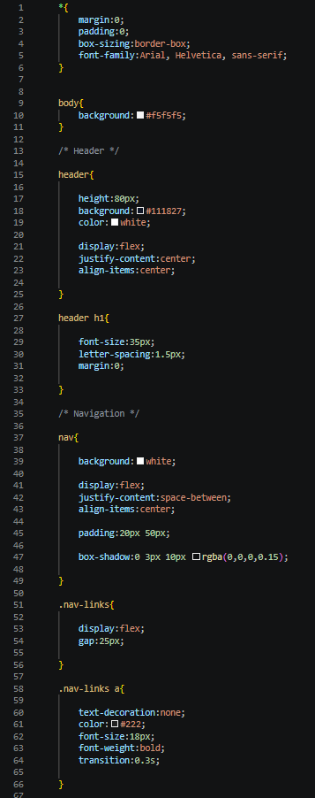

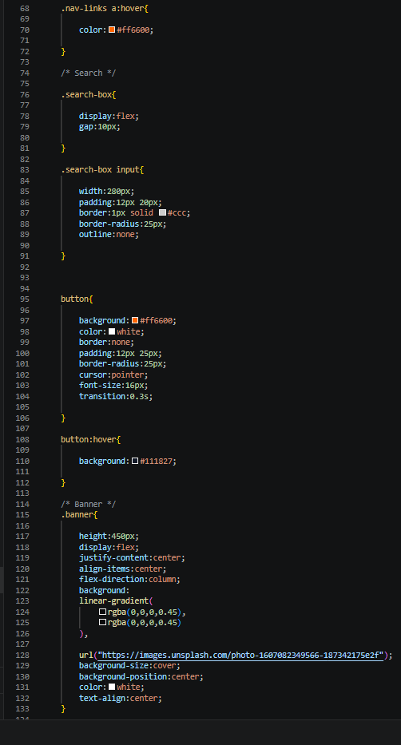

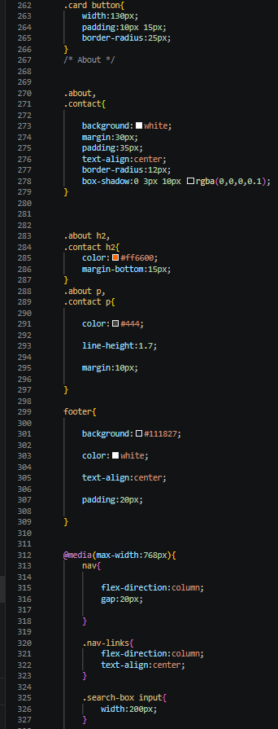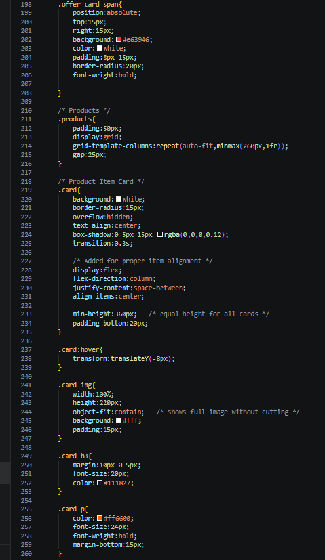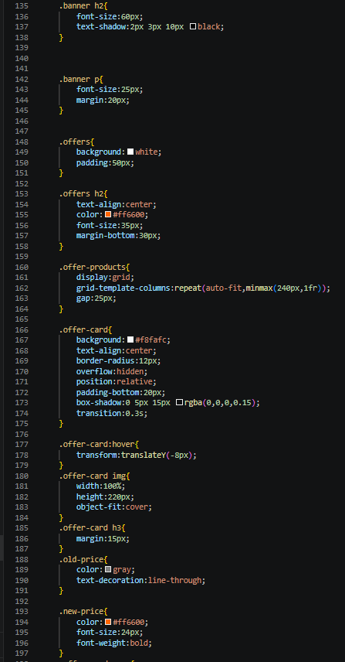
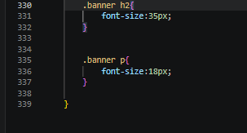

4.OUTPUT

Home Page :-

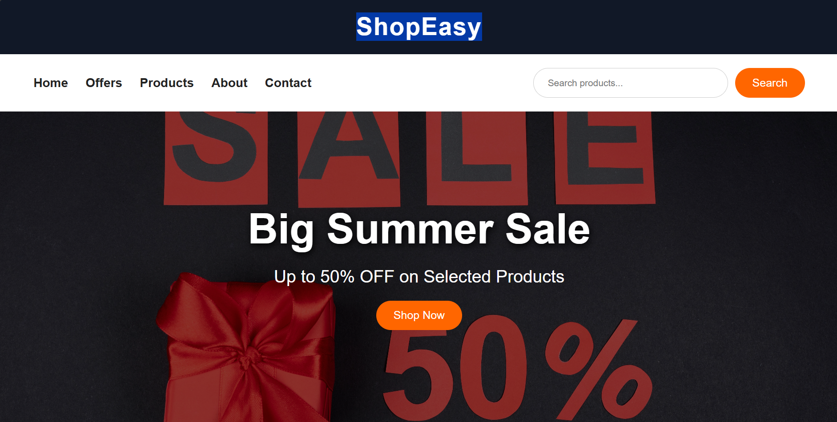

Menu Page :-
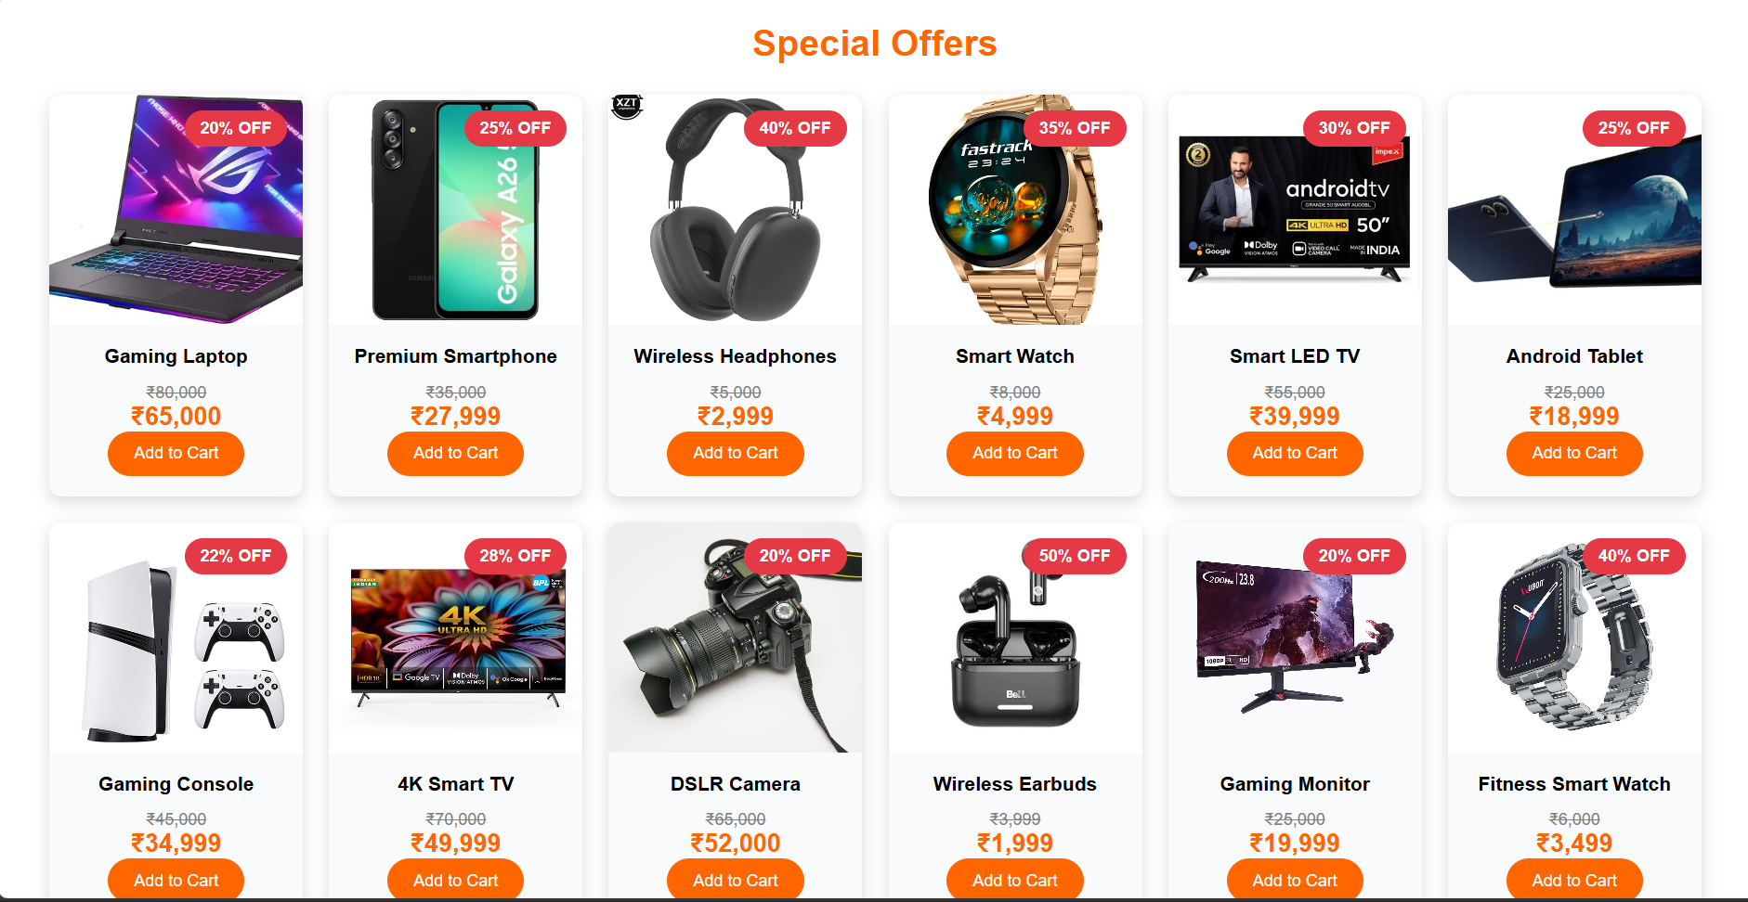

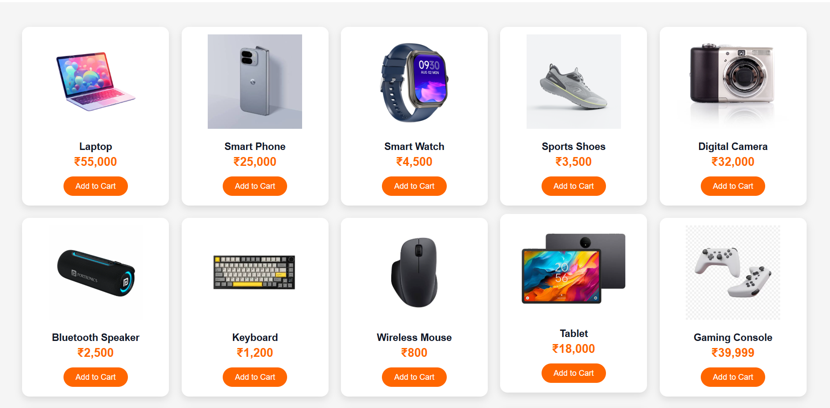

About & Contact Page :-

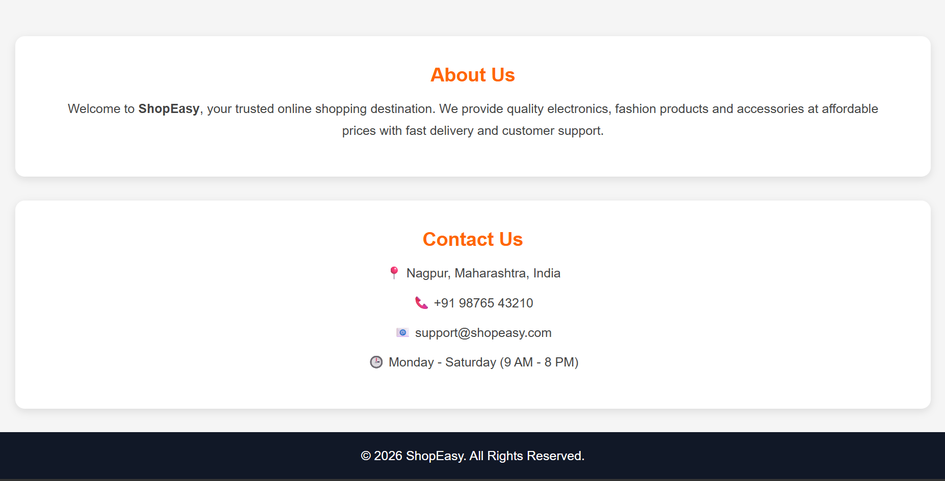

5.CONCLUSION

ShopEasy is a simple and user-friendly e-commerce product catalog website designed to provide customers with an easy way to browse and explore products. The project demonstrates the implementation of front-end web technologies such as HTML and CSS to create an attractive and responsive interface. It includes features like product display, search functionality, product categories, offers section, and an organized layout to improve user experience.

The main objective of ShopEasy is to provide a digital platform where users can quickly find products and get product information in an efficient manner. This project helped in understanding website structure, styling, UI design, and implementing interactive features for better usability.

In the future, ShopEasy can be enhanced by adding advanced features such as user authentication, shopping cart functionality, payment integration, product filtering, database connectivity, and an admin panel for managing products. Overall, ShopEasy provides a strong foundation for developing a complete e-commerce application.

6.REFERENCES

W3Schools – HTML & CSS Tutorials
https://www.w3schools.com
MDN Web Docs – HTML and CSS Documentation
https://developer.mozilla.org
GeeksforGeeks – Web Development Tutorials
https://www.geeksforgeeks.org
CSS-Tricks – CSS Flexbox and Responsive Design Guide
https://css-tricks.com
freeCodeCamp – Responsive Web Design Course
https://www.freecodecamp.org

