CODE IMPLEMENTATION
Html :-
<!DOCTYPE html>
<html lang="en">
<head>
<meta charset="UTF-8">
<meta name="viewport" content="width=device-width, initial-scale=1.0">
<title>Yash Dekate | Portfolio</title>
<link rel="stylesheet" href="style.css">
</head>
<body>
<!-- Navbar -->
<nav>
<div class="logo">
YD
</div>
<div class="links">
<a href="#home">Home</a>
<a href="#about">About</a>
<a href="#skills">Skills</a>
<a href="#projects">Projects</a>
<a href="#education">Education</a>
<a href="#contact">Contact</a>
</div>
</nav>
<!-- Home -->
<section id="home" class="hero">
<div class="hero-text">
<p class="intro">
Hello, I'm
</p>
<h1>
Yash Dekate
</h1>
<h2>
Aspiring Software Developer | Problem Solver | Tech Enthusiast
</h2>
<p>
I am a B.Tech student interested in Artificial Intelligence,
Data Science, Machine Learning and Software Development.
I enjoy solving problems and building useful projects.
</p>
<div class="buttons">
<a href="#projects">
View Projects
</a>
<a href="#contact">
Contact Me
</a>
</div>
</div>
<div class="hero-image">
<img src="Photo.jpeg" alt="Yash Dekate">
</div>
</section>
<!-- About -->
<section id="about">
<h2>
About Me
</h2>
<p>
I am passionate about technology and programming. I enjoy
learning new concepts, solving coding problems and developing
projects that improve my technical skills.
</p>
<p>
Currently, I am focusing on programming, Data Structures,
Machine Learning, Artificial Intelligence and Flutter
App Development.
</p>
<div class="interests">
<span>💻 Coding</span>
<span>📱 App Development</span>
<span>🤖 AI & ML</span>
<span>📚 Learning</span>
<span>📖 Reading</span>
</div>
</section>
<!-- Skills -->
<section id="skills">
<h2>
Skills
</h2>
<div class="skill-list">
<div>
<h3>
Programming
</h3>
<p>
C
</p>
<p>
Python
</p>
<p>
Java
</p>
</div>
<div>
<h3>
Development
</h3>
<p>
HTML & CSS
</p>
<p>
Flutter App Development
</p>
<p>
</p>
</div>
<div>
<h3>
Technologies
</h3>
<p>
Machine Learning
</p>
<p>
Data Science
</p>
<p>
Git & GitHub
</p>
</div>
</div>
</section>
<!-- Projects -->
<section id="projects">
<h2>
Projects
</h2>
<!-- Sign Language -->
<div class="project">
<h3>
Sign Language Recognition
</h3>
<p>
A machine learning project that recognizes sign language
gestures using computer vision and machine learning
techniques.
</p>
<p class="tech">
Python | OpenCV | MediaPipe | SVM
</p>
</div>
<!-- Loan Approval -->
<div class="project">
<h3>
Loan Approval System
</h3>
<p>
A machine learning based system that predicts whether a
loan application should be approved based on applicant
information and financial factors.
</p>
<p class="tech">
Python | Machine Learning | Pandas | Scikit-learn
</p>
</div>
</section>
<!-- My Journey -->
<section id="journey">
<h2>My Journey</h2>
<div class="journey-container">
<div class="journey-card">
<div class="journey-top">
<span class="journey-year">2024 - 2028</span>
<span class="journey-number">01</span>
</div>
<h3>B.Tech - Information Technology</h3>
<p>
Currently in 5th semester at St. Vincent Pallotti
College of Engineering & Technology, Nagpur.
Focusing on core AI concepts, data structures,
and software engineering principles.
</p>
<strong>CGPA: 7.90</strong>
</div>
<div class="journey-card">
<div class="journey-top">
<span class="journey-year">2022 - 2024</span>
<span class="journey-number">02</span>
</div>
<h3>12th Standard (HSC)</h3>
<p>
Completed higher secondary education with a focus
on Physics, Chemistry, Mathematics, and Biology.
</p>
<strong>Result: 69.80%</strong>
</div>
<div class="journey-card">
<div class="journey-top">
<span class="journey-year">2020 - 2022</span>
<span class="journey-number">03</span>
</div>
<h3>10th Standard (SSC)</h3>
<p>
Completed secondary school education with a strong
foundation in science and mathematics.
</p>
<strong>Result: 78.50%</strong>
</div>
</div>
</section>
<section id="contact">
<h2>Let's Connect!</h2>
<p>
Interested in working together or just want to say hello?
</p>
<div class="contact-links">
<a href="mailto:yashdekate312@gmail.com">
📧 Email
</a>
<a href="https://www.linkedin.com/in/yash-dekate-a210a2358"
target="_blank">
💼 LinkedIn
</a>
<a href="https://github.com/YashDekate19"
target="_blank">
💻 GitHub
</a>
</div>
</section>
<!-- Footer -->
<footer>
<p>
© 2026 Yash Dekate. All Rights Reserved.
</p>
</footer>
</body>
</html>

Output :-

Home Page :-
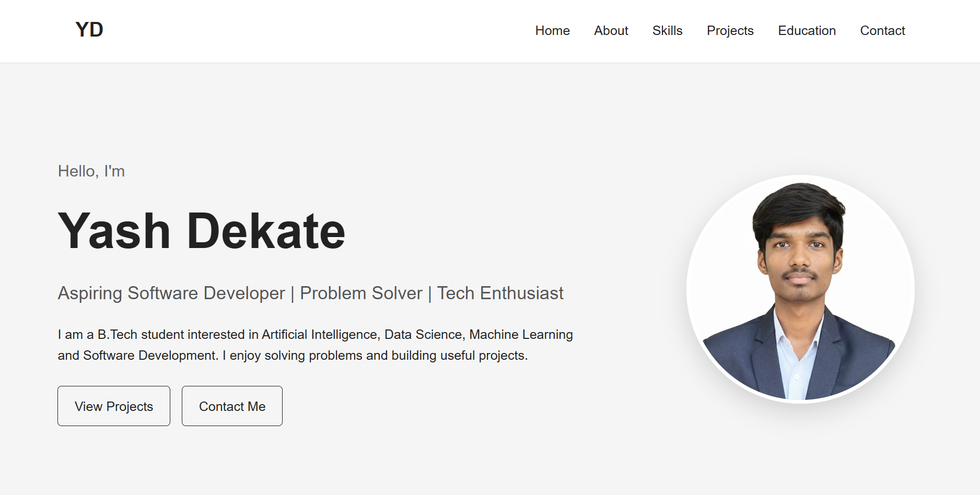

About :-
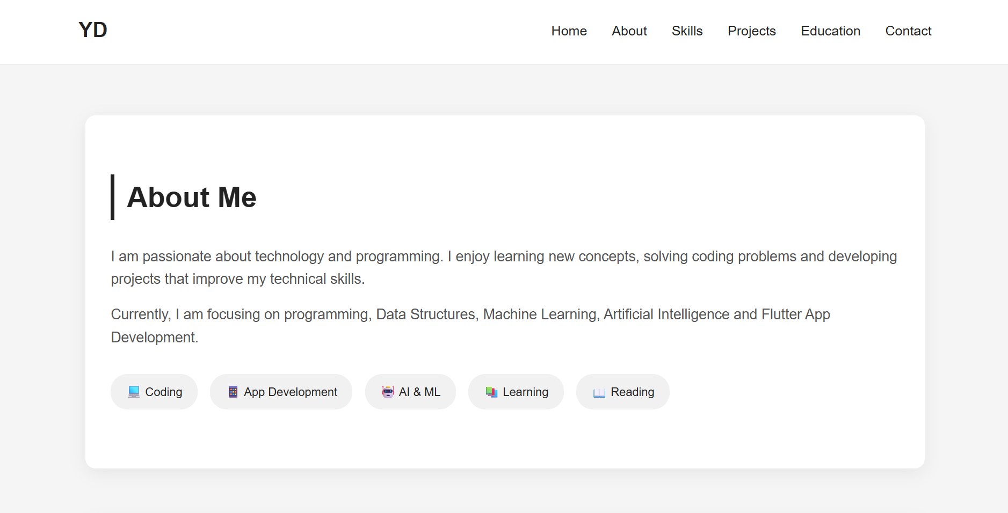

Skills :-
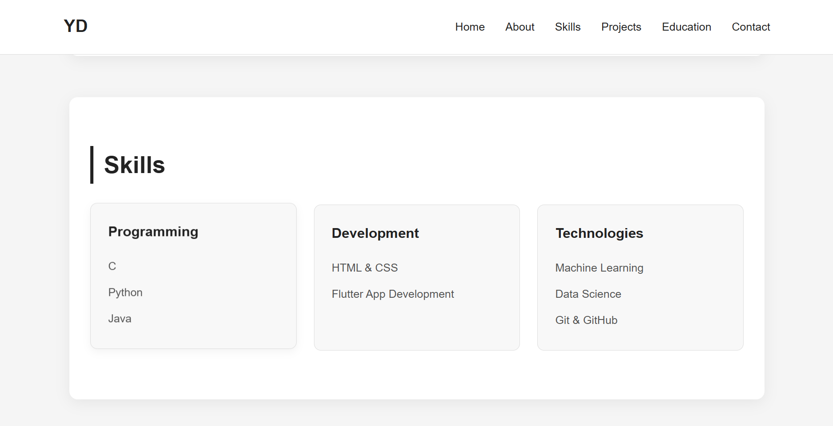

Projects :-
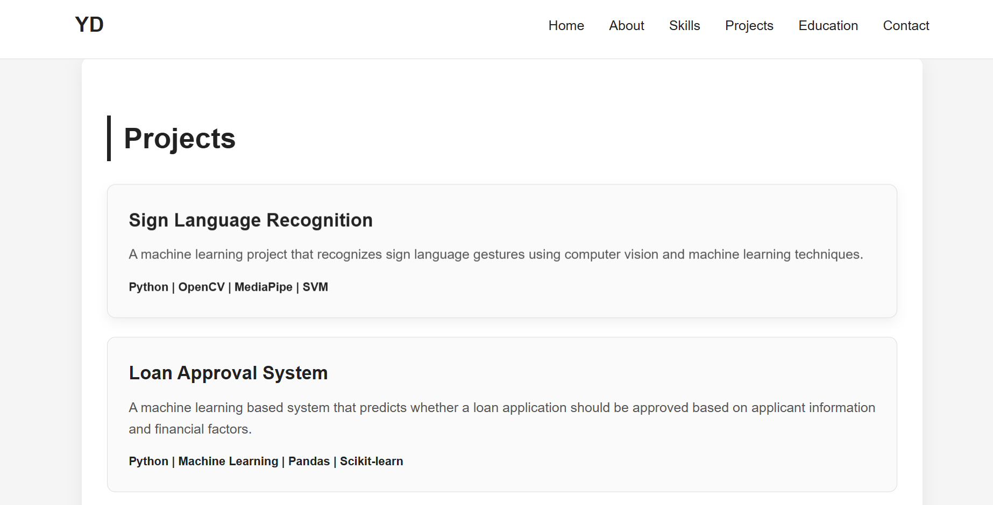

Journey :-
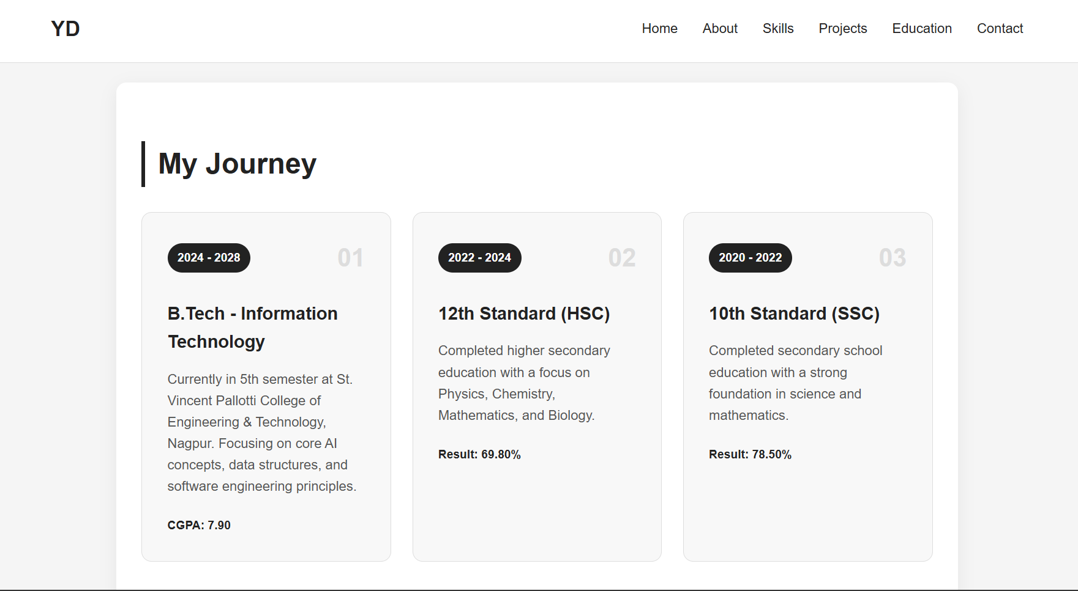

Contact :-


