YD’s DataViz1: Profit of State and Province Analysis

YD's DataViz

Find the Profit of State and Province in US using P1-SuperStoreUS-2015 dataset.

Let’s Do It:

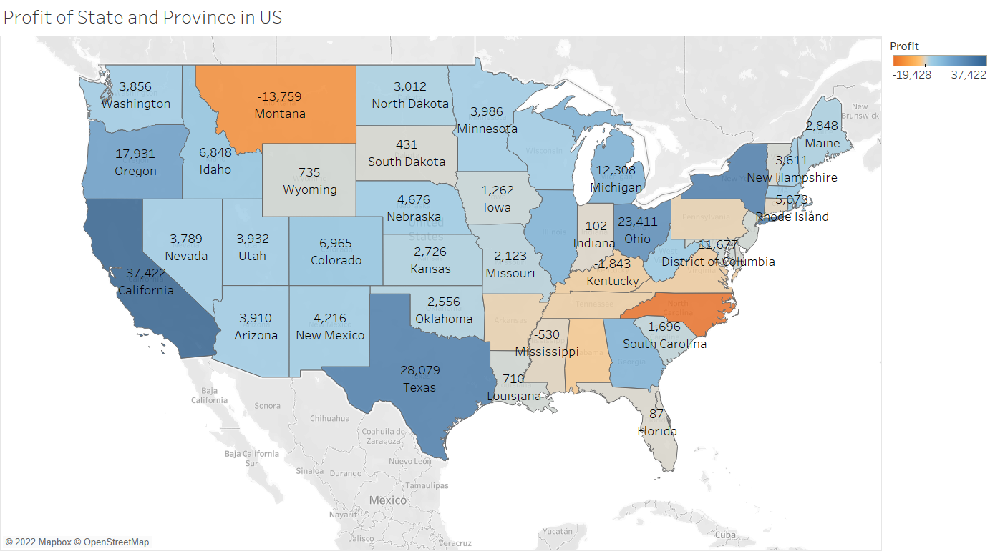

Thanks for reading till the end hope so you liked it leave your opinion about it in the comment section.