YD’s DataViz11: New York State Salary Analysis

You are required to build a visualisation within Tableau to enable the analysis of average salary across industries for the State of New York.

Analysis of the following is required:

1. Average Annual Salary by County displayed on a map

2. Top 5 highest earning industries by County

3. Time series analysis of average annual salary by County.

The client specifically mentioned that they do not want separate graphs on different sheets, and also don’t want to work with a dashboard.

They would like all information contained within a single sheet, with pop-up charts while the map is being explored.

Disclaimer: Case study was developed for educational purposes. Any reference to real facts or real events is purely coincidental.

Let’s Do It:

* Time series analysis of average annual salary by County

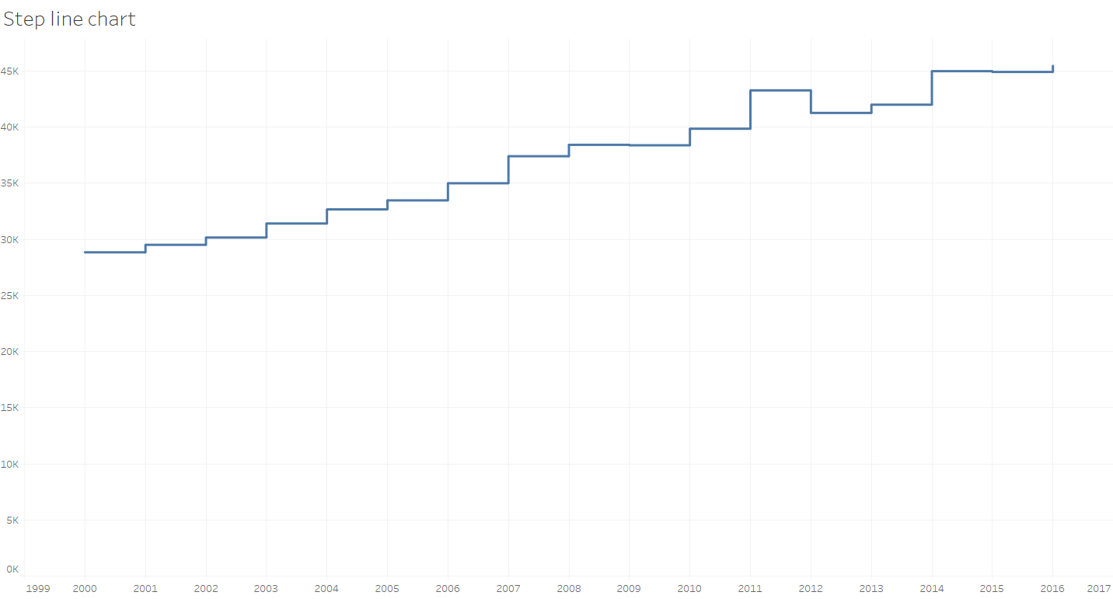

* Top 5 highest earning industries by County

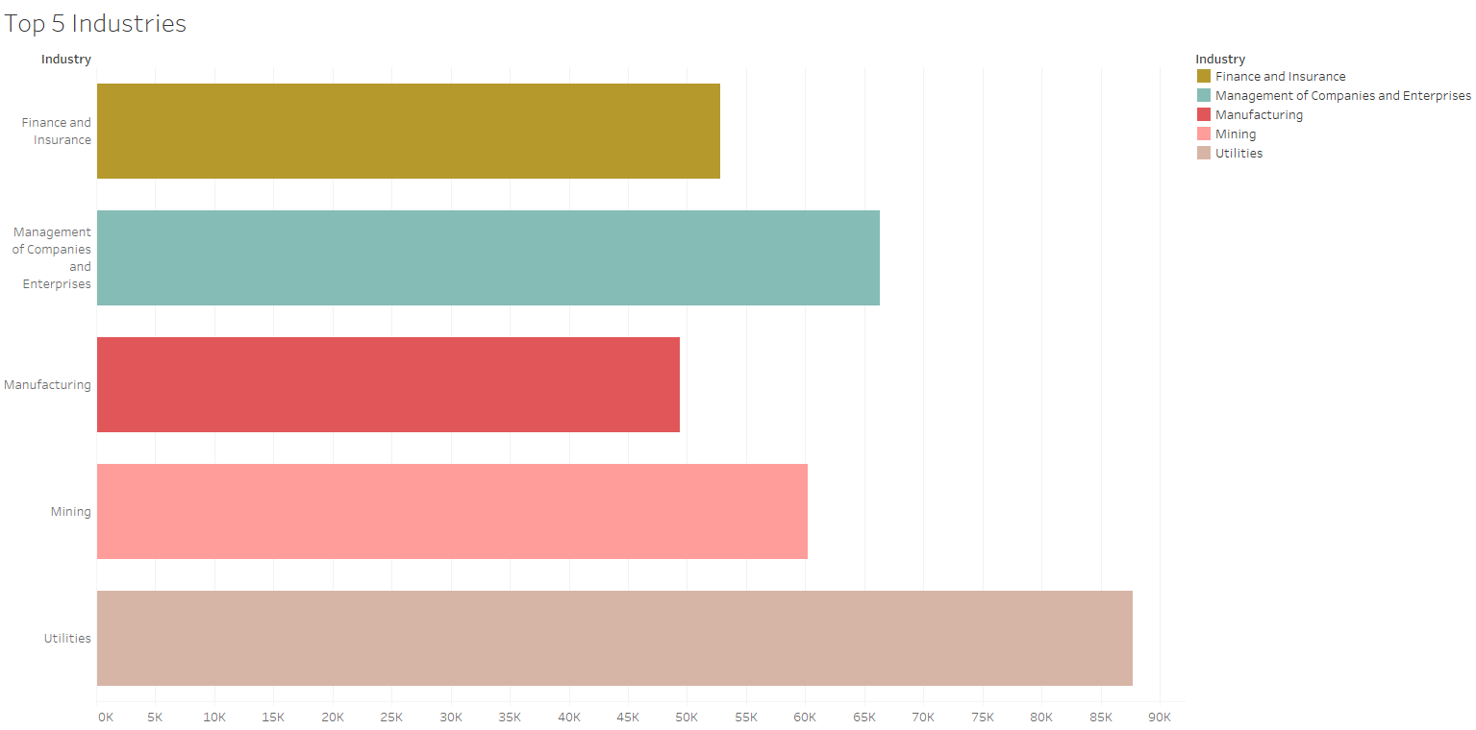

* Average Annual Salary by County displayed on a map

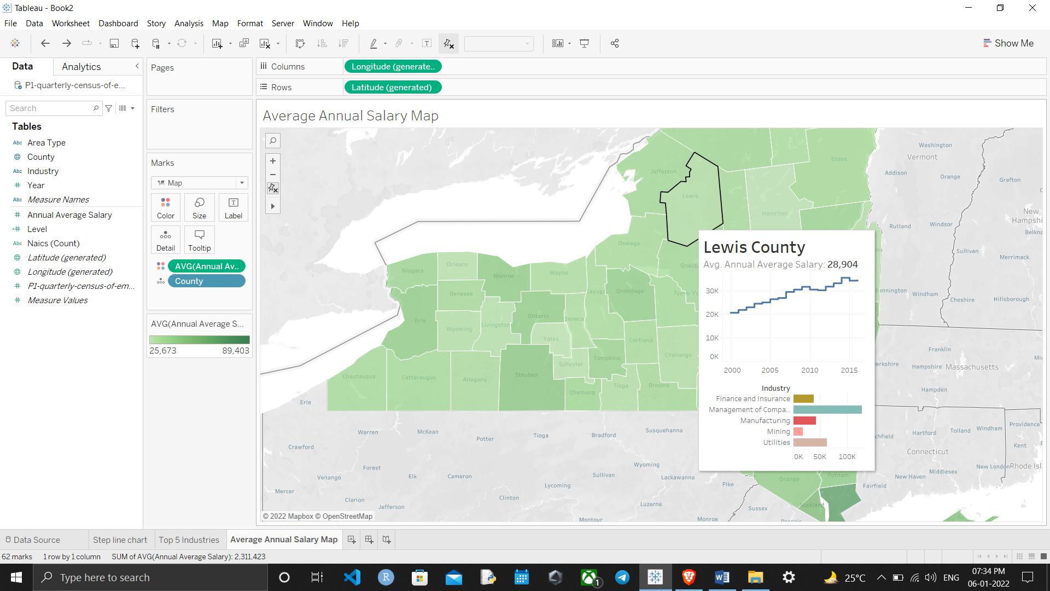

Thanks for reading till the end hope so you liked it leave your opinion about it in the comment section.