YD’s DataViz5: Dual Axis Chart

Create a Dual Axis Chart with Sales and Target dimensions and find if each category of company meets the Profit Margin.

Let’s Do It:

* Technology:

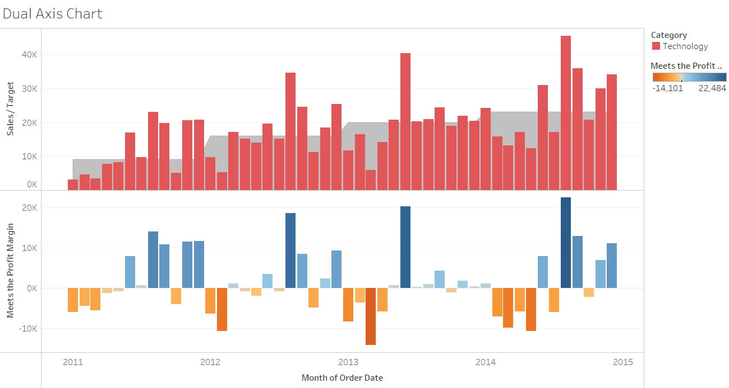

* Office Supplies:

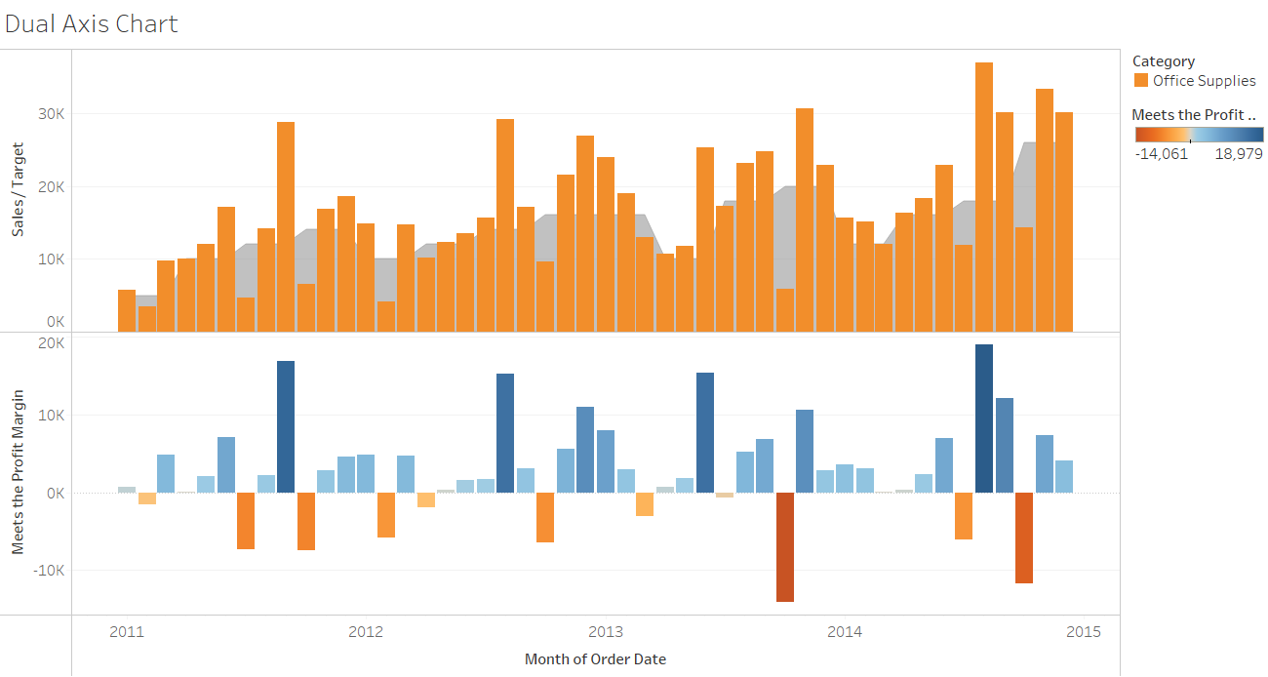

* Furniture:

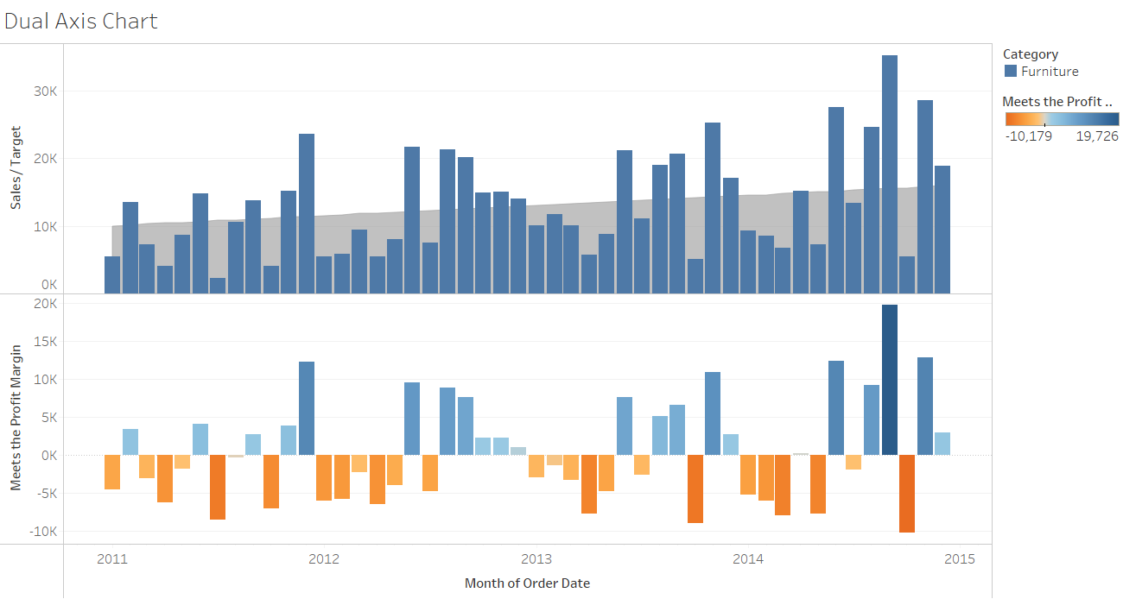

Thanks for reading till the end hope so you liked it leave your opinion about it in the comment section.