# YD’s DataViz6: Joining various dataset to from Schema and get insights.

# You are a Data Scientist at the Brazilian E-Commerce Store. Your manager has asked you to create a map showing Sellers in their geolocations with bubbles to illustrate how much money in total payments they have received from customers.

Let’s Do It:

* Schema:

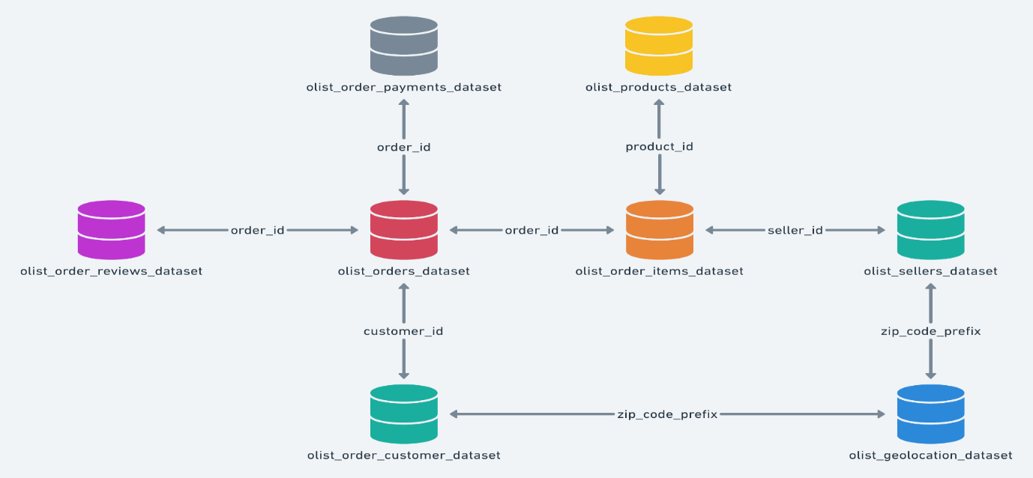

* Tableau relationship connection:

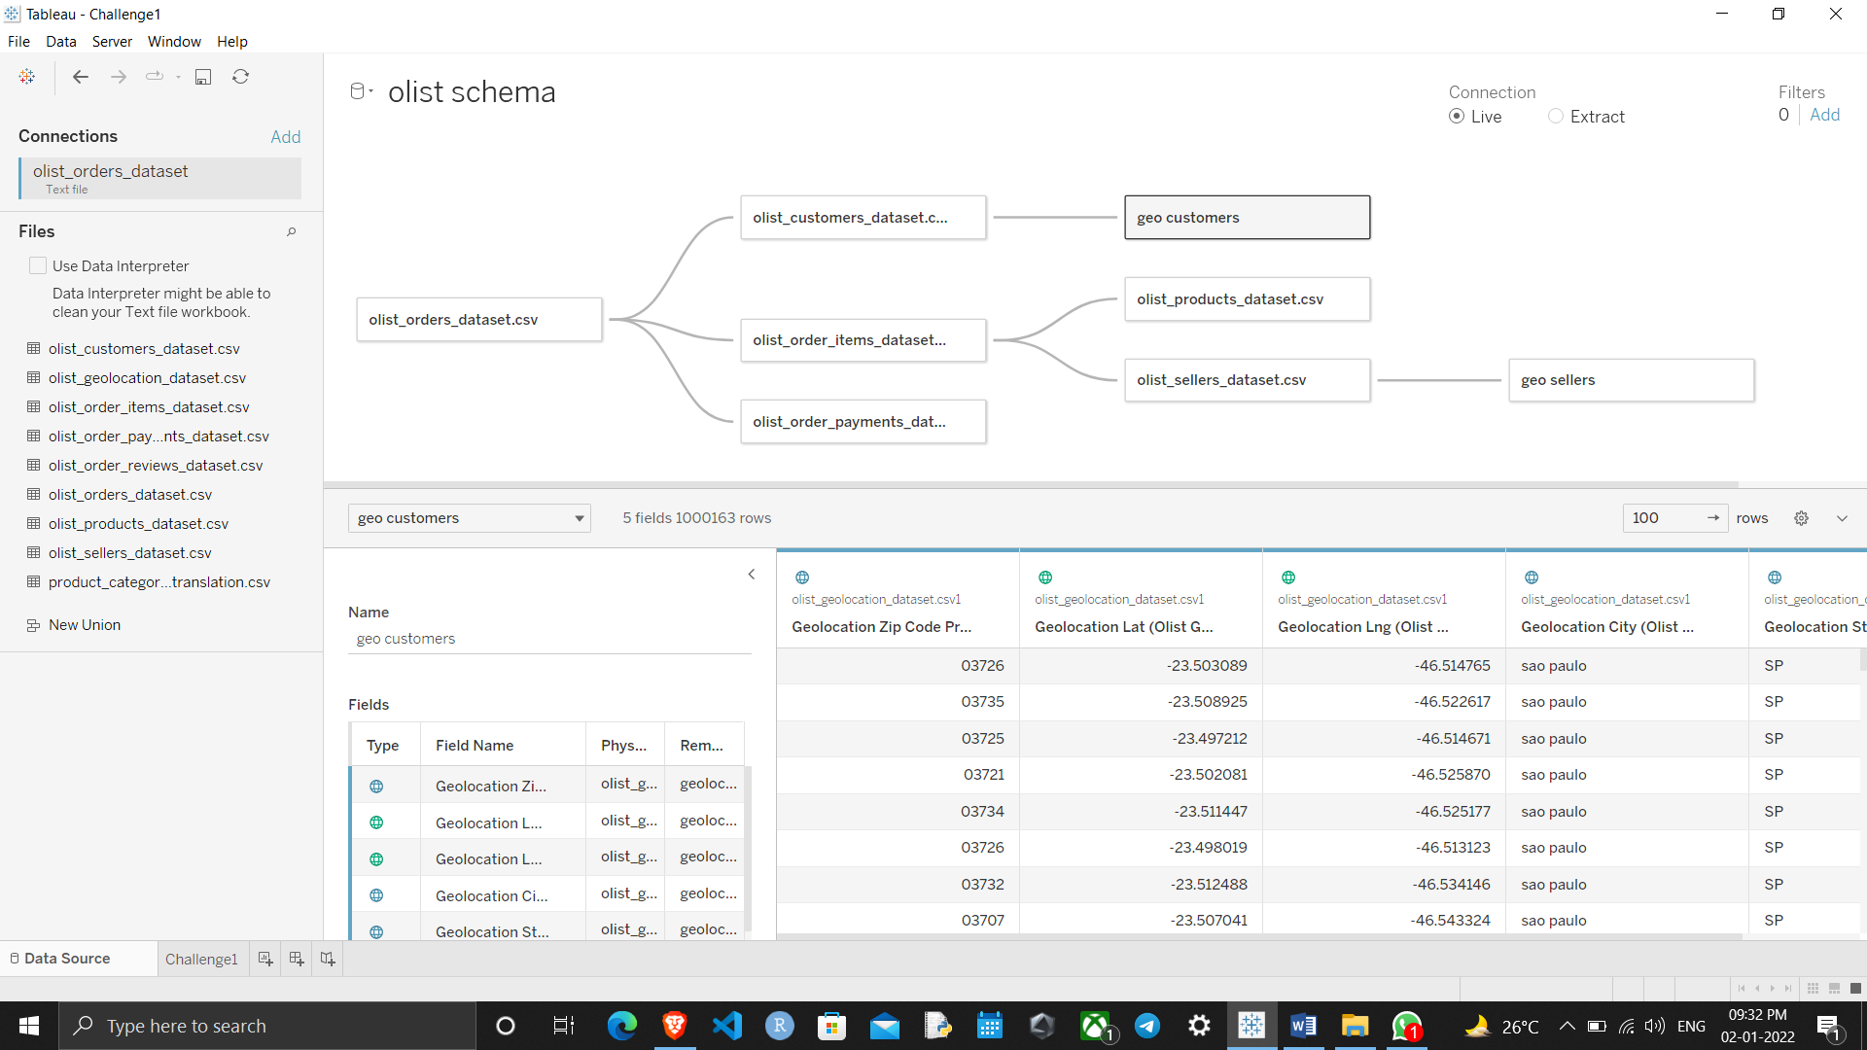

* Final Data Visualization:

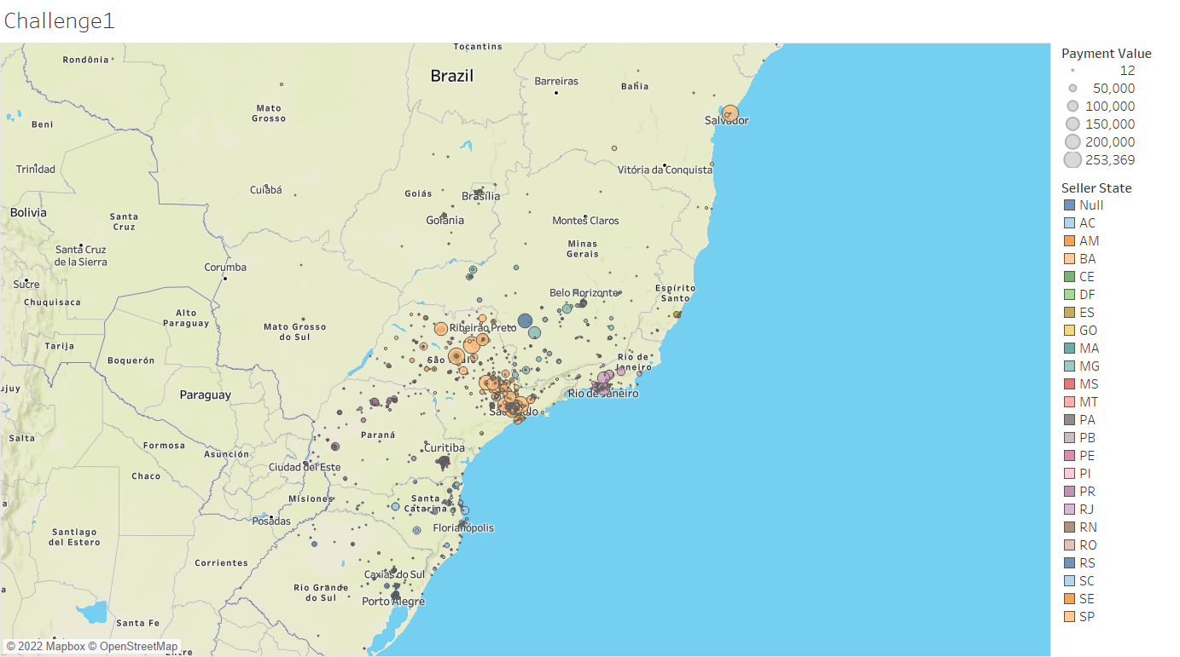

Thanks for reading till the end hope so you liked it leave your opinion about it in the comment section.