YD’s DataViz7:

Create a Customer Segmentation dashboard of a new bank which has customers in England, Northern Ireland, Scotland and Wales and narrate a story of the insights.

**Let’s Do It:**

* **Map**

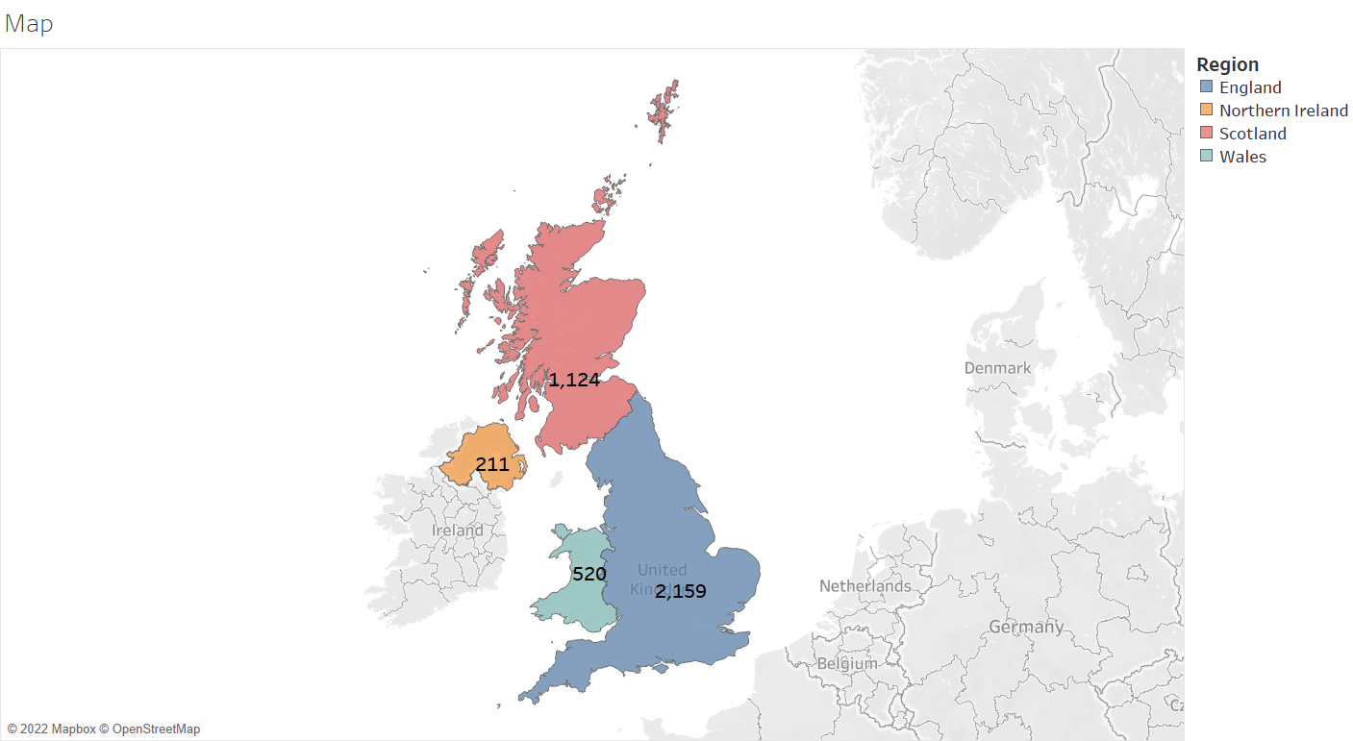

* **Gender**

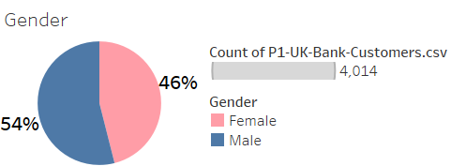

* **Distribution by Age**

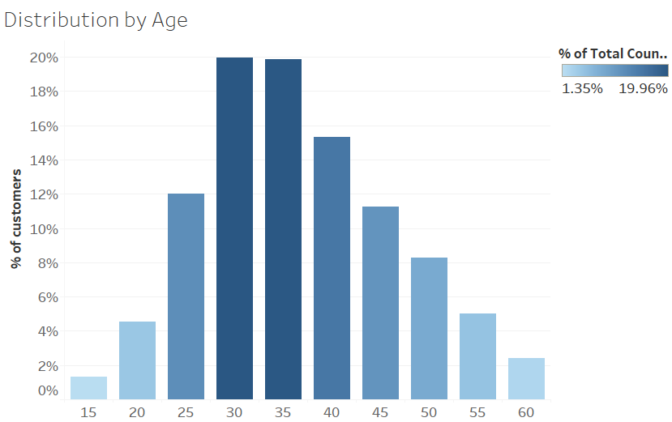

* **Distribution by Balance**

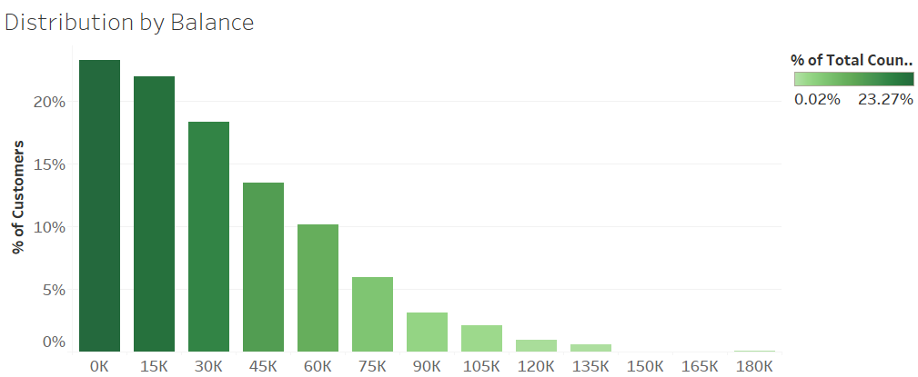

* **Job Classification**

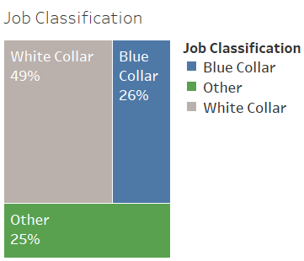

* **Customer Segmentation Dashboard**

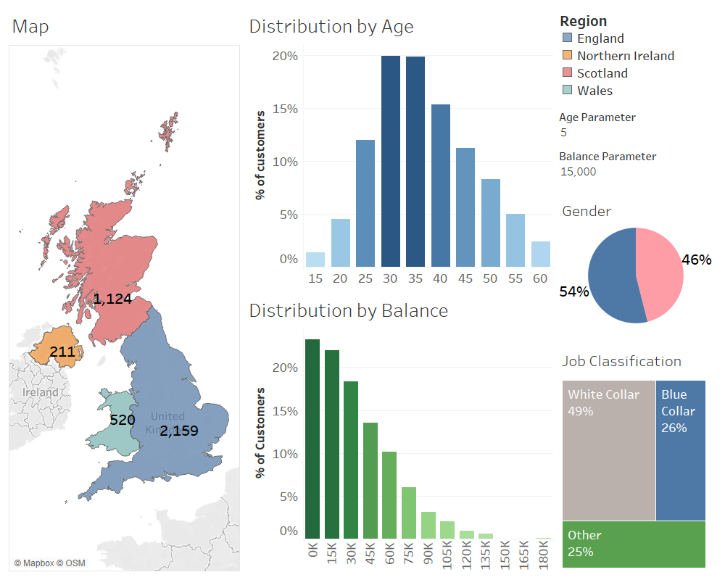

* **Story:**
* This is the customer segmentation of our bank

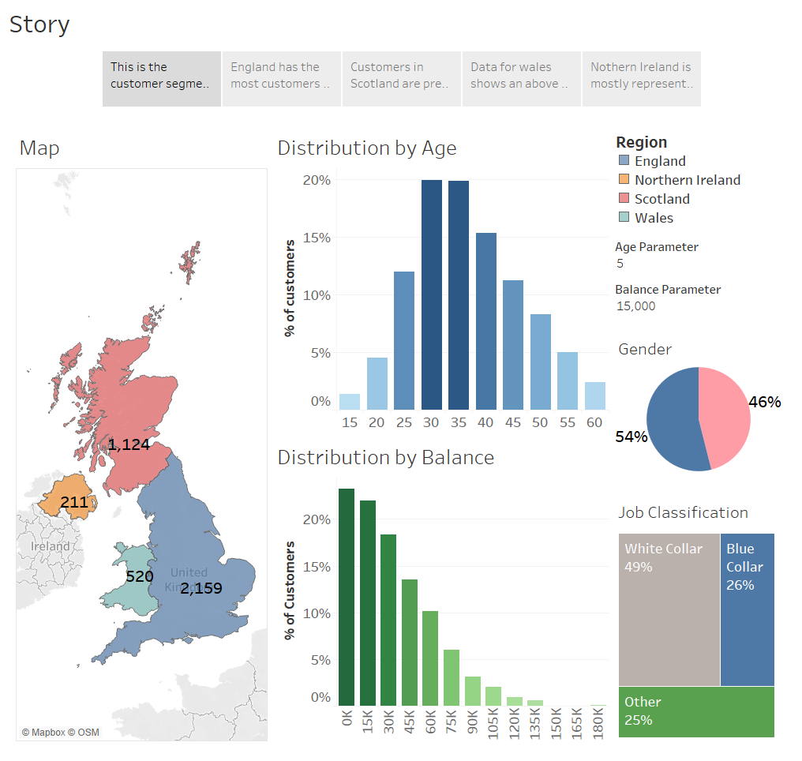

* England has the most customers of our bank i.e.2159. England is mostly represented by White Collar workers (70%).

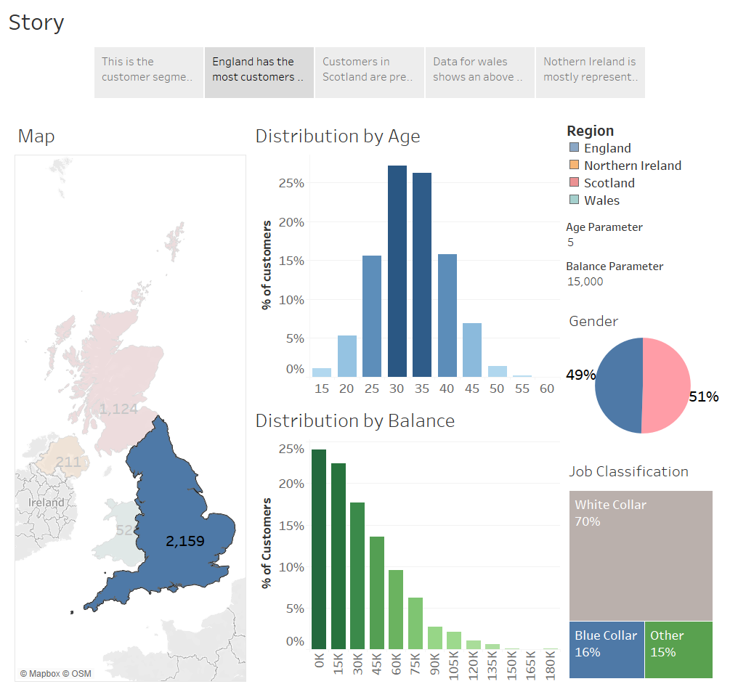

* + Customers in Scotland are predominantly male in their late 40's and early 50's. Representation of White Collar workers are low.

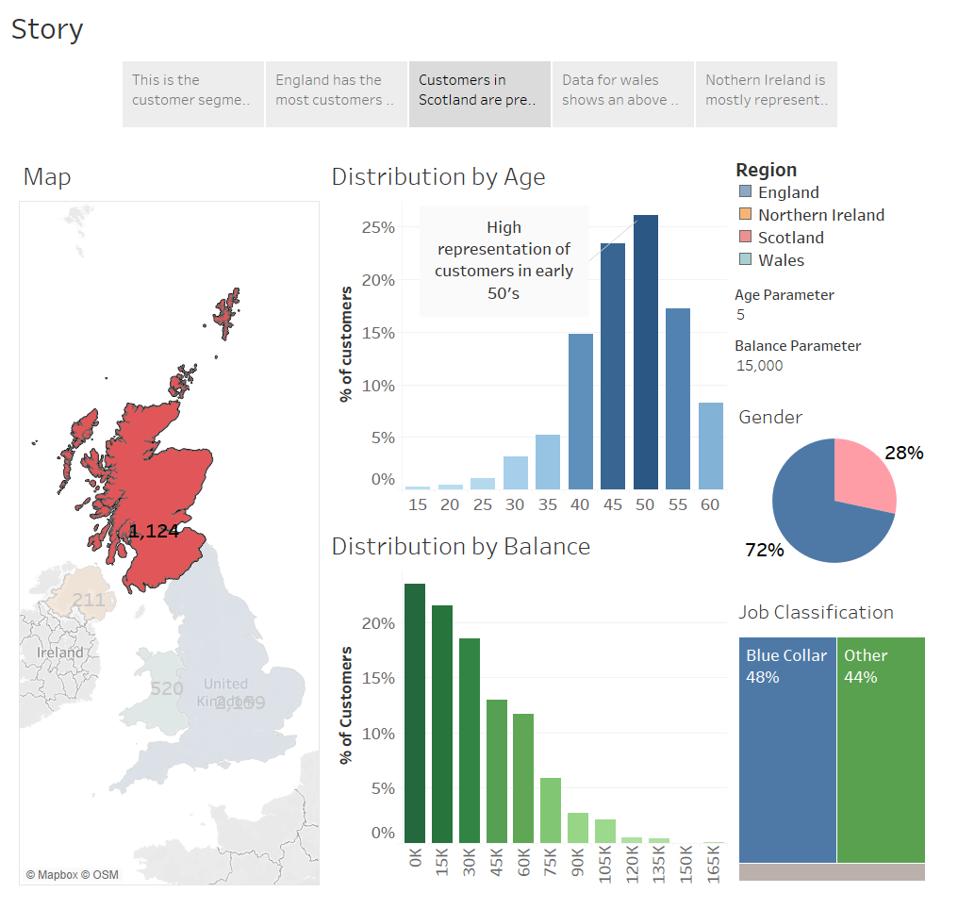

* Data for Wales shows an above average representation of mid-sized balances.

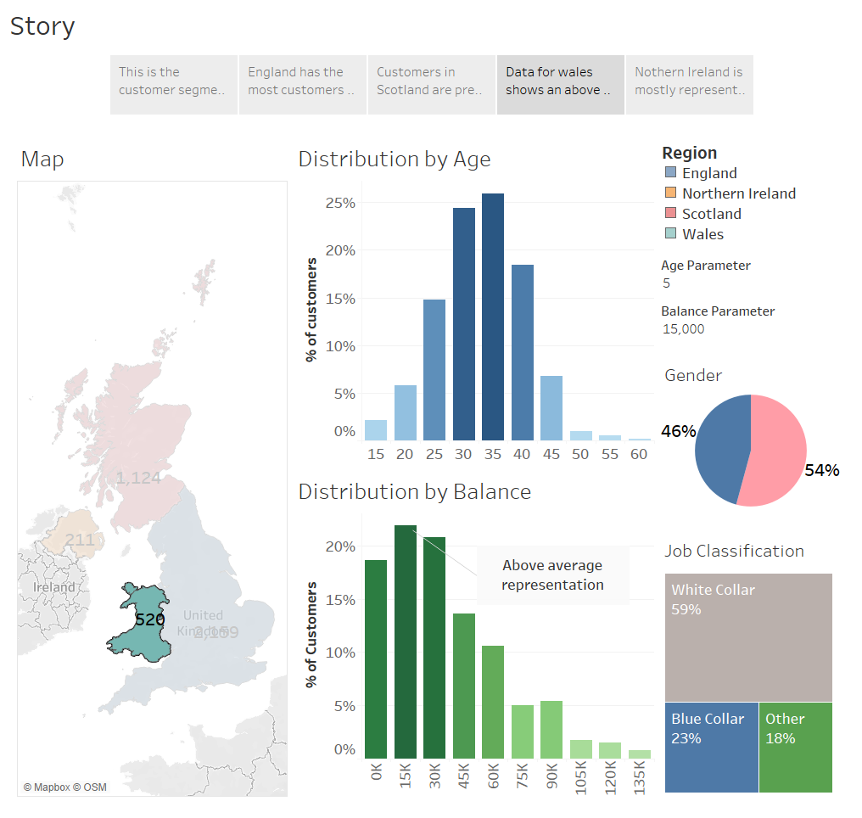

* Northern Ireland is mostly represented by female customers in younger age group.

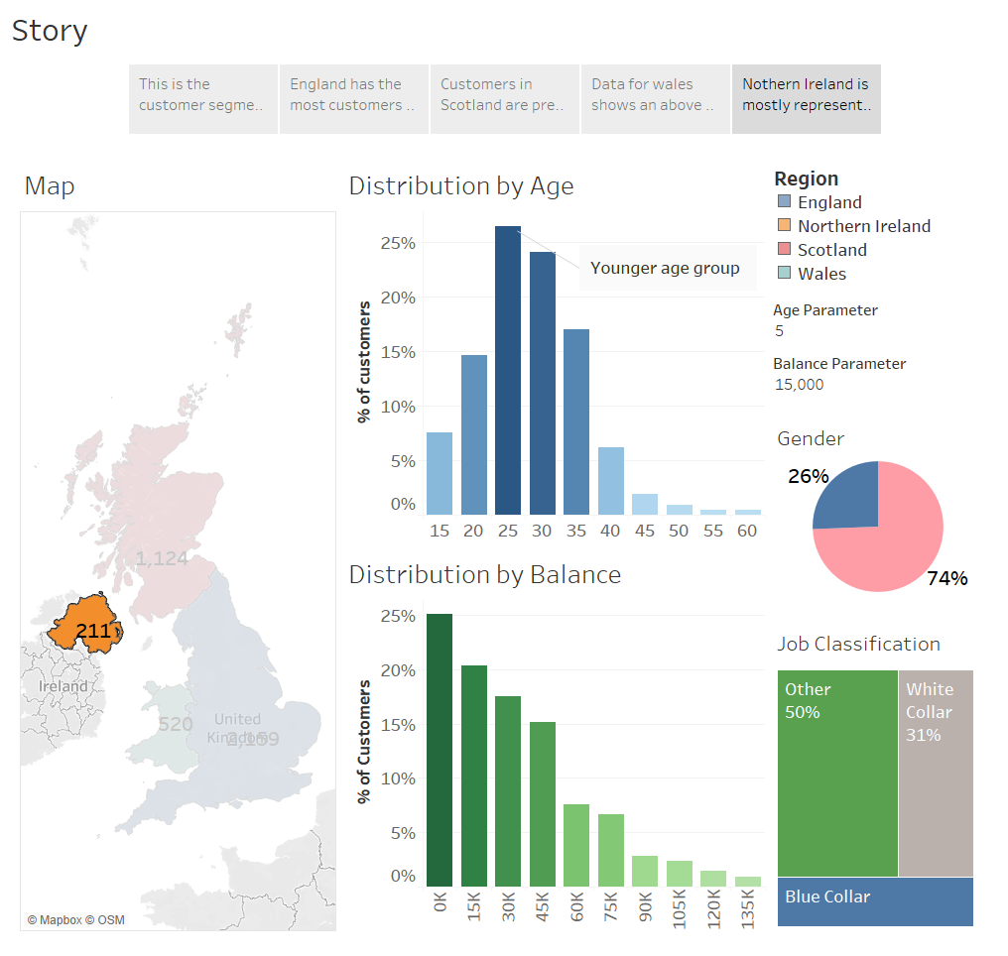

Thanks for reading till the end hope so you liked it leave your opinion about it in the comment section.