YD’s DataViz8:

Converting Human Data to Computer readable data using Tableau and generating insights.

Let’s Do It:

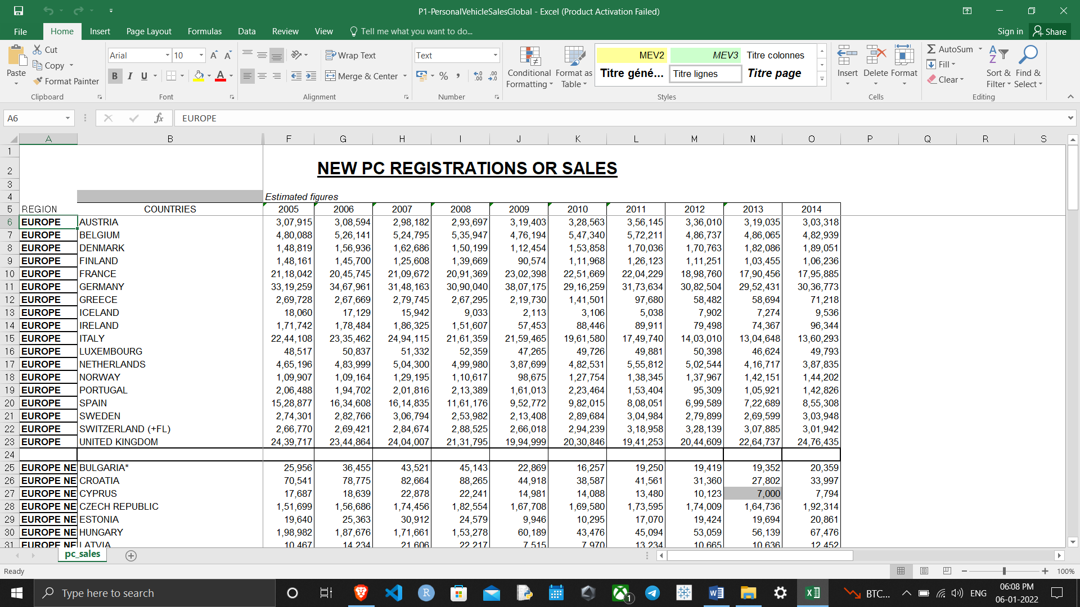

Using Data Interpreter

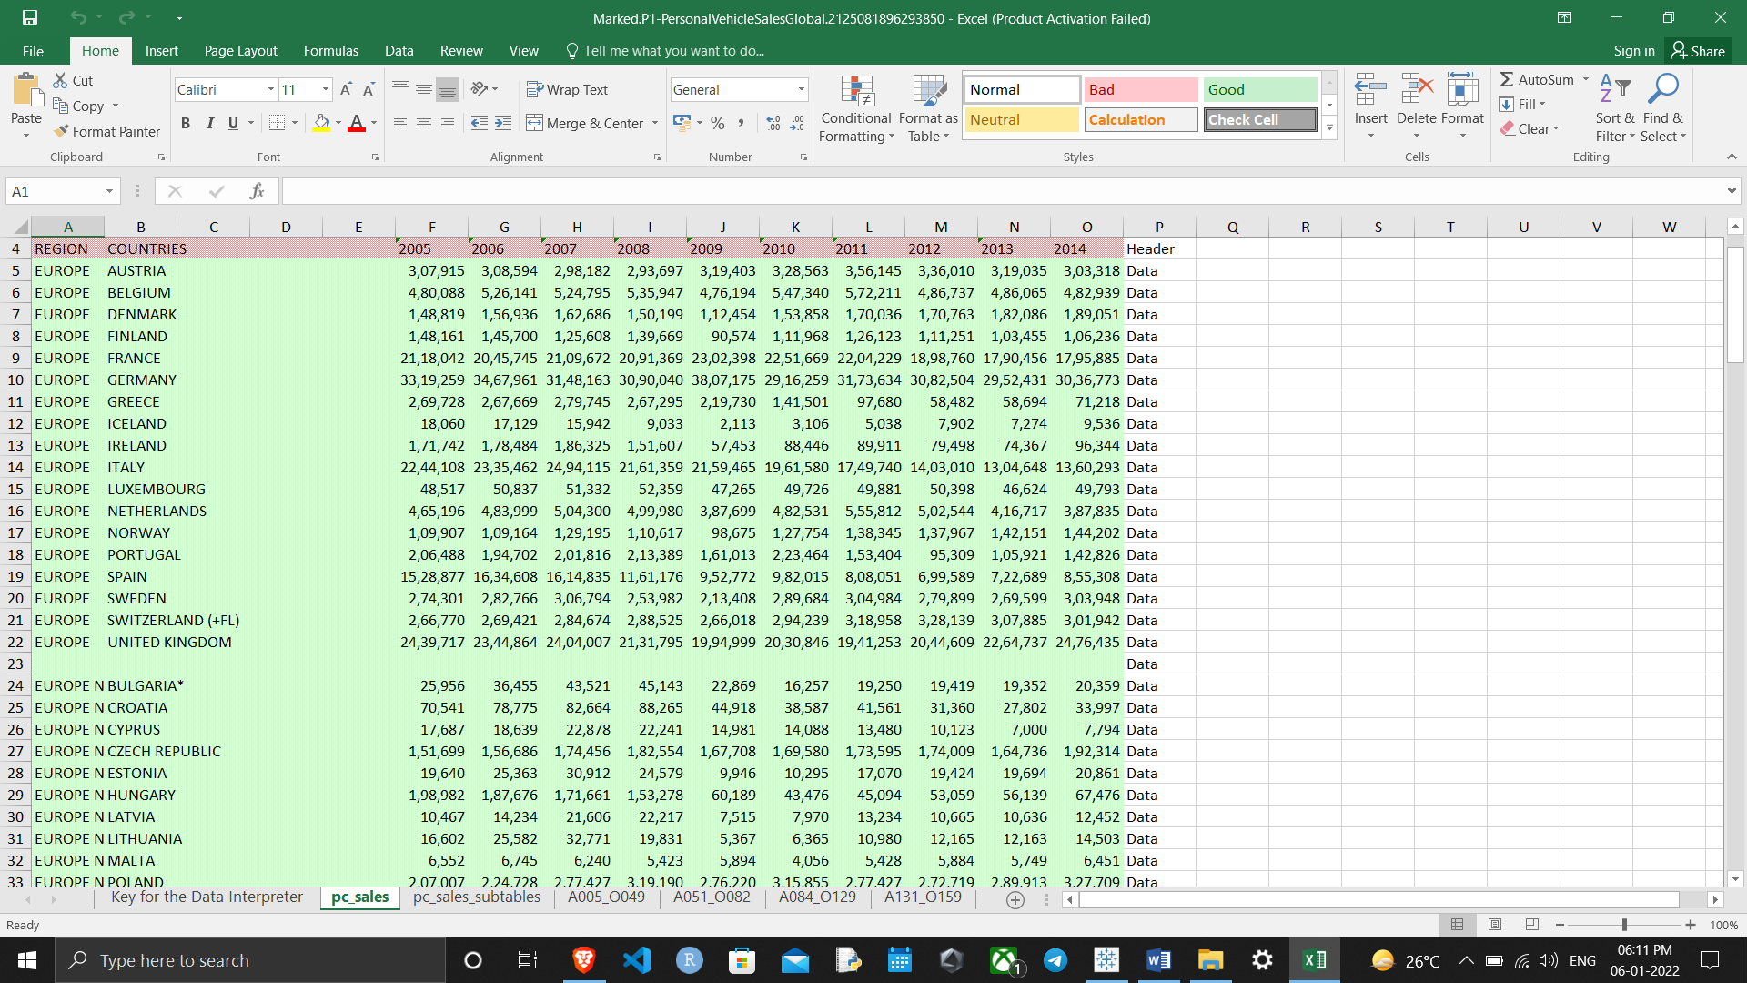

* Relative Cars Sold:

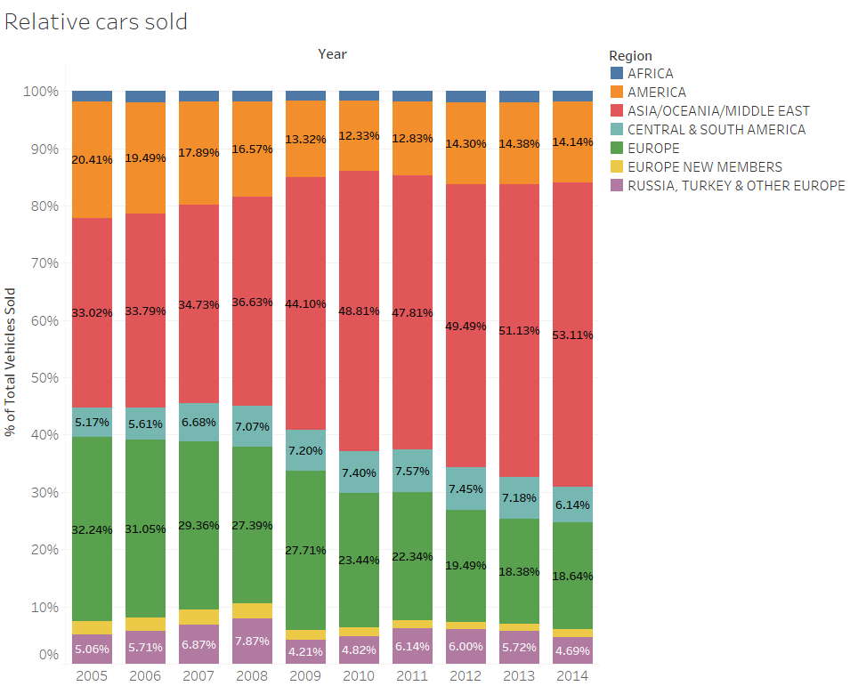

* Map

