YD’s DataViz9: Laundry Company Analysis

You are a Data Scientist working for a laundry-pickup services start-up WeWashUSleep. This is a relatively small company and they cannot compete with the big players in major cities. The company's strategy is to build a vast network in the smaller cities.

WeWashUSleep already had a strong presence in 140 locations and recently opened stores in 10 new cities. Additionally, the company has two separate sales regions.

You have been assigned the following two analytics tasks.

#1

Identify which of the two sales regions is performing better (i.e. outperforms the other in 2 of the following 3 metrics):

• Average Revenue per City

• Average Marketing spend per city (tip: less is better)

• Average ROMI (Return on Marketing Investment) per city (revenue/marketing spend)

#2

Identify which of the 10 new locations have the best potential for the company to invest more funds into marketing.

Let’s Do It:

#1

• Average Revenue per City

• Average Marketing spend per city (tip: less is better)

• Average ROMI (Return on Marketing Investment) per city (revenue/marketing spend)

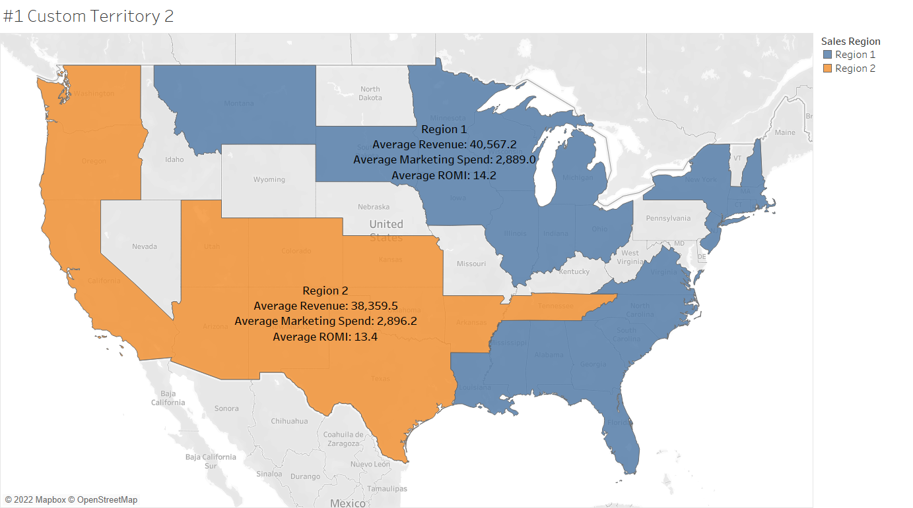

#2

Which of the 10 new locations have the best potential for the company to invest more funds into marketing.

According to the trend line the revenue of the cluster1 is more than other cluster. Therefore, Companies in cluster1 which are closer to the trend line will be selected.

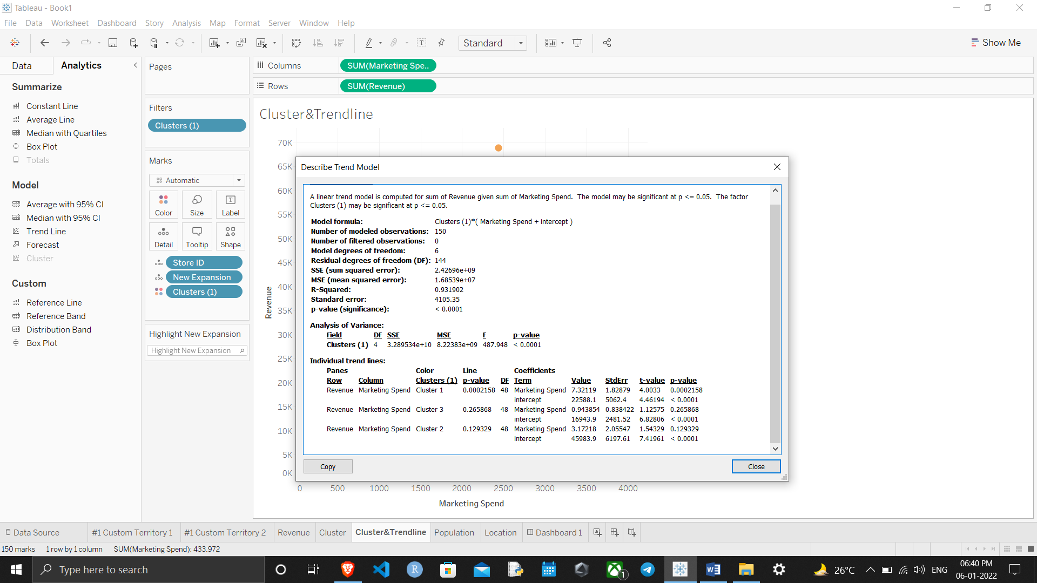

Companies near the trend line and in cluster1 generates the most revenue.

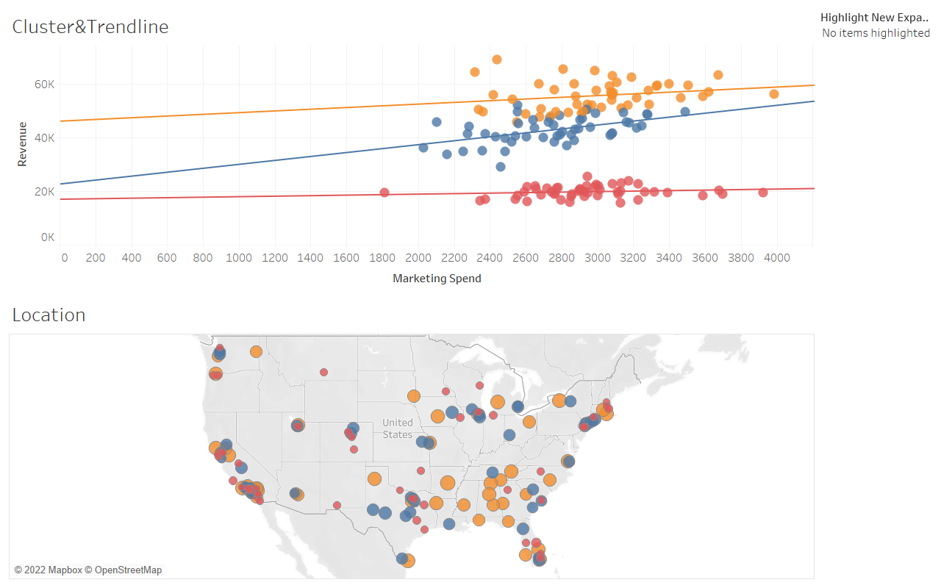

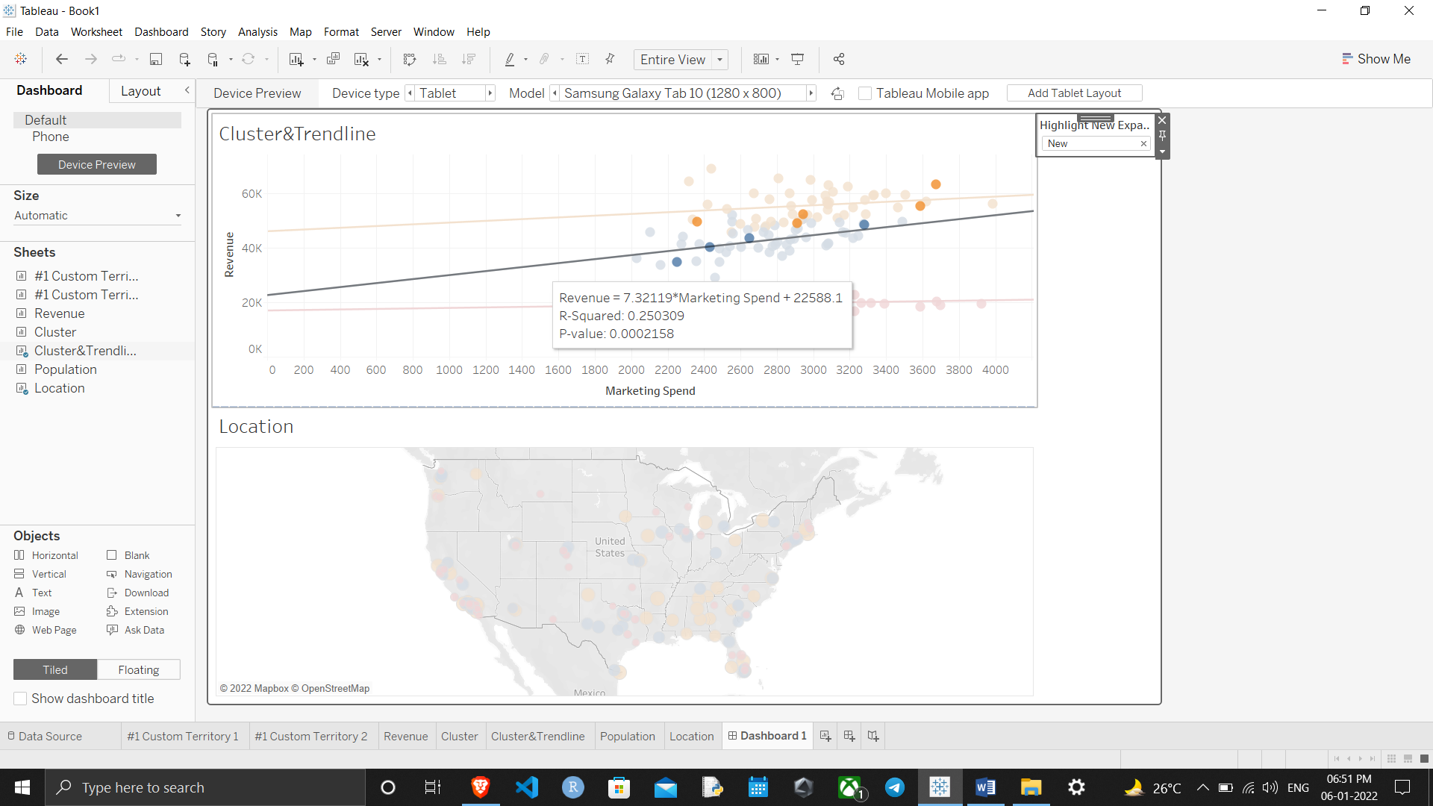

Hence, if we select top 3 companies to invest in they would be companies with Store ID 143, 148, 150.

Thanks for reading till the end hope so you liked it leave your opinion about it in the comment section.