StudentID: 1810111

StudentName: Yash Djson Dookun

Labsheet 3

**Question 1**

1.

DECLARE (int) n, sum, i

SET sum = 0

SET I = 0

DISPLAY “Enter Value of n: ”

INPUT n

WHILE (i <=n)

SET sum = sum + i

i++

END WHILE

DISPLAY “TOTAL: {0}”, sum

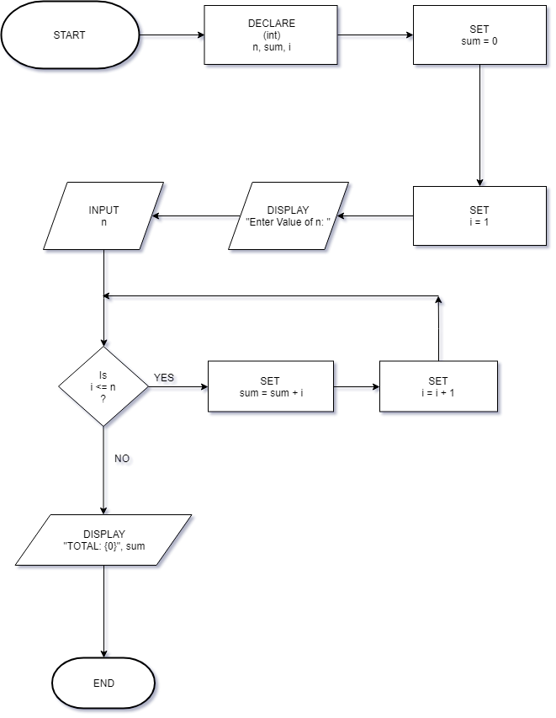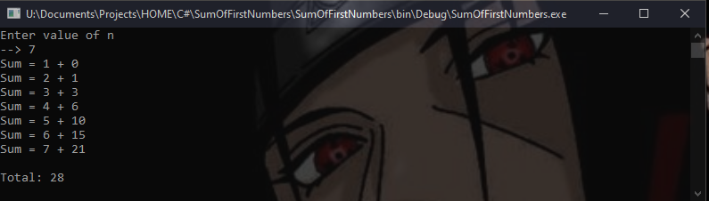

2.

DECLARE (int) n, sum, i

SET sum = 0

SET I = 0

DISPLAY “Enter Value of n: ”

INPUT n

WHILE (i <=n)

SET sum = sum + 2

i++

END WHILE

DISPLAY “TOTAL: {0}”, sum

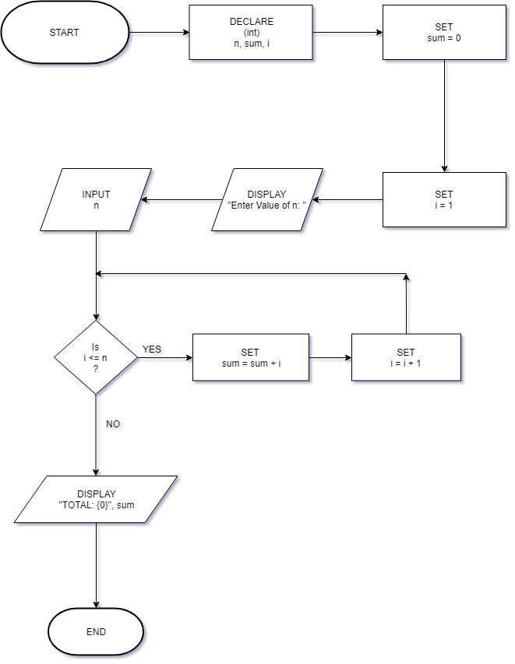

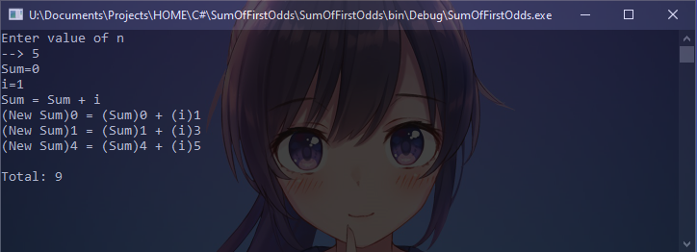

3.

DECLARE (double) sum, marks, average

DECLARE (int) j, i

SET i = 1

SET j = 1

SET sum, marks, average = 0

FOR i = 1 to 5

FOR j = 1 to 3

DISPLAY “Enter marks for subject {0}”, j

INPUT marks

SET sum += marks

SET j++

END FOR

SET average = sum / 3

DISPLAY “TOTAL: {0}”, sum

DISPLAY “Average: {0}”, average

SET i++

END FOR

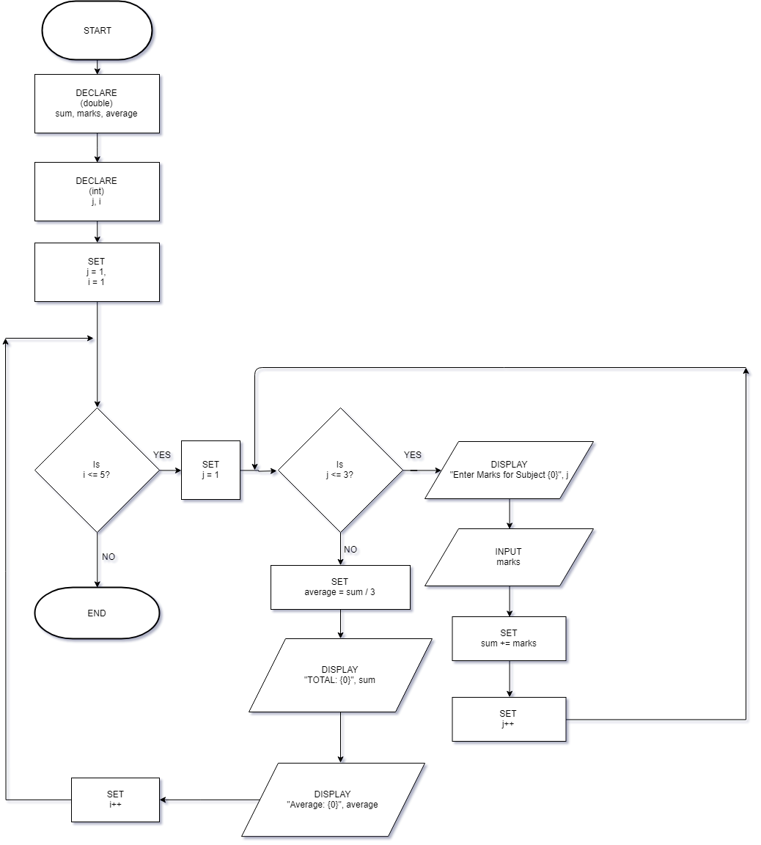

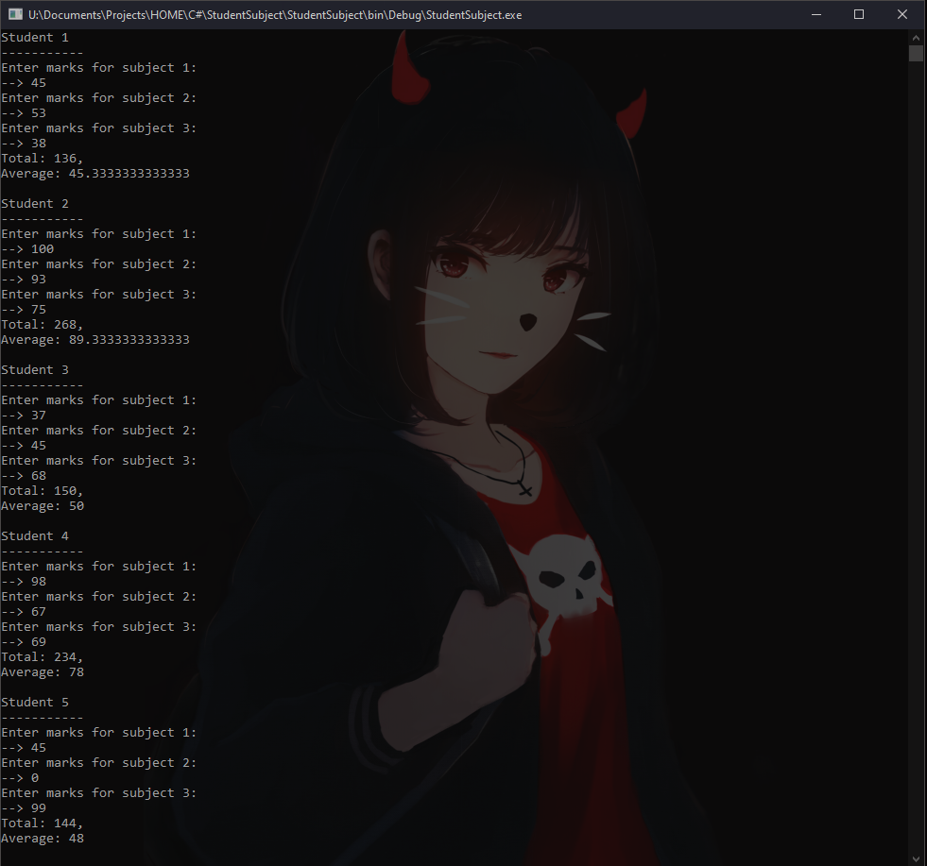

4.

DECLARE (double) P, r, amount

DECLARE (int) i, n

DISPLAY “Enter Principal, P($): ”

INPUT P

DISPLAY “Enter annual interest rate, r(%): ”

INPUT r

DISPLAY “ENTER Period, n(years): ”

INPUT n

SET i = 1

DO

SET amount = P * (1+((r/100)/1))^(i))

DISPLAY “Value of bank deposit for years {0} is {1}”, i, amount

SET i = i + 1

WHILE (i < (n+1))

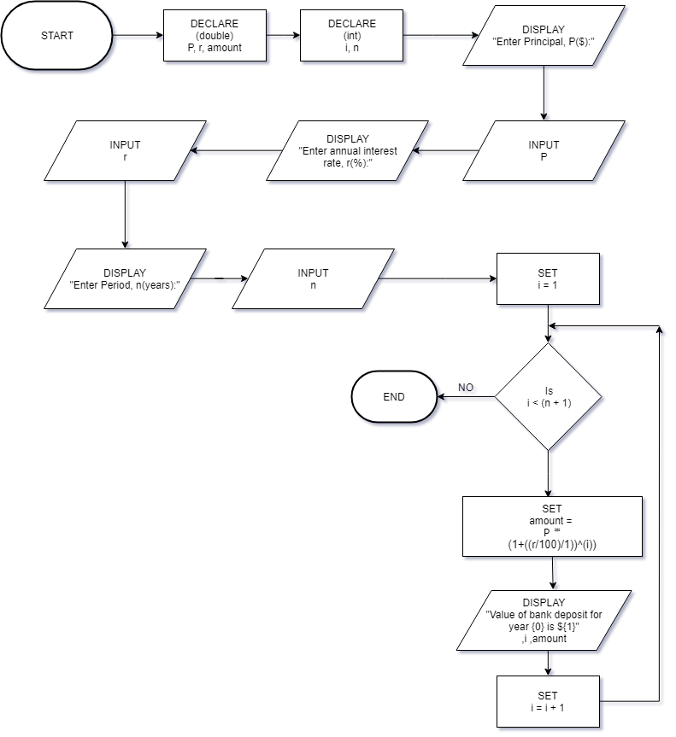

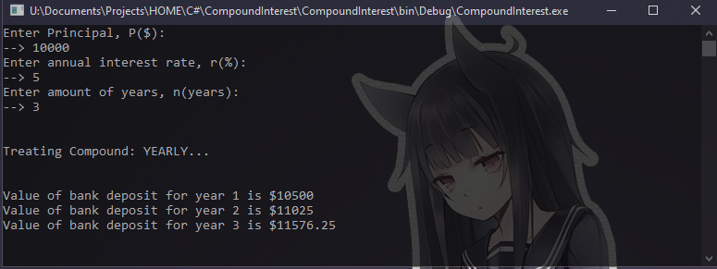

5.

DECLARE (double[]) marks

DECLARE (double) total

DECLARE (int) n, i, j

DISPLAY “Enter number of subjects: ”

INPUT n

SET marks[] = NEW marks[n]

SET i=1

SET j=0

DO

DISPLAY “Marks for subject {0}: ”, i

DECLARE (double) mark

INPUT mark

SET marks[j] = mark

SET i++

SET j++

WHILE (i < (n+1))

CALL findMinMax(marks)

CALL findTotal(marks)

CALL findAverage(n, total)

FUNCTION findMinMax(double[] a)

DECLARE (double t) = 0

FOR (int) p = 0 TO a.length() - 2

FOR (int) i = 0 TO a.length() – 2

IF (a[i] > a[i+1]) THEN

SET t = a[i+1]

SET a[i+1] = a[i]

SET a[i] = t

SET i++

END FOR

SET p++

END FOR

DECLARE (double) min, max

DISPLAY “Minimum: {0}\nMaximum: {1}”, min, max

RETURN a

END FUNCTION

FUNCTION findTotal (double[] x)

FOR (int) i = 0 TO x.length()

SET total += x[i]

SET i++

END FOR

RETURN total  
END FUNCTION

FUNCTION findAverage(int x, double y)

DECLARE Average = y/x

DISPLAY “Average: {0}”, average

END FUNCTION

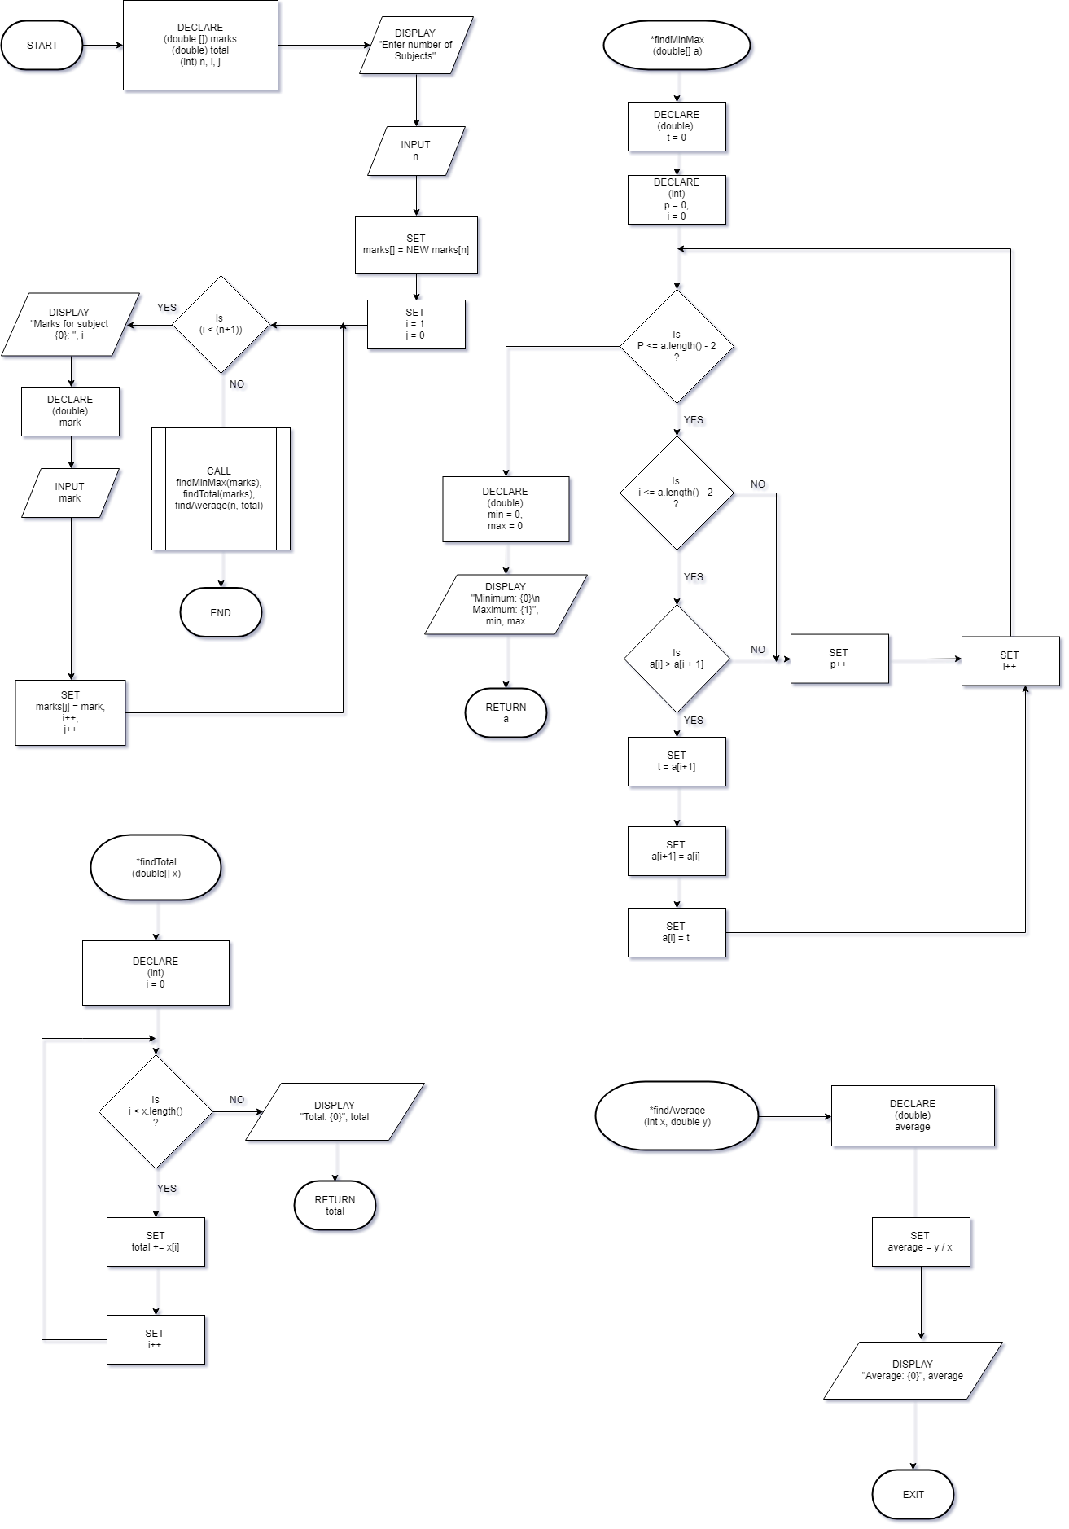

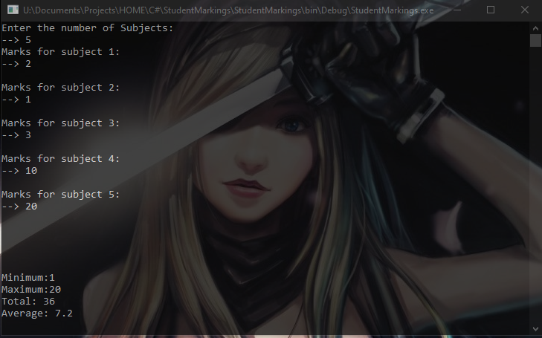

6.

DECLARE (string) original, enteredPassword

DECLARE (int) i

DISPLAY “Set Original Password: ”

INPUT original

SET i = 0

DO

DISPLAY “Enter Password: ”

INPUT enteredPassword

IF (enteredPassword == original) THEN

DISPLAY “Password Entered Correctly!”

BREAK;

ELSE

DISPLAY “Password Entered Incorrectly!”

SET i++

END IF

IF (i == 3) THEN

DISPLAY “3 Bad Attempts”

BREAK

ENDIF

WHILE (i < 3)

