Student Name: Yash Djson Dookun

StudentID: 1810111

Labsheet 2

**Question 1**

1.

DECLARE (double) num1, num2, num3

DISPLAY “Input num1: ”

Input num1

DISPLAY “Input num2: ”

Input num2

DISPLAY “Input num3: ”

Input num3

CALL FindLargestNumber(num1, num2, num3)

FUNCTION FindLargestNumber(double x. y, z)

IF (x == y) AND (x == z) THEN

DISPLAY “All 3 numbers are the same!”

ELSEIF (x > y) AND (x > z)

DISPLAY “The Largest of The 3 is: {0}”, x

ELSEIF (x < y) AND (y > z)

DISPLAY ”The Largest of the 3 is: {0}”, y

ELSE

DISPLAY “The Largest of the 3 is: {0}”, z

ENDIF

END FUNCTION

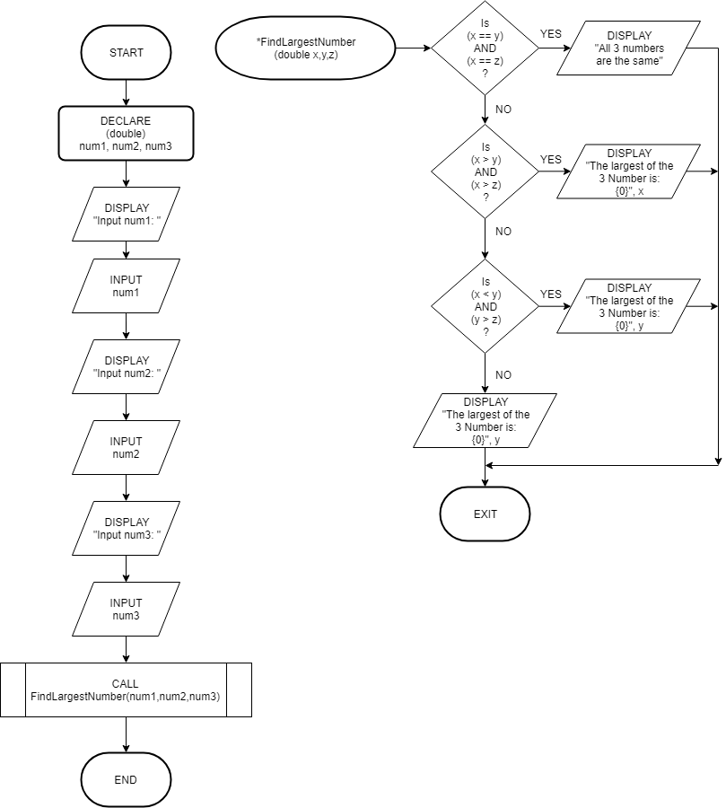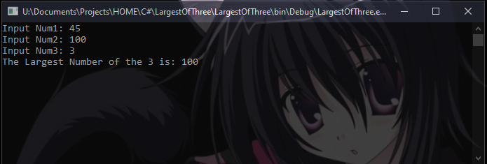

2.

DECLARE (double) num1, num2, num3, largest, smallest, sum, sumMinMax

DISPLAY “Input num1: ”

Input num1

DISPLAY “Input num2: ”

Input num2

DISPLAY “Input num3: ”

Input num3

CALL FindLargest(num1, num2, num3)

CALL FindSmallest(num1, num2, num3)

CALL Sum (num1, num2, num3)

CALL Average(sum, sumMinMax)

FUNCTION FindLargest (double x. y, z)

IF (x > y) AND (x > z)

SET largest = x

ELSEIF (x < y) AND (y > z)

SET largest = y

ELSE

SET largest = z

ENDIF

DISPLAY “The Largest of The 3 is: {0}”, largest

END FUNCTION

FUNCTION FindLargest (double x. y, z)

IF (x < y) AND (x < z)

SET smallest = x

ELSEIF (x > y) AND (y < z)

SET smallest = y

ELSE

SET smallest = z

ENDIF

DISPLAY “The Smallest of The 3 is: {0}”, smallest

END FUNCTION

FUNCTION Sum (double x. y, z)

SET sum = (x + y + z)

SET sumMinMax = (smallest + smallest)

DISPLAY “Total of all 3 numbers is: {0}”, sum

DISPLAY “Total of Minimum and Maximum is: {0}”, sum

END FUNCTION

FUNCTION Average (double x. y)

DECLARE (double) average, averageMinMax

SET average = (x/3)

SET averageMinMax = (y/2)

DISPLAY “Average of all 3 numbers is: {0}”, average

DISPLAY “Average of Minimum and Maximum is: {0}”, averageMinMax

END FUNCTION

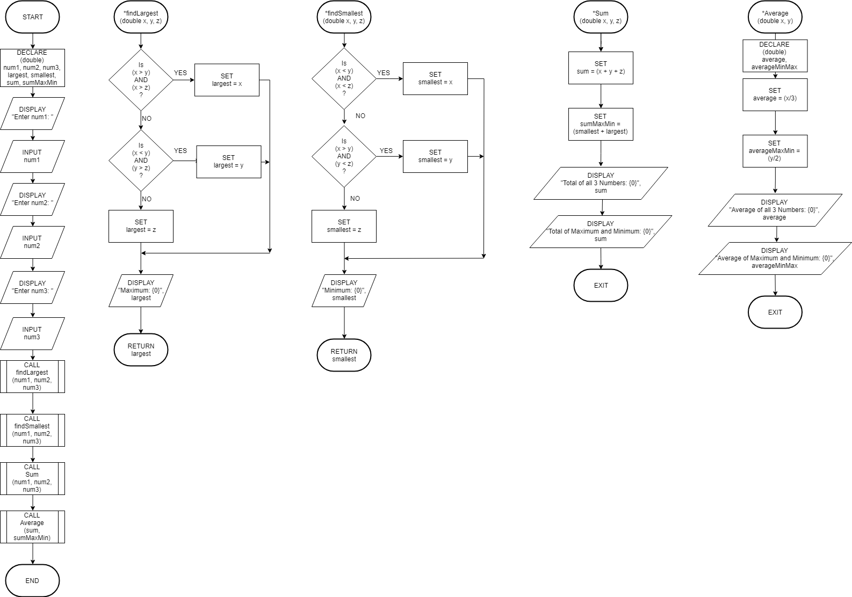

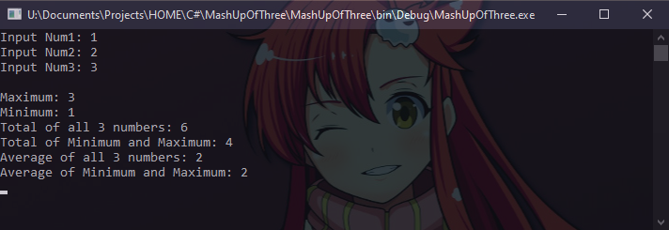

3.

DECLARE (double) marks

DECLARE (char) grade

DISPLAY “Input marks: ”

Input marks

CALL CheckGrade (marks)

FUNCTION CheckGrade(double x)

DO

IF (x < 40) THEN

SET grade = ‘F‘

ELSEIF (x > 39) AND (x < 50)

SET grade = ‘D‘

ELSEIF (x > 49) AND (x < 60)

SET grade = ‘‘C

ELSEIF (x > 59) AND (x < 70)

SET grade = ‘B‘

ELSE

SET grade = ‘A‘

ENDIF

DISPLAY “Grade: {0}”, grade

BREAK

WHILE (true)

END FUNCTION

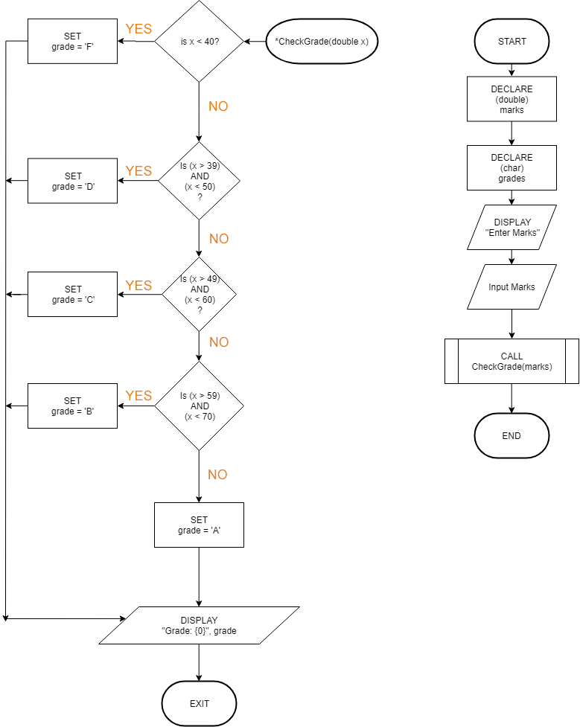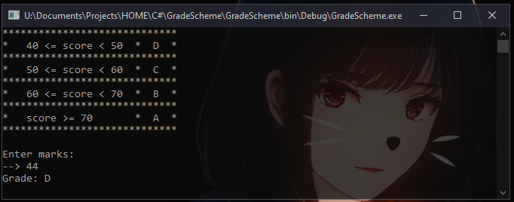

4.

DECLARE (int) month

DISPLAY “Input here: ”

Input month

CALL CheckForDay (month)

FUNCTION CheckForDay (int x)

SELECT CASE (x)

Case 1:

DISPLAY “January has 31 days”

BREAK

Case 2:

DISPLAY “February has 28/29 days”

BREAK

Case 3:

DISPLAY “March has 31 days”

BREAK

Case 4:

DISPLAY “April has 30 days”

BREAK

Case 5:

DISPLAY “May has 31 days”

BREAK

Case 6:

DISPLAY “June has 30 days”

BREAK

Case 7:

DISPLAY “July has 31 days”

BREAK

Case 8:

DISPLAY “August has 31 days”

BREAK

Case 9:

DISPLAY “September has 30 days”

BREAK

Case 10:

DISPLAY “October has 31 days”

BREAK

Case 11:

DISPLAY “November has 30 days”

BREAK

Case 12:

DISPLAY “December has 31 days”

BREAK

Case Default:

DISPLAY “Input an integer in range of 1-12 Only!”

BREAK

END SELECT

END FUNCTION

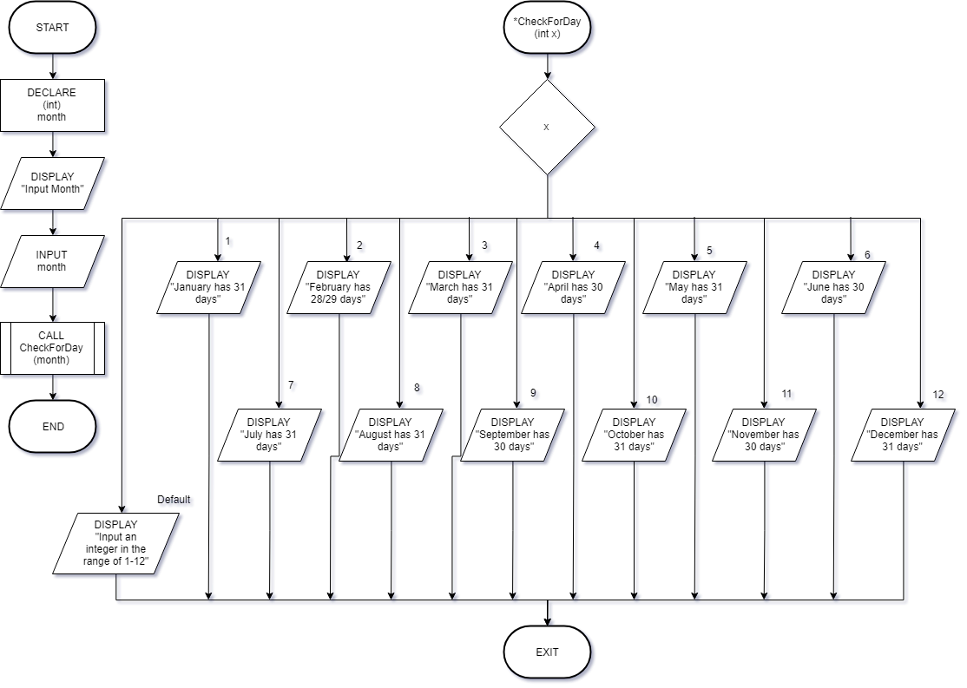

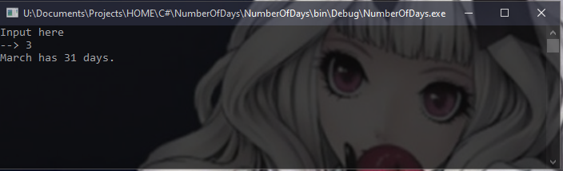

**Question 2**

