StudentID: 1810111

StudentName: Yash Djson Dookun

BSc(Hons.)Web & Multimedia Development – Year 2

**Question 1**

DECLARE (double) miles, kilometers

DECLARE (Const double) conversionRate = 1.609

DISPLAY “Input Distance (in miles): ”

INPUT miles

Kilometers = (miles * conversionRate)

DISPLAY “{0} miles = {1}Km”, miles, kilometers

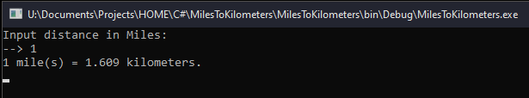

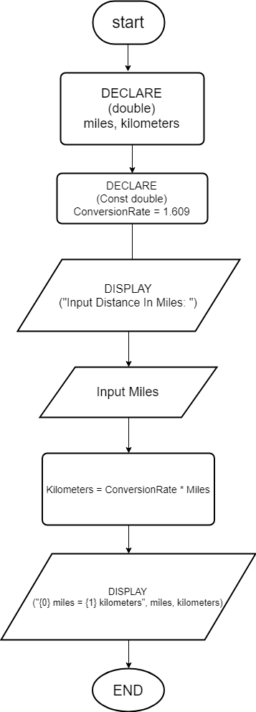

**Question 2**

DECLARE (double) r, area

DECARE (Const double) pi = 3.14159265359

DISPLAY (“Input radius (in cm)”)

INPUT r

Area = (pi * r * r)

DISPLAY “The area of the circle is: {0} cm2”, area

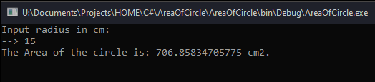

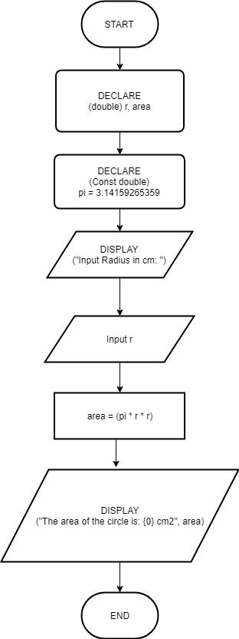

**Question 3**

DECLARE (double) Celsius, Fahrenheit, depth

DISPLAY “Input depth (in Km)”

INPUT depth

Celsius = (10 * (depth) + 20)

Fahrenheit = (1.8 * (Celsius) + 32)

DISPLAY “Celsius: {0} oC”, Celsius

DISPLAY “Fahrenheit: {0} F”, Fahrenheit

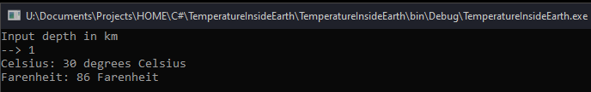

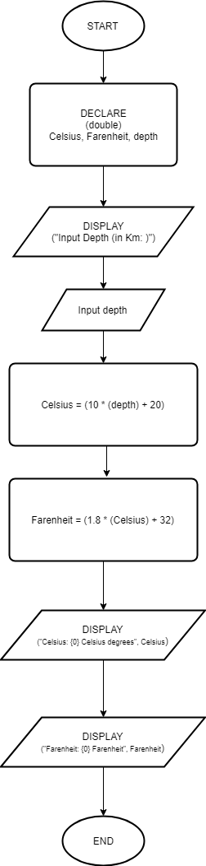

**Question 4**

DECLARE (double) distance, estimatedDistancePerLitre,

costPerLitre, cost, numberOfLitresRequired

DISPLAY “Input distance (in Km)”

INPUT distance

DISPLAY “Input kilometer per Litre estimate (in Km/L)”

INPUT estimatedDistancePerLitre

DISPLAY “Input cost per litre (in $)”

INPUT costPerLitre

numberOfLitresRequired = (estimatedDistancePerLitre / distance)

cost = (costPerLitre * numberOfLitresRequired)

DISPLAY “Number of litres required for {0}Km = {1}L”, distance, numberOfLitresRequired

DISPLAY “The estimated cost for the {0}Km trip is ${1}”, distance, cost

