Project
High Level Design
on Automotive GenAI Visualizer
Course Name | Datagami Skill Based Course – Generative AI
Institution Name | Medicaps University
Student Name(s) & Enrolment | Yashit Jain – EN22EL301069  Yugal Bisani- EN22EL301070  Yashasvi Nannaware – EN22EL301068  Yuvraj Singh Sikarwar – EN22CS3011129
Group Name | 03-D10
Project Number | GAI-16
Industry Mentor Name | Mr Rishab
University Mentor Name | Mrs Divya Kumawat
Academic Year | 2025–2026
Deployment URL | https://automotive-gen-ai-visualizer-mbz87xugx2ibv768j7mpsm.streamlit.app/
Document Version | v1.0 — March 2026

Table of Contents
1. Introduction
1.1 Scope of the Document
1.2 Intended Audience
1.3 System Overview
2. System Design
2.1 Application Design
2.2 Process Flow
2.3 Information Flow
2.4 Components Design
2.5 Key Design Considerations
2.6 API Catalogue
3. Data Design
3.1 Data Model
3.2 Data Access Mechanism
3.3 Data Retention Policies
3.4 Data Migration
4. Interfaces
5. State and Session Management
6. Caching
7. Non-Functional Requirements
7.1 Security Aspects
7.2 Performance Aspects
8. References

1. Introduction
The Automotive GenAI Visualizer is a Streamlit-based web application that leverages generative AI (diffusion models) to produce photorealistic car renderings from natural-language prompts or hand-drawn sketches. Deployed on Streamlit Community Cloud, the app gives students, designers, and automotive enthusiasts an instant visual ideation tool — no design software required.

1.1 Scope of the Document
This High-Level Design (HLD) document describes the system at an architectural level. It covers system functionality, component interactions, data flows, API definitions, and design decisions. Low-level implementation details and source code are outside the scope of this document.

1.2 Intended Audience
This document is intended for:
- Software architects and developers building or extending the system
- Project mentors (industry & university) reviewing the design
- Students in the Datagami Skill Based Course at Medicaps University

1.3 System Overview
The application follows a client–server architecture. The Streamlit frontend runs in the user's browser; the backend is a Python/Tornado process that orchestrates model inference. The generative AI core uses Stable Diffusion (Hugging Face Diffusers) for text-to-image and image-to-image synthesis. An optional LLM module refines raw prompts before passing them to the diffusion pipeline.

Core workflow: User Input → Security / Validation → Prompt Refinement (optional) → Stable Diffusion Inference → Image Display → Optional Save

2. System Design

2.1 Application Design
The app is a single-page Streamlit application. Key design choices:
- Reactive model: the Python script reruns top-to-bottom on every widget interaction
- Session isolation: each browser tab maintains its own WebSocket session and state
- Cache-first model loading: @st.cache_resource loads the diffusion model once at startup
- Configurable inference: model endpoint, style, resolution, and seed are all configurable via UI widgets or environment variables

System Architecture Diagram
The sketch below illustrates the four-tier system architecture — drawn to show the component layout and data pathways at a glance: 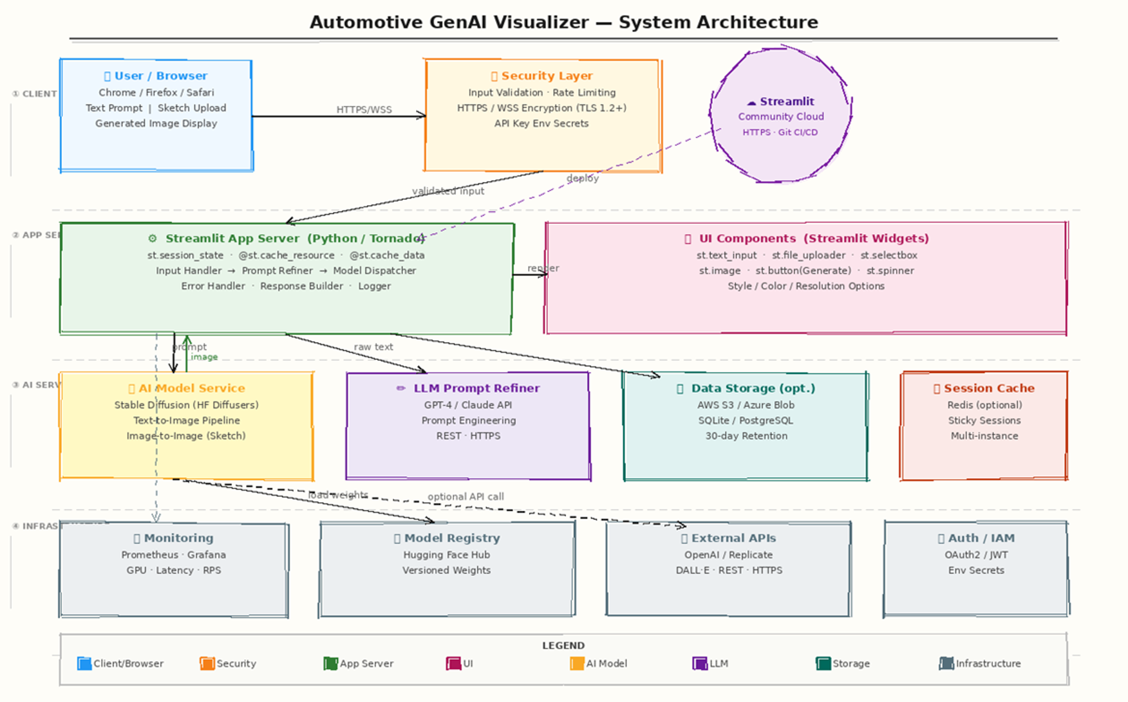

Figure 1 — System Architecture (sketch style)

2.2 Process Flow
The diagram below shows the step-by-step process from the moment a user opens the app to receiving a generated image. Decision points (validation, LLM refinement) and the retry loop are explicitly shown:
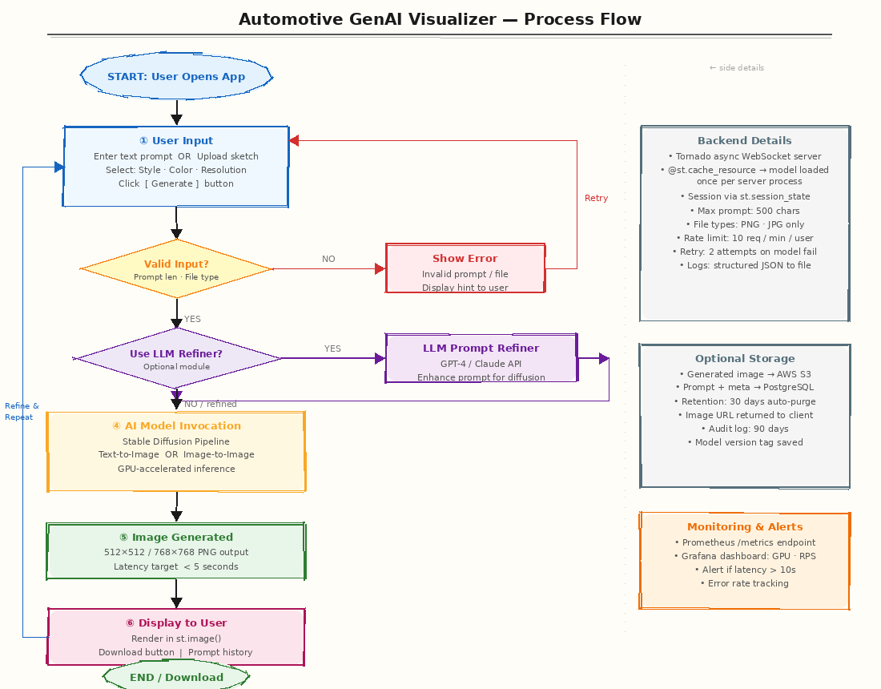
Figure 2 — End-to-End Process Flow Diagram
Key steps:
- User opens app; selects style/resolution, types a prompt or uploads a sketch
- Input validated (prompt length ≤ 500 chars; file type PNG/JPG only)
- Optional LLM Refiner enriches the prompt via GPT-4/Claude API
- Stable Diffusion pipeline runs inference (GPU-accelerated, < 5 s target)
- Generated PNG returned to the browser via WebSocket
- User may download the image or refine the prompt and regenerate

2.3 Information Flow
The diagram below maps how data moves between every node — user, security layer, app server, AI model, storage, and monitoring:
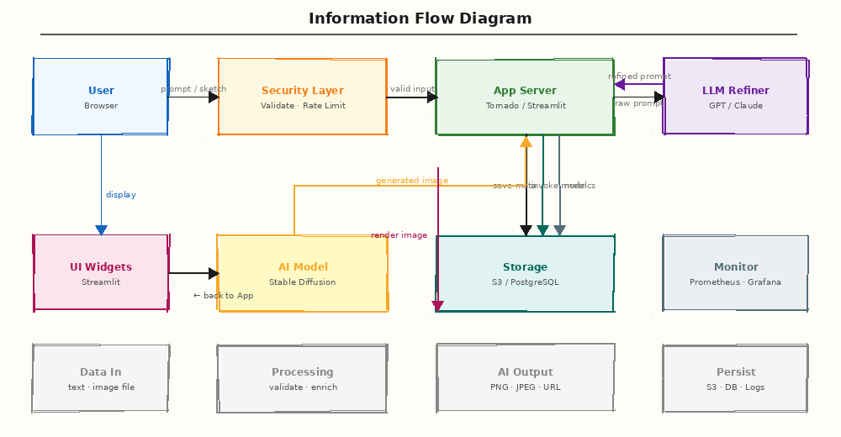
Figure 3 — Information Flow Diagram
Summary of data flows:
- User → Security Layer: raw prompt text or sketch file over HTTPS/WSS
- Security Layer → App Server: validated, sanitised input
- App Server → LLM Refiner: raw prompt string (optional, REST/HTTPS)
- LLM Refiner → App Server: refined prompt string
- App Server → AI Model: refined prompt + optional image bytes
- AI Model → App Server: generated image binary (PNG)
- App Server → Storage: image file (S3) + metadata (PostgreSQL) — optional
- App Server → Browser: image binary over open WebSocket connection
- App Server → Monitoring: /metrics endpoint scraped by Prometheus

2.4 Components Design
Component | Responsibility | Technology
User Interface | Widgets for input/output, reactive rendering | Streamlit (Python)
App Server | Session management, orchestration, caching | Tornado / Streamlit
AI Model Service | Text-to-image & image-to-image synthesis | Stable Diffusion (HF Diffusers)
LLM Prompt Refiner | Enhance raw prompts for better output | GPT-4 / Claude API
Security Layer | Input validation, rate limiting, encryption | Custom middleware + HTTPS
Data Storage | Persist images & metadata (optional) | AWS S3 + PostgreSQL
Monitoring | Track latency, GPU usage, error rate | Prometheus + Grafana
Model Registry | Version-controlled model weights | Hugging Face Hub

2.5 Key Design Considerations
Dimension | Decision | Rationale
Scalability | Multiple inference containers + load balancer | Model inference is the bottleneck
Performance | GPU acceleration + @st.cache_resource | < 5 s per image target
Reliability | Retry logic (2 attempts) + graceful error UI | User-facing failures handled cleanly
Extensibility | Model endpoint in env var; modular pipeline | Swap SD v1.5 → SDXL with zero code change
Cost Control | Rate limiting (10 req/min/user) + usage alerts | Prevent runaway GPU/API spend
Maintainability | Separated modules; version-controlled codebase | Clear separation of UI / backend / model

2.6 API Catalogue

POST /generate-image
Field | Detail
Input | { prompt: string, style?: string, resolution?: string, image?: binary }
Operation | Invokes the Stable Diffusion pipeline
Output | Binary PNG/JPEG or image URL in JSON
Auth | Session cookie or API key header

POST /refine-prompt
Field | Detail
Input | { current_prompt: string, user_message: string }
Operation | Calls GPT-4/Claude API to enrich prompt
Output | { refined_prompt: string }
Auth | API key in env variable

POST /upload-sketch
Field | Detail
Input | Multipart form-data: image file (PNG/JPG) + params
Operation | Validates file; feeds into img2img pipeline
Output | { sketch_id: string, status: 'accepted' }
Auth | Session cookie

POST /session/login (Optional)
Field | Detail
Input | { email: string, password: string }
Operation | Authenticates user via JWT / OAuth2
Output | { token: string, expires_at: datetime }
Auth | N/A

3. Data Design

3.1 Data Model
Core entities and their relationships:
Entity | Key Fields | Storage | Notes
Users (opt.) | id, name, email, api_key, created_at | PostgreSQL | Nullable if anonymous use
Prompts | id, user_id?, prompt_text, refined_prompt, model_ver, created_at | PostgreSQL | Links to Images
Images | id, prompt_id, image_url, width, height, latency_ms, created_at | PostgreSQL + S3 | URL points to S3 object
Sketch Uploads | id, user_id?, file_path, created_at | PostgreSQL + S3 | Linked to Prompt

Relationships: User 1→N Prompts · Prompt 1→N Images · Prompt 0→1 Sketch Upload

3.2 Data Access Mechanism
- Backend uses SQLAlchemy ORM for all relational DB operations
- Object storage accessed via boto3 (AWS) or azure-storage-blob SDK
- Credentials stored as environment secrets — never in source code
- Frontend never accesses the database directly; all access is via the App Server

3.3 Data Retention Policies
Data Type | Retention Period | Purge Mechanism
Generated images (S3) | 30 days | S3 lifecycle rule
Prompt & image metadata | 30 days | Scheduled DB cleanup job
Audit & error logs | 90 days | Log rotation / CloudWatch expiry
User account data | Until deletion request | Manual or API-triggered delete
Model artifacts (HF Hub) | Indefinite | Version-tagged; old versions archived

3.4 Data Migration
- Model Updates: image rows store model_version field; no re-generation required on upgrade
- Schema Changes: managed via Alembic migrations (SQL) or equivalent
- Cloud Provider Move: S3 → Azure Blob via aws s3 sync / az copy; DB dumps exported first
- Zero-downtime migrations: blue-green deployment with schema-compatible intermediate versions

4. Interfaces
Interface | Protocol | Direction | Description
User ↔ App Server | HTTPS / WSS | Bidirectional | Browser renders UI; WebSocket streams events
App Server → AI Model | In-process / REST HTTPS | Outbound | Diffusers library call or external API endpoint
App Server → LLM | REST HTTPS | Outbound | Prompt refinement via OpenAI / Anthropic API
App Server → S3 | HTTPS (S3 API) | Outbound | Save/retrieve images & sketches
App Server → DB | TCP (SQL driver) | Bidirectional | CRUD on prompts, images, user metadata
App Server → Monitoring | HTTP (Prometheus) | Outbound | Expose /metrics; Grafana scrapes
App Server → HF Hub | HTTPS | Outbound | Download versioned model weights on startup

5. State and Session Management
Streamlit creates a separate WebSocket session per browser tab. Session state is maintained using st.session_state, which persists variables — current prompt, last generated image, prompt history — across reruns within a session.

For multi-instance deployments, session stickiness is required (load balancer must route a user's requests consistently to the same server instance). An optional Redis-backed session store can be configured for shared state across instances.
- st.session_state keys: current_prompt, last_image, history[], sketch_id, refined_prompt
- Session expires: on browser tab close or server restart
- Stateless fallback: if session state is lost, the user simply starts a new generation

6. Caching
Cache Type | Decorator / Tool | What Is Cached | Scope
Model weights | @st.cache_resource | Stable Diffusion pipeline object | Per server process (shared across sessions)
Tokenizer / vocab | @st.cache_resource | CLIP tokenizer instance | Per server process
Static embeddings | @st.cache_data | Style preset embeddings | Per server process, TTL = 1 h
Results cache | @st.cache_data (opt.) | Common prompt → image URL mapping | Per session, TTL = 10 min
External data | Redis (opt.) | Cross-instance session state | Shared across all instances

7. Non-Functional Requirements

7.1 Security Aspects
- All traffic encrypted with HTTPS/WSS (TLS 1.2+)
- API keys and credentials stored as environment secrets, never committed to source control
- Input validation: maximum prompt length 500 chars; accepted file types PNG/JPG only
- Rate limiting: 10 generation requests per user per minute
- Content Security Policy (CSP) headers set on all responses
- Dependency pinning + automated vulnerability scanning (Dependabot / Snyk)
- User data deletion on request; no PII stored beyond what is strictly necessary

7.2 Performance Aspects
Metric | Target | Approach
Image generation latency | < 5 seconds (p95) | GPU acceleration + model caching
App startup time | < 30 seconds | @st.cache_resource model pre-load
Concurrent users | 50–100 on community cloud | Tornado async + sticky sessions
Uptime / Availability | ≥ 99% | Health checks + auto-restart on Streamlit Cloud
Error rate | < 1% of requests | Retry logic (2 attempts) + graceful fallback
Max image resolution | 768 × 768 px | Configurable; higher = longer latency

COMPONENT DESIGN
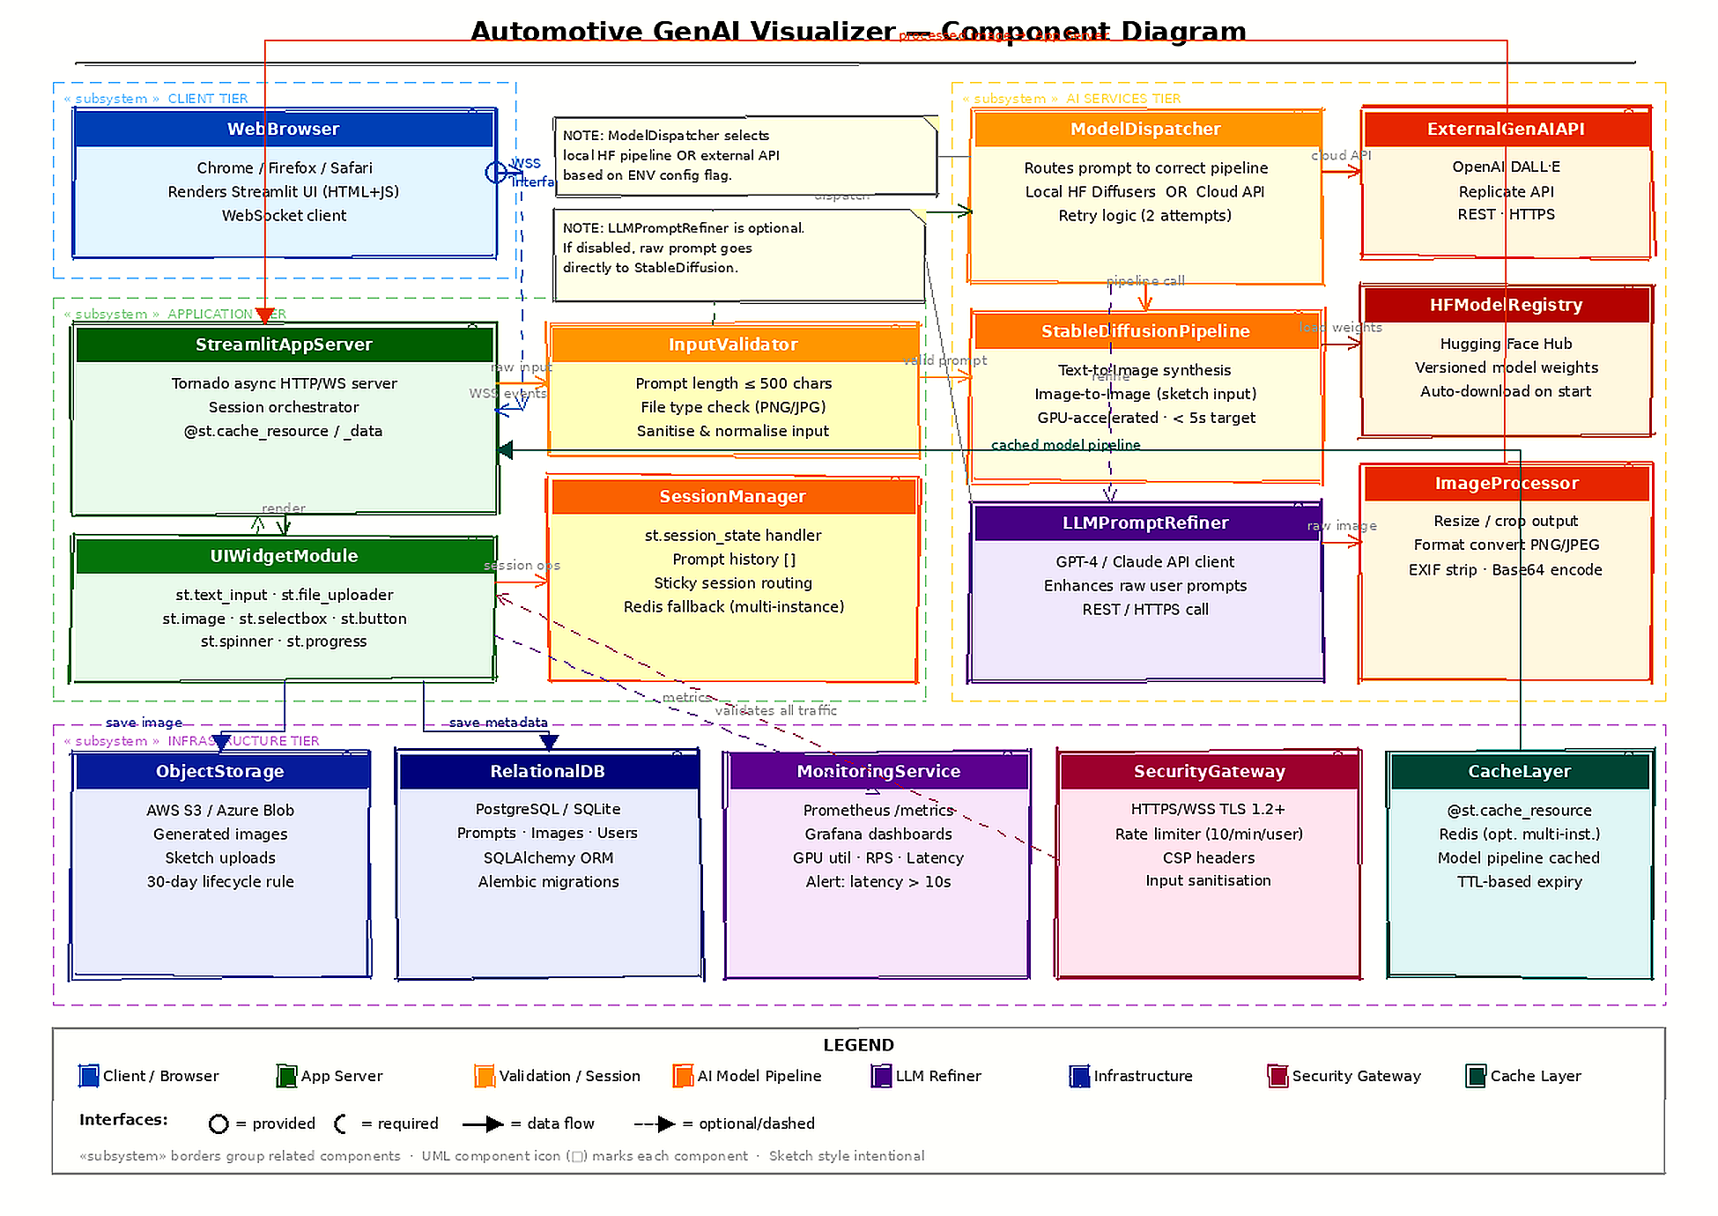

8. References
- Autodesk Research — A Novel Generative AI System to Assist Conceptual Automotive Design. https://www.research.autodesk.com/publications/generative-ai-automotive-design/
- Streamlit Documentation — Understanding Streamlit's client-server architecture. https://docs.streamlit.io/develop/concepts/architecture/architecture
- Hugging Face — Stable Diffusion Pipelines. https://huggingface.co/docs/diffusers/api/pipelines/stable_diffusion/overview
- LakeFS Blog — Machine Learning Architecture Diagram. https://lakefs.io/blog/machine-learning-architecture-diagram/
- Medium / Salvadiswar — Design Checklist for Model Deployment. https://medium.com/@salvadiswar.ds/design-checklist-for-model-deployment-2157c520fa6d
- StackHawk — AI Security Best Practices. https://www.stackhawk.com/blog/ai-security-best-practices/
- Streamlit Community Forum — Maximum concurrent users. https://discuss.streamlit.io/t/maximum-number-of-concurrent-users-for-streamlit-app/22438
- Visualizee.ai — AI Car Generator. https://visualizee.ai/solutions/ai-car-generator
- Hugging Face Hub — Model versioning documentation. https://huggingface.co/docs/hub/model-cards

