Software Requirements Specification
PhishGuard
Intelligent Phishing Website Detection using Machine Learning, Explainable AI (SHAP), and FastAPI
Requirements Specification Document
Submitted to | Submitted by
Project Supervisor / Faculty Guide  Department of Information Technology  Institute of Technology and Science Mohan Nagar, Ghaziabad | PhishGuard Development Team  Mini Project Submission  Version 1.0

Institute of Technology and Science Mohan Nagar, Ghaziabad
Document version: 1.0 | Date: 08 August 2026

Document Control
Field | Value
Document title | Software Requirements Specification - PhishGuard
Project type | Academic mini-project / cybersecurity web application
Version | 1.0
Status | Baseline requirements for implementation and evaluation
Primary users | Security analysts, students, project evaluators, and general users
System boundary | React frontend, FastAPI backend, feature pipeline, ML model, SHAP explanation, SQLite persistence

Requirement convention: Each requirement is identified with a unique REQ-* tag. Functional requirements use REQ-001 onward; non-functional requirements use REQ-033 onward. Verification identifies how the requirement can be demonstrated or tested.

Table of Contents
- Purpose
- Scope
- Intended Audiences
- Definitions and Abbreviations
- References
- Assumptions and Dependencies
- Problem Statement
- Scenario Document
- Overall Description
- Use Cases
- Functional Requirements
- Data Requirements
- Non-Functional Requirements
- Acceptance Criteria
- Risks, Constraints, and Future Work
- Appendix A - API Summary
- Appendix B - Feature Dictionary

1. Purpose
This Software Requirements Specification defines the functional, non-functional, data, interface, and operational requirements for PhishGuard. PhishGuard is a web-based phishing website detection system that accepts an absolute URL, extracts structural URL signals and optional webpage/HTML signals, classifies the target with a machine-learning model, explains the result with SHAP or a deterministic fallback, and stores an auditable scan record.
The document is intended to establish a shared baseline for design, implementation, testing, demonstration, and academic evaluation. It also records the problem statement, operating scenarios, use cases, activity flow, and system flow needed to understand how a scan moves through the product.
Project objective: Provide a fast, explainable, and API-accessible phishing assessment without depending on paid third-party threat-intelligence APIs. The system must still return a useful URL-only assessment when a target webpage cannot be reached.

2. Scope

2.1 In scope
- URL submission and strict absolute HTTP(S) URL validation.
- Extraction of 15 URL-structure features and 7 optional HTML/DOM features.
- Bounded best-effort webpage retrieval with graceful URL-only degradation.
- Model inference, confidence calculation, 0-100 risk scoring, and low/medium/high risk tiers.
- Top-five contributing feature explanations using SHAP when supported, with deterministic fallback support.
- SQLite persistence of scan history and active-model metadata.
- History search/filtering, pagination, deletion, analytics, model information, API documentation, and printable scan reports through the planned frontend.
- FastAPI REST endpoints, validation errors, health checks, logging, and automated tests for the backend contract.

2.2 Out of scope
- Blocking or quarantining webpages directly in a browser or network gateway.
- Guaranteed detection of every zero-day attack; the result is an ML-based risk assessment.
- Paid external threat-intelligence, reputation, or blacklist APIs.
- User authentication, role-based access control, and multi-tenant isolation in the mini-project version.
- Automatic takedown, remediation, or notification of website owners.

3. Intended Audiences
Audience | How this document is used
Project sponsor / evaluator | Confirm the problem, scope, expected behavior, and acceptance criteria.
Developers | Implement frontend screens, API routes, feature extraction, inference, explanations, and persistence.
Testers | Derive unit, API, integration, negative, performance, and acceptance tests.
Security analysts / users | Understand the meaning and limitations of the verdict, risk score, and evidence.
Future maintainers | Trace requirements to architecture, data fields, endpoints, and extension opportunities.

4. Definitions and Abbreviations
Term | Description
API | Application Programming Interface used by the frontend to call backend services.
DOM | Document Object Model representing the structure of fetched webpage HTML.
FastAPI | Python web framework used to expose typed REST endpoints.
HTML feature | A signal derived from fetched webpage markup, forms, links, scripts, or redirects.
ML model | The active classifier used to estimate legitimate versus phishing probability.
Phishing | A malicious or deceptive webpage intended to steal credentials, payment data, or sensitive information.
Risk score | An integer from 0 to 100 derived from phishing probability.
SHAP | SHapley Additive exPlanations; an explainability method used to rank contributing features.
URL feature | A signal computed from the submitted URL without needing a network fetch.
XAI | Explainable Artificial Intelligence; techniques that make model results interpretable.

5. References
- PhishGuard project overview and architecture guide: OVERVIEW.md, repository version current at this SRS baseline.
- PhishGuard API contract: files/03_api_contract.md.
- PhishGuard feature engineering specification: files/04_feature_engineering_spec.md.
- PhishGuard backend implementation: phishing_detector/backend/app and associated tests.
- Active model comparison report: phishing_detector/backend/ml/comparison_report.json.
- Retained SRS template: SRSTemplate_v1.0 (1).docx.

6. Assumptions and Dependencies
Category | Assumption / dependency | Impact if unmet
Runtime | Python 3.11+, FastAPI, Uvicorn, scikit-learn, NumPy, BeautifulSoup4, requests, SQLAlchemy, and related pinned dependencies are available. | Backend cannot start or model training/inference cannot run.
Frontend | A React 18 / Vite client communicates with the backend over the configured development or production origin. | The API remains usable through Swagger or another HTTP client, but the planned UI is unavailable.
Network | Target pages may be reachable, slow, or unavailable; fetches are bounded by a configured timeout. | HTML features are omitted and URL-only analysis is returned.
Model artifact | A trained model artifact may be present; otherwise the deterministic heuristic fallback is enabled for demonstration. | The response identifies the fallback model and its limitations.
Dataset | Training data contains both phishing and legitimate labels and is deduplicated before training. | Model quality and comparison metrics cannot be trusted without representative data.
Persistence | SQLite is writable by the backend process and is suitable for mini-project volume. | History and model-audit features are unavailable or read-only.

7. Problem Statement
Phishing websites are designed to appear trustworthy while redirecting users to pages that collect credentials, payment details, or other sensitive information. Traditional static blacklists are slow to recognize short-lived or newly generated domains. Commercial reputation services can reduce implementation effort, but they introduce cost, network dependence, rate limits, and limited transparency into the reason a URL was flagged.
The project therefore needs a self-contained detection workflow that can analyze suspicious URLs quickly using observable URL and webpage characteristics, select a trained classifier, expose an understandable verdict, and preserve the evidence used for later review. The solution must also remain useful when the target site is offline, blocked, or too slow to fetch.
Problem statement: Design and implement PhishGuard, an explainable web-based phishing detection system that classifies a submitted URL as legitimate or phishing, presents a calibrated risk view with contributing signals, and maintains an auditable scan history while avoiding dependence on paid external threat APIs.

7.1 Objectives
- Return a prediction through a typed FastAPI endpoint after validating the submitted URL.
- Use a 22-feature hybrid vector: 15 always-available URL signals and 7 optional HTML signals.
- Use the active Random Forest model selected by the project benchmark when its artifact is available, with deterministic heuristic fallback for offline demonstration.
- Provide a risk score from 0 to 100 and evidence that a human can interpret.
- Persist each successful scan with the URL, domain, verdict, confidence, risk tier, features, top signals, model version, and timestamp.
- Support analyst review through history, analytics, model metadata, and printable reports.

8. Scenario Document
The following scenario describes the primary operating situation and the alternate outcomes that the system must handle. It is written from the perspective of a security analyst or general user reviewing a suspicious link.

8.1 Primary scenario: analyze a suspicious URL
Step | Actor | Scenario action / system response
1 | User | Opens the Overview or Scan URL page and enters an absolute URL.
2 | Frontend | Performs basic client-side format validation and shows an inline error if the value is missing or malformed.
3 | Backend | FastAPI validates the HttpUrl request and starts the prediction workflow.
4 | Backend | The scraper makes a bounded best-effort request to the target page. Redirects are counted if the page responds.
5 | Feature service | Extracts 15 URL features and, when HTML is available, 7 HTML/DOM features. Otherwise it records html_features_available=false and safe defaults for HTML features.
6 | Model service | Loads the active model or configured fallback, generates phishing probability, prediction, confidence, and risk tier.
7 | Explainability service | Ranks the top five contributing signals using SHAP where supported or the deterministic fallback explanation.
8 | Database | Persists the complete scan record and model version in SQLite.
9 | Frontend | Displays the verdict, confidence, risk score, evidence, full feature matrix, and an optional degradation note.
10 | User | Reviews the result, opens the detailed report, or later finds the scan in history and analytics.

8.2 Alternate and exception scenarios
Scenario | Expected behavior
Malformed URL | Return HTTP 422 with a human-readable validation detail; do not create a scan-history row.
Target page timeout / DNS / TLS / HTTP failure | Complete URL-only analysis, set html_features_available=false, and show the degradation note.
Model artifact missing | If fallback is enabled, use the heuristic model and identify it in model metadata; otherwise return HTTP 503.
Unexpected extraction or persistence failure | Rollback the transaction, log the failure, and return HTTP 500 with a generic detail.
History id not found | Return HTTP 404 and leave existing records unchanged.
Multiple users scan concurrently | Each request receives its own scan record; SQLite transactions must prevent partial or cross-linked results.

9. Overall Description

9.1 Product perspective
PhishGuard is a layered client-server application. The React frontend provides the analyst workspace, the FastAPI backend owns validation and orchestration, the service layer extracts features and runs inference, the explainability service produces evidence, and SQLite stores durable scan history and model metadata. Swagger UI is exposed by FastAPI for interactive API inspection and testing.
Layer | Main responsibility | Representative technology
Presentation | URL input, verdicts, history, analytics, model/API page, and report view. | React 18, Vite, Tailwind CSS, chart components
API | Typed request/response contract, route handling, HTTP status codes, CORS, health, and persistence orchestration. | FastAPI, Pydantic, Uvicorn
Feature services | URL parsing, HTML fetch, DOM parsing, and 22-feature aggregation. | urllib, tldextract, requests, BeautifulSoup4
ML/XAI | Model loading, probability inference, risk mapping, and top-five feature explanation. | scikit-learn, Random Forest, SHAP, NumPy
Persistence | Scan history and active-model metadata. | SQLite, SQLAlchemy, JSON

9.2 Operating environment
- Backend: Python 3.11+, FastAPI, Uvicorn; default development port 8000.
- Frontend: Node.js 18+, React/Vite development server; default development port 5173.
- Data store: SQLite database file writable by the backend process.
- Supported client: current modern browser with JavaScript enabled; API remains accessible from Swagger UI.
- Deployment target: frontend hosting such as Vercel/Netlify, FastAPI hosting such as Render/Railway, and persistent database volume as appropriate for production hardening.

9.3 System constraints
- The system cannot guarantee that a webpage is safe solely because it is reachable or uses HTTPS.
- HTML enrichment is best effort and must not block URL-only prediction indefinitely.
- The mini-project version has no authentication; it should not be exposed as a public multi-user service without security hardening.
- SQLite is appropriate for demonstration and moderate local use but is not a substitute for a production concurrent database at scale.
- Model performance depends on dataset quality, feature drift, and the selected decision threshold.

10. Use Cases

10.1 Actors
Actor | Description
Analyst / User | Submits URLs, reviews verdicts, investigates evidence, searches history, views analytics, and exports reports.
Target Website | External webpage optionally contacted to enrich the scan with HTML and redirect signals. It is not trusted and must not control the backend workflow.
ML Model | Internal classifier that returns probabilities for legitimate and phishing classes.
SQLite Database | Internal persistence component for scan history and model metadata.

10.2 Use Case Diagram
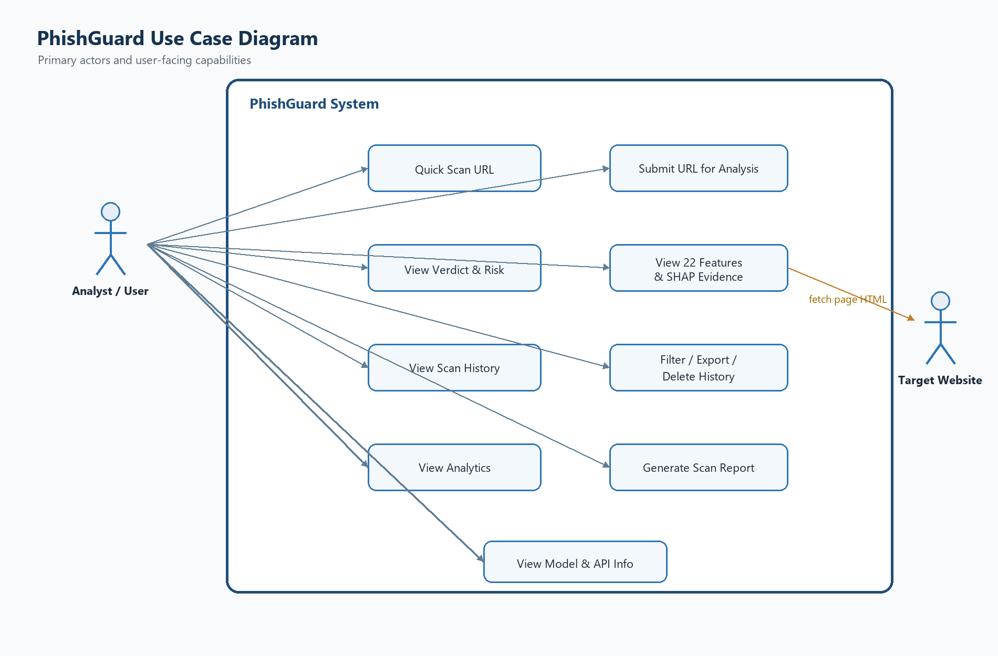
Figure 10-1: PhishGuard use case diagram

10.3 Use case summary
Use case | Primary actor | Precondition | Success outcome
UC-01 Submit URL | Analyst / User | Scan page is available. | A valid URL is sent to POST /predict.
UC-02 Review verdict | Analyst / User | A scan response exists. | User sees prediction, confidence, risk score, risk level, and evidence.
UC-03 Review history | Analyst / User | Database is reachable. | Paginated scan records are displayed and can be filtered.
UC-04 Manage history | Analyst / User | A history record is selected. | Record is viewed, exported, or deleted after confirmation.
UC-05 Review analytics | Analyst / User | History/model data is available. | Aggregate scan and model metrics are visible.
UC-06 Generate report | Analyst / User | A detailed scan is selected. | A print/PDF-ready report is displayed.
UC-07 Enrich scan | Target Website | The URL is syntactically valid. | HTML features and redirect count are added when reachable.

11. Functional Requirements
The requirements below describe observable behavior. Verification may be performed through unit tests, API contract tests, integration tests, UI demonstrations, or inspection of persisted records.

11.1 Request and validation requirements
ID | Requirement | Priority | Verification
REQ-001 | The system shall expose a health endpoint that reports service status, model readiness, and database connectivity. | Must | API test
REQ-002 | The system shall accept a JSON request containing one required url field. | Must | Schema test
REQ-003 | The system shall reject missing, malformed, or non-absolute URL values with HTTP 422. | Must | Negative API test
REQ-004 | The system shall normalize the submitted URL to a string for downstream parsing and persist the hostname/domain in lowercase. | Must | Integration test
REQ-005 | The system shall return human-readable error details using the API's standard detail field without exposing stack traces to the client. | Must | Error-path test

11.2 Analysis and model requirements
ID | Requirement | Priority | Verification
REQ-006 | The system shall attempt a bounded webpage fetch using a configurable timeout and a PhishGuard user agent. | Must | Integration test
REQ-007 | The system shall extract all 15 URL features for every syntactically valid URL without requiring a network call. | Must | Unit test
REQ-008 | The system shall extract seven HTML/DOM features when page HTML is available and set html_features_available=true. | Must | Unit/integration test
REQ-009 | When the target page cannot be fetched, the system shall set the seven HTML features to safe defaults, set html_features_available=false, and continue URL-only prediction. | Must | Failure-path test
REQ-010 | The system shall load the active trained model artifact when available, or use the configured deterministic heuristic fallback when permitted. | Must | Configuration test
REQ-011 | The system shall classify each scan as exactly one of phishing or legitimate based on the active model probability threshold. | Must | Unit/API test
REQ-012 | The system shall return confidence as a decimal value in the range 0.0 to 1.0 for the selected prediction. | Must | Schema test
REQ-013 | The system shall calculate an integer risk score from 0 to 100 using the phishing probability. | Must | Unit test
REQ-014 | The system shall map risk scores 0-33 to low, 34-66 to medium, and 67-100 to high. | Must | Boundary test
REQ-015 | The system shall return the five largest absolute feature contributions using SHAP where supported and a deterministic fallback explanation otherwise. | Must | Unit/API test

11.3 Persistence and history requirements
ID | Requirement | Priority | Verification
REQ-016 | The system shall persist each successful prediction with scan id, URL, domain, prediction, confidence, risk score, risk level, features JSON, top-features JSON, model version, and UTC scan timestamp. | Must | Database inspection
REQ-017 | The system shall create or reuse metadata for the model version used by a scan, including metrics when available. | Must | Database inspection
REQ-018 | The system shall return paginated history records in reverse chronological order. | Must | API test
REQ-019 | The history endpoint shall support optional prediction filtering for phishing or legitimate records. | Must | API test
REQ-020 | The system shall delete an existing history record only when its identifier exists and shall return HTTP 404 for an unknown identifier. | Must | API test
REQ-021 | The frontend shall provide a confirmation step before a user deletes a history record. | Should | UI demonstration

11.4 Frontend and analyst-workspace requirements
ID | Requirement | Priority | Verification
REQ-022 | The Overview page shall expose system health, active-model information, a quick scan input, and the latest scan summary. | Should | UI demonstration
REQ-023 | The Scan URL workspace shall show input validation, active-analysis state, verdict, confidence, risk score, risk level, and degradation status. | Must | UI demonstration
REQ-024 | The scan result view shall display the top five contributing signals with value, impact, direction, and plain-language meaning where available. | Must | UI demonstration
REQ-025 | The scan result view shall expose the full 22-feature matrix and indicate whether HTML enrichment was available. | Must | UI demonstration
REQ-026 | The History page shall provide search/filter controls, pagination, record detail viewing, deletion, and CSV export behavior. | Should | UI demonstration
REQ-027 | The Analytics page shall display total scans, phishing count/percentage, average confidence, model accuracy, and model comparison artifacts when data is available. | Should | UI demonstration
REQ-028 | The Model & API page shall display active model metadata, endpoint descriptions, health status, and a link or embedded view for Swagger UI. | Should | UI demonstration
REQ-029 | The report page shall present a print/PDF-ready audit view containing target URL, verdict, risk, top evidence, full feature matrix, model signature, and timestamp. | Should | UI demonstration

11.5 Observability and integration requirements
ID | Requirement | Priority | Verification
REQ-030 | The backend shall log bounded scrape failures with enough context for diagnosis without returning sensitive internal exception details to the client. | Must | Log inspection
REQ-031 | The backend shall rollback a database transaction when prediction persistence fails. | Must | Failure-path test
REQ-032 | The API shall expose OpenAPI/Swagger documentation for the supported endpoints. | Must | Endpoint inspection

11.6 Activity Diagram
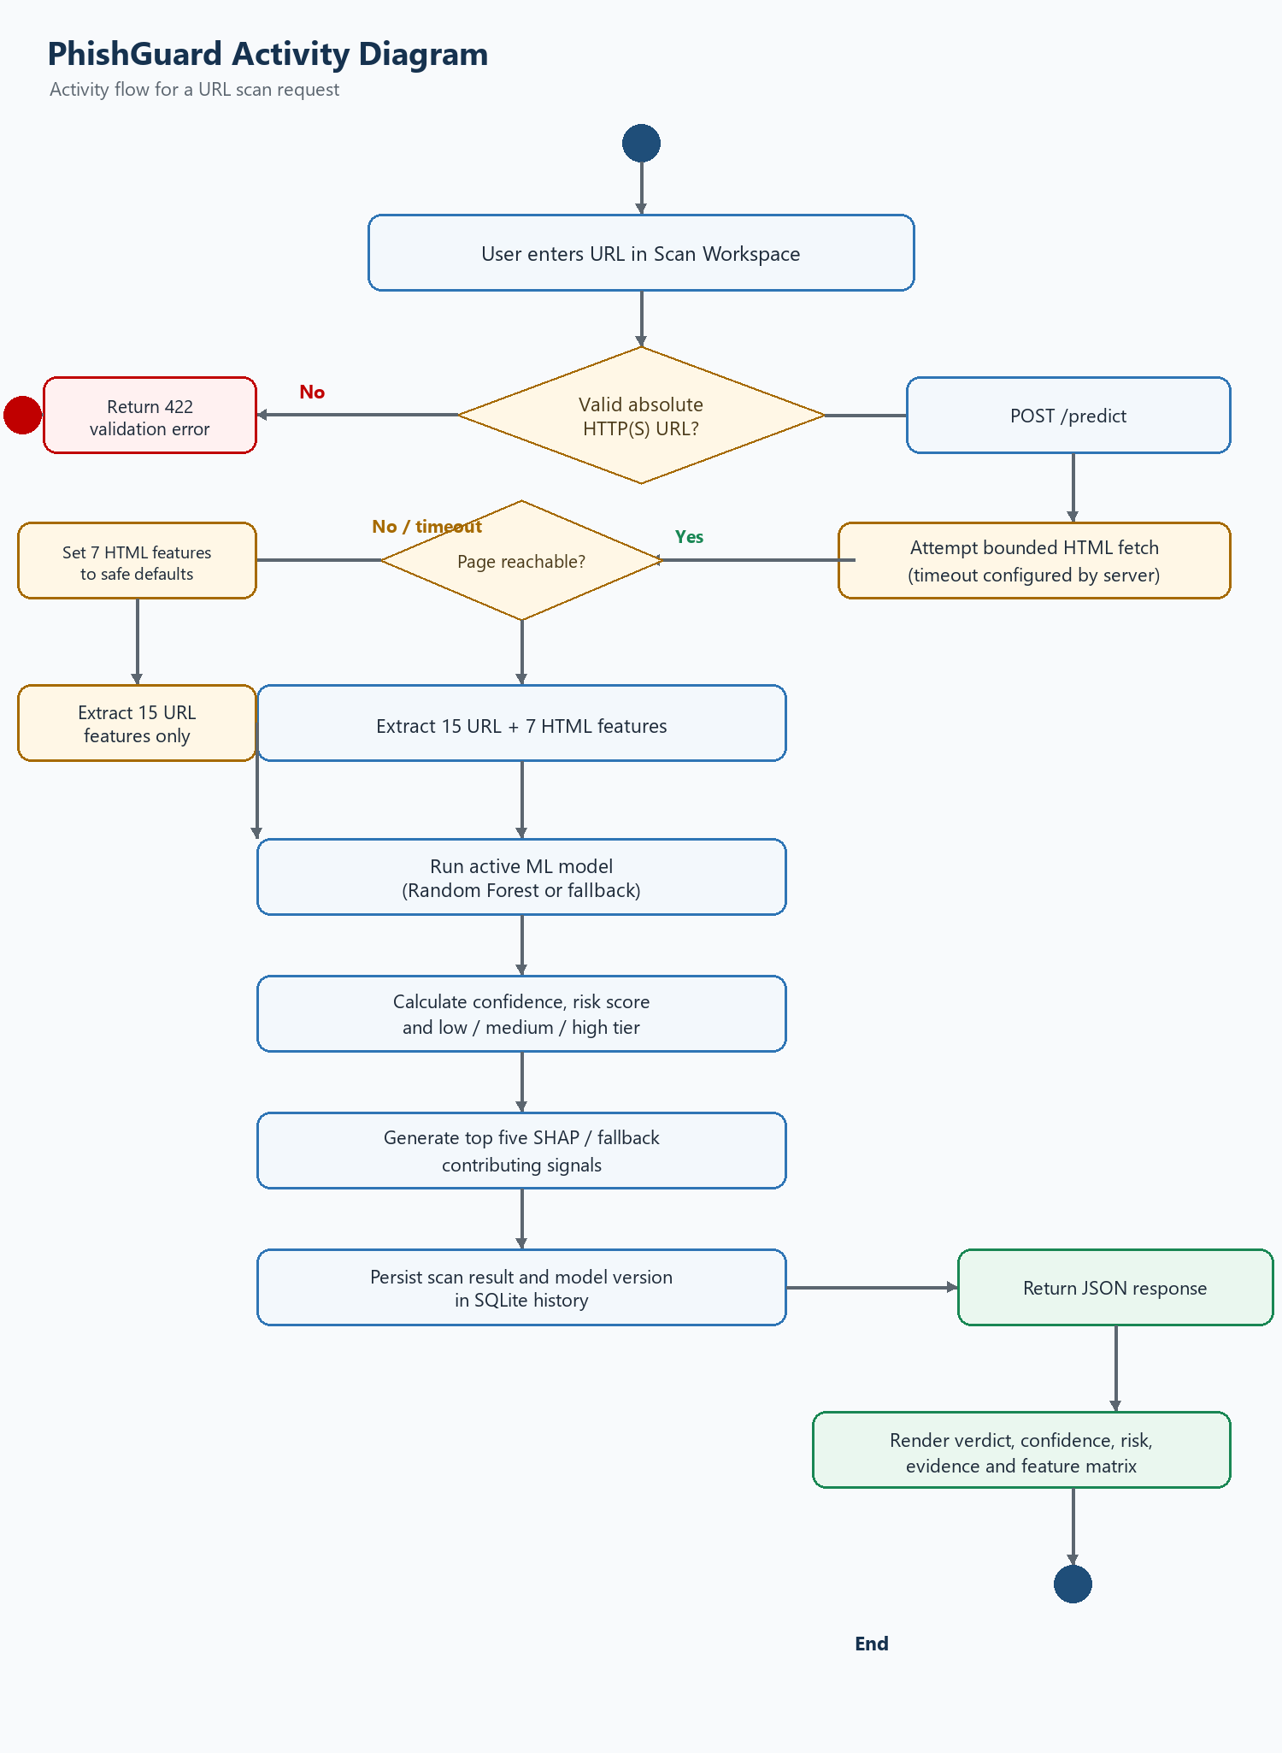
Figure 11-1: PhishGuard activity diagram for a URL scan

11.7 Flow Chart
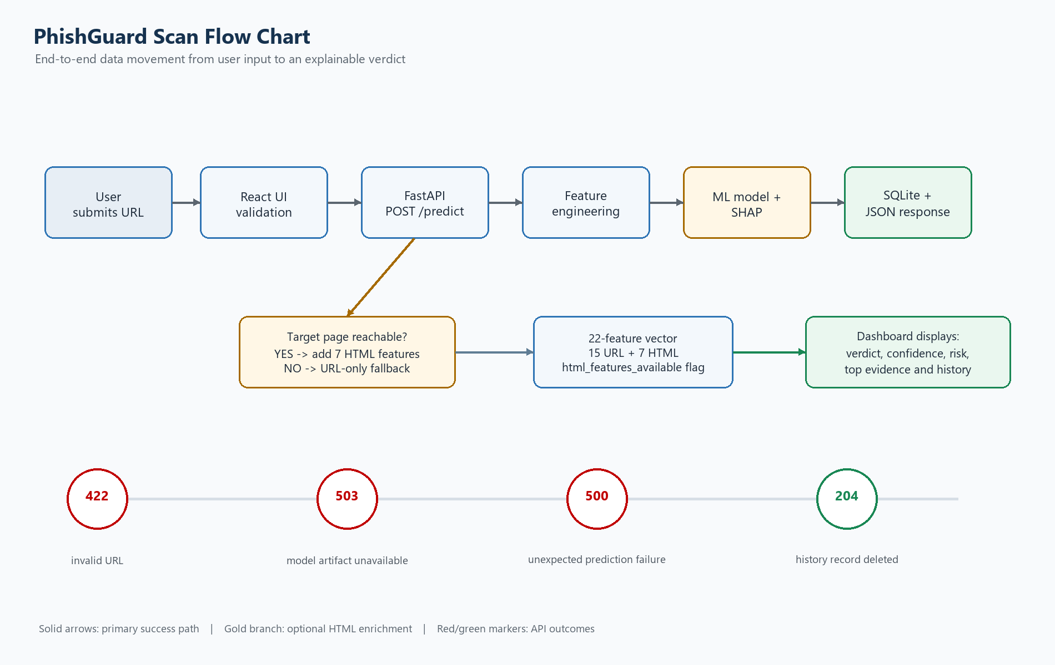
Figure 11-2: PhishGuard end-to-end scan flow chart

12. Data Requirements

12.1 Scan history entity
Field | Type | Required | Description
id / scan_id | Integer | System | Auto-incrementing identifier for the scan.
url | VARCHAR(2048) | Yes | Validated URL submitted by the user.
domain | VARCHAR(255) | System | Lowercase hostname extracted from the URL.
prediction | VARCHAR(20) | System | phishing or legitimate.
confidence | FLOAT | System | Confidence for the selected prediction, 0.0-1.0.
risk_score | INTEGER | System | Phishing probability mapped to 0-100.
risk_level | VARCHAR(10) | System | low, medium, or high.
features_json | TEXT | System | 22 named features plus html_features_available.
top_features_json | TEXT | System | Top five contributing signals and directions.
model_version | VARCHAR(50) | System | Model artifact or fallback version used for the scan.
scanned_at | DATETIME | System | UTC timestamp for the completed scan.

12.2 Model metadata entity
Field group | Description
Identity | id, model_name, algorithm, version, and is_active.
Evaluation | accuracy, precision, recall, f1_score, and roc_auc when a benchmark report is available.
Training context | dataset_size, trained_at, file_path, and optional notes.

12.3 Data integrity rules
- A scan record is created only after prediction and explanation succeed.
- A failed transaction must not leave a partial scan or orphaned model metadata row.
- Timestamps are stored and returned in UTC / ISO-8601 form.
- Feature names must remain stable because they are shared by extraction, inference, explanation, JSON output, and the frontend matrix.
- History deletion is permanent in the mini-project database and must therefore require explicit user confirmation in the UI.

13. Non-Functional Requirements
ID | Requirement | Priority | Verification
REQ-033 | For URL-only analysis under normal local conditions, the API should return a prediction within 500 ms after request validation, excluding external page-fetch time. | Target | Performance test
REQ-034 | The webpage fetch shall use a bounded timeout and shall not prevent a response when the target is offline or unreachable. | Must | Failure-path test
REQ-035 | The system shall use strict typed request/response schemas and shall not silently accept malformed URL input. | Must | Contract test
REQ-036 | The system shall avoid paid third-party threat-intelligence APIs in the baseline workflow. | Must | Architecture inspection
REQ-037 | The frontend shall present risk, confidence, and evidence with clear visual distinction and readable labels. | Should | UI inspection
REQ-038 | The backend shall isolate routing, feature extraction, scraping, inference, explainability, and persistence responsibilities into maintainable modules. | Must | Code review
REQ-039 | The application shall preserve scan history across backend restarts when the SQLite database is retained. | Must | Restart test
REQ-040 | The application shall be testable with unit tests for feature extraction and API tests for health, prediction, history, validation, and deletion paths. | Must | Test run
REQ-041 | The application shall disclose whether the result used full HTML enrichment or URL-only fallback so users do not overinterpret incomplete evidence. | Must | UI/API inspection

13.1 Security requirements
- The system shall treat fetched HTML as untrusted input and parse it without executing page scripts in the backend.
- The scraper shall use a bounded timeout and a controlled user agent to limit resource consumption.
- The API shall not return raw server tracebacks, model file contents, or database connection details in client-facing errors.
- Production deployment should add authentication, rate limiting, HTTPS, secret management, input-size limits, and stronger SSRF protections before public exposure.
- The report and history views shall expose only data already produced by the user's scan workflow; they shall not invent threat-intelligence claims.

14. Acceptance Criteria
ID | Acceptance criterion | Evidence
AC-01 | A valid URL returns a 200 response with scan id, prediction, confidence, risk score, risk level, features, top features, model version, and timestamp. | API test response
AC-02 | The response contains exactly 22 feature values plus html_features_available. | Schema/unit test
AC-03 | An unreachable target still returns a URL-only prediction and clearly marks HTML enrichment unavailable. | Integration/failure test
AC-04 | An invalid URL returns 422 and creates no scan history record. | Negative API test
AC-05 | A prediction is stored and can be retrieved from paginated history. | Database + API test
AC-06 | An existing record can be deleted and a missing record returns 404. | API test
AC-07 | The dashboard can present verdict, risk, confidence, evidence, and the full feature matrix. | UI demonstration
AC-08 | The SRS includes a problem statement, primary scenario, use case diagram, activity diagram, and flow chart aligned to implementation behavior. | Document review

15. Risks, Constraints, and Future Work

15.1 Risks
Risk | Consequence | Mitigation
False positive / false negative | A legitimate site may be flagged or a phishing site may be missed. | Show confidence and evidence, keep the user in the review loop, retrain with representative data, and monitor metrics.
HTML fetch / SSRF exposure | Fetching arbitrary URLs can consume resources or reach unintended internal services. | Use timeouts, response-size limits, URL/IP policy checks, egress restrictions, and production SSRF controls.
Feature drift | Attackers change URL and page construction patterns. | Track history, review explanations, refresh datasets, and compare candidate models periodically.
SQLite concurrency limits | High concurrent writes can cause contention. | Retain SQLite for mini-project scale; migrate to a production database for larger deployments.
Fallback model overconfidence | Heuristic predictions may look authoritative without a trained artifact. | Identify the fallback model in metadata and report view; do not present fallback metrics as trained-model metrics.

15.2 Future work
- Add authentication, role-based permissions, rate limiting, audit events, and secure deployment defaults.
- Add calibrated probability analysis, threshold tuning, confusion-matrix monitoring, and model drift alerts.
- Support additional features such as certificate metadata, domain age, DNS signals, and safe sandboxed rendering where appropriate.
- Introduce a production database and background job queue for high-volume scanning.
- Add feedback workflows so analysts can label false positives/negatives for future training.
- Add browser extension or mail-client integrations after the core API is hardened.

16. Appendix A - API Summary
Method / path | Purpose | Important response
GET /health | Liveness/readiness check. | status, model_loaded, database_connected
POST /predict | Validate, analyze, explain, persist, and return one URL scan. | scan_id, prediction, confidence, risk_score, risk_level, features, top_features, html_features_available
GET /history | Return paginated history with optional prediction filter. | items and pagination
DELETE /history/{id} | Delete one existing history record. | 204 on success; 404 if missing
GET /model-info | Return active model metadata and evaluation metrics. | model name/version, metrics, dataset size, trained_at
GET /docs | FastAPI-generated interactive OpenAPI/Swagger UI. | Interactive endpoint documentation

17. Appendix B - Feature Dictionary
# | Feature | Group | Definition
1 | url_length | URL | Length of submitted URL.
2 | domain_length | URL | Length of extracted registrable domain.
3 | num_dots | URL | Count of dots across the URL.
4 | num_hyphens | URL | Count of hyphens.
5 | num_digits | URL | Count of decimal digits.
6 | num_subdomains | URL | Number of subdomain labels.
7 | has_https | URL | Whether the scheme is HTTPS.
8 | has_ip_address | URL | Whether hostname is an IP literal.
9 | has_at_symbol | URL | Whether URL contains @ user-info syntax.
10 | has_double_slash_redirect | URL | Whether an extra // appears after the scheme.
11 | is_shortened_url | URL | Whether hostname matches a known shortener.
12 | num_suspicious_chars | URL | Count of @, %, _, =, and & obfuscation characters.
13 | url_entropy | URL | Shannon entropy of URL characters.
14 | has_suspicious_tld | URL | Whether suffix is in the configured abused-TLD set.
15 | path_length | URL | Length of parsed URL path.
16 | has_iframe | HTML | Whether HTML contains an iframe.
17 | redirect_count | HTML | Number of HTTP redirects followed.
18 | num_external_links | HTML | Count of anchor links to other hostnames.
19 | form_action_suspicious | HTML | Whether a form action is empty, external, or an IP literal.
20 | has_javascript_events | HTML | Whether inline event handlers are present.
21 | has_popup_window | HTML | Whether JavaScript calls window.open().
22 | has_hidden_elements | HTML | Whether inline styles hide elements.
- | html_features_available | Metadata | Whether the seven HTML features were computed from fetched page content.

Model baseline: The repository's current comparison report identifies RandomForest as the selected model based on highest F1 and ROC-AUC. The recorded benchmark uses dataset_size 1,225,480; RandomForest metrics are accuracy 0.9195, precision 0.8992, recall 0.8873, F1 0.8932, and ROC-AUC 0.9693. These are benchmark values, not a guarantee for every future dataset or URL population.

