INDEX

Serial No | Practical | Page No | Date | Sign
1 | Installation of Ethereum, Truffle, Ganache, and other tools | 3-10
2 | Writing and deploying basic smart contracts on Ethereum | 11-16
3 | Configuring and running a Hyperledger Fabric network | 17-20
4 | Storing and retrieving data using IPFS | 17=20
5 | Using blockchain to ensure data integrity in ML models | 21-23
6 | Implementing a blockchain-based data provenance system | 24-26
7 | Developing a decentralized marketplace for data exchange | 27-30
8 | Writing and deploying chaincode on Hyperledger Fabric | 31-40
9 | Implementing a secure voting system using blockchain | 41-48
10 | Combining blockchain with IoT for secure data management | 49-53

Practical 1
Aim: Installation of Ethereum, Truffle, Ganache, and other tools

Installation Steps
Step 1: Install Node.js
- Open the official Node.js download page.
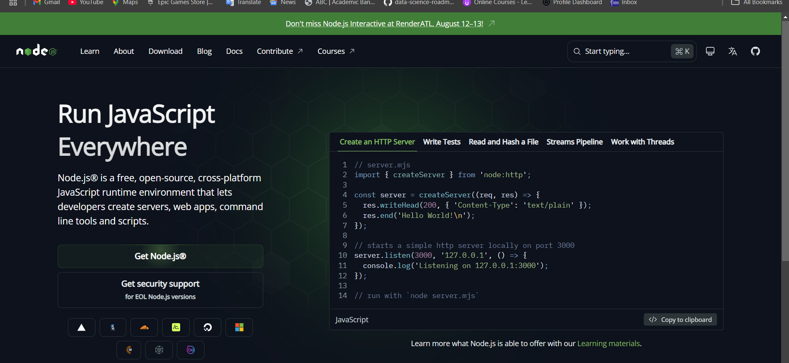
- Download the LTS version for Windows.
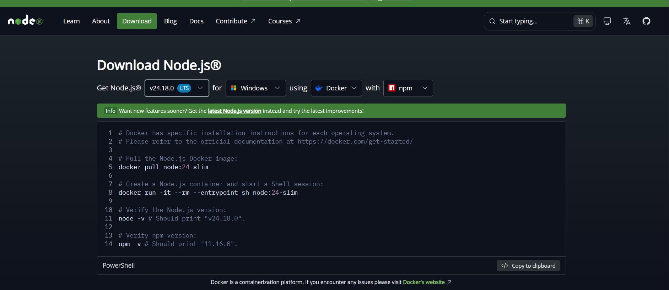

- Run the installer.
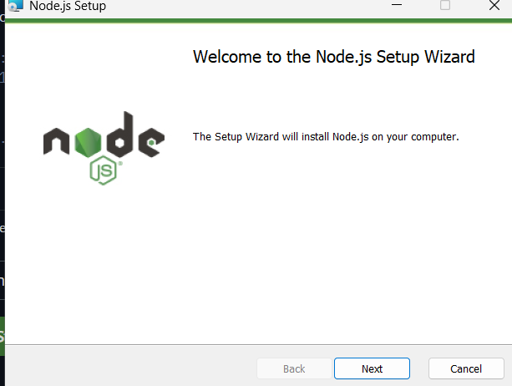

- Finish installation.

- 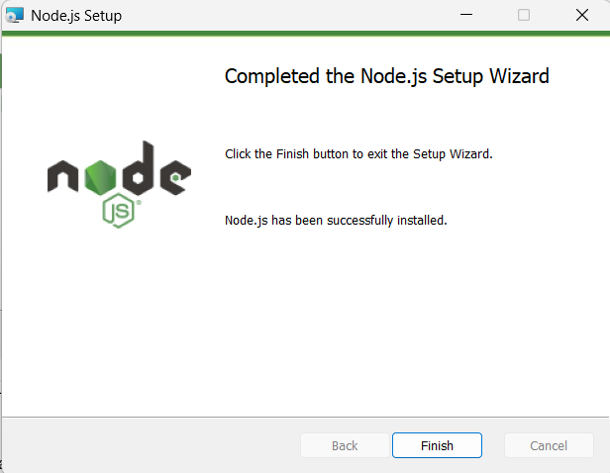

Step 2: Verify Node.js and npm
Open Command Prompt or Git Bash and run:
node -v
npm -v
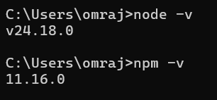
Step 3: Install Truffle
Open terminal and run:
npm install -g truffle
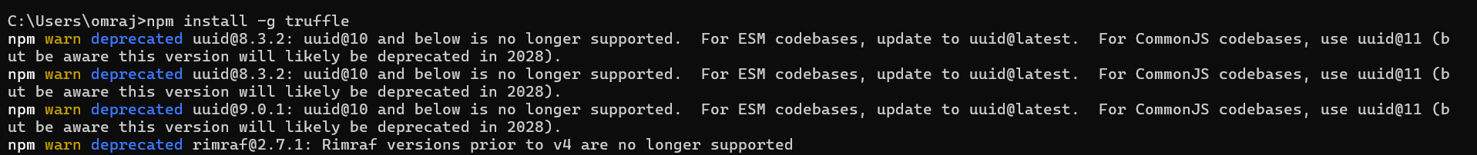
Verify:
truffle version
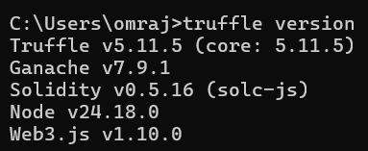

Step 4: Install Ganache
- Open the official Ganache page.
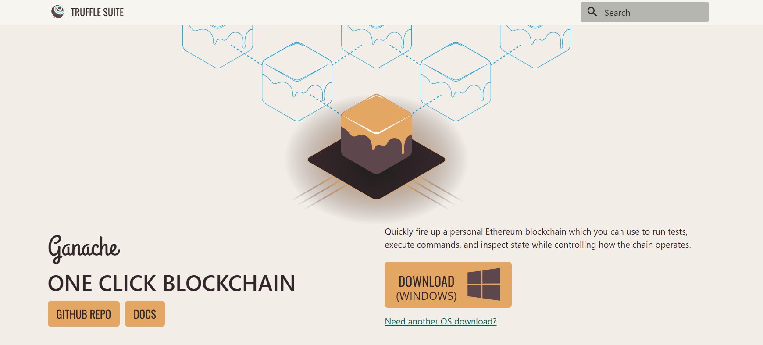
- Download the Windows installer.
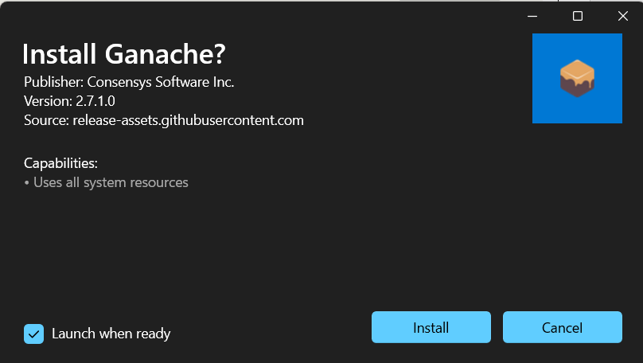
- Install Ganache.
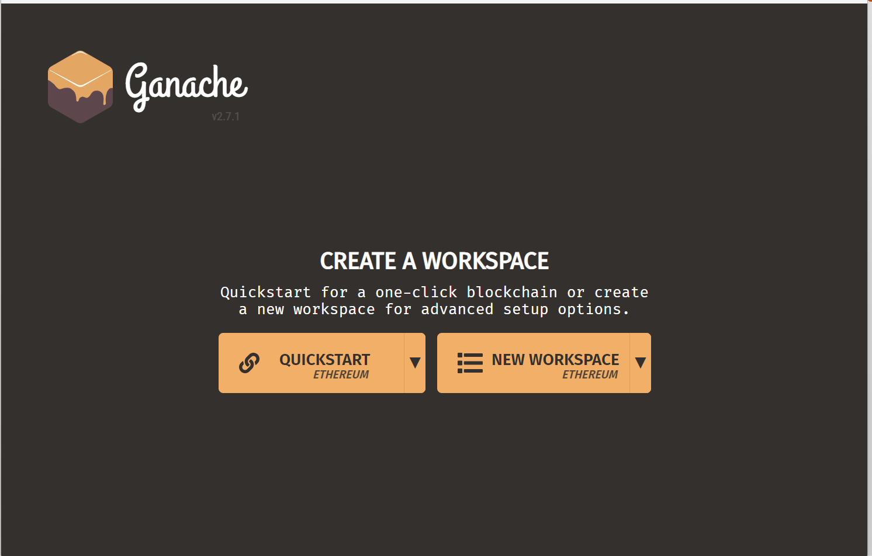
- Open it and select Quickstart Ethereum.
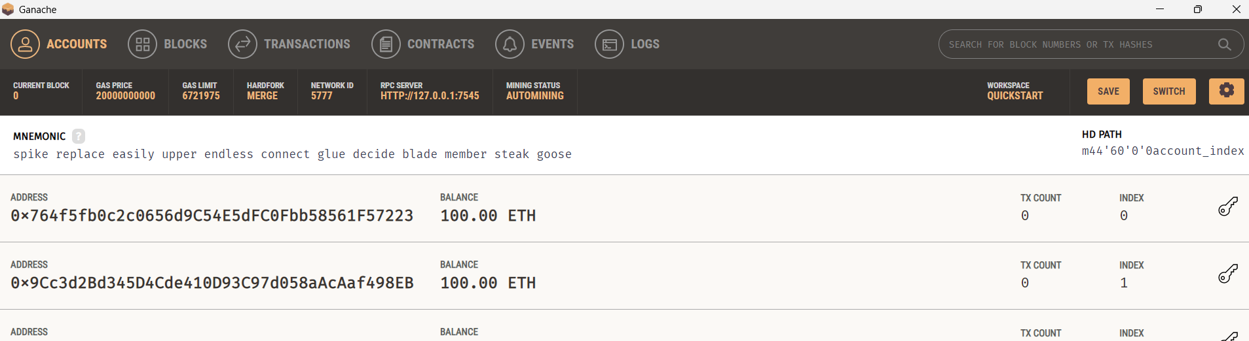

Step 5: Install MetaMask
- Open the MetaMask official download page.
- Install the browser extension.
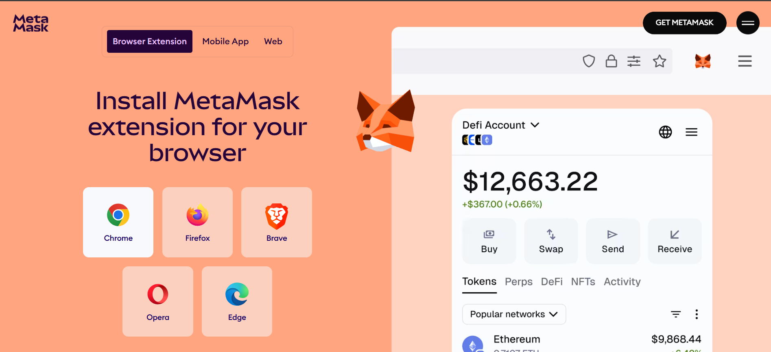
- Create a wallet.
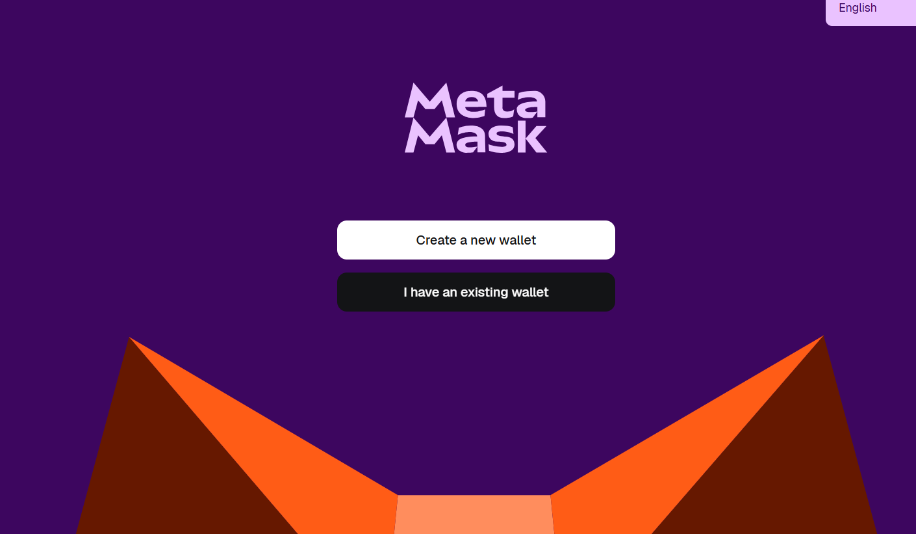
- Save the recovery phrase safely.
Step 6: Install VS Code
- Open the official VS Code download page.
- Install VS Code.
- Open Extensions and install a Solidity extension.
Step 7: Install Git Bash
Install Git for Windows so you can use a bash-style terminal for blockchain commands.

Configuration
Ganache Configuration
After launching Ganache Quickstart Ethereum, note:
- RPC URL, commonly http://127.0.0.1:7545
- test accounts
- private keys
- balances
Ganache’s official overview highlights its local blockchain, accounts, balances, and state inspection features.
MetaMask Configuration
- Open MetaMask.
- Add a custom network manually.
- Enter the Ganache RPC URL.
- Set the chain ID shown by Ganache.
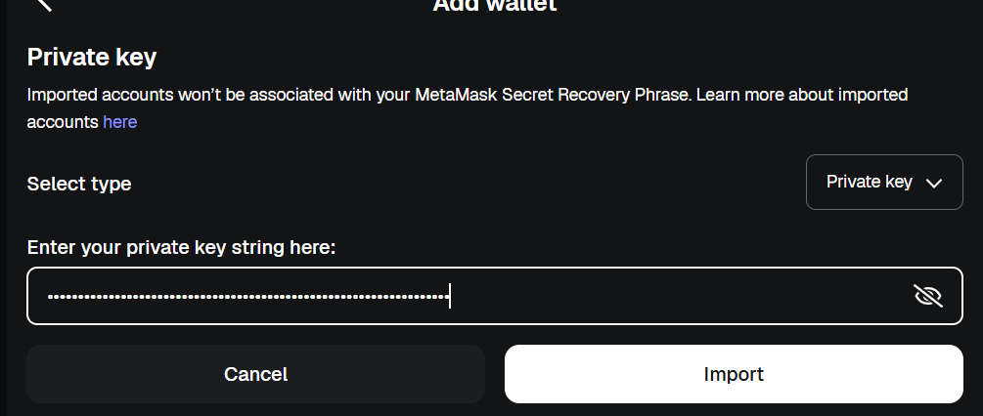
- Import one Ganache account using its private key.

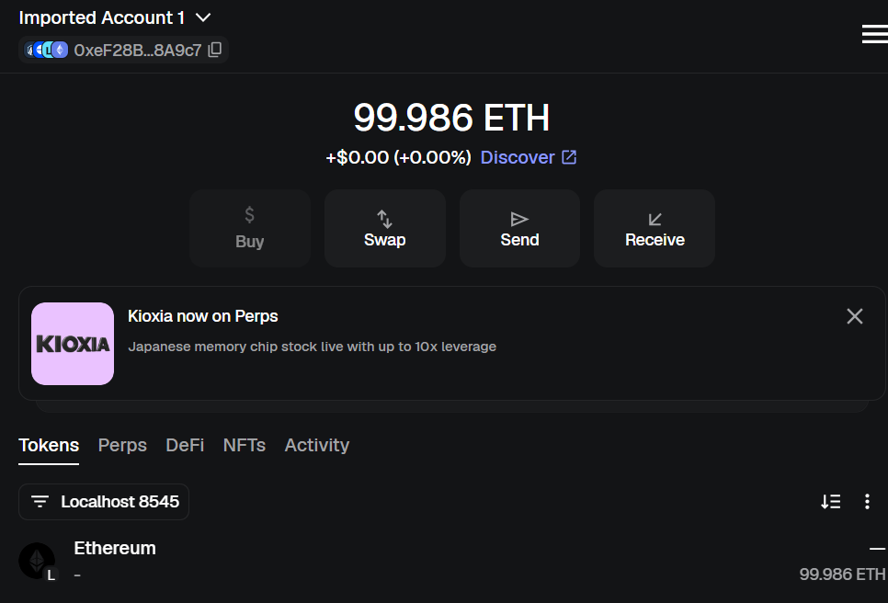

Practical 2
Aim : Writing and deploying basic smart contracts on Ethereum

Step 1: Open Ganache
Search:
Ganache
Open it.
Select:
Quickstart Ethereum
Keep Ganache running.
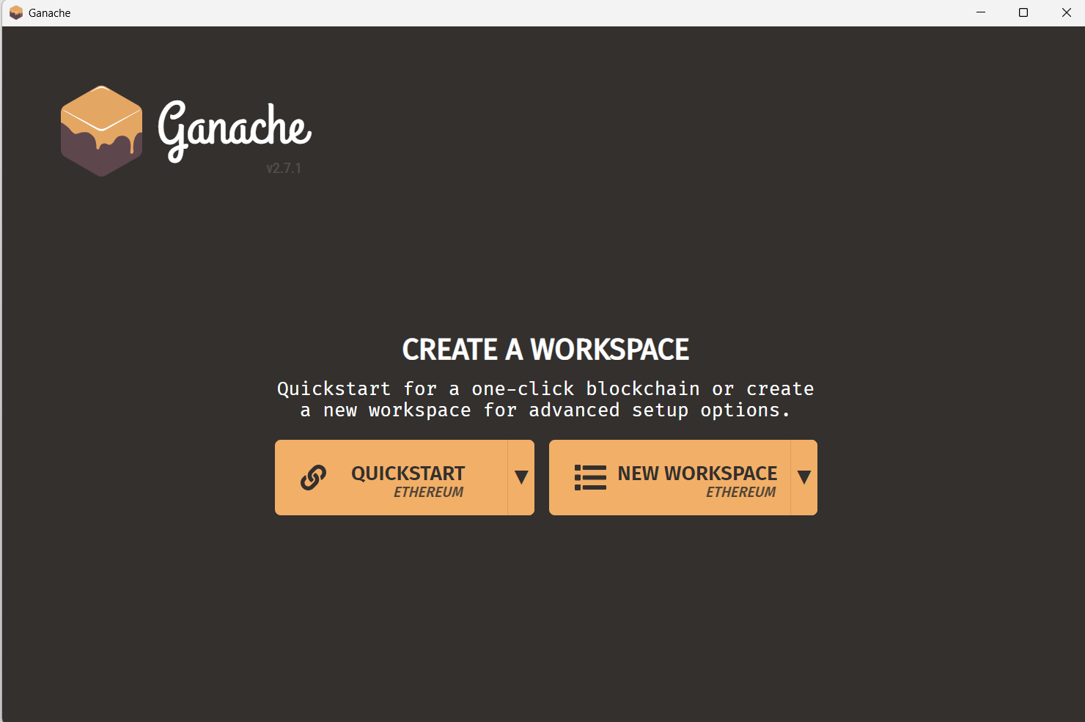

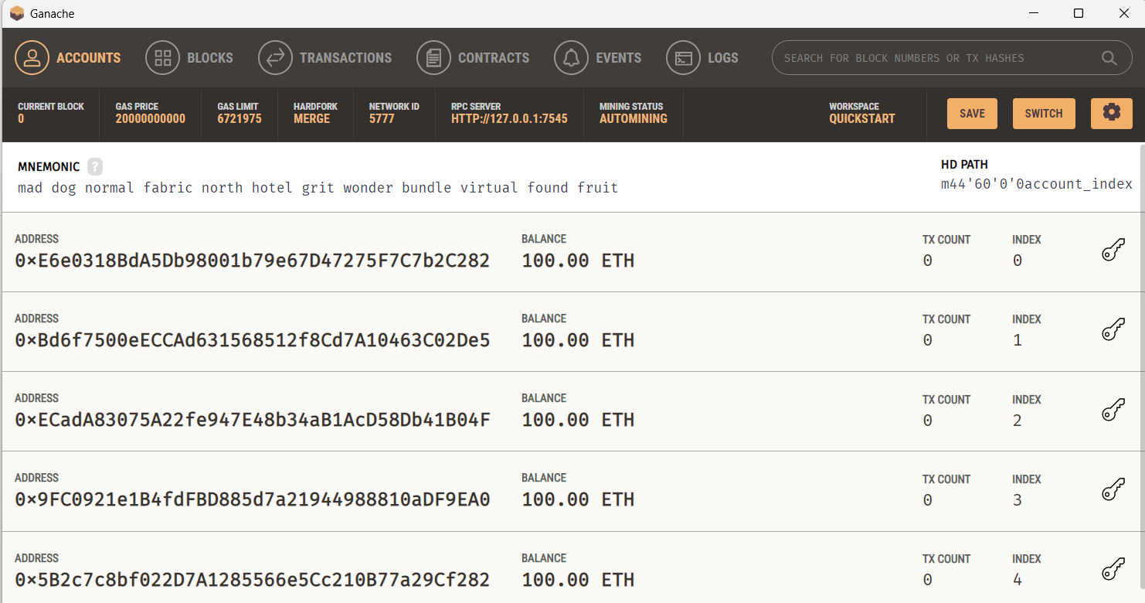

Step 2: Create Smart Contract
Inside contracts folder create:
HelloWorld.sol
Code:
// SPDX-License-Identifier: MIT
pragma solidity ^0.8.19;

contract HelloWorld {
string public message = "Hello Blockchain";
}
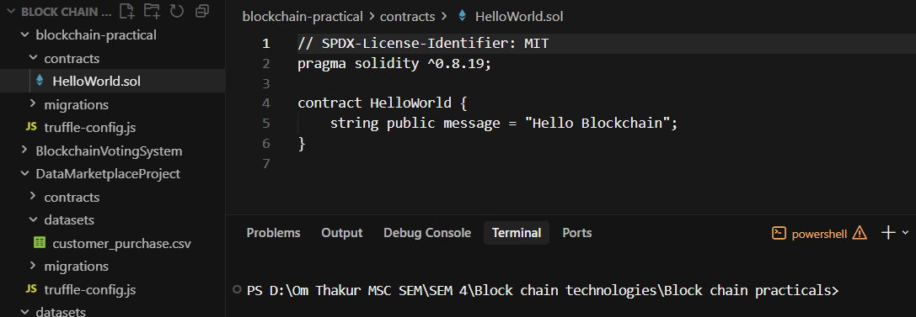

Step 3: Create Migration File
Inside migrations folder create:
2_deploy_contracts.js
Code:
const HelloWorld = artifacts.require("HelloWorld");
module.exports = function (deployer) {
deployer.deploy(HelloWorld);
};
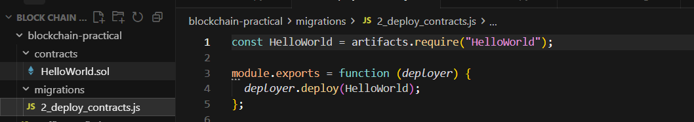
Step 4: Configure Truffle
Open:
truffle-config.js
Use:
module.exports = {
networks: {
development: {
host: "127.0.0.1",
port: 7545,
network_id: "*"
}
},
compilers: {
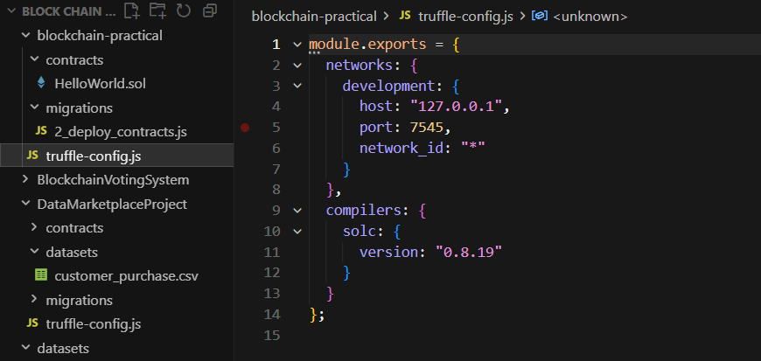
Step 8: Compile Contract
Run:
truffle compile
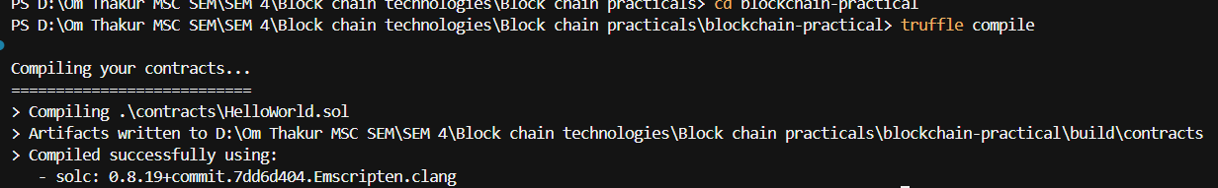

Step 9: Deploy Contract
Run:
truffle migrate
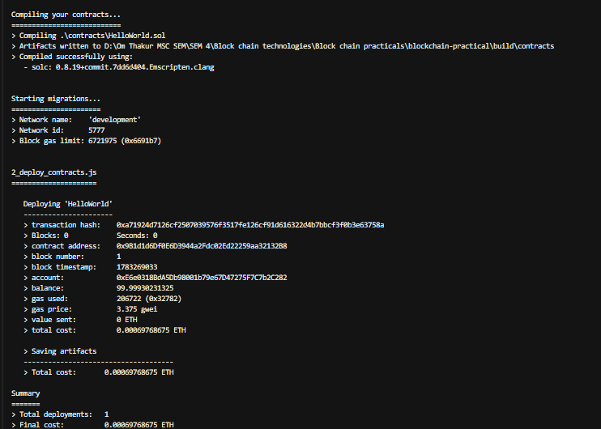

Step 10: Check Ganache
Open Ganache.
You will see:
New transaction
New block
Gas used
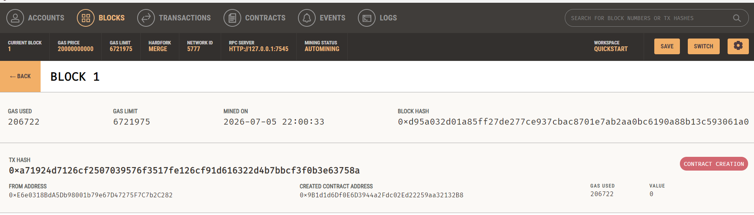

Step 11: Open Console
truffle console
Run:
msg.toString()
Output:
Hello Blockchain
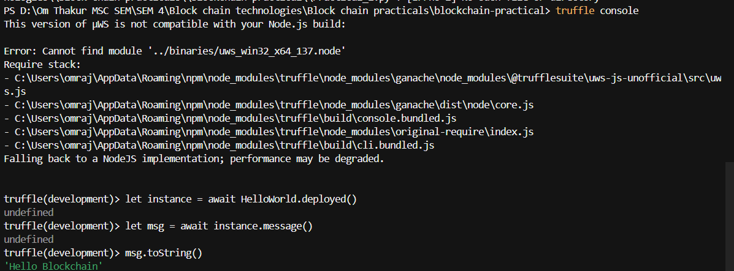

Practical 3
Aim : Configuring and Running a Hyperledger Fabric Network
Step 1: Install Required Software
Install the following tools:
- Docker
- Docker Compose
- Git
- cURL
- Hyperledger Fabric binaries
Check installation:
docker --version
git --version
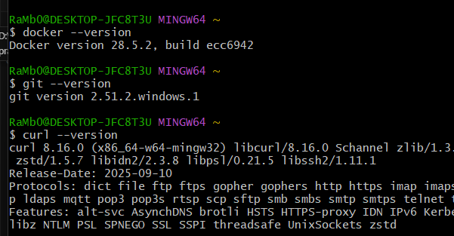
Step 2: Download Hyperledger Fabric
Open terminal and run:
curl -sSL https://bit.ly/2ysbOFE | bash -s
It downloads:
- Fabric binaries
- Docker images
- Fabric samples
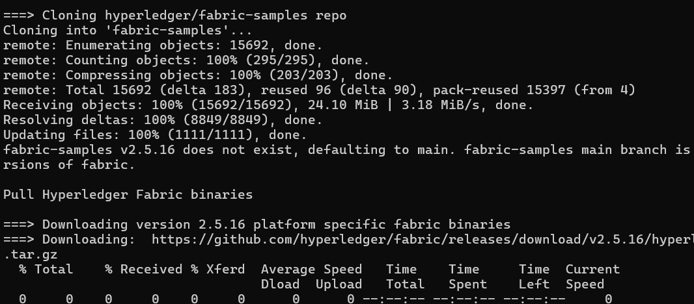
Step 3: Open Fabric Folder
Go to:
cd fabric-samples
Open test network:
cd test-network

Step 4: Start Fabric Network
Run command:
./network.sh up
This starts:
- Peer nodes
- Ordering service
- Certificate authorities
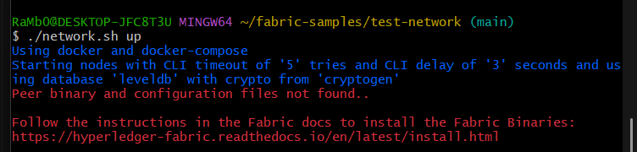

Step 5: Create Channel
Create blockchain channel:
./network.sh createChannel
Default channel:
mychannel
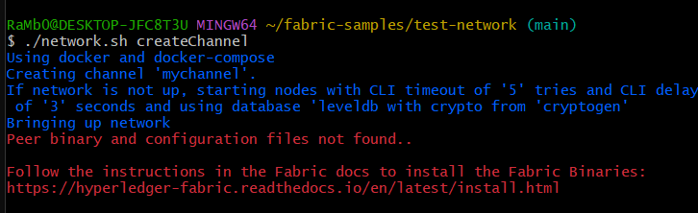
Step 6: Deploy Chaincode
Deploy smart contract:
./network.sh deployCC \
-ccn basic \
-ccp ../asset-transfer-basic/chaincode-go \
-ccl go
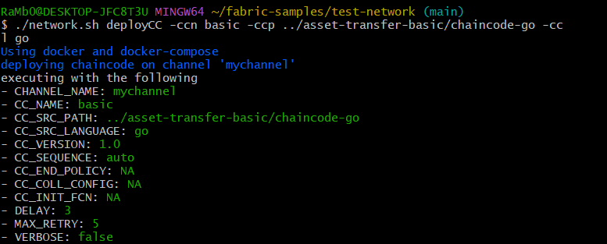

Step 7: Set Environment Variables
Configure Org1 peer:
export CORE_PEER_LOCALMSPID="Org1MSP"
export CORE_PEER_ADDRESS=localhost:7051
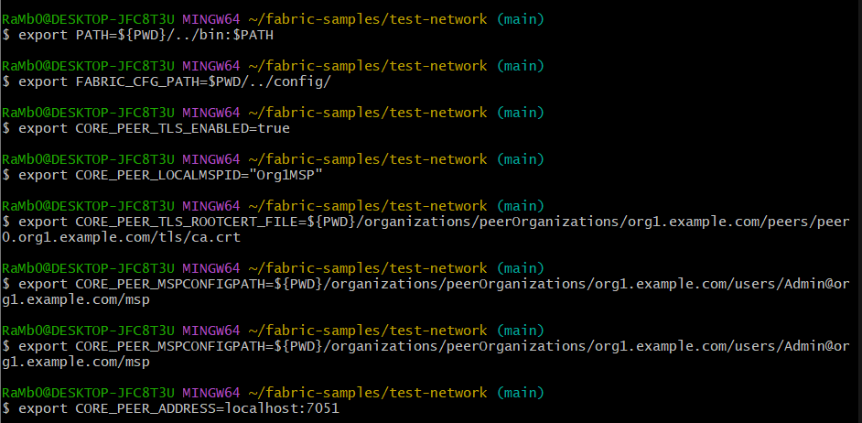

Step 8: Initialize Ledger
Run:
peer chaincode invoke \
-C mychannel \
-n basic \
-c '{"function":"InitLedger","Args":[]}'

Step 9: Query Blockchain Data
Run:
peer chaincode query \
-C mychannel \
-n basic \
-c '{"Args":["GetAllAssets"]}'

Output

Step 10: Add New Transaction
Create asset:
peer chaincode invoke \
-C mychannel \
-n basic \
-c '{"function":"CreateAsset","Args":["asset10","red","10","Om","500"]}'
Step 11: Verify Transaction
Query again:
peer chaincode query \
-C mychannel \
-n basic \
-c '{"Args":["ReadAsset","asset10"]}'
Output:

Step 12: Stop Network
Run:
./network.sh down
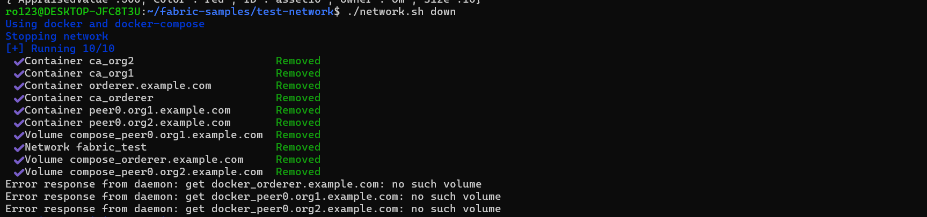

Practical 4
Aim : Storing and Retrieving Data using IPFS

Step 1: Install IPFS
Download and install IPFS Desktop.
Start IPFS application.
Check installation:
ipfs --version

Step 2: Initialize IPFS Node
Open terminal and run:
ipfs init
It creates:
- IPFS node identity
- Configuration files
- Local repository

Step 3: Start IPFS Node
Run:
ipfs daemon
Output:
Daemon is ready
IPFS node is now running.

Step 4: Create Data File
Create a file:
data.txt
Add sample data:
Blockchain data stored using IPFS

Step 5: Add File to IPFS
Run:
ipfs add data.txt
Expected Output:
added QmXyz123... data.txt
The generated value is called:
IPFS CID (Content Identifier)
Example:
QmXyz123abc

Step 6: Retrieve Data from IPFS
Use CID to access file:
ipfs cat QmXyz123abc
Output:
Blockchain data stored using IPFS

Step 7: Download File from IPFS
Run:
ipfs get QmXyz123abc
The file is downloaded from IPFS network.

Step 8: Check Stored Files
View stored objects:
ipfs refs local
It displays locally stored IPFS data hashes.

Step 9: Pin Important Data
Run:
ipfs pin add QmXyz123abc
Pinning prevents data removal.
Code Explanation
IPFS Add
Stores file into IPFS and generates unique CID.
CID
Acts as the address of the stored data.
IPFS Cat
Retrieves data using CID.
Hash Verification
If file data changes:
- CID changes
- Tampering is detected

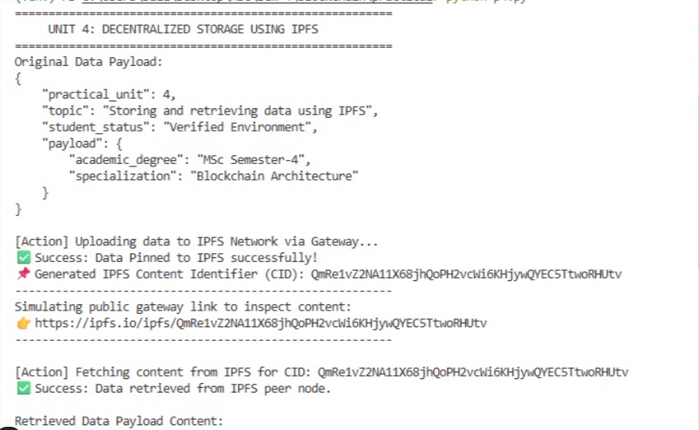

Practical 5
Aim : Using blockchain to ensure data integrity in ML models
Step 1 – Create Python File
Create:
blockchain_ml.py

Step 2 – Import Libraries
import pandas as pd
import hashlib
from sklearn.model_selection import train_test_split
from sklearn.linear_model import LogisticRegression
Step 3 – Load Dataset
df = pd.read_csv("dataset.csv")
print(df)
Step 4 – Generate Dataset Hash
dataset_string = df.to_string()
hash_value = hashlib.sha256(dataset_string.encode()).hexdigest()
print("Dataset Hash:")
print(hash_value)
Step 5 – Create Simple Blockchain
blockchain = []
block = {
"index": 1,
"data_hash": hash_value
}
blockchain.append(block)
print("\nBlockchain Block:")
print(blockchain)
Step 6 – Train ML Model
X = df[['Age', 'Salary']]
y = df['Purchased']
X_train, X_test, y_train, y_test = train_test_split(
X, y, test_size=0.2, random_state=42
)
model = LogisticRegression()
model.fit(X_train, y_train)
print("\nModel Trained Successfully")
Step 7 – Verify Dataset Integrity
new_dataset_string = df.to_string()
new_hash = hashlib.sha256(new_dataset_string.encode()).hexdigest()
print("\nVerification Hash:")
print(new_hash)
Step 8 – Compare Hashes
if hash_value == new_hash:
print("\nDataset Integrity Verified")
else:
print("\nWARNING! Dataset Tampered")
Output : 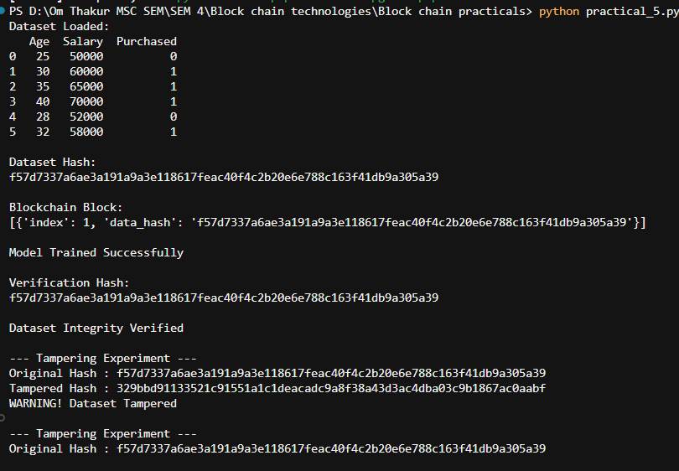

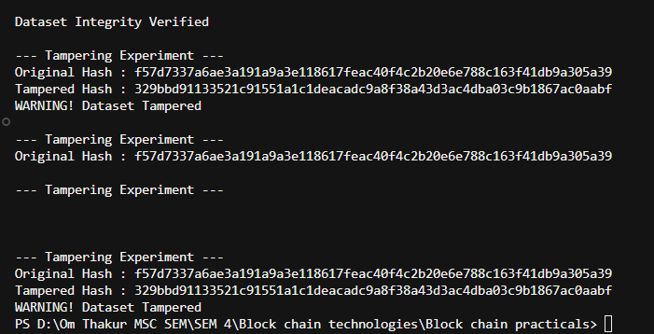

Practical 6
Aim : Implementing a blockchain-based data provenance system
Code :
import hashlib
import datetime

class Block:
def __init__(self, index, data, owner, previous_hash):
self.index = index
self.data = data
self.owner = owner
self.timestamp = str(datetime.datetime.now())
self.previous_hash = previous_hash
self.data_hash = self.generate_data_hash()
self.block_hash = self.generate_block_hash()

def generate_data_hash(self):
return hashlib.sha256(self.data.encode()).hexdigest()

def generate_block_hash(self):
block_content = (
str(self.index)
+ self.data
+ self.owner
+ self.timestamp
+ self.previous_hash
+ self.data_hash
)
return hashlib.sha256(block_content.encode()).hexdigest()

class Blockchain:
def __init__(self):
self.chain = []
self.create_genesis_block()

def create_genesis_block(self):
genesis_block = Block(
0,
"Genesis Block",
"System",
"0"
)
self.chain.append(genesis_block)

def add_block(self, data, owner):
previous_block = self.chain[-1]
new_block = Block(
len(self.chain),
data,
owner,
previous_block.block_hash
)
self.chain.append(new_block)

def display_chain(self):
for block in self.chain:
print("\n--------------------------------")
print("Block Number:", block.index)
print("Data:", block.data)
print("Owner:", block.owner)
print("Timestamp:", block.timestamp)
print("Data Hash:", block.data_hash)
print("Previous Hash:", block.previous_hash)
print("Block Hash:", block.block_hash)

def verify_chain(self):
for i in range(1, len(self.chain)):
current = self.chain[i]
previous = self.chain[i - 1]
if current.previous_hash != previous.block_hash:
return False
if current.data_hash != current.generate_data_hash():
return False
return True

provenance_chain = Blockchain()

provenance_chain.add_block(
"Patient Record: Name=Riya, Disease=Fever, Medicine=Paracetamol",
"Dr. Sharma"
)

provenance_chain.add_block(
"Patient Record Updated: Disease=Viral Fever, Medicine=Paracetamol",
"Dr. Mehta"
)

provenance_chain.add_block(
"Record Shared with Insurance Department",
"Hospital Admin"
)

provenance_chain.display_chain()

provenance_chain.chain[1].data = "Patient Record: Name=Riya, Disease=Covid, Medicine=Antiviral"

if provenance_chain.verify_chain():
print("\nBlockchain Provenance Verified Successfully")
else:
print("\nWarning! Data Provenance Chain Tampered")

Output :
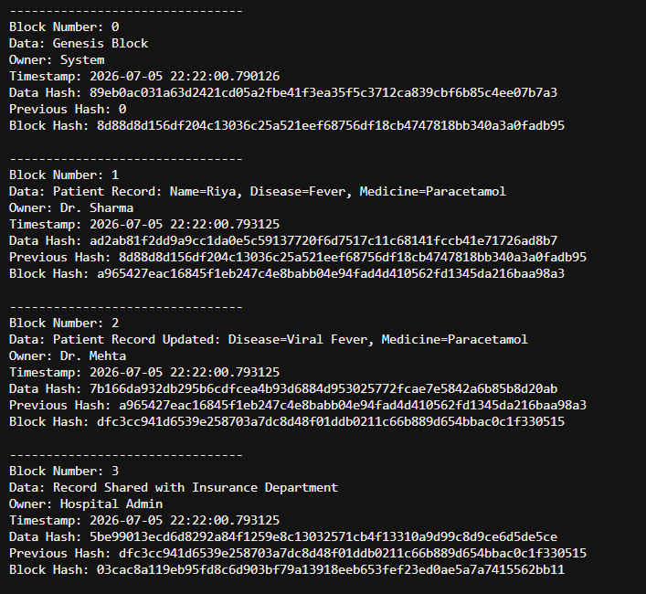
Practical 7
Aim : Developing a decentralized marketplace for data exchange
Step 1: Open Ganache
- Search Ganache in Start Menu.
- Open Ganache.
- Click Quickstart Ethereum.
- Keep Ganache running.
Note these details:
RPC Server: HTTP://127.0.0.1:7545
Network ID: 5777 or 1337
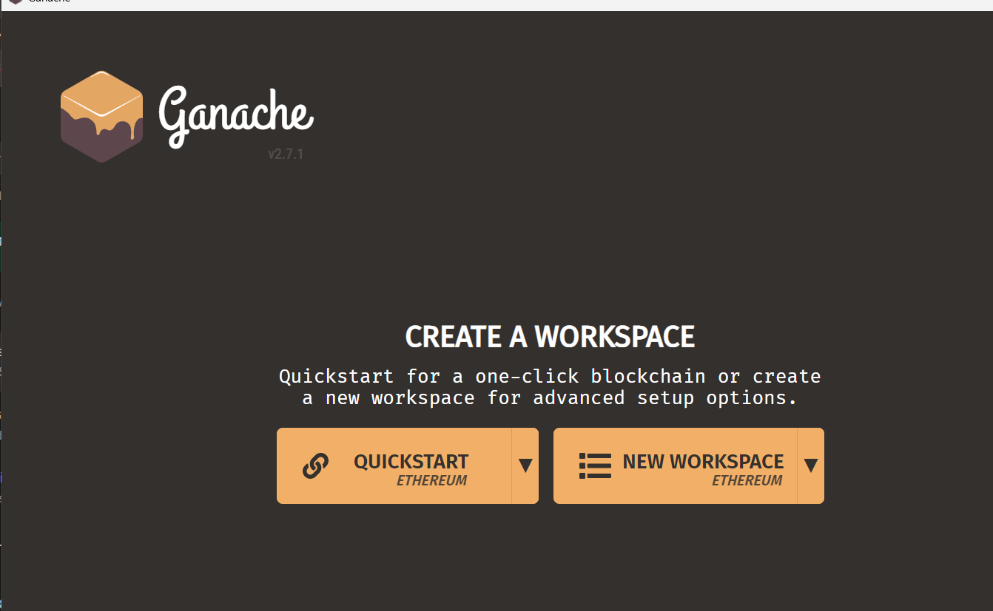

Step 2: Create Project Folder
Open VS Code.
Go to:
File → Open Folder
Create/open folder:
DataMarketplaceProject
Open terminal in VS Code:
Terminal → New Terminal
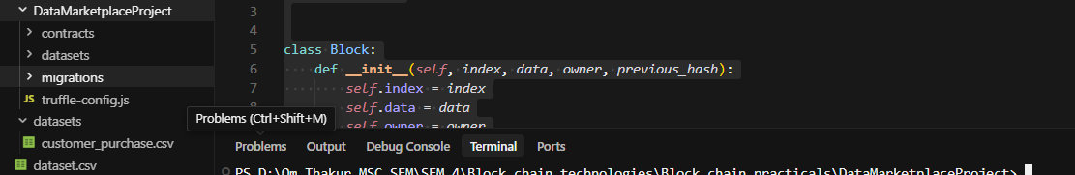

Step 3: Initialize Truffle Project
In VS Code terminal, run:
truffle init
If PowerShell gives error, use:
truffle.cmd init
After this, you should get:
contracts/
migrations/
test/
truffle-config.js
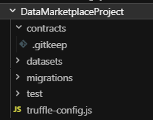

Step 4: Create Smart Contract File
Inside contracts folder, create:
DataMarketplace.sol
Paste this code:
// SPDX-License-Identifier: MIT
pragma solidity ^0.8.19;
contract DataMarketplace {
struct Dataset {
uint id;
string name;
string description;
uint price;
address payable owner;
bool isAvailable;
}
uint public datasetCount = 0;
mapping(uint => Dataset) public datasets;
mapping(uint => mapping(address => bool)) public accessGranted;
event DatasetListed(
uint id,
string name,
uint price,
address owner
);
event DatasetPurchased(
uint id,
address buyer,
address owner,
uint price
);
function listDataset(
string memory _name,
string memory _description,
uint _price
) public {
require(_price > 0, "Price must be greater than zero");
datasetCount++;
datasets[datasetCount] = Dataset(
datasetCount,
_name,
_description,
_price,
payable(msg.sender),
true
);
emit DatasetListed(
datasetCount,
_name,
_price,
msg.sender
);
}
function purchaseDataset(uint _id) public payable {
Dataset storage dataset = datasets[_id];
require(dataset.id > 0, "Dataset does not exist");
require(dataset.isAvailable == true, "Dataset is not available");
require(msg.value >= dataset.price, "Insufficient payment");
require(msg.sender != dataset.owner, "Owner cannot buy own dataset");
dataset.owner.transfer(msg.value);
accessGranted[_id][msg.sender] = true;
emit DatasetPurchased(
_id,
msg.sender,
dataset.owner,
msg.value
);
}
function checkAccess(uint _id, address _user) public view returns (bool) {
return accessGranted[_id][_user];
}
}

Step 5: Configure truffle-config.js
Open:
truffle-config.js
Replace content with:
module.exports = {
networks: {
development: {
host: "127.0.0.1",
port: 7545,
network_id: "*"
}
},
compilers: {
solc: {
version: "0.8.19"
}
}
};
This connects Truffle with Ganache.

Step 6: Create Migration File
Inside migrations folder, create:
2_deploy_datamarketplace.js
Paste:
const DataMarketplace = artifacts.require("DataMarketplace");
module.exports = function (deployer) {
deployer.deploy(DataMarketplace);
};

Step 7: Compile Smart Contract
In VS Code terminal, run:
truffle compile
If needed:
truffle.cmd compile
Expected output:
Compiling your contracts...
Compiled successfully
If old build creates issue, run:
truffle compile --all

Step 8: Deploy Contract to Ganache
Make sure Ganache is open.
Run:
truffle migrate
or:
truffle.cmd migrate
If you already deployed earlier, use:
truffle migrate --reset
Expected output:
Deploying 'DataMarketplace'
contract address: 0x....
Migration successful
Now check Ganache. You should see a new transaction.

Step 9: Open Truffle Console
Run:
truffle console
or:
truffle.cmd console
You should see:
truffle(development)>

Step 10: Get Contract Instance
Inside Truffle console, run:
let marketplace = await DataMarketplace.deployed()
If variable already declared, use:
marketplace = await DataMarketplace.deployed()
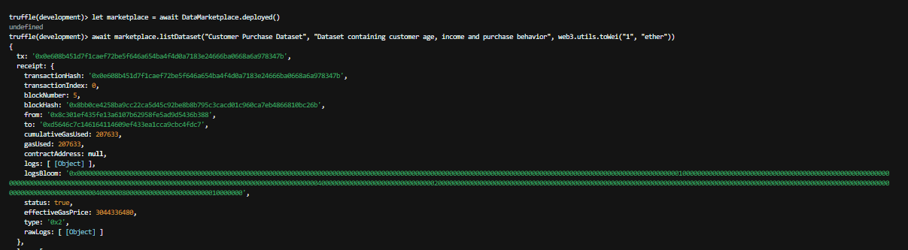

Step 11: List Dataset as Seller
Run:
await marketplace.listDataset(
"Customer Purchase Dataset",
"Dataset containing customer age, income and purchase behavior",
web3.utils.toWei("1", "ether")
)
This lists a dataset with price 1 ETH.
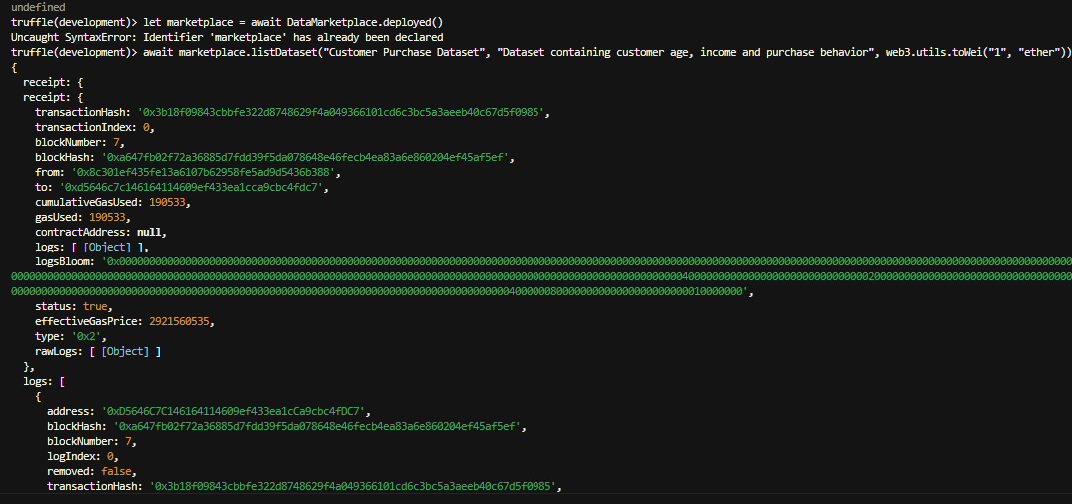

Step 12: Check Dataset Details
Run:
let data = await marketplace.datasets(1)
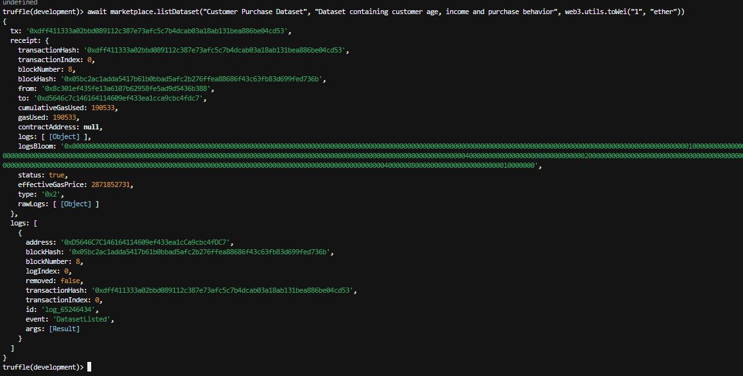

Step 13: Get Ganache Accounts
Run:
let accounts = await web3.eth.getAccounts()
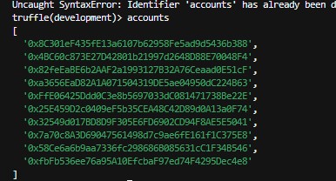

Step 14: Purchase Dataset as Buyer
Run:
await marketplace.purchaseDataset(1, {
from: accounts[1],
value: web3.utils.toWei("1", "ether")
})
This means buyer pays 1 ETH to purchase dataset access.
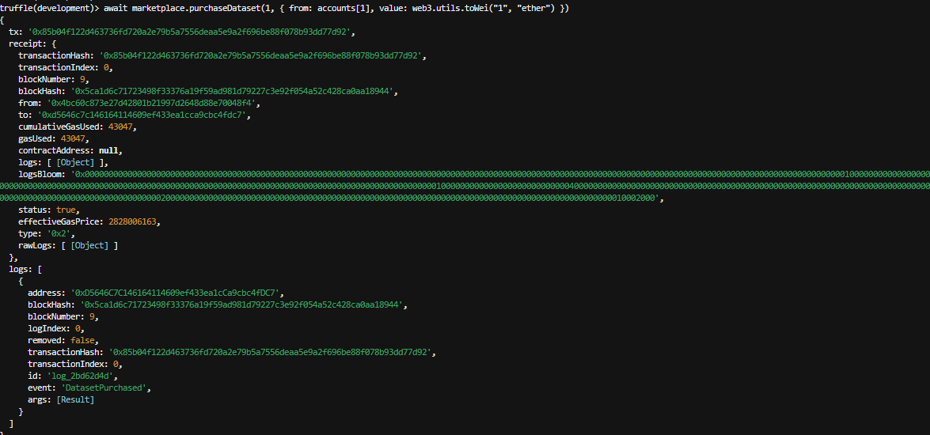

Step 15: Check Access Permission
Run:
let access = await marketplace.checkAccess(1, accounts[1])
access

Step 16 : Check Ganache
In Ganache, check:
Transactions
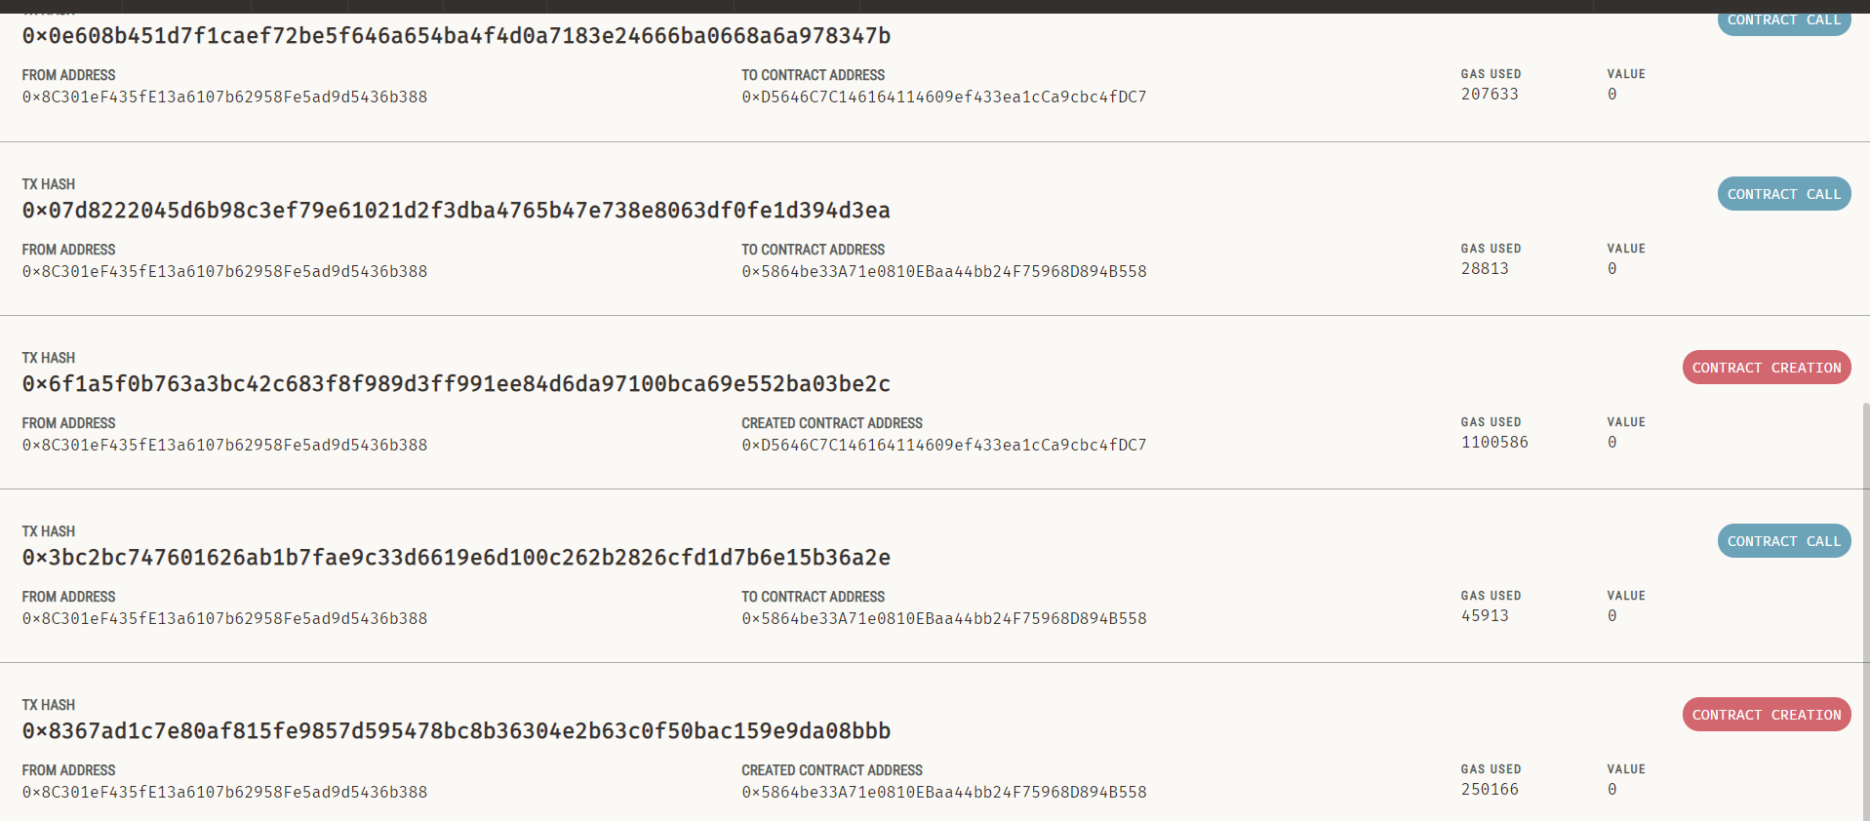

Practical 8
Aim : Writing and deploying chaincode on Hyperledger Fabric

Step 1: Open Ganache
Open Ganache → Quickstart Ethereum
Note RPC Server: http://127.0.0.1:7545
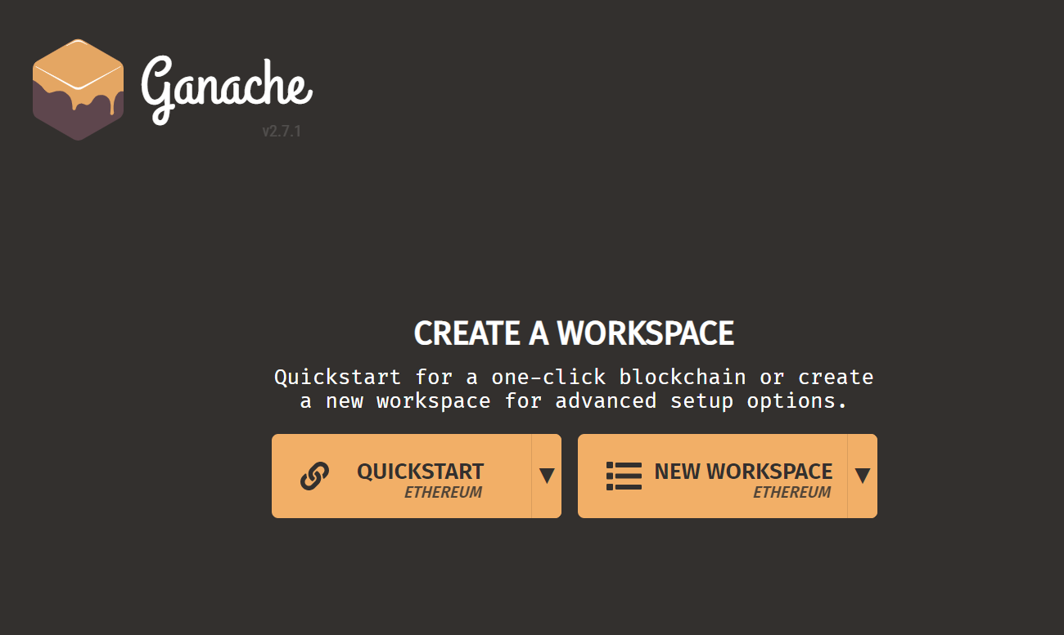
Step 2: Create Truffle Project
- Create folder DataMarketplaceProject
- Open VS Code terminal and run: truffle init

Step 3: Add Dataset
- Create folder:
datasets/customer_purchase.csv
- Add customer purchase dataset.
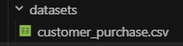

Step 4: Create Smart Contract
- Create file:
contracts/DataMarketplace.sol
- Write Solidity contract containing:
  - Dataset structure
  - List dataset function
  - Purchase dataset function
  - Access verification function
Code : // SPDX-License-Identifier: MIT
pragma solidity ^0.8.19;

contract DataMarketplace {
struct Dataset {
uint id;
string name;
string description;
uint price;
address payable owner;
bool isAvailable;
}

uint public datasetCount = 0;
mapping(uint => Dataset) public datasets;
mapping(uint => mapping(address => bool)) public accessGranted;

event DatasetListed(
uint id,
string name,
uint price,
address owner
);

event DatasetPurchased(
uint id,
address buyer,
address owner,
uint price
);

function listDataset(
string memory _name,
string memory _description,
uint _price
) public {
require(_price > 0, "Price must be greater than zero");

datasetCount++;
datasets[datasetCount] = Dataset(
datasetCount,
_name,
_description,
_price,
payable(msg.sender),
true
);

emit DatasetListed(
datasetCount,
_name,
_price,
msg.sender
);
}

function purchaseDataset(uint _id) public payable {
Dataset storage dataset = datasets[_id];
require(dataset.id > 0, "Dataset does not exist");
require(dataset.isAvailable == true, "Dataset is not available");
require(msg.value >= dataset.price, "Insufficient payment");
require(msg.sender != dataset.owner, "Owner cannot buy own dataset");

dataset.owner.transfer(msg.value);
accessGranted[_id][msg.sender] = true;

emit DatasetPurchased(
_id,
msg.sender,
dataset.owner,
msg.value
);
}

function checkAccess(uint _id, address _user) public view returns (bool) {
return accessGranted[_id][_user];
}
}

Step 5: Configure Truffle
Edit truffle-config.js:
- Host: 127.0.0.1
- Port: 7545
- Solidity version: 0.8.19
Step 6: Create Migration File
Create:
migrations/2_deploy_datamarketplace.js
Add deployment code for DataMarketplace contract.
Step 7: Compile Smart Contract
truffle compile
Output:
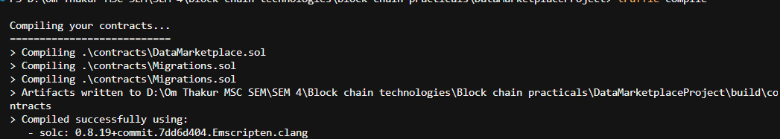
Step 8: Deploy Contract
truffle migrate --reset
Output:
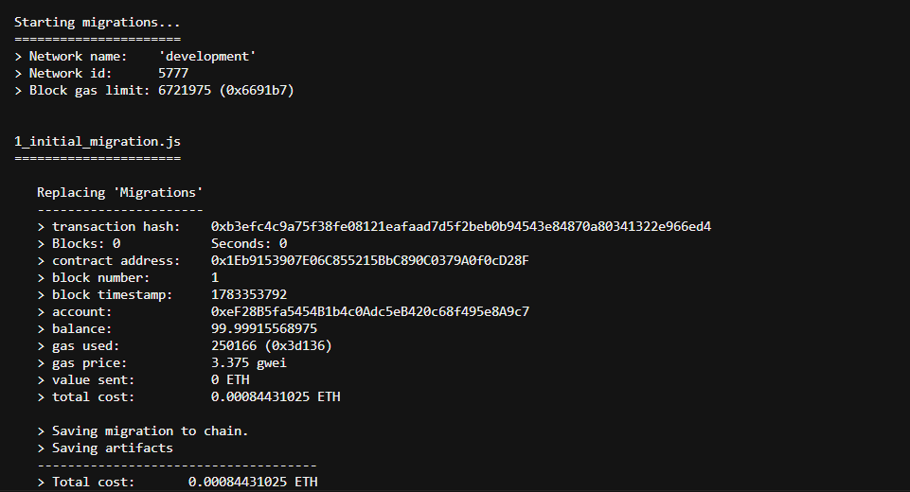

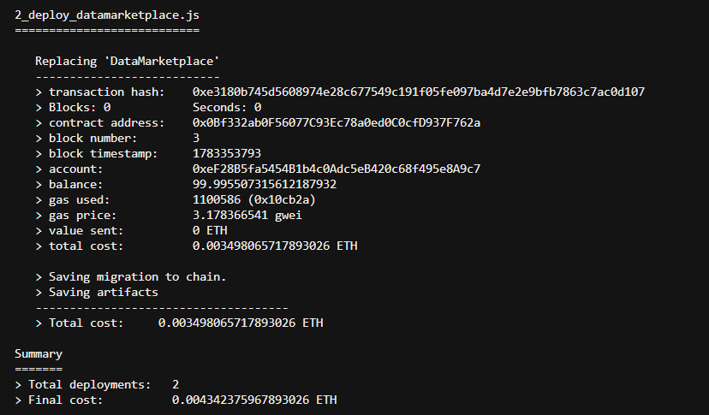
Step 9: Open Truffle Console
truffle console
Get contract instance:
marketplace = await DataMarketplace.deployed()
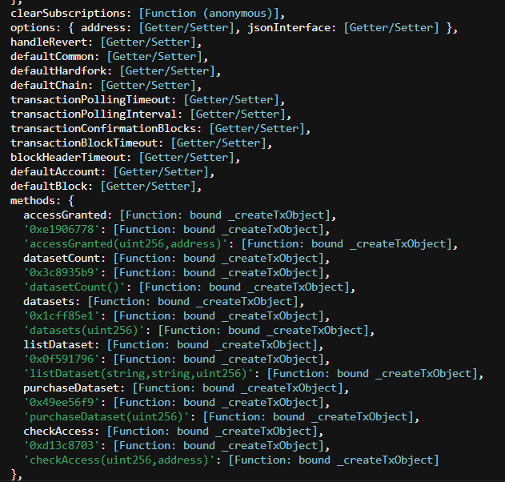
Step 10: List Dataset
Call listDataset() with:
- Dataset name
- Description
- Price (1 Ether)
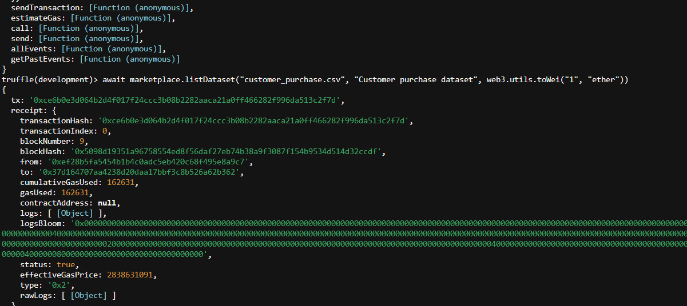
Step 11: Verify Dataset
Run:
marketplace.datasets(1)
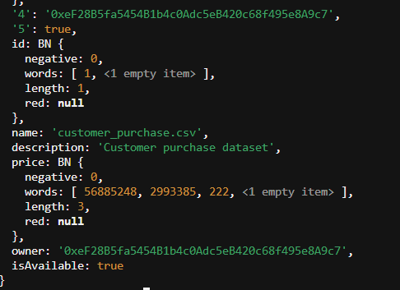

Step 12: Purchase Dataset
Get Ganache accounts:
web3.eth.getAccounts()
Use buyer account to call purchaseDataset() and pay 1 Ether.
Step 13: Check Access
Run:
checkAccess()
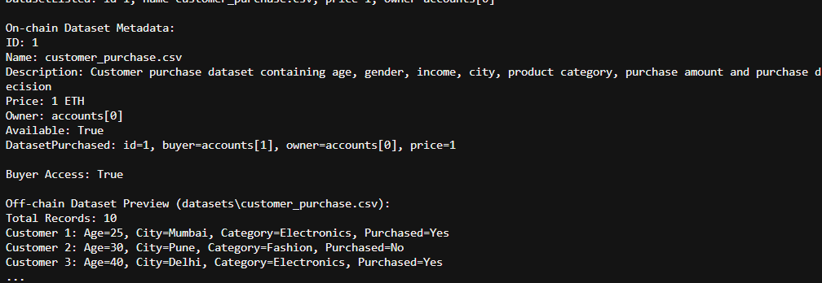

Practical 9
Aim : Implementing a secure voting system using blockchain
Step 1: Start Ganache
- Open Ganache → Quickstart Ethereum
- Keep Ganache running
Details:
- RPC Server: http://127.0.0.1:7545
- Network ID: 5777
Step 2: Create Truffle Project
- Create folder:
BlockchainVotingSystem
Open VS Code terminal and run:
truffle init
It creates:
- contracts
- migrations
- test
- truffle-config.js
Step 3: Configure Truffle
Open truffle-config.js
Set:
- Host: 127.0.0.1
- Port: 7545
- Solidity version: 0.8.19
Step 4: Create Smart Contract
Create file:
contracts/VotingSystem.sol
Add Solidity contract containing:
- Candidate structure
- Candidate storage
- Voter tracking
- Voting function
- Duplicate vote prevention
Smart Contract Functions:
- Candidate Structure
Stores:
- Candidate ID
- Candidate name
- Vote count
- Voter Mapping
Stores voter address and prevents duplicate voting.
- Constructor
Automatically creates:
- Alice
- Bob
- Vote Function
Allows users to vote for candidates.
Duplicate vote check:
require(!voters[msg.sender])
prevents users from voting twice.
Step 5: Create Migration File
Create:
migrations/2_deploy_voting.js
Step 6: Compile Contract
Run:
truffle compile
Output:
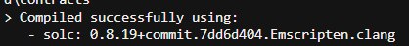

Step 7: Deploy Contract
Run:
truffle migrate --reset
Output:
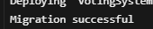
Step 8: Open Console
Run:
truffle console
Get contract instance:
voting = await VotingSystem.deployed()
Step 9: Check Candidates
Run:
voting.candidates(1)
Output:
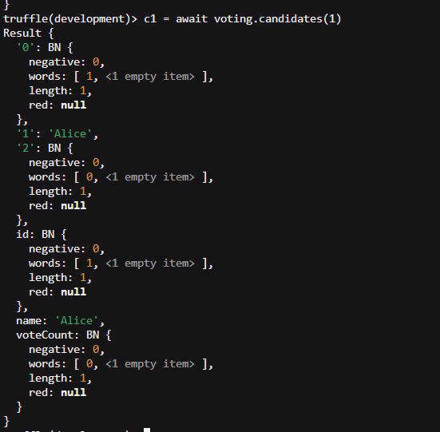

Run:
voting.candidates(2)
Output:
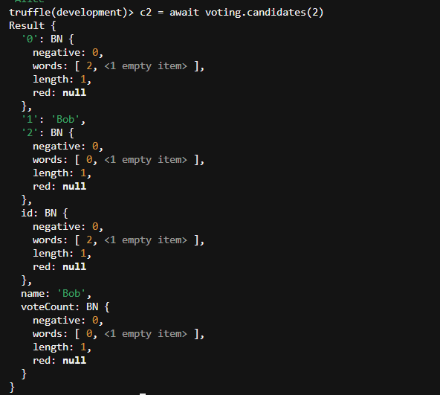
Step 10: Get Accounts
Run:
accounts = await web3.eth.getAccounts()
Step 11: Cast Votes
Vote Alice:
await voting.vote(1,{from:accounts[1]})
Vote Bob:
await voting.vote(2,{from:accounts[2]})
Step 12: Verify Vote Count
Check Alice:
result1 = await voting.candidates(1)
result1.voteCount.toString()

Check Bob:
result2 = await voting.candidates(2)
result2.voteCount.toString()
Step 13: Test Duplicate Voting
Run same vote again:
await voting.vote(1,{from:accounts[1]})
Expected Error:
You have already voted
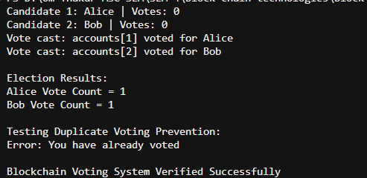

Practical 10
Aim : Combining blockchain with IoT for secure data management

Step 1: Create Project
Open VS Code and create folder:
IoTBlockchain
Create Python file:
iot_blockchain.py

Step 2: Import Libraries
Import required libraries:
- hashlib → Generate SHA-256 hash
- datetime → Store timestamp
- random → Generate IoT sensor values

Step 3: Create Block Class
Create Block class containing:
- Block number
- Sensor data
- Timestamp
- Previous hash
- Current hash
generate_hash() function creates a SHA-256 hash for every block.

Purpose of Hash:
If IoT data changes, the hash value changes and tampering can be detected.

Step 4: Create Blockchain Class
Create Blockchain class with:
- Blockchain list
- Genesis block
- Add block function
Genesis block is the first block of the blockchain.
add_block() stores new IoT sensor data and connects it with the previous block hash.

Step 5: Display Blockchain
Create display_chain() function.
It displays:
- Block number
- IoT sensor data
- Timestamp
- Previous hash
- Current hash

Step 6: Verify Blockchain
Create verify_chain() function.
It checks:
- Previous hash connection
- Current block hash
If hash values change, tampering is detected.

Step 7: Create IoT Blockchain
Create blockchain object:
iot_chain = Blockchain()

Step 8: Generate IoT Sensor Data
Generate random:
- Temperature values
- Humidity values
Example:
Temperature=32°C, Humidity=68%
Add data into blockchain blocks.

Step 9: Run Program
Execute:
python iot_blockchain.py

Output :

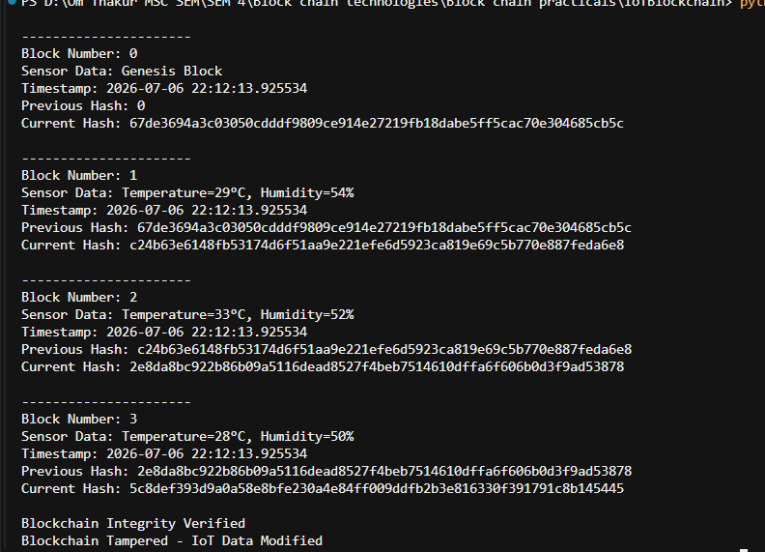

Tampering Test
Modify sensor data:
iot_chain.chain[1].sensor_data = "Temperature=100°C"
Output :

