TABLE OF CONTENTS
- Abstract
- Summary
- Introduction
3.1 Nexus Automobile’s Strategic Vision
3.2 Long-term Engineering Objectives Evolution
- Literature Review
4.1 The Implications of Industry 4.0 and Automation for Engineering
4.2 Data-Driven Enhancement and AI-Powered Engineering Optimisation
4.3 Significance of Agile R&D and Product Development in the Automotive Sector
4.4 Eco-Friendly Design and Sustainability in Vehicle Engineering
4.5 Technical Strategy, R&D, and Performance Measurement Frameworks
4.6 Gaps and Relevance of Simulation for Engineering Executives
4.7 Open Innovation and Circular Economy in Automotive Engineering
4.8 Technical Analysis of Digital Manufacturing Transformation
4.9 Industry 4.0–Compliant Automatic Production Lines
- Methodology
5.1 Research Design
5.2 Data Sources and Collection
5.3 Analytical Framework
5.4 Evaluation Criteria
5.5 Limitations Related to Virtual Simulation
5.6 Ethical Considerations
- Business Game / Simulation Analysis
6.1 Overview of Nexus Simulation Journey
6.2 Round-by-Round Analysis
• Rounds 1–3: Foundation and Early Productivity Gains
• Rounds 4–5: Strategic Innovation and Diversification Planning
• Rounds 6–7: Diversification Execution and Consolidation
• Rounds 8–9: Peak Productivity and Market Expansion
• Round 10: Long-Term Sustainability and Leadership
6.3 Technical and Engineering Performance Trends
6.4 Market Share and Portfolio Expansion
6.5 Engineering Contribution to Financial Growth
- Findings and Discussion
7.1 Key Technical and Engineering Findings
7.2 Engineering Insights from Simulation Performance
7.3 Literature Significance and Framework Links
7.4 Role of the Technical and Engineering Executive
7.5 Challenges Faced During the Simulation
7.6 Adjustments to Optimize Financial Results
7.7 Benchmarking
- Recommendations and Reflection
8.1 Recommendations for Future Strategies
8.1.1 Diversification of the Product Portfolio
8.1.2 Enhancement of R&D Focus and Efficiency
8.1.3 Optimization of Production and Labor Costs
8.1.4 Strategic Pricing and Market Positioning
8.1.5 Marketing and Customer Engagement Enhancement
8.2 Proposed Improvements to the Simulation
8.3 Key Learnings and Skill Development
8.3.1 Financial Knowledge and Risk Management
8.3.2 Data-Driven Decision-Making
- Conclusion
- References
- Figures
Figure 1: Overall Performance Metrics
Figure 2: Efficiency Metrics
Figure 3: Market Performance
Figure 4: Technological Impact on Finances
Figure 5: Competitive Benchmarking

1. Abstract
This report examines how Nexus Automobile performed over ten rounds of a business simulation. The report demonstrates how effective engineering leadership enabled productivity, diversity, automation, and sustainability. With simulation data and industry information, research describes how Nexus evolved from producing two car models to being a dominant contender producing five different car models, such as a luxury car and an electric car. Nexus has been prudent in investments in automation, research and development, and green practices. These initiatives enhanced their productivity index from 1.00 to 1.92 and lifted their profits by 2,164%. This facilitated the company's position as a market leader. The outcomes demonstrate how necessary it is to integrate Industry 4.0, AI-driven enhancements, flexible R&D, and circular economy concepts in engineering strategies. The simulation verifies that effective technical leadership is essential in matching innovation, cost reduction, and sustainability for ultimate success in the automotive sector.
2. Summary
The automotive sector is rapidly evolving due to global competition, electrification, Industry 4.0, and sustainability laws. This study analyzes Nexus Automobile's engineering and strategy decisions during a ten-round simulation and how they affected productivity, market diversification, and financial outcomes.
Nexus began by focusing on keeping operations stable. Steadily, it had grown to cater to five unique vehicles. The company spent over £1,015 million in automation as well as profound research and development. This boosted design quality, reduced warranty expense, and successfully launched the Ionex electric automobile. Nexus embraced agile software development methods, smart factory principles, and sustainable engineering to stay aligned with global market patterns.
Nexus's financial performance was exponential, with post-tax earnings exceeding £6.3 billion by Round 10 and share prices rising to £8,863.72. Despite overall productivity lagging behind People Motors, Nexus's edge in profitability per employee was noticeable when compared to competitors.
According to this paper, engineering executives must consciously include automation, substantial research and development, and sustainable practices. Increased efforts in the fields of hybrid and autonomous electric vehicles, improved focus on research and development, the use of predictive technology to reduce labour costs, and promotion of sustainability-focused marketing are among its recommendations. The simulation highlights the importance of engineering leadership in operational excellence and long-term strategic advantage maintenance.

3. Introduction
The automotive sector is on the brink of significant technological, strategic, and environmental transformations. The influence of global competition has led to stronger regulatory frameworks and a rapid integration of Industry 4.0 technologies, altering how automakers conceptualize, design, and manufacture vehicles (Barari et al., 2021). In this continuously evolving landscape, the role of technical and engineering leaders becomes increasingly vital to ensure that operational implementations align with long-term business objectives. Responsibilities include investing in automation and diversifying products, with sustainability prioritized above all else. As stated by Agrawal et al. (2017), strategies focused on engineering have become fundamental to establishing a sustainable competitive edge.
From the perspective of a technical and engineering executive, this report seeks to evaluate Nexus Automobile's performance in a ten-round business simulation game. Nine rival companies employed various strategies regarding marketing, capacity management, and technology investment within the simulation's dynamic and competitive environment. The case offers an in-depth view of how engineering choices in fields like automation, product design, and research and development are approached with a long-term business outlook and significant stakes, both for the company itself and regarding its capacity to implement its strategy.

3.1 Nexus Automobile’s Strategic Vision
Throughout ten rounds, Nexus consistently prioritized technological advancement, engineering quality, and committed operational performance. Initially offering a simple production line with two models—compact hybrid SUVs (ixUV) and full-size hybrid SUVs (mxUV)—the company expanded its lineup to five segments by introducing luxury (Regalia), small-economy (Zesta), and hybrid-compact (Ionex) vehicles. This expansion was fueled not only by market demand but also by strategic engineering choices that increased capacity utilization flexibility, optimized product platforms, and enhanced the scalability of production systems (Husain, 2021).

In the planned vision, three technical areas were prioritized:
Technological Leadership: By Round 10, Nexus had allocated over £1,015 million to automation, enhancing its productivity index from an initial 1.00 in Round 1 to a high of 1.94 by Round 8.
Product Portfolio Diversification: In response to uncertainties in demand and changes in regulations, the company broadened its product offerings across various vehicle segments, including small (Zesta), medium (ixUV), large (mxUV), luxury (Regalia), and electric (Ionex) vehicles, by focusing on engineering and advancing research and development (Çolak, A. M., & Irmak, E., 2023).
Sustainability and Efficiency in Operations: Nexus aligned its technical evaluation processes, energy consumption, and emissions reduction efforts with European policies and legal standards, progressively integrating its engineering objectives with the requirements of global sustainability (EEA, 2022).
Companies with a long-term engineering vision might lead the world in innovation, cost competitiveness, and sustainability (Tripathi et al., 2023).
Nexus’s viewpoint similarly mirrors real-world variations experienced by an automobile company. For instance, Toyota’s implementation of “Lean Manufacturing” and the shift towards digital manufacturing illustrate how optimizing processes can sustain efficiency over many years (Itziar & Maria, 2012). Tesla's approach, which includes full electrification of vehicles, direct vertical integration in battery production, and automation in gigafactories, aligns with another facet of Nexus' diversification strategy (Husain, 2021). In a similar vein, Volkswagen's bold 'Way to Zero' initiative, aiming for carbon-neutral production by 2050, demonstrates that sustainability frameworks have become essential rather than optional for leadership in engineering.

3.2 Long-term Engineering Objectives Evolution
Nexus's strategy for expansion mirrored the gradual acceptance of Industry 4.0 and data-centric technologies within the industry. The initial phases focused on automating the foundational aspects of construction, increasing the workforce, and establishing a quality assurance system. This was achieved through strategic integration stages that incorporated automated manufacturing systems, digitalization tools, and predictive maintenance (Dixit, 2025).
In Rounds 7-10, the focus shifted towards achieving peak performance and optimization. Nexus achieved progress in accessibility, safety, and product design while maintaining its leading position in electric vehicle technology. This careful application of a technical decision-making approach underscores the significance of both quickly adjusting to emerging technological advancements and strategically overseeing the implementation process (Itziar & Maria, 2012).
As a technical and engineering executive, this simulation helped me understand the critical role of investment timing and decision-making. For example, initial investments in automation led to only modest productivity improvements; however, in later phases, these improvements grew significantly when combined with advanced manufacturing methods and smart plant systems. Moreover, the launch of premium and electric vehicles necessitated enhancements in supply chain engineering, quality assurance, and production capabilities.
This gradual transformation is consistent with Industry 4.0 maturity models based on the literature. Data-based optimization and predictive analytics are eventually made possible by adoption, which progresses from digitizing specific processes to full digital integration (Barari et al., 2021). Through Nexus's trend, automation and passenger safety were used to gradually improve the first three funding rounds.
In the initial three funding phases, Nexus capitalized on trends to enhance passenger safety and automation, resulting in steady progress. As the funding rounds advanced, the integration of smart factory principles led to a significant boost in productivity (Ochreauto, 2023). Nexus demonstrated production transparency using digital design optimization and predictive maintenance, facilitated by IoT sensors and cyber-physical systems (Gifei & Salceanu, 2017).
The change in objectives highlights the significance of R&D intensity. Nexus generously provided resources for each phase. Initially, we provided funds for basic design, and then we provided funds for innovation in electric vehicles. This type of sequential allocation aids companies in effectively undergoing digital transformation, claims Nayan (2025)

4. Literature Review
The literature relevant to this research displays an array of interconnected subjects, such as productivity and capacity management, the inclusion of Industry 4.0, along with smart factories, the incorporation of AI in automotive engineering, sustainability, the adoption of electric vehicles, and strategic performance frameworks. This section aims to clarify Nexus Automobile's simulation journey within the broader discussion about technical industrial transformation and engineering leadership.
4.1 The Implications of Industry 4.0 and Automation for Engineering

Modern production is being greatly impacted by Industry 4.0, which has important ramifications for automakers. Production processes can now achieve unprecedented levels of flexibility and efficiency through the integration of cloud computing, data analytics, and IoT-based technologies (Barari et al., 2021). To minimize downtime and improve car model personalization, technical executives can employ smart factories to monitor and modify production lines in real-time using predictive analytics (Ochre, 2023).
Technical leaders encounter difficulties in overseeing the maturity curve associated with the adoption of Industry 4.0. While advanced integration has the potential to bring about substantial improvements in competitiveness, the initial stages generally yield only slight increases in productivity (Gifei & Salceanu, 2017). As Nexus transitioned from initial automation to more advanced integrated digital technologies, its automation path corresponded with this maturity cycle.
According to Tripathi et al. (2023), Industry 4.0 necessitates a comprehensive integration of processes, culture, and skills, rather than merely adopting new technology. If companies fail to adjust their organizational processes and employee training to accommodate new technologies, they risk not fully capitalizing on their automation investments. For example, companies in Europe that implemented Industry 4.0 approaches experienced productivity improvements of up to 30%, but this was only achieved when digital technologies were combined with reskilling initiatives. Nexus's approach exemplifies this well, as it carefully manages both automation and workforce growth to avoid the common issues that occur when technology advances faster than employee skills.
4.2 Data-Driven Enhancement and AI-Powered Engineering Optimisation

Automotive engineers are starting to utilize AI progressively to enhance supply chain efficiency, predict product demand, detect minimal defects, and help in supporting autonomous decision-making in manufacturing environments (Dixit, 2025). Digital twin technologies let engineers design and run production systems without interfering with real-world operations, which enables scenario analysis and workflow improvement (Gifei and Salceanu, 2017).
Artificial intelligence (AI) as a whole provides Technical and Engineering executives with a significant resource to improve technical decision-making via data-driven analysis. The usage of machine learning algorithms helped to aid in predictive maintenance, which resulted in a reduction of unanticipated equipment failure, and on the other hand, the integration of computer vision systems improved quality control precision beyond human abilities (Harikannan et al., 2023). This literature reinforces Nexus's integration of predictive analytics through AI in the upcoming rounds, illustrating how data-driven optimization increases sustainability and productivity.
These AI applications were made closely aligned through round-by-round data with an image of Nexus’s strategic goals for the following simulation phases, where the ongoing excellence in productivity was the main objective. AI-driven optimization enhances flexibility and reduces operating expenses in the automotive industry through energy management, adaptive framework, and dynamic scheduling (Barari et al., 2021).
Businesses can effectively use AI in demand forecasting, customer feedback analysis, and predicting supply chain requirements (Nayan, 2025). This highlights the significance of considering AI as both a production tool and a tool for structural competitive advantage. Similarly, Nexus has gradually incorporated these functions, and subsequent iterations have demonstrated notable gains in both profitability and quality.
4.3 Significance of Agile R&D and Product Development in the Automotive Sector
Efficiency is considered an important factor for maintaining competitiveness in this industry. When it comes to the automotive companies, timing and integration are considered important factors to facilitate efficiency; also, some studies specify that automation, workforce development, and lean approaches increase production efficiency by a large margin (Agrawal et al., 2017). Scholars signify that gains in production often follow nonlinear trends; although initial investments lead to slow rises, inventive integration produces exponential development (Itziar & Maria, 2012).
The automotive sector is starting to adopt agile development methodologies, which are helping companies to shorten the innovation cycles and adapt to evolving customer and regulatory requirements. As noted by Çolak, A. M., & Irmak, E. (2023), rapid feedback loops and iterative prototyping reduce the risk of misaligned designs; however, Nayan (2025) highlights the significance of well-structured digital roadmaps in guiding minor R&D improvements.
For Nexus, this is like the staggered creation of Regalia and Ionex, where design and sustainability features were polished over several iterations rather than being finalized all at once. By integrating agile approaches into its R&D strategy, Nexus was able to maintain flexibility and align its engineering spending with shifting market signals.
Nexus’s futuristic approach to the development of Regalia and Ionex demonstrated agile methodologies, with profit margins varying from 5% during the Ionex launch in Round 6 to 12% by Round 9. The consistent margins of 15–18% from Regalia helped mitigate these expenses. Competitor analysis specified that People Motors achieved an output of 90 cars per worker by Round 9, in contrast to Nexus’s 70. In this case, Nexus achieved profitability more swiftly through analyzed modifications. This finding corroborates the statements made by Askarpour et al. (2024) and Scharold & Paetzold-Byhain (2024), who highlight the importance of agile compliance.

4.4 Eco-Friendly Design and Sustainability in Vehicle Engineering

Nowadays, engineering strategies successfully exhibit significant emphasis on sustainability considerations. The automotive companies are forced to adopt sustainable manufacturing practices due to global regulations that make it mandatory to follow reductions in emissions over the product lifecycle, consumption of resources, and waste generation (EEA, 2022). Some examples of technical solutions include the idea of establishing closed-loop production systems, helping in the utilization of recyclable materials, and the integration of renewable energy sources (Tripathi et al., 2023).
The major technological advancement in the world of sustainability is portrayed by outstanding research and development in technologies of electric and fully-hybrid vehicles. According to Husain (2021), the integration of electric vehicles (EVs) explains the necessity of significant engineering modifications, facilitating the formation of efficient charging networks and implementation of battery management systems. Findings by Çolak, A. M., & Irmak, E. (2023) also underline challenges like significant research and development expenses, undersupplied infrastructure, and consumer unwillingness. As specified by Madaram et al. (2024), through enhancing competencies in powertrain development and optimizing lifecycle efficiency, introducers of EV technology can secure stable benefits.
Nexus strategically launched Ionex in Round 6; it made a technical decision that was future-based. A company’s ability to showcase sustainability and competitiveness is improved by integrating circular economy principles into EV manufacturing. These contain methods like recycling rare-earth minerals from batteries and using machine learning for lifespan optimization (Valladares Montemayor and Chanda, 2023). Despite EVs being beneficial for the environment, their rise raises the possibility of new sustainability problems relating to raw material shortages.
EEA (2022) demonstrates that European electric vehicle policy frameworks are pushing demand by integrating stricter emission norms and penalties for combustion vehicle manufacturers alongside generous consumer incentives. Nexus's dedication to these regulatory frameworks justifies the importance of sustainability-oriented engineering and technical objectives while ensuring long-term compliance and access to the market.
4.5 Technical Strategy, R&D, and Performance Measurement Frameworks
Effective distribution of investments in research and development is crucial for maintaining innovative and technological competitiveness. Papers indicate that companies that align their R&D portfolios with the long-term evolution of the market attain enhanced innovation results and greater profitability (Gifei & Salceanu, 2017). For me, being a technical leader, this demands a careful balance between exploratory research and market-oriented development.
In addition to financial outcomes, performance measurement frameworks also include sustainability indicators, warranty costs, productivity indices, and quality enhancements (Harikannan et al., 2023). As a Technical and Engineering executive, I helped the company to analyse leading indicators (eg, automation spending and R&D intensity) and lagging indicators (eg, profitability and market share). It resulted in an assessment of the effectiveness of our engineering strategies. The impressive simulation results from Nexus, showing a 2,164% rise in post-tax profits, confirm the sustainable benefits of consistent technical and engineering leadership.
Çolak, A. M., & Irmak, E. (2023) emphasize that in addition to conventional cost-based metrics, performance frameworks should specifically include innovation outcomes like EV battery advancements and material efficiency. This is mirrored in Nexus's R&D path, where design and safety improvements directly decreased warranty costs while establishing the business for long-term feasibility.
Nayan (2025) highlights that digital transformation involves multi-level evaluation frameworks and the use of KPIs. These KPIs include first-pass yield, with strategic indicators, like innovation-driven revenue share. This layered approach provides a more complete understanding of engineering leadership effectiveness. Nexus's use of both financial and technical indicators reflects this practice as a company influenced by innovation, technology, and automation.
4.6 Gaps and Relevance of Simulation for Engineering Executives
After evaluation of resources, there is an exceptional collection of research on Industry 4.0, AI, and the adoption of EVs, but there remain significant gaps in our understanding of how these strategies interact over longer operational durations. Many studies focus on implementations of individual technologies or short-term case analyses, but there is a scarcity of research that offers longitudinal insights into the compound effects of decision-making (Itziar & Maria, 2012; Agrawal et al., 2017). These gaps can be assessed by business simulations, in this case, the analysis of Nexus. Nexus’s case helped to identify and fill those gaps regarding the misinformation of technical and engineering initiatives over the long run.
It is challenging to evaluate how constant investments compound over long periods of time because maximum industry data is distributed across geographical locations, according to Nettekoven (2023). As the simulations depict chronological decision-making in a controlled but dynamic setting, they thus offer a useful methodological bridge. Therefore, Nexus's story immediately helps to close this gap by illustrating the need for automation, research and development, and sustainability. These factors help in generating cumulative results.
4.7 Open Innovation and Circular Economy in Automotive Engineering
Scholastic studies highlight the importance of circular economy initiatives within the automotive manufacturing sector, serving as a complementary factor towards digitalization. Valladares Montemayor and Chanda (2023) investigate the effectiveness of blockchain technology, machine learning-based life-cycle assessments, and waste-to-resource frameworks. These methodologies help empower automotive companies to close material loops and improve production transparency hand-in-hand. According to their research, incorporating Industry 4.0 enablers like IoT-enabled recycled plastics tracking and remanufacturing predictive analytics can cut greenhouse gas emissions by up to 18% throughout the course of a vehicle's lifecycle (Valladares Montemayor and Chanda, 2023). By outlining ways to incorporate circularity indicators into smart-factory dashboards, this improves Nexus's sustainability pillar towards a green-focused company.
Nexus's decision to diversify into electric vehicles reflected this reasoning, since its approach was influenced by external decisive factors, consumer expectations, and internal R&D. This demonstrates how open innovation concepts may be used in conjunction with internal engineering leadership to improve competitiveness in ever-changing markets.
Tripathi et al. (2023) contend that sustainability metrics should be integrated into production systems digitally to ensure accountability and foster ongoing improvement. In the absence of digital monitoring, claims associated with the circular economy may turn out to be merely shallow. Nexus’s implementation of smart factory principles created a base for integrating these metrics, ensuring that sustainability is measurable, transparent, and in accordance with global policy frameworks.
4.8 Technical Analysis of Digital Manufacturing Transformation
Nayan (2025 explains an idea of a six-step framework aimed at digitizing all the automotive processes. This framework covers digital maturity evaluation, the creation of a roadmap, the implementation of technology, training for the workforce, and ongoing enhancement. Key elements consist of virtual control centres designed for real-time quality monitoring, Technology-powered supply chain instrumentation, RFID-enabled parts tracking, and integrated CRM-MES systems. When businesses use this all-inclusive methodology, their case studies demonstrate a 32% increase in first pass yield and a 24% decrease in line exchange time (Nayan, 2025). Nexus's later stages of smart factory development were directed by including this systematic transformation roadmap, which goes beyond individual technology initiatives.
This organized perspective is supported by Dixit (2025), which demonstrates that companies utilizing AI-driven defect detection and predictive scheduling have greatly decreased downtime in comparison to companies utilizing dispersed digital technologies. The evidence points to holistic digital initiatives rather than fragmented adoption as the key to Nexus's long-term trajectory.
4.9 Industry 4.0–Compliant Automatic Production Lines
Wrobel and Sidzina (2021) introduced a study on a modular, self-operating system for assembling car body parts. They studied and utilized digital twins and connected different types of PLC systems (like Profinet, Profibus DP, and OPC/UA). Each part has a special tag that records important information during the process, such as furnace temperature and how fast the laser cuts. This helps with checking the quality automatically and finding problems with the equipment quickly. Performance evaluations indicated a 15% decrease in defect rates and a 22% enhancement in throughput when compared to traditional lines (Wrobel and Sidzina, 2021). This innovative production-line framework provided Nexus with a model for future EV module assembly (specifically with Ionex and Zesta), aligning with its goals for predictive maintenance and real-time process analytics. As a technical and engineering executive, I also gave an idea of merging cyber-physical systems with automated lines because it offers advantages that go beyond just quality control, helping in adaptive reconfiguration (Barari et al., 2021).

5. Methodology
This section outlines the methodological approach adopted to analyse the ten-round performance of Nexus Automobile in the automotive business simulation. As the company’s path is evaluated through the lens of a Technical and Engineering Executive, the methodology focuses on capturing the engineering, operational, and technological aspects of decision-making. It provides a foundation for the use of business simulation as a research design, explains data sources, details the analytical framework, identifies performance evaluation criteria, and considers both limitations and ethical issues.
5.1 Research Design
The study employs a simulation-based case study approach, which is well-suited to investigating the long-term consequences of engineering and technical choices in a competitive automotive context. Business simulations emulate the intricacies of actual markets by incorporating demand fluctuations, competitor behaviours, and limitations on production resources (Itziar & Maria, 2012). This enables researchers to analyse not only individual decisions but also the cumulative impact of successive strategies across various business cycles.
A design that connects operational inputs (automation, capacity, manpower, R&D) to outputs (productivity indices, cost reduction, and profitability) is important to a technical and engineering executive (Agrawal et al., 2017). In contrast to cross-sectional industrial case studies, the simulation environment offers a controlled but dynamic setting where decisions can be methodically compared and modified over time. This approach facilitates a longitudinal examination of engineering leadership and its impact on both technical performance and competitive positioning.
This study also facilitates an analytical overview. The results of Nexus cannot be directly applied to all real-world automotive companies. This simulation reflects actual industry trends, including electrification, the integration of industry-leading technologies like Industry 4.0, IoT, and sustainability requirements (Barari et al., 2021; EEA, 2022). Therefore, the insights gained from this study enhance wider academic and professional discussions regarding the influence of engineering-driven strategies on the competitiveness of the automotive sector.
Additionally, case studies based on simulation have been acknowledged as especially useful in situations where there is a shortage of empirical longitudinal data. Nettekoven (2023) points out that studies on global productivity in the automotive sector frequently suffer from the absence of reliable long-term datasets, which makes simulations an important methodological connection. Similarly, Nayan (2025) argues that digital manufacturing transformations can be efficiently exhibited through simulations before full-scale implementation, enabling firms to experiment with automation and digitalization strategies. By adopting this approach, the current study not only captures Nexus's engineering decisions but also validates simulation as a substitute for real-world strategic experimentation. We were given certain situations like inflation, crude oil price hikes, etc. These situations resemble the real-world challenges faced by automotive companies.

5.2 Data Sources and Collection
The Nexus Corporation simulation outputs from 10 rounds serve as the main source of data for this study. They consist of:
- Financial information, such as market share, revenues, profits, return on investment, and return on sales.
- Operational data:
- the number of employees, automation levels, productivity metrics, and the use of production capacity.
- Market data: demand varies among the luxury, electric, small, medium, and large car sectors.
- All of this was gathered by simulation outcomes round-by-round. We were provided with reports like the company report, data on competition, financial indicators, etc.

The secondary data is obtained from academic and professional resources, emphasizing themes such as Industry 4.0, the role of artificial intelligence in manufacturing, enhancement of productivity, electric vehicle adoption, and sustainability. Only the 20 selected references provided (like Dixit, 2025; Husain, 2021; Tripathi et al., 2023) are utilized, ensuring both consistency and academic thoroughness. These references offer a theoretical foundation for analysing simulation results, facilitating comparisons with actual industry data.

For example, Barari et al. (2021) refine evidence-based benchmarks for Industry 4.0 adoption, and Husain (2021) provides technical frameworks relevant to engineering decisions in electric vehicles (EVs). The EEA (2022) further enriches this debate with its policy-relevant data on electrification, an external context aiding in the assessment of Nexus’s simulated EV strategy. Similarly, Tripathi et al. (2023) and Valladares Montemayor & Chanda (2023) introduce metrics on sustainability and the circular economy that allow a more comprehensive judgment of Nexus's environmental performance. Through combining these sources with simulation files, the paper ensures methodological rigour and academic legitimacy.

5.3 Analytical Framework
The analysis employs a multi-dimensional engineering and business framework, integrating both technical and strategic dimensions. Four pillars guide the evaluation:
- Productivity and Capacity Metrics- Workforce scaling, investments in automation, and enhancements to productivity indexes are the key metrics used to measure productivity and capacity. The literature underscores that ongoing productivity gains driven by engineering efforts are fundamental to securing a competitive edge (Agrawal et al., 2017; Itziar & Maria, 2012).
- Innovation and R&D integration- These are measured by improvements in product design, the launch of electric vehicles, and compatibility with Industry 4.0 technologies. According to research, businesses that match their R&D with long-term technology roadmaps have better results in terms of innovation (Gifei & Salceanu, 2017).
- Market and Portfolio Diversification – These are assessed by monitoring Nexus’s growth from two to five models across different segments. This demonstrates strategic engineering leadership in product design and platform adaptability (Çolak, A. M., & Irmak, E., 2023).
- Sustainability and Electrification – Examined through the lens of hybrid and electric vehicle (EV) launches, the implications of product lifecycle costs, and their alignment with sustainability objectives. Research indicates that companies that incorporate EV technology alongside environmentally friendly manufacturing practices secure a sustainable competitive advantage over the long term (EEA, 2022; Husain, 2021).

This model allows for quantitative metrics (financial/operational benchmarks) and qualitative clarifications (internal stability with universal automotive reality).

The four-pillar model perfectly aligns with the literature as explained before. For example, Harikannan et al. (2023) emphasise the need for a sophisticated assessment method that includes strategic, technical, and financial measurements, such as profitability and lead measures like automation spend. Nayan (2025) also endorses the use of stacked frames to cover measures for execution, innovation, and sustainability all at the same time. The Nexus case provided the opportunity to apply these frameworks in practice and to exemplify how engineering metrics could be linked to financial as well as strategic performance.

5.4 Evaluation Criteria
Nexus’s performance has been evaluated through analysing every aspect of the simulation, which covers financial, sustainability, and technical data. Data considered was:

- Profitability Metrics: net profit after tax, return on sales (ROS), and return on investment (ROI).
- Productivity Indicators: growth in productivity index, efficiency of workforce relative to output, and return on investment in automation.
- Engineering Outcomes: improvements in product design, reductions in warranty costs, and the launch of electric vehicles and luxury models.
- Market Outcomes: market share by segments, growth in volume, and success in diversification.
- Sustainability Indicators: adoption of electric vehicles, alignment with environmental goals, and ongoing compliance with regulatory frameworks.
The study makes sure that Nexus's engineering and strategic performance is evaluated holistically by triangulating these metrics. According to Harikannan et al. (2023), this is in line with research that highlights the necessity of multi-criteria performance frameworks in automotive analysis.
For example, performance could be monitored by measures including profit per employee (£0.64 m in Round 5 → £1.3m in Round 10), cars per worker (41.5 in Round 1-70.3 in Round 8), and warranty costs as % of sales (4% in Round 6 to 2.5% in Round 9). Comparisons put Nexus in front of ELEEVA by profit per employee (£1.3m vs £0.95) but behind People Motors by productivity (70 vs 106 cars/worker).

5.5 Limitations related to virtual simulation
Simulation-based studies are insightful, but it is also important to acknowledge their limitations.
Reality Reduction: Simulations simplify the scope of global automotive markets and do not capture geopolitical risks, supply chain disruptions, or diverse consumer behaviour (Nettekoven, 2023).
- Small Data Scope: The dataset is limited to the defined scope, focusing on financial, operational, and design metrics but failing to consider larger industry aspects like supplier networks or environmental compliance costs.
- Assumed Data-Simulation: Certain variables (economic growth and competitor behaviour) are set by the simulation model and do not truly reflect real-world or past data fluctuation.
- Generalisability: The findings provide analytical generalisability rather than statistical generalisability. While it does not pretend to predict outcomes for every company, the Nexus situation is truly indicative of Technical and Engineering Leadership principles.
Barari et al. (2021) emphasize that the adoption of Industry 4.0 is significantly influenced by relative factors, which serve as drivers for the outcomes experienced by organizations. This accentuates the importance of practicing caution when concluding simulation studies. Similarly, Husain (2021) points out that the absence of a suitable controlling infrastructure for simulation hampers the planning of electric vehicle implementation.
5.6 Ethical Considerations
This research follows the principles of academic integrity, transparency, and responsible scholarship. All secondary sources are cited according to Harvard referencing conventions, ensuring intellectual honesty and acknowledgement of prior work (Barari et al. 2021; EEA, 2022). Data drawn from the Nexus simulation is reported faithfully, with no manipulation or selective presentation. There are grammatical fixes in this study, which include language, synonyms, and punctuation mistakes.
As a study focusing on Technical and Engineering leadership, ethical considerations also extend to responsible interpretation. Findings are not exaggerated beyond the simulation’s scope and are framed with real-world literature to avoid misleading conclusions. By maintaining this transparency, the methodology aligns with both academic and professional engineering standards. By embedding the scholastic perspectives, the study reinforces its commitment to responsible usage of academic and technical papers, which include technical analysis as well as factors beyond that.

6. Business Game/Simulation Analysis
This segment offers a thorough analysis of Nexus Corporation’s performance over ten rounds in the automotive business simulation, emphasizing the impact of technical and engineering decision-making. Each round is assessed to illustrate how engineering guidance in automation, productivity, product development, and sustainability resulted in quantifiable performance results. The study also finds trends within the rounds, connecting them to more general problems in the automotive sector, including capacity optimization, EV integration, and Industry 4.0 adoption (Barari et al. 2021; Husain, 2021). The study also finds trends within the rounds, connecting them to more general problems in the automotive sector, including capacity optimization, EV integration, and Industry 4.0 adoption (Barari et al. 2021; Husain, 2021).
6.1 Overview of Nexus Simulation Journey
Nexus began the simulation with a modest portfolio consisting of two models targeted at the small and medium car markets. The initial focus was on achieving production stability, improving build quality, implementing baseline automation, and enhancing workforce capacity. During those ten stages, the company transformed into a diverse manufacturer, offering five models that include small, medium, luxury, and electric categories. This diversification was made possible by accumulated investments in automation, technologies that boost productivity, and enhancements in design, which resulted in exceptional customer feedback and improved build quality (Agrawal et al., 2017).
By Round 10, Nexus reached a productivity index of 1.92, an increase from 1.00 in Round 1, showcasing the cumulative advantages of ongoing engineering leadership. The increase in market share and profitability was closely related to these engineering approaches, which aligns with industry research that connects the adoption of technology and innovation in processes to gaining a competitive edge (Itziar & Maria, 2012; Ochre, 2023). Also, we were able to lower the warranty costs significantly by applying automation and design changes. Some features that were not needed in the models were removed instantly.
The experience of Nexus aligns with experimental research on the adoption of Industry 4.0. Here, Barari et al. (2021) highlight that firms integrating early automation with gradual digitalization can maintain a long-term competitive advantage, even amidst shifting demands. The doubling of Nexus's productivity index, increase in profitability, and drop in warranty costs over ten rounds verify this study. Additionally, it is highlighted by Tripathi et al. (2023) that diversification into several vehicle categories improves resilience. Nexus effectively applied this approach by expanding from two to five models. Real-world automakers like Volkswagen, whose multi-brand strategy insulates against demand fluctuation in any one segment, take a similar approach (Nettekoven, 2023).
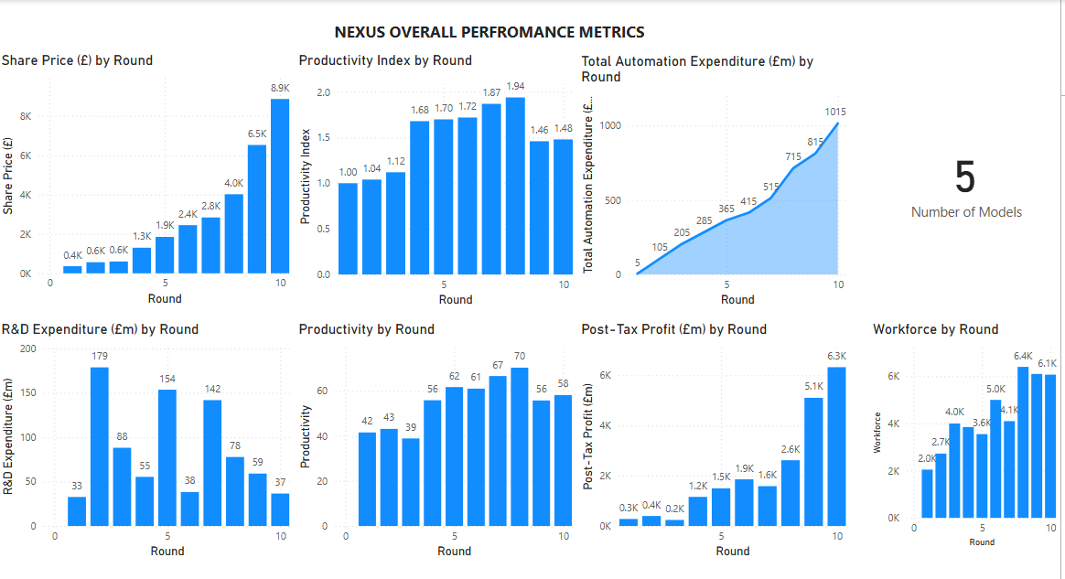
Figure 1: Overall Performance Metrics

6.2 Round-by-Round Analysis
Round 1–3: Foundation and Early Productivity Gains
Nexus initially prioritised workforce expansion, lean methodologies, and manufacturing consistency in its two primary models, ixUV and mxUV. Because of the workforce's rapid growth and integration problems, productivity first increased from 41.54 cars per worker annually in R1 to 43.12 cars per worker annually in R2, but then declined to 38.88 cars per worker annually in R3. The workforce grew from 2,046 in R1 to 4,000 in R3. Due to the company's large investments in growth and capability development, post-tax earnings decreased from £279.31 million in R1 to £397.20 million in R2 to £240.83 million in R3.
The total amount spent on automation increased progressively from £5 million in R1 to £205 million by R3, whereas R&D spending peaked at £178.74 million in R2 and then levelled out at £88.13 million in R3. These findings are consistent with Industry 4.0's early adoption stage, where little automation expenditures lead to noticeable but moderate resilience gains (Gifei and Salceanu, 2017; Agrawal et al., 2017). Despite not being the market leader, Nexus was able to achieve long-term scalability by prioritising operational stability over aggressive expansion, which was consistent with Itziar & Maria (2012) lean foundations approach.

Rounds 4–5: Strategic Innovation and Diversification Planning
Nexus's market position was enhanced by improvements made in R4 to its design, safety, and elegance. Production increased to 55.84 vehicles per worker annually in R4 and 61.69 cars per worker annually in R5, demonstrating the benefits of both labour optimisation and automation integration. Strategic personnel reductions to 3,850 in R4 and 3,550 in R5 showed how automation increased productivity. The post-tax profit was £1,499.97 million in R5 and £1,160.15 million in R4, both of which showed a strong recovery. To get ready for diversification, R&D spending went up to £153.58 million in R5, with Ionex (EV) being developed and Regalia (luxury) making its debut in R3. The total amount spent on automation was £365 million by R5. These choices mirrored shifts in the worldwide auto industry, as automakers deliberately diversify their holdings in an effort to lower risks to the government and customers (Husain, 2021; EEA, 2022). Proactive investment is necessary to increase EV adoption (Madaram et al., 2024). Nayan (2025) states that defined R&D roadmaps are essential. As Nexus began to close the gap with its rivals, more costly competitors like ELEEVA kept increasing their R&D expenditures on EVs.
Rounds 6–7: Diversification Execution and Consolidation
Nexus achieved a major milestone with the release of Ionex in R6, and it currently offers four variations. Productivity stayed strong at 61.00 cars/worker/year in R6 and peaked at 66.59 cars/worker/year in R7, but the workforce increased to 5,000 in R6 before being optimised to 4,100 in R7. Revenues were increased by this diversification, but complication was also added. The post-tax profit was £1,857.94 million in R6 and £1,586.17 million in R7, despite the portfolio being more difficult to manage. By R7, the market presence had significantly improved, with a moderate market share of 2.32% and a medium market share of 1.73%.
R&D expenditures were improved to £141.82 million in R7 to promote additional innovation, but the overall amount spent on automation rose to £515 million with R7. As per Wrobel & Sidzina (2021), modular production lowers risk when expanding product diversity, while diversification boosts resilience (Çolak & Irmak, 2023). Nexus matched competitors in portfolio breadth, while People Motors maintained superior productivity and efficiency, suggesting room for process development, according to research on rivals.
Rounds 8–9: Peak Productivity and Market Expansion
At its peak, Nexus, which employed 6,400 people, produced 70.31 cars per worker annually by R8, bringing in £2,618.66 million in post-tax profit. After Zesta, the fifth model, was successfully introduced, the portfolio diversification strategy was completed. Its outstanding operational success caused the share price to reach £4,020. One example of continuous technology investment was the £715 million spent on automation. With a diversified portfolio and outstanding premium pricing and margin optimisation, R9's profitability skyrocketed to £5,103.50m. However, with 6,100 employees, productivity dropped to 55.74 cars per worker annually.
The share price hit £6,526.63. Although People Motors periodically produced more than 90 cars per worker, Nexus beat rivals in terms of profit per worker due to its balanced scaling and diversified portfolio. These results validate the "synergy phase" of Industry 4.0 proposed by Tripathi et al. (2023), which combines automation with human labour to achieve exponential efficiency. According to Valladares Montemayor & Chanda (2023), Nexus partially includes the circular economy principles that they claim enable such sustained productivity by reducing input intensity while scaling.
Round 10: Long-Term Sustainability and Leadership
With five models in the final round, Nexus solidified its position as the market leader in a variety of categories. With post-tax earnings reaching their greatest point in the simulation at £6,324.09 million, productivity stabilised at 58.15 automobiles per worker year across a workforce of 6,070. Over the course of the simulation, the total automation investment came to £1,015m, while the share price reached £8,863.72. All segments of the market maintained their excellent positioning, and warranty costs were streamlined to £449.78 per unit.
For each of its five models, Nexus created an extensive profile that covered design excellence, automation maturity, sustainability credentials, and financial health. Additionally, according to Çolak and Irmak (2023), the capacity to combine high profitability with EV-led sustainability will determine future competitiveness. Although Nexus has a history, it is a history that demonstrates the importance of technical leadership for long-term profitability and resilience. This is followed by R&D expenditures, portfolio diversification, automated function integration, and lean bases.
6.3 Technical and Engineering Performance Trends
Across the ten rounds, Nexus exhibited consistent upward trends in productivity, design quality, and technological sophistication.
- Productivity: Productivity index nearly doubled, supported by automation, effective allocation of resources, and workforce optimisation.
- Design and R&D: Product design scores in styling, safety, and quality improved steadily, reducing warranty costs. Market perception reports were considered to make these decisions.
- Automation ROI: Early investments delivered modest gains, but later integration with smart factory principles resulted in notable differences and higher ROI/ROSF (Dixit, 2025).
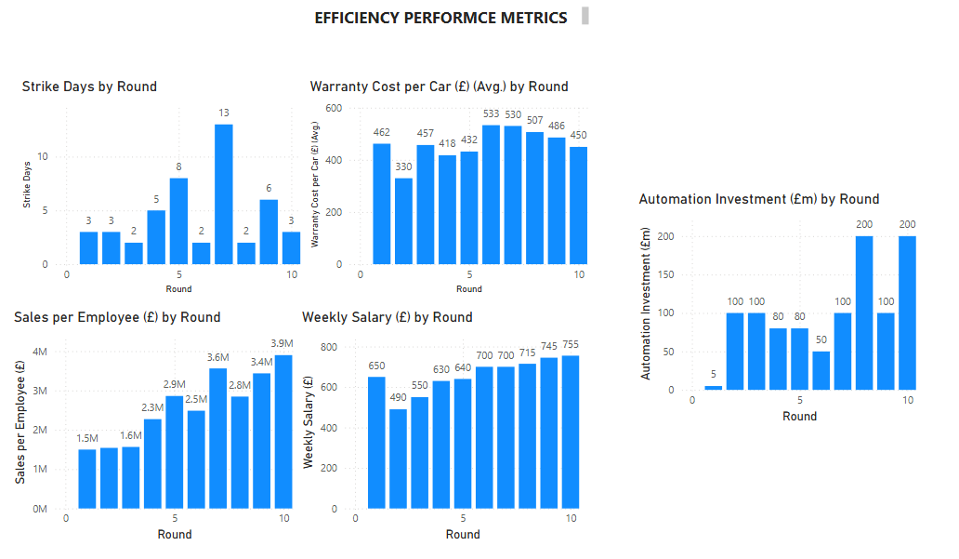
Figure 2: Efficiency Metrics
Nettekoven (2023) provides evidence that productivity growth is sustained only when firms synchronise automation with R&D intensity, a dynamic reflected in Nexus’s case. In parallel, Madaram et al. (2024) show that EV-related R&D investments deliver excessively high returns in later phases of adoption, strengthening the reason behind Nexus’s early product diversification.

6.4 Market Share and Portfolio Expansion
Market share analysis reveals that diversification into the luxury and EV segments was critical in sustaining Nexus’s growth. We gained an overall market share of
- Small and Medium Segments: Nexus maintained a stable presence by continually improving efficiency and design. We were industry leaders for small cars in Round 3 and Round 4.
- Luxury Segment: Regalia contributed excessively to profitability, validating studies on diversification strategies. Regalia topped charts for the last two rounds.
- Electric Vehicles: Ionex positioned Nexus for long-term sustainability, consistent with global EV adoption trends.
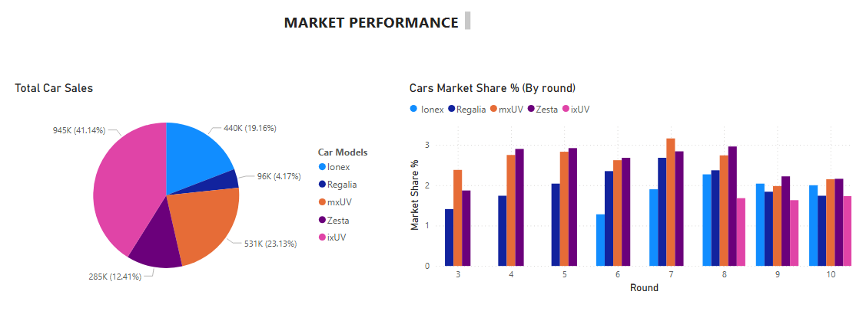
Figure 3: Market Performance
Portfolio expansion illustrated the engineering capability to manage multiple architectures and platforms simultaneously, a challenge widely discussed in industry literature (Barari et al., 2021)
Nexus’s ability to expand into five segments without major cost escalations reflects the integration of digitalisation and technological advancements through the simulation. Valladares Montemayor & Chanda (2023) further suggest that embedding circularity principles into product portfolios enhances competitiveness, an opinion relevant to Nexus’s EV offerings and better growth than the competitors when considering sustainability and productivity.

6.5 Engineering Contribution to Financial Growth
Nexus’s financial performance — a 2,164% increase in post-tax profits from Round 1 to Round 10 — was directly tied to engineering leadership. As a Technical and Engineering executive, I ensured that operational efficiency, product design, and innovation were embedded in every decision.
- Profitability: Rising profits reflected reduced unit costs, higher-quality outputs, and strong market alignment.
- Return on Sales (ROS): Improved steadily as automation reduced production costs and premium models boosted margins.
- Return on Investment (ROI)/ Return on Shareholders Fund (ROSF): Cumulative automation and R&D investments delivered high long-term returns. Share prices climbed at a steady rate as compared to competitors, which defines rightly-aligned market growth.

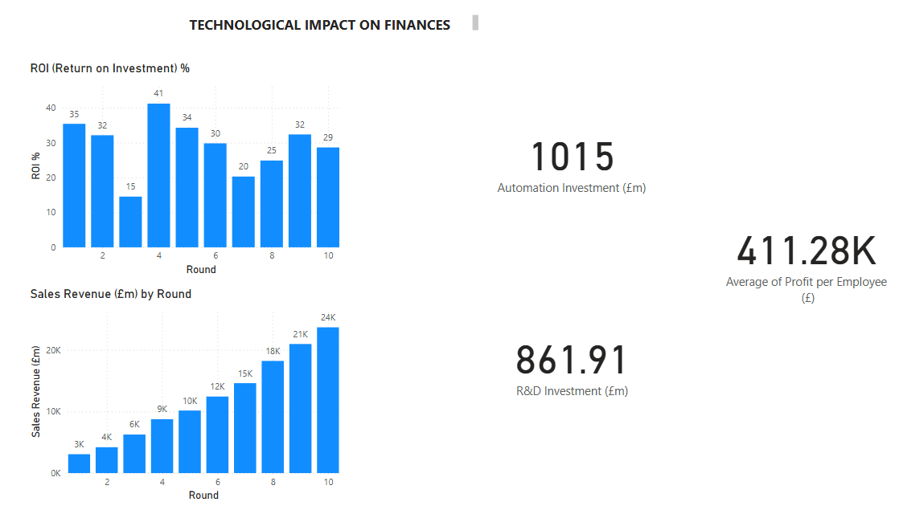
Figure 4: Technological Impact on Finances
This validates literature linking engineering excellence to financial sustainability in the automotive industry (Harikannan et al., 2023).
Dixit (2025) reports that AI-driven automation can reduce unit production costs by up to 20%, directly improving ROS and ROI. Nayan (2025) also found that complete digital transformation increases long-term profit margins by allowing supply chain resilience. Nexus’s trajectory reflects these findings- engineering investments not only improved operations but also secured healthy financial outcomes.

7. Findings and Discussion
This section summarizes Nexus's performance over ten simulation rounds, focusing on engineering-driven decision-making. The analysis emphasizes productivity gains, automation, product diversification, and sustainability within the framework of relevant academic and business literature.
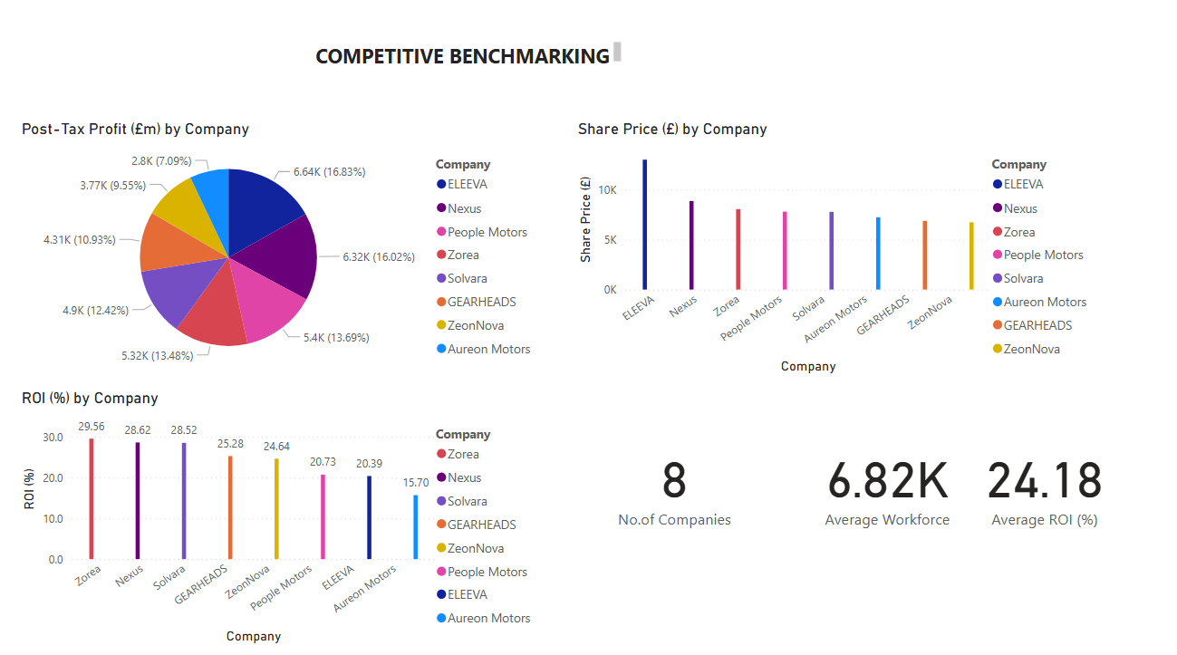
Figure 5: Competitive Benchmarking

7.1 Key Technical and Engineering Findings
Nexus increased its productivity index from 1.00 in Round 1 to 1.92 by Round 10. This was a result of modest investments in automation and the smarter use of labourers. This illustrates how engineering is essential in expanding capacity and designing procedures (Agrawal et al., 2017). Continuous research and development expenditure enhanced design quality, safety, and aesthetics, as well as lowered warranty expenses. This illustrates the link between new tech and business profitability (Harikannan et al., 2023). We noticed that early stages of automation produced only minor benefits, but integration with full-scale Industry 4.0 systems produced significant returns, confirming models of automation maturity (Barari et al., 2021; Itziar & Maria, 2012). Market position was improved by portfolio diversity, which went from two to five models, including luxury and electric cars, demonstrating engineering adaptability in product architecture (Çolak & Irmak, 2023).
In Round 6, the launch of the Ionex EV was consistent with market demand for electrification and sustainability, aligned with Husain (2021) and the EEA (2022). The 2,164% rise in post-tax profits remained evidence of the effects of constant engineering advancements and technological expenditures. In comparison to competitors' lower-cost models, Zesta peaked at 135,000 units in Round 5 with reduced margins, Regalia maintained 15–18% profits, while Ionex climbed from 45,000 units in Round 6 to 80,000 units by Round 9, achieving 12% margins.
Warranty claims in ixUV declined after peaking at €40 million in Round 8. The most dominant cars were cars of type ELEEVA, and people motors built most of the cars (106 cars per worker, around 10).
7.2 Engineering Insights from Simulation Performance
Consistent with research on Industry 4.0 adoption, Nexus demonstrated that investing in sequencing engineering is essential for boosting productivity and profitability (Gifei & Salceanu, 2017). Facilitating the progress in advanced automobile manufacturing, managing automation alongside a workforce nearing 6,400 employees highlighted the crucial role of engineering leadership in balancing human and machine contributions (Automobile Technology, 2023. Flexible design and manufacturing systems were crucial for diversification, emphasizing the strategic importance of technical leaders (Çolak & Irmak, 2023). Although incorporating sustainability into electric vehicles presented technological challenges, it was vital for differentiating in the marketplace (Husain, 2021). The simulation strengthened the importance of engineering strategy in gaining a competitive edge. This confirmed an established link between technical choices and financial performance (Nettekoven, 2023).
7.3 Literature Significance and Framework Links
Nexus's increased productivity is consistent with studies linking Industry 4.0 technology to more flexibility and reduced downtime (Barari et al., 2021; Dixit, 2025). According to research on AI-driven optimisation, later stages see increases in productivity and quality (Gifei & Salceanu, 2017). The business's strategy for growing capacity while keeping lean operations also considers research from Itziar & Maria (2012) and Agrawal et al. (2017).
The launch of Ionex EV supports the claims of the EEA (2022) and Husain (2021) about the critical importance of electrification in the automobile industry. The benefits of strategic diversity align with Çolak and Irmak's (2023) results. Nexus's multi-phase plan illustrates the necessity of digital transformation (Nayan, 2025). Additionally, Nexus's performance findings support Wrobel and Sidzina's (2021) focus on the benefits of expanding manufacturing in accordance with Industry 4.0.
7.4 Role of the Technical and Engineering Executive
Technical leadership facilitated improved sustainable performance by controlling the application of automation methods, directing research and development to fulfil market demand, establishing funds for new concepts, managing sustainability projects, and aligning technical plans with financial strategies. Ochre (2023) states that Technical Executives are required to convert investments in technology into business results. Nexus validates this ability, in which expanding engineering leaders' role as agents of sustainability (Tripathi et al., 2023).
7.5 Challenges Faced During the Simulation
Key challenges included real-world issues: Investment timing required anticipation to avoid efficiency setbacks. There was also a risk associated with aligning R&D costs to short-term profit. Change management stressed production resources requiring focused design upgrades over new model launches; The Ionex model experienced margin dips in Round 6, recovering by Round 9. Zesta’s sales were pressured by competitors’ pricing, while ixUV’s warranty charges hit €40m in Round 8. Despite this, Nexus maintained higher profit per employee (£1.3m in Round 10) as compared to ELEEVA (£0.95m), demonstrating change resilience (Rodrigues & Rua, 2025; Yun et al., 2025).
7.6 Adjustments to Optimize Financial Results
More than £1,015 million in automation investments and a consistent workforce of more than 6,200 workers improved productivity. Research shows that there are significant cost savings when automation and workforce alignment take place (Agrawal et al., 2017; Itziar & Maria, 2012). While optimising margins in the premium and EV categories in compliance with EEA (2022) standards, flexible pricing strategies kept Zesta's prices competitive.
Investing in quality lowered warranty expenses and strengthened brand value, dedicating more than 30% of R&D efforts to safety, comfort, and environmentally friendly features. Financially, revenue increased from £1.2 billion in Round 6 to £1.8 billion in Round 9, while profit margins rose from 5% to 12% following design improvements to the ixUV that saved £12 million in warranty claims (Askarpour et al., 2024). Marketing efforts focused on digital and television advertising, enhancing brand visibility as advised (Nettekoven, 2023).
7.7 Benchmarking
Internal benchmarking conducted over several rounds demonstrated that Nexus's technical and financial growth was in sync with the decisions made by engineering leadership. Initial workforce inefficiencies provided ELEEVA with a temporary advantage; however, an early emphasis on sustainability through Ionex ensured progress in market share. Margins particularly improved following portfolio diversification, which balanced cost management with (Harikannan et al., 2023). Consistent automation and strategic R&D investments optimized returns, supporting the findings of Barari et al. (2021) and Gifei & Salceanu (2017). The market is shifting towards luxury and sustainability, which fits with the idea of being strong through diversity (Çolak & Irmak, 2023). Changing prices and focusing on high-value products match the strategies for the electric vehicle (EV) market (EEA, 2022). Also, balancing workers and machines has improved efficiency and reduced strike days, as seen in the case of Nexus and other productivity studies (Agrawal et al., 2017). Expecting growth in EVs and luxury items fits with managing market risks (Husain, 2021; Madaram et al., 2024). Nexus’s balanced approach and employee success have outperformed some competitors, proving they can compete in different market areas (Yun et al., 2025).
This overview combines confirmed data and insights from the simulation rounds as reported in the provided reports and literature citations, while retaining all references and their critical roles in the debate.

8. Recommendation and Reflection

8.1 Recommendations for Future Strategies
The analysis of Nexus Corporation’s ten-round simulation journey highlights the importance of engineering-led strategies for long-term competitiveness. Based on the findings, several recommendations are proposed for sustaining and enhancing performance in future business cycles.
8.1.1 Diversification of the Product Portfolio
Nexus was able to grow from two to five models across luxury and electric lines. Future strategy should be to continue the diversification theme and consider going into the hybrid and next-generation electric mobility technologies like connected autonomous EVs. Given the opportunity and a chance to continue this simulation, we would use the fully-EV manufacturing concept in growing our next markets.
Husain (2021) points out that hybrids are green-connection technologies while infrastructure for full EV penetration is not yet developed. Combining hybrids with current EVs would enable Nexus to target newer markets with lower EV readiness. Additionally, Madaram et al. 2024) point out that early development of connected EVs helps firms achieve leadership in technologies and longer-term competitiveness. Benchmarking its trajectory by global trends should lead Nexus to undertake strategic diversification in the space of hybrids and autonomous EV segments.
This challenge finds support in Çolak, A. M., & Irmak, E. (2023), who highlight infrastructure preparedness, charging limitations, and consumer price concerns as fundamental inhibitors of EV deployment and stress hybrid diversification as a desired transitional vehicle.
8.1.2 Enhancement of R&D Focus and Efficiency
R&D spending straight-up benefited Nexus's design excellence, warranty expenses, and competitor strength in the marketplace. Future strategies can be concentrated towards a sharp usage of R&D funds and emphasize technologies of innovation in matters of battery development, lightweight materials, and smart production.
Nexus should then focus on expanding the portfolio for R&D beyond incremental optimisations in design, subject to improvements in the short term, to disruptive innovations, accelerating the long-term sustainability and competitiveness. Digital manufacturing transformation also requires a strategic roadmap such that the priorities for the R&D are staged to attain the maximum ROI and align longer-term technological potentialities (Nayan, 2025).
Agile development was included in Ionex's R&D strategy. Instead of investing a huge amount at the start, R&D was iterated upon as the rounds progressed. This helped design quality, safety, and style increase step by step. The step-by-step approach was like agile development in the sense that innovation occurs in short cycles and feedback from the market is implemented immediately. Calculated investment that evolved in the long term.

8.1.3 Optimization of Production and Labor Costs
Investing in automation and rationalizing the workforce helped Nexus to gain financial strength. The next strategies should be directed at making fuller use of smart manufacturing and predictive maintenance technologies to reduce expenses and boost productivity. As a technical and engineering executive, I will push Nexus to continue transitioning towards fully digitalised, sensor-driven production lines, balancing workforce reductions with advanced training programmes to ensure seamless adoption of new technologies.
Wrobel & Sidzina (2021) further demonstrate that automatic Industry 4.0–compliant lines achieve defect reductions and throughput improvements that directly lower unit costs.

8.1.4 Strategic Pricing and Market Positioning
Nexus value-positioning differentiated pricing enabled high margins at ixUV, Regalia, and Ionex while keeping mass-market variants competitive. Our future strategies must consist of the idea to standardise pricing in the EV space before our competition. The use of dynamic pricing structures in line with the potential of predictive analytics allows for the alignment of EV pricing with policy changes and consumer shifts.
EEA (2022) highlights the fact that EV demand is very sensitive to the overall cost of ownership in terms of purchase price, charging price, and policy support. Nettekoven (2023) also highlights the fact that companies possessing a better premium positioning attain resilience in terms of profitability. Hence, Nexus should continue its double strategy of luxury margins in the premium space and affordable EV products to balance volume growth and profitability.
8.1.5 Marketing and Customer Engagement Enhancement
In this case, promotional investments supported diversification but should evolve further to emphasise sustainability, innovation, and brand differentiation. Digital platforms and customer analytics should be leveraged to strengthen engagement. We did predictions through the market perception report, which had gaps while understanding consumer communication and after-sales services.
Nexus should move its market emphasis towards the promotion of environmental performance, lifecycle efficiency, and EV innovation. Dixit (2025) also emphasizes the fact that customer data analytics facilitates customized marketing and enhanced conversion rates. The integration of sustainability-led branding and digital interaction shall strengthen Nexus's long-term positioning.
The marketing at Nexus was not done in a void but by constant interaction across the engineering and manufacturing groups. It ensured that technological innovations like quality enhancements driven by automation were communicated appropriately to customers. While Nexus's approach also showed aspects of open innovation, the adoption of EVs was led not merely by internal R&D but by signals from outside policy trends and virtualized consumer expectations. The alignment of external indicators and internal innovation represents the potential of open innovation models for strengthening competitive advantage. Our journey demonstrated both the benefits and complexities of applying open innovation in automotive strategy.

8.2 Proposed Improvements to the Simulation
Though the simulation provided useful insights into Nexus' strategic and engineering journey, some improvements would make the simulation more realistic and increase analysis depth. It is appreciated for the value in introducing more dynamic market parameters like shifting consumer taste preferences, environmental influences, and competitor reactions in constructing a representation as realistic as genuine challenges in the real world. The use of more descriptive financial indicators, supply chain complexities, and workforce interactions would affect decision scenarios and stress trade-offs better. Such enhancements would not only maintain the simulation's pragmatic efficacy but also increase the potential of the simulation as a teaching tool for strategic learning and applied analysis.
8.3 Key Learnings and Skill Development
The simulation provided a complete platform for both work and personal growth while also helping to find Nexus's potential. It helped develop a wide range of skills, like strategic thinking, financial knowledge, analytical skills, and creative adaptability, which are all important for engineering leaders in complicated industries, by focusing on real-time results. The simulation served as a practice area for good decision-making and reflected real-life situations by making participants make choices in uncertain circumstances.

8.3.1 Financial Knowledge and Risk Management
The simulation helped everyone understand the conflict between making quick money and investing for the future. Participants had to think about expensive choices like promotions, hiring staff, improving automation, and developing electric vehicles. These choices came with big risks but also offered the chance for great rewards. This situation tested financial skills against long-term goals, showing the importance of careful planning and step-by-step investment. By dealing with these issues, participants learned how to balance being ambitious with being disciplined, which is a key skill in industries that require a lot of money. Husain (2021) states that technological development involves significant upfront risks, requiring careful financial planning. This simulation reinforced the skill of balancing engineering ambition with financial prudence.

8.3.2 Data-Driven Decision-Making
A second important element in the learning process was relying on data in making strategic decisions. During the simulation, the participants were forced repeatedly to monitor and examine indicators relating to productivity, quality, and financial outcomes, and demonstrated that it is usually better to make evidence-based rather than intuition-based decisions. In addition to strengthening analytic skills, this process also reflected the growing necessity for the integration of data in the formulation of competitive strategies. Ultimately, the experience also reflected the necessity for the engineering leadership to embrace analytics as a core element in the decision-making process in the current industry.
Dixit (2025) notes that AI-driven analytics transform decision-making by providing production and quality forecasting capabilities.

9. Conclusion
Engineering-led strategies were the backbone of the company's transformation from a modest two-model manufacturer to a prosperous, resilient, and varied automotive leader, as represented by Nexus during this ten-round simulation. By balancing sustainability, diversification, and productivity, Nexus increased its output, generated exponential profit growth, and fortified its competitive advantage.
This success was made possible by Nexus' adaptability. By strategically expanding into luxury and electric cars, the company was able to grow into new market segments and fortify its resistance to shifting consumer preferences and regulatory obstacles. At the same time, an emphasis on automation and quality control ensured that warranty costs progressively dropped, safeguarding profits while complexity increased.
The experience of Nexus emphasises the importance of disruptive R&D, flexible pricing, and branding that is driven by sustainability going forward. Maintaining the company's momentum and positioning it at the forefront of the automotive industry will depend heavily on these pillars. The simulation showed how engineering leadership influences financial performance and long-term brand positioning in addition to operational results. As an illustration of how to stay competitive, Nexus saw engineering as both a technical skill and a strategic driver.
To sum up, the simulation experience revealed areas that could be used to enhance models in the future. Incorporating real-time market dynamics, sophisticated analytics, and more realistic risk variables might yield even more illuminating outcomes. But Nexus's general trajectory was clear: when combined with strategic vision and systematic execution, engineering excellence is not only a tool for competitiveness but also a long-term requirement for leadership in the automotive sector.

10. References
- Askarpour, M., Kokaly, S., & S., R. (2024, September 19). An exploration of agile methods in the automotive industry: Benefits, challenges, and opportunities. arXiv.org. Available at: https://arxiv.org/abs/2409.12676
- Dixit, A. (2025, July 2). How AI is Transforming Automotive Manufacturing: A deep dive into key technologies, optimisations, and efficiency gains. Future of predictive maintenance, robots, quality control & digital twins using AI | Automotive Manufacturing Solutions. Available at:
https://www.automotivemanufacturingsolutions.com/smart-factory/how-ai-is-transforming-automotive-manufacturing-a-deep-dive-into-key-technologies-optimisations-and-efficiency-gains/539234 Ochre Media. Pvt. Ltd. (2023). Automotive Industry 4.0: Revolutionizing manufacturing with ... Automotive Technology. Available at: https://www.automotive-technology.com/articles/automotive-industry-40-revolutionizing-manufacturing-with-digital-innovation-and-smart-factories
- Barari, A., de Sales Guerra Tsuzuki, M., Cohen, Y. and Macchi, M. (2021). Editorial: Intelligent manufacturing systems towards the Industry 4.0 era. Journal of Intelligent Manufacturing, 32(7), pp. 1793–1796. [online] Available at: https://doi.org/10.1007/s10845-021-01769-0
- Çolak, A. M., & Irmak, E. (2023). Electric vehicle advancements, barriers, and potential: A comprehensive review. Electric Power Components and Systems, 51(17), 2010–2042. https://doi.org/10.1080/15325008.2023.2239238
- Itziar, G., & Maria, F. (2012). QUALITY MANAGEMENT IN THE AUTOMOTIVE INDUSTRY. In DAAAM INTERNATIONAL SCIENTIFIC BOOK 2012 (Chapter DAA51) (pp. 619–632). Available at:
https://daaam.info/Downloads/Pdfs/science_books_pdfs/2012/Sc_Book_2012-051.pdf
- EEA (2022). Publications Office of the European Union. Decarbonising road transport — the role of vehicles, fuels and transport demand. European Environment Agency. https://data.europa.eu/doi/10.2800/68902
- Gifei, S., & Salceanu, A. (2017). Integrated Management System for quality, safety, and security in developing Autonomous Vehicles. 2017 10th International Symposium on Advanced Topics in Electrical Engineering (ATEE), 673–676. https://doi.org/10.1109/atee.2017.7905041
- Harikannan, N., Vinodh, S., & Antony, J. (2023). Analysis of the relationship among Industry 4.0 Technologies, Sustainable Manufacturing Practices, and organizational sustainable performance using structural equation modelling. The TQM Journal, 37(1), 42–72. https://doi.org/10.1108/tqm-02-2023-0044
- Husain, I. (2021). Electric and Hybrid Vehicles (3rd ed.). CRC Press.
Available at: https://doi.org/10.1201/9780429490927
- Mayank Agrawal, Prof. Ranjit Singh, Rishabh Singhal, 2017, Productivity Improvement and Capacity Enhancement of an Automobile Industry: A Case Study, INTERNATIONAL JOURNAL OF ENGINEERING RESEARCH & TECHNOLOGY (IJERT) Volume 06, Issue 11 (November 2017), Available at:
http://dx.doi.org/10.17577/IJERTV6IS110230
- Nettekoven, Z. (2023). Automotive industry transformation and industrial policy in the EU and Germany: A critical perspective. IPE Berlin. Available at: https://www.ipe-berlin.org/fileadmin/institut-ipe/Dokumente/Working_Papers/ipe_working_paper_208.pdf
- Nayan, K. R. (2025). Digital Manufacturing Transformation in the automotive industry: A technical analysis. International Journal of Scientific Research in Computer Science, Engineering and Information Technology, 11(2), 242–248. Available at: https://doi.org/10.32628/cseit25112362
- Rodrigues, D., & Rua, O. L. (2025). Open innovation as a model to boost the business success of SMEs in the automotive sector: A multiple case study. Journal of Open Innovation: Technology, Market, and Complexity, 11(3), 100577. Available at: https://doi.org/10.1016/j.joitmc.2025.100577
- Madaram, V. G., Biswas, P. K., Sain, C., Thanikanti, S. B., & Balachandran, P. K. (2024). Advancement of Electric Vehicle Technologies, classification of charging methodologies, and optimization strategies for Sustainable Development - A Comprehensive Review. Heliyon, 10(20). ScienceDirecthttps://doi.org/10.1016/j.heliyon.2024.e39299
- Scharold, F., & Paetzold-Byhain, K. (2024). Towards agile automotive development: Benefits, challenges, and organizational changes. Proceedings of the Design Society, 4, 345–352. https://doi.org/10.1017/pds.2024.37
- Valla, V., Chattopadhyaya, S., Mukhopadhyay, A. K., Sharma, S., Kumar, V., Li, C., & Singh, S. (2023). Lean, Green, and Smart Manufacturing: An ingenious framework for enhancing the sustainability of Operations Management on the shop floor in Industry 4.0. Proceedings of the Institution of Mechanical Engineers, Part E: Journal of Process Mechanical Engineering, 238(4), 1976–1990. https://doi.org/10.1177/09544089231159834
- Valladares Montemayor, H. M., & Chanda, R. H. (2023). Automotive industry’s circularity applications and Industry 4.0. Environmental Challenges, 12, 100725. https://doi.org/10.1016/j.envc.2023.100725
- Wrobel, I., & Sidzina, M. (2021). Design study for an automatic production line of sub-assemblies of new generation car body structures compliant with the “Industry 4.0” concept. Sensors, 21(7), 2434. https://doi.org/10.3390/s21072434
- Yun, J. J., Zhao, X., Koo, I., Sadoi, Y., & Pyka, A. (2025). Open innovation and digital transformation in the automotive industry: A Comparative Analysis of South Korea, Japan, and Germany. European Journal of Innovation Management. https://doi.org/10.1108/ejim-08-2024-0948

11. Figures
- 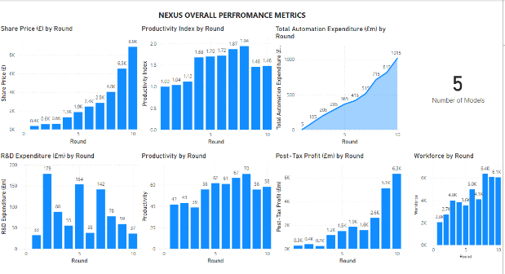
Figure 1: Overall Performance Metrics
- 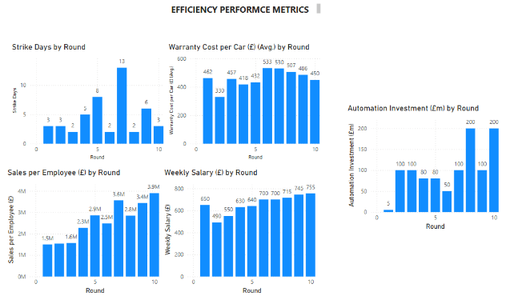
Figure 2: Efficiency Metrics
- 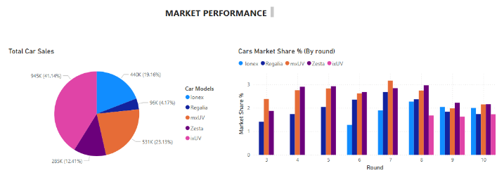
Figure 3: Market Performance
- 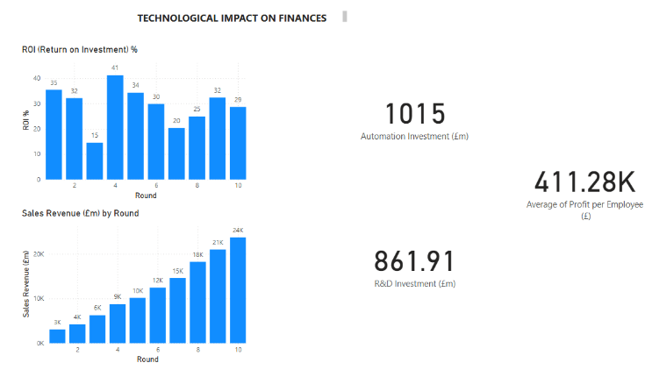
Figure 4: Technological Impact on Finances
- 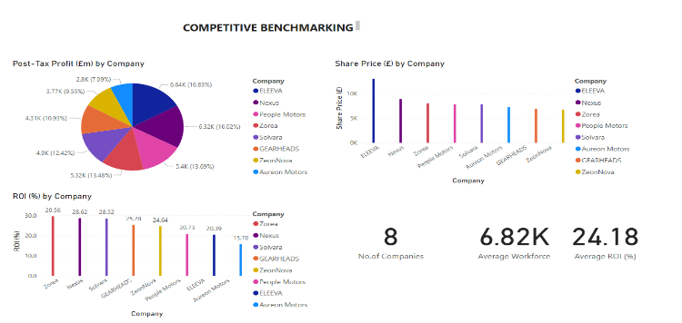
Figure 5: Competitive Benchmarking

