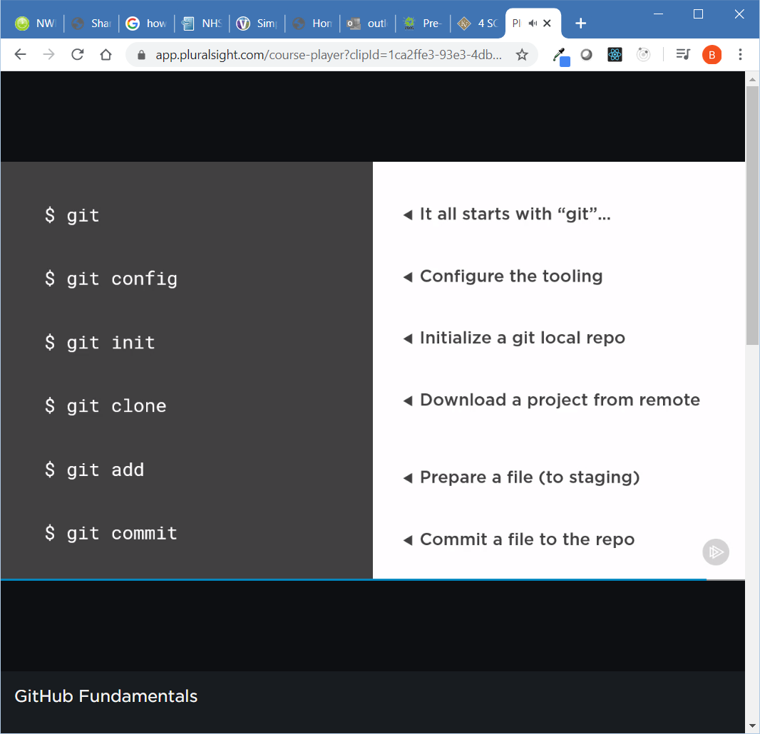

ls –la to list all files in readable format

‘git status’ to see the status of your code repo

‘git add’ adds file to staging so that they will be included in the next commit

When you create a new git repository using the web front end it gives you a summary of the commands to use to link that repository to your local directory.

git remote add origin <https://github.com/bmcd77/repoName>

git push –u origin master

and git remote –v will tell you if you already have a remote repository configured i.e.

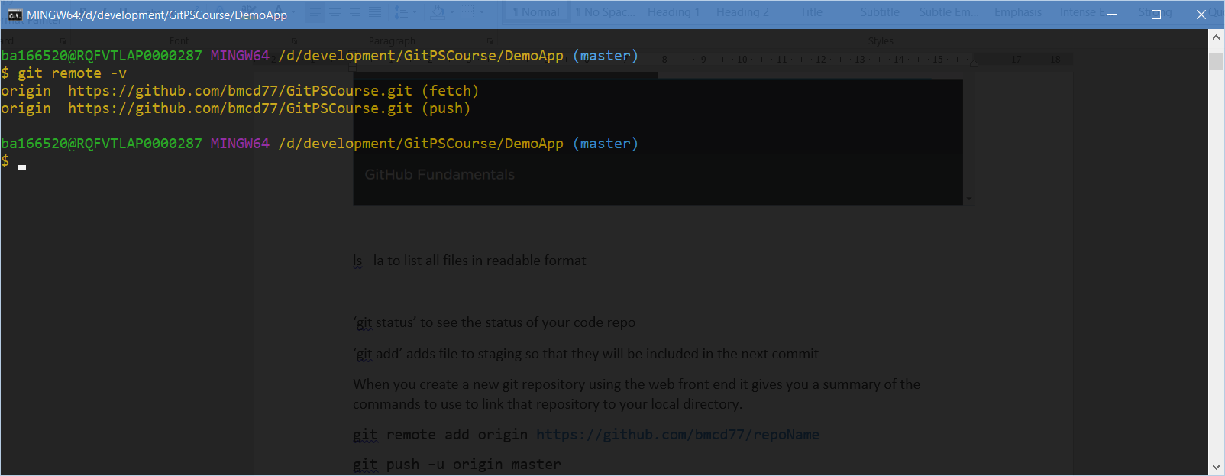

Generate an ssh key with :

ssh-keygen -t -rsa -b 4096 -C [bmcd77@hotmail.com](mailto:bmcd77@hotmail.com)

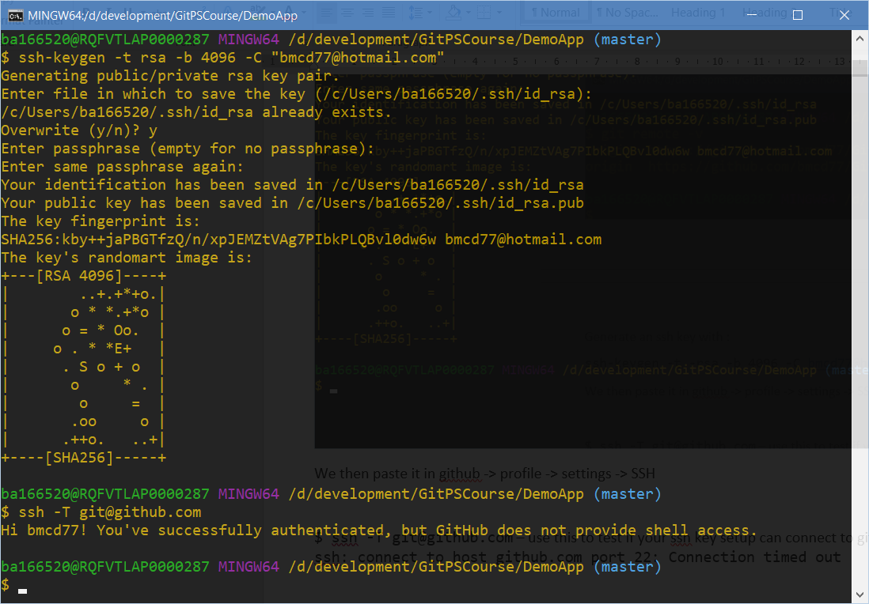

We then paste it in github -> profile -> settings -> SSH

$ ssh -T [git@github.com](mailto:git@github.com) – use this to test if your ssh key setup can connect to git. Note it will fail on vpn with ssh: connect to host github.com port 22: Connection timed out

Git log origin (what I called my first commit)/<branch> is useful

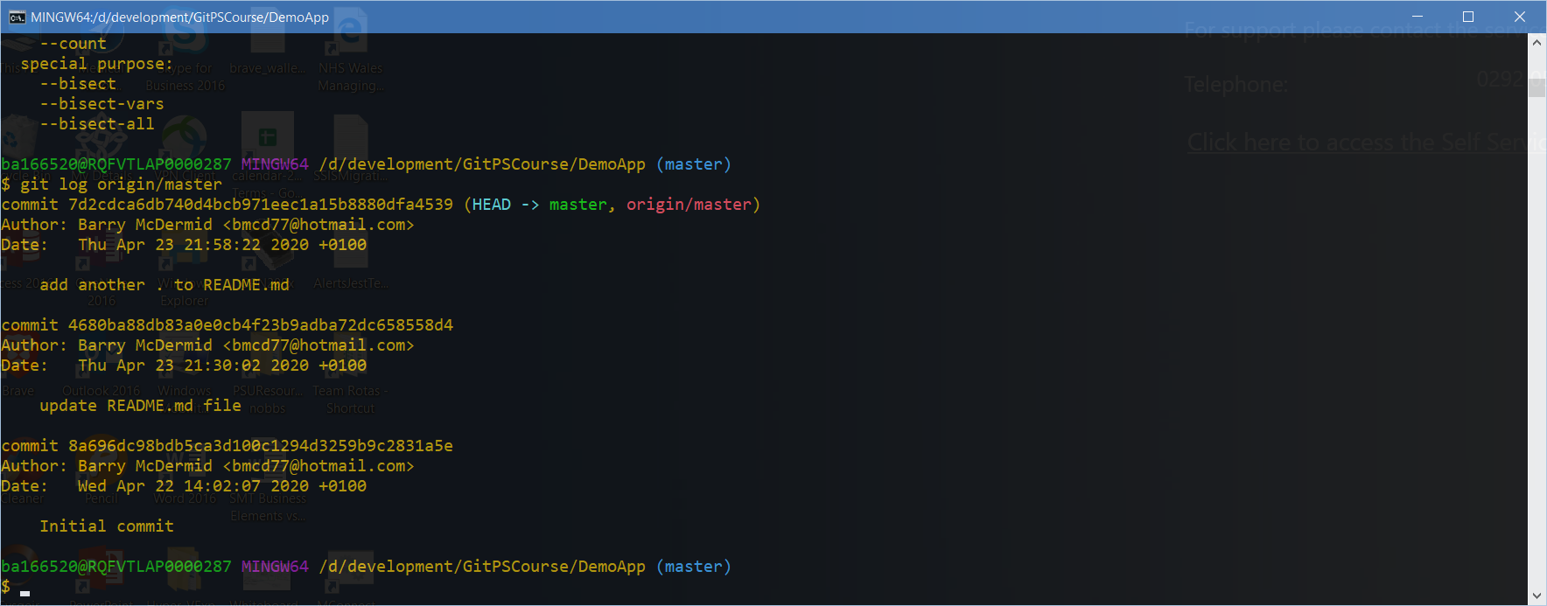

This is good however you may need to have merged the latest from the branch before pushing like this:

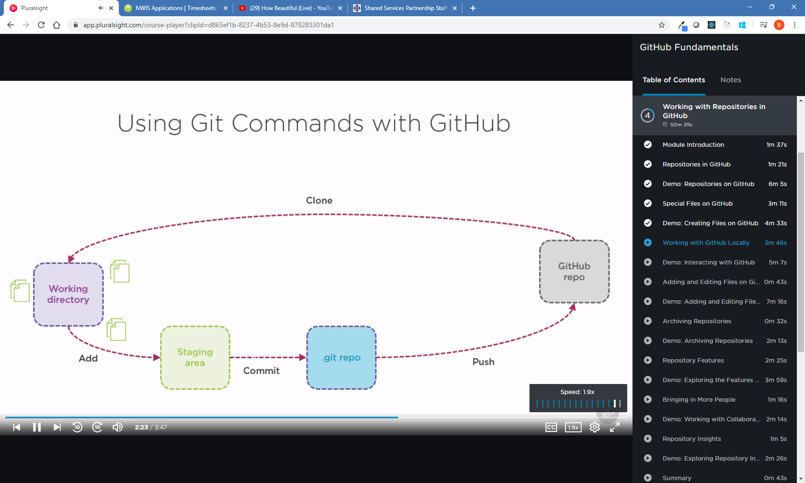

A Pull is a git pull & merge in one movement.

