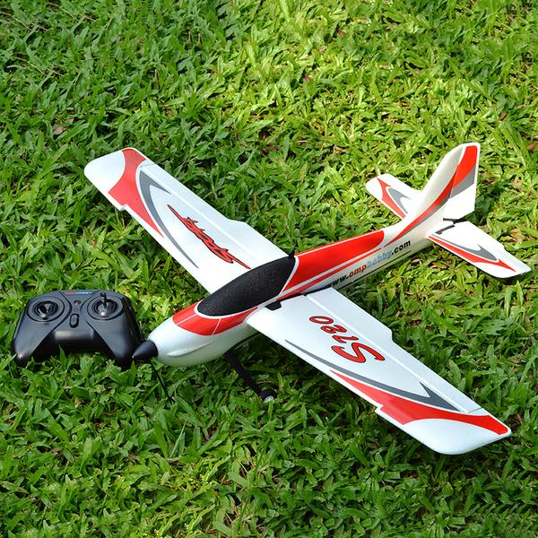

**LA-TRAJECTORY**

**Introduction**

Has the flight of an aeroplane ever fantasized you? So here comes **TECHNEX’20** with **LA-TRAJECTORY** an event providing all the aero modellers a platform to fulfil their quenched dreams. An event where we call upon engineers and aero designers to design an RC powered electric motor aircraft and put their skills and technicality to the test. The event includes not only flight but also coupled with a series of hurdles, a real test of aeromodelling expertise.

So, give your imaginations wings. Build your own RC aircraft and soar high up in

the sky.

**Challenge**

The competition requires the teams to design and fabricate an RC plane that is

capable of performing the given set of tasks. Propellers, Motors, ESC, Servos,

Receiver and Transmitter are allowed as off-the-shelf items. The event will be

conducted outdoors and participants will need to bring their aircraft and all

necessary equipment to the venue.

The arena will be an open ground. Teams will be disqualified after each round of

the event based on the performance.

The event consists of two rounds

1. Preliminary Round

2. Final Round

**Design Constraints**

● The RC plane should measure a maximum (must not exceed) of 1.2 m along

any direction.

● The Propeller diameter should not be greater than 10 inches.

● The use of Nitro, IC engines is strictly prohibited. Only electrical motors are

allowed.

● Metal propellers are not allowed.

● No Design change will be allowed after the start of the competition.

● The model should be self-made, if the design is found to be a readymade then

the team will be disqualified.

● One of the team members should fly the aircraft and another should call the

stunts as they are performed (just before).

● T/W <1(if excess thrust is found, it will be neutralized by adding weight below the plane at centre of gravity) Where T=Thrust and W=Weight of plane.

● Use of gyroscopes and programming assistance in receivers is prohibited.

● Metal propellers are not allowed.

● During flight plane must always remain in flying zone.

**Preliminary Round ( Free Style):-**

Each team will be given **4 minutes** to perform stunts. Within the time limit,

teams can try any stunt multiple times, but each stunt will be scored only

once (the one with the maximum score).

Teams have to perform task in the following sequence and each task is mandatory.

Stunts are mentioned below. Some of them may be too difficult but it’s all

relative.

|  |  |
| --- | --- |
| **ACTION PERFORMED** | **POINTS** |
| Clockwise horizontal round | 20 |
| Anticlockwise horizontal round | 20 |
| Figure of eight | 40 |
| Any flip | 40 |
| Landing (in zone) | 30 |
| Landing (outside zone) | 0 |
| Crashing | -20 |

**The task will be considered complete only if all of the following conditions are satisfied-**

As the plane takes off, a timer will start. The teams will be given a **maximum of 4 minutes** and a **maximum of 2 takeoffs** for this task. Only the last take off will be marked. It totally depends upon the team members that they want to take another chance or not.

Flyer has to land the plane as smooth as possible in the flying arena.

● The plane does not touch the ground except the starting zone and landing zone.

● In case of a tie in scores, time taken to complete will be considered.

● Only top **12 teams** will be qualified to the next round (more teams may

qualify based on their performance).

**FINAL ROUND**

Pilot’s controlling and plane's manoeuvrability will be tested in this FINAL Round.

In Final round the participants have to follow the following sequence

1. Take off the plane from the specified area of 10*5 ( bottom two squares in figure).
2. Plane should be pass inside the 5*5 gate.
3. Make the figure of 8 with the two poles as instructed by the coordinator.
4. Then pass plane from above of (3*6) gate
5. Then drop bomb in the specified area of 6m diameter.
6. Land plane in the specified area of 10*5 ( right two squares in figure).

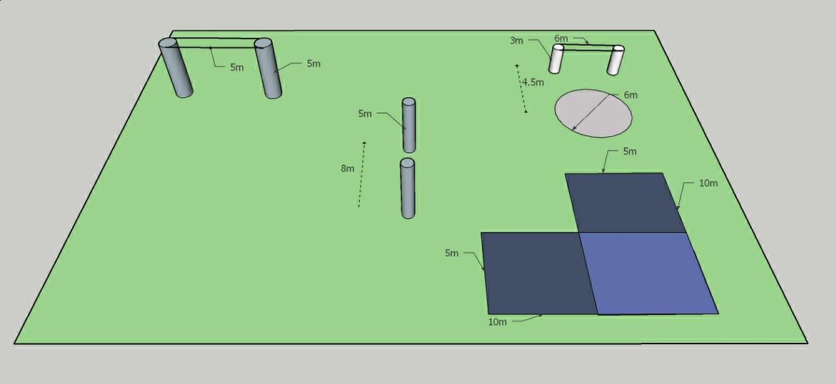

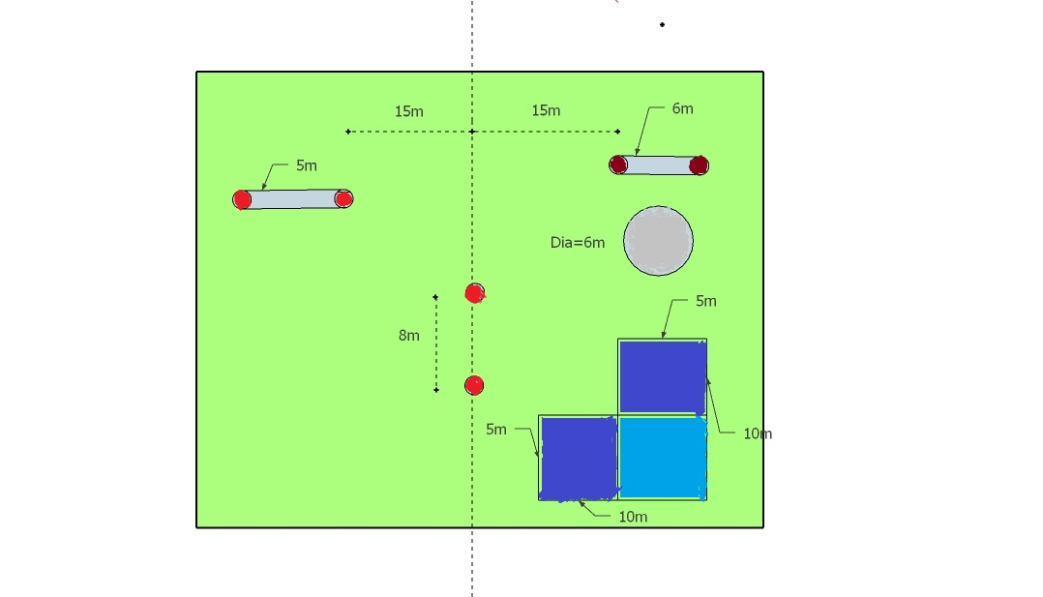

**Rules for final round:-**

**TAKE OFF:**

Flyer has to take off his plane from specified TAKE-OFF ZONE as specified of 10m*5m

|  |  |
| --- | --- |
| Take off ( without wheels) | 15 |
| Take off ( with wheels) | 25 |

**CRITERIA FOR GATE PASSING:**

Plane has to pass inside GATE A (5m*5m)

Plane has to pass **above** GATE B (3*6m).

Points for the above task are as follows:

|  |  |
| --- | --- |
| Inside gate 1 | 80 |

**NOTE-**

* **Gate 2 does not contain any point but it is mandatory to go from above gate 2.**
* **Plane should not touch any of the ropes.**
* **If the plane passes below the gate B , no points will be given to flyer for bomb drop and landing.**

**CRITERIA FOR FIGURE OF 8 :**

* 50 points will be given for making eight for the first time.
* + 25 points for all other consecutive eight.
* Flyer can make 8 any number of times within the time limit to earn extra points , but 8 made after passing through gate 2 will not be counted.
* Plane should not touch the poles.

**CRITERIA FOR BOMB DROP:**

Bomb must be drop inside the arena as specified in fig.

|  |  |
| --- | --- |
| Bomb drop ( inside the region) | 50 ( +25 for extra bomb) |
| Bomb drop ( outside the region) | 0 |

* Maximum of 3 bombs can be used.
* Bombs will be provided by the coordinators.

**LANDING:**

Flyer has to land his plane his plane inside the specified LANDING ZONE of 10m*5m for extra points as below.

|  |  |
| --- | --- |
| Smooth landing ( inside zone) | 40 |
| Rough landing (inside zone) | 20 |
| Landing ( outside zone) | 0 |
| Crashing | -40 |

**Rough and smooth landing will be decided by the judges. Their decision will be final.**

**RULES:**

1. Two trials will be given for FINAL ROUND. The best will be considered.

2. Trial will be considered to end when plane **touches the ground** by any means.

3. Flyer should pass the GATE A and GATE B from specified direction only

4. Flyer can move any where on the specified arena without disturbing the same.

5. No extra points will be given for repeating the obstacles unless mention.

6. Judges decision will be final at the end.

7. Time of first round will be the tie breaker.

**Basic rules:-**

Team Structure

1. Maximum 4 members are allowed in a team.

2. Members can be from different college/University.

**Abstract Submission**

1. Each team will submit only one abstract. In case of multiple abstracts, only the first abstract shall be considered.

2. All the abstracts must be in .pdf format only.

3. All the abstracts must be mailed at **events@technex.in** with cc to **aryan.kumar.met17@iitbhu.ac.in**

4. Send the abstract through the team leader only, with the same email id by which he/she has registered on the website.

5. The abstract should be sent with the subject: “ABSTRACT_LA-TRAJECTOIRE_TEAMNAME"

6. Team name is compulsory and should be same in abstract and on the registration data on the website.

7. The teams shortlisted on the basis of their abstracts will be notified through mail.

**Guidelines for Abstract Submission**

● You also have to send a Zip file containing at least 5 and not more than 10

photographs of your aircraft while it is being built.

● You can also attach photos within abstract and fill the details given below.

● Fill in the following team details:-

|  |  |
| --- | --- |
| **Team id-** |  |
| **Team name-** |  |
| **College name-** |  |
| **Team leader name-** |  |
| **Email id-** |  |
| **Contact no.** |  |

|  |  |  |  |
| --- | --- | --- | --- |
| **Other member name** | **Contact no.** | **Email** | **College name** |
| **1.** |  |  |  |
| **2.** |  |  |  |
| **3.** |  |  |  |

**● Describe the Basic Design of the aircraft and also explain how is your designed aircraft is suitable for the given task in the Abstract?**

**Flying rules (applicable for both round)**

1. Teams will be scored only if: The plane always remains in the arena during its flight. The mentioned tasks for each round are done properly.

2. Each team will be given two runs and the better of the two will be considered for the calculation of points.

3. The aircraft has to be hand launched i.e. the aircraft will be launched in the air with hand and no other launch devices.

4. The use of 2.4 GHz radio is required for all aircraft competing in the competition.

5. All parts must remain attached to the aircraft during flight and landing. While in air, if any part of the plane is found to be detached, that flight will be considered as disqualified. (Breaking of propellers while landing will not lead to disqualification)

6. Broken propellers and metal propellers are not allowed.

7. In case of any discrepancy, final decision will be that of the coordinators.

8. Decision in the above round’s format, rules & regulations are liable to change as per the suitable condition.

**Model Specifications**

1. No dimension of the aircraft should exceed 120 cm.

2. The weight of the aircraft should not exceed 1000 grams at any instant of time’

3. The use of IC engines is prohibited. Only electrical motors are allowed.

4. Use of gyroscopes is prohibited. Participants must make all parts of the aircraft themselves.

5. The participants may use any material as per their choice.

6. Use of Ready-to-Fly (RTF) And Almost-Ready-to-Fly (ARTF) kits is strictly prohibited. Use of ready-made motors, remote controls, propellers and other electrical parts are allowed.

7. Anyone found not following the above rules will be disqualified.

8. Any change regarding the event will be highlighted on the website and mailed to the registered participant.

**9. You are advised to visit the website regularly. The decision of organizing team will be final and binding on all.**

**Contacts:**

Aryan Kumar

Mail: **aryan.kumar.met17@iitbhu.ac.in**

Mob: +91-8969715425

Prayansh Dhariwal

Mail: **prayansh.dhariwal.civ17@itbhu.ac.in**

Mob: +91-9893896943