

Neural Networks
Viva Questions
Comprehensive Q&A Guide
Group A | Group B | Group C
Activation Functions | Perceptron | BAM | CNN | TensorFlow | PyTorch

Table of Contents
Right-click and select "Update Field" to refresh page numbers

Group A Viva Questions 3
Activation Functions 3
McCulloch-Pitts ANDNOT Network 5
Perceptron Even/Odd Recognition 6
Perceptron Learning Law and Decision Regions 8
BAM Network 9
Number Recognition using 5x3 Matrix 10
ANN using Forward and Back Propagation 11
Multi-class Classification Network 13
Group B Viva Questions 15
XOR using Backpropagation 15
ART Neural Network 16
Backpropagation Feed Forward Network 17
Hopfield Network 18
CNN Object Detection 19
Group C Viva Questions 21
TensorFlow / PyTorch / Logistic Regression 21
TensorFlow / PyTorch CNN 23
ConvNet and Hyperparameter Tuning 24
MNIST Character Detection 25

Group A Viva Questions

Activation Functions
Q: What is an activation function?
Ans: An activation function is a mathematical function applied to the output of a neuron. It introduces non-linearity into the network, enabling it to learn complex patterns. Without activation functions, a neural network would behave like a simple linear regression model, regardless of depth.
Q: Why are activation functions used in neural networks?
Ans: Activation functions enable neural networks to learn non-linear relationships in data. They decide whether a neuron should be activated (fire) or not based on the weighted sum of inputs. This non-linearity allows the network to approximate complex functions and solve problems that are not linearly separable.
Q: What happens if activation functions are not used?
Ans: Without activation functions, the entire neural network collapses into a single linear transformation. No matter how many layers are stacked, the output remains a linear function of the input. This severely limits the network's capacity to learn complex patterns, making it equivalent to linear regression.
Q: Explain sigmoid activation function.
Ans: The sigmoid function maps any input value to a range between 0 and 1. Formula: sigmoid(x) = 1 / (1 + e^(-x)). It has an S-shaped curve. Historically popular for binary classification, it outputs values that can be interpreted as probabilities.
Q: What is the range of sigmoid function?
Ans: The range of the sigmoid function is (0, 1). As x approaches negative infinity, the output approaches 0. As x approaches positive infinity, the output approaches 1. At x = 0, the output is exactly 0.5.
Q: Explain tanh activation function.
Ans: The hyperbolic tangent (tanh) function maps inputs to a range between -1 and 1. Formula: tanh(x) = (e^x - e^(-x)) / (e^x + e^(-x)). It is zero-centered, meaning its output has a mean of zero, which helps with convergence during training compared to sigmoid.
Q: Difference between sigmoid and tanh.
Ans: 1. Range: Sigmoid outputs (0,1) while tanh outputs (-1,1). 2. Centering: Sigmoid is not zero-centered; tanh is zero-centered, which helps gradient descent converge faster. 3. Symmetry: Tanh is symmetric around the origin, making learning more efficient. 4. Both suffer from the vanishing gradient problem, but tanh is generally preferred in hidden layers.
Q: What is ReLU?
Ans: ReLU stands for Rectified Linear Unit. It is defined as: ReLU(x) = max(0, x). If the input is positive, it outputs the input unchanged; if negative, it outputs zero. It is the most widely used activation function in deep learning due to its simplicity and effectiveness.
Q: Why is ReLU widely used in deep learning?
Ans: ReLU is computationally efficient (simple max operation), mitigates the vanishing gradient problem for positive values, induces sparsity by deactivating neurons with negative input, and allows faster convergence during training compared to sigmoid and tanh.
Q: What is Leaky ReLU?
Ans: Leaky ReLU is a variant of ReLU that allows a small, non-zero gradient for negative inputs. Formula: LeakyReLU(x) = x if x > 0, else ax where a is a small constant (typically 0.01). This prevents the "dying ReLU" problem where neurons permanently output zero.
Q: What is vanishing gradient problem?
Ans: The vanishing gradient problem occurs when gradients become extremely small during backpropagation, causing weights in early layers to update very slowly or not at all. This happens with activation functions like sigmoid and tanh whose derivatives approach zero for large positive or negative inputs, effectively stopping learning in deep networks.
Q: Which activation function suffers from vanishing gradient?
Ans: Sigmoid and tanh activation functions suffer from the vanishing gradient problem. Their derivatives are very small (close to zero) when inputs are in the saturation regions (very positive or very negative), causing gradients to shrink exponentially as they propagate backward through layers.
Q: Why is ReLU computationally efficient?
Ans: ReLU requires only a simple thresholding operation (max(0,x)) with no expensive exponentiation or division. This makes forward and backward passes much faster compared to sigmoid and tanh, which require computing exponential functions.
Q: What is softmax activation function?
Ans: Softmax converts a vector of raw scores (logits) into a probability distribution. Formula: softmax(x_i) = e^(x_i) / sum(e^(x_j)) for all j. The output values are in range (0,1) and sum to 1, making it ideal for multi-class classification problems.
Q: Where is softmax used?
Ans: Softmax is used in the output layer of neural networks for multi-class classification. Common applications include image classification (e.g., MNIST digit recognition), natural language processing (predicting next word), and any task requiring probability distribution over multiple classes.
Q: Difference between binary step and sigmoid function.
Ans: Binary step outputs exactly 0 or 1 based on a threshold (not differentiable). Sigmoid outputs continuous values between 0 and 1 (smooth and differentiable). Binary step is not suitable for gradient-based learning, while sigmoid's differentiability makes it usable in backpropagation.
Q: Which activation function is suitable for binary classification?
Ans: Sigmoid is suitable for binary classification as it outputs a single probability value between 0 and 1. Alternatively, softmax with 2 output neurons can also be used. For hidden layers in binary classification networks, ReLU is typically preferred.
Q: Why are nonlinear activation functions important?
Ans: Nonlinear activation functions allow neural networks to learn and model complex, non-linear relationships in data. Without nonlinearity, stacking multiple layers would be mathematically equivalent to a single linear layer, severely limiting the network's representational power and ability to solve real-world problems.
Q: What is dead neuron problem in ReLU?
Ans: A dead neuron occurs when a ReLU neuron consistently outputs zero for all inputs (always in the negative region). The gradient flowing through this neuron becomes zero, so its weights never update during training. Leaky ReLU and PReLU were introduced to mitigate this issue.
Q: Why do we plot activation functions?
Ans: Plotting activation functions helps visualize their behavior, understand their output ranges, identify saturation regions, compare characteristics (linearity, differentiability), and select the most appropriate function for a given problem. It also aids in debugging convergence issues during training.
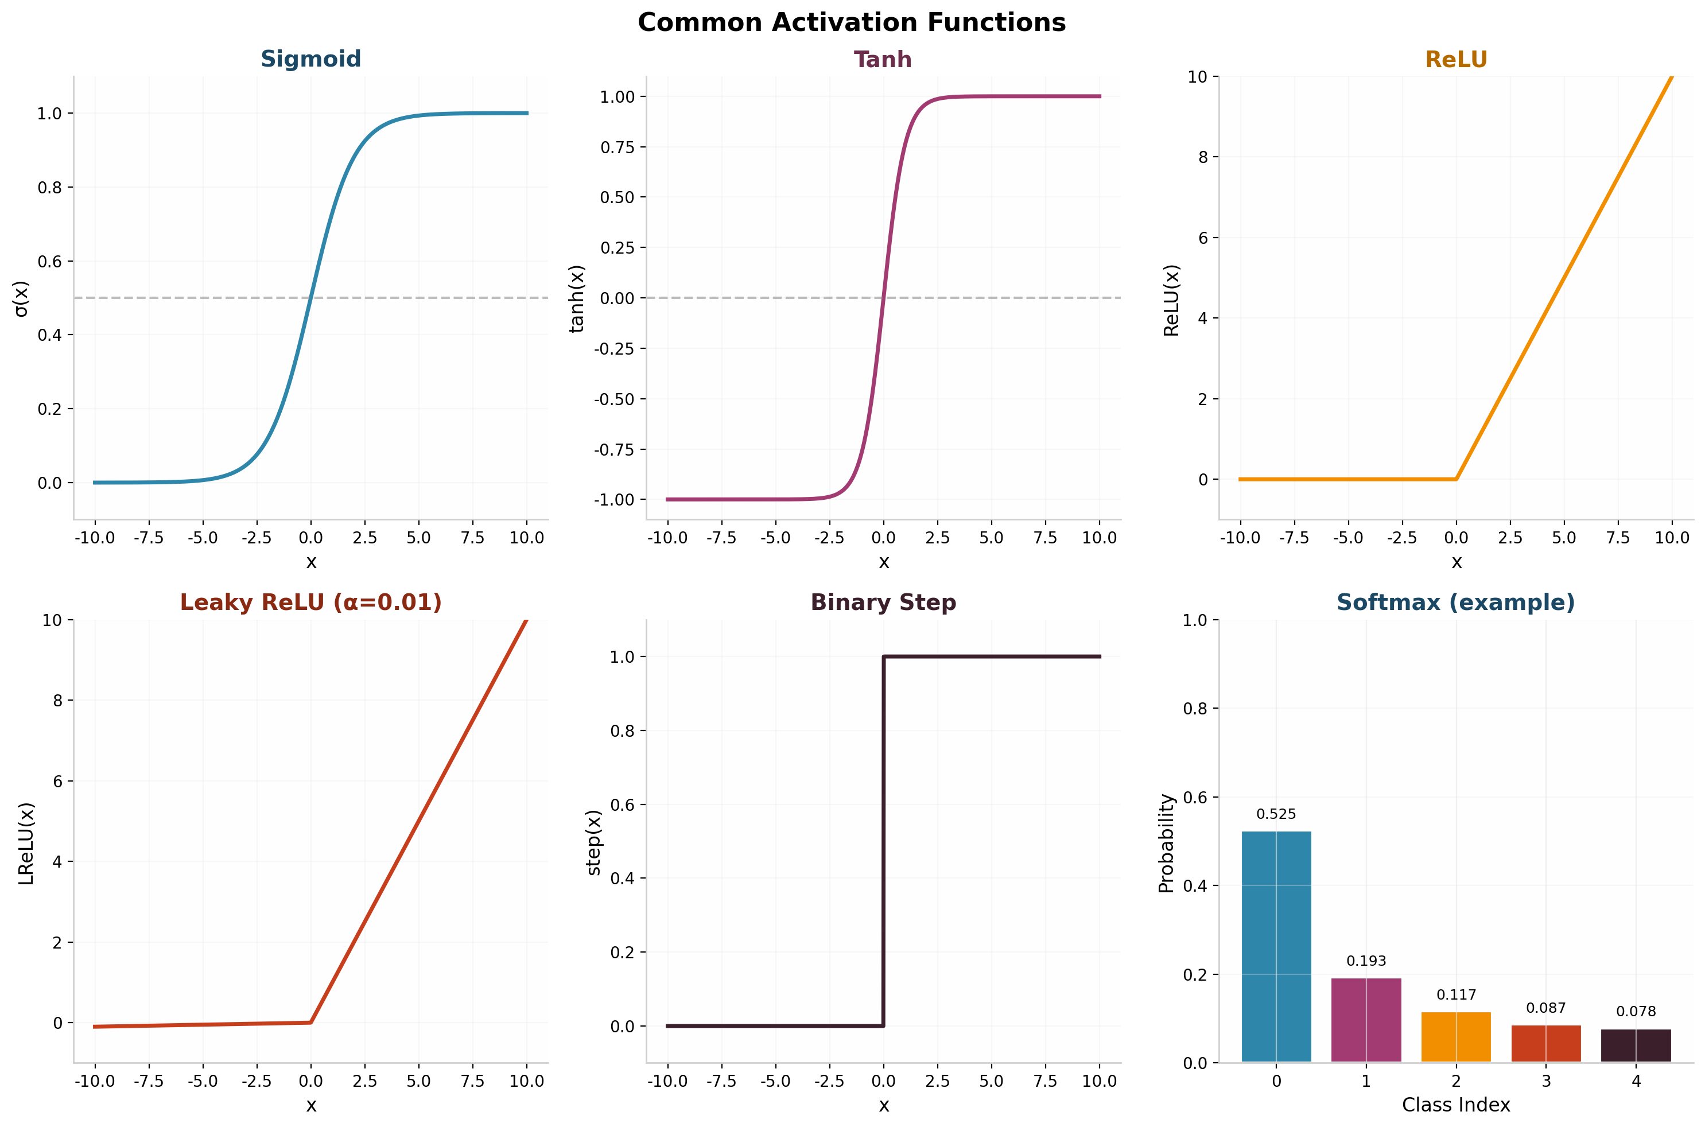
Figure 1: Common Activation Functions - Sigmoid, Tanh, ReLU, Leaky ReLU, Step, and Softmax

McCulloch-Pitts ANDNOT Network
Q: What is McCulloch-Pitts neuron?
Ans: The McCulloch-Pitts neuron (1943) is the first mathematical model of a biological neuron. It takes binary inputs, computes a weighted sum, compares it against a threshold, and produces a binary output (0 or 1). It forms the foundation of modern artificial neural networks.
Q: Who proposed McCulloch-Pitts model?
Ans: The McCulloch-Pitts model was proposed by Warren McCulloch (neurophysiologist) and Walter Pitts (mathematician) in their 1943 paper "A Logical Calculus of the Ideas Immanent in Nervous Activity".
Q: What are the characteristics of McCulloch-Pitts neuron?
Ans: Characteristics: (1) Binary inputs and outputs (0 or 1), (2) Fixed weights (cannot learn), (3) A threshold value determines firing, (4) Excitatory and inhibitory connections, (5) Operates as a simple logic gate, (6) No learning algorithm - weights must be manually set.
Q: What is threshold logic?
Ans: Threshold logic is a form of logic where a neuron fires (outputs 1) if the weighted sum of its inputs exceeds a specified threshold value; otherwise, it does not fire (outputs 0). It forms the basis of perceptron and other early neural network models.
Q: Explain ANDNOT gate.
Ans: ANDNOT is a logic gate where the output is 1 only when the first input is 1 AND the second input is NOT 1. For inputs A and B: Output = A AND (NOT B). Truth table: (0,0)->0, (0,1)->0, (1,0)->1, (1,1)->0. It can be implemented using excitatory and inhibitory connections in an M-P neuron.
Q: Write truth table for ANDNOT function.
Ans: ANDNOT Truth Table: A=0,B=0 -> Output=0; A=0,B=1 -> Output=0; A=1,B=0 -> Output=1; A=1,B=1 -> Output=0. The output is 1 only when A=1 and B=0.
Q: Why are inhibitory connections used?
Ans: Inhibitory connections (with negative weights) are used to suppress or block the neuron's firing when certain inputs are active. In the ANDNOT gate, the inhibitory connection on the B input prevents the output from being 1 when B is active, regardless of A's value.
Q: Why are negative weights assigned?
Ans: Negative weights represent inhibitory synapses in biological neurons. In the M-P model, assigning a sufficiently large negative weight ensures that when the inhibitory input is active (1), the weighted sum falls below the threshold, forcing the output to 0 regardless of other inputs.
Q: What is threshold value?
Ans: The threshold value (theta) is a predetermined constant in the M-P neuron. If the weighted sum of inputs is greater than or equal to the threshold, the neuron fires (outputs 1); otherwise, it outputs 0. The threshold determines the sensitivity of the neuron to its inputs.
Q: How does McCulloch-Pitts neuron generate output?
Ans: The neuron computes: y = 1 if sum(w_i * x_i) >= theta, else y = 0. Where w_i are weights (positive for excitatory, negative for inhibitory), x_i are binary inputs (0 or 1), and theta is the threshold. The output is strictly binary.
Q: What are binary inputs and outputs?
Ans: Binary inputs and outputs are values restricted to {0, 1}. In the M-P model, inputs represent whether a signal is absent (0) or present (1), and the output represents whether the neuron fires (1) or not (0). This simplifies the model to boolean logic operations.
Q: Difference between perceptron and McCulloch-Pitts neuron.
Ans: (1) Learning: Perceptron can learn weights automatically; M-P has fixed weights. (2) Inputs: Perceptron accepts real-valued inputs; M-P uses only binary inputs. (3) Weights: Perceptron weights can be positive or negative; M-P has separate excitatory/inhibitory connections. (4) Algorithm: Perceptron has a learning rule; M-P does not learn.
Q: What are the limitations of McCulloch-Pitts model?
Ans: Limitations: (1) No learning capability - weights are fixed, (2) Only binary inputs and outputs, (3) Cannot handle noise or continuous data, (4) No graded response - all-or-nothing output, (5) Cannot solve linearly inseparable problems like XOR, (6) Requires manual weight assignment for each logic function.
Q: Why is it called a logic neuron?
Ans: It is called a logic neuron because the M-P model can implement basic boolean logic functions (AND, OR, NOT, ANDNOT) using appropriate weights and thresholds. It essentially performs threshold logic operations, making it a mathematical abstraction of logical computation in the brain.
Q: Can McCulloch-Pitts neuron learn automatically?
Ans: No, the M-P neuron cannot learn automatically. Its weights and threshold must be manually designed and set by the programmer for each specific logic function. This is its biggest limitation compared to the perceptron, which introduced the concept of automated weight adjustment through learning rules.
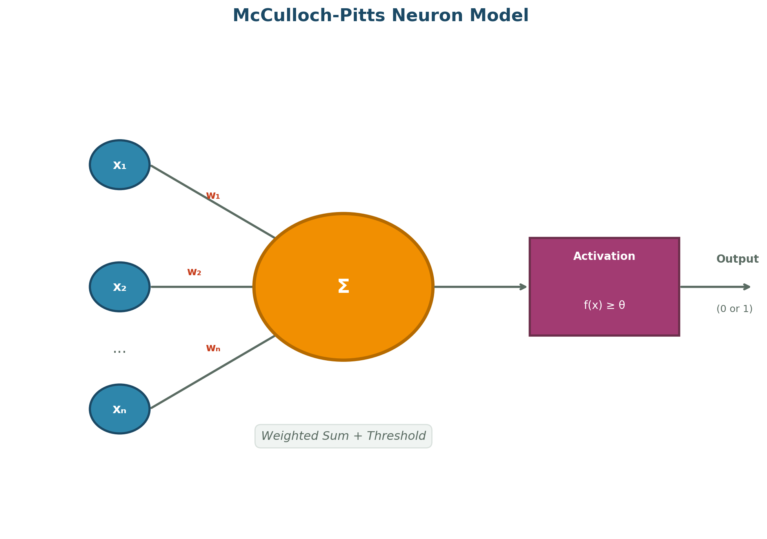
Figure 2: McCulloch-Pitts Neuron Model

Perceptron Even/Odd Recognition
Q: What is perceptron?
Ans: The perceptron, developed by Frank Rosenblatt (1958), is a single-layer neural network that can learn linearly separable patterns. It takes weighted inputs, adds a bias, applies an activation function, and compares with a threshold to produce a binary output. It uses a learning rule to automatically adjust weights based on errors.
Q: What is perceptron learning rule?
Ans: The perceptron learning rule updates weights based on the error between predicted and target outputs. Formula: w_new = w_old + learning_rate * (target - predicted) * input. If the prediction is correct, weights remain unchanged. If wrong, weights are adjusted in the direction that would produce the correct output.
Q: What is linear separability?
Ans: A dataset is linearly separable if a single straight line (in 2D) or hyperplane (in higher dimensions) can separate the data points of different classes. The perceptron can only solve problems that are linearly separable.
Q: Why can perceptron solve only linearly separable problems?
Ans: The perceptron is a linear classifier - its decision boundary is a straight line (or hyperplane). It computes a linear combination of inputs and can only separate classes that can be divided by such a linear boundary. Non-linearly separable problems (like XOR) cannot be solved by a single perceptron.
Q: Why are ASCII values used in this program?
Ans: ASCII values provide a numerical representation of characters. For digit characters '0'-'9', ASCII values 48-57 allow the perceptron to process them as numerical inputs. The perceptron can then learn patterns based on these numeric representations to classify even and odd digits.
Q: What is the ASCII value of digit 0?
Ans: The ASCII value of digit '0' is 48.
Q: What is the ASCII value of digit 9?
Ans: The ASCII value of digit '9' is 57.
Q: How is even/odd classification performed?
Ans: Even/odd classification is performed by training a perceptron to distinguish digits based on patterns in their ASCII values or binary representations. The perceptron learns weight values that produce positive output for even digits and negative output for odd digits (or vice versa).
Q: What are weights in perceptron?
Ans: Weights are numerical parameters that determine the importance of each input feature. Each input is multiplied by its corresponding weight, and the results are summed. During training, the perceptron learning rule adjusts these weights to minimize classification errors.
Q: What is bias?
Ans: Bias is an additional learnable parameter in the perceptron that shifts the decision boundary. It is added to the weighted sum of inputs before applying the activation function. Mathematically: output = f(w*x + b), where b is the bias term.
Q: Why is bias necessary?
Ans: Bias allows the decision boundary to shift away from the origin. Without bias, the separating line/hyperplane is forced to pass through the origin (0,0), which may not correctly separate the data. Bias provides the model with additional flexibility to fit the data better.
Q: What is learning rate?
Ans: Learning rate (eta) is a hyperparameter that controls the step size of weight updates during training. It determines how much the weights are adjusted in response to the estimated error. A value between 0 and 1 is typical.
Q: What happens if learning rate is very high?
Ans: A very high learning rate causes the perceptron to take large steps during weight updates. This can cause the model to overshoot the optimal solution, oscillate around the minimum, or even diverge, leading to unstable training and failure to converge.
Q: What happens if learning rate is very low?
Ans: A very low learning rate causes tiny weight updates. Training becomes extremely slow, requiring many more epochs to converge. The model may get stuck in local minima or take an impractically long time to reach the optimal solution.
Q: Explain perceptron training process.
Ans: The training process: (1) Initialize weights and bias (often to zero or small random values). (2) For each training sample, compute the output. (3) Compare with target; if error exists, update weights using the learning rule. (4) Repeat for multiple epochs until all samples are correctly classified or a stopping criterion is met.
Q: What is an epoch?
Ans: An epoch is one complete pass through the entire training dataset. During one epoch, the perceptron processes every training example once and updates its weights based on prediction errors. Multiple epochs are typically needed for the perceptron to converge.
Q: What is decision boundary?
Ans: The decision boundary is a line (in 2D) or hyperplane (in higher dimensions) that separates different classes. For the perceptron, it is defined by the equation: w1*x1 + w2*x2 + ... + wn*xn + b = 0. Points on one side are classified as one class, points on the other side as another class.
Q: Why is perceptron called single-layer network?
Ans: The perceptron is called a single-layer network because it has only one layer of learnable weights (from inputs to output). There are no hidden layers. This simple architecture limits its ability to solve complex, non-linearly separable problems.
Q: Difference between supervised and unsupervised learning.
Ans: In supervised learning, the training data includes labeled examples (input-output pairs), and the model learns to map inputs to correct outputs. In unsupervised learning, the data has no labels; the model discovers hidden patterns, clusters, or structures in the data on its own.
Q: Why XOR cannot be solved using single perceptron?
Ans: XOR is not linearly separable - no single straight line can separate the positive cases (0,1) and (1,0) from the negative cases (0,0) and (1,1) in the input space. A single perceptron can only learn linear decision boundaries, so it cannot solve XOR. Multi-layer networks are required.
Q: What is convergence in perceptron?
Ans: Convergence occurs when the perceptron has learned weights that correctly classify all training samples. Once converged, no further weight updates occur (error = 0 for all samples). The perceptron convergence theorem states that the perceptron will converge in a finite number of steps if the data is linearly separable.
Q: How are weights updated?
Ans: Weights are updated using the perceptron learning rule: w_i = w_i + learning_rate * (target - predicted) * x_i. If predicted = target, no update. If target=1 and predicted=0, weights increase. If target=0 and predicted=1, weights decrease. Bias is updated similarly.
Q: What activation function is used in perceptron?
Ans: The classical perceptron uses the step function (Heaviside function) as its activation function: output = 1 if weighted_sum >= threshold, else 0. Modern variants may use the sign function or other threshold-based activation functions.
Q: What is classification?
Ans: Classification is a supervised learning task where the goal is to assign input data to predefined categories or classes. The model learns from labeled training data to predict the class label of new, unseen inputs. Examples: digit recognition, spam detection, disease diagnosis.
Q: Difference between training data and testing data.
Ans: Training data is used to train the model - the model learns patterns and adjusts its weights using this data. Testing data is a separate, unseen dataset used to evaluate the model's performance and generalization ability. The model should not see testing data during training.
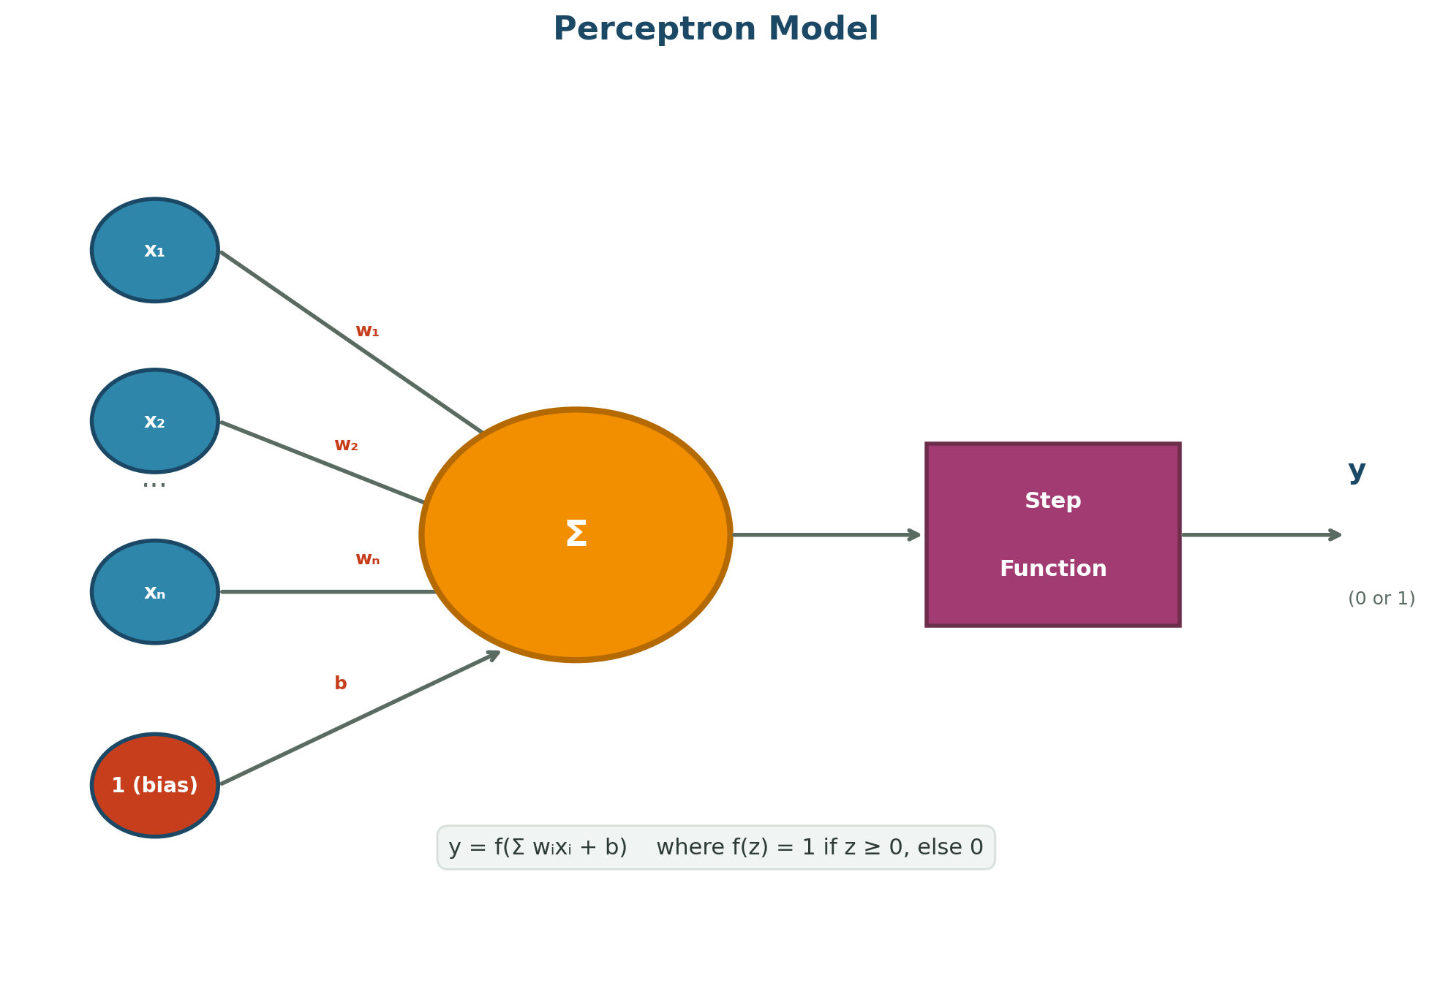
Figure 3: Perceptron Model Architecture

Perceptron Learning Law and Decision Regions
Q: What is perceptron learning law?
Ans: The perceptron learning law states that weights are updated proportionally to the error (difference between desired and actual output), the input value, and the learning rate. It ensures that the network gradually improves its classification accuracy over successive training iterations.
Q: Explain weight update formula.
Ans: The weight update formula is: delta_w = eta * (d - y) * x, where eta is learning rate, d is desired output, y is actual output, and x is input. New weight = old weight + delta_w. Bias is updated as: delta_b = eta * (d - y). This adjustment pushes the decision boundary toward misclassified points.
Q: What is decision region?
Ans: A decision region is the area in the input space where all points are classified into the same category. For a perceptron, the decision regions are separated by the decision boundary (a line or hyperplane). Points in one region belong to class A, points in the other region belong to class B.
Q: What is decision boundary?
Ans: The decision boundary is the surface (line in 2D, plane in 3D, hyperplane in higher dimensions) that separates different decision regions. It is defined by the equation where the net input to the perceptron equals zero: w^T * x + b = 0.
Q: Why are graphs plotted in perceptron learning?
Ans: Graphs visually demonstrate how the perceptron separates data, show the position and movement of the decision boundary during training, help identify whether data is linearly separable, and provide intuitive understanding of the learning process and convergence.
Q: What do different regions in graph represent?
Ans: Different regions in a perceptron decision graph represent areas where data points are classified into different categories. Points on one side of the decision boundary belong to one class (typically output = 1), while points on the other side belong to the other class (output = 0).
Q: How does perceptron classify points?
Ans: The perceptron classifies a point by computing the weighted sum of its coordinates plus bias. If the result is >= 0, it classifies the point as class 1; otherwise, class 0. Geometrically, points above the decision boundary line are classified as one class, points below as the other.
Q: What is a linearly separable dataset?
Ans: A linearly separable dataset is one where points of different classes can be completely separated by a single straight line (in 2D) or hyperplane (in higher dimensions). The perceptron convergence theorem guarantees that a perceptron will find such a separator if one exists.
Q: Why is graphical representation important?
Ans: Graphical representation provides visual intuition about the classification problem, helps verify that the perceptron has converged to a correct solution, reveals the geometry of decision boundaries, and helps diagnose why a problem might not be solvable by a linear classifier.
Q: What happens when data is not linearly separable?
Ans: When data is not linearly separable, the perceptron learning algorithm will never converge - it will keep updating weights indefinitely. The decision boundary will oscillate between different positions. Solutions include: using a multi-layer network, applying the delta rule, or using kernel methods.
Q: Explain convergence theorem.
Ans: The Perceptron Convergence Theorem (proven by Rosenblatt) states: If there exists a set of weights that can correctly classify all training examples (i.e., the data is linearly separable), then the perceptron learning algorithm will find such weights in a finite number of steps.
Q: What is misclassification?
Ans: Misclassification occurs when the perceptron assigns a data point to the wrong class. The difference between the target output and the perceptron's output is called the error. Each misclassification triggers a weight update during training.
Q: What are target outputs?
Ans: Target outputs (also called desired outputs or labels) are the correct class values provided in the training data. For binary classification, targets are typically 0 or 1 (or -1 and +1). The perceptron compares its predicted output against the target to compute the error for learning.
Q: Why are weights initialized randomly?
Ans: Random initialization breaks symmetry between neurons and prevents all neurons from learning identical features. It helps the optimization process explore different regions of the weight space. For perceptrons, small random values or zeros are common initial choices.
Q: What is the role of bias in shifting decision boundary?
Ans: The bias term shifts the decision boundary away from the origin. Geometrically, changing the bias moves the decision boundary parallel to itself (closer to or farther from the origin) without changing its orientation. This allows the perceptron to find better separation even when classes are not centered around the origin.
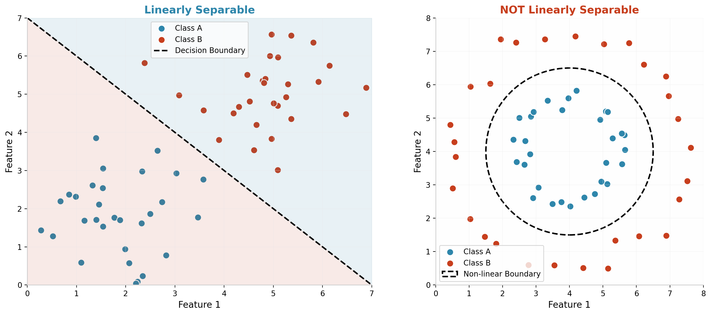
Figure 4: Linearly Separable vs Non-linearly Separable Data

BAM Network
Q: What is BAM network?
Ans: BAM (Bidirectional Associative Memory) is a recurrent neural network that stores and recalls pairs of patterns. It can map an input pattern to an associated output pattern and vice versa. BAM is a hetero-associative memory network developed by Bart Kosko in 1988.
Q: What does BAM stand for?
Ans: BAM stands for Bidirectional Associative Memory."Bidirectional" refers to the ability to recall patterns in both directions, and "Associative Memory" indicates that it stores pattern associations rather than isolated patterns.
Q: What is associative memory?
Ans: Associative memory is a type of memory that retrieves stored patterns based on partial or noisy input cues. It stores relationships between patterns so that presenting one pattern can recall its associated pattern. Examples include auto-associative (same type) and hetero-associative (different types) memory.
Q: Why is BAM called bidirectional?
Ans: BAM is called bidirectional because it can perform association in both directions. Given pattern A, it recalls pattern B; conversely, given pattern B, it recalls pattern A. The weight matrix W is used for forward mapping (A to B) and its transpose W^T for backward mapping (B to A).
Q: What are hetero-associative networks?
Ans: Hetero-associative networks store and recall mappings between different types of patterns. For example, mapping names to phone numbers, or English words to their translations. BAM is a hetero-associative network because it associates patterns from one set (X) with patterns from a different set (Y).
Q: Difference between auto-associative and hetero-associative memory.
Ans: Auto-associative memory retrieves the same type of pattern from partial or noisy versions of itself (e.g., completing a corrupted image from its clean version). Hetero-associative memory maps between different categories of patterns (e.g., name to phone number). Hopfield networks are auto-associative; BAM is hetero-associative.
Q: How does BAM store vector pairs?
Ans: BAM stores vector pairs using outer product learning. For each pair (X, Y), the weight matrix is computed as W = sum(X_i^T * Y_i) across all pattern pairs. The weights are set to the sum of outer products of associated pattern vectors, allowing the network to recall one pattern when the other is presented.
Q: What is bipolar representation?
Ans: Bipolar representation uses values {-1, +1} instead of {0, 1}. In this encoding, -1 represents inactive/off and +1 represents active/on. Bipolar encoding often provides better performance in associative memory networks because it creates stronger weight contributions and better noise tolerance.
Q: Why are bipolar values used instead of binary?
Ans: Bipolar values {-1, +1} are preferred over binary {0, 1} because: (1) They produce symmetric weight matrices, (2) The zero value in binary creates no learning signal, (3) Bipolar encoding provides better noise immunity, (4) It creates more stable energy landscapes for pattern recall.
Q: Explain BAM architecture.
Ans: BAM consists of two layers: Layer A (X) and Layer B (Y). Each layer has neurons corresponding to the dimensions of their respective pattern types. The layers are fully connected via weight matrix W (for X to Y) and W^T (for Y to X). There are no self-connections within a layer.
Q: What happens during recall phase?
Ans: During recall, an input pattern is presented to one layer. Signals propagate to the other layer through the weight matrix, producing an output pattern. This output is fed back to the original layer, and the process repeats until the network stabilizes (patterns stop changing). The stable state represents the recalled association.
Q: What is energy function in BAM?
Ans: The BAM energy function is: E = -X * W * Y^T. The network always converges to a state of minimum energy. As the network iterates, the energy monotonically decreases until it reaches a local minimum (stable state), which corresponds to a stored pattern pair.
Q: What are stable states?
Ans: Stable states (also called fixed points or attractors) are pattern pairs where the network's output stops changing upon iteration. When the network reaches a stable state, it has successfully recalled a stored association. Each stable state corresponds to a local minimum of the energy function.
Q: Applications of BAM network.
Ans: Applications include: pattern association and retrieval, content-addressable memory, error correction, image-to-text and text-to-image mapping, associative search, data completion from partial inputs, and bidirectional translation systems.
Q: Difference between BAM and Hopfield network.
Ans: BAM is hetero-associative (associates different pattern types bidirectionally) with two layers. Hopfield is auto-associative (recalls same pattern type from noisy input) with a single layer. BAM stores pair associations; Hopfield stores individual patterns. Both use energy minimization for convergence.
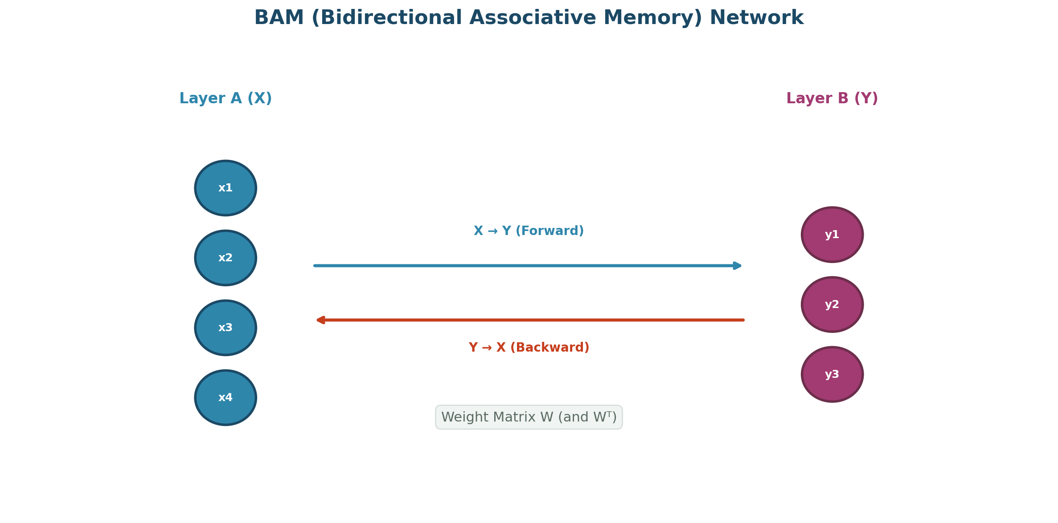
Figure 5: BAM (Bidirectional Associative Memory) Network Architecture

Number Recognition using 5x3 Matrix
Q: Why is 5x3 matrix used?
Ans: A 5x3 matrix (5 rows, 3 columns) provides a compact binary representation of digit patterns. It has 15 pixels total, which is sufficient to visually distinguish digits 0-9 while keeping the input dimension small enough for simple neural network training and fast computation.
Q: How are numbers represented in matrix form?
Ans: Each digit is represented as a 5x3 grid where each cell contains either 1 (pixel ON) or 0 (pixel OFF). For example, digit '0' has all border cells as 1 and center cells as 0. These 15 binary values form a 15-element input vector for the neural network.
Q: What is pattern recognition?
Ans: Pattern recognition is the process of identifying patterns in data and classifying them into categories. In the context of number recognition, it involves extracting features from digit representations and matching them against known patterns to identify which digit is being presented.
Q: Why are binary values used in matrix?
Ans: Binary values (0 and 1) simplify the representation and computation. They clearly indicate whether a pixel is ON or OFF, making it easy for the neural network to process. Binary inputs also work well with threshold-based activation functions and reduce storage requirements.
Q: What is feature extraction?
Ans: Feature extraction is the process of identifying and selecting relevant characteristics from raw data that help distinguish between different classes. In 5x3 digit recognition, the binary pixel values themselves serve as features that the network learns to associate with specific digit labels.
Q: What is training pattern?
Ans: A training pattern is a labeled example used to train the neural network. In number recognition, each training pattern consists of a 15-element input vector (flattened 5x3 matrix) paired with its corresponding digit label (0-9). The network learns by processing many such patterns.
Q: How does the network recognize numbers?
Ans: The network recognizes numbers by learning weight patterns that associate input features (pixel configurations) with output classes (digits). During training, weights are adjusted so that when a digit pattern is presented, the corresponding output neuron has the highest activation.
Q: Why matrix is converted into vector?
Ans: A 2D matrix is converted (flattened) into a 1D vector so it can be fed as input to the neural network. Most neural network implementations expect flat input vectors. A 5x3 matrix becomes a 15-element vector by concatenating rows or columns.
Q: What is noise in pattern recognition?
Ans: Noise refers to random variations or distortions in input patterns that differ from the ideal training examples. In digit recognition, noise could be flipped pixels, missing segments, or extra marks. A well-trained network should be robust to some level of noise.
Q: Can the network recognize distorted patterns?
Ans: Yes, if the network has been properly trained with sufficient examples and generalization capability. Neural networks can tolerate some noise and distortion because they learn the essential features rather than memorizing exact patterns. However, excessive distortion may exceed the network's tolerance.
Q: What is supervised learning in pattern recognition?
Ans: Supervised learning uses labeled training data (input patterns paired with correct output labels). The network learns by comparing its predictions against the true labels and adjusting weights to minimize errors. In digit recognition, each training image comes with its correct digit label.
Q: What are input neurons?
Ans: Input neurons are the neurons in the input layer that receive the raw data features. For 5x3 digit recognition, there are 15 input neurons, each receiving one binary pixel value from the flattened matrix.
Q: What are output neurons?
Ans: Output neurons are the neurons in the output layer that produce the network's predictions. For digit recognition (0-9), there are typically 10 output neurons, one for each digit class. The neuron with the highest activation indicates the predicted digit.
Q: Why normalization may be needed?
Ans: Normalization scales input values to a standard range (e.g., [0,1] or [-1,1]). For binary 5x3 matrices, values are already in {0,1}, so explicit normalization may not be necessary. However, converting to bipolar {-1,1} representation can sometimes improve learning.
Q: Applications of character recognition.
Ans: Applications include: postal code reading (ZIP codes), bank check processing (MICR), vehicle license plate recognition, document digitization (OCR), signature verification, form processing, assistive technology for the visually impaired, and automated data entry systems.
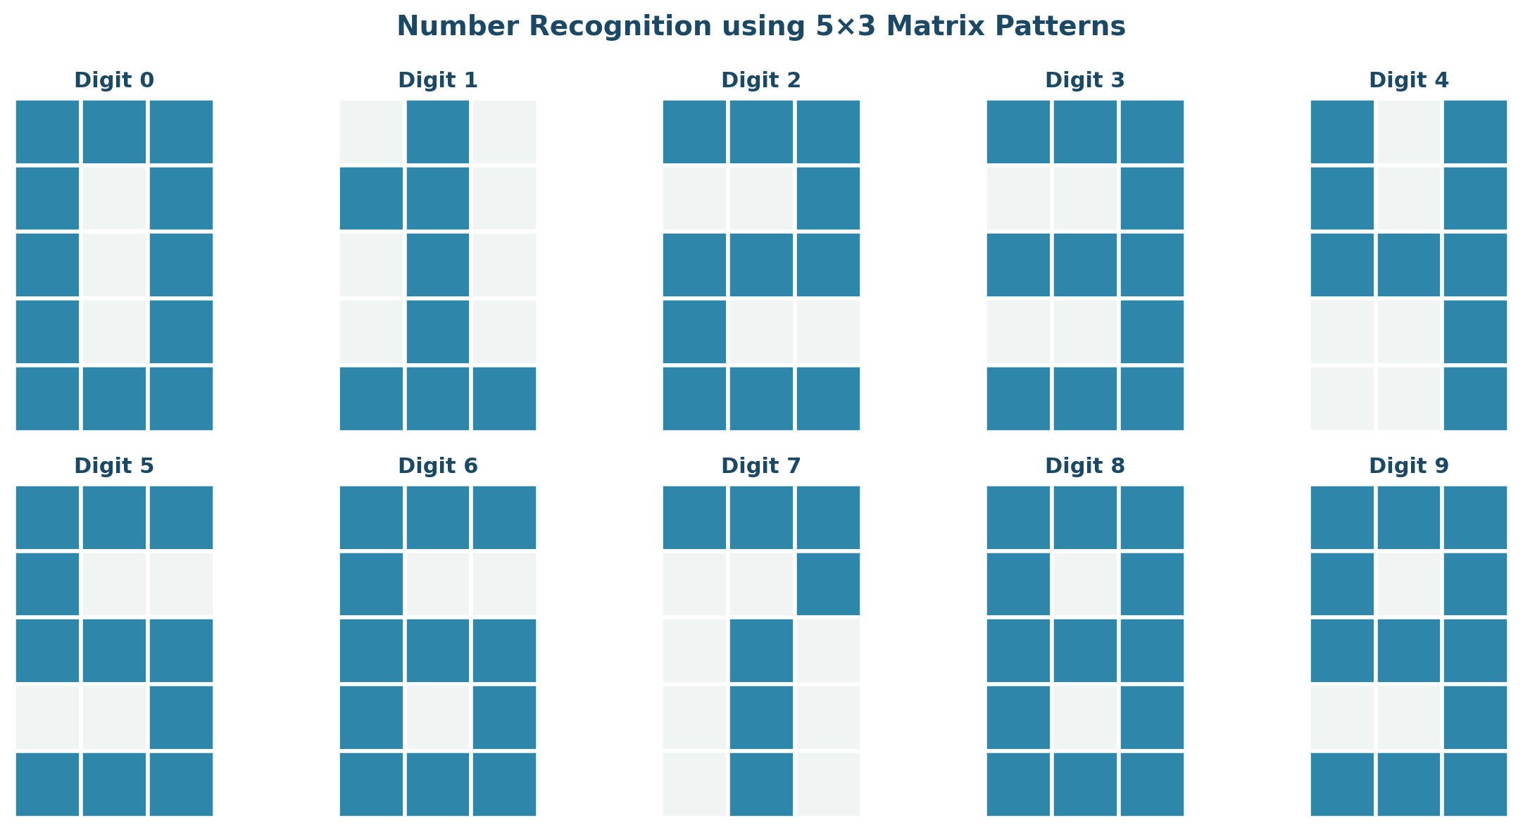
Figure 6: Digit Patterns in 5x3 Matrix Representation

ANN using Forward and Back Propagation
Q: What is forward propagation?
Ans: Forward propagation is the process of passing input data through the network layer by layer to compute the output. Each neuron's output is calculated by applying weights, adding bias, and passing the result through an activation function. The process flows from input layer to output layer.
Q: What is backpropagation?
Ans: Backpropagation (backward propagation of errors) is an algorithm for training neural networks. It computes the gradient of the loss function with respect to each weight by applying the chain rule, starting from the output layer and propagating backward to the input layer. These gradients are used to update weights and minimize error.
Q: Why is backpropagation important?
Ans: Backpropagation is the foundation of deep learning. It provides an efficient way to compute gradients for all weights in a multi-layer network, enabling automatic learning of complex representations. Without backpropagation, training deep networks with many layers would be computationally infeasible.
Q: Explain ANN architecture.
Ans: An Artificial Neural Network consists of: (1) Input layer - receives raw data features, (2) Hidden layer(s) - intermediate layers that extract and transform features, (3) Output layer - produces final predictions. Layers are fully or partially connected via weighted edges. Each neuron applies an activation function to its weighted inputs.
Q: What is hidden layer?
Ans: A hidden layer is a layer of neurons between the input and output layers. Hidden layers enable the network to learn complex, non-linear representations. Networks with one or more hidden layers are called multi-layer perceptrons (MLPs). Deep networks have many hidden layers.
Q: Why hidden layers are used?
Ans: Hidden layers allow neural networks to learn hierarchical feature representations. Each hidden layer can learn increasingly abstract features. Without hidden layers, the network can only learn linear relationships. Hidden layers enable universal function approximation - given enough neurons, a network with one hidden layer can approximate any continuous function.
Q: What is feed-forward network?
Ans: A feed-forward network is a neural network where information flows only in one direction - from input layer to hidden layers to output layer. There are no cycles or feedback connections. It is the simplest type of artificial neural network and the most common architecture.
Q: What is loss function?
Ans: A loss function (or cost function) measures the difference between the network's predicted output and the true target value. Common loss functions include Mean Squared Error (MSE) for regression and Cross-Entropy for classification. The goal of training is to minimize the loss function.
Q: What is mean squared error?
Ans: Mean Squared Error (MSE) = (1/n) * sum((y_true - y_pred)^2). It calculates the average of squared differences between predicted and actual values. MSE is commonly used for regression problems. Squaring penalizes larger errors more heavily and ensures the loss is always positive.
Q: What is gradient descent?
Ans: Gradient descent is an optimization algorithm that minimizes the loss function by iteratively moving in the direction of steepest descent (negative gradient). Weights are updated as: w = w - learning_rate * gradient. It is the fundamental algorithm for training neural networks.
Q: What is optimizer?
Ans: An optimizer is an algorithm that adjusts the network's weights and biases to minimize the loss function. While basic gradient descent is an optimizer, modern variants like Adam, RMSprop, and SGD with momentum provide faster convergence and better performance through adaptive learning rates and momentum.
Q: Explain Adam optimizer.
Ans: Adam (Adaptive Moment Estimation) combines ideas from RMSprop and momentum. It maintains moving averages of both the gradients (first moment) and squared gradients (second moment). It adapts the learning rate for each parameter, providing fast convergence, low memory requirements, and good performance across many problems.
Q: What is chain rule in backpropagation?
Ans: The chain rule from calculus allows computing the derivative of composite functions. In backpropagation, it is used to calculate how much each weight contributes to the overall error by multiplying partial derivatives through each layer: dL/dw = dL/dy * dy/dz * dz/dw. This decomposes the gradient computation into manageable steps.
Q: Why derivatives are required?
Ans: Derivatives tell us the direction and rate of change of the loss with respect to each weight. They indicate how to adjust weights to reduce the loss. The sign tells us which direction to move; the magnitude tells us how large the adjustment should be. Without derivatives, we could not perform gradient-based optimization.
Q: What is weight adjustment?
Ans: Weight adjustment is the process of updating weights during training based on computed gradients. Formula: w_new = w_old - learning_rate * (dL/dw). This iterative adjustment gradually reduces the loss function, improving the network's predictions over time.
Q: What is convergence?
Ans: Convergence occurs when the network's loss stops decreasing significantly and weights stabilize. The network has found (or is near) a minimum of the loss function. At convergence, further training yields little improvement in performance.
Q: What is local minima?
Ans: A local minimum is a point in the loss landscape where the loss is lower than all nearby points but not necessarily the lowest point overall. Gradient descent can get stuck in local minima, especially in complex loss landscapes with many dimensions.
Q: What is global minima?
Ans: The global minimum is the point in the entire loss landscape with the absolute lowest loss value. In practice, finding the true global minimum is often impossible or unnecessary - a good local minimum (low enough loss) usually provides satisfactory performance.
Q: What is overfitting?
Ans: Overfitting occurs when a model learns the training data too well, including noise and specific patterns that don't generalize. An overfit model performs well on training data but poorly on new, unseen data. Signs include: training accuracy much higher than test accuracy, and complex decision boundaries that capture noise.
Q: What is underfitting?
Ans: Underfitting occurs when a model is too simple to capture the underlying patterns in the data. The model performs poorly on both training and test data. Causes include: insufficient model complexity, too few features, excessive regularization, or insufficient training time.
Q: How can overfitting be reduced?
Ans: Techniques to reduce overfitting: (1) Increase training data, (2) Use dropout (randomly disable neurons during training), (3) Apply L1/L2 regularization (penalize large weights), (4) Early stopping (halt training when validation loss increases), (5) Data augmentation, (6) Simplify the model architecture, (7) Use batch normalization.
Q: What is dropout?
Ans: Dropout is a regularization technique where randomly selected neurons are temporarily disabled (set to zero) during training with probability p (typically 0.2-0.5). This prevents neurons from co-adapting too much and forces the network to learn more robust features. During inference, all neurons are used with weights scaled.
Q: Why epochs are required?
Ans: One epoch is one pass through the entire training dataset. Multiple epochs are needed because: (1) A single pass rarely achieves convergence, (2) Iterative weight updates gradually reduce the loss, (3) The model needs multiple exposures to learn complex patterns, (4) Each epoch refines the learned representations.
Q: What is batch size?
Ans: Batch size is the number of training samples used in one forward/backward pass before updating weights. Common choices: batch gradient descent (entire dataset), mini-batch (32-512 samples), or stochastic (1 sample). Larger batches provide more stable gradient estimates; smaller batches offer more frequent updates.
Q: Difference between stochastic and batch gradient descent.
Ans: Batch gradient descent uses the entire dataset for each weight update - stable but slow. Stochastic gradient descent (SGD) uses one random sample per update - fast but noisy. Mini-batch gradient descent uses a small batch (e.g., 32-256) - balances stability and speed. Mini-batch is most commonly used in practice.
Q: Why activation function is needed in hidden layers?
Ans: Without activation functions, hidden layers would perform only linear transformations, and the entire network would be equivalent to a single linear layer. Nonlinear activation functions enable hidden layers to learn and represent complex, non-linear relationships in the data, giving deep networks their expressive power.
Q: Why output differs from target initially?
Ans: Initially, weights are randomly initialized, so the network has not yet learned any meaningful patterns. The random weights produce essentially random outputs, resulting in large errors. Through training and backpropagation, weights are gradually adjusted to reduce this difference.
Q: What is training accuracy?
Ans: Training accuracy is the percentage of training samples correctly classified by the model. It measures how well the model has learned the training data. High training accuracy with low test accuracy indicates overfitting.
Q: What is testing accuracy?
Ans: Testing accuracy (or validation accuracy) is the percentage of correctly classified samples from a held-out test dataset that the model has never seen during training. It measures the model's generalization ability - how well it performs on new, real-world data.
Q: Why normalization improves training?
Ans: Normalization (scaling inputs to a standard range) improves training by: (1) Preventing features with large magnitudes from dominating, (2) Ensuring gradients are in a similar range for all weights, (3) Enabling higher learning rates without divergence, (4) Helping the optimization process converge faster to a better solution.
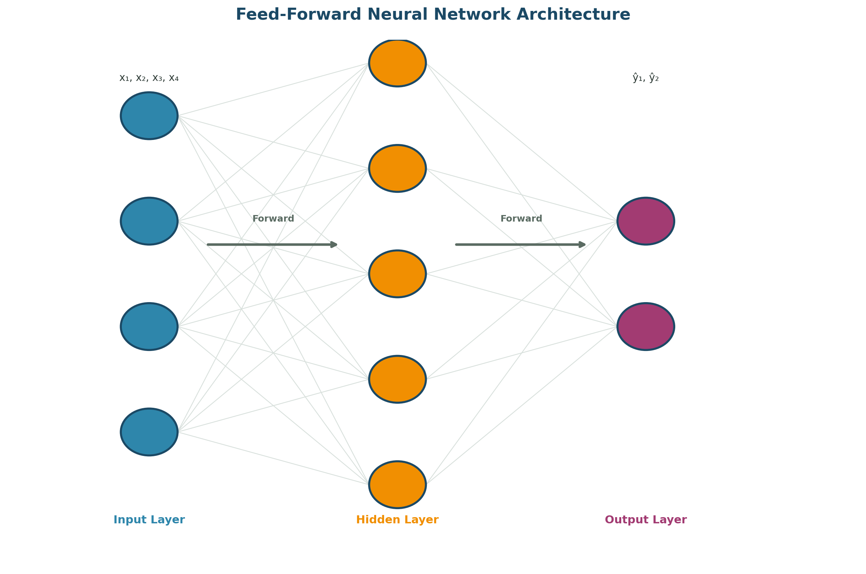
Figure 7: Feed-Forward Neural Network Architecture
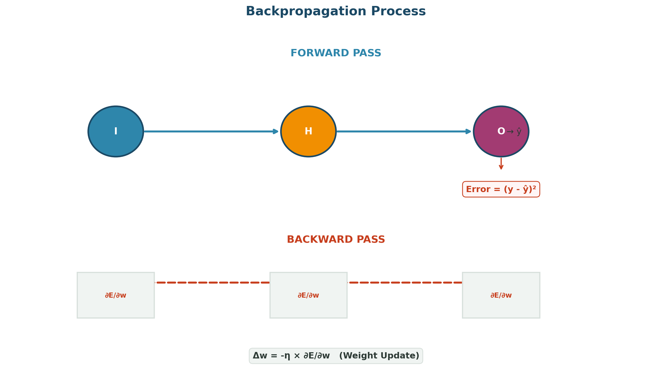
Figure 8: Backpropagation Process - Forward Pass and Backward Pass

Multi-class Classification Network
Q: What is multiclass classification?
Ans: Multiclass classification is the task of assigning an input to one of more than two categories. Unlike binary classification (two classes), multiclass handles three or more classes. Examples: handwritten digit recognition (10 classes), object recognition, and species classification.
Q: Why are multiple output neurons used?
Ans: In multiclass classification, each output neuron represents one class. The neuron with the highest activation value indicates the predicted class. This one-vs-all approach allows the network to learn separate decision boundaries for each class simultaneously.
Q: Why softmax is used in output layer?
Ans: Softmax converts raw output scores (logits) into a probability distribution where all values are between 0 and 1 and sum to 1. This makes the outputs interpretable as class probabilities and works well with cross-entropy loss for training multiclass classifiers.
Q: Why ReLU is used in hidden layer?
Ans: ReLU is used in hidden layers because it is computationally efficient, mitigates vanishing gradients for positive values, and enables sparse activations. It allows the network to learn faster and deeper representations compared to sigmoid or tanh activations.
Q: What is one-hot encoding?
Ans: One-hot encoding represents categorical labels as binary vectors where only the index corresponding to the correct class is 1 and all others are 0. For 10 digits, class '3' becomes [0,0,0,1,0,0,0,0,0,0]. This format is required for softmax output and cross-entropy loss computation.
Q: Explain neural network architecture used.
Ans: A typical multiclass architecture includes: (1) Input layer matching feature dimensions, (2) One or more hidden layers with ReLU activation, (3) Output layer with one neuron per class using softmax activation. The number of hidden layers and neurons depends on problem complexity.
Q: Why 100 neurons are used in hidden layer?
Ans: 100 neurons in a hidden layer provide sufficient capacity to learn complex patterns without excessive computation. This is a common default that balances expressiveness and efficiency. The optimal number depends on the problem and is often determined through experimentation.
Q: What is optimization algorithm?
Ans: An optimization algorithm minimizes the loss function by updating model parameters. Common algorithms include: SGD (Stochastic Gradient Descent), Adam, RMSprop, and Adagrad. Adam is widely preferred for its adaptive learning rates and fast convergence.
Q: Difference between binary and multiclass classification.
Ans: Binary classification distinguishes between two classes (output: single neuron with sigmoid). Multiclass classification assigns inputs to one of three or more classes (output: multiple neurons with softmax). Binary uses binary cross-entropy loss; multiclass uses categorical cross-entropy.
Q: What is confusion matrix?
Ans: A confusion matrix is a table that visualizes classification performance. Rows represent actual classes, columns represent predicted classes. Diagonal elements show correct predictions; off-diagonal elements show misclassifications. It reveals which classes are commonly confused with each other.
Q: What is precision?
Ans: Precision = True Positives / (True Positives + False Positives). It measures the accuracy of positive predictions - of all instances predicted as a class, what fraction actually belongs to that class. High precision means few false positives.
Q: What is recall?
Ans: Recall = True Positives / (True Positives + False Negatives). It measures the ability to find all positive instances - of all actual instances of a class, what fraction were correctly identified. High recall means few false negatives.
Q: What is F1-score?
Ans: F1-score is the harmonic mean of precision and recall: F1 = 2 * (Precision * Recall) / (Precision + Recall). It provides a single balanced metric that considers both false positives and false negatives. It is especially useful when classes are imbalanced.
Q: What is categorical cross entropy?
Ans: Categorical Cross-Entropy = -sum(y_true * log(y_pred)). It measures the difference between the predicted probability distribution (from softmax) and the true one-hot encoded labels. It penalizes confident wrong predictions heavily and is the standard loss for multiclass classification.
Q: Why threshold values are used?
Ans: Threshold values (typically 0.5 for binary, argmax for multiclass) convert continuous model outputs into discrete class predictions. They define the decision boundary for classification. Adjusting thresholds can trade off precision and recall depending on application requirements.
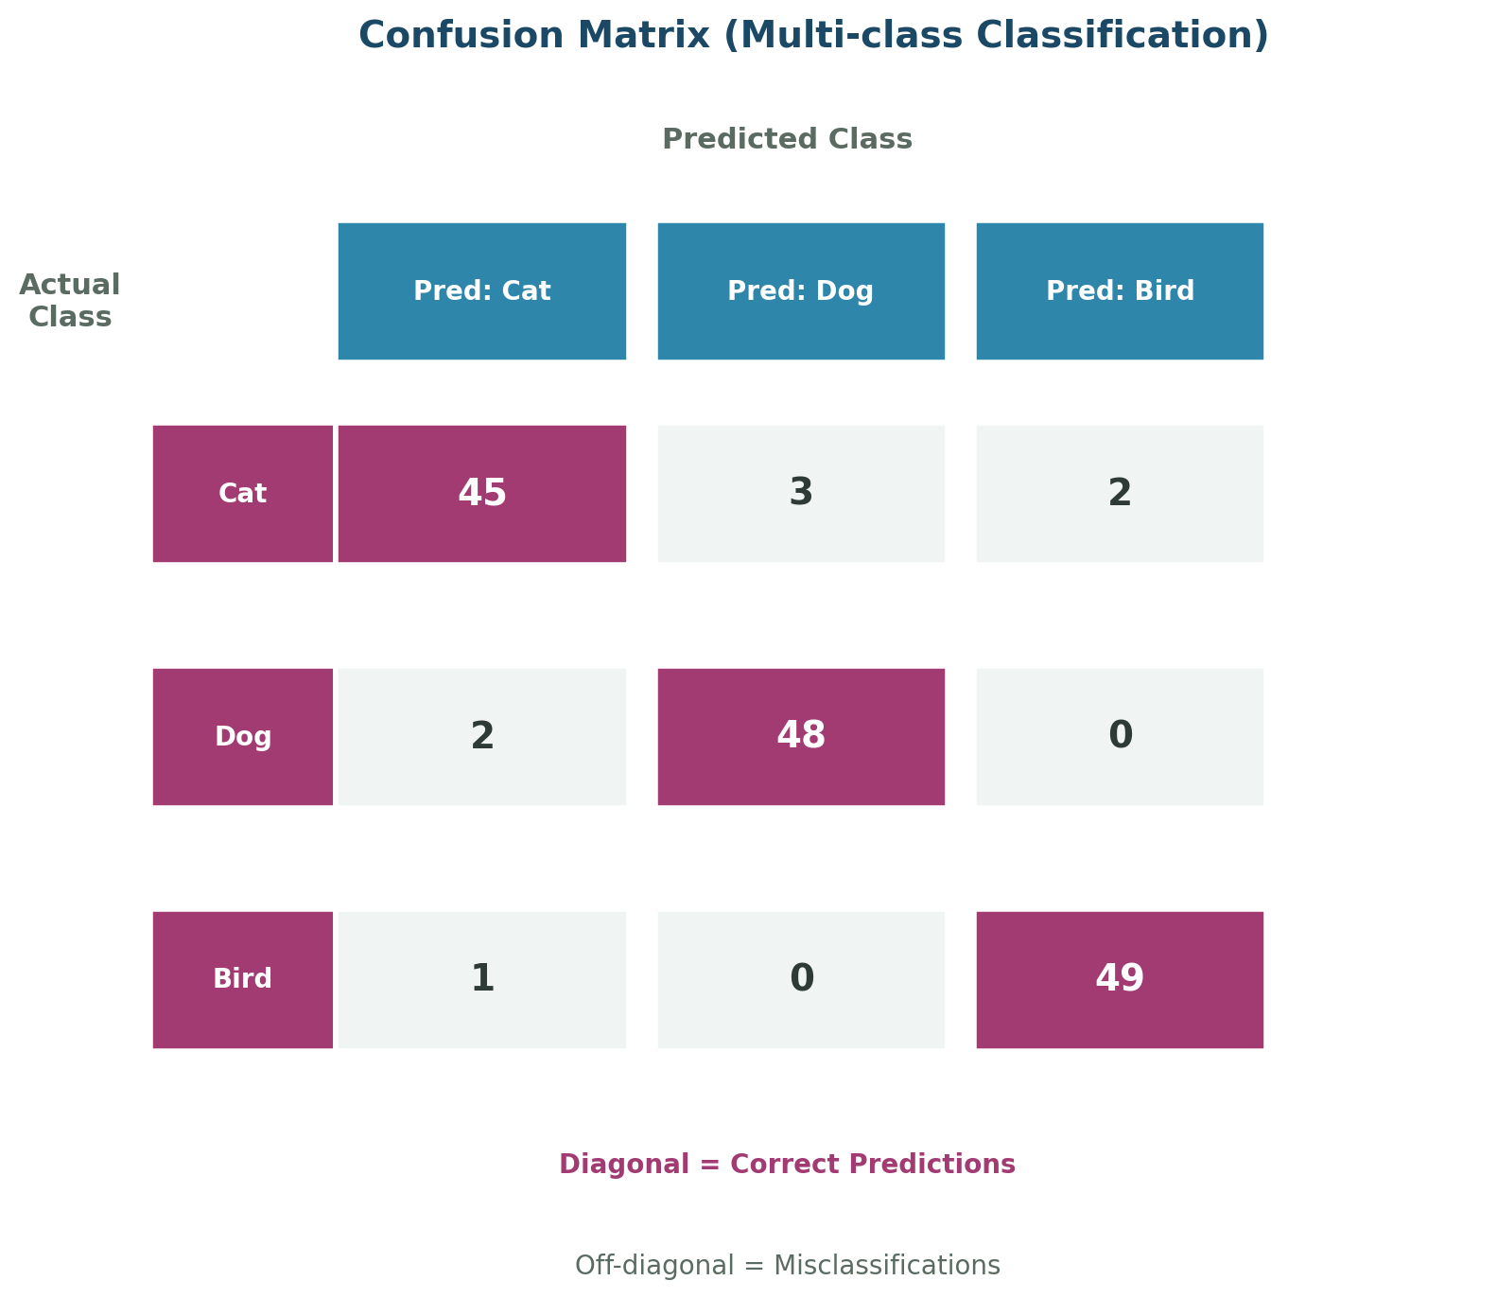
Figure 9: Confusion Matrix for Multi-class Classification

Group B Viva Questions

XOR using Backpropagation
Q: What is XOR problem?
Ans: The XOR (Exclusive OR) problem requires outputting 1 when inputs are different (0,1 or 1,0) and 0 when they are the same (0,0 or 1,1). It is a classic problem that demonstrates the limitation of single-layer perceptrons and the need for multi-layer networks with hidden layers.
Q: Why XOR is not linearly separable?
Ans: In the 2D input space, the positive points (0,1) and (1,0) cannot be separated from the negative points (0,0) and (1,1) by any single straight line. No matter how the line is positioned, at least one point will be on the wrong side. This makes XOR impossible for linear classifiers.
Q: Why perceptron fails for XOR?
Ans: A single perceptron can only learn linear decision boundaries. Since XOR is not linearly separable, no single line can correctly classify all four input patterns. The perceptron learning algorithm will oscillate indefinitely without converging.
Q: Why hidden layer solves XOR?
Ans: A hidden layer allows the network to learn non-linear decision boundaries. The hidden neurons can learn intermediate representations - for example, one hidden neuron can learn OR and another can learn AND. Combining these enables the network to solve XOR by creating non-linear separation in the transformed feature space.
Q: Explain XOR truth table.
Ans: XOR Truth Table: Input A=0, B=0 -> Output=0; A=0, B=1 -> Output=1; A=1, B=0 -> Output=1; A=1, B=1 -> Output=0. The output is 1 (true) when exactly one input is 1, and 0 (false) otherwise.
Q: What activation function is used?
Ans: For XOR with backpropagation, sigmoid is commonly used in both hidden and output layers. Modern implementations might use ReLU in hidden layers and sigmoid in the output layer. The sigmoid's differentiability enables gradient-based learning through backpropagation.
Q: Why backpropagation is required in XOR?
Ans: Backpropagation is required to train the multi-layer network because there is no direct way to determine how hidden layer weights affect the output error. Backpropagation uses the chain rule to compute gradients for all weights, including those in hidden layers, enabling end-to-end training.
Q: How are weights updated?
Ans: Weights are updated through backpropagation: (1) Compute output error, (2) Calculate gradients for output layer weights, (3) Propagate error backward to hidden layer, (4) Calculate hidden layer gradients using the chain rule, (5) Update all weights using: w = w - learning_rate * gradient.
Q: What is nonlinear classification?
Ans: Nonlinear classification involves separating data using curved or complex decision boundaries that cannot be represented by a single straight line or hyperplane. Problems like XOR require nonlinear classifiers, which multi-layer neural networks can learn through hidden layers and nonlinear activation functions.
Q: What is error propagation?
Ans: Error propagation is the process of distributing the output error backward through the network during backpropagation. The error at each layer is computed based on the errors of the subsequent layer, weighted by the connecting weights. This allows hidden layers to learn by attributing their contribution to the overall error.
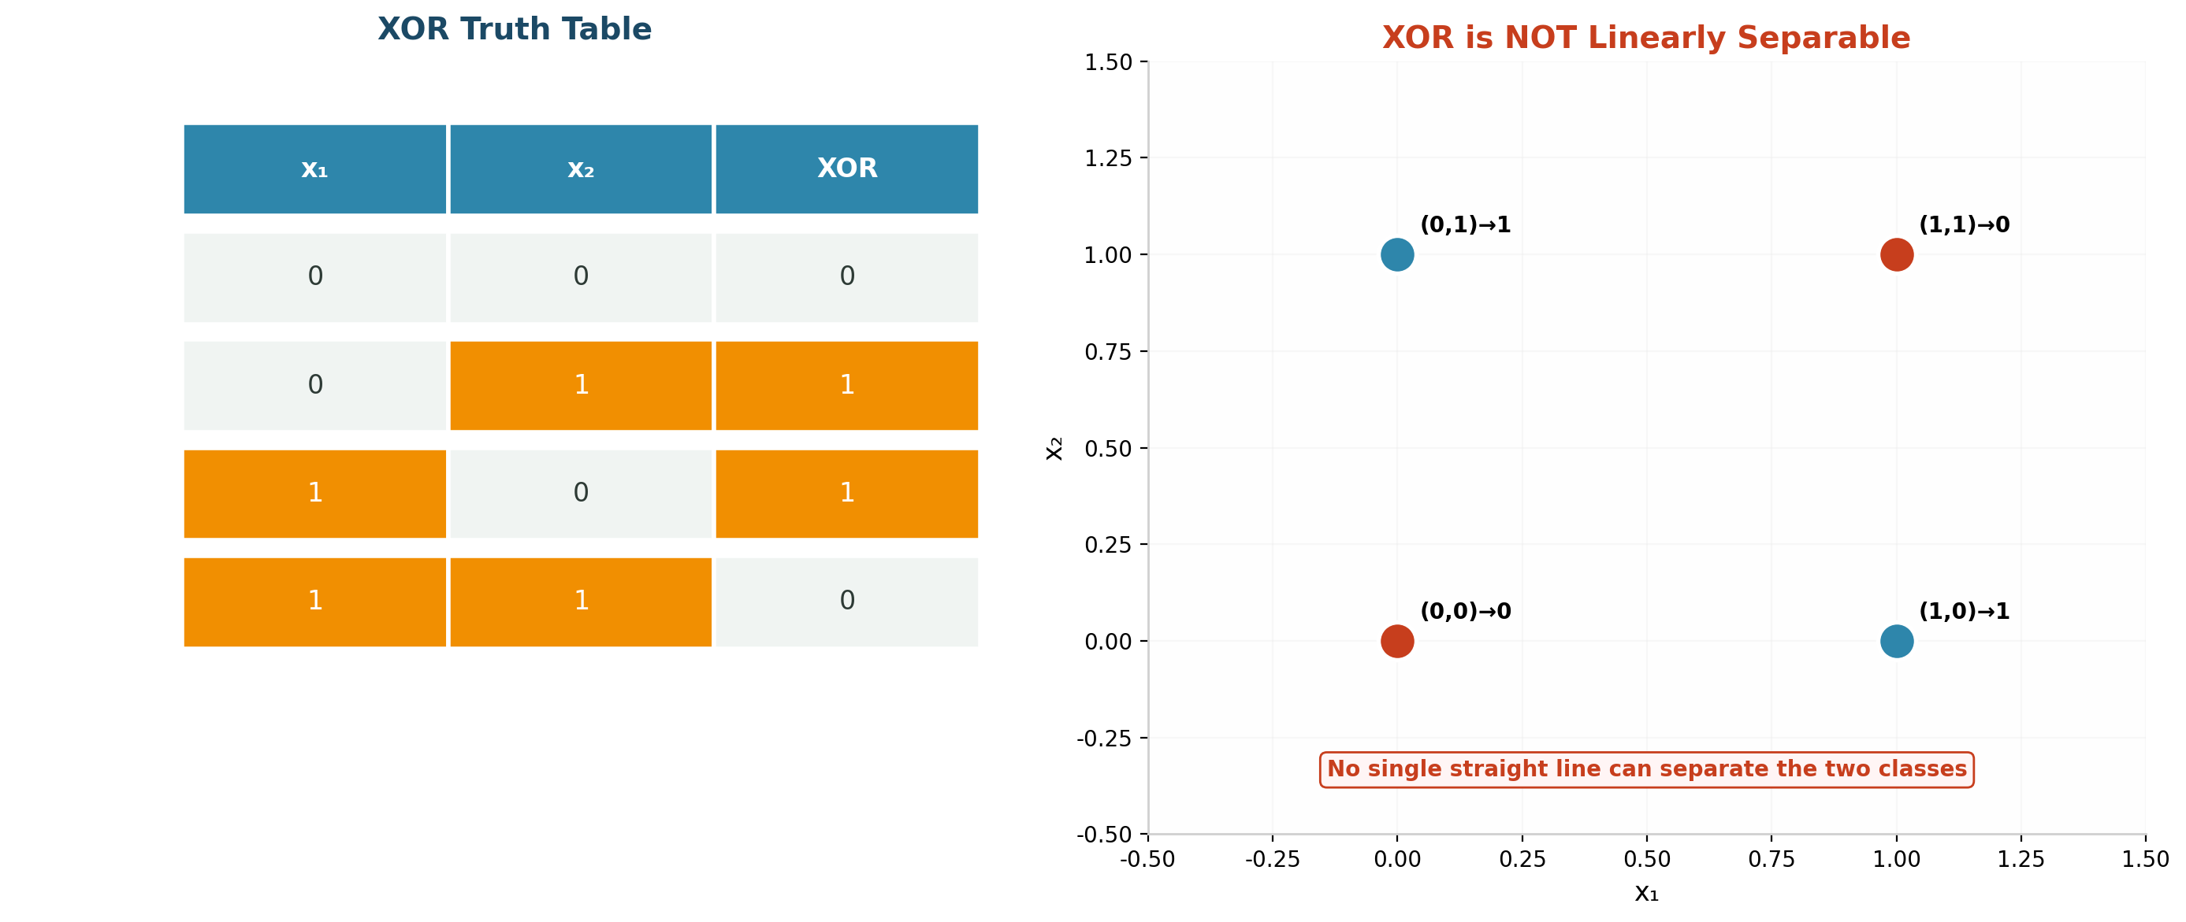
Figure 10: XOR Problem - Truth Table and Linear Inseparability

ART Neural Network
Q: What is ART network?
Ans: ART (Adaptive Resonance Theory) is a type of neural network developed by Stephen Grossberg and Gail Carpenter. It is designed for unsupervised learning and clustering. ART networks can learn new patterns without forgetting previously learned ones, solving the stability-plasticity dilemma.
Q: What does ART stand for?
Ans: ART stands for Adaptive Resonance Theory. 'Adaptive' refers to the network's ability to learn new patterns, 'Resonance' describes the matching process between input and stored patterns, and 'Theory' indicates the mathematical framework behind these networks.
Q: What problem does ART solve?
Ans: ART solves the stability-plasticity dilemma - the challenge of being able to learn new information (plasticity) while retaining previously learned information (stability). Traditional networks often suffer from catastrophic forgetting when learning new patterns. ART maintains both capabilities.
Q: What is stability-plasticity dilemma?
Ans: The stability-plasticity dilemma is the trade-off between a network's ability to learn new patterns (plasticity) and its ability to preserve existing knowledge (stability). A network that is too plastic forgets old patterns; one that is too stable cannot learn new ones. ART addresses this through its vigilance mechanism.
Q: What is vigilance parameter?
Ans: The vigilance parameter (rho, typically 0-1) controls how closely an input must match an existing cluster prototype to be assigned to that cluster. Higher vigilance requires closer matches (more clusters); lower vigilance allows more dissimilar patterns to group together (fewer clusters).
Q: What happens when vigilance is high?
Ans: High vigilance (close to 1) requires very close matches between input and stored prototypes. This creates many fine-grained clusters, potentially creating a new cluster for each slightly different input. The network becomes highly selective and may create too many categories.
Q: What happens when vigilance is low?
Ans: Low vigilance (close to 0) allows dissimilar patterns to be grouped into the same cluster. This creates fewer, broader categories. The network becomes more generalizing but may incorrectly merge genuinely different patterns into the same cluster.
Q: Explain resonance in ART.
Ans: Resonance occurs when the similarity between an input pattern and a selected prototype exceeds the vigilance threshold. When resonance is achieved, the network enters a stable state where the matching prototype is updated (learns from the input). Without resonance, the network searches for another prototype or creates a new category.
Q: Is ART supervised or unsupervised?
Ans: Basic ART (ART1, ART2) is unsupervised - it discovers clusters in data without labeled examples. Fuzzy ART and ARTMAP variants exist for supervised learning. The classic ART networks perform competitive learning and clustering without requiring target outputs.
Q: Applications of ART network.
Ans: Applications include: pattern recognition and clustering, data mining, image processing, speech recognition, fault diagnosis, medical diagnosis, customer segmentation, document classification, anomaly detection, and real-time learning systems where data arrives sequentially.
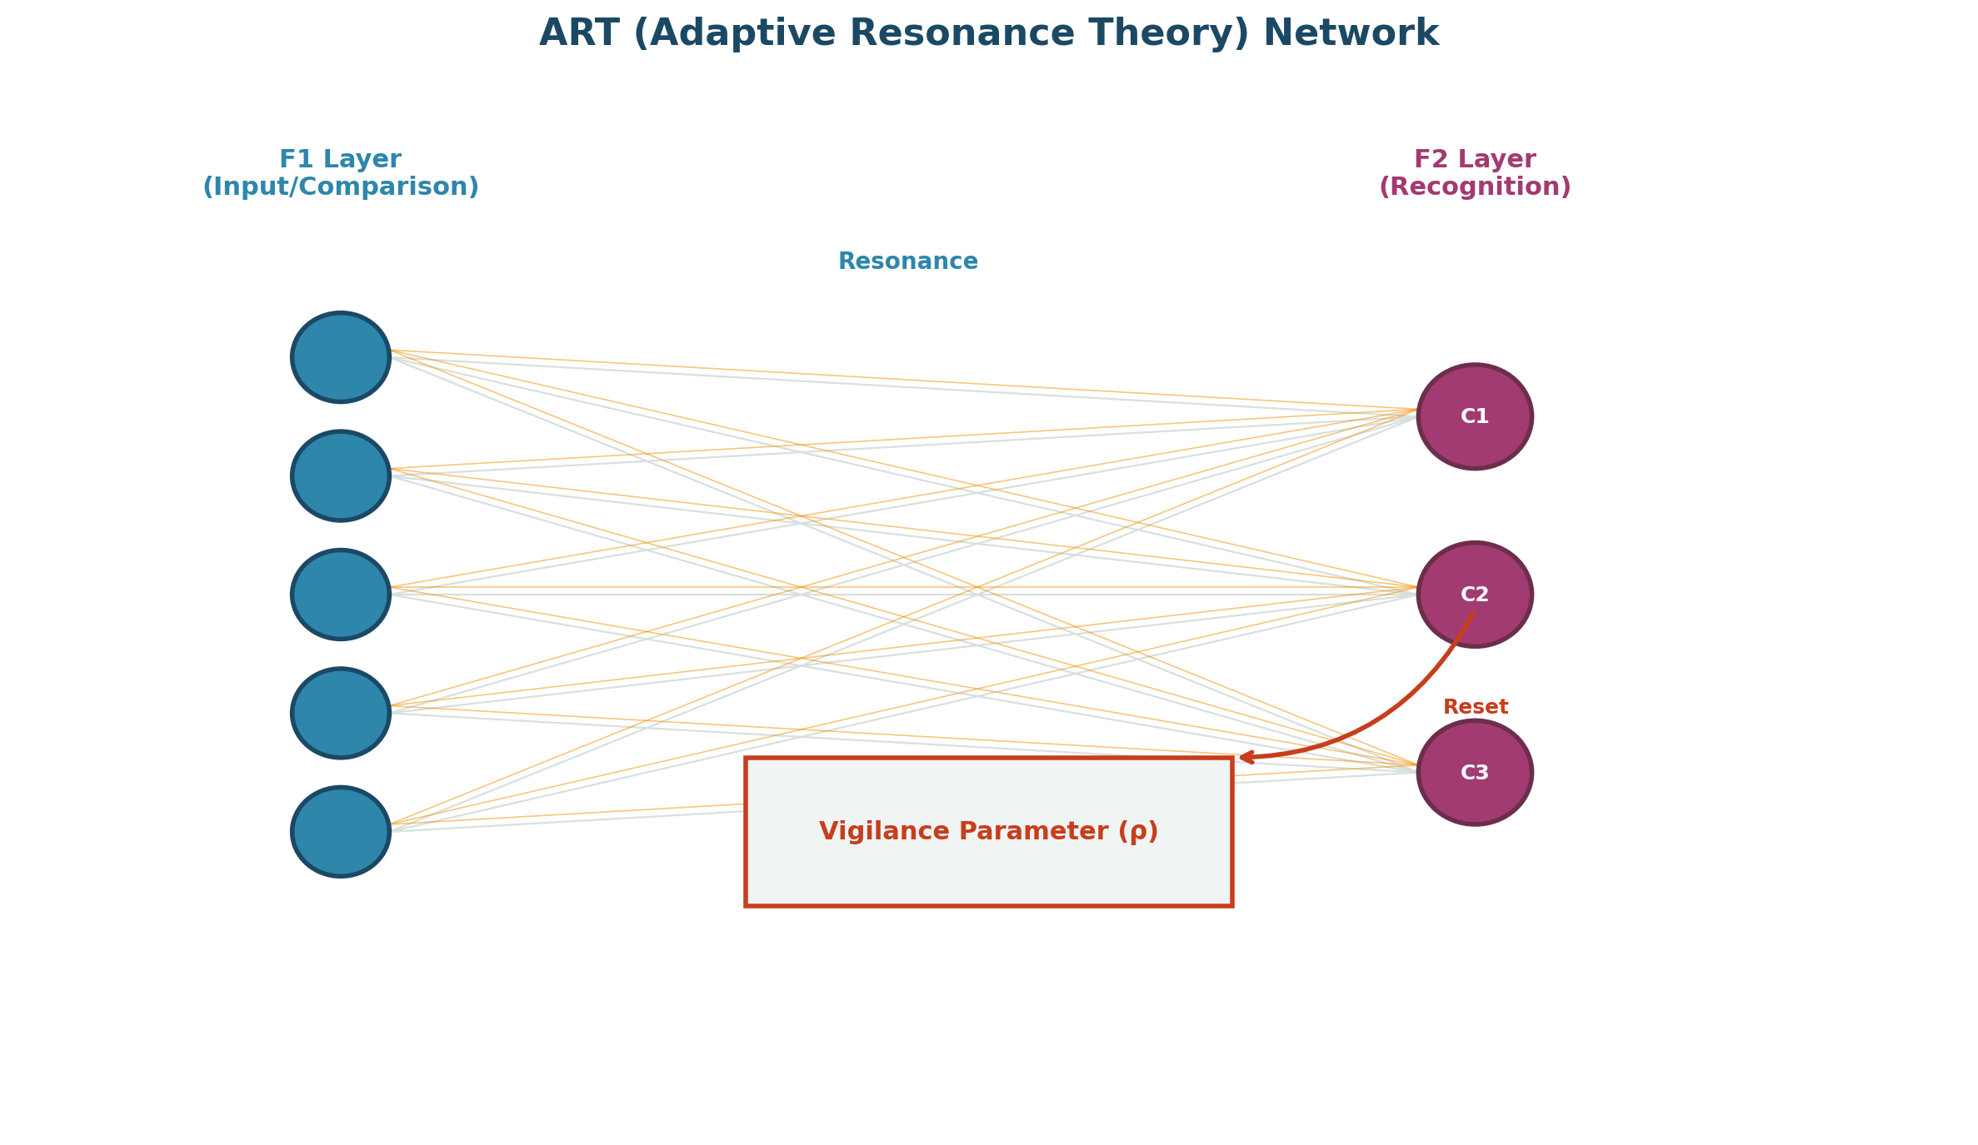
Figure 11: ART (Adaptive Resonance Theory) Network Architecture

Backpropagation Feed Forward Network
Q: What is feed-forward neural network?
Ans: A feed-forward neural network is a type of artificial neural network where connections between neurons do not form cycles. Information moves in one direction only: from the input layer, through any hidden layers, to the output layer. It is the simplest and most commonly used neural network architecture.
Q: Why is it called feed-forward?
Ans: It is called feed-forward because data flows only in the forward direction - from input to output. There are no feedback connections where outputs of later layers are fed back into earlier layers. The term 'feed' refers to data being fed through the network layer by layer.
Q: Difference between feed-forward and recurrent networks.
Ans: Feed-forward networks have no cycles - information flows one way from input to output. Recurrent Neural Networks (RNNs) have feedback connections, allowing information to persist and flow in cycles. RNNs are suited for sequential data (time series, text); feed-forward networks are suited for static inputs (images, tabular data).
Q: What are hidden layers?
Ans: Hidden layers are intermediate layers between the input and output layers in a neural network. They perform feature extraction and transformation. A network with one hidden layer is a simple MLP; with many hidden layers, it becomes a deep neural network (DNN). Each hidden layer learns increasingly abstract representations.
Q: Explain training process.
Ans: The training process: (1) Initialize weights randomly, (2) Forward pass - compute predictions, (3) Calculate loss (difference between prediction and target), (4) Backward pass - compute gradients via backpropagation, (5) Update weights using optimizer, (6) Repeat for multiple epochs until convergence.
Q: Why backpropagation is used?
Ans: Backpropagation is used because it provides an efficient way to compute gradients for all weights in a multi-layer network. Without it, calculating how each weight contributes to the output error would be computationally infeasible for deep networks. It enables automatic, end-to-end training.
Q: What is forward pass?
Ans: The forward pass is the process of computing the network's output given an input. Data flows from the input layer through each hidden layer (applying weights, biases, and activation functions) to the output layer. This produces the prediction used to calculate the loss.
Q: What is backward pass?
Ans: The backward pass (backpropagation) computes gradients of the loss with respect to each weight by applying the chain rule from the output layer back to the input layer. These gradients indicate how to adjust weights to reduce the loss and are used by the optimizer for weight updates.
Q: What is error minimization?
Ans: Error minimization is the goal of training - finding the set of weights that produces the smallest possible difference between predicted and actual outputs. This is achieved through iterative gradient descent optimization, which adjusts weights to reduce the loss function.
Q: What is weight initialization?
Ans: Weight initialization is the process of setting initial values for network weights before training begins. Good initialization (e.g., Xavier/Glorot, He initialization) helps prevent vanishing or exploding gradients, enables faster convergence, and can improve final model performance.

Hopfield Network
Q: What is Hopfield network?
Ans: The Hopfield network, introduced by John Hopfield in 1982, is a recurrent auto-associative neural network that stores and recalls patterns. It uses bidirectional connections with symmetric weights and converges to stable states (attractors) representing stored memories.
Q: What type of network is Hopfield network?
Ans: Hopfield network is a type of recurrent neural network (RNN) with fully connected symmetric weights. It is also an auto-associative memory network - it retrieves a complete stored pattern from a partial or noisy version of the same pattern type.
Q: What is associative memory?
Ans: Associative memory is memory that can be accessed by content rather than by address. Given a partial, noisy, or corrupted version of a stored pattern, the network can recall the complete original pattern. Hopfield implements auto-associative memory (same pattern type in and out).
Q: What are recurrent neural networks?
Ans: Recurrent Neural Networks (RNNs) are networks with feedback connections where outputs can be fed back as inputs. This allows them to maintain internal state and process sequential data. Unlike feed-forward networks, RNNs can have cycles in their connection graph.
Q: Why are weights symmetric?
Ans: Weights in Hopfield networks are symmetric (w_ij = w_ji) to guarantee that the network converges to a stable state. Symmetric weights ensure the energy function decreases monotonically, preventing oscillations and ensuring the network settles into an attractor state.
Q: What is energy function?
Ans: The Hopfield energy function is: E = -0.5 * sum(w_ij * s_i * s_j) + sum(theta_i * s_i), where s_i are neuron states and w_ij are weights. The network always evolves toward a state of minimum energy. Each stored pattern corresponds to a local minimum of this energy landscape.
Q: What is stable state?
Ans: A stable state (attractor or fixed point) is a pattern where all neuron states remain unchanged upon update. When the network reaches a stable state, it has successfully recalled a stored memory. The network dynamics guarantee convergence to such states due to energy minimization.
Q: What is spurious state?
Ans: A spurious state is a stable state that does not correspond to any stored pattern. These are unintended attractors in the energy landscape, typically linear combinations of stored patterns (e.g., mixtures of memories). They represent false memories that the network can incorrectly converge to.
Q: How are patterns stored?
Ans: Patterns are stored using Hebbian learning: w_ij = sum(p_i * p_j) for all patterns p, with w_ii = 0 (no self-connections). This outer product rule creates weights that encode correlations between pattern elements. The network capacity is approximately 0.15 * N patterns for N neurons.
Q: What is pattern recall?
Ans: Pattern recall is the process of retrieving a stored pattern from a partial or noisy input. The input pattern is set as the initial state, and the network dynamics evolve the state until it converges to the nearest stable state (stored pattern). This is content-addressable memory in action.
Q: Applications of Hopfield network.
Ans: Applications include: pattern completion and restoration, noise reduction in images, content-addressable memory, error correction, optimization problems (TSP), associative memory systems, handwriting recognition, and as a theoretical model for understanding human memory.
Q: Difference between BAM and Hopfield network.
Ans: BAM is hetero-associative (bidirectional mapping between different pattern types, X <-> Y) with two layers. Hopfield is auto-associative (recalls same pattern type from partial/noisy input) with one layer. BAM uses weight matrix W and W^T; Hopfield uses symmetric weight matrix W with zero diagonal.
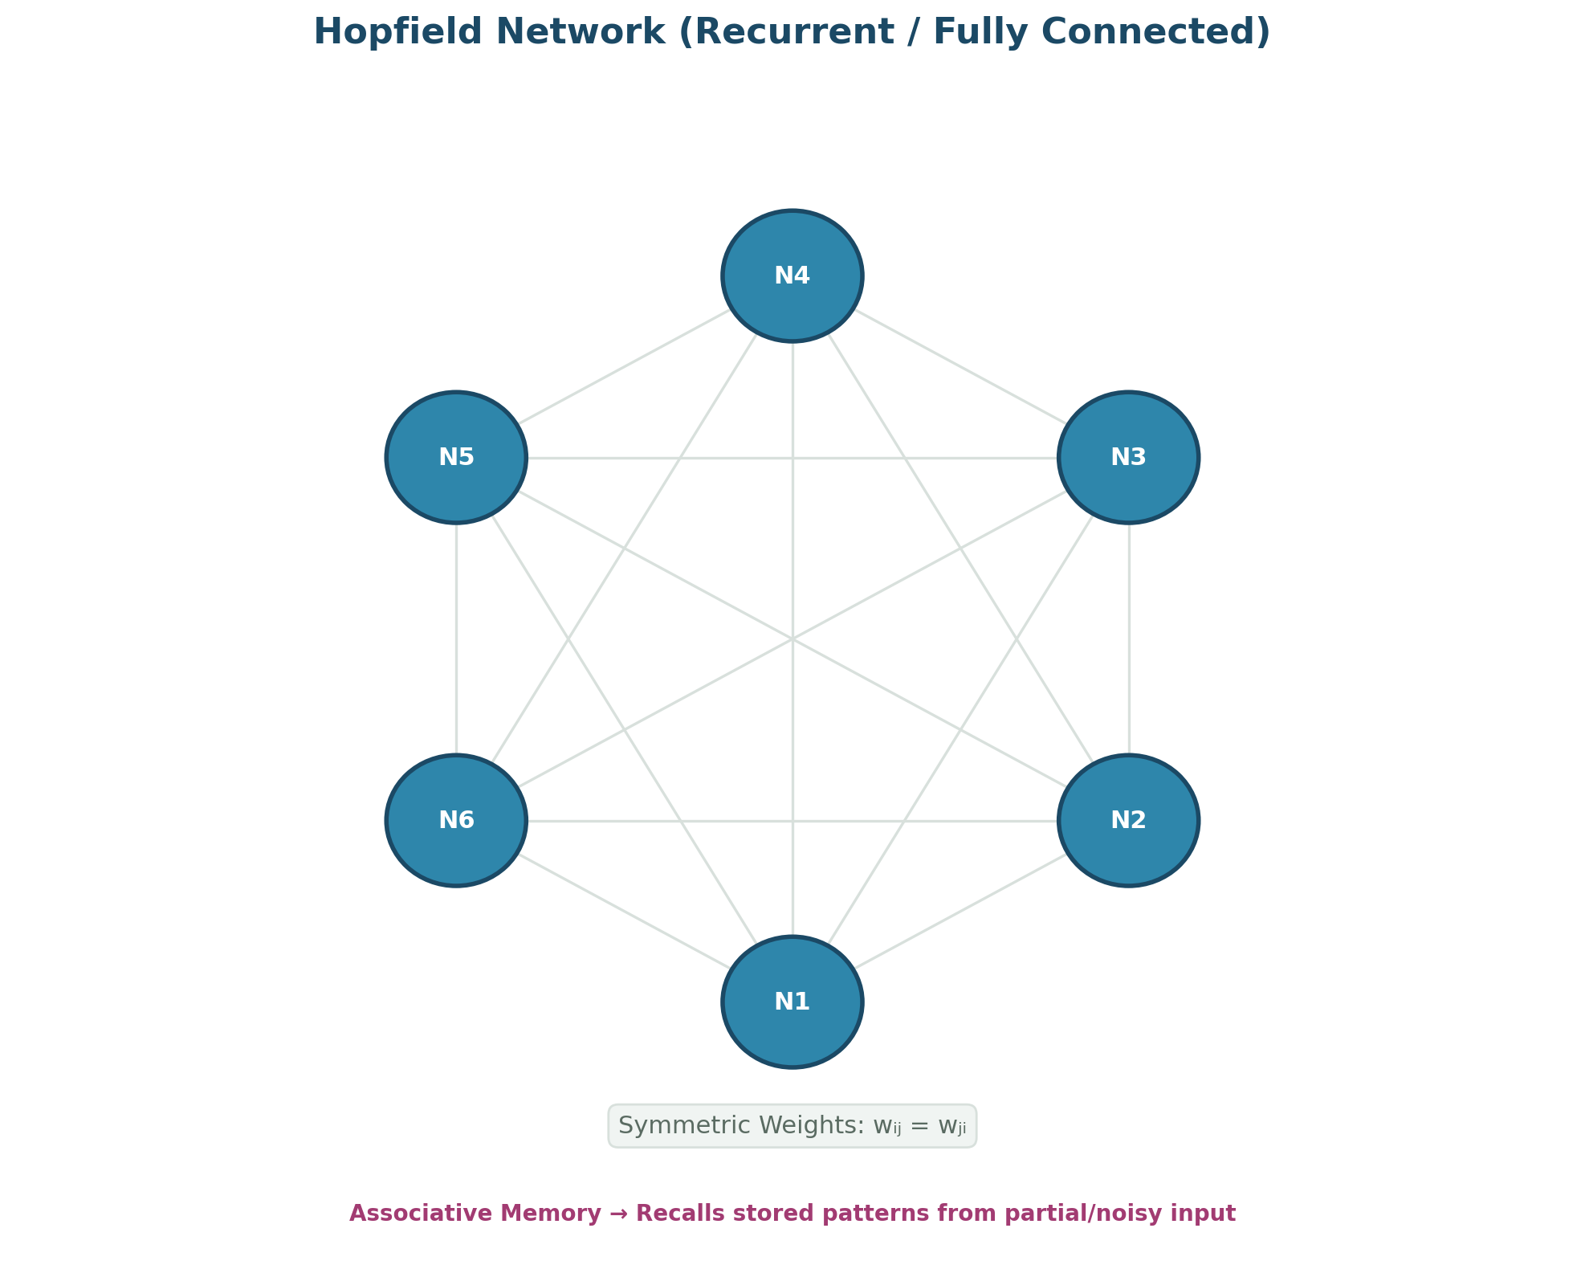
Figure 12: Hopfield Network - Fully Connected Recurrent Architecture

CNN Object Detection
Q: What is CNN?
Ans: CNN (Convolutional Neural Network) is a deep learning architecture specifically designed for processing grid-like data such as images. It uses convolutional layers that apply learnable filters to detect local features like edges, textures, and patterns, significantly reducing parameters compared to fully connected networks.
Q: Why CNN is suitable for images?
Ans: CNNs are suitable for images because: (1) Convolutional layers capture spatial hierarchies of features, (2) Weight sharing reduces parameters dramatically, (3) Translation invariance allows detecting features regardless of position, (4) Pooling provides spatial downsampling and robustness to small shifts.
Q: What is convolution?
Ans: Convolution is a mathematical operation where a filter (kernel) slides over the input image, computing dot products at each position. It extracts local features like edges, corners, or textures. Each filter learns to detect a specific feature pattern across the entire image.
Q: What is a filter/kernel?
Ans: A filter (or kernel) is a small matrix of learnable weights that slides across the input image during convolution. Each filter detects a specific feature (e.g., horizontal edge, vertical edge, blur). Multiple filters in a layer detect different features, producing multiple feature maps.
Q: What is feature map?
Ans: A feature map is the output of applying a filter to the input image through convolution. Each position in the feature map represents the presence and strength of a specific feature at that location. A convolutional layer with N filters produces N feature maps.
Q: What is pooling?
Ans: Pooling is a downsampling operation that reduces the spatial dimensions of feature maps while retaining important information. It makes the network more computationally efficient and provides translation invariance. The most common types are max pooling and average pooling.
Q: Difference between max pooling and average pooling.
Ans: Max pooling takes the maximum value from each pooling window, preserving the most prominent features. Average pooling computes the average of each window, providing a smoothed summary. Max pooling is more commonly used as it better preserves important feature information.
Q: What is stride?
Ans: Stride is the step size by which the filter moves across the input. A stride of 1 moves one pixel at a time (overlapping). A stride of 2 moves two pixels at a time (non-overlapping, reduces output size). Larger strides produce smaller feature maps.
Q: What is padding?
Ans: Padding adds extra pixels (typically zeros) around the input image border. 'Same' padding preserves input dimensions in the output. 'Valid' padding uses no padding, reducing output size. Padding helps control output dimensions and ensures border pixels are processed equally.
Q: What is flattening?
Ans: Flattening converts the 2D feature maps from convolutional layers into a 1D vector that can be fed to fully connected (dense) layers. It is typically done after the last pooling layer, before the classification layers of the network.
Q: What is object detection?
Ans: Object detection is a computer vision task that identifies and locates objects in images. Unlike classification (which only labels the image), detection outputs bounding boxes around detected objects along with their class labels. It combines localization and classification.
Q: Difference between object detection and image classification.
Ans: Image classification assigns a single label to an entire image (what is in the image). Object detection identifies multiple objects, their locations (bounding boxes), and their classes (what and where). Detection is more complex and requires both classification and localization capabilities.
Q: What is IoU?
Ans: IoU (Intersection over Union) measures the overlap between a predicted bounding box and the ground truth box. IoU = Area of Intersection / Area of Union. Values range from 0 (no overlap) to 1 (perfect match). IoU >= 0.5 is typically considered a correct detection.
Q: What is precision in object detection?
Ans: Precision = TP / (TP + FP). In object detection, it measures the proportion of detected objects that are actually correct. High precision means few false detections. It is computed at various IoU thresholds and averaged.
Q: What is recall in object detection?
Ans: Recall = TP / (TP + FN). In object detection, it measures the proportion of actual objects that were successfully detected. High recall means the model finds most of the objects in the image. It is also computed at various IoU thresholds.
Q: What is mAP?
Ans: mAP (mean Average Precision) is the primary metric for evaluating object detection models. It computes the average precision (area under precision-recall curve) for each class and takes the mean across all classes. Higher mAP indicates better detection performance.
Q: What is bounding box?
Ans: A bounding box is a rectangular box that tightly encloses a detected object in an image. It is typically defined by four coordinates: (x_min, y_min, x_max, y_max) or (center_x, center_y, width, height). Bounding boxes provide the spatial location of detected objects.
Q: Why CNN reduces number of parameters?
Ans: CNN reduces parameters through: (1) Weight sharing - the same filter is used across all positions, (2) Local connectivity - each neuron connects only to a small local region, (3) Pooling reduces spatial dimensions. A fully connected layer for a 224x224 image would need millions of weights; CNN uses thousands.
Q: What are convolution layers?
Ans: Convolutional layers are the core building blocks of CNNs. Each layer consists of multiple learnable filters that slide over the input to detect features. Early layers detect simple features (edges, colors); deeper layers combine these into complex patterns (shapes, textures, object parts).
Q: What is overfitting in CNN?
Ans: Overfitting in CNN occurs when the model memorizes training images instead of learning generalizable features. Signs include high training accuracy but low validation accuracy. Causes include: too many parameters, insufficient training data, lack of regularization, or training too long.
Q: How can CNN performance be improved?
Ans: Improvement strategies: (1) Data augmentation (rotate, flip, crop images), (2) Transfer learning (use pre-trained models), (3) Batch normalization, (4) Dropout and regularization, (5) Deeper/wider architectures, (6) Better optimizers (Adam), (7) Ensemble methods, (8) More training data.
Q: Applications of CNN.
Ans: Applications include: image classification, object detection (YOLO, R-CNN), facial recognition, medical image analysis, self-driving cars, satellite imagery analysis, video analysis, style transfer, image segmentation, optical character recognition, and generative adversarial networks.
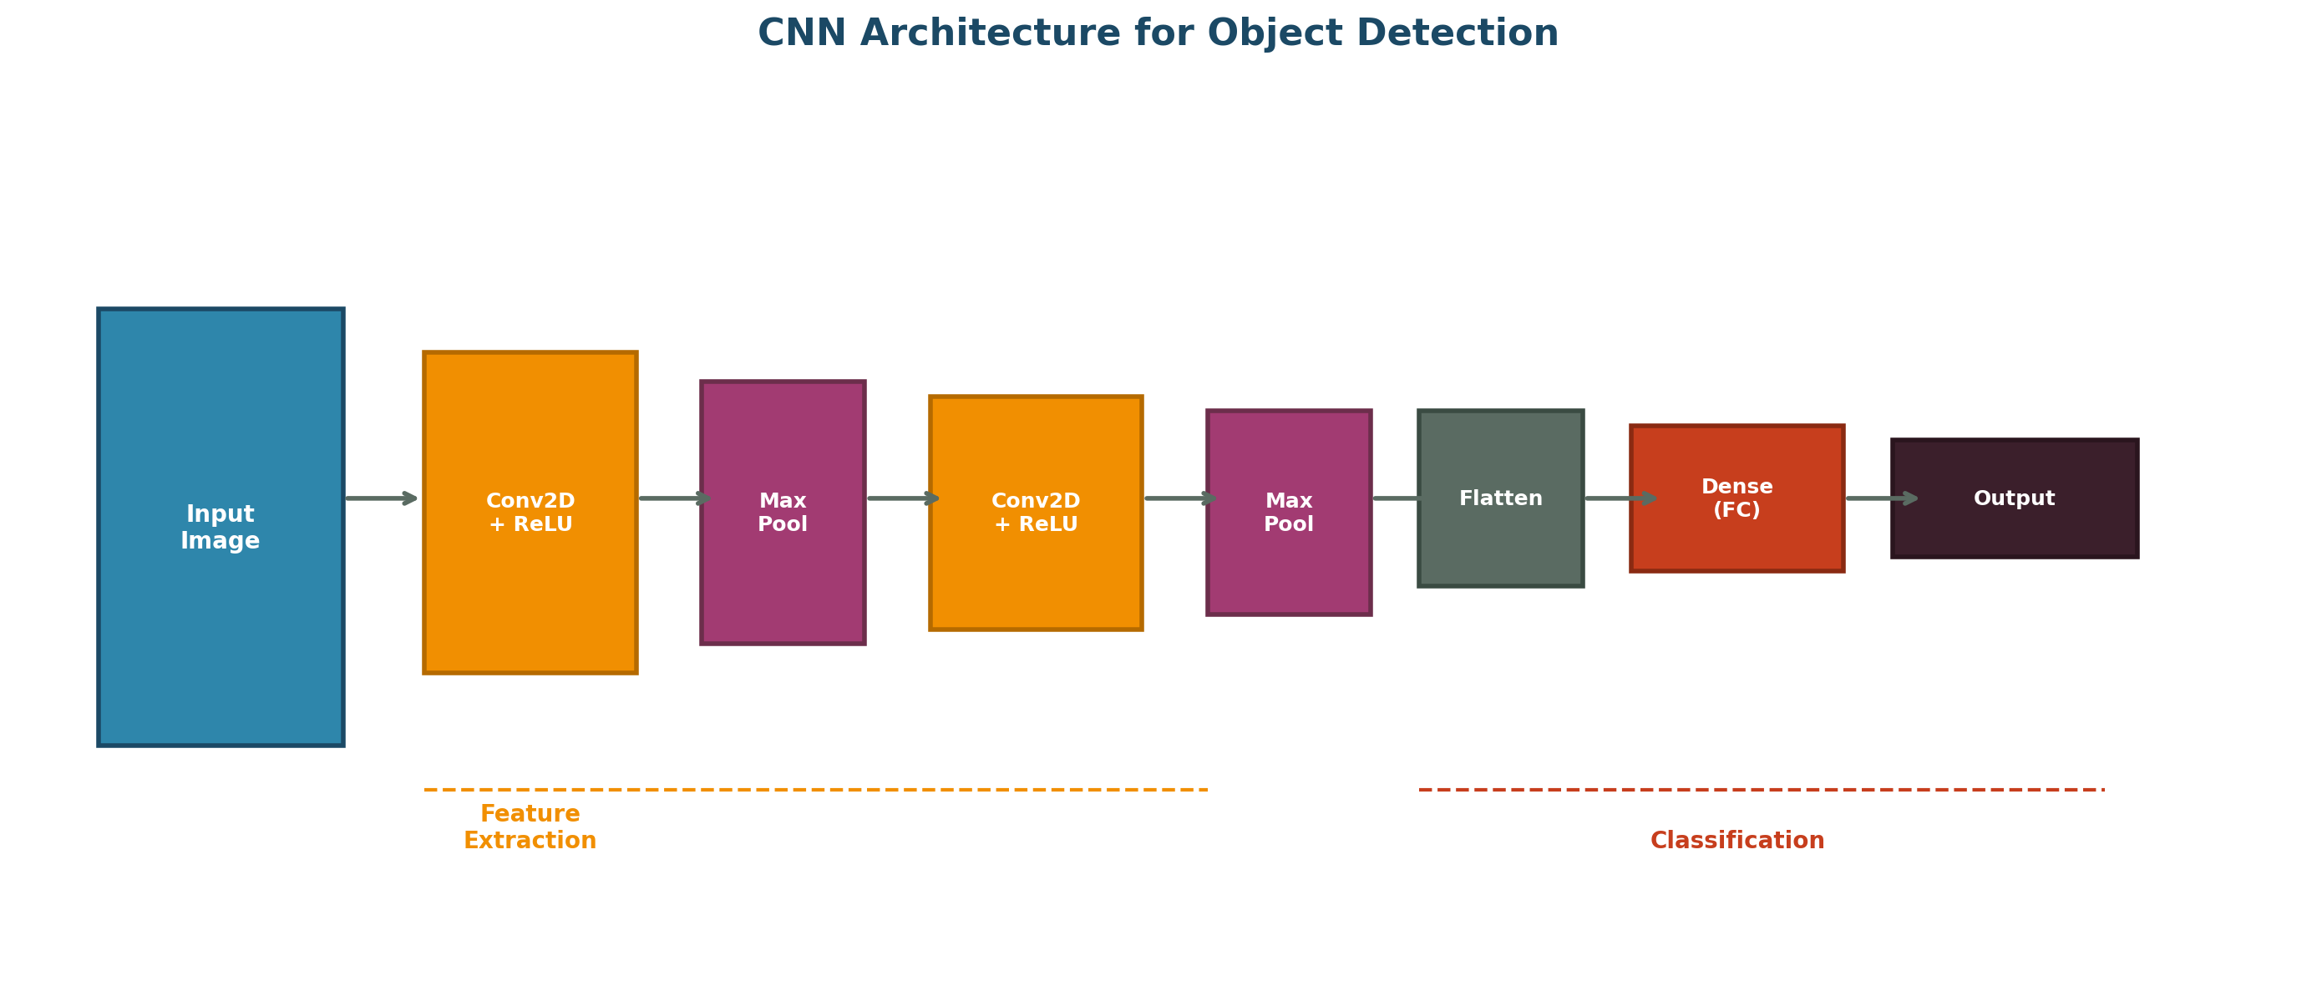
Figure 13: CNN Architecture for Object Detection

Group C Viva Questions

TensorFlow / PyTorch / Logistic Regression
Q: What is TensorFlow?
Ans: TensorFlow is an open-source machine learning framework developed by Google. It provides tools for building and deploying ML models, with strong support for deep learning. It uses dataflow graphs and tensors for computation and runs on CPUs, GPUs, and TPUs.
Q: What is PyTorch?
Ans: PyTorch is an open-source deep learning framework developed by Facebook (Meta). It uses dynamic computation graphs (define-by-run), making it intuitive and Pythonic. It is widely used in research for its flexibility, ease of debugging, and strong GPU acceleration support.
Q: Difference between TensorFlow and PyTorch.
Ans: TensorFlow uses static graphs (define-and-run) with eager execution option; PyTorch uses dynamic graphs (define-by-run). TensorFlow has stronger production deployment tools (TFX, TF Serving); PyTorch is more popular in research. TensorFlow uses Keras as high-level API; PyTorch has a more Pythonic, imperative style.
Q: What is tensor?
Ans: A tensor is a multi-dimensional array that generalizes scalars (0D), vectors (1D), and matrices (2D) to any number of dimensions. Tensors are the fundamental data structure in deep learning frameworks, representing inputs, outputs, weights, and intermediate computations.
Q: What is logistic regression?
Ans: Logistic regression is a statistical model used for binary classification. It applies the sigmoid function to a linear combination of inputs to predict the probability of an instance belonging to a particular class. Despite its name, it is a classification algorithm, not regression.
Q: Why logistic regression is used for classification?
Ans: Logistic regression outputs probabilities (via sigmoid) that can be thresholded for classification. It is simple, interpretable, fast to train, works well with linearly separable data, and serves as a good baseline model. It is the foundation of neural network classification.
Q: Explain sigmoid function in logistic regression.
Ans: The sigmoid function sigma(z) = 1/(1+e^(-z)) maps any real number to (0,1), interpreted as the probability of the positive class. For input features X and weights W, P(y=1|X) = sigma(W^T * X). If P >= 0.5, predict class 1; else class 0.
Q: Difference between linear regression and logistic regression.
Ans: Linear regression predicts continuous values using identity function (output range: -infinity to +infinity). Logistic regression predicts class probabilities using sigmoid function (output range: 0 to 1). Linear regression uses MSE loss; logistic regression uses cross-entropy loss.
Q: What is binary classification?
Ans: Binary classification is the task of assigning inputs to one of two classes (e.g., spam/not spam, diseased/healthy, pass/fail). The model outputs a probability, and a threshold (typically 0.5) converts it to a class prediction.
Q: What is model training?
Ans: Model training is the process of teaching a neural network to make accurate predictions by adjusting its weights. It involves: feeding input data, computing predictions, calculating loss, computing gradients via backpropagation, and updating weights using an optimizer over multiple epochs.
Q: What is model evaluation?
Ans: Model evaluation assesses how well a trained model performs on unseen data. Common metrics include accuracy, precision, recall, F1-score, confusion matrix, and loss values. Evaluation is done on a separate validation or test set that was not used during training.
Q: What is accuracy?
Ans: Accuracy = (Correct Predictions) / (Total Predictions). It measures the overall correctness of the model. While simple to understand, accuracy can be misleading on imbalanced datasets, which is why precision, recall, and F1-score are also important.
Q: What is loss function?
Ans: A loss function measures the discrepancy between predicted and actual values. Common losses include: Mean Squared Error (MSE) for regression, Binary Cross-Entropy for binary classification, and Categorical Cross-Entropy for multiclass classification. Training minimizes the loss.
Q: What is optimizer in TensorFlow?
Ans: An optimizer in TensorFlow is an algorithm that updates model weights to minimize the loss function. Common optimizers include: SGD (Stochastic Gradient Descent), Adam (adaptive learning rates), RMSprop, and Adagrad. Adam is the most commonly used due to its efficiency.
Q: What is Dense layer?
Ans: A Dense layer (fully connected layer) is a neural network layer where every neuron is connected to every neuron in the previous layer. In TensorFlow/Keras, Dense(units, activation) creates a layer with specified number of neurons and activation function. It is used for classification and regression outputs.
Q: What is Sequential model?
Ans: Sequential model in Keras is a linear stack of layers where data flows from the first layer to the last in order. It is the simplest model type, suitable for most standard architectures. Example: model = Sequential([Dense(64, activation='relu'), Dense(10, activation='softmax')]).
Q: What is compile() in TensorFlow?
Ans: The compile() method configures the model for training. It specifies: (1) optimizer - how weights are updated, (2) loss function - what to minimize, (3) metrics - what to monitor during training. Example: model.compile(optimizer='adam', loss='categorical_crossentropy', metrics=['accuracy']).
Q: What is fit() function?
Ans: The fit() function trains the model on the training data. Parameters include: training data, target labels, epochs (number of training iterations), batch_size, and validation_data. It returns a history object containing training metrics over epochs.
Q: What is predict() function?
Ans: The predict() function generates predictions from a trained model given input data. It returns the model's raw output (probabilities for classification, continuous values for regression). For classification, argmax is typically applied to get the predicted class index.
Q: What is verbose in TensorFlow?
Ans: Verbose controls the logging output during training. verbose=0: silent (no output), verbose=1: progress bar showing loss and metrics per batch, verbose=2: one line per epoch. It helps monitor training progress without affecting the model's learning.
Q: What is epoch in TensorFlow?
Ans: An epoch is one complete pass through the entire training dataset. During fit(), the model processes all training examples once per epoch. Multiple epochs are typically needed for the model to converge. The number of epochs is a key hyperparameter.
Q: What is batch size?
Ans: Batch size is the number of training examples processed before the model updates its weights. Common values: 32, 64, 128, 256. Smaller batches provide more frequent updates; larger batches offer more stable gradients and better utilize GPU parallelization.
Q: What is GPU acceleration?
Ans: GPU acceleration uses Graphics Processing Units to speed up neural network computations. GPUs are optimized for parallel matrix operations, making them much faster than CPUs for deep learning. TensorFlow and PyTorch automatically utilize available GPUs for training and inference.
Q: Why TensorFlow is popular?
Ans: TensorFlow is popular because: (1) Developed and backed by Google, (2) Comprehensive ecosystem (Keras, TensorBoard, TF Lite, TF Serving), (3) Strong production deployment capabilities, (4) Excellent GPU/TPU support, (5) Large community, extensive documentation and tutorials.

TensorFlow/PyTorch CNN
Q: How is CNN implemented in TensorFlow?
Ans: CNN in TensorFlow is implemented using Keras layers: Conv2D for convolution, MaxPooling2D for downsampling, Flatten to convert to 1D, and Dense for classification. A Sequential model stacks these layers: Conv2D -> MaxPool2D -> Conv2D -> MaxPool2D -> Flatten -> Dense -> Output.
Q: What are Conv2D layers?
Ans: Conv2D is a Keras layer that performs 2D convolution on image data. Parameters include: number of filters, kernel size (e.g., 3x3), activation function, padding, and strides. Example: Conv2D(32, (3,3), activation='relu') creates 32 filters of size 3x3 with ReLU activation.
Q: Why MaxPooling2D is used?
Ans: MaxPooling2D reduces spatial dimensions by taking the maximum value from each pooling window. Benefits: (1) Reduces computation, (2) Provides translation invariance, (3) Prevents overfitting by reducing parameters, (4) Helps the network focus on most salient features.
Q: What is Flatten layer?
Ans: The Flatten layer converts multi-dimensional feature maps (e.g., 4x4x64) into a 1D vector (e.g., 1024 elements). It is placed after the last pooling layer to prepare the data for fully connected (Dense) classification layers.
Q: What is Dense layer in CNN?
Ans: In CNNs, Dense layers appear at the end for classification. After feature extraction by convolutional layers, Dense layers learn to combine extracted features into final class predictions. The last Dense layer typically has softmax activation with one neuron per class.
Q: What optimizer did you use?
Ans: Adam optimizer is most commonly used for CNN training. It combines momentum and adaptive learning rates, providing fast convergence with minimal hyperparameter tuning. Alternative: SGD with momentum for potentially better generalization.
Q: Why ReLU is used in CNN?
Ans: ReLU is used in CNN hidden layers because: (1) It is computationally efficient, (2) It mitigates vanishing gradient problem, (3) It induces sparsity (some neurons are inactive), (4) Empirically, it enables faster and better convergence in deep networks compared to sigmoid/tanh.
Q: What loss function is used in CNN?
Ans: For multiclass classification: Categorical Cross-Entropy (for one-hot labels) or Sparse Categorical Cross-Entropy (for integer labels). For binary classification: Binary Cross-Entropy. For regression tasks: Mean Squared Error (MSE).
Q: What dataset did you use?
Ans: Common datasets for CNN experiments include: MNIST (handwritten digits, 60K training, 10K test), CIFAR-10 (10 classes of color images), CIFAR-100 (100 classes), ImageNet (1000 classes, large scale), or custom datasets for specific applications.
Q: What is image preprocessing?
Ans: Image preprocessing prepares raw images for neural network input. Common steps: resizing to consistent dimensions, normalization (scaling pixel values to [0,1] or [-1,1]), data augmentation (rotation, flipping, cropping), grayscale conversion, and noise reduction.

ConvNet and Hyperparameter Tuning
Q: What is hyperparameter tuning?
Ans: Hyperparameter tuning is the process of finding the optimal set of hyperparameters (configuration settings not learned from data) that maximize model performance. Common hyperparameters include learning rate, batch size, number of layers, number of filters, and dropout rate.
Q: What are hyperparameters?
Ans: Hyperparameters are configuration variables set before training that control the learning process. Unlike model weights (learned during training), hyperparameters must be manually specified. Examples: learning rate, epochs, batch size, network architecture, activation functions, regularization strength.
Q: What is learning rate tuning?
Ans: Learning rate tuning involves finding the optimal learning rate that enables fast convergence without instability. Too high causes divergence; too low causes slow training. Methods include: grid search, learning rate schedules (decay, step), cyclical learning rates, and adaptive optimizers like Adam.
Q: Why does overfitting occur?
Ans: Overfitting occurs when a model is too complex relative to the available training data. The model memorizes training examples including noise, rather than learning generalizable patterns. Causes: too many parameters, insufficient data, excessive training without regularization.
Q: Why does underfitting occur?
Ans: Underfitting occurs when a model is too simple to capture the underlying patterns in the data. The model performs poorly on both training and test data. Causes: insufficient model capacity, too much regularization, inadequate features, or insufficient training.
Q: How does dropout reduce overfitting?
Ans: Dropout randomly deactivates neurons during training with probability p. This prevents neurons from relying too heavily on specific other neurons, forcing the network to learn more robust and distributed representations. It acts like training multiple sub-networks and averaging their predictions.
Q: What is early stopping?
Ans: Early stopping is a regularization technique that halts training when validation performance stops improving. It monitors validation loss/metrics and stops training if no improvement is seen for a specified number of epochs (patience). This prevents overfitting from excessive training.
Q: Why data augmentation is used?
Ans: Data augmentation artificially increases the training dataset by applying random transformations (rotation, flipping, cropping, brightness changes, zoom). Benefits: reduces overfitting, improves generalization, makes the model invariant to transformations, and is especially useful when training data is limited.
Q: What graphs are maintained during training?
Ans: Common training graphs include: (1) Training loss vs. validation loss over epochs, (2) Training accuracy vs. validation accuracy over epochs. These plots help diagnose overfitting (growing gap), underfitting (both high), and determine optimal stopping points.
Q: Why validation data is used?
Ans: Validation data is a held-out subset used during training to tune hyperparameters and detect overfitting. It provides an unbiased evaluation of the model during training. Unlike test data (used only for final evaluation), validation data can inform training decisions.
Q: What is training loss?
Ans: Training loss is the value of the loss function computed on the training dataset. It measures how well the model fits the training data. A decreasing training loss indicates the model is learning. Monitoring training loss helps verify that learning is occurring.
Q: What is validation loss?
Ans: Validation loss is the loss computed on the validation dataset (unseen during weight updates). It measures generalization. If validation loss increases while training loss decreases, the model is overfitting. The minimum validation loss often indicates the best model.

MNIST Character Detection
Q: What is MNIST dataset?
Ans: MNIST (Modified National Institute of Standards and Technology) is a benchmark dataset of handwritten digits. It contains 60,000 training images and 10,000 test images, each a 28x28 grayscale image of a single digit (0-9). It is the 'hello world' of deep learning.
Q: How many classes are present in MNIST?
Ans: MNIST has 10 classes, representing digits 0 through 9. Each class has approximately 6,000 training images and 1,000 test images, providing a balanced dataset for digit classification experiments.
Q: Why MNIST is popular?
Ans: MNIST is popular because: (1) It is well-curated and clean, (2) Small size enables quick experimentation, (3) Balanced classes prevent bias issues, (4) Sufficiently complex to benchmark algorithms, (5) Easy to understand and visualize results, (6) Standard benchmark for comparing approaches.
Q: What preprocessing is done on MNIST images?
Ans: Common preprocessing: (1) Normalize pixel values from [0,255] to [0,1] or [-1,1], (2) Reshape images to include channel dimension (28x28x1 for grayscale), (3) One-hot encode labels for categorical cross-entropy, (4) Optionally apply data augmentation for improved generalization.
Q: What is image normalization?
Ans: Image normalization scales pixel values to a standard range, typically [0,1] by dividing by 255, or [-1,1] using (pixel/127.5)-1. Normalization helps the network train faster and more stably by ensuring inputs are in a consistent, manageable range for gradient-based optimization.
Q: What is handwritten character recognition?
Ans: Handwritten character recognition (HCR) is the task of automatically converting images of handwritten text into machine-readable text. It involves preprocessing, feature extraction, and classification. MNIST digit recognition is a specific instance of this broader problem.
Q: Why CNN performs well on MNIST?
Ans: CNN performs well on MNIST because: (1) Convolutional layers detect local features (strokes, loops, edges) relevant to digit shapes, (2) Weight sharing reduces parameters, (3) Pooling provides spatial invariance to slight shifts in writing position, (4) Hierarchical feature learning captures digit-specific patterns.
Q: What accuracy did your model achieve?
Ans: A well-tuned CNN on MNIST typically achieves 99%+ accuracy. Simple architectures (2 conv layers + 2 dense) reach ~99.0%. State-of-the-art approaches achieve >99.7%. A basic fully connected network typically reaches ~97-98% accuracy.
Q: What activation functions were used?
Ans: Typical activation setup: ReLU for convolutional and hidden dense layers (efficient, avoids vanishing gradients), Softmax for the output layer (produces probability distribution over 10 digit classes). Some implementations use LeakyReLU or ELU in deeper architectures.
Q: What optimizer was used?
Ans: Adam optimizer is most commonly used for MNIST CNN training due to its adaptive learning rates and fast convergence. SGD with momentum is an alternative that may provide slightly better generalization. The default learning rate of 0.001 for Adam works well for MNIST.
Q: What is softmax output?
Ans: The softmax output is a 10-element probability vector where each element represents the probability that the input image belongs to a particular digit class (0-9). All probabilities sum to 1. The predicted digit is the index of the maximum probability (argmax).
Q: What is confusion matrix in MNIST?
Ans: The confusion matrix for MNIST is a 10x10 table showing how often each digit was correctly or incorrectly classified. Rows represent true digits, columns represent predicted digits. Diagonal elements show correct predictions; off-diagonal elements reveal which digits are commonly confused (e.g., 4 vs 9, 3 vs 8).
Q: Difference between TensorFlow, Keras and PyTorch implementations.
Ans: TensorFlow (with Keras API) uses a declarative style: define model architecture with Sequential/Functional API, compile with optimizer and loss, then fit. PyTorch uses an imperative style: manually define forward pass, compute loss, call backward(), and update weights in a training loop. Keras is higher-level and more concise; PyTorch offers more flexibility and control.
Q: Why grayscale images are used in MNIST?
Ans: MNIST uses grayscale (single channel, 0-255) because handwritten digits can be effectively recognized without color information. Grayscale reduces data size and computational requirements. Color would add unnecessary complexity without improving digit recognition accuracy.
Q: Applications of handwritten digit recognition.
Ans: Applications include: postal mail sorting (ZIP code reading), bank check processing (account numbers, amounts), form data entry, tax return processing, meter reading automation, accessibility tools for visually impaired, mobile banking apps, and CAPTCHA solving systems.



Best of Luck!
for your Viva Examination
Neural Networks & Deep Learning

