Lab Assignment 4
Name : Yash S. Kharangate
Roll No. : 230150032

Creating students table:

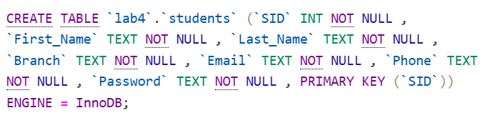

Creating exams table:



Creating questions table:

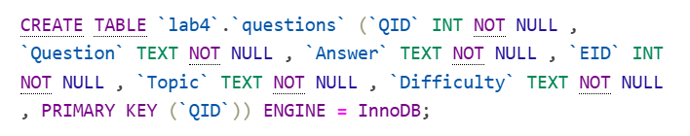

Creating slots table:

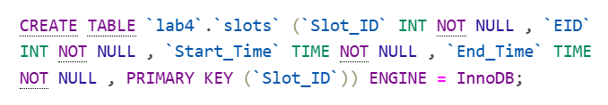

Creating booking table:

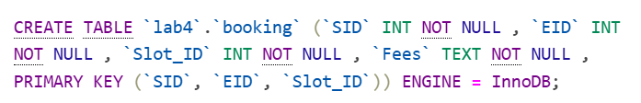

Creating results table:

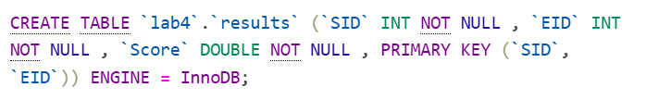

Creating answers table:

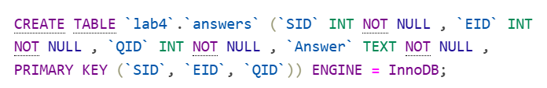

SQL Queries

- Student Registration

INSERT INTO students (SID, First_Name, Last_Name, Branch, Email, Phone, Password)
VALUES (1, 'Amit', 'Kumar', 'DSAI', 'kumar.amit@gmail.com', '1234567890', abcde');

- Exam Registration

INSERT INTO exams (EID, Department) VALUES (1, 'DSAI');
INSERT INTO slots (Slot_ID, EID, Start_Time, End_Time) VALUES (1, 1, '09:00:00', '10:00:00');

- Exam Booking

INSERT INTO booking (SID, EID, Slot_ID, Fees)
VALUES (1, 1, 1, 'Paid');

- Reschedule

UPDATE booking
SET Slot_ID = 2
WHERE SID = 1 AND EID = 1;

- Disconnect

INSERT INTO results(SID,EID,Score) VALUES (1,1,10);

- Percentile Calculation

SELECT SID, EID, Score,
(100 * PERCENT_RANK() OVER (PARTITION BY EID ORDER BY Score ASC)) AS Percentile
FROM results
WHERE EID = 1;

- Checking whether the answer is correct or not

SELECT a.SID, a.EID, a.QID, a.Answer AS Student_Answer, q.Answer AS Correct_Answer,
CASE
WHEN a.Answer = q.Answer THEN 'Correct'
ELSE 'Incorrect'
END AS Result
FROM answers a
JOIN questions q ON a.QID = q.QID AND a.EID = q.EID
WHERE a.SID = 1 AND a.EID = 1;

