Name: Yash Kharangate
Roll No: 230150032
Problem 2
Creating Employees Table:
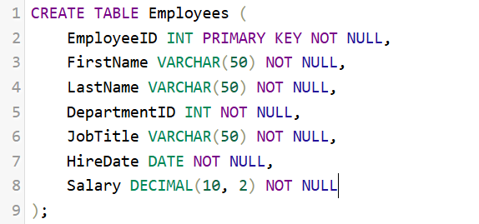
Table Structure:
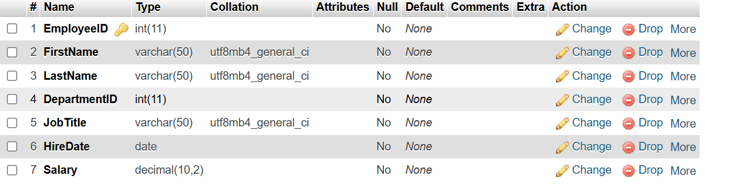

Creating Departments Table:
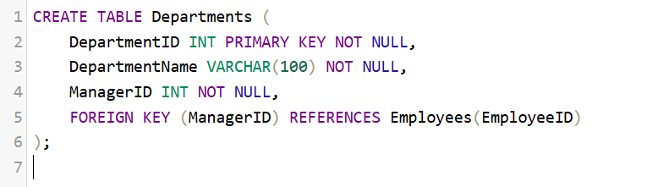
Table Structure:
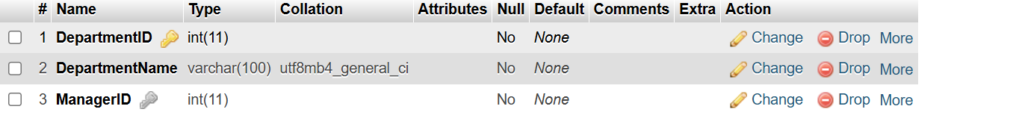

Creating Projects Table:
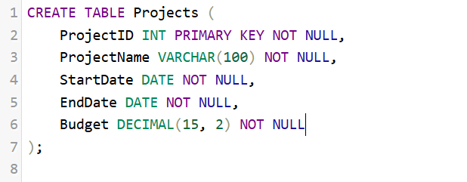
Table Structure:
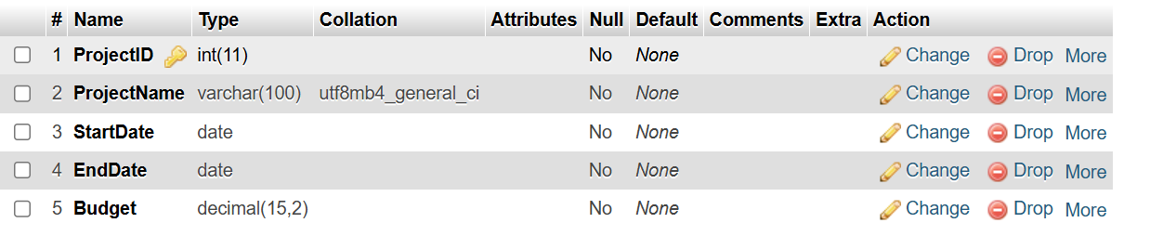

Creating EmployeeProjects Table:
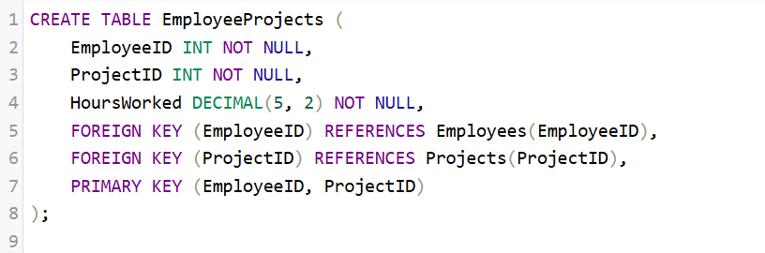
Table Structure:
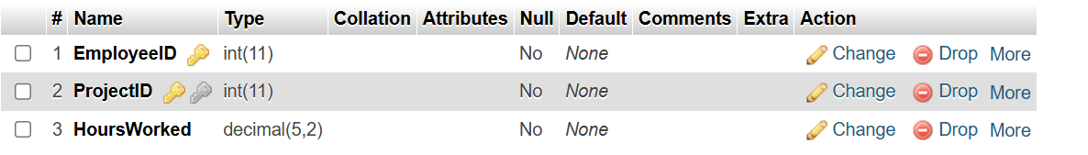

Inserting in Departments Table:
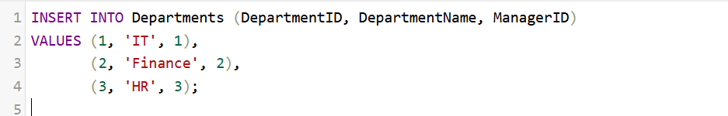
Result:
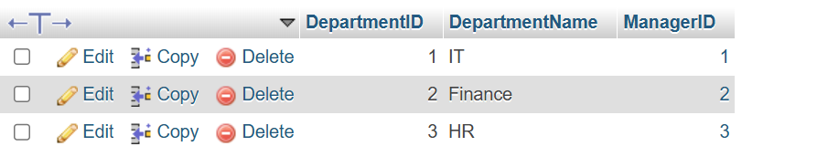

Inserting in Employees Table:
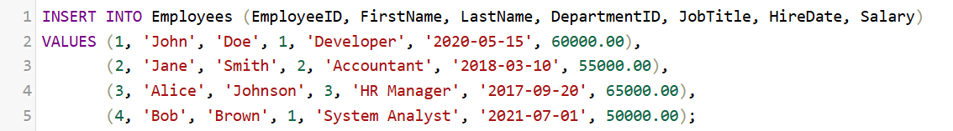
Result:
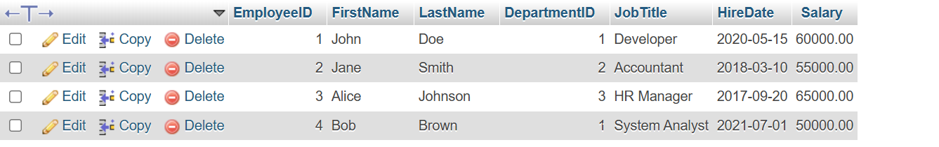

Inserting in Projects Table:
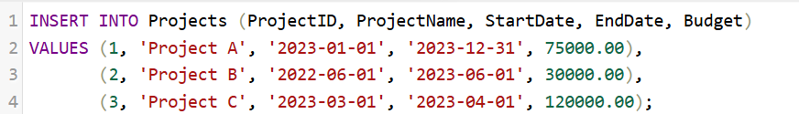
Result:


Inserting in EmployeeProjects Table:
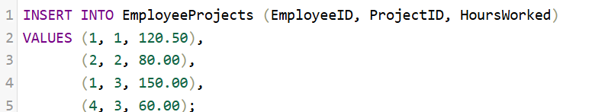

Result:
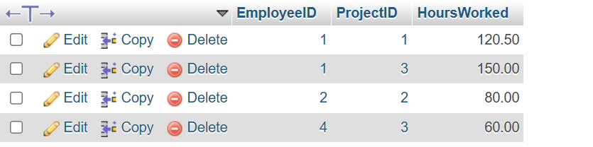

2)
Query:
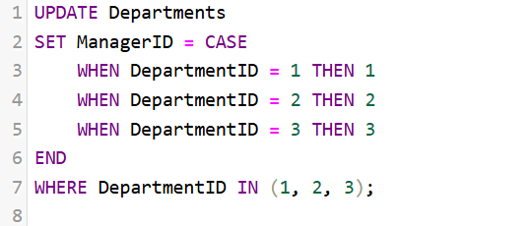
Result:
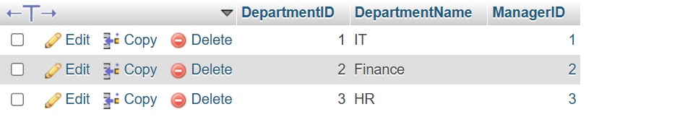

3)
Query:
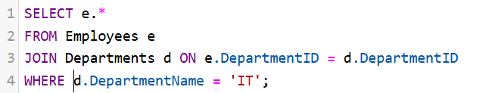
Result:
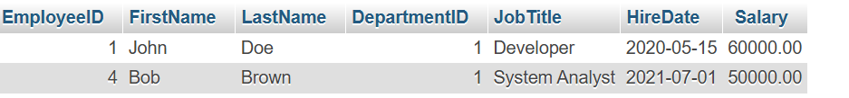

4)
Query:
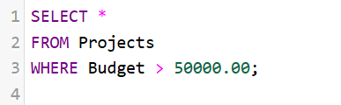
Result:
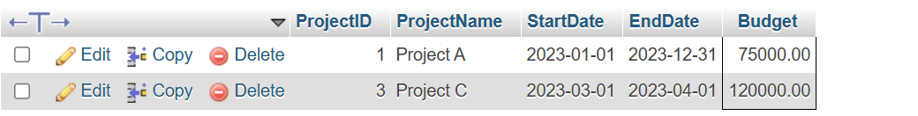

5)
Query:

Result:
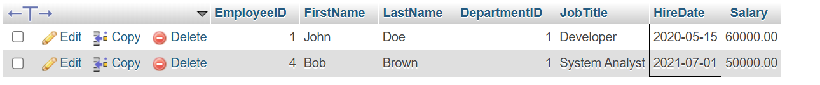

6)
Query:
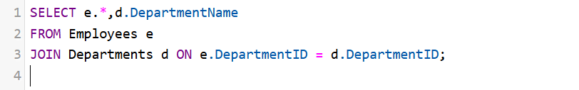
Result:
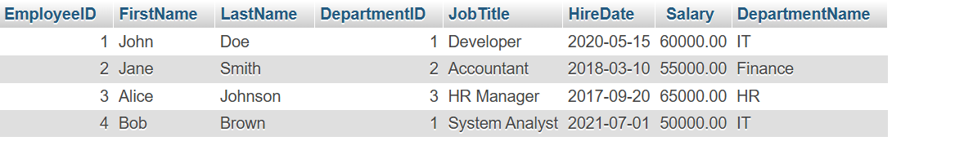

7)
Query:
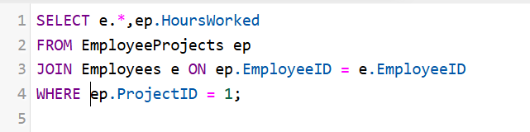
Result:

8)
Query:

Result:
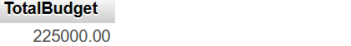
9)
Query:
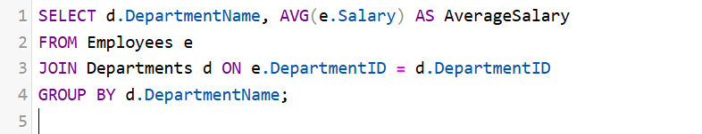
Result:
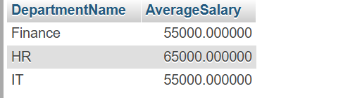

10)
Query:
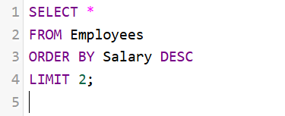
Result:

11)
Query:
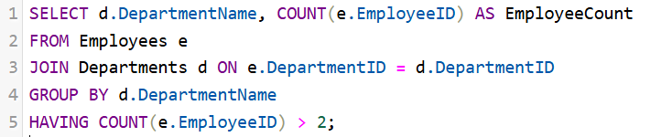
Result:

12)
Query:
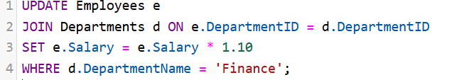
Result:
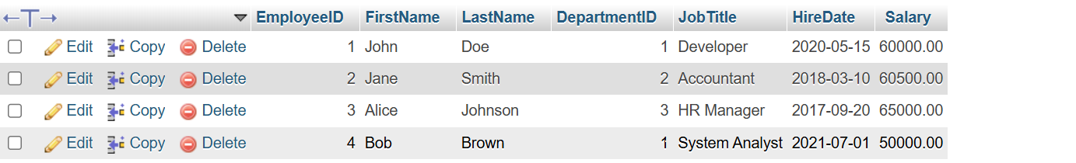

13)
Query:

Result:
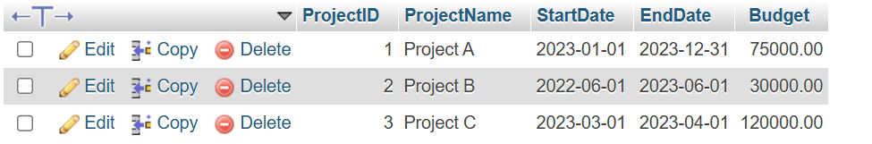
14)
Query:
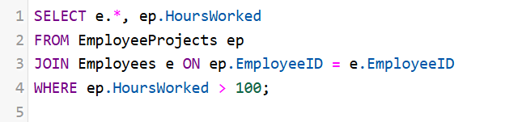
Result:

15)
Query:
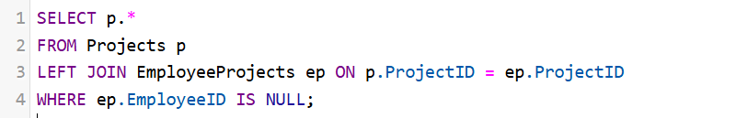
Result:
16)
Query:
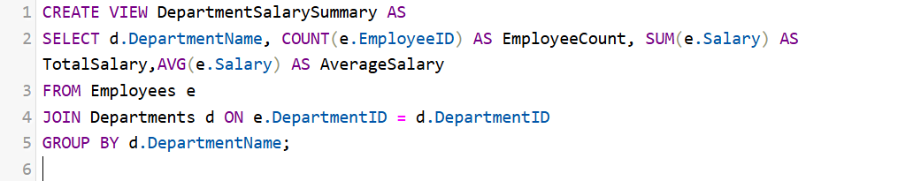
Result:
