**Lab Assignment 4**

Name : Yash S. Kharangate

Roll No. : 230150032

Creating students table:

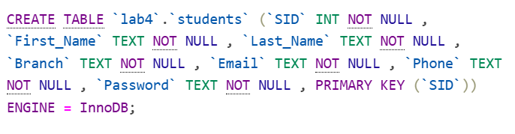

Creating exams table:



Creating questions table:

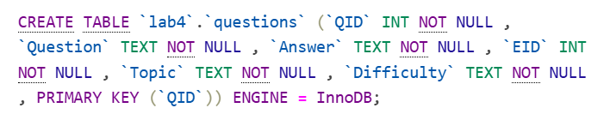

Creating slots table:

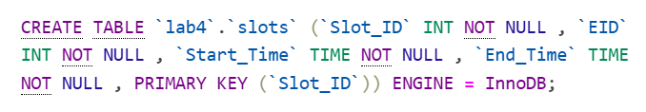

Creating booking table:

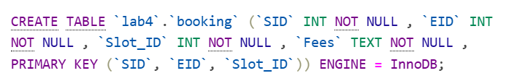

Creating results table:

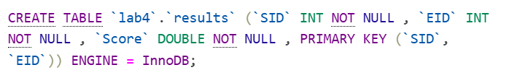

Creating answers table:

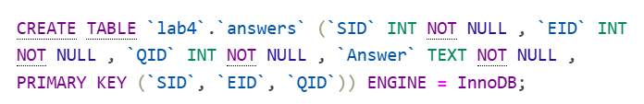

**SQL Queries**

1. Student Registration

INSERT INTO students (SID, First_Name, Last_Name, Branch, Email, Phone, Password)

VALUES (1, 'Amit', 'Kumar', 'DSAI', 'kumar.amit@gmail.com', '1234567890', abcde');

1. Exam Registration

INSERT INTO exams (EID, Department) VALUES (1, 'DSAI');

INSERT INTO slots (Slot_ID, EID, Start_Time, End_Time) VALUES (1, 1, '09:00:00', '10:00:00');

1. Exam Booking

INSERT INTO booking (SID, EID, Slot_ID, Fees)

VALUES (1, 1, 1, 'Paid');

1. Reschedule

UPDATE booking

SET Slot_ID = 2

WHERE SID = 1 AND EID = 1;

1. Disconnect

INSERT INTO results(SID,EID,Score) VALUES (1,1,10);

1. Percentile Calculation

SELECT SID, EID, Score,

(100 * PERCENT_RANK() OVER (PARTITION BY EID ORDER BY Score ASC)) AS Percentile

FROM results

WHERE EID = 1;

1. Checking whether the answer is correct or not

SELECT a.SID, a.EID, a.QID, a.Answer AS Student_Answer, q.Answer AS Correct_Answer,

CASE

WHEN a.Answer = q.Answer THEN 'Correct'

ELSE 'Incorrect'

END AS Result

FROM answers a

JOIN questions q ON a.QID = q.QID AND a.EID = q.EID

WHERE a.SID = 1 AND a.EID = 1;