Name: Yash Kharangate

Roll No: 230150032

Problem 2

Creating Employees Table:

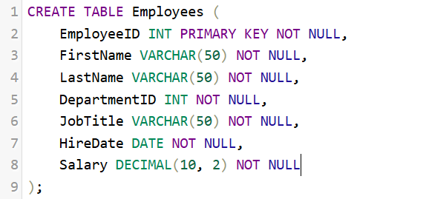

Table Structure:

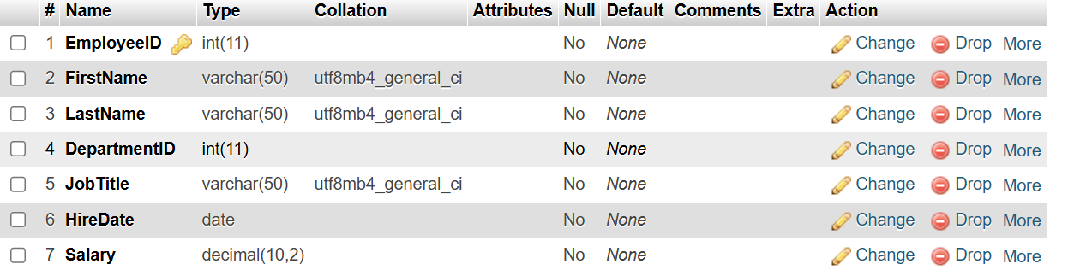

Creating Departments Table:

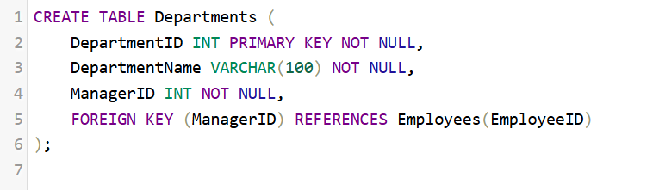

Table Structure:

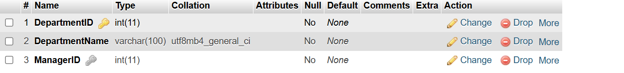

Creating Projects Table:

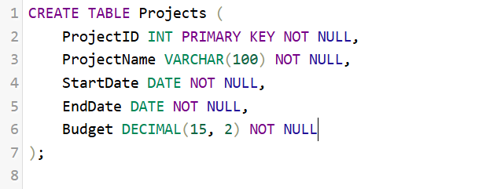

Table Structure:

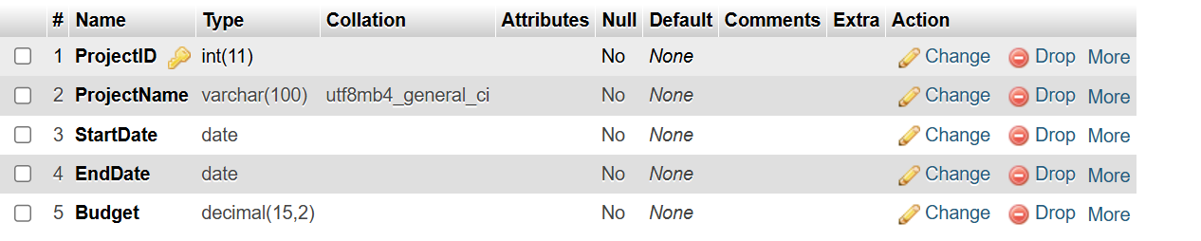

Creating EmployeeProjects Table:

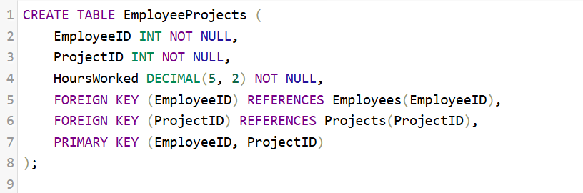

Table Structure:

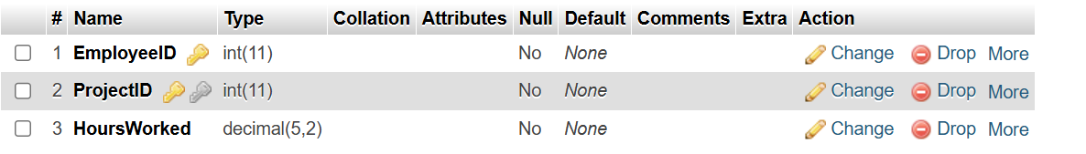

Inserting in Departments Table:

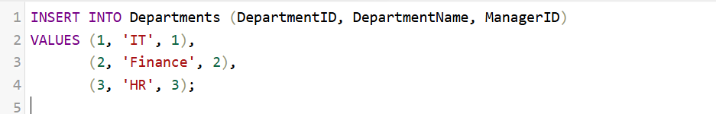

Result:

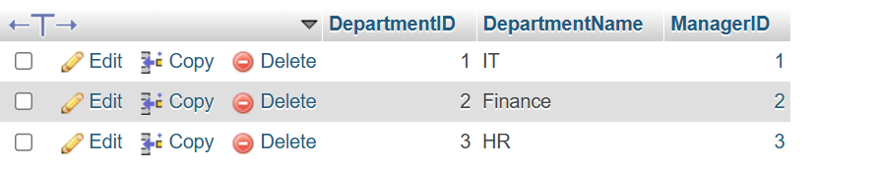

Inserting in Employees Table:

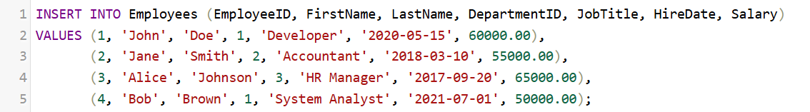

Result:

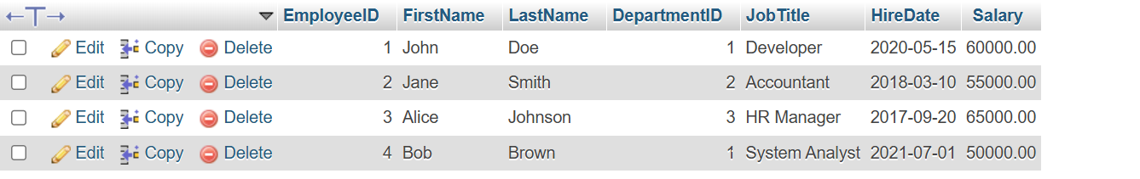

Inserting in Projects Table:

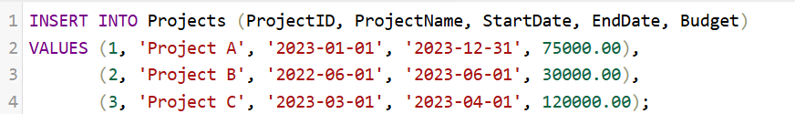

Result:



Inserting in EmployeeProjects Table:

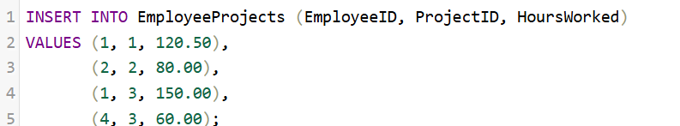

Result:

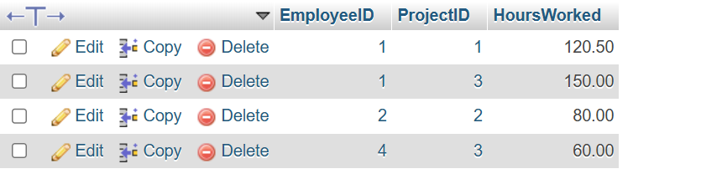

2)

Query:

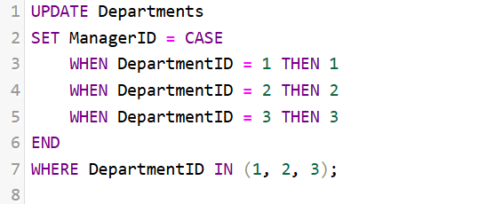

Result:

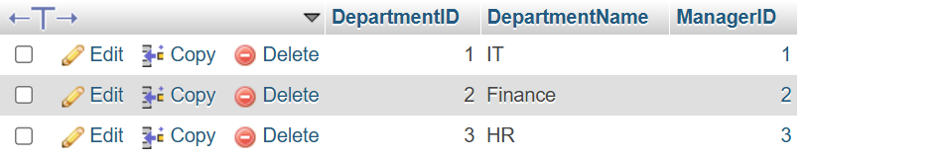

3)

Query:

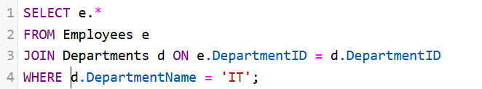

Result:

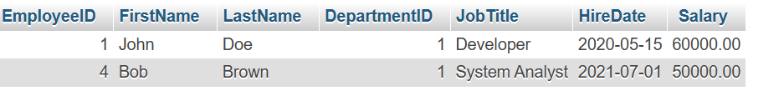

4)

Query:

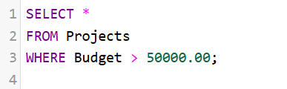

Result:

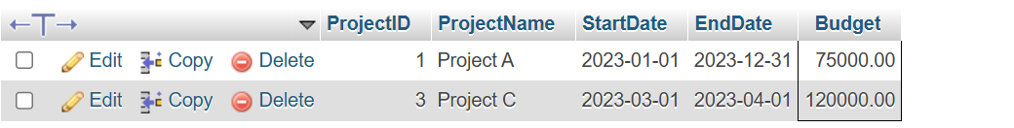

5)

Query:



Result:

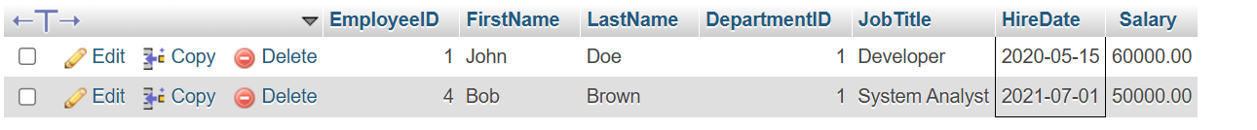

6)

Query:

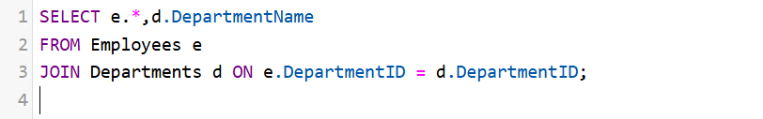

Result:

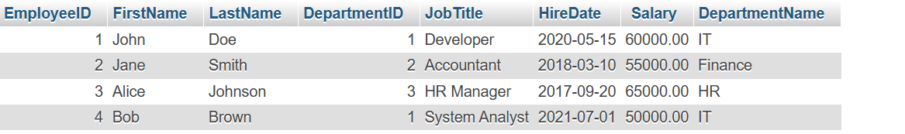

7)

Query:

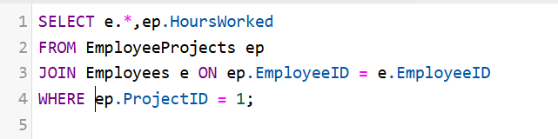

Result:



8)

Query:



Result:



9)

Query:

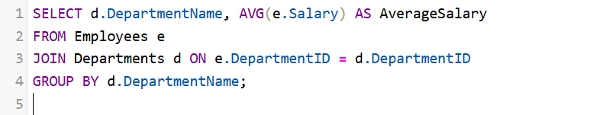

Result:

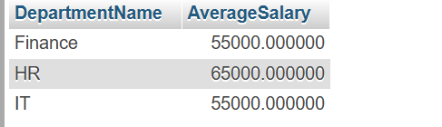

10)

Query:

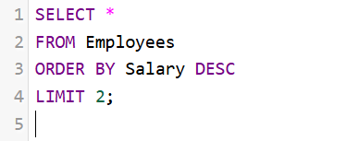

Result:



11)

Query:

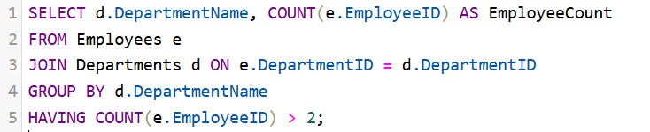

Result:



12)

Query:

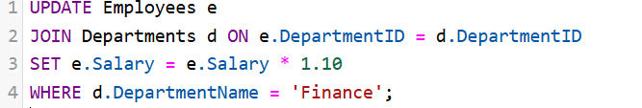

Result:

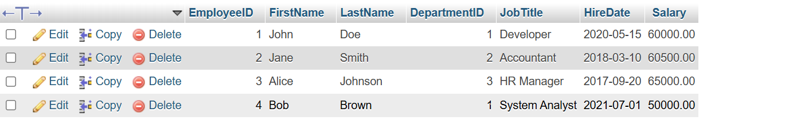

13)

Query:



Result:

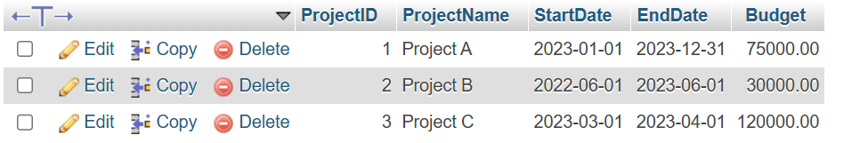

14)

Query:

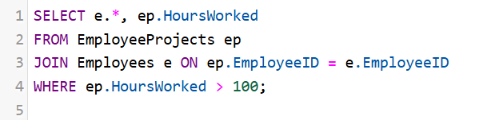

Result:



15)

Query:

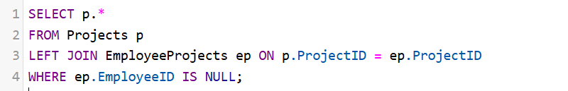

Result:



16)

Query:

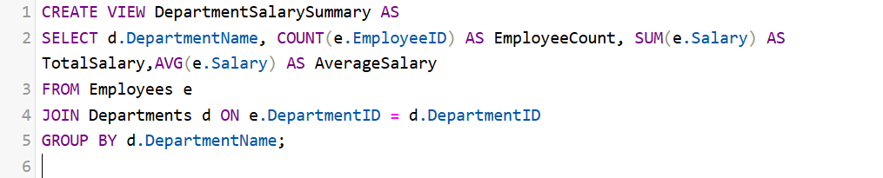

Result:

