Github https://github.com/YashKarnik/documentUploadCosmos  
UI uploaded on app service

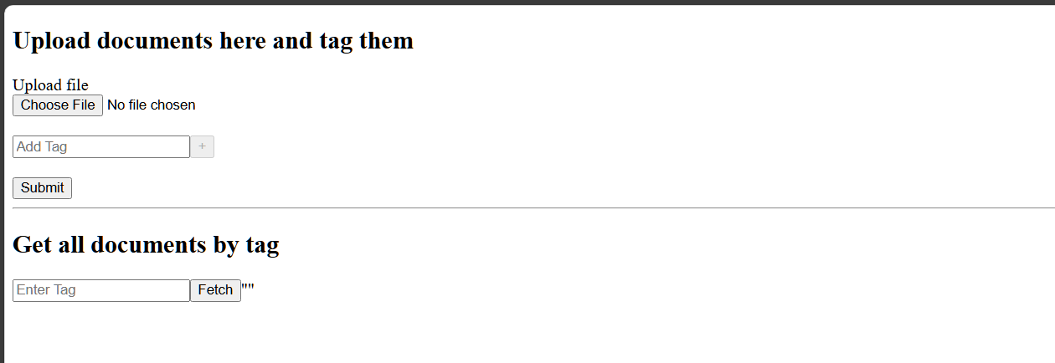

Files get uploaded on blob service  
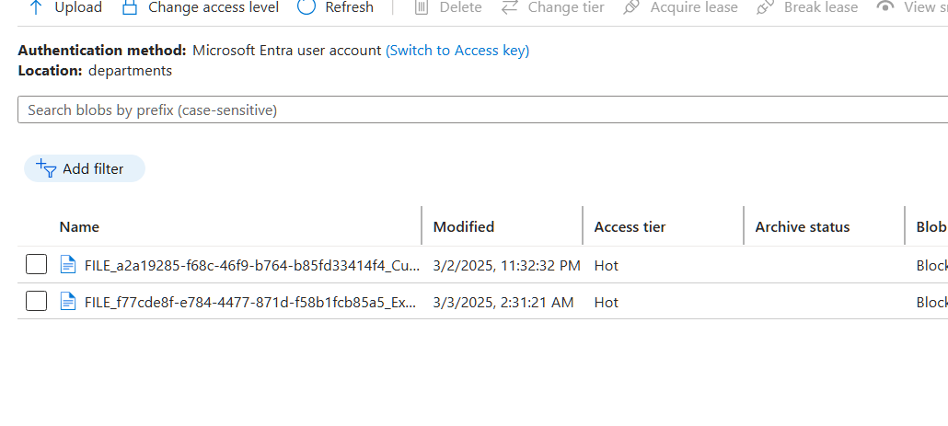  
Blob trigger azure durable function runs that uploads file metadata to cosmos db

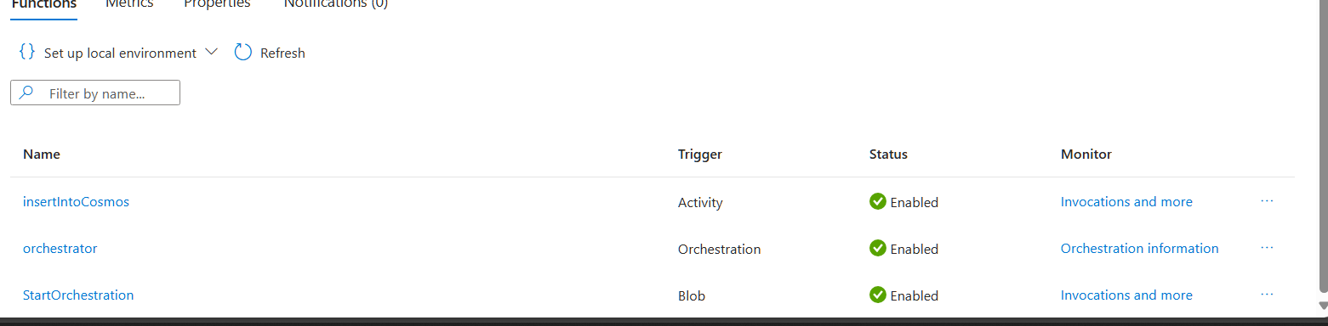

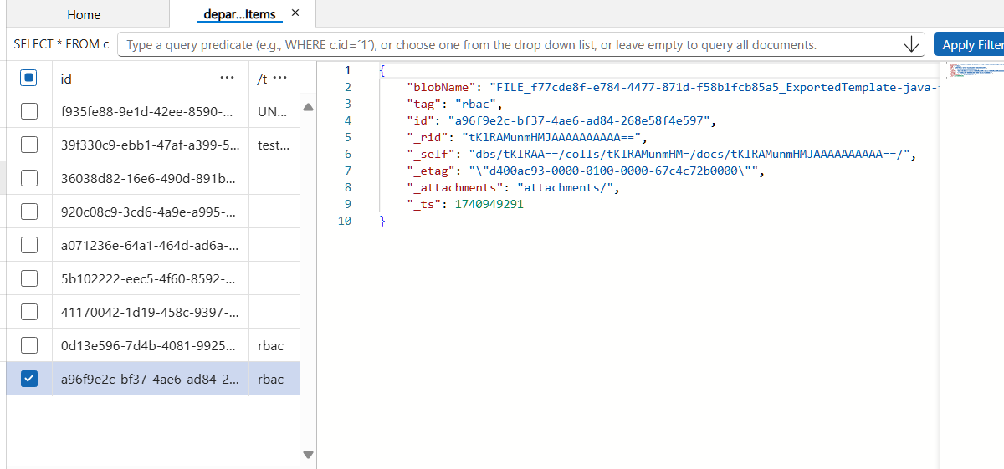

User can fetch documents uploaded byt searching by tag. (Query runs on cosmosdb)

