# Pad6K2R
My First Project.
Its a 6 Key 2 Rotary Encoder Switch Macropad.
Components Used are:-
1.Switches - Cherry MX 1.00u switch
2.Rotary Encoder (2)
3.Oled 128*32 display
4.1N914 diode (6)
5.RGB LEDs - SK6812MINI (10)
6.Microcontroller - Arduino Nano RP2040 Connect

#PCB
Schematic
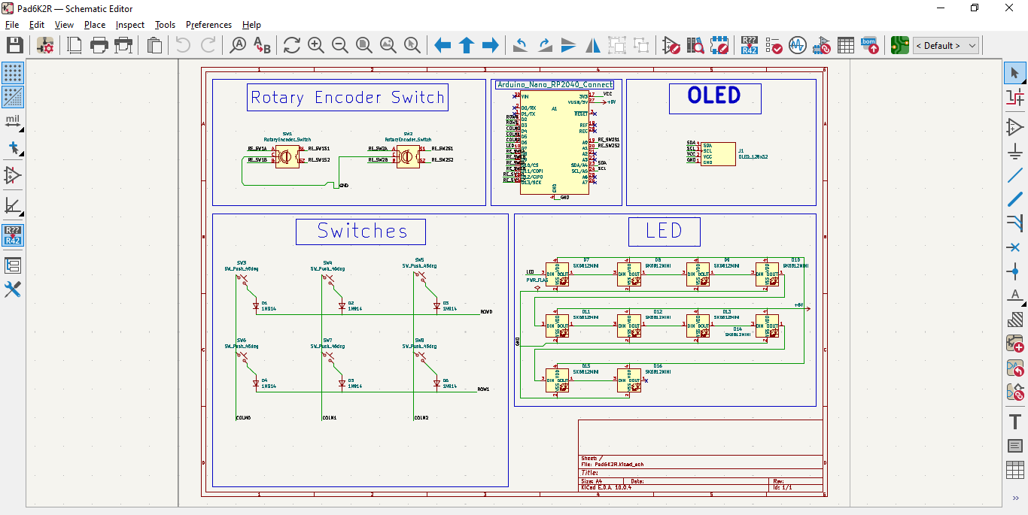
PCB
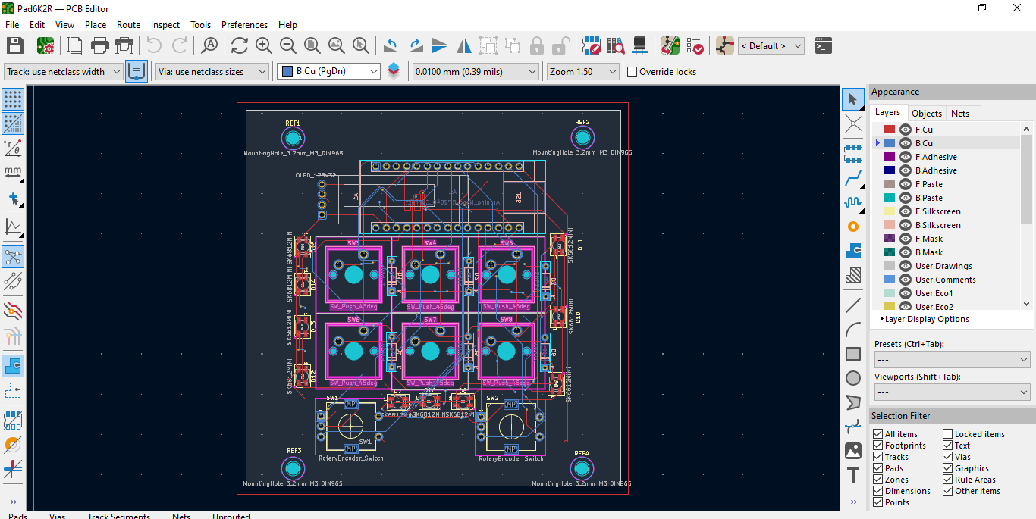
3D Front View
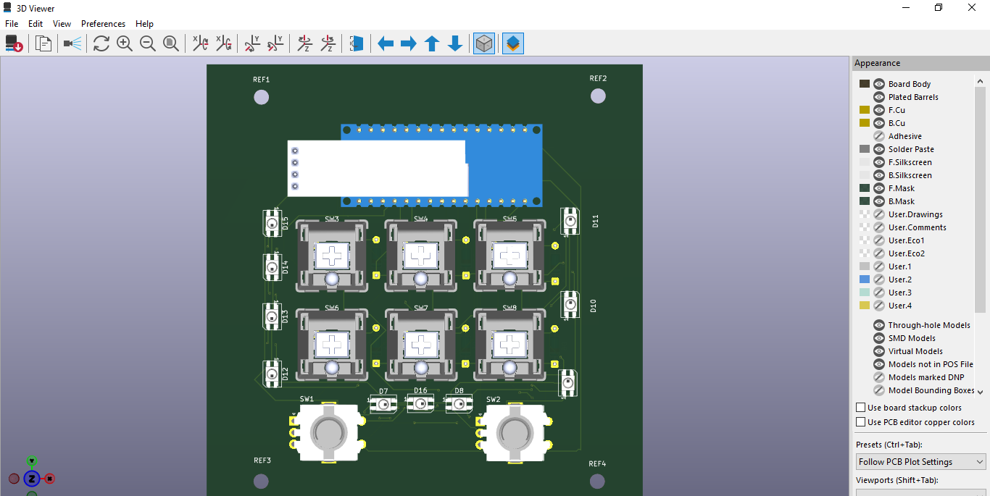
3D Back View
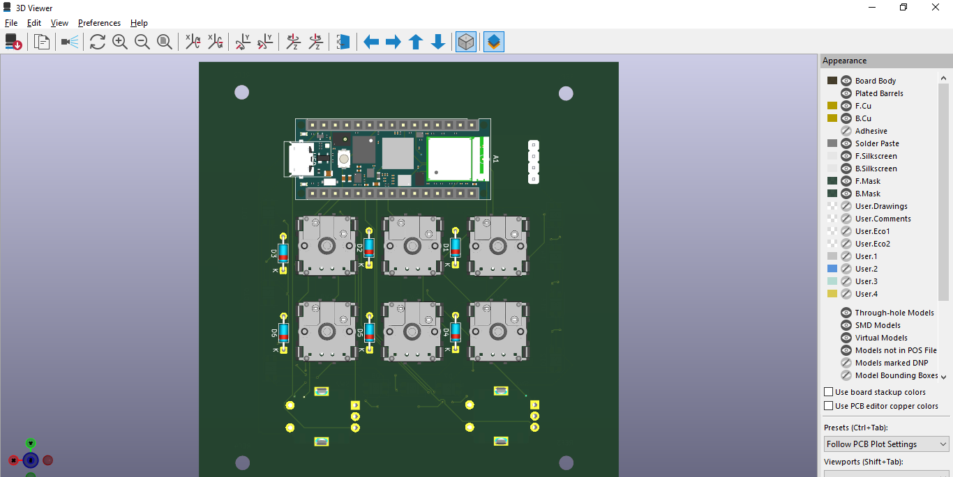
About
Build as part of a Hackclub Project , as a way to learn PCB design embedded programming and electronics fundamentals.
Thank you,
Abhiraj Kashyap.

