**Voxel Busters Interactive LLP Assignment Documentation**

* The goal of the assignment is to create an invite feature using the ‘Cross-Platform Native Plugin: Essential Kit’ provided by Voxel Busters Interactive LLP.
* In this project, I have used one of my on-going project which is titled as ‘Fox Days’ using open-source asset pack.

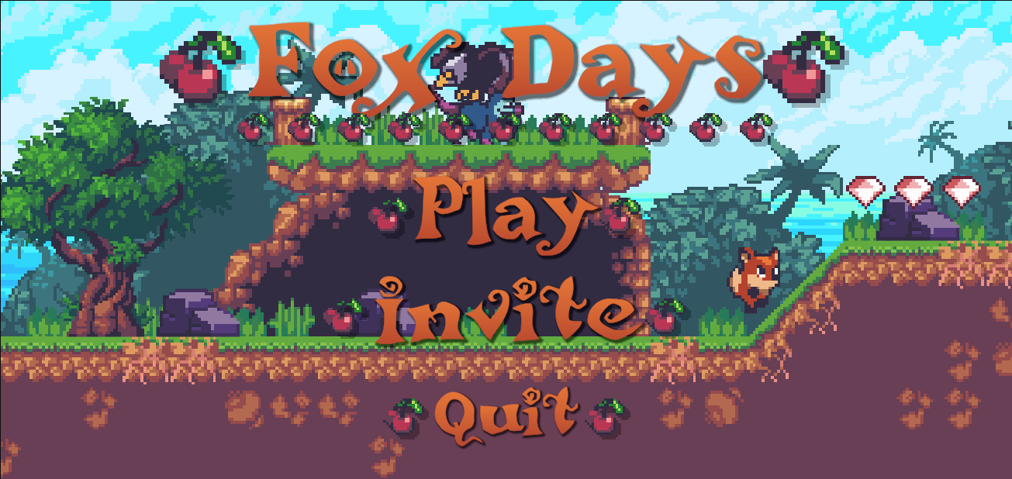

* The original version of my game only has 2 options in the initial main menu scene which are ‘Play’ and ‘Quit’. For this project additionally I have added an ‘Invite’ button which is the whole point of the assignment.
* This ‘Invite’ button displays an address book with a list of contacts provided by the plugin one below the other.

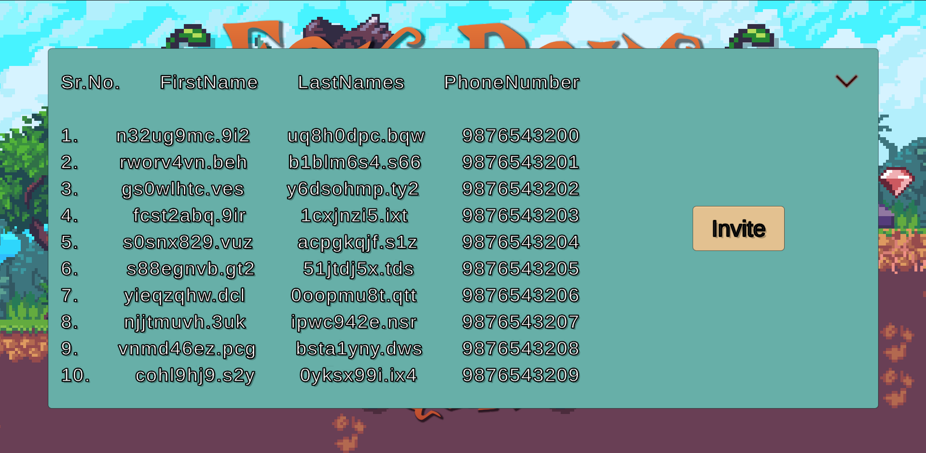

* As for the current situation of issue I faced is that I am unable to retrieve the email addresses. For that I just created a single ‘Invite’ button which when clicked opens the Mail App from Windows from which the user can send the mail.

