**Aim:** To use 2D arrays and Strings for solving given problem.

**Objective:**  To use 2D array concept and strings in java to solve real world problem

**Theory:**

* An array is used to store a fixed-size sequential collection of data of the same type.
* An array can be init in two ways:

1. Initializing at the time of declaration:

dataType[] myArray = {value0, value1, ..., valuek};

2. Dynamic declaration:

dataType[] myArray = new dataType[arraySize];

myArray[index] = value;

· Two – dimensional array is the simplest form of a multidimensional array. Data of only same data type can be stored in a 2D array.Data in a 2D Array is stored in a tabular manner which can be represented as a matrix.

· A 2D Array can be declared in 2 ways:

1. Intializing at the time of declaration:

dataType[][] myArray = { {valueR1C1, valueR1C2...}, {valueR2C1, valueR2C2...},..}

2. Dynamic declaration:

dataType[][] myArray = new dataType[x][y];

myArray[row_index][column_index] = value;

In [Java](https://www.javatpoint.com/java-tutorial), string is basically an object that represents sequence of char values. An [array](https://www.javatpoint.com/array-in-java) of characters works same as Java string. **Java String** class provides a lot of methods to perform operations on strings such as compare(), concat(), equals(), split(), length(), replace(), compareTo(), intern(), substring() etc.

### **1.String literal**

To make Java more memory efficient (because no new objects are created if it exists already in the string constant pool).

**Example:**

String demoString = “GeeksforGeeks”;

### **2. Using new keyword**

· String s = new String(“Welcome”);

· In such a case, JVM will create a new string object in normal (non-pool) heap memory and the literal “Welcome” will be placed in the string constant pool. The variable s will refer to the object in the heap (non-pool)

**Example:**

String demoString = new String (“GeeksforGeeks”);

**Code:**

**1}**

class Testarray3{

public static void main(String args[]){

int arr[][]={{1,2,3},{2,4,5},{4,4,5}};

for(int i=0;i<3;i++){

for(int j=0;j<3;j++){

System.out.print(arr[i][j]+" ");

}

System.out.println();

}

}}

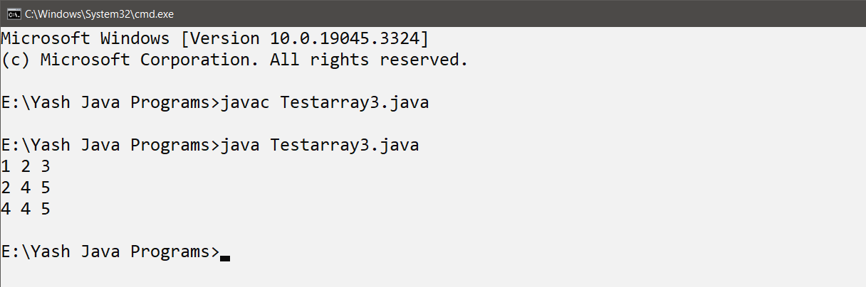

**2}**

class StringExample{

public static void main(String args[]){

String s1="java";

char ch[]={'s','t','r','i','n','g','s'};

String s2=new String(ch);

String s3=new String("example");

System.out.println(s2);

System.out.println(s3);

}}

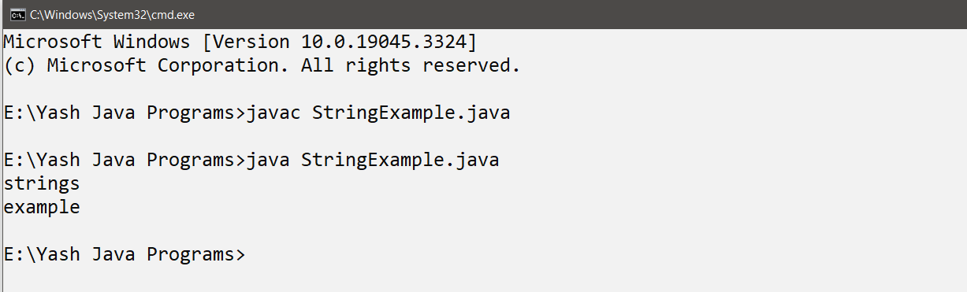

**Conclusion:**

Comment on how you have used the concept of string and 2D array.

String Usage:

String s1 = "java";: Here, we've created a string s1 using a string literal.

char ch[] = {'s','t','r','i','n','g','s'};: We've defined a character array ch, and then we've created a string s2 using this character array. This demonstrates the creation of a string from an array of characters.

String s3 = new String("example");: This is another way to create a string, using the new keyword and a constructor. We have created s3 from the string literal "example".

2D Array Usage:

int arr[][] = {{1,2,3},{2,4,5},{4,4,5}};: We defined a 2D integer array arr with three rows and three columns. This represents a 3x3 grid of integer values.

The nested loops (for loops) in the Testarray3 class are used to iterate through the elements of the 2D array and print them out. This demonstrates how to access and display elements from a 2D array.