SQL Queries:
a. Design and Develop SQL DDL statements which demonstrate the use of SQL objects such as Table, View, Index, Sequence, Synonym, different constraints etc.
b. Write at least 10 SQL queries on the suitable database application using SQL DML statements.

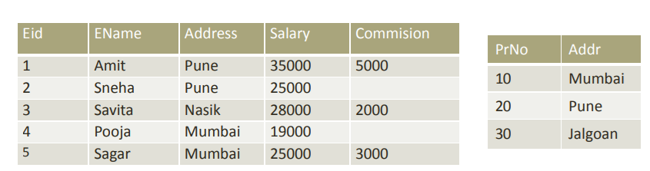

- Find different locations from where employees belong to?
- What is maximum and minimum salary?
- Display the content of employee table according to the ascending order of salary amount.
- Find the name of employee who lived in Nasik or Pune city.
- Find the name of employees who does not get commission.
- Change the city of Amit to Nashik.
- Find the information of employees whose name starts with ‘A’.
- Find the count of staff from Mumbai.
- Find the count of staff from each city
- Find city wise minimum salary.
- Find city wise maximum salary having maximum salary greater than 26000
- Delete the employee who is having salary greater than 30,000.

