SQL Queries - all types of Join and View:

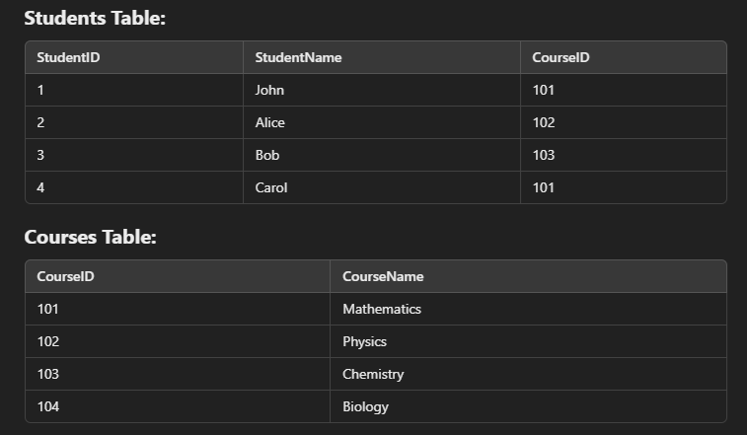

- SELECT Students.StudentID, Students.StudentName, Courses.CourseName
FROM Students INNER JOIN Courses ON Students.CourseID = Courses.CourseID;
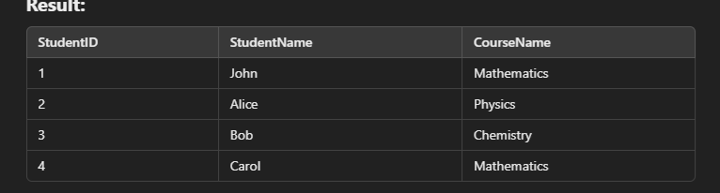

- SELECT Students.StudentID, Students.StudentName, Courses.CourseName
FROM Students
LEFT JOIN Courses
ON Students.CourseID = Courses.CourseID;
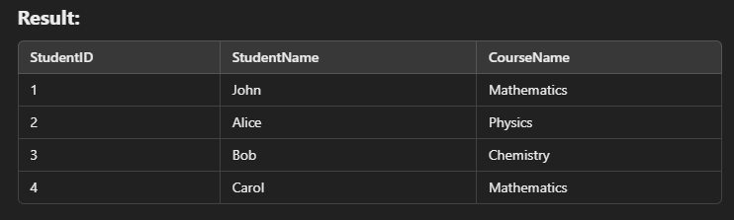

- SELECT Students.StudentID, Students.StudentName, Courses.CourseName
FROM Students
RIGHT JOIN Courses
ON Students.CourseID = Courses.CourseID;
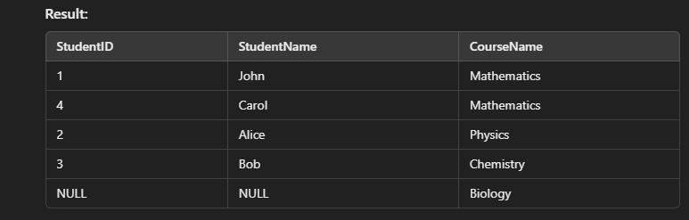

- SELECT Students.StudentID, Students.StudentName, Courses.CourseName
FROM Students FULL OUTER JOIN Courses ON Students.CourseID = Courses.CourseID;

But if Full outer join is not supported by SQL then query is modified as
- SELECT Students.StudentID, Students.StudentName, Courses.CourseName
FROM Students LEFT JOIN Courses ON Students.CourseID = Courses.CourseID
UNION
- SELECT Students.StudentID, Students.StudentName, Courses.CourseName
FROM Students RIGHT JOIN Courses ON Students.CourseID = Courses.CourseID;

View:
- CREATE VIEW StudentCourseView AS
SELECT Students.StudentID, Students.StudentName, Courses.CourseName
FROM Students;
- CREATE VIEW StudentCourseView AS
SELECT Students.StudentID, Students.StudentName, Courses.CourseName
FROM Students FULL OUTER JOIN Courses
ON Students.CourseID = Courses.CourseID;
- CREATE VIEW StudentCourseView AS SELECT Students.StudentID, Students.StudentName, Courses.CourseName FROM Students LEFT JOIN Courses ON Students.CourseID = Courses.CourseID
UNION
SELECT Students.StudentID, Students.StudentName, Courses.CourseName FROM Students
RIGHT JOIN Courses ON Students.CourseID = Courses.CourseID;

- SELECT * FROM StudentCourseView;

