1. **Multiply 2 columns in M language.**

In the PQ Editor. The in Standard tab the multiply

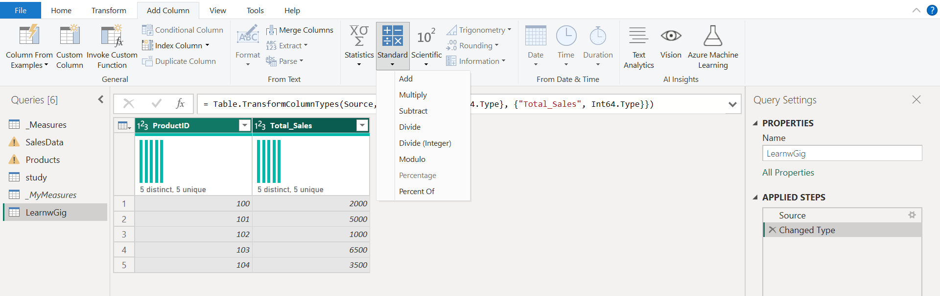

1. Split’s and replace value in the PQ.
2. How to remove duplicate (solved in the csv comparison and in Ariba AMS).
3. **What is a limitation of VLOOKUP.**

* VLOOKUP can only look up values to the right on the lookup value. i.e., the lookup only works left to right.
* VLOOKUP can only perform a vertical lookup across columns. It cannot search across rows.
* A VLOOKUP function does not automatically update when a formula is added.

1. How to find the duplicate the record in excel.
2. **List How many DAX function use in power bi.**

SUM, IF, BLANK(), SWITCH, TRUE(), COUNT, NETWORKDAYS, CONCATENATE, COUNTBLANK, WEEKNUM, YEAR, CALCULATE, ALLSELECTED, DISTINCTCOUNT, COUNTROWS,

**CALCULATE** = (Expression, filter). Evaluates an expression in a filter context.

**Filter**= take the (table, <Filter>) and returns the table.

**VALUES =** take a one table column and return a distinct column.

**ALL =** Return all rows ignoring the filters apply to it.

**ALLSELECTED** = it retains all other context filter or explicit filer.

**ALLEXCEPT** = remove all context filter in the table except filter that have been applied to the specified columns. – {Table name and column name}.

**COUNTROWS** = Counts the number of rows in the table.

**COUNT** = Count the cells in a column that contains non-blank value.

**COUNTX =** Count non-blank value with the expression given to it.

**SELECTEDVALUES** = Shows the value for one distinct value only. If selected other, it will show for that as well. By default, it shows selected value.  
suppose we select the filter city 10 city are there we select “Mumbai” by default it shows value for Mumbai till we select another city.

**SUMMARIZE =** Group BY. Return a table.

**ROW =**

running total

TotalYTD =

IF (

    [total sales] <> BLANK (),

    CALCULATE (

        [total sales],

        FILTER ( ALL ( DimDate[Date] ), DimDate[Date] <= MAX ( DimDate[Date] ) )

    )

)

With product

Product Running Total =

VAR PdtRank =

    RANKX(

        ALL(Products[Product]),

        [Total Sales],,

        DESC,

        Dense

    )

VAR RunningTotal =

    CALCULATE(

        [Total Sales],

        FILTER(

            ALL(Products[Product]),

            PdtRank >= RANKX(

                        ALL(Products[Product]),

                        [Total Sales],,

                        DESC,

                        Dense

                    )

        )

    )

RETURN

    IF(

        [Total Sales] <> BLANK(),

        RunningTotal

    )

1. Data model

* One-to-many (1:*)
* Many-to-one (*:1)
* One-to-one (1:1)
* Many-to-many (*:*)

1. **Running Total. –** answer written above.
2. In the power bi service
   1. How to schedule report in the power bi service.
   2. How to do incremental refresh.
   3. How send everyday mail to stakeholder of report.