PROJECT REPORT / 2026

CUSTOMER CHURN
PREDICTION SYSTEM
Machine Learning • Risk Analysis • Customer Retention

PROJECT SUMMARY
A Streamlit-based customer churn prediction application using a Random Forest model. Users enter customer attributes and receive a predicted churn/stay outcome with probability indicators.

SUBMISSION DETAILS | INFORMATION
Submitted by | Yash Amar Kharat
Programme | AICTE | IBM SkillsBuild Data Analytics with AI Internship 2026
Project title | Customer Churn Prediction System
Interface / runtime | Streamlit, launched from Anaconda Prompt
Repository | github.com/YashKharat-9124/ML-Projects-/tree/main/Churn%20Prediction

Prepared for project documentation and certificate verification

Report Overview
This report documents the Customer Churn Prediction System in a project-report format inspired by the submitted Bug Hunt 101 report: introduction, objectives, environment, methodology, implementation evidence, results, limitations, conclusion, and learning outcomes. The project-specific screenshots supplied by the student are included as implementation evidence.
SECTION | CONTENT
01 | Introduction and problem statement
02 | Objectives, scope, and responsible use
03 | Tools and application environment
04 | System workflow and methodology
05 | Application interface and sample prediction
06 | Execution evidence and runtime warning
07 | Testing, evaluation, and limitations
08 | Conclusion, learning outcomes, and references

Executive Summary
Customer churn occurs when a customer stops using a company's product or service. This project presents a machine-learning application intended to estimate churn risk from customer attributes. The supplied interface identifies Random Forest as the machine-learning algorithm and provides fields for credit score, age, tenure, account balance, number of products, credit-card status, active-member status, estimated salary, country, and gender.
The provided UI screenshot displays a sample result of 7.00% churn probability and 93.00% stay probability for the values entered in that example. These are individual prediction outputs, not model-wide accuracy metrics. The supplied terminal screenshot shows the app launched with `streamlit run app.py` and also shows a scikit-learn feature-name warning that should be checked before final submission.
EVIDENCE NOTE
This report uses details visible in the supplied screenshots and the project context. Dataset dimensions, training/test split, model evaluation scores, and dataset source are not asserted because they were not confirmed by the screenshots.

1. Introduction
Customer retention is important to businesses because losing customers can reduce recurring revenue and increase the effort needed to acquire replacements. Customer records may contain patterns related to churn, such as account tenure, product usage, account balance, or customer engagement. Data analytics and machine learning can help explore these patterns and estimate which customers may be more likely to leave.
The Customer Churn Prediction System provides a simple interactive interface for entering customer information and viewing a predicted outcome. It is designed as a decision-support demonstration: the output can inform further review, but it does not guarantee what a customer will do.

1.1 Problem Statement
Identifying customers who may leave can be difficult when customer records are reviewed manually. The project aims to provide a repeatable way to submit customer attributes to a trained classification model and display a churn-risk estimate through a web interface.

1.2 Project Objectives
- Build or demonstrate a machine-learning workflow for customer churn prediction.
- Provide a user-friendly Streamlit interface for entering customer attributes.
- Display a predicted outcome and churn/stay probability indicators.
- Document how the application is launched and how the output should be interpreted.
- Identify implementation issues that should be checked for consistent, reliable inference.

1.3 Project Scope
The documented scope covers the local Streamlit application, its customer-input form, the Random Forest model label shown in the UI, sample prediction output, and the visible runtime warning. This report does not claim cloud deployment, production integration, verified business impact, or specific model performance metrics.

2. Tools and Environment
TOOL / COMPONENT | ROLE IN THE PROJECT
Python | Application and machine-learning implementation language, as indicated by the Python/Streamlit runtime.
Streamlit | Interactive web interface for customer input and prediction output.
Random Forest | Classification algorithm identified in the application interface.
Anaconda Prompt | Terminal used to navigate to the project directory and launch the app.
scikit-learn | Machine-learning library indicated by the StandardScaler warning in the terminal.
Web browser | Displays the locally running application.

2.1 Launch Procedure
- Open Anaconda Prompt.
- Switch to the drive containing the project folder.
- Navigate to the project directory, shown in the screenshot as `E:\Yash Kharat ML\Churn_Prediction`.
- Run `streamlit run app.py`.
- Open the local address printed by Streamlit, shown as `http://localhost:8501`.
LOCAL-ONLY ADDRESS
The screenshot shows localhost and a private network address. These addresses are for accessing the app in the local environment or local network; they are not public deployment links.

3. System Workflow and Methodology
The expected application flow, based on the supplied UI and terminal screenshots, is summarized below. Training and dataset-processing details must be checked in the actual notebook/source code before they are documented as completed steps.
STEP | PROCESS | PURPOSE
1 | Enter customer attributes | Collect the feature values required by the prediction interface.
2 | Prepare model input | Represent the entered values in the feature order and format expected by preprocessing and the model.
3 | Apply saved preprocessing | Use the same transformations used during model training, where applicable.
4 | Run Random Forest prediction | Generate a predicted class and/or probability output.
5 | Display the result | Show stay/churn status and probability indicators to the user.
6 | Review output responsibly | Treat the output as an estimate that may require further investigation.

3.1 Input Features Shown in the Interface
FEATURE | DESCRIPTION
Credit Score | Credit-score value entered by the user.
Age | Customer age.
Tenure (Years) | Length of the customer relationship in years.
Account Balance | Displayed account balance value.
Number of Products | Number of products associated with the customer.
Has Credit Card? | Credit-card status selection.
Active Member? | Customer activity status selection.
Estimated Salary | Estimated salary value.
Country | Country selection.
Gender | Gender selection.

The exact encoding, allowed ranges, and preprocessing of these fields should be verified in `app.py` and the model-training notebook. The UI labels alone do not establish the underlying dataset schema or how each category is encoded.

4. Application Interface and Sample Prediction
Figure 1 shows the supplied Customer Churn Prediction System interface. The page is organized into a customer information form on the left and a prediction-result panel on the right. The interface uses a clear hierarchy of input controls, action buttons, probability cards, a model-confidence indicator, and a customer snapshot.
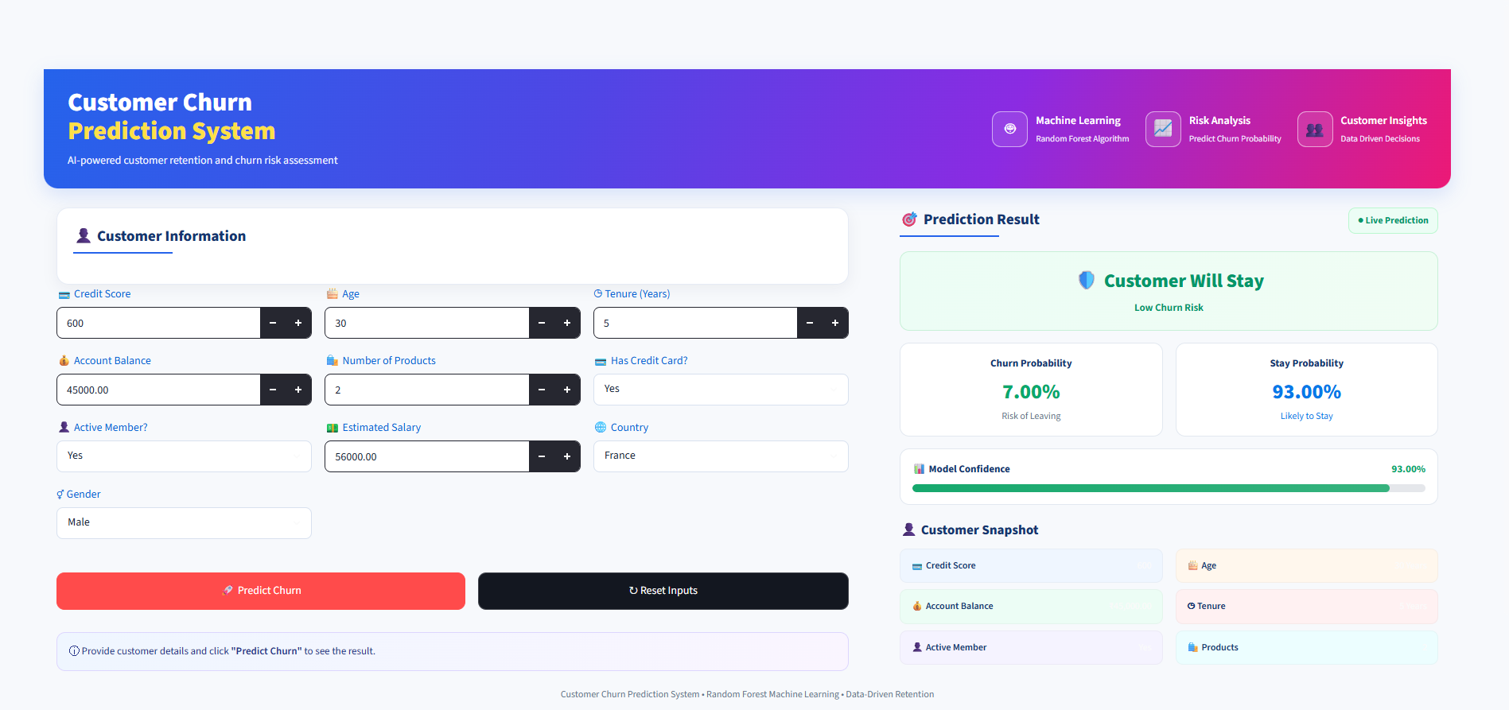
Figure 1. Customer Churn Prediction System — Streamlit user interface.

4.1 Example Output Shown
DISPLAYED RESULT | VALUE IN SCREENSHOT | INTERPRETATION
Predicted outcome | Customer Will Stay | The displayed prediction for the sample input.
Churn probability | 7.00% | Estimated probability of leaving for this input.
Stay probability | 93.00% | Estimated probability of staying for this input.
Model confidence indicator | 93.00% | UI indicator; exact calculation needs verification in source code.

IMPORTANT
A single prediction is not the same as model accuracy. Report overall accuracy, precision, recall, F1-score, ROC-AUC, or confusion-matrix results only if they have been calculated and verified using a documented evaluation procedure.

5. Application Execution Evidence
Figure 2 documents the local execution process. The terminal shows navigation into the Churn_Prediction directory followed by the Streamlit launch command. It reports that the server started on port 8501 and prints the local browser URL.
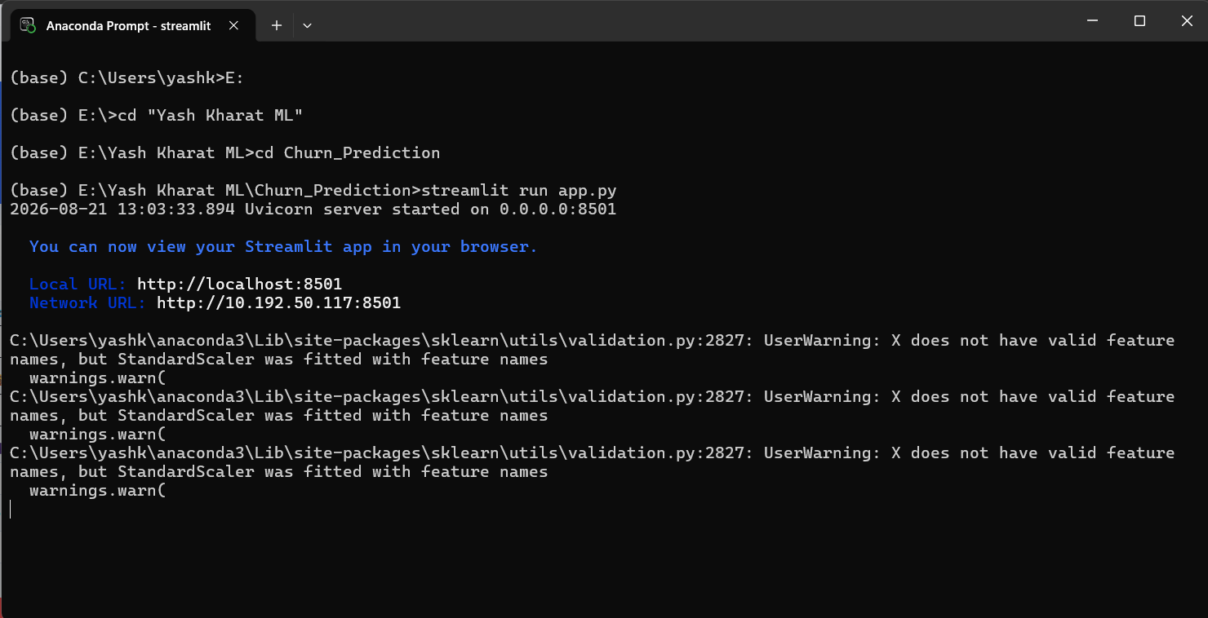
Figure 2. Anaconda Prompt showing the Streamlit application launch.

5.1 Runtime Warning Observed
SCIKIT-LEARN WARNING
The terminal reports: input X does not have valid feature names, but StandardScaler was fitted with feature names. The screenshot shows a warning, not a visible fatal exception.

This warning commonly appears when preprocessing was fitted using named columns, such as a pandas DataFrame, but prediction-time input is supplied without matching feature names, such as a plain array. It should be investigated because feature order and preprocessing consistency matter for correct predictions.

5.2 Recommended Technical Fix
- Inspect the code where `StandardScaler` is fitted and where it is called inside `app.py`.
- Use a pandas DataFrame with the same feature names and column order used during training, if that matches the training design.
- Ensure categorical encoding, scaling, and feature ordering are identical at training and prediction time.
- Where practical, package preprocessing and the estimator in one scikit-learn Pipeline and save/load that single pipeline.
- Retest several known examples and compare predictions before and after the change.

6. Testing, Results, and Evaluation

6.1 Checks Supported by the Available Evidence
CHECK | OBSERVATION | STATUS / NOTE
Application launch | `streamlit run app.py` is shown in the terminal. | Launch command is evidenced.
Local endpoint | `http://localhost:8501` is printed. | Local server address is evidenced.
Input interface | Customer fields and action buttons are visible. | UI is evidenced.
Prediction display | Stay/churn labels and probabilities are visible. | One example output is evidenced.
Preprocessing consistency | StandardScaler feature-name warning appears. | Needs source-code review and retesting.
Overall model performance | No evaluation report is visible in the supplied screenshots. | Add verified notebook metrics if available.

6.2 Evaluation Metrics to Include if Available
To demonstrate model performance, use results from a held-out test set or a clearly described cross-validation procedure. Suitable classification metrics include:
- Accuracy — proportion of all predictions that are correct.
- Precision — proportion of predicted churn cases that are actual churn cases.
- Recall — proportion of actual churn cases detected by the model.
- F1-score — harmonic mean of precision and recall.
- Confusion matrix — counts of true/false positives and true/false negatives.
- ROC-AUC — ranking performance across classification thresholds, when suitable for the evaluation setup.
DO NOT INVENT RESULTS
The current report intentionally leaves out numerical model-performance scores because none were verified from the supplied screenshots. Populate this section from the executed notebook or evaluation output.

7. Limitations and Responsible Use
- The report does not confirm the dataset source, sample size, target distribution, or full preprocessing workflow.
- The displayed probabilities depend on the trained model and its preprocessing; their calibration has not been established by the screenshots.
- A model prediction is an estimate and should not be treated as a guaranteed customer outcome.
- Data quality, class imbalance, data leakage, or a mismatch between training and inference features can affect reliability.
- Customer attributes should be handled privately and only for legitimate project purposes.
- Retention decisions should include human review and should not unfairly penalize customers based only on a prediction.

8. Learning Outcomes
- Understanding how a classification model can be exposed through a web interface.
- Learning how customer features are entered and used to produce a prediction.
- Understanding the difference between an individual probability output and overall model accuracy.
- Recognizing the importance of consistent preprocessing and feature names at inference time.
- Documenting project setup, visible results, limitations, and evidence in a structured report.

9. Conclusion
The Customer Churn Prediction System demonstrates a machine-learning application presented through a Streamlit interface. The supplied evidence shows a Random Forest label, customer input fields, churn/stay probability cards, and a successful local launch command. The sample UI output indicates a 7.00% churn probability and a 93.00% stay probability for the values shown; these are example outputs rather than overall performance metrics.
Before the project is submitted as final, the preprocessing warning should be reviewed, model evaluation scores should be added from the actual notebook if available, and dataset/model details should be verified against the source code. These steps will improve reproducibility, clarity, and technical credibility.

References and Project Link
- Project repository: https://github.com/YashKharat-9124/ML-Projects-/tree/main/Churn%20Prediction

- Streamlit documentation: https://docs.streamlit.io/

- scikit-learn documentation: https://scikit-learn.org/stable/

- Pandas documentation: https://pandas.pydata.org/docs/

Thank You…
With Gratitude to
BHARATCARES
AICTE
IBM

