**HOSPITAL MANAGEMENT SYSTEM**

**Introduction :-**

The hospital management system (HMS) is an integrated software that handles different directions of clinic workflows.It manages the smooth healthcare performance that makes it easier and convenient to manage the details of patient in a hospital.

The project Hospital Management system includes registration of patients, diagnosis, full history of the patient, update patient record and hospital information. The software has the facility to give a unique id for every patient and stores the details of every patient along with diagnosis.

The Hospital Management System can be entered using a username and password. It is accessible either by an administrator or receptionist. Only they can add data into the database. The data can be retrieved easily. The interface is very user-friendly. The data are well protected for personal use and makes the data processing very fast.

The purpose of the project entitled as “HOSPITAL MANAGEMENT SYSTEM” is to computerize the Front Office Management of Hospital to develop software which is user friendly, simple, fast, and cost – effective. It deals with the collection of patient’s information, diagnosis details, etc. Traditionally, it was done manually. The main function of the system is to register and store patient details and retrieve these details as and when required.

# Advantages :-

* It is fast, efficient and reliable
* Avoids data redundancy and inconsistency
* Very user-friendly
* Easy accessibility of data
* Number of personnel required is considerably less
* Provides more security and integrity to data

# Project Overview :-

The Hospital Management System (HMS) is designed for any hospital to replace their existing manual, paper based system. The new system is to control the following information: patient information, diagnosis, full history of the patient, update the patient record and hospital information. These services are to be provided in an efficient, cost effective manner, with the goal of reducing the time and resources

currently required for such tasks. The main aim is to manage patient details in a hospital efficiently. It consists of Front-end Java programs and connector program with some libraries / jar files to connect with Back-end mysql database.

# Software Requirements :-

MYSQL 8.0

Microsoft Windows 10 as an Operating System Google Docs for report

NetBeans IDE 8.2

Mysql-connector.jar and rs2xml.jar (for connection between Java IDE and MYSQL) JDK 1.8

# Limitation :-

A typical hospital management system, which covers all functional areas, is large enough. In our short project period it was difficult to develop all system components. Thus I decided to reduce the size of our systems in the design phase. I have designed only operational activities of a typical computer aided hospital management systems.

# Conclusion :-

The project was designed in such a way that future modifications can be done easily. The following conclusion can be deduced from the development of the project.

* Automation of the entire system improves the efficiency
* It provides a friendly graphical user interface which proves to be better when compared to the existing system.
* It gives appropriate access to the authorized users depending on their permissions.
* It effectively overcomes the delay in communications.
* Updating of information becomes so easier.
* System security, data security and reliability are the striking features.
* The System has adequate scope for modification in future if it is necessary.

# Snap-shots of the project :-

**Login.java**

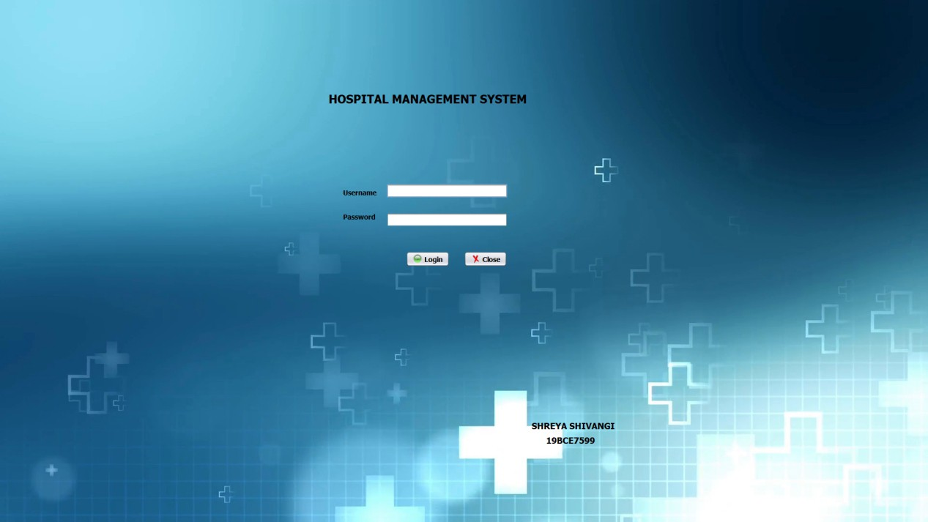

If we enter wrong username or password it will show a message as Incorrect username or password.

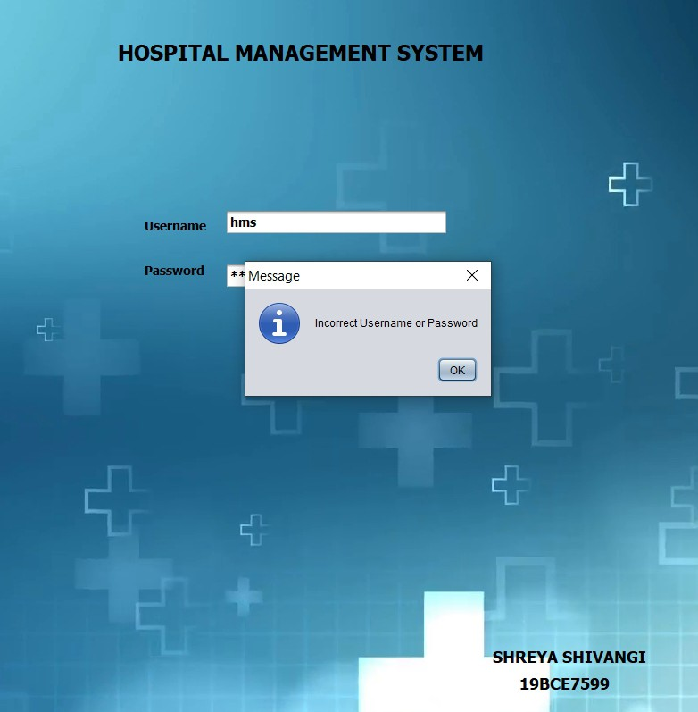

# Home.java



The arrow button is used to change the direction of other buttons from vertical to horizontal , whichever way is convenient by the user.

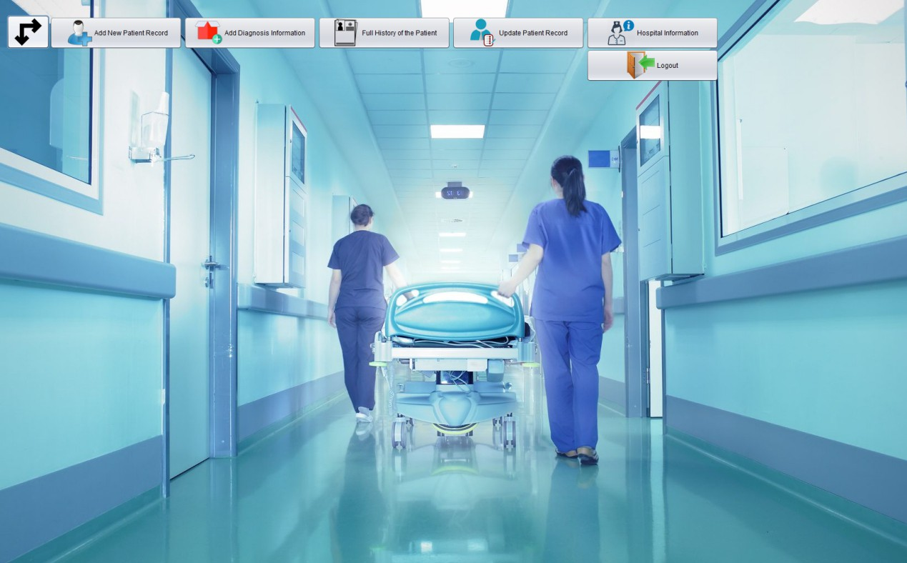

# AddNewPatientRecord.java

When we enter correct information about the patient and save it then, it will show the message “Successfully Updated” as it is being shown for patient 1 when we enter the details correctly.

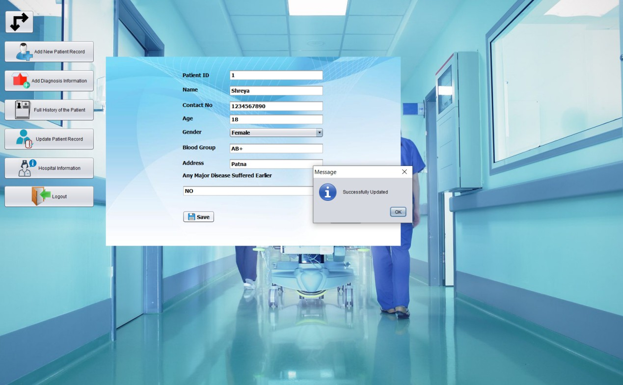

Same as for patient 2

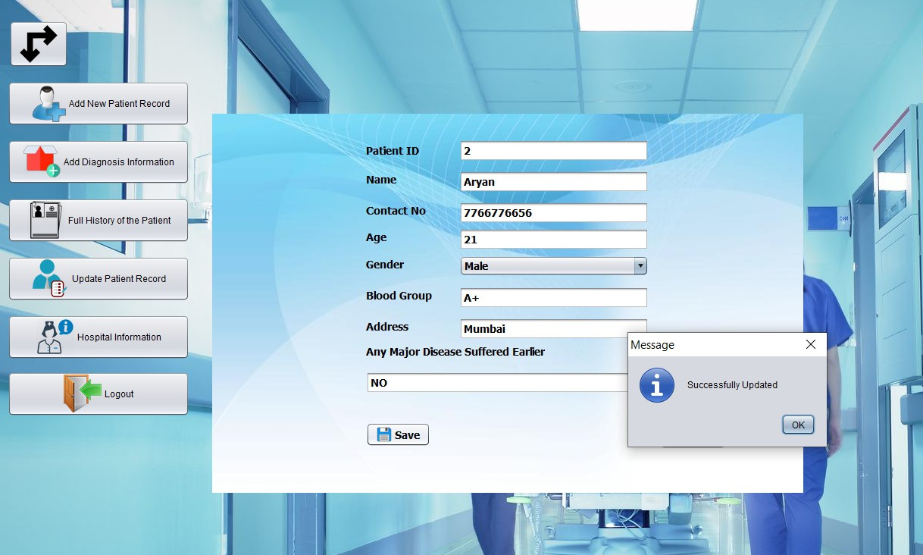

# AddDiagnosisInformation.java

When we enter the incorrect Patient ID that has not been added in the AddNewPatientRecord , then it will show the message as “PatientID does not Exist”.

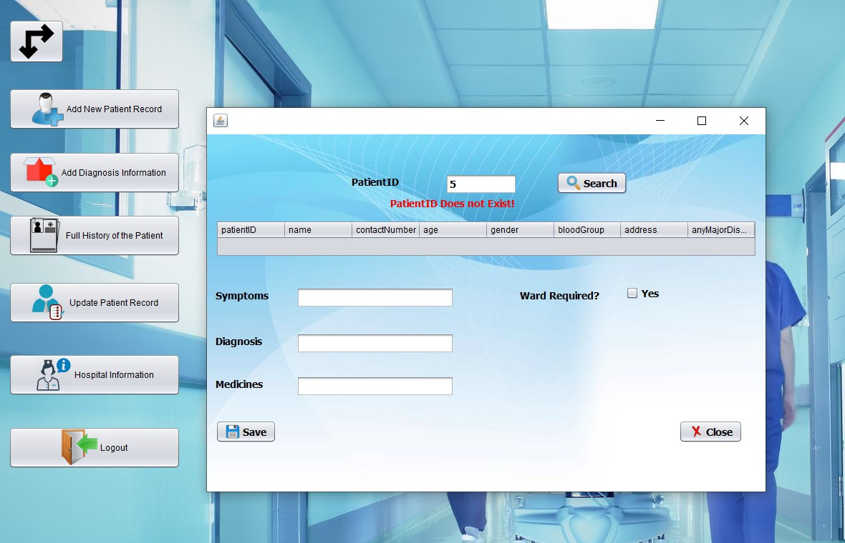

When we enter the correct Patient ID and click on Search button , it will display the details of patient that we have entered in Add New Patient Record and when we enter all the details correctly and save it then it will show the message as “Successfully Updated”.

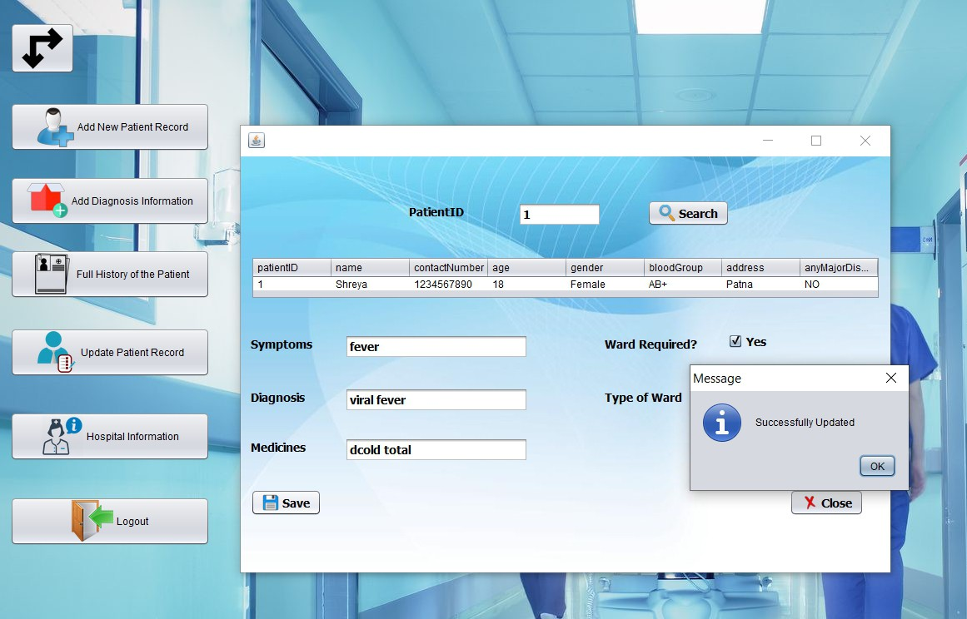

When we have entered all the details correctly, then there is the option shown as “Ward Required”. If we click on “YES”, then it will show the user that which type of ward they want that is available in the hospital.

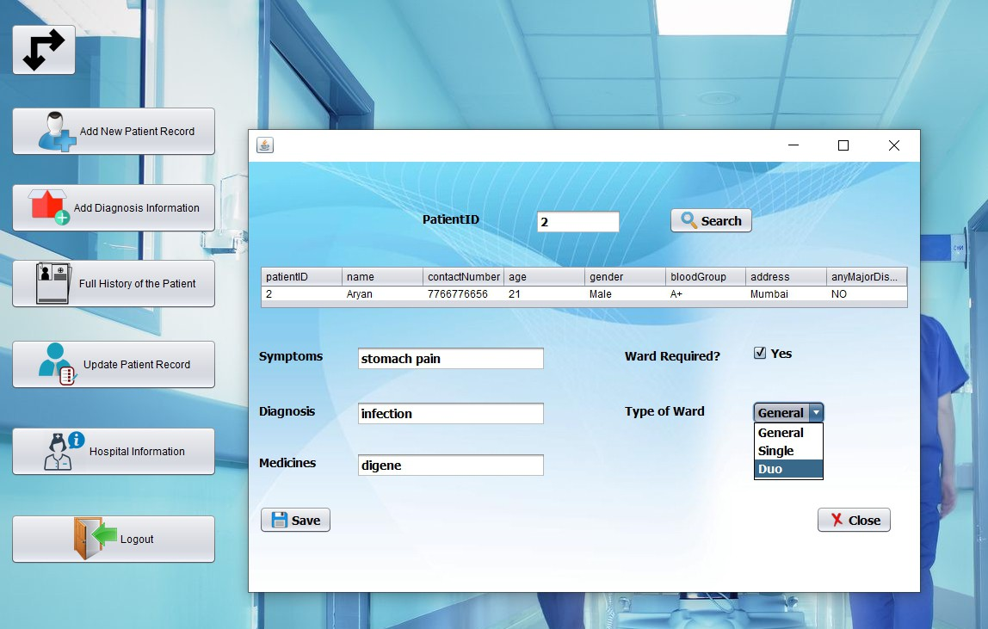

After we have entered all the information correctly and save it then, it will show the message as “Successfully Updated”.



# FullHistoryOfThePatient.java

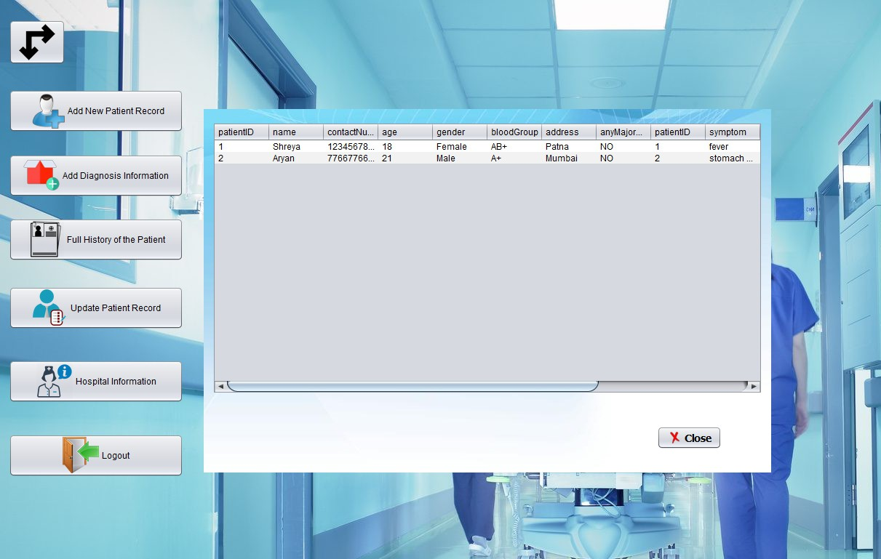

It will display all the information that we have entered in Add New Patient Record and Add New Diagnosis Information.

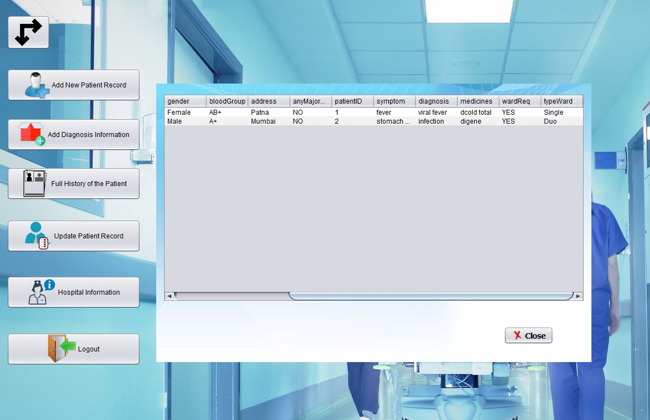

# UpdatePatientRecord.java

When we enter the correct patient id and click on search , it will display all the details of the patient that was entered earlier. If we want to update any information , we can update here and then click on save and it will show the message as “Successfully Updated”.

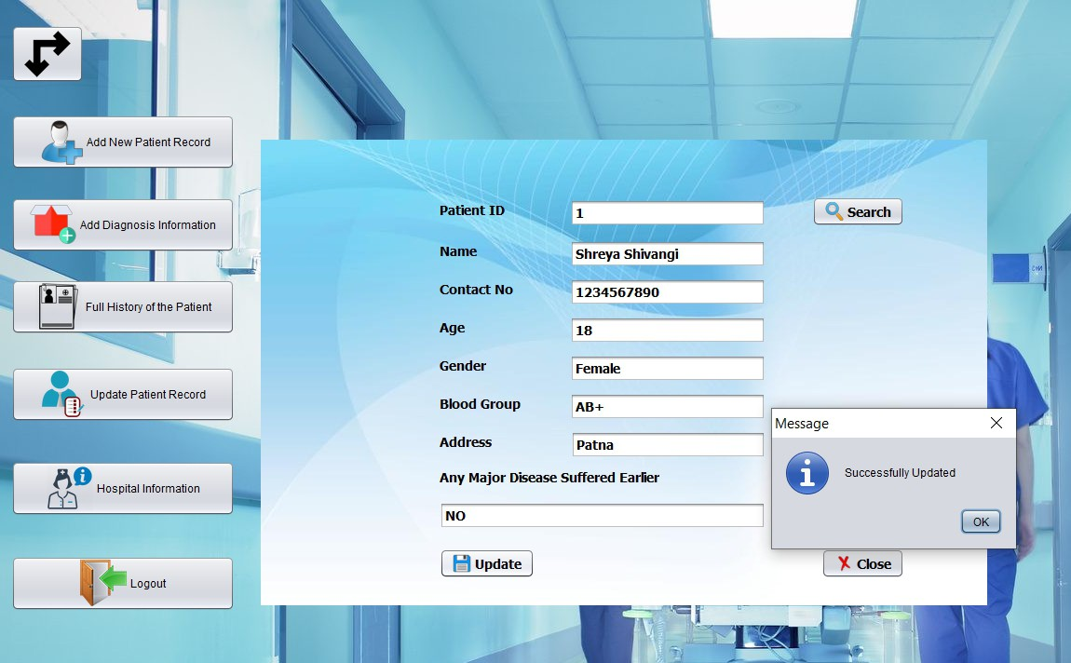

# HospitalInformation.java

All the details of the hospital are shown here.

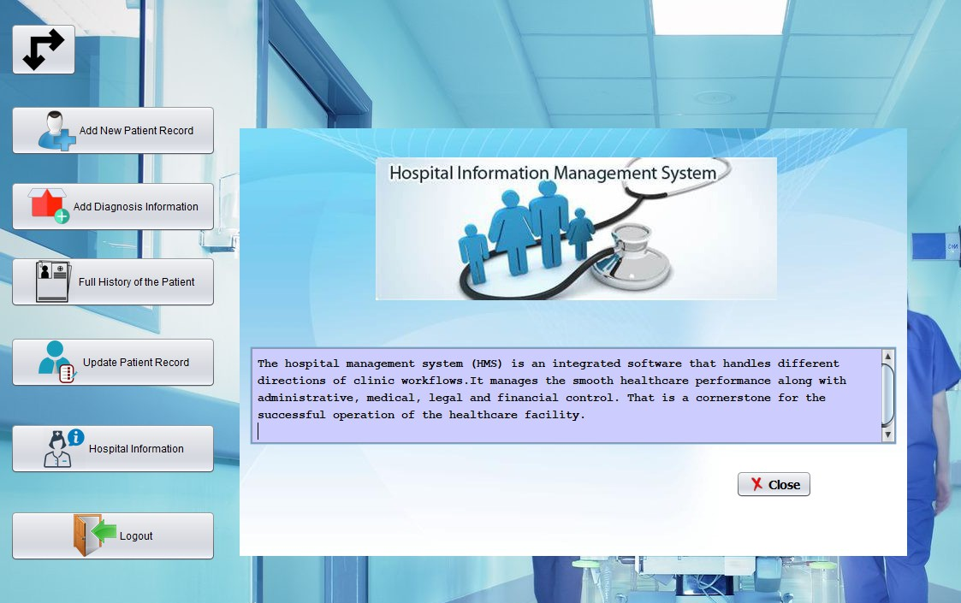

# Logout.java

When we click on logout button , it will show the message “Do you really want to logout”.

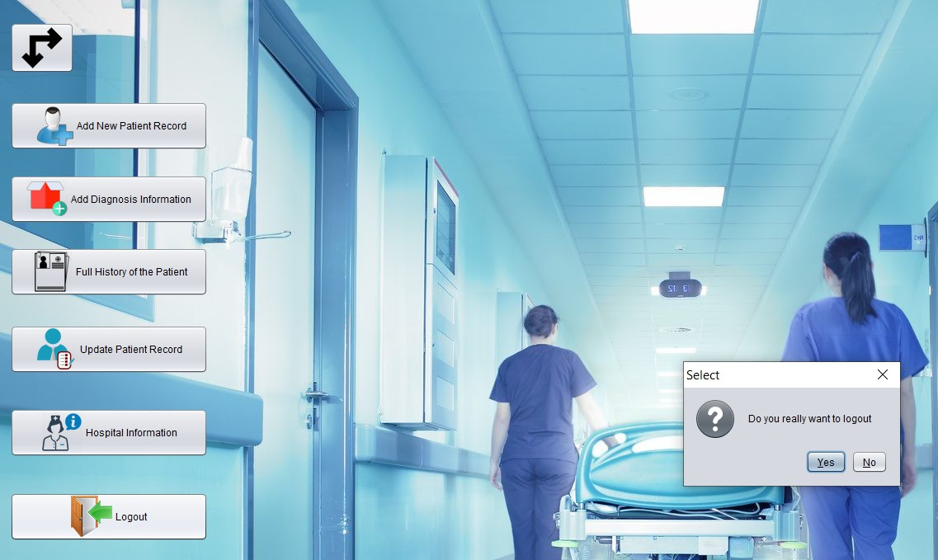

When we click on “YES” that we really want to logout then, it will take us back to the home page and a message will be displayed as “Do you really want to close the application”. If you click on “YES” then you are successfully logged out.

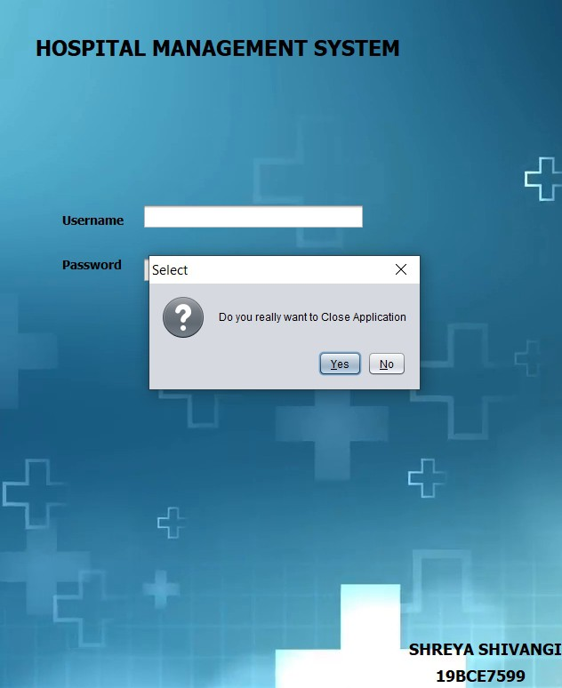

# MYSQL Database

## To create the patient table :-

create table patient(patientID varchar(10)primary key,name varchar(100),contactNumber varchar(10),age varchar(3),gender varchar(10),bloodGroup varchar(20),address varchar(100),anyMajorDisease varchar(500));

## To display the patient table :-

select * from patient;

It will display all the details of the patient that we have entered in the “Add New Patient Record”.

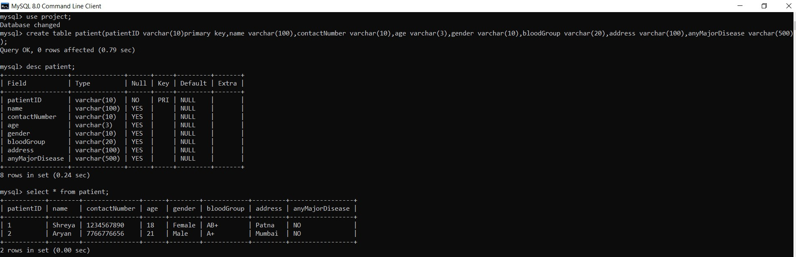

## To create the patient report table :-

create table patientreport(patientID varchar(10)primary key,symptom varchar(200),diagnosis varchar(200),medicines varchar(200),wardReq varchar(5),typeWard varchar(10));

## To display the patient report table :--

select * from patientreport;

It will display all the details of the patient that we have entered in the “Add Diagnosis Information”.

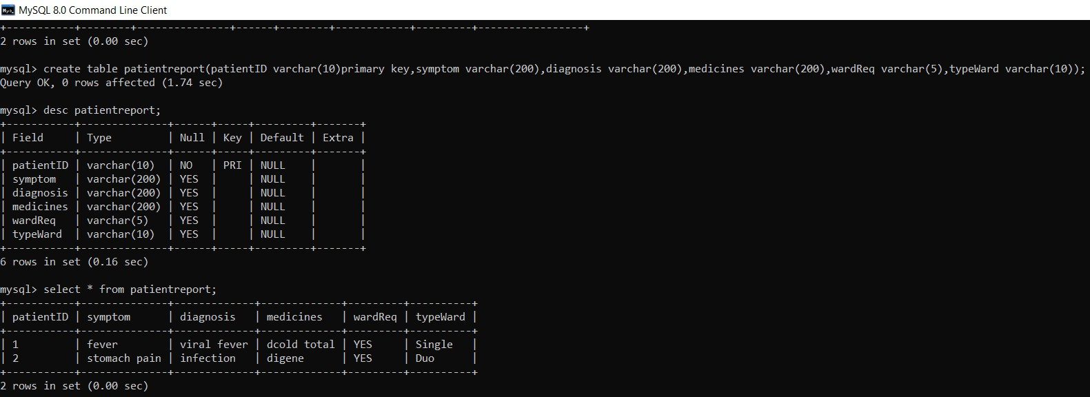

When we update the patient details in the “Update Patient Record” and save it. Then if we again display the table using the query “select * from patient;” it will display the updated patient details.

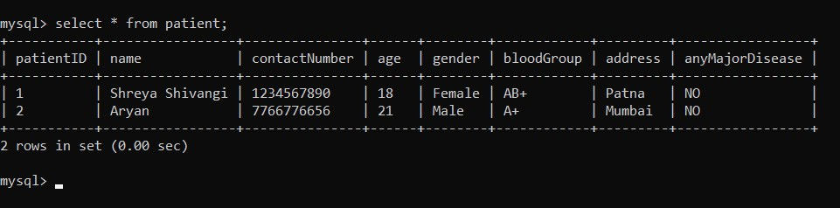

**E-R Diagram :-**

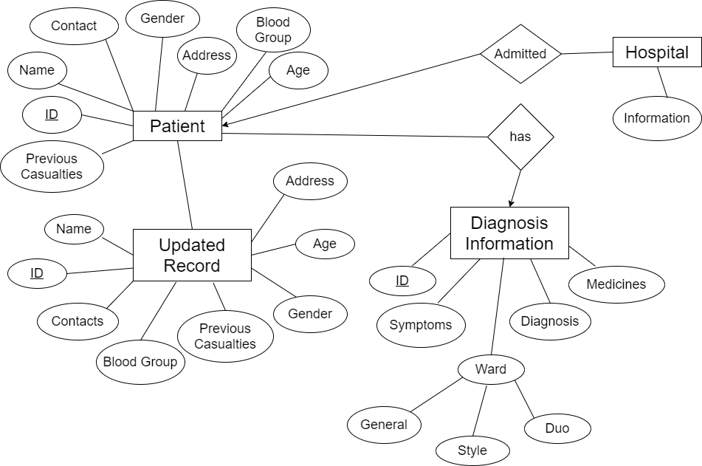

**HMS Project File :-**

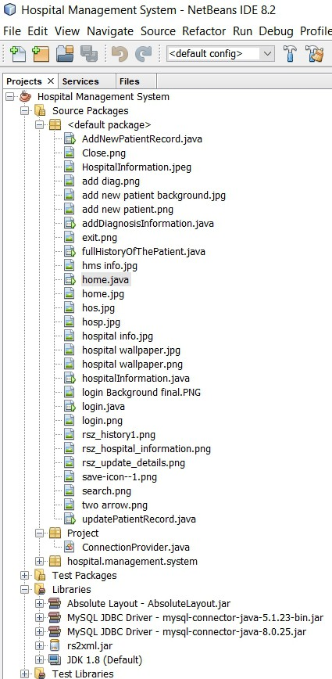

**Codes :-**

**Login.java**

import javax.swing.JOptionPane;

/*

* To change this license header, choose License Headers in Project Properties.
* To change this template file, choose Tools | Templates
* and open the template in the editor.

*/

/**

*

* @author shrey

*/

public class login extends javax.swing.JFrame {

/**

* + Creates new form login

*/

public login() { initComponents();

}

/**

* This method is called from within the constructor to initialize the form.
* WARNING: Do NOT modify this code. The content of this method is always
* regenerated by the Form Editor.

*/ @SuppressWarnings("unchecked")

// <editor-fold defaultstate="collapsed" desc="Generated Code"> private void initComponents() {

jLabel4 = new javax.swing.JLabel(); jLabel3 = new javax.swing.JLabel(); jLabel1 = new javax.swing.JLabel(); jLabel2 = new javax.swing.JLabel(); jTextField1 = new javax.swing.JTextField();

jPasswordField1 = new javax.swing.JPasswordField(); jButton1 = new javax.swing.JButton();

jButton2 = new javax.swing.JButton(); jLabel6 = new javax.swing.JLabel(); jLabel7 = new javax.swing.JLabel(); jLabel5 = new javax.swing.JLabel(); jLabel8 = new javax.swing.JLabel(); jLabel10 = new javax.swing.JLabel();

jLabel4.setIcon(new javax.swing.ImageIcon(getClass().getResource("/hos.jpg"))); // NOI18N

jLabel4.setText("jLabel4");

jLabel3.setIcon(new javax.swing.ImageIcon(getClass().getResource("/hos.jpg"))); // NOI18N

jLabel3.setText("jLabel3");

setDefaultCloseOperation(javax.swing.WindowConstants.EXIT_ON_CLOSE); setUndecorated(true);

getContentPane().setLayout(new org.netbeans.lib.awtextra.AbsoluteLayout());

jLabel1.setFont(new java.awt.Font("Tahoma", 1, 14)); // NOI18N jLabel1.setText("Username");

getContentPane().add(jLabel1, new org.netbeans.lib.awtextra.AbsoluteConstraints(710, 390, -1, -1));

jLabel2.setFont(new java.awt.Font("Tahoma", 1, 14)); // NOI18N jLabel2.setText("Password");

getContentPane().add(jLabel2, new org.netbeans.lib.awtextra.AbsoluteConstraints(710, 440, -1, -1));

jTextField1.setFont(new java.awt.Font("Tahoma", 1, 14)); // NOI18N jTextField1.addActionListener(new java.awt.event.ActionListener() {

public void actionPerformed(java.awt.event.ActionEvent evt) { jTextField1ActionPerformed(evt);

}

});

getContentPane().add(jTextField1, new org.netbeans.lib.awtextra.AbsoluteConstraints(800, 380, 250, -1));

jPasswordField1.setFont(new java.awt.Font("Tahoma", 1, 14)); // NOI18N jPasswordField1.addActionListener(new java.awt.event.ActionListener() {

public void actionPerformed(java.awt.event.ActionEvent evt) { jPasswordField1ActionPerformed(evt);

}

});

getContentPane().add(jPasswordField1, new org.netbeans.lib.awtextra.AbsoluteConstraints(800, 440, 250, -1));

jButton1.setFont(new java.awt.Font("Tahoma", 1, 14)); // NOI18N jButton1.setIcon(new

javax.swing.ImageIcon(getClass().getResource("/login.png"))); // NOI18N jButton1.setText("Login");

jButton1.addActionListener(new java.awt.event.ActionListener() { public void actionPerformed(java.awt.event.ActionEvent evt) {

jButton1ActionPerformed(evt);

}

});

getContentPane().add(jButton1, new org.netbeans.lib.awtextra.AbsoluteConstraints(840, 520, -1, -1));

jButton2.setFont(new java.awt.Font("Tahoma", 1, 14)); // NOI18N jButton2.setIcon(new

javax.swing.ImageIcon(getClass().getResource("/Close.png"))); // NOI18N jButton2.setText("Close");

jButton2.addActionListener(new java.awt.event.ActionListener() { public void actionPerformed(java.awt.event.ActionEvent evt) {

jButton2ActionPerformed(evt);

}

});

getContentPane().add(jButton2, new org.netbeans.lib.awtextra.AbsoluteConstraints(960, 520, -1, -1));

getContentPane().add(jLabel6, new org.netbeans.lib.awtextra.AbsoluteConstraints(960, 280, -1, -1));

jLabel7.setFont(new java.awt.Font("Tahoma", 1, 24)); // NOI18N jLabel7.setText("HOSPITAL MANAGEMENT SYSTEM");

getContentPane().add(jLabel7, new org.netbeans.lib.awtextra.AbsoluteConstraints(680, 190, -1, -1));

jLabel5.setFont(new java.awt.Font("Tahoma", 1, 18)); // NOI18N jLabel5.setText("SHREYA SHIVANGI"); getContentPane().add(jLabel5, new

org.netbeans.lib.awtextra.AbsoluteConstraints(1100, 870, -1, -1));

jLabel8.setFont(new java.awt.Font("Tahoma", 1, 18)); // NOI18N jLabel8.setText("19BCE7599");

getContentPane().add(jLabel8, new org.netbeans.lib.awtextra.AbsoluteConstraints(1130, 900, -1, -1));

jLabel10.setIcon(new javax.swing.ImageIcon(getClass().getResource("/hospital wallpaper.png"))); // NOI18N

jLabel10.setText("jLabel10"); getContentPane().add(jLabel10, new

org.netbeans.lib.awtextra.AbsoluteConstraints(0, 0, 1920, -1));

pack();

}// </editor-fold>

private void jTextField1ActionPerformed(java.awt.event.ActionEvent evt) {

// TODO add your handling code here:

}

private void jPasswordField1ActionPerformed(java.awt.event.ActionEvent evt) {

// TODO add your handling code here:

}

private void jButton2ActionPerformed(java.awt.event.ActionEvent evt) {

// TODO add your handling code here:

int a=JOptionPane.showConfirmDialog(null,"Do you really want to Close Application", "Select", JOptionPane.YES_NO_OPTION);

if(a==0) System.exit(0);

}

private void jButton1ActionPerformed(java.awt.event.ActionEvent evt) {

// TODO add your handling code here: if(jTextField1.getText().equals("hms") &&

jPasswordField1.getText().equals("admin"))

{

setVisible(false);

new home().setVisible(true);

}

else

JOptionPane.showMessageDialog(null, "Incorrect Username or Password");

}

/**

* @param args the command line arguments

*/

public static void main(String args[]) {

/* Set the Nimbus look and feel */

//<editor-fold defaultstate="collapsed" desc=" Look and feel setting code (optional) ">

/* If Nimbus (introduced in Java SE 6) is not available, stay with the default look and feel.

* For details see <http://download.oracle.com/javase/tutorial/uiswing/lookandfeel/plaf.html>

*/ try {

for (javax.swing.UIManager.LookAndFeelInfo info : javax.swing.UIManager.getInstalledLookAndFeels()) {

if ("Nimbus".equals(info.getName())) { javax.swing.UIManager.setLookAndFeel(info.getClassName()); break;

}

}

} catch (ClassNotFoundException ex) {

java.util.logging.Logger.getLogger(login.class.getName()).log(java.util.logging.Level. SEVERE, null, ex);

} catch (InstantiationException ex) {

java.util.logging.Logger.getLogger(login.class.getName()).log(java.util.logging.Level. SEVERE, null, ex);

} catch (IllegalAccessException ex) {

java.util.logging.Logger.getLogger(login.class.getName()).log(java.util.logging.Level. SEVERE, null, ex);

} catch (javax.swing.UnsupportedLookAndFeelException ex) {

java.util.logging.Logger.getLogger(login.class.getName()).log(java.util.logging.Level. SEVERE, null, ex);

}

//</editor-fold>

/* Create and display the form */ java.awt.EventQueue.invokeLater(new Runnable() {

public void run() {

new login().setVisible(true);

}

});

}

// Variables declaration - do not modify private javax.swing.JButton jButton1; private javax.swing.JButton jButton2; private javax.swing.JLabel jLabel1; private javax.swing.JLabel jLabel10; private javax.swing.JLabel jLabel2; private javax.swing.JLabel jLabel3; private javax.swing.JLabel jLabel4; private javax.swing.JLabel jLabel5; private javax.swing.JLabel jLabel6; private javax.swing.JLabel jLabel7; private javax.swing.JLabel jLabel8;

private javax.swing.JPasswordField jPasswordField1; private javax.swing.JTextField jTextField1;

// End of variables declaration

}

# Home.java

import javax.swing.JOptionPane;

/*

* To change this license header, choose License Headers in Project Properties.
* To change this template file, choose Tools | Templates
* and open the template in the editor.

*/

/**

*

* @author shrey

*/

public class home extends javax.swing.JFrame { public int i=0;

/**

* + Creates new form home

*/

public home() { initComponents();

}

/**

* + This method is called from within the constructor to initialize the form.
  + WARNING: Do NOT modify this code. The content of this method is always
  + regenerated by the Form Editor.

*/ @SuppressWarnings("unchecked")

// <editor-fold defaultstate="collapsed" desc="Generated Code"> private void initComponents() {

jButton1 = new javax.swing.JButton(); jButton2 = new javax.swing.JButton(); jButton3 = new javax.swing.JButton(); jButton4 = new javax.swing.JButton(); jButton5 = new javax.swing.JButton(); jButton6 = new javax.swing.JButton(); jButton7 = new javax.swing.JButton(); jLabel1 = new javax.swing.JLabel(); jLabel3 = new javax.swing.JLabel();

setDefaultCloseOperation(javax.swing.WindowConstants.EXIT_ON_CLOSE); setUndecorated(true);

getContentPane().setLayout(new org.netbeans.lib.awtextra.AbsoluteLayout());

jButton1.setIcon(new javax.swing.ImageIcon(getClass().getResource("/two arrow.png"))); // NOI18N

jButton1.addActionListener(new java.awt.event.ActionListener() {

public void actionPerformed(java.awt.event.ActionEvent evt) { jButton1ActionPerformed(evt);

}

});

getContentPane().add(jButton1, new org.netbeans.lib.awtextra.AbsoluteConstraints(12, 27, -1, -1));

jButton2.setIcon(new javax.swing.ImageIcon(getClass().getResource("/add new patient.png"))); // NOI18N

jButton2.setText("Add New Patient Record"); jButton2.setPreferredSize(new java.awt.Dimension(240, 59)); jButton2.addActionListener(new java.awt.event.ActionListener() {

public void actionPerformed(java.awt.event.ActionEvent evt) { jButton2ActionPerformed(evt);

}

});

getContentPane().add(jButton2, new org.netbeans.lib.awtextra.AbsoluteConstraints(12, 123, -1, -1));

jButton3.setIcon(new javax.swing.ImageIcon(getClass().getResource("/add diag.png"))); // NOI18N

jButton3.setText("Add Diagnosis Information"); jButton3.setPreferredSize(new java.awt.Dimension(240, 59)); jButton3.addActionListener(new java.awt.event.ActionListener() {

public void actionPerformed(java.awt.event.ActionEvent evt) { jButton3ActionPerformed(evt);

}

});

getContentPane().add(jButton3, new org.netbeans.lib.awtextra.AbsoluteConstraints(12, 212, -1, -1));

jButton4.setIcon(new javax.swing.ImageIcon(getClass().getResource("/rsz_history1.png"))); // NOI18N

jButton4.setText("Full History of the Patient"); jButton4.setPreferredSize(new java.awt.Dimension(240, 59)); jButton4.addActionListener(new java.awt.event.ActionListener() {

public void actionPerformed(java.awt.event.ActionEvent evt) { jButton4ActionPerformed(evt);

}

});

getContentPane().add(jButton4, new org.netbeans.lib.awtextra.AbsoluteConstraints(12, 300, -1, -1));

jButton5.setIcon(new javax.swing.ImageIcon(getClass().getResource("/rsz_update_details.png"))); // NOI18N

jButton5.setText("Update Patient Record"); jButton5.setPreferredSize(new java.awt.Dimension(240, 59)); jButton5.addActionListener(new java.awt.event.ActionListener() {

public void actionPerformed(java.awt.event.ActionEvent evt) {

jButton5ActionPerformed(evt);

}

});

getContentPane().add(jButton5, new org.netbeans.lib.awtextra.AbsoluteConstraints(12, 394, -1, -1));

jButton6.setIcon(new javax.swing.ImageIcon(getClass().getResource("/rsz_hospital_information.png"))); // NOI18N

jButton6.setText("Hospital Information"); jButton6.setPreferredSize(new java.awt.Dimension(240, 59)); jButton6.addActionListener(new java.awt.event.ActionListener() {

public void actionPerformed(java.awt.event.ActionEvent evt) { jButton6ActionPerformed(evt);

}

});

getContentPane().add(jButton6, new org.netbeans.lib.awtextra.AbsoluteConstraints(12, 495, -1, -1));

jButton7.setIcon(new javax.swing.ImageIcon(getClass().getResource("/exit.png"))); // NOI18N

jButton7.setText("Logout");

jButton7.setPreferredSize(new java.awt.Dimension(240, 59)); jButton7.addActionListener(new java.awt.event.ActionListener() {

public void actionPerformed(java.awt.event.ActionEvent evt) { jButton7ActionPerformed(evt);

}

});

getContentPane().add(jButton7, new org.netbeans.lib.awtextra.AbsoluteConstraints(12, 597, -1, -1));

jLabel1.setText("jLabel1"); getContentPane().add(jLabel1, new

org.netbeans.lib.awtextra.AbsoluteConstraints(-90, -120, -1, -1));

jLabel3.setIcon(new javax.swing.ImageIcon(getClass().getResource("/home.jpg"))); // NOI18N

jLabel3.setText("jLabel3"); getContentPane().add(jLabel3, new

org.netbeans.lib.awtextra.AbsoluteConstraints(0, 0, -1, -1));

pack();

}// </editor-fold>

private void jButton3ActionPerformed(java.awt.event.ActionEvent evt) {

// TODO add your handling code here:

new addDiagnosisInformation().setVisible(true);

}

private void jButton7ActionPerformed(java.awt.event.ActionEvent evt) {

// TODO add your handling code here:

int a=JOptionPane.showConfirmDialog(null,"Do you really want to logout","Select",JOptionPane.YES_NO_OPTION);

if(a==0)

{

setVisible(false);

new login().setVisible(true);

}

}

private void jButton1ActionPerformed(java.awt.event.ActionEvent evt) {

// TODO add your handling code here: if(i==0)

{

jButton2.setLocation(90,30); jButton3.setLocation(333,30); jButton4.setLocation(576,30); jButton5.setLocation(819,30); jButton6.setLocation(1062,30); jButton7.setLocation(1062,89); i=1;

}

else

{

jButton2.setLocation(10,107); jButton3.setLocation(10,184); jButton4.setLocation(10,261); jButton5.setLocation(10,338); jButton6.setLocation(10,415); jButton7.setLocation(10,490); i=0;

}

}

private void jButton2ActionPerformed(java.awt.event.ActionEvent evt) {

// TODO add your handling code here:

new AddNewPatientRecord().setVisible(true);

}

private void jButton4ActionPerformed(java.awt.event.ActionEvent evt) {

// TODO add your handling code here:

new fullHistoryOfThePatient().setVisible(true);

}

private void jButton5ActionPerformed(java.awt.event.ActionEvent evt) {

// TODO add your handling code here:

new updatePatientRecord().setVisible(true);

}

private void jButton6ActionPerformed(java.awt.event.ActionEvent evt) {

// TODO add your handling code here: new hospitalInformation().setVisible(true);

}

/**

* + @param args the command line arguments

*/

public static void main(String args[]) {

/* Set the Nimbus look and feel */

//<editor-fold defaultstate="collapsed" desc=" Look and feel setting code (optional) ">

/* If Nimbus (introduced in Java SE 6) is not available, stay with the default look and feel.

* + - For details see <http://download.oracle.com/javase/tutorial/uiswing/lookandfeel/plaf.html>

*/ try {

for (javax.swing.UIManager.LookAndFeelInfo info : javax.swing.UIManager.getInstalledLookAndFeels()) {

if ("Nimbus".equals(info.getName())) { javax.swing.UIManager.setLookAndFeel(info.getClassName()); break;

}

}

} catch (ClassNotFoundException ex) {

java.util.logging.Logger.getLogger(home.class.getName()).log(java.util.logging.Level. SEVERE, null, ex);

} catch (InstantiationException ex) {

java.util.logging.Logger.getLogger(home.class.getName()).log(java.util.logging.Level. SEVERE, null, ex);

} catch (IllegalAccessException ex) {

java.util.logging.Logger.getLogger(home.class.getName()).log(java.util.logging.Level. SEVERE, null, ex);

} catch (javax.swing.UnsupportedLookAndFeelException ex) {

java.util.logging.Logger.getLogger(home.class.getName()).log(java.util.logging.Level. SEVERE, null, ex);

}

//</editor-fold>

/* Create and display the form */ java.awt.EventQueue.invokeLater(new Runnable() {

public void run() {

new home().setVisible(true);

}

});

}

// Variables declaration - do not modify private javax.swing.JButton jButton1; private javax.swing.JButton jButton2; private javax.swing.JButton jButton3; private javax.swing.JButton jButton4; private javax.swing.JButton jButton5; private javax.swing.JButton jButton6; private javax.swing.JButton jButton7; private javax.swing.JLabel jLabel1; private javax.swing.JLabel jLabel3;

// End of variables declaration

}

# AddNewPatientRecord.java :-

import Project.ConnectionProvider; import java.sql.*;

import javax.swing.JOptionPane;

/*

* To change this license header, choose License Headers in Project Properties.
* To change this template file, choose Tools | Templates
* and open the template in the editor.

*/

/**

*

* @author shrey

*/

public class AddNewPatientRecord extends javax.swing.JFrame {

/**

* + Creates new form AddNewPatientRecord

*/

public AddNewPatientRecord() { initComponents();

}

/**

* + This method is called from within the constructor to initialize the form.
  + WARNING: Do NOT modify this code. The content of this method is always
  + regenerated by the Form Editor.

*/ @SuppressWarnings("unchecked")

// <editor-fold defaultstate="collapsed" desc="Generated Code"> private void initComponents() {

jButton1 = new javax.swing.JButton(); jLabel1 = new javax.swing.JLabel(); jLabel2 = new javax.swing.JLabel(); jLabel3 = new javax.swing.JLabel(); jLabel4 = new javax.swing.JLabel(); jLabel5 = new javax.swing.JLabel(); jLabel6 = new javax.swing.JLabel(); jLabel7 = new javax.swing.JLabel(); jLabel8 = new javax.swing.JLabel(); jTextField1 = new javax.swing.JTextField(); jTextField2 = new javax.swing.JTextField(); jTextField3 = new javax.swing.JTextField(); jTextField4 = new javax.swing.JTextField(); jTextField6 = new javax.swing.JTextField(); jTextField7 = new javax.swing.JTextField(); jTextField8 = new javax.swing.JTextField();

jComboBox1 = new javax.swing.JComboBox<>();

jButton2 = new javax.swing.JButton(); jLabel9 = new javax.swing.JLabel();

setDefaultCloseOperation(javax.swing.WindowConstants.EXIT_ON_CLOSE); setLocation(new java.awt.Point(280, 150));

setUndecorated(true);

getContentPane().setLayout(new org.netbeans.lib.awtextra.AbsoluteLayout());

jButton1.setFont(new java.awt.Font("Tahoma", 1, 14)); // NOI18N jButton1.setIcon(new

javax.swing.ImageIcon(getClass().getResource("/Close.png"))); // NOI18N jButton1.setText("Close");

jButton1.addActionListener(new java.awt.event.ActionListener() { public void actionPerformed(java.awt.event.ActionEvent evt) {

jButton1ActionPerformed(evt);

}

});

getContentPane().add(jButton1, new org.netbeans.lib.awtextra.AbsoluteConstraints(590, 410, -1, -1));

jLabel1.setFont(new java.awt.Font("Tahoma", 1, 14)); // NOI18N jLabel1.setText("Patient ID");

getContentPane().add(jLabel1, new org.netbeans.lib.awtextra.AbsoluteConstraints(203, 40, -1, -1));

jLabel2.setFont(new java.awt.Font("Tahoma", 1, 14)); // NOI18N jLabel2.setText("Name");

getContentPane().add(jLabel2, new org.netbeans.lib.awtextra.AbsoluteConstraints(203, 78, -1, -1));

jLabel3.setFont(new java.awt.Font("Tahoma", 1, 14)); // NOI18N jLabel3.setText("Contact No");

getContentPane().add(jLabel3, new org.netbeans.lib.awtextra.AbsoluteConstraints(203, 119, -1, -1));

jLabel4.setFont(new java.awt.Font("Tahoma", 1, 14)); // NOI18N jLabel4.setText("Age");

getContentPane().add(jLabel4, new org.netbeans.lib.awtextra.AbsoluteConstraints(203, 154, -1, -1));

jLabel5.setFont(new java.awt.Font("Tahoma", 1, 14)); // NOI18N jLabel5.setText("Gender");

getContentPane().add(jLabel5, new org.netbeans.lib.awtextra.AbsoluteConstraints(203, 190, -1, -1));

jLabel6.setFont(new java.awt.Font("Tahoma", 1, 14)); // NOI18N jLabel6.setText("Blood Group");

getContentPane().add(jLabel6, new org.netbeans.lib.awtextra.AbsoluteConstraints(203, 231, -1, -1));

jLabel7.setFont(new java.awt.Font("Tahoma", 1, 14)); // NOI18N jLabel7.setText("Address");

getContentPane().add(jLabel7, new org.netbeans.lib.awtextra.AbsoluteConstraints(203, 272, -1, -1));

jLabel8.setFont(new java.awt.Font("Tahoma", 1, 14)); // NOI18N jLabel8.setText("Any Major Disease Suffered Earlier"); getContentPane().add(jLabel8, new

org.netbeans.lib.awtextra.AbsoluteConstraints(203, 305, -1, -1));

jTextField1.setFont(new java.awt.Font("Tahoma", 1, 14)); // NOI18N getContentPane().add(jTextField1, new

org.netbeans.lib.awtextra.AbsoluteConstraints(326, 34, 250, -1));

jTextField2.setFont(new java.awt.Font("Tahoma", 1, 14)); // NOI18N getContentPane().add(jTextField2, new

org.netbeans.lib.awtextra.AbsoluteConstraints(326, 75, 250, -1));

jTextField3.setFont(new java.awt.Font("Tahoma", 1, 14)); // NOI18N getContentPane().add(jTextField3, new

org.netbeans.lib.awtextra.AbsoluteConstraints(326, 116, 250, -1));

jTextField4.setFont(new java.awt.Font("Tahoma", 1, 14)); // NOI18N getContentPane().add(jTextField4, new

org.netbeans.lib.awtextra.AbsoluteConstraints(326, 151, 250, -1));

jTextField6.setFont(new java.awt.Font("Tahoma", 1, 14)); // NOI18N getContentPane().add(jTextField6, new

org.netbeans.lib.awtextra.AbsoluteConstraints(326, 228, 250, -1));

jTextField7.setFont(new java.awt.Font("Tahoma", 1, 14)); // NOI18N getContentPane().add(jTextField7, new

org.netbeans.lib.awtextra.AbsoluteConstraints(326, 269, 250, -1));

jTextField8.setFont(new java.awt.Font("Tahoma", 1, 14)); // NOI18N getContentPane().add(jTextField8, new

org.netbeans.lib.awtextra.AbsoluteConstraints(203, 340, 373, -1));

jComboBox1.setFont(new java.awt.Font("Tahoma", 1, 14)); // NOI18N jComboBox1.setModel(new javax.swing.DefaultComboBoxModel<>(new

String[] { "Male", "Female", "Others" })); getContentPane().add(jComboBox1, new

org.netbeans.lib.awtextra.AbsoluteConstraints(326, 187, 250, -1));

jButton2.setFont(new java.awt.Font("Tahoma", 1, 14)); // NOI18N jButton2.setIcon(new javax.swing.ImageIcon(getClass().getResource("/save-

icon--1.png"))); // NOI18N jButton2.setText("Save");

jButton2.addActionListener(new java.awt.event.ActionListener() { public void actionPerformed(java.awt.event.ActionEvent evt) {

jButton2ActionPerformed(evt);

}

});

getContentPane().add(jButton2, new org.netbeans.lib.awtextra.AbsoluteConstraints(203, 407, -1, -1));

jLabel9.setIcon(new javax.swing.ImageIcon(getClass().getResource("/add new patient background.jpg"))); // NOI18N

jLabel9.setText("jLabel9"); getContentPane().add(jLabel9, new

org.netbeans.lib.awtextra.AbsoluteConstraints(0, 0, 780, -1));

pack();

}// </editor-fold>

private void jButton1ActionPerformed(java.awt.event.ActionEvent evt) {

// TODO add your handling code here: setVisible(false);

}

private void jButton2ActionPerformed(java.awt.event.ActionEvent evt) {

// TODO add your handling code here:

String patientID=jTextField1.getText(); String name=jTextField2.getText();

String contactNumber=jTextField3.getText();

String gender=(String)jComboBox1.getSelectedItem(); String age=jTextField4.getText();

String bloodGroup=jTextField6.getText(); String address=jTextField7.getText();

String anyMajorDisease=jTextField8.getText(); try{

Connection con=ConnectionProvider.getCon(); Statement st=con.createStatement(); st.executeUpdate("insert into patient

values('"+patientID+"','"+name+"','"+contactNumber+"','"+age+"','"+gender+"','"+blo odGroup+"','"+address+"','"+anyMajorDisease+"')");

JOptionPane.showMessageDialog(null,"Successfully Updated"); setVisible(false);

new AddNewPatientRecord().setVisible(true);

}

catch(Exception e)

{

JOptionPane.showMessageDialog(null,"Please enter data in correct Format!");

}

}

/**

* + @param args the command line arguments

*/

public static void main(String args[]) {

/* Set the Nimbus look and feel */

//<editor-fold defaultstate="collapsed" desc=" Look and feel setting code (optional) ">

/* If Nimbus (introduced in Java SE 6) is not available, stay with the default look and feel.

* + - For details see <http://download.oracle.com/javase/tutorial/uiswing/lookandfeel/plaf.html>

*/ try {

for (javax.swing.UIManager.LookAndFeelInfo info : javax.swing.UIManager.getInstalledLookAndFeels()) {

if ("Nimbus".equals(info.getName())) { javax.swing.UIManager.setLookAndFeel(info.getClassName()); break;

}

}

} catch (ClassNotFoundException ex) {

java.util.logging.Logger.getLogger(AddNewPatientRecord.class.getName()).log(java. util.logging.Level.SEVERE, null, ex);

} catch (InstantiationException ex) {

java.util.logging.Logger.getLogger(AddNewPatientRecord.class.getName()).log(java. util.logging.Level.SEVERE, null, ex);

} catch (IllegalAccessException ex) {

java.util.logging.Logger.getLogger(AddNewPatientRecord.class.getName()).log(java. util.logging.Level.SEVERE, null, ex);

} catch (javax.swing.UnsupportedLookAndFeelException ex) {

java.util.logging.Logger.getLogger(AddNewPatientRecord.class.getName()).log(java. util.logging.Level.SEVERE, null, ex);

}

//</editor-fold>

/* Create and display the form */ java.awt.EventQueue.invokeLater(new Runnable() {

public void run() {

new AddNewPatientRecord().setVisible(true);

}

});

}

// Variables declaration - do not modify private javax.swing.JButton jButton1; private javax.swing.JButton jButton2;

private javax.swing.JComboBox<String> jComboBox1; private javax.swing.JLabel jLabel1;

private javax.swing.JLabel jLabel2; private javax.swing.JLabel jLabel3; private javax.swing.JLabel jLabel4; private javax.swing.JLabel jLabel5; private javax.swing.JLabel jLabel6; private javax.swing.JLabel jLabel7; private javax.swing.JLabel jLabel8; private javax.swing.JLabel jLabel9;

private javax.swing.JTextField jTextField1; private javax.swing.JTextField jTextField2; private javax.swing.JTextField jTextField3; private javax.swing.JTextField jTextField4; private javax.swing.JTextField jTextField6; private javax.swing.JTextField jTextField7; private javax.swing.JTextField jTextField8;

// End of variables declaration

}

# AddDiagnosisInformation.java :-

import Project.ConnectionProvider; import java.sql.*;

import javax.swing.JOptionPane; import net.proteanit.sql.DbUtils;

/*

* To change this license header, choose License Headers in Project Properties.
* To change this template file, choose Tools | Templates
* and open the template in the editor.

*/

/**

*

* @author shrey

*/

public class addDiagnosisInformation extends javax.swing.JFrame { public int flag=0;

/**

* + Creates new form addDiagnosisInformation

*/

public addDiagnosisInformation() { initComponents(); jLabel2.setVisible(false); jLabel7.setVisible(false); jComboBox1.setVisible(false);

}

/**

* + This method is called from within the constructor to initialize the form.
  + WARNING: Do NOT modify this code. The content of this method is always
  + regenerated by the Form Editor.

*/ @SuppressWarnings("unchecked")

// <editor-fold defaultstate="collapsed" desc="Generated Code"> private void initComponents() {

jLabel1 = new javax.swing.JLabel(); jTextField1 = new javax.swing.JTextField(); jButton1 = new javax.swing.JButton(); jScrollPane1 = new javax.swing.JScrollPane(); jTable1 = new javax.swing.JTable();

jLabel2 = new javax.swing.JLabel(); jLabel3 = new javax.swing.JLabel(); jLabel4 = new javax.swing.JLabel(); jLabel5 = new javax.swing.JLabel(); jTextField2 = new javax.swing.JTextField(); jTextField3 = new javax.swing.JTextField(); jTextField4 = new javax.swing.JTextField();

jLabel6 = new javax.swing.JLabel(); jLabel7 = new javax.swing.JLabel();

jCheckBox1 = new javax.swing.JCheckBox(); jComboBox1 = new javax.swing.JComboBox<>(); jButton2 = new javax.swing.JButton();

jButton3 = new javax.swing.JButton(); jLabel9 = new javax.swing.JLabel();

setDefaultCloseOperation(javax.swing.WindowConstants.EXIT_ON_CLOSE); setLocation(new java.awt.Point(280, 150));

getContentPane().setLayout(new org.netbeans.lib.awtextra.AbsoluteLayout());

jLabel1.setFont(new java.awt.Font("Tahoma", 1, 14)); // NOI18N jLabel1.setText("PatientID");

getContentPane().add(jLabel1, new org.netbeans.lib.awtextra.AbsoluteConstraints(202, 58, -1, -1));

jTextField1.setFont(new java.awt.Font("Tahoma", 1, 14)); // NOI18N jTextField1.addActionListener(new java.awt.event.ActionListener() {

public void actionPerformed(java.awt.event.ActionEvent evt) { jTextField1ActionPerformed(evt);

}

});

getContentPane().add(jTextField1, new org.netbeans.lib.awtextra.AbsoluteConstraints(333, 55, 100, -1));

jButton1.setFont(new java.awt.Font("Tahoma", 1, 14)); // NOI18N jButton1.setIcon(new

javax.swing.ImageIcon(getClass().getResource("/search.png"))); // NOI18N jButton1.setText("Search");

jButton1.addActionListener(new java.awt.event.ActionListener() { public void actionPerformed(java.awt.event.ActionEvent evt) {

jButton1ActionPerformed(evt);

}

});

getContentPane().add(jButton1, new org.netbeans.lib.awtextra.AbsoluteConstraints(488, 52, -1, -1));

jTable1.setModel(new javax.swing.table.DefaultTableModel( new Object [][] {

{null, null, null, null}

},

new String [] {

"Title 1", "Title 2", "Title 3", "Title 4"

}

));

jScrollPane1.setViewportView(jTable1);

getContentPane().add(jScrollPane1, new org.netbeans.lib.awtextra.AbsoluteConstraints(12, 120, 756, 52));

jLabel2.setFont(new java.awt.Font("Tahoma", 1, 14)); // NOI18N

jLabel2.setForeground(new java.awt.Color(255, 0, 0)); jLabel2.setText("PatientID Does not Exist!"); getContentPane().add(jLabel2, new

org.netbeans.lib.awtextra.AbsoluteConstraints(256, 88, -1, -1));

jLabel3.setFont(new java.awt.Font("Tahoma", 1, 14)); // NOI18N jLabel3.setText("Symptoms");

getContentPane().add(jLabel3, new org.netbeans.lib.awtextra.AbsoluteConstraints(12, 217, -1, -1));

jLabel4.setFont(new java.awt.Font("Tahoma", 1, 14)); // NOI18N jLabel4.setText("Diagnosis");

getContentPane().add(jLabel4, new org.netbeans.lib.awtextra.AbsoluteConstraints(12, 281, -1, -1));

jLabel5.setFont(new java.awt.Font("Tahoma", 1, 14)); // NOI18N jLabel5.setText("Medicines");

getContentPane().add(jLabel5, new org.netbeans.lib.awtextra.AbsoluteConstraints(12, 341, -1, -1));

jTextField2.setFont(new java.awt.Font("Tahoma", 1, 14)); // NOI18N getContentPane().add(jTextField2, new

org.netbeans.lib.awtextra.AbsoluteConstraints(125, 214, 220, -1));

jTextField3.setFont(new java.awt.Font("Tahoma", 1, 14)); // NOI18N getContentPane().add(jTextField3, new

org.netbeans.lib.awtextra.AbsoluteConstraints(125, 278, 220, -1));

jTextField4.setFont(new java.awt.Font("Tahoma", 1, 14)); // NOI18N jTextField4.addActionListener(new java.awt.event.ActionListener() {

public void actionPerformed(java.awt.event.ActionEvent evt) { jTextField4ActionPerformed(evt);

}

});

getContentPane().add(jTextField4, new org.netbeans.lib.awtextra.AbsoluteConstraints(125, 338, 220, -1));

jLabel6.setFont(new java.awt.Font("Tahoma", 1, 14)); // NOI18N jLabel6.setText("Ward Required?"); getContentPane().add(jLabel6, new

org.netbeans.lib.awtextra.AbsoluteConstraints(437, 217, -1, -1));

jLabel7.setFont(new java.awt.Font("Tahoma", 1, 14)); // NOI18N jLabel7.setText("Type of Ward");

getContentPane().add(jLabel7, new org.netbeans.lib.awtextra.AbsoluteConstraints(437, 281, -1, -1));

jCheckBox1.setFont(new java.awt.Font("Tahoma", 1, 14)); // NOI18N

jCheckBox1.setText("Yes");

jCheckBox1.addActionListener(new java.awt.event.ActionListener() { public void actionPerformed(java.awt.event.ActionEvent evt) {

jCheckBox1ActionPerformed(evt);

}

});

getContentPane().add(jCheckBox1, new org.netbeans.lib.awtextra.AbsoluteConstraints(585, 213, 80, -1));

jComboBox1.setFont(new java.awt.Font("Tahoma", 1, 14)); // NOI18N jComboBox1.setModel(new javax.swing.DefaultComboBoxModel<>(new

String[] { "General", "Single", "Duo" })); getContentPane().add(jComboBox1, new

org.netbeans.lib.awtextra.AbsoluteConstraints(585, 278, -1, -1));

jButton2.setFont(new java.awt.Font("Tahoma", 1, 14)); // NOI18N jButton2.setIcon(new javax.swing.ImageIcon(getClass().getResource("/save-

icon--1.png"))); // NOI18N jButton2.setText("Save");

jButton2.addActionListener(new java.awt.event.ActionListener() { public void actionPerformed(java.awt.event.ActionEvent evt) {

jButton2ActionPerformed(evt);

}

});

getContentPane().add(jButton2, new org.netbeans.lib.awtextra.AbsoluteConstraints(12, 400, -1, -1));

jButton3.setFont(new java.awt.Font("Tahoma", 1, 14)); // NOI18N jButton3.setIcon(new

javax.swing.ImageIcon(getClass().getResource("/Close.png"))); // NOI18N jButton3.setText("Close");

jButton3.addActionListener(new java.awt.event.ActionListener() { public void actionPerformed(java.awt.event.ActionEvent evt) {

jButton3ActionPerformed(evt);

}

});

getContentPane().add(jButton3, new org.netbeans.lib.awtextra.AbsoluteConstraints(659, 400, -1, -1));

jLabel9.setIcon(new javax.swing.ImageIcon(getClass().getResource("/add new patient background.jpg"))); // NOI18N

jLabel9.setText("jLabel9"); getContentPane().add(jLabel9, new

org.netbeans.lib.awtextra.AbsoluteConstraints(0, 0, 780, -1));

pack();

}// </editor-fold>

private void jButton1ActionPerformed(java.awt.event.ActionEvent evt) {

// TODO add your handling code here:

String patientID=jTextField1.getText(); try{

Connection con=ConnectionProvider.getCon();

Statement st = con.createStatement (ResultSet.TYPE_SCROLL_INSENSITIVE, ResultSet.CONCUR_READ_ONLY);

ResultSet rs=st.executeQuery("select * from patient where patientID='"+patientID+"'");

jTable1.setModel(DbUtils.resultSetToTableModel(rs)); if(!rs.first())

jLabel2.setVisible(true); else

{

jLabel2.setVisible(false); jTextField1.setEditable(false); flag=1;

}

}

catch(Exception e)

{

JOptionPane.showMessageDialog(null,"Connection Error");

}

}

private void jTextField4ActionPerformed(java.awt.event.ActionEvent evt) {

// TODO add your handling code here:

}

private void jButton3ActionPerformed(java.awt.event.ActionEvent evt) {

// TODO add your handling code here: setVisible(false);

}

private void jCheckBox1ActionPerformed(java.awt.event.ActionEvent evt) {

// TODO add your handling code here: if(jCheckBox1.isSelected())

{

jLabel7.setVisible(true); jComboBox1.setVisible(true);

}

else

{

jLabel7.setVisible(false); jComboBox1.setVisible(false);

}

}

private void jButton2ActionPerformed(java.awt.event.ActionEvent evt) {

// TODO add your handling code here: if(flag==1)

{

String patientID=jTextField1.getText(); String symptom=jTextField2.getText(); String diagnosis=jTextField3.getText(); String medicines=jTextField4.getText(); String wardReq;

String typeWard; if(jCheckBox1.isSelected())

{

wardReq="YES"; typeWard=(String)jComboBox1.getSelectedItem();

}

else

{

wardReq="NO"; typeWard="";

}

try{

Connection con=ConnectionProvider.getCon(); Statement st=con.createStatement(); st.executeUpdate("insert into patientreport

values('"+patientID+"','"+symptom+"','"+diagnosis+"','"+medicines+"','"+wardReq+"', '"+typeWard+"')");

JOptionPane.showMessageDialog(null,"Successfully Updated"); setVisible(false);

new addDiagnosisInformation().setVisible(true);

}

catch(Exception e)

{

JOptionPane.showMessageDialog(this, e);

}

}

else

JOptionPane.showMessageDialog(null,"PatientID Field is empty!");

}

private void jTextField1ActionPerformed(java.awt.event.ActionEvent evt) {

// TODO add your handling code here:

}

/**

* + @param args the command line arguments

*/

public static void main(String args[]) {

/* Set the Nimbus look and feel */

//<editor-fold defaultstate="collapsed" desc=" Look and feel setting code (optional) ">

/* If Nimbus (introduced in Java SE 6) is not available, stay with the default look and feel.

* + - For details see <http://download.oracle.com/javase/tutorial/uiswing/lookandfeel/plaf.html>

*/ try {

for (javax.swing.UIManager.LookAndFeelInfo info : javax.swing.UIManager.getInstalledLookAndFeels()) {

if ("Nimbus".equals(info.getName())) { javax.swing.UIManager.setLookAndFeel(info.getClassName()); break;

}

}

} catch (ClassNotFoundException ex) {

java.util.logging.Logger.getLogger(addDiagnosisInformation.class.getName()).log(ja va.util.logging.Level.SEVERE, null, ex);

} catch (InstantiationException ex) {

java.util.logging.Logger.getLogger(addDiagnosisInformation.class.getName()).log(ja va.util.logging.Level.SEVERE, null, ex);

} catch (IllegalAccessException ex) {

java.util.logging.Logger.getLogger(addDiagnosisInformation.class.getName()).log(ja va.util.logging.Level.SEVERE, null, ex);

} catch (javax.swing.UnsupportedLookAndFeelException ex) {

java.util.logging.Logger.getLogger(addDiagnosisInformation.class.getName()).log(ja va.util.logging.Level.SEVERE, null, ex);

}

//</editor-fold>

/* Create and display the form */ java.awt.EventQueue.invokeLater(new Runnable() {

public void run() {

new addDiagnosisInformation().setVisible(true);

}

});

}

// Variables declaration - do not modify private javax.swing.JButton jButton1; private javax.swing.JButton jButton2; private javax.swing.JButton jButton3; private javax.swing.JCheckBox jCheckBox1;

private javax.swing.JComboBox<String> jComboBox1; private javax.swing.JLabel jLabel1;

private javax.swing.JLabel jLabel2; private javax.swing.JLabel jLabel3; private javax.swing.JLabel jLabel4;

private javax.swing.JLabel jLabel5; private javax.swing.JLabel jLabel6; private javax.swing.JLabel jLabel7; private javax.swing.JLabel jLabel9;

private javax.swing.JScrollPane jScrollPane1; private javax.swing.JTable jTable1;

private javax.swing.JTextField jTextField1; private javax.swing.JTextField jTextField2; private javax.swing.JTextField jTextField3; private javax.swing.JTextField jTextField4;

// End of variables declaration

}

# FullHistoryOfThePatient.java :-

import Project.ConnectionProvider; import java.sql.*;

import javax.swing.JOptionPane; import net.proteanit.sql.DbUtils;

/*

* To change this license header, choose License Headers in Project Properties.
* To change this template file, choose Tools | Templates
* and open the template in the editor.

*/

/**

*

* @author shrey

*/

public class fullHistoryOfThePatient extends javax.swing.JFrame {

/**

* + Creates new form fullHistoryOfThePatient

*/

public fullHistoryOfThePatient() { initComponents();

}

/**

* + This method is called from within the constructor to initialize the form.
  + WARNING: Do NOT modify this code. The content of this method is always
  + regenerated by the Form Editor.

*/ @SuppressWarnings("unchecked")

// <editor-fold defaultstate="collapsed" desc="Generated Code"> private void initComponents() {

jScrollPane1 = new javax.swing.JScrollPane(); jTable1 = new javax.swing.JTable();

jButton1 = new javax.swing.JButton(); jLabel1 = new javax.swing.JLabel();

setDefaultCloseOperation(javax.swing.WindowConstants.EXIT_ON_CLOSE); setLocation(new java.awt.Point(280, 150));

setUndecorated(true);

addComponentListener(new java.awt.event.ComponentAdapter() { public void componentShown(java.awt.event.ComponentEvent evt) {

formComponentShown(evt);

}

});

getContentPane().setLayout(new org.netbeans.lib.awtextra.AbsoluteLayout()); jTable1.setModel(new javax.swing.table.DefaultTableModel(

new Object [][] {

{null, null, null, null},

{null, null, null, null},

{null, null, null, null},

{null, null, null, null}

},

new String [] {

"Title 1", "Title 2", "Title 3", "Title 4"

}

));

jScrollPane1.setViewportView(jTable1);

getContentPane().add(jScrollPane1, new org.netbeans.lib.awtextra.AbsoluteConstraints(12, 18, 756, 374));

jButton1.setFont(new java.awt.Font("Tahoma", 1, 14)); // NOI18N jButton1.setIcon(new

javax.swing.ImageIcon(getClass().getResource("/Close.png"))); // NOI18N jButton1.setText("Close");

jButton1.addActionListener(new java.awt.event.ActionListener() { public void actionPerformed(java.awt.event.ActionEvent evt) {

jButton1ActionPerformed(evt);

}

});

getContentPane().add(jButton1, new org.netbeans.lib.awtextra.AbsoluteConstraints(623, 436, -1, -1));

jLabel1.setIcon(new javax.swing.ImageIcon(getClass().getResource("/add new patient background.jpg"))); // NOI18N

jLabel1.setText("jLabel1"); getContentPane().add(jLabel1, new

org.netbeans.lib.awtextra.AbsoluteConstraints(0, 0, 780, -1));

pack();

}// </editor-fold>

private void formComponentShown(java.awt.event.ComponentEvent evt) {

// TODO add your handling code here:

try{

Connection con=ConnectionProvider.getCon(); Statement st=con.createStatement();

ResultSet rs=st.executeQuery("select *from patient inner join patientreport where patient.patientID=patientreport.patientID");

jTable1.setAutoResizeMode(jTable1.AUTO_RESIZE_OFF); jTable1.setModel(DbUtils.resultSetToTableModel(rs));

}

catch(Exception e)

{

JOptionPane.showMessageDialog(null,"Connection Error");

}

}

private void jButton1ActionPerformed(java.awt.event.ActionEvent evt) {

// TODO add your handling code here: setVisible(false);

}

/**

* + @param args the command line arguments

*/

public static void main(String args[]) {

/* Set the Nimbus look and feel */

//<editor-fold defaultstate="collapsed" desc=" Look and feel setting code (optional) ">

/* If Nimbus (introduced in Java SE 6) is not available, stay with the default look and feel.

* + - For details see <http://download.oracle.com/javase/tutorial/uiswing/lookandfeel/plaf.html>

*/ try {

for (javax.swing.UIManager.LookAndFeelInfo info : javax.swing.UIManager.getInstalledLookAndFeels()) {

if ("Nimbus".equals(info.getName())) { javax.swing.UIManager.setLookAndFeel(info.getClassName()); break;

}

}

} catch (ClassNotFoundException ex) {

java.util.logging.Logger.getLogger(fullHistoryOfThePatient.class.getName()).log(jav a.util.logging.Level.SEVERE, null, ex);

} catch (InstantiationException ex) {

java.util.logging.Logger.getLogger(fullHistoryOfThePatient.class.getName()).log(jav a.util.logging.Level.SEVERE, null, ex);

} catch (IllegalAccessException ex) {

java.util.logging.Logger.getLogger(fullHistoryOfThePatient.class.getName()).log(jav a.util.logging.Level.SEVERE, null, ex);

} catch (javax.swing.UnsupportedLookAndFeelException ex) {

java.util.logging.Logger.getLogger(fullHistoryOfThePatient.class.getName()).log(jav a.util.logging.Level.SEVERE, null, ex);

}

//</editor-fold>

/* Create and display the form */ java.awt.EventQueue.invokeLater(new Runnable() {

public void run() {

new fullHistoryOfThePatient().setVisible(true);

}

});

}

// Variables declaration - do not modify private javax.swing.JButton jButton1; private javax.swing.JLabel jLabel1;

private javax.swing.JScrollPane jScrollPane1; private javax.swing.JTable jTable1;

// End of variables declaration

}

# UpdatePatientRecord.java :-

import Project.ConnectionProvider; import java.sql.*;

import javax.swing.JOptionPane;

/*

* To change this license header, choose License Headers in Project Properties.
* To change this template file, choose Tools | Templates
* and open the template in the editor.

*/

/**

*

* @author shrey

*/

public class updatePatientRecord extends javax.swing.JFrame {

/**

* + Creates new form updatePatientRecord

*/

public updatePatientRecord() { initComponents();

}

/**

* + This method is called from within the constructor to initialize the form.
  + WARNING: Do NOT modify this code. The content of this method is always
  + regenerated by the Form Editor.

*/ @SuppressWarnings("unchecked")

// <editor-fold defaultstate="collapsed" desc="Generated Code"> private void initComponents() {

jLabel1 = new javax.swing.JLabel(); jLabel2 = new javax.swing.JLabel(); jLabel3 = new javax.swing.JLabel(); jLabel4 = new javax.swing.JLabel(); jLabel5 = new javax.swing.JLabel(); jLabel6 = new javax.swing.JLabel(); jLabel7 = new javax.swing.JLabel(); jLabel8 = new javax.swing.JLabel(); jTextField1 = new javax.swing.JTextField(); jTextField2 = new javax.swing.JTextField(); jTextField3 = new javax.swing.JTextField(); jTextField4 = new javax.swing.JTextField(); jTextField5 = new javax.swing.JTextField(); jTextField6 = new javax.swing.JTextField(); jTextField7 = new javax.swing.JTextField(); jTextField8 = new javax.swing.JTextField(); jButton1 = new javax.swing.JButton();

jButton2 = new javax.swing.JButton(); jButton3 = new javax.swing.JButton(); jLabel9 = new javax.swing.JLabel();

setDefaultCloseOperation(javax.swing.WindowConstants.EXIT_ON_CLOSE); setLocation(new java.awt.Point(280, 150));

setUndecorated(true);

getContentPane().setLayout(new org.netbeans.lib.awtextra.AbsoluteLayout());

jLabel1.setFont(new java.awt.Font("Tahoma", 1, 14)); // NOI18N jLabel1.setText("Patient ID");

getContentPane().add(jLabel1, new org.netbeans.lib.awtextra.AbsoluteConstraints(192, 67, -1, -1));

jLabel2.setFont(new java.awt.Font("Tahoma", 1, 14)); // NOI18N jLabel2.setText("Name");

getContentPane().add(jLabel2, new org.netbeans.lib.awtextra.AbsoluteConstraints(192, 111, -1, -1));

jLabel3.setFont(new java.awt.Font("Tahoma", 1, 14)); // NOI18N jLabel3.setText("Contact No");

getContentPane().add(jLabel3, new org.netbeans.lib.awtextra.AbsoluteConstraints(192, 152, -1, -1));

jLabel4.setFont(new java.awt.Font("Tahoma", 1, 14)); // NOI18N jLabel4.setText("Age");

getContentPane().add(jLabel4, new org.netbeans.lib.awtextra.AbsoluteConstraints(192, 193, -1, -1));

jLabel5.setFont(new java.awt.Font("Tahoma", 1, 14)); // NOI18N jLabel5.setText("Gender");

getContentPane().add(jLabel5, new org.netbeans.lib.awtextra.AbsoluteConstraints(192, 234, -1, -1));

jLabel6.setFont(new java.awt.Font("Tahoma", 1, 14)); // NOI18N jLabel6.setText("Blood Group");

getContentPane().add(jLabel6, new org.netbeans.lib.awtextra.AbsoluteConstraints(192, 275, -1, -1));

jLabel7.setFont(new java.awt.Font("Tahoma", 1, 14)); // NOI18N jLabel7.setText("Address");

getContentPane().add(jLabel7, new org.netbeans.lib.awtextra.AbsoluteConstraints(192, 316, -1, -1));

jLabel8.setFont(new java.awt.Font("Tahoma", 1, 14)); // NOI18N jLabel8.setText("Any Major Disease Suffered Earlier"); getContentPane().add(jLabel8, new

org.netbeans.lib.awtextra.AbsoluteConstraints(192, 354, -1, -1));

jTextField1.setFont(new java.awt.Font("Tahoma", 1, 14)); // NOI18N

getContentPane().add(jTextField1, new org.netbeans.lib.awtextra.AbsoluteConstraints(332, 64, 210, -1));

jTextField2.setFont(new java.awt.Font("Tahoma", 1, 14)); // NOI18N getContentPane().add(jTextField2, new

org.netbeans.lib.awtextra.AbsoluteConstraints(332, 108, 210, -1));

jTextField3.setFont(new java.awt.Font("Tahoma", 1, 14)); // NOI18N getContentPane().add(jTextField3, new

org.netbeans.lib.awtextra.AbsoluteConstraints(332, 149, 210, -1));

jTextField4.setFont(new java.awt.Font("Tahoma", 1, 14)); // NOI18N getContentPane().add(jTextField4, new

org.netbeans.lib.awtextra.AbsoluteConstraints(332, 190, 210, -1));

jTextField5.setFont(new java.awt.Font("Tahoma", 1, 14)); // NOI18N getContentPane().add(jTextField5, new

org.netbeans.lib.awtextra.AbsoluteConstraints(332, 231, 210, -1));

jTextField6.setFont(new java.awt.Font("Tahoma", 1, 14)); // NOI18N getContentPane().add(jTextField6, new

org.netbeans.lib.awtextra.AbsoluteConstraints(332, 272, 210, -1));

jTextField7.setFont(new java.awt.Font("Tahoma", 1, 14)); // NOI18N getContentPane().add(jTextField7, new

org.netbeans.lib.awtextra.AbsoluteConstraints(333, 313, 209, -1));

jTextField8.setFont(new java.awt.Font("Tahoma", 1, 14)); // NOI18N getContentPane().add(jTextField8, new

org.netbeans.lib.awtextra.AbsoluteConstraints(192, 389, 350, -1));

jButton1.setFont(new java.awt.Font("Tahoma", 1, 14)); // NOI18N jButton1.setIcon(new

javax.swing.ImageIcon(getClass().getResource("/search.png"))); // NOI18N jButton1.setText("Search");

jButton1.addActionListener(new java.awt.event.ActionListener() { public void actionPerformed(java.awt.event.ActionEvent evt) {

jButton1ActionPerformed(evt);

}

});

getContentPane().add(jButton1, new org.netbeans.lib.awtextra.AbsoluteConstraints(592, 61, -1, -1));

jButton2.setFont(new java.awt.Font("Tahoma", 1, 14)); // NOI18N jButton2.setIcon(new javax.swing.ImageIcon(getClass().getResource("/save-

icon--1.png"))); // NOI18N jButton2.setText("Update");

jButton2.addActionListener(new java.awt.event.ActionListener() { public void actionPerformed(java.awt.event.ActionEvent evt) {

jButton2ActionPerformed(evt);

}

});

getContentPane().add(jButton2, new org.netbeans.lib.awtextra.AbsoluteConstraints(192, 439, -1, -1));

jButton3.setFont(new java.awt.Font("Tahoma", 1, 14)); // NOI18N jButton3.setIcon(new

javax.swing.ImageIcon(getClass().getResource("/Close.png"))); // NOI18N jButton3.setText("Close");

jButton3.addActionListener(new java.awt.event.ActionListener() { public void actionPerformed(java.awt.event.ActionEvent evt) {

jButton3ActionPerformed(evt);

}

});

getContentPane().add(jButton3, new org.netbeans.lib.awtextra.AbsoluteConstraints(602, 439, -1, -1));

jLabel9.setIcon(new javax.swing.ImageIcon(getClass().getResource("/add new patient background.jpg"))); // NOI18N

jLabel9.setText("jLabel9"); getContentPane().add(jLabel9, new

org.netbeans.lib.awtextra.AbsoluteConstraints(0, 0, 780, -1));

pack();

}// </editor-fold>

private void jButton3ActionPerformed(java.awt.event.ActionEvent evt) {

// TODO add your handling code here: setVisible(false);

}

private void jButton1ActionPerformed(java.awt.event.ActionEvent evt) {

// TODO add your handling code here: String patientID=jTextField1.getText(); try

{

Connection con=ConnectionProvider.getCon(); Statement st=con.createStatement();

ResultSet rs=st.executeQuery("select *from patient where patientID='"+patientID+"'");

if(rs.next())

{

jTextField2.setText(rs.getString(2)); jTextField3.setText(rs.getString(3)); jTextField4.setText(rs.getString(4)); jTextField5.setText(rs.getString(5)); jTextField6.setText(rs.getString(6)); jTextField7.setText(rs.getString(7)); jTextField8.setText(rs.getString(8));

jTextField1.setEditable(false);

}

else

JOptionPane.showMessageDialog(null,"PatientID does not Exist");

}

catch(Exception e)

{}

}

private void jButton2ActionPerformed(java.awt.event.ActionEvent evt) {

// TODO add your handling code here:

String patientID=jTextField1.getText(); String name=jTextField2.getText();

String contactNumber=jTextField3.getText(); String age=jTextField4.getText();

String gender=jTextField5.getText(); String bloodGroup=jTextField6.getText(); String address=jTextField7.getText();

String anyMajorDisease=jTextField8.getText(); try{

Connection con=ConnectionProvider.getCon(); Statement st=con.createStatement(); st.executeUpdate("update patient set

name='"+name+"',contactNumber='"+contactNumber+"',age='"+age+"',gender='"+ge nder+"',bloodGroup='"+bloodGroup+"',address='"+address+"',anyMajorDisease='"+a nyMajorDisease+"' where patientID='"+patientID+"'");

JOptionPane.showMessageDialog(null,"Successfully Updated"); setVisible(false);

new updatePatientRecord().setVisible(true);

}

catch(Exception e)

{

JOptionPane.showMessageDialog(null,"Please enter data in correct format !");

}

}

/**

* + @param args the command line arguments

*/

public static void main(String args[]) {

/* Set the Nimbus look and feel */

//<editor-fold defaultstate="collapsed" desc=" Look and feel setting code (optional) ">

/* If Nimbus (introduced in Java SE 6) is not available, stay with the default look and feel.

* + - For details see <http://download.oracle.com/javase/tutorial/uiswing/lookandfeel/plaf.html>

*/ try {

for (javax.swing.UIManager.LookAndFeelInfo info : javax.swing.UIManager.getInstalledLookAndFeels()) {

if ("Nimbus".equals(info.getName())) { javax.swing.UIManager.setLookAndFeel(info.getClassName()); break;

}

}

} catch (ClassNotFoundException ex) {

java.util.logging.Logger.getLogger(updatePatientRecord.class.getName()).log(java.uti l.logging.Level.SEVERE, null, ex);

} catch (InstantiationException ex) {

java.util.logging.Logger.getLogger(updatePatientRecord.class.getName()).log(java.uti l.logging.Level.SEVERE, null, ex);

} catch (IllegalAccessException ex) {

java.util.logging.Logger.getLogger(updatePatientRecord.class.getName()).log(java.uti l.logging.Level.SEVERE, null, ex);

} catch (javax.swing.UnsupportedLookAndFeelException ex) {

java.util.logging.Logger.getLogger(updatePatientRecord.class.getName()).log(java.uti l.logging.Level.SEVERE, null, ex);

}

//</editor-fold>

/* Create and display the form */ java.awt.EventQueue.invokeLater(new Runnable() {

public void run() {

new updatePatientRecord().setVisible(true);

}

});

}

// Variables declaration - do not modify private javax.swing.JButton jButton1; private javax.swing.JButton jButton2; private javax.swing.JButton jButton3; private javax.swing.JLabel jLabel1; private javax.swing.JLabel jLabel2; private javax.swing.JLabel jLabel3; private javax.swing.JLabel jLabel4; private javax.swing.JLabel jLabel5; private javax.swing.JLabel jLabel6; private javax.swing.JLabel jLabel7; private javax.swing.JLabel jLabel8; private javax.swing.JLabel jLabel9;

private javax.swing.JTextField jTextField1; private javax.swing.JTextField jTextField2; private javax.swing.JTextField jTextField3;

private javax.swing.JTextField jTextField4; private javax.swing.JTextField jTextField5; private javax.swing.JTextField jTextField6; private javax.swing.JTextField jTextField7; private javax.swing.JTextField jTextField8;

// End of variables declaration

}

# HospitalInformation.java :-

/*

* To change this license header, choose License Headers in Project Properties.
* To change this template file, choose Tools | Templates
* and open the template in the editor.

*/

/**

*

* @author shrey

*/

public class hospitalInformation extends javax.swing.JFrame {

/**

* + Creates new form hospitalInformation

*/

public hospitalInformation() { initComponents();

}

/**

* + This method is called from within the constructor to initialize the form.
  + WARNING: Do NOT modify this code. The content of this method is always
  + regenerated by the Form Editor.

*/ @SuppressWarnings("unchecked")

// <editor-fold defaultstate="collapsed" desc="Generated Code"> private void initComponents() {

jScrollPane1 = new javax.swing.JScrollPane(); jTextArea1 = new javax.swing.JTextArea(); jButton1 = new javax.swing.JButton(); jLabel1 = new javax.swing.JLabel();

jLabel2 = new javax.swing.JLabel();

setDefaultCloseOperation(javax.swing.WindowConstants.EXIT_ON_CLOSE); setLocation(new java.awt.Point(280, 150));

setUndecorated(true);

getContentPane().setLayout(new org.netbeans.lib.awtextra.AbsoluteLayout());

jTextArea1.setBackground(new java.awt.Color(204, 204, 255)); jTextArea1.setColumns(20);

jTextArea1.setFont(new java.awt.Font("Monospaced", 1, 14)); // NOI18N jTextArea1.setRows(5);

jTextArea1.setText("The hospital management system (HMS) is an integrated software that handles different \ndirections of clinic workflows.It manages the smooth healthcare performance along with\nadministrative, medical, legal and financial control. That is a cornerstone for the \nsuccessful operation of the healthcare facility.\n");

jScrollPane1.setViewportView(jTextArea1);

getContentPane().add(jScrollPane1, new org.netbeans.lib.awtextra.AbsoluteConstraints(12, 255, 756, 115));

jButton1.setFont(new java.awt.Font("Tahoma", 1, 14)); // NOI18N jButton1.setIcon(new

javax.swing.ImageIcon(getClass().getResource("/Close.png"))); // NOI18N jButton1.setText("Close");

jButton1.addActionListener(new java.awt.event.ActionListener() { public void actionPerformed(java.awt.event.ActionEvent evt) {

jButton1ActionPerformed(evt);

}

});

getContentPane().add(jButton1, new org.netbeans.lib.awtextra.AbsoluteConstraints(580, 400, -1, -1));

jLabel1.setIcon(new javax.swing.ImageIcon(getClass().getResource("/hms info.jpg"))); // NOI18N

jLabel1.setText("jLabel1"); getContentPane().add(jLabel1, new

org.netbeans.lib.awtextra.AbsoluteConstraints(159, 34, 469, -1));

jLabel2.setIcon(new javax.swing.ImageIcon(getClass().getResource("/add new patient background.jpg"))); // NOI18N

jLabel2.setText("jLabel2"); getContentPane().add(jLabel2, new

org.netbeans.lib.awtextra.AbsoluteConstraints(0, 0, 780, -1));

pack();

}// </editor-fold>

private void jButton1ActionPerformed(java.awt.event.ActionEvent evt) {

// TODO add your handling code here: setVisible(false);

}

/**

* + @param args the command line arguments

*/

public static void main(String args[]) {

/* Set the Nimbus look and feel */

//<editor-fold defaultstate="collapsed" desc=" Look and feel setting code (optional) ">

/* If Nimbus (introduced in Java SE 6) is not available, stay with the default look and feel.

* + - For details see <http://download.oracle.com/javase/tutorial/uiswing/lookandfeel/plaf.html>

*/ try {

for (javax.swing.UIManager.LookAndFeelInfo info : javax.swing.UIManager.getInstalledLookAndFeels()) {

if ("Nimbus".equals(info.getName())) { javax.swing.UIManager.setLookAndFeel(info.getClassName()); break;

}

}

} catch (ClassNotFoundException ex) {

java.util.logging.Logger.getLogger(hospitalInformation.class.getName()).log(java.util. logging.Level.SEVERE, null, ex);

} catch (InstantiationException ex) {

java.util.logging.Logger.getLogger(hospitalInformation.class.getName()).log(java.util. logging.Level.SEVERE, null, ex);

} catch (IllegalAccessException ex) {

java.util.logging.Logger.getLogger(hospitalInformation.class.getName()).log(java.util. logging.Level.SEVERE, null, ex);

} catch (javax.swing.UnsupportedLookAndFeelException ex) {

java.util.logging.Logger.getLogger(hospitalInformation.class.getName()).log(java.util. logging.Level.SEVERE, null, ex);

}

//</editor-fold>

/* Create and display the form */ java.awt.EventQueue.invokeLater(new Runnable() {

public void run() {

new hospitalInformation().setVisible(true);

}

});

}

// Variables declaration - do not modify private javax.swing.JButton jButton1; private javax.swing.JLabel jLabel1; private javax.swing.JLabel jLabel2;

private javax.swing.JScrollPane jScrollPane1; private javax.swing.JTextArea jTextArea1;

// End of variables declaration

}

# ConnectionProvider.java :-

/*

* To change this license header, choose License Headers in Project Properties.
* To change this template file, choose Tools | Templates
* and open the template in the editor.

*/

package Project; import java.sql.*;

/**

*

* @author shrey

*/

public class ConnectionProvider { public static Connection getCon() {

try

{

Class.forName("com.mysql.jdbc.Driver");

Connection con=DriverManager.getConnection("jdbc:mysql://localhost:3306/project","root","123 4");

return con;

}

catch(Exception e)

{

return null;

}

}

}