Experiment-1.1
Student Name: Yash Kotra UID: 23BCS10599
Branch: B.E-C.S.E Section/Group: 23KRG-2A
Semester: 5th Date of Performance: 15/08/2025
Subject Name: DAA Subject Code: 23CSH-301

- Aim: Create Java programs to manage product details, library systems, and student information using classes, inheritance, and abstraction.

- Objective: To understand stacks.

- Input/Apparatus Used: Stack are implemented using templates.

- Procedure:
Step1: Create stack.
Step2: Check underflow and overflow condition.
Step3: Increment top to store element in stack.
Step4: Decrement top after removing element form stack.
Step5: Check is stack empty or not.
- Code:

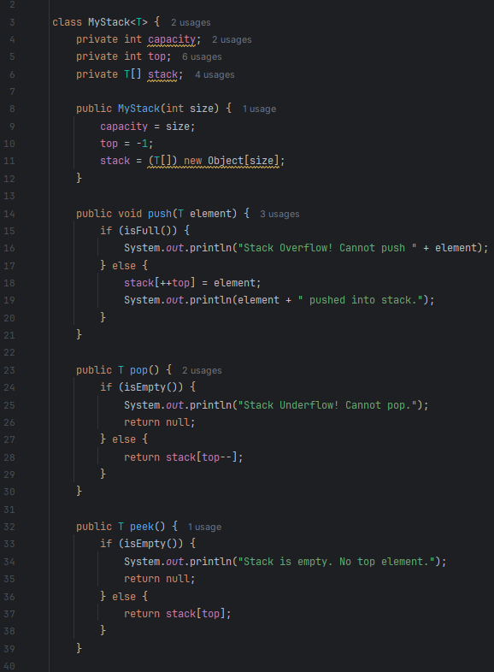
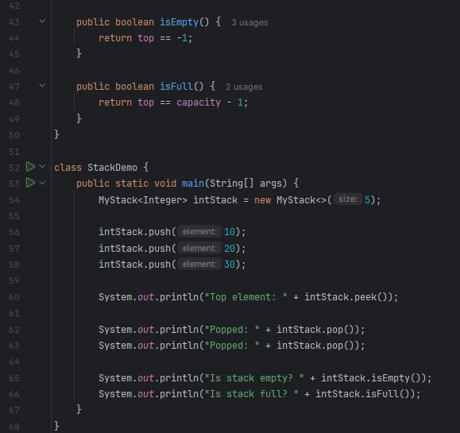

- Output:

