Experiment-1.2
Student Name: Yash Kotra UID: 23BCS10599
Branch: B.E-C.S.E Section/Group: 23KRG-2A
Semester: 5th Date of Performance: 15/08/2025
Subject Name: DAA Subject Code: 23CSH-301

- Aim: Code implement power function in O(logn) time complexity.

- Objective: To implement power function in O(logn) time complexity.

- Input/Apparatus Used: In this program , power is divided by 2 in order to get complexity in log.

- Procedure/Algorithm: Pseudocode:

if(y==0):
return 1;
temp = power(x,y/2); if(y%2==0):
return temp*temp; else
return x*temp*temp;

Various possible cases
1)The power value can be 0
2)The power value can be negative.
3)The power value can be even.
4)The power value can be odd.

- Code:

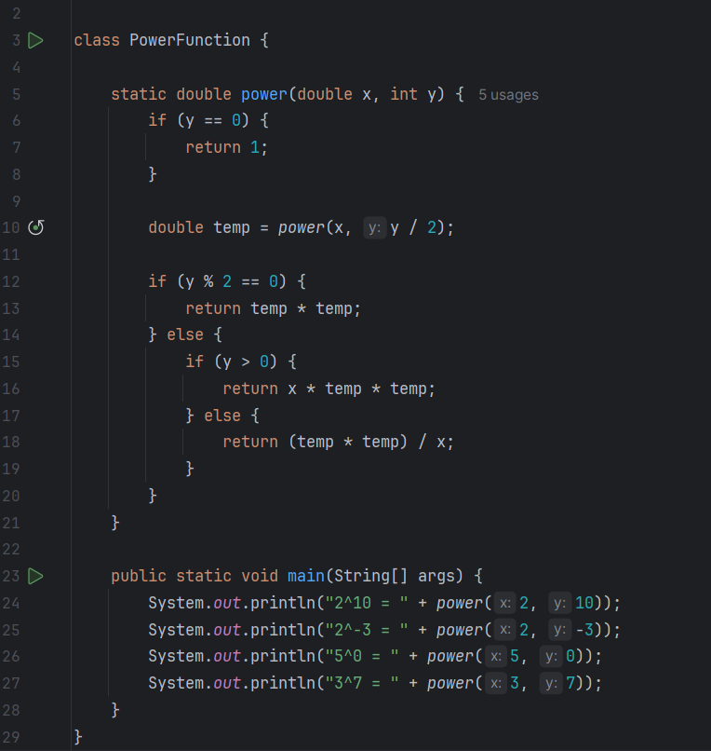

- Output:

