Experiment-1.3
Student Name: Yash Kotra UID: 23BCS10599
Branch: B.E-C.S.E Section/Group: 23KRG-2A
Semester: 5th Date of Performance: 19/08/2025
Subject Name: DAA Subject Code: 23CSH-301

- Aim: Code to find frequency of elements in a given array in O(n) time complexity.

- Objective: To find frequency of elements in a given array in O(n) time complexity.

- Input/Apparatus Used: In this program, HashMap concept is used in order to get less complexity.

- Procedure/Algorithm: Pseudocode:

Algorithm to find the frequency of each element of an array :
• Input the number of elements of an array.
• Input the array elements.
• Create another array to store the frequency of elements.
• Traverse the input array and update the count of the elements in the frequency array.
• Print the frequency array which displays the frequency of all the elements of the array.

Algorithm to find the frequency of each element of an array using hashing
• Input the number of elements of the array.
• Input the array elements.
• Create a hash table and update the element in one column and its frequency in the other column.
• Print the element along with its frequency.

Algorithm :

1. Create an extra space of size n (hm), use it as a HashMap.
2. Traverse the array from start to end.
3. For every element update hm[array[i]-1], i.e. hm[array[i]-1]++
4. Run a loop from 0 to n and print hm[array[i]-1] along with the index i

Sample Input:

1). arr[] = {10, 20, 20, 10, 10, 20, 5, 20}
2). arr[] = {10, 20, 20}

Sample Output:
1). 10 3
20 4
5 1

2). 10 1
20 2

- Code:

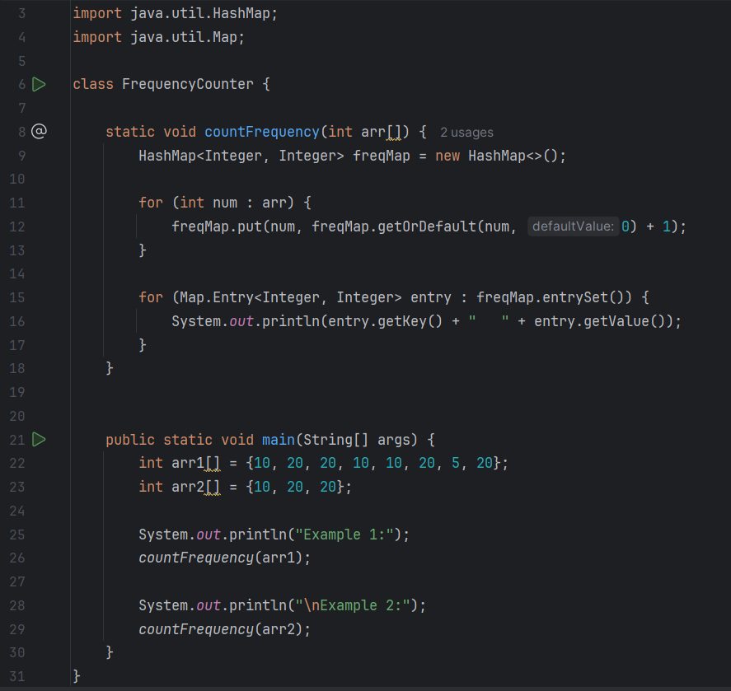

- Output:

