Program 1 : Write a program that compares two strings and checks for substring presence.

public class Program1 {
public static void main(String[] args) {
// PROGRAM 1:
// WRITE A PROGRAM THAT COMPARES TWO STRINGS AND CHECKS FOR SUBSTRING PRESENCE.

String str = "Hellow World !!";
String str1 = new String("Hellow World !!");
String str2 = "HELLOW WORLD !!";
String subStr = "World !!";

System.out.println("*** Program 1: ***\n");

// USING equals() METHOD (CASE SENSITIVE COMPARISON)
if (str.equals(str1)) {
System.out.println("Str & str1 are equal using equals()");
} else {
System.out.println("Str & str1 are not equal using equals()");
}
//----------------------------------------------------------------------------

// USING equalIgnoreCase() METHOD (CASE INSENSITIVE COMPARISION)
if (str.equalsIgnoreCase(str2)) {
System.out.println("str & str2 are equal using equalIgnoreCase()");
} else {
System.out.println("str & str2 are not equal using equalIgnoreCase()");
}
// ----------------------------------------------------------------------------

// USING == OPERATOR
if (str == str1) {
System.out.println("str & str1 object are equal using == ");
} else {
System.out.println("str & str1 object are not equal using == ");
}
// ----------------------------------------------------------------------------

// USING compareTo() method (LEXICOGRAPHICAL COMPARISON)
int result = str.compareTo(str1);

if (result == 0) {
System.out.println("str and str1 are equal using compareTo()");
} else if (result > 0) {
System.out.println("str is lexicographically greater than str1 using compareTo()");
} else {
System.out.println("str is lexicographically smaller than str1 using compareTo()");
}
// ----------------------------------------------------------------------------

// CHECK SUBSTRING IS PRESENT OR NOT
if (str.contains(subStr)) {
System.out.println("The subStr is substring of the first string.");
} else {
System.out.println("The subStr is not substring of the first string.");
}
// ----------------------------------------------------------------------------
}
}

Output:

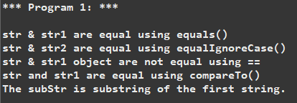

Program 2: Program to encode characters to their Unicode representations and decode them back.

package plo1;

import java.nio.charset.StandardCharsets;
import java.util.Scanner;

public class Program2 {

public static void main(String[] args) {
// TODO Auto-generated method stub
Scanner scanner = new Scanner(System.in);
System.out.println("Program 2:");

// INPUT A STRING FROM THE USER
System.out.println("Enter a string:");
String string = scanner.nextLine();

// CONVERT THE STRING TO UNICODE CODE POINTS
System.out.println("\nUnicode code points for the input string: " + string);

for (int x = 0; x < string.length(); x++) {

// GET UNICODE CODE POINT
int cp = string.codePointAt(x);
System.out.printf("Character: '%c' -> Unicode: \\u%04X\n", string.charAt(x), cp);
}

// CONVERT THE STRING TO BYTES USING UTF-8 ENCODING
byte[] bytes = string.getBytes(StandardCharsets.UTF_8);
System.out.println("\nString in UTF-8 byte encoding:");

for (byte b : bytes) {

// PRINT EACH BYTES IN HEXADECIMAL FORMAT
System.out.printf("%02X ", b);
}

// DECODE THE BYTES BACK TO THE ORIGINAL STRING
String decodedStr = new String(bytes, StandardCharsets.UTF_8);
System.out.println("\n\nDecoded string from UTF-8 Bytes: " + decodedStr);
scanner.close();
}
}

Output:

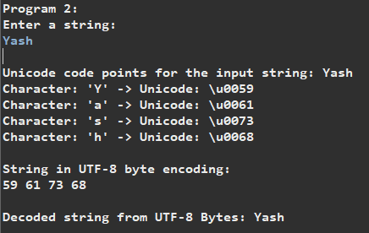

Program 3: Write a program that takes user input for multiple strings and appends them using StringBuilder.

package plo1;

import java.util.Scanner;

public class Program3 {
public static void main(String[] args) {
System.out.println("Program 3:");

Scanner scanner = new Scanner(System.in);

StringBuilder sb = new StringBuilder();

System.out.println("Enter strings to concatenate (Type exit to stop):");

while (true) {
String string = scanner.nextLine();

if (string.equalsIgnoreCase("exit")) {
break;
}
sb.append(string.trim()).append(" ");
}
System.out.println("Concatenated result: "+ sb.toString().trim());
scanner.close();
}
}

Output:

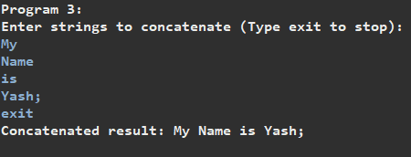
Program 4: Write a program to split a paragraph into individual sentences.

package plo1;

public class Program4 {

public static void main(String[] args) {
// TODO Auto-generated method stub
System.out.println("Program 4:");

String para = "This is the first sentence. Is this the second sentence? Yes! It is the third one.";

// SPLIT THE PARAGRAPH INTO SENTENCES BASED ON DELIMITERS LIKE '.', '?';
String[] sentences = para.split("[.?!]");

// PRINT EACH SENTENCE
System.out.println("\nSeparated Paragraph:");
for (String str : sentences) {

// TRIM ANY LEADING/TRAILING WHITESPACES
System.out.println(str.trim());
}

}
}

Output:

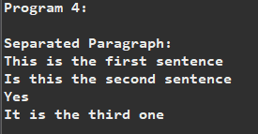

Program 5: Write a program to insert a substring into a string at a specific position using StringBuilder.

package plo1;

public class Program5 {

public static void main(String[] args) {
// TODO Auto-generated method stub

// PROGRAM 5:
// WRITE A PROGRAM TO INSERT A SUBSTRING INTO A STRING AT A SPECIFIC
// POSITION USING STRINGBULIDER;

System.out.println("Program 5:\n");
String s = "Hellow World !!";
String s1 = "Yash ";

StringBuilder sb = new StringBuilder(s);
sb.insert(7, s1);

System.out.println("String after insertion: " + sb.toString());

}

}

Output:

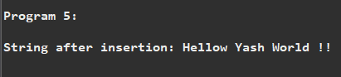

Program 6: Write a program to convert a Data object to a string in a specific format.

package plo1;

import java.text.SimpleDateFormat;
import java.util.Date;

public class Program6 {
public static void main(String[] args) {
System.out.println("Program 6:\n");

// CREATE A DATE OBJECT REPRESENTING THE CURRENT DATE AND TIME;
Date currDate = new Date();

// DEFINE THE DESIRED FORMAT;
SimpleDateFormat format = new SimpleDateFormat("dd MMM yyyy");

// CONVERT THE DATE OBJECT INTO A STRING IN THE SPECIFIED FORMAT;
String formattedDate = format.format(currDate);

// PRINT THE FORMATTED DATE;
System.out.println("Formatted Date: " + formattedDate);
}
}

Output:

