Academic Year 2025-26
FY MCA- SEM II
ITL21: Practical Based on Java Programming, Full Stack Development

Date: 07/05/2026 Set: A1
Time: 120 Min Roll No: 2501001
Marks: 50 Name: Parth Aherrao

Q1. Java Programming (25M)
Create a package TreeSetPkg. Write a class Player with attributes id and score.
Use TreeSet to store player objects in sorted order based on score using Comparable.
Write a main class to add players and display sorted output.

# Player.java
package TreeSetPkg;

import java.util.*;

class Player implements Comparable<Player> {
int id;
String name;
int score;

Player(int id, String name,int score) {
this.id = id;
this.name=name;
this.score = score;
}

public int compareTo(Player p) {
return Integer.compare(this.score, p.score);
}

public String toString() {
return "id: " + id + ", name:"+name+", Score: " + score;
}
}

#Main Class
package TreeSetPkg;

import java.util.TreeSet;

public class MainClass {
public static void main(String[] args) {
TreeSet<Player> players = new TreeSet<>();

players.add(new Player(101, "Virat Kohli", 85));
players.add(new Player(102, "MS Dhoni", 92));
players.add(new Player(103, "Rohit Sharma", 76));
players.add(new Player(104, "Hardik Pamdya", 90));

System.out.println("sorting players by score:");
for (Player p : players) {
System.out.println(p);
}
}
}

#OutPut
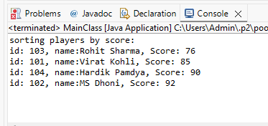

Q2. Full Stack Development (25M)
Write a Node.js program to perform the following operations on a text file. Create a text file named myfile.txt. Write some sample content into the file. Read the contents of the file. Display the file contents on the console.
Further, read the file content and display the following output:
- Number of characters
- Number of words
- Number of lines
- Number of vowels
- Number of consonants
- Number of digits
- Number of special characters

#fileOps
const fs = require('fs');
fs.writeFileSync('myfile.txt', 'Hello World! This is a sample text file.\nMy name is Parth.\nMy roll number is 2501001.');

const data = fs.readFileSync('myfile.txt', 'utf8');
console.log("File Contents:\n" + data);

const Chars = data.length;
console.log("total characters:", Chars);

const Words = data.split(/\s+/).length;
console.log("total of words:", Words);

const Lines = data.split('\n').length;
console.log("total of lines:", Lines);

const Vowels = (data.match(/[aeiouAEIOU]/g)).length;
console.log("total of vowels:", Vowels);

const Consonants = (data.match(/[bcdfghjklmnpqrstvwxyzBCDFGHJKLMNPQRSTVWXYZ]/g)).length;
console.log("total of consonants:", Consonants);

const Digits = (data.match(/[0-9]/g)).length;
console.log("total of digits:", Digits);

const Special = (data.match(/[^a-zA-Z0-9\s]/g)).length;
console.log("total of special characters:", Special);
#myfile.txt

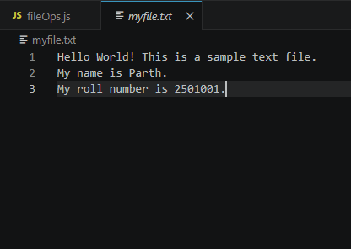

#OutPut
