PROJECT REPORT
Loan Default Risk Intelligence & Credit Portfolio Analytics
A plain-language guide to what we did, how we did it, what we found and how well it worked
Data: LendingClub accepted loans, 2007 to 2018 (2,260,668 loans)
Tools: Python, DuckDB, MySQL, Power BI
Prepared: November 2026
Report type: Project summary and analytical findings report

Contents
1. The project in one page 3
2. Key terms explained simply 4
3. What we did, step by step 5
Step 1: Inspect the raw data 5
Step 2: Clean the data 5
Step 3: Check the cleaning 5
Step 4: Analyse 5
Step 5: Build a database 5
Step 6: Build the dashboard 5
Step 7: Test everything 5
4. A measurement trap we avoided 6
5. The questions we answered 7
Q1. How is the overall portfolio performing? 7
Q2. What share of finished loans defaulted? 7
Q3. Which loan grades and subgrades have the highest losses? 7
Q4. Which borrower characteristics are linked to more defaults? 8
Q5. How do interest rate, loan amount and term relate to outcomes? 8
Q6. How does debt-to-income ratio (DTI) affect performance? 9
Q7. Which employment and income groups have greater risk? 9
Q8. Which loan purposes have higher default rates? 9
Q9. How much principal was recovered from charged-off loans? 9
Q10. Which loan segments cause most of the losses? 10
Q11. How does performance vary across years? 10
6. The dashboard: what it shows and how to use it 11
How to use it 11
7. What management should consider 13
8. How well did the project perform? 14
Do the numbers agree across tools? 14
Testing results 14
Problems found and fixed during testing 14
Speed 14
9. What this analysis cannot tell us 15
10. Where to find everything 15

If page numbers are missing, right-click the contents list in Word and choose Update Field.

1. The project in one page
A lender wants to know how its loans have performed and where it is losing money. We took 11 years of real loan records from LendingClub, an American online lender, cleaned them, analysed them, stored them in a database and built an interactive dashboard that managers can explore.
Every number in this report was calculated from the data. The headline figures were then checked in three separate tools (Python, MySQL and Power BI) to make sure they agree.
What we measured | Result | In plain words
Loans analysed | 2,260,668 | Every accepted loan from June 2007 to December 2018
Money lent | $34.00 billion | Total original loan amounts
Default rate | 19.96% | About 1 in 5 finished loans was never fully repaid
Default rate on loans that ran their full term | 15.15% | A fairer figure, explained in section 4
Principal lost at default | $3.00 billion | Money still owed when the lender gave up on the loan (an estimate)
Recovered afterwards | 10.8% | Only about 11 cents of every lost dollar came back

Five things to remember
1. Loan grade is the best single warning sign: grade A loans defaulted 6% of the time, grade G loans 50%.
2. Five-year loans defaulted about twice as often as three-year loans.
3. Borrowers with high existing debt, lower credit scores or lower incomes defaulted more often.
4. The riskiest group of loans made up 39% of the money lent but 66% of the money lost.
5. Once a loan defaults, very little comes back, so preventing defaults matters far more than collecting afterwards.

2. Key terms explained simply
These words appear throughout the report.
Term | What it means
Loan grade (A to G) | LendingClub's risk rating at the time of lending. A is safest, G is riskiest. Each grade has five subgrades, such as A1 to A5.
Fully Paid | The borrower repaid the whole loan.
Charged Off | The lender decided the loan would not be repaid and wrote it off. This is what we call a default.
Current / Late | The loan is still running. We do not know yet whether it will be repaid, so these loans are left out of the default rate.
Resolved loan | A loan with a final outcome: either Fully Paid or Charged Off.
Default rate | Charged Off loans divided by all resolved loans.
Mature loan | A loan whose full 36- or 60-month term had ended by March 2019, when the data was captured.
DTI (debt-to-income) | The borrower's monthly debt payments as a percentage of monthly income. Higher means more stretched.
FICO score | A standard US credit score. Higher is better.
Recovery | Money collected after a loan was charged off.
Principal | The amount originally lent, excluding interest.

3. What we did, step by step
The work followed seven steps. Each one fed the next.

Step 1: Inspect the raw data
The raw file is 1.6 GB, with 2,260,701 rows and 151 columns. The computer has only 7 GB of memory, so we used DuckDB, a tool that can query large files without loading them all at once.
- 33 rows were not loans (summary totals at the end of the file), leaving 2,260,668 real loans.
- No duplicate loans were found.
- Some columns were empty or nearly empty, and a few contained placeholder values such as a DTI of 999.

Step 2: Clean the data
We fixed problems without throwing away real loans or overwriting the original file.
- Converted text into proper numbers and dates.
- Treated placeholder values (DTI of -1 or 999, income of zero) as unknown instead of guessing.
- Kept unusual but possible values, such as very high incomes, and flagged them.
- Added helpful groupings: income bands, DTI bands, credit-score bands and loan-amount bands.
- Recorded every change in a cleaning log.

Step 3: Check the cleaning
We wrote 37 automatic checks. For example: no loan disappeared; money totals were unchanged by cleaning; Current loans were never counted as defaults; and for every loan, payments received equal principal plus interest plus fees plus recoveries. All checks passed.

Step 4: Analyse
- Compared default rates across grades, terms, purposes, incomes, DTI, credit scores, employment, home ownership, states and years.
- Ran statistical tests to make sure the patterns are real and not chance, and measured how strong each one is.
- Grouped loans into Low, Medium and High risk tiers using simple, published rules.

Step 5: Build a database
We loaded all 2.26 million loans into a MySQL database with five linked tables, then wrote 35 business queries, 14 data-quality checks and reusable summary views.

Step 6: Build the dashboard
We built an 8-page Power BI dashboard (6 main pages, a drill-down page and a pop-up detail page) with 52 calculated measures.

Step 7: Test everything
We compared 16 headline numbers across Python, MySQL and Power BI, tested the dashboard's interactive features and fixed every problem we found. Section 8 has the details.

4. A measurement trap we avoided
A simple approach would count all finished loans. That gives a default rate of 19.96%, but it is misleading for recent years.
Here is why. A bad loan can fail within a few months, while a good loan takes three or five years to be fully repaid. For loans issued in 2016, by early 2019 most of the bad ones had already failed but many good ones were still being paid. So counting only finished loans makes recent years look worse than they really are.
Year issued | Default rate (finished loans only) | Default rate (mature loans only)
2014 | 18.4% | 14.6%
2015 | 20.2% | 14.9%
2016 | 23.3% | 16.1%
2017 | 23.1% | Too early to tell
2018 | 15.7% | Too early to tell

To compare years fairly, we only use loans whose full term had ended. Across the whole portfolio that rate is 15.15%. We report both figures and say which is which.
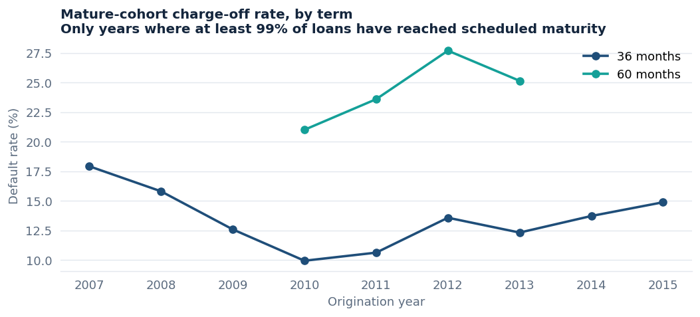
Default rate by year, using only mature loans, for three-year and five-year loans

5. The questions we answered
Management asked twelve questions. The short answers are below, followed by more detail.
# | Question | Short answer
1 | How is the overall portfolio performing? | 48% of loans fully paid, 12% charged off, 39% still running
2 | What share of finished loans defaulted? | 19.96% (about 1 in 5); 15.15% on mature loans
3 | Which grades and subgrades lose most? | Grade G (49.9%); subgrade G5 (53.6%)
4 | Which borrower traits go with default? | Low credit score, high DTI, low income, renting, recent credit applications
5 | How do rate, amount and term relate to outcomes? | All three rise with default; 60-month loans default about twice as often
6 | How does DTI affect performance? | Default doubles from 14.9% (DTI under 10) to 30.6% (DTI 40+)
7 | Which employment and income groups are riskier? | Lower incomes; employment length barely matters unless missing
8 | Which loan purposes default most? | Small business (29.7%); weddings and cars least
9 | How much was recovered after default? | $325M of $3.0B owed (10.8%)
10 | Which segments cause most of the losses? | Grades C and D, and debt consolidation loans
11 | How does performance vary by year? | Lending grew fast; fair default rates stayed between 13% and 18%
12 | What should management do? | See section 7

Q1. How is the overall portfolio performing?
Loan status | Loans | Share
Fully Paid | 1,076,751 | 47.6%
Current (still paying on time) | 878,317 | 38.9%
Charged Off | 268,559 | 11.9%
Late or in grace period | 34,252 | 1.5%
Other (special categories) | 2,789 | 0.1%

The average loan was $15,042 and the average interest rate was 13.09%. Most loans were for three years.

Q2. What share of finished loans defaulted?
Of 1,345,310 finished loans, 268,559 were charged off: 19.96%, or about 1 in 5. Weighted by money instead of loan count it is 21.55%, because larger loans defaulted slightly more often. Using only mature loans it is 15.15%.
We never counted Current or Late loans as defaults, because their outcome is not yet known.

Q3. Which loan grades and subgrades have the highest losses?
The default rate climbs steadily with every grade, which shows LendingClub's grades did rank risk well.
Grade | A | B | C | D | E | F | G
Default rate | 6.0% | 13.4% | 22.4% | 30.4% | 38.5% | 45.2% | 49.9%
Average interest | 7.1% | 10.7% | 14.1% | 18.1% | 21.8% | 25.5% | 28.1%

By subgrade, the safest was A1 (3.2%) and the riskiest were G5 (53.6%), G3 (51.4%) and G4 (51.2%).
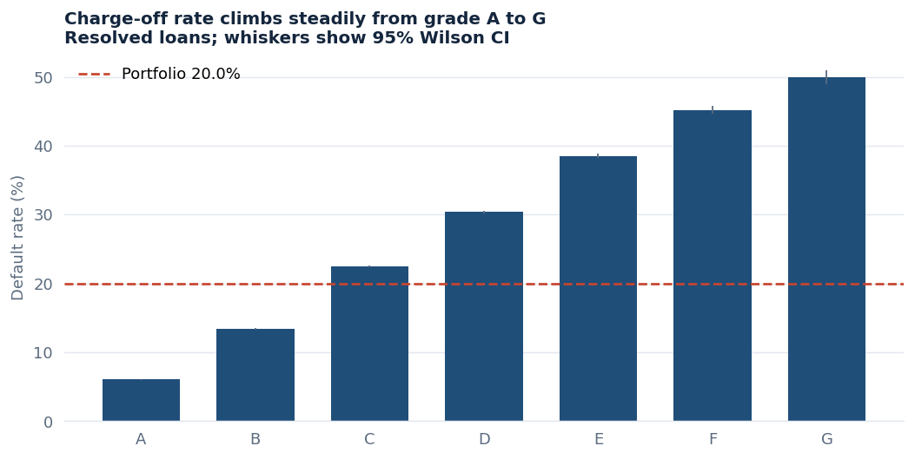
Default rate by grade. The thin lines show the 95% confidence range.

Q4. Which borrower characteristics are linked to more defaults?
Characteristic | Safer group | Riskier group
Credit score (FICO) | 750+: 8.9% | 660-679: 25.3%
Annual income | $150K+: 14.9% | Under $40K: 23.8%
Debt-to-income (DTI) | Under 10: 14.9% | 40+: 30.6%
Home ownership | Mortgage: 17.2% | Renting: 23.2%
Credit applications in last 6 months | None: 17.9% | 3 or more: 26.7%
Length of credit history | 30+ years: 18.1% | Under 5 years: 24.2%

These are links, not proof of cause. A riskier borrower usually also received a worse grade and a higher rate.
One surprise: loans with verified income defaulted more often (23.9%) than unverified ones (14.7%). LendingClub likely verified the applicants it already considered riskier, so verification marks risk rather than reducing it.

Q5. How do interest rate, loan amount and term relate to outcomes?
- Interest rate: loans under 8% defaulted 5.8% of the time; loans at 25% or more defaulted 47.8%. Rates are set from risk, so this reflects pricing for risk.
- Loan amount: loans under $5,000 defaulted 15.5%; loans of $30,000 or more defaulted 24.2%.
- Term: 60-month loans defaulted 32.5% of the time against 16.0% for 36-month loans. Even within the same grade, a 60-month loan had about 1.2 times the odds of default.

Q6. How does debt-to-income ratio (DTI) affect performance?
DTI band | Under 10 | 10-20 | 20-30 | 30-40 | 40+
Default rate | 14.9% | 17.8% | 23.0% | 29.1% | 30.6%

The default rate roughly doubles from the lowest to the highest DTI band. DTI still matters after allowing for grade, term, credit score and income: every extra 10 DTI points raised the odds of default by about 16%.

Q7. Which employment and income groups have greater risk?
Income matters: each step down in income band means a higher default rate, from 14.9% ($150K+) to 23.8% (under $40K).
Employment length hardly matters. Borrowers who stated any length, from under 1 year to 10+ years, all defaulted between 18.8% and 20.6% of the time. The exception is borrowers who left employment length blank: they defaulted 26.9% of the time. That gap is worth investigating.

Q8. Which loan purposes have higher default rates?
Purpose | Default rate | Note
Small business | 29.7% | Highest rate
Renewable energy | 23.7% | Few loans
Moving | 23.4%
Debt consolidation | 21.2% | Most loans and most money lost
Credit card | 16.9% | Second-largest purpose
Car | 14.7%
Wedding | 12.2% | Lowest rate

Q9. How much principal was recovered from charged-off loans?
Step | Amount
Originally lent on loans that later defaulted | $4.18 billion
Repaid by borrowers before default | $1.18 billion
Still owed when the loan was charged off | $3.00 billion
Recovered afterwards (gross) | $324.8 million (10.8%)
Paid to collection agencies as fees | $54.1 million
Recovered after fees | $270.7 million (9.0%)
Estimated principal never recovered | $2.73 billion

31% of charged-off loans recovered nothing at all. Loans that went through debt settlement recovered 25.7% against 9.0% for the rest.
The $2.73 billion is an estimate of unrecovered principal, not an accounting loss: it ignores interest already earned and the lender's costs.
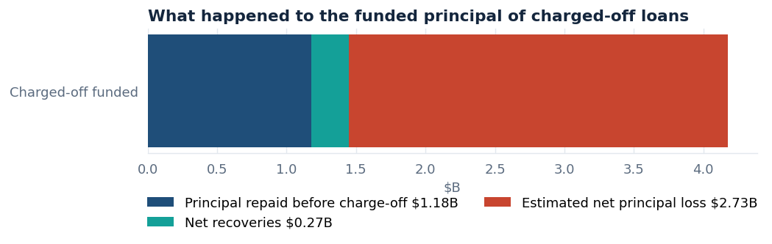
What happened to the money lent on loans that later defaulted

Q10. Which loan segments cause most of the losses?
- By grade: grades C and D hold 54% of the money lost. They are not the riskiest grades, but they are very large.
- By purpose: debt consolidation loans account for 64% of the money lost, mainly because there are so many of them.
- By risk tier: the High tier is 39% of the money lent but 66% of the money lost.
Risk tier | Default rate | Share of money lent | Share of money lost
Low (grade A) | 6.0% | 19% | 4%
Medium (grades B and C, 36 months; B, 60 months) | 16.3% | 43% | 30%
High (everything else) | 32.9% | 39% | 66%

A segment is High when its mature default rate is at least 1.25 times the portfolio average, and Low when it is below 0.75 times. These tiers describe past performance only. They are not lending rules.

Q11. How does performance vary across years?
Lending grew from $4.8 million in 2007 to $7.9 billion in 2018. On a fair, mature-loans basis, default rates for three-year loans ranged from about 10% to 18% across years, with no sign of steady decline. Loans from 2017 and 2018 are too new to judge.

6. The dashboard: what it shows and how to use it
Page | What it answers
Executive Overview | Headline numbers, loan status, lending by year, default rate by grade
Borrower Risk | Default rates by income, DTI, employment, home ownership, verification and credit score
Loan Performance | Default by grade, subgrade and purpose; interest rate and loan size spread; term comparison
Exposure & Recovery | Money lent against money received, losses and recoveries by grade, purpose and year
Time & Geography | Trends by year and month, and lending and default rates by US state
Risk Insights | Risk tiers, statistical findings, recommendations and limitations
Grade Detail (hidden) | Opens when you drill into one grade
Risk Tooltip (hidden) | Pop-up with the default rate, its confidence range and loan counts

How to use it
- Filters (slicers): pick a year, grade, purpose, term or state at the top of a page. The choice carries over to the other pages.
- Click a bar: the rest of the page filters to that item. Clicking grade G shows a 49.93% default rate on 12,168 loans.
- Hover over a bar: a pop-up shows the default rate with its 95% confidence range.
- Right-click a grade and choose Drill through: the Grade Detail page opens for that grade only.
- Navigation buttons: move between pages from the left-hand menu. In Power BI Desktop, hold Ctrl while clicking.
- Clear all slicers: resets every filter.
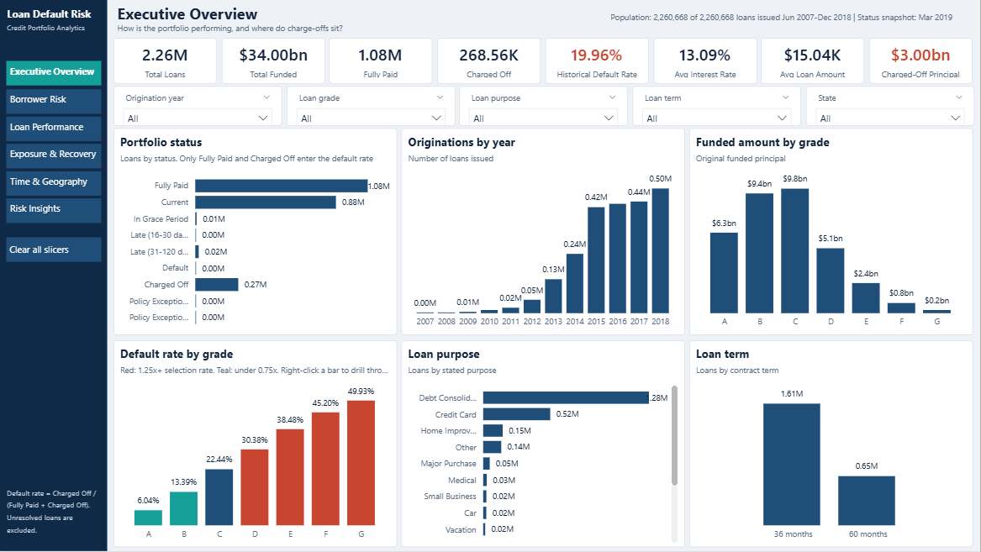
Executive Overview page
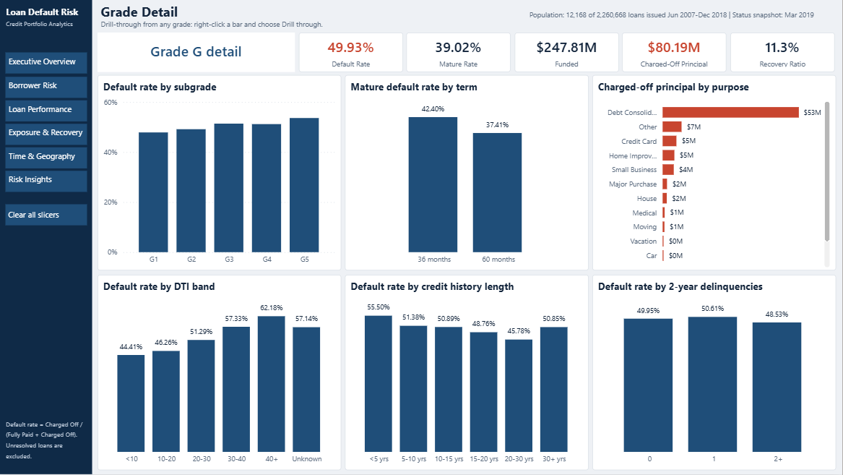
Grade Detail page after drilling into grade G

7. What management should consider
These ideas come directly from the results. Each should be tested in a small, controlled trial and reviewed by compliance before becoming policy.
- Review the High-risk tier first. It takes 1.7 times its fair share of losses. Consider pricing or limit changes.
- Tighten five-year loans in grades C to E. Longer terms stay riskier even within the same grade.
- Add a debt-to-income check within each grade. DTI still separates good and bad loans after the grade is known.
- Watch debt consolidation concentration. It is 60% of the money lent and 64% of the money lost.
- Rethink collections. Recovery is low, and settled loans recovered almost three times more. Test earlier settlement offers.
- Judge new loans on mature data. Rates based only on finished loans overstate recent years.
- Investigate missing employment information. These borrowers defaulted far more often, and the reason should be understood.

8. How well did the project perform?

Do the numbers agree across tools?
Yes. We calculated the same 16 key figures separately in Python, MySQL and Power BI.
Figure | Python | MySQL | Power BI
Total loans | 2,260,668 | 2,260,668 | 2,260,668
Money lent | $34,004,208,600 | $34,004,208,600 | $34,004,208,600
Default rate | 19.9626% | 19.9626% | 19.9626%
Mature default rate | 15.1505% | 15.1505% | 15.1505%
Principal lost at default | $2,999,584,427 | $2,999,584,427 | $2,999,584,427

The largest difference on any money figure was $10.40, out of billions, from rounding cents. Every rate matched.

Testing results
Area | What was checked | Result
Data cleaning | 37 rules: no lost loans, totals unchanged, correct status handling | All passed
Database | 14 quality checks and 35 business queries | All passed and ran
Dashboard numbers | 52 measures, grade-by-grade and filtered results | All matched Python
Dashboard features | Page loading, clicking bars, navigation, drill-through, pop-ups | All worked
Dashboard filters | Clicking slicers and Clear all slicers | Not tested by clicking, so please check once by hand

Problems found and fixed during testing
- A random sample used for some statistics was badly unbalanced (82% from one year). We replaced the sampling method and added an automatic check.
- MySQL rounded rates to four decimal places (0.1996). We raised its precision.
- A chart double-counted collection fees. A built-in balance check caught it.
- Dashboard bands were sorted alphabetically ("$100K" before "<$40K"). We fixed the sort order.
- Drill-through and pop-up pages did not connect at first. We corrected their settings and retested.
- One database query took over 7 minutes. We rewrote it to run in about 20 seconds.

Speed
Despite limited memory, cleaning all 2.26 million loans takes about a minute, the dashboard loads all the data in about a minute, and typical database queries take 10 to 30 seconds.

9. What this analysis cannot tell us
- It only includes approved loans, so it says nothing about people LendingClub turned down.
- It shows links between factors and default, not what causes default.
- Each loan has one status as of March 2019, with no month-by-month payment history.
- The loss figures are estimates of unrecovered principal, not accounting losses: they leave out interest earned, funding costs and staff costs.
- Five-year loans that had fully matured were all issued before March 2014, so they reflect older economic conditions.
- No protected characteristics such as race or gender were used. Even so, location or loan purpose can act as indirect stand-ins, so any lending policy needs a fairness review.
- The data covers a recovering economy and does not show how loans behave in a recession.

10. Where to find everything
What | Where (inside Loan_Default_Risk_Analytics)
Dashboard file | powerbi/Loan_Default_Risk_Dashboard.pbix
Full technical report | documentation/final_project_report.md
How each number is defined | documentation/methodology.md
All test results | documentation/testing_report.md
Database scripts | sql/ (six files)
Analysis code | python/
Step-by-step notebooks | notebooks/ (seven notebooks)
Charts | visuals/eda/ and visuals/dashboard_screenshots/

