AUTO-ML PIPELINE BUILDER

PROJECT: Software Engineering
(DLMCSPSE01)
In
M.Sc. in Computer Science
By
Yash Manohar Chaudhari
ID: 4252695

Under the Guidance of
Holger Klus

ABSTRACT
Systems that streamline and automate the creation of ML pipelines are growing even more in demand as ML becomes more widely used across sectors. But creating an end-to-end ML workflow, which includes activities like data preprocessing, model selction, training the data and evaluating the data usually calls for a high level of technical skills. For inexperienced users this complwxity frequently serves as a barrier and for seasoned practitioners it slows down the quick exploration.
TheAuto-ML Pipeline Builder, a full-stack software system designed to automate machine learning pipeline building with user participation,is shown in this project. Users can upload a dataset, choos e atarget variable and the system will determine the type of problem (regression or classification) automatically. Several candidate models are trained and assessed based on this analysis and the best ,odel is chosen usig the relevant performance indicators.
The suggested solution is put into practice using a modern software architecture that consists of a FastAPI backend for pipeline orchestration and machine learning funtions and a React-based frontend for user interaction. Data preprocessing, model training, evaluation and pipeline creation are all carried out by backend using scikit-learn. The systems ability to automatically generate a completely reusable python pipeline file with processing steps, model parameterization, and evaluation logic is one of its important features. Users can download and edit this file for use in experiments or deployment in future.
The outcomes show that while preserving usability and flexibility, the system effectively automates pipeline generation and model selection across various datasets. The Auto-ML Pipeline Builder offers a practical solution for quick and repeatable machine learning developments by fusing automated machine learning techniques with strong software engineering principles.

ACKNOWLEDGEMENT
I want to thank the IU International Univeristy of Applied Sciences faculty for all their help and advice during this course. This course was cpmleted succesfully thanks in large part to the course’s organized curriculum and ongoing feedback.
I woould especially want to thank Prof. Holger Klus for his insightful advice, helpful criticism and unwavering support during the project’s development. His advice and ideas were crucial in helping the project become more focused on software engineering principles, requirements clarity and realistic execution.
The availability of modern software tools, frameworks and open-source libraries like FastAPI, React and Scikit-Learn which made the project’s implementation possible and succesful is another reason for my gratitude.
Yash Chaudhari (4252695)

Table of Contents
1. INTRODUCTION: 5
2. PROBLEM DEFINITION AND OBJECTIVES: 6
2.1 Problem Definition: 6
2.2 Project Objectives: 7
2.3 Target User Group: 8
3. LITERATURE REVIEW: 8
4. SYSTEM ARCHITECTURE AND DESIGN: 10
4.1 Architectural Overview: 10
4.2 Frontend Architecture: 10
4.3 Backend Architecture: 11
4.4 AutoML Pipeline Design: 11
4.5 UML Component Diagram: 12
5. IMPLEMENTATION: 13
5.1 Technology Stack: 13
5.2 Frontend Implementation: 13
5.3 Backend and API Routing: 13
5.4 AutoML Service Layer: 14
5.5 Pipeline Generation and Artifact Management: 14
6. TESTING AND EVALUATION: 15
7. LIMITATIONS, RISKS AND LESSONS LEARNED: 16
7.1 Limitations: 16
7.2 Risks: 16
7.3 Lessons Learned: 17

INTRODUCTION:
Machine Learning (ML) has emerged as akey tool in many fields including software engineering, marketing, healthcare, education and finance. Although advanced data-driven decision making is made possible by ML techniques creating a comprehensive ML solution is still a difficult and time-consumiing procedure. Data preparation, feature engineering, model selection, training, evaluation and deployment are some of the many steps involved in creating an ML model. Technical proficiency, meticulous configuration and iterative experimentation are necessary for each of these phases which can be a major obstacle for non-expert users and a productivity difficulty even for seasoned practitioners.The idea of Automated Machine Learning (Auto-ML) has drawn more attention as a solution to this complexity. By automating tedious and error-prone aspects of ML lifecycle, AutoML seeks to shorten development times and decrease the barrier to entry for users lacking in-depth ML knowledge. Neverthenless, a lot of the AutoML solutions that are currently in use operate as “black-box” systems providing little insight into the models that are chosen the preprocessing stages and the evaluation processes. From the standpoint of software engineering this lack of flexibility and openness restricts their applicability for experimentation, teaching and everyday system integration.
The Auto-ML Pipeline Builder project was created to close this gap by fusing automation with usability and transparency. The system’s objective is to offer a web-based platform that enables the user to upload a dataset, specify a target column and have a end-to-end machine learning pipeline automatically generated. In contrast to completely transparent Auto-ML systems, the suggested approach generates a thorough human-readable python file in addition to choosing the best ML model based on dataset attributes. Automation and learning are made possible by the user’s ability to download, examine, alter and retrain this exported pipeline. Delivering a clean, modular and manageable full-stack solution is the project’s major goal from a software engineering perspective. FastAPI is used to create the backend which has service-oriented design that divides tasks like pipeline execution, model selection, data handling and artifact creation. React was used in the development of the frontend, which offers an interactive and user-friendly interface that directs users through pipeline creation, execution, dataset submission and result examination. To guarantee that users with different level of technical skills may use the system efficiently, special attention was given to usability and clear feedback.
An iterative development method that was in line with the three official project phases was used to complete the project. The system developed from a conceptual design into a fully deployable application as a result of each phase’s gradual improvement of the requirements, architecture and implementation. Software engineering concepts including modularity, consistency between specification and implementation, sensible naming conventions and reproducible deployment were adopted and verified throughout the development process.
The remaining report sections are organized as follows. The statement and project objectives are thoroughly defined in Section 2. Related research and current AutoML solutions are presented in Section 3. The methodology and general system architecture with a UML-based component diagram are covered in Section 4. The frontend and backend implementation details are described in Section 5. Testing methods and evaluation outcomes utilizing specific datasets and test scenarios are covered in Section 6. Lessons learnt through the project, including difficulties and enhancements for upcoming iterations are discussed in Section 7. Section 8 describes potential extensions and future work, while Section 9 concludes.

PROBLEM DEFINITION AND OBJECTIVES:

Problem Definition:
Even if Machine Learning is becoming more and more popular creating a comprehensive and trustworthy ML solutions is still a challenging engineering task. A number of closely related steps including as dataset integration, data preprocessing, feature engineering, model selection, training and eveluation make up the end-toend machine learning workflow. Each of these phases demands technical knowledge, subject understanding and precise configuration. Because of this ML development frequently becomes laborious, prone to mistakes and challenging to replicate.
By automating certain stages of the ML lifecycle, current AutoML systems aims to lessen this complexity. However, from a software engineering and instructural standpoint many of these technologies have a number of drawbacks. First they frequently function as “black-box” systems that don’t reveal anything about how model are chosen, what preprocessing techniques are used or how performance is assessed. Secondly thy often need complicated settings or proprietary platforms which makes them inappropriate for academic or light exploration. Third, reusable and editable pipeline artifacts that can be incorporated into other software systems are not produced by the majority of AutoML solutions.
When trying to experiment with machine learning, non-expert users like students, academics or early-stage developers encounter substantial usability challenges. Writing a lot of routine code and comprehending several libraries may be necessary for even basic operations like training a classifier on CSV dataset. Experienced users however might prefer automation support while maintaining control over future extensions and model settings.
Thus, the main issue our project attempts to solve can be summed up as follows:
“Transparent, reusable and user-friendly AutoML systems that automates the building ML pipelines while maintaining accessibility, inspectibility and extensibility from a software engineering standpoint are lacking.”

Project Objectives:
Designing and implenting a full-stack software solution that automates the building of ML pipelines while preserving transparency, usability and extensibility is the core goal of the Auto-ML Pipeline Builder project.
The project establishes the following specific goals in order to accomplish this goal:
- Automate creation of end-to-end ML pipeline – The system should automatically preprocess the data, identify the type of problem(regression or classification), choose a suitable ML model, train the model and assess the model’s performance using the uploaded dataset.
- Turn-On Dataset Agnostic Function – Without the need for explicit feature engineering or model configuration users will be able to upload any CSV dataset and designate a target column.
- Assure Reusability and Transparency – The system should provide a comprehensive and human-readable python file rsther than just internal results. This file needs to be reusable outside of the system and contain preprocessing, model training and evaluation logic.
- Offer a User-Friendly Web-Based Interface – In order to facilitate dataset upload, pipeline development, execution and resulr inspection the frontend should have an interactive, user friendly design that prioritizes feedback and usability.
- Encourage Extensible and Iterative Development – Users shopuld be able to change settings, retrain models using fresh data and expand the code for further testing using the produced pipeline.
- Adhere to Best Practices in Software Engineering – Modular design concepts, meaningful naming coventions, separation of concerns and consistency between specification and implementation should all be followed in the implementation.

Target User Group:
The following target groups are included in the system’s design –
- Learners and students that wish to comprehend machine learning pipeline without creation a lot of routine code.
- Academic users and researchers who require rapid experimentation and repeatable process.
- Junior developers and data practitioners who are looking for a customizable starting point for machine learning initiatives.
- Students studying software engineering who wish to research how ML systems are integrated into full-stack applications.

LITERATURE REVIEW:
The goal of recent Automated Mchine Learning (AutoML) research has shifted from isloated automation of model selection to comprehensive pipeline development with a growing emphasis on optimizing the entire machine learning lifecycle. Modern AutoML systems seek to automate not just model training but also data precrocessing, feature handling, assesment and deployment readiness according to the paper Automated Machine Learning (AutoML): Streamlining the end-to-end ML Pipeline (2024). The authors point out that despite tremendous advancements, many current solutions still have trouble striking a balance between automation, usability and transparency while pipelines are created without revealing their fundamental structure to users.
The POE-ML approach presented in POE-ML: An automated pipeline for optimization and evaluation of machine learning (2024) further emphasizes the significance of organized and reusable ML pipelines. In order to show that automated workflows may drastically cut experimentation time without sacrificing competitive performance, this work offers an automated method that combines pipeline opti,ization with systematic evaluation. However, the authors also point out that these frameworks acceptance in applied software engineering context is limited since they frequently remain closely linked to research environments and lack useful mechanisms for exporting pipelines as reusable software objects.
Large scale data management research has also looked on the scalability and resilience of ML pipelines. Yakovlav et al.(2020) examine pipeline execution and optimization issues in data-intensive machine learning systems in their VLDB publications. Their results demonstrate that in order to prevent technological debt and complexity accumulation, automated pipelines should be designed with modularity and distinct execution boundries. This study emphasizes the need for pipeline designs that can be examined, changed and expanded – a feature that blackbox AutoML platforms frequently lack.
One major obstacle to the automation of machine learning processes is still feature engineering. A pipeline-centric approach to feature engineering is suggested in the paper Development of Pipeline Feature Engineering for Building AutoML Service (2022), which contends that automated systems must explicitly incorporate preprocessing and transformation logic rather than executing transformations implicitly. The authors show how adding explicit feature engineering phases enhances reproducibility and allow users to modify pipelines for new datasets or changing needs. This realization is consistent with current trends that place equal emphasis on automation and pipeline transparency.
A common element appears in all of these studies: while current AutoML systems recognizes the necessity of automation it is also increasingly views software engineering compatibility, transparency and resuability as equal significant design objectives. Although many frameworks are excellent at speed optimization, thy frequrntly fall short of producing artifacts that can be maintained over time or directly integrrated into custom workflows. This gap is particularly essential to software engineering and instructural programs, because reusing generated outputs and comprehending system behavior are crucial evaluation criteria. These shortcomings found in the recent research are directly addressed by the Auto-ML Pipeline Builder in this project. The system concentrates on creating comprehensive, human-readable python pipelines that contains preprocessing, model selection and logic evaluation rather than functioning as a closed optimization engine. The suggested method is in accordance with currenr recent approaches that support transparent, modular and reusable AutoML systems by enabling users to download and alter the downloaded pipeline code. By doing this the project offers a useful software engineering focused interpretation of AutoML that takes into account both current research findings and actual usability requirements.

SYSTEM ARCHITECTURE AND DESIGN:

Architectural Overview:
The Auto-ML Pipeline Builder is a service-oriented, modular online application that distinguishes between machine learning execution, application logic and display. A browser-based frontend communicates with a RESTful backend that handles data handling, pipeline orchestration and pipeline creation in this client-server architecture system.
The architecture emphasis on extensibility, opennes and loose coupling reflects the needs found in recent AutoML research as well as the input gathered during phase 2. Rather of putting in place a single AutoML engine, the system is broken down into several parts that interact via well defined interfaces. This approach enables machine learning pipeline reproducibility, guarantees maintainability and makes future expansions(like more models or metrics) easier.
The system is made up of four main layers:-
- Frontend UI (Presentation Layer)
- Routing and API (Application Layer)
- Model Selection and Pipeline Logic (Service Layer)
- Generate Pipelines (Artifact Layer)

  - Frontend Architecture:
React is used to implement the frontend which is the users main point of engagement. Uploading datasets, configuring pipelines, monitoring execution and downloading artifacts are among its duties. Reusable UI elements and sepration of concerns are made possible by frontend’s component based architecture.
Key frontend components are:
- CreatePipeline component which manages user input, dataset upload and pipelie building requests.
- PipelineList component which shows pipelines that are currently in use along with their execution status.
- PipelineDestails component which offers detailed information about a chosen pipeline such as model, evaluation metrics and download option.
In order to prevent client-side execution of machine learning logic the frontend only uses HTTP requests to connect with the backend. This divisio makes deployment easier and enhances security.

  - Backend Architecture:
FastAPI which was selected for its lightweight design, robust type support and automatic API documentation is used to implement the backend. Dataset uploads, pipeline building, pipeline execution and artifact retrieval are all handled by REST APIs that are exposed by the backend.
There are three main modules that make up the backend:
- The routing layer which is in charge of request validation and API endpoint defination.
- The service layer which contains business logic such as model selection, training, evaluation, dataset analysis and problem type recognition.
- Artifact management which is in charge of creating and keeping Python pipeline scripts that may be downloaded.

  - AutoML Pipeline Design:
A pipeline-centric process is used to implement the AutoML logic. Based on the properties of the target variable, the system automatically identifies whether the problem is a classification or regression task once a dataset and target column are supplied. A train-test split is used to assess several candidate models and the best performing model is chosen using a suitable metric.
In contrast to black-box AutoML solutions a resulting python script openly encodes the chosen preprocessing processess, model setup and evaluation logic. This script is an example of a fully operational machine learning pipeline that the user can extend, modify or reuse outside of the platform.

  - UML Component Diagram:
A UML Component Diagram is used to oficially define the system architecture. As suggested in Phase 2 feedback, The diagram uses conventional UML notation to show the system’s major components and how they interact.
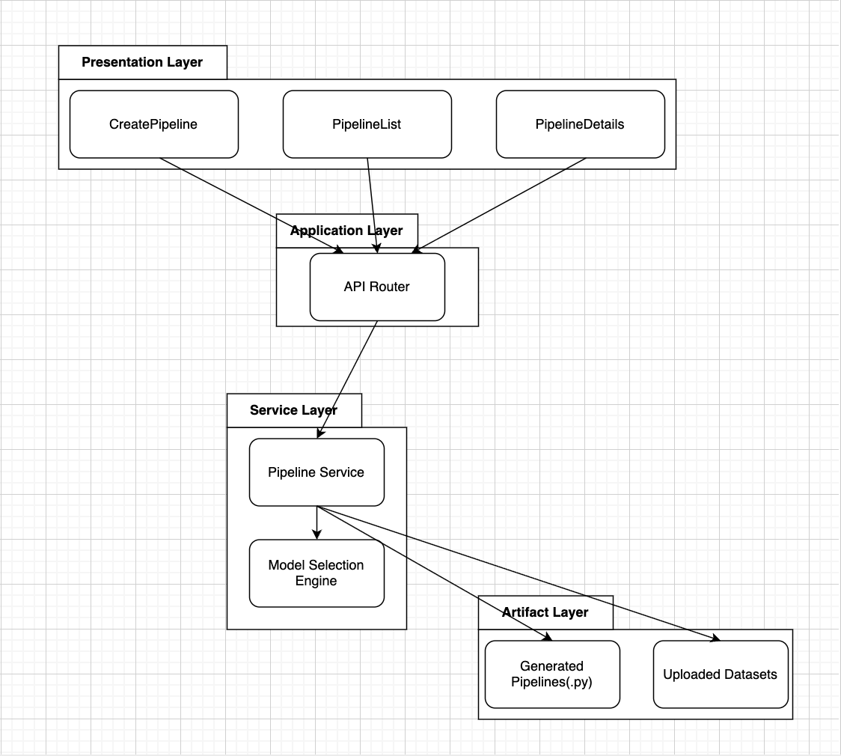
Fig.1 UML Component Diagram
By grouping system components into discrete architectural layers the UML Component Diagram depicts the Auto-ML Pipeline Builder’s structure. It demonstrates how the presentation layer, application layer, service layer and artifact layer are distinct from one another. The system’s extensibility, maintainability and modularity are all enhanced by this layered design.

IMPLEMENTATION:
This section explains the Auto-ML Pipeline Builder’s actual implementation including the technologies employed and the practical realization of the system’s components. In accordance with software engineering goals of the project the implementation adheres to the layered architecture described in the previous section and prioritizes repeatability, clarity and modularity over aggressive optimization.

  - Technology Stack:
A contemporary web-based technology stack is used to construct the Auto-ML Pipeline Builder. React is used in the development of the frontend allowing for dynamic user interaction and a component based architecture. FastAPI which was chosen for its excellent performance, lightweight design and integrated support for RESTful APIs is used create the backend. Python is used to provide machine learning functionality including Scikit-learn for preprocessing, model training and assesment and pandas for data processing.

  - Frontend Implementation:
User interaction and pipeline related information visualization are handled by the frontend. It is divided into reusable React components, each of which is responsible for a particular task. Users can upload dataset and selct configuration parameters, including the target column using the CreatePipeline component. All built pipelines are retrieved and shown along with their current status by the PipelineList component. In-depth details about a specific pipeline such as chosen model, evaluation metrics and download choices for generated pipelines are displayed via the PipelineDetails component.

  - Backend and API Routing:
A collection of REST endpoints that make up systems application layer are exposed by the backend. Dataset uploads, pipeline formation, pipeline execution and ppipeline download requests are all handled by these endpoints. By ensuring that incoming data comolies with expected formats, FastAPIs request validation procedures increase robustness and reliability.
Each API endpoint assigns essential functionality to the service layer and rputing loguc is purposefully kept to a minimum. This division guarantees that business logic is centralized in specific service functions and that routing code remains short.

  - AutoML Service Layer:
The system’s main AutoML capability is implemented at the service layer. When a pipeline construction request is received, the service loads the uploaded dataset and determines if the task is regression or classification by examining the designated target column. One-hot encoding is used to automaticlly encode categorical features and the dataset is divided into training and testing subsets.
Depending on identified problem category several possible models are assessed. Accuracy is the performance statistic used to assess models like Random Forest Classifier and Logistic Regressio for Classification jobs. The R2 score is used to assess Random Forest Regressor and Linear Regression for Regression tasks. The model that performs the best is automatically chosen and added to the pipeline information.

  - Pipeline Generation and Artifact Management:
The creation of reusable machine learning pipeline is a crucial component of the system. The service layer creates a python file that contains preprocessing procedures, model training and evaluation logic after choosing the top-performing model. The frontend allow users to download the scripts which are kept in a special artifact directory.
The resulting pipeline scripts are completely executable and human-readable without requiring any extra system requirements in contrast to many of the AutoML platforms now in use. Transparency, reproducibility and future user customization are all supported by this design decision.

TESTING AND EVALUATION:

LIMITATIONS, RISKS AND LESSONS LEARNED:
  - Limitations:
The Auto-ML Pipeline Builder has a number of drawbacks that should be noted even if it effectively accomplishes its main goals. The lack of persistent storage is a major drawback. When the backend service is restarted, all pipelines are lost since pipeline information and execution outcomes are kept in memory. This design decision limits long-term use and multi-session evaluation but it makes implementation and deployment easier.
The range of automatic model selection is another drawback. For both classification and regression tasks the system assesses a small number of traditional machine learning models. The system does not yet support more sophisticated models like gradient boosting frameworks or neural networks, even though this models are adequate to show automated selection and pipeline development. Furthermore the system may not be able to optimal predictive performance on increasingly complicated datsets because hyperparameter optimization is restricted to default setups.
Using a straightforward train-test split technique also limits pipeline evaluation. The lack of cross-validation and sophisticated evaluation techniques could cause performance estimates to differ, especially for smaller datasets. Additionally, the system lacks comprehensive data validation and automated data cleaning procedures and believes that the uploaded datasets are generally clean.

  - Risks:
During the systems development and assesment a number of risks were found. Technically speaking, using in memory storage restricts scalability and increase the risk of data loss. This method would need to be swapped out for a persistent database or more reliable state management in a production setting.
Validation of user input is another concern. Even with basic validation, runtime mistakes or deceptive assesment results can still happen from innacurate or improperly constructed datasets. Despite the streamlined evaluation setting, there is nevertheless a chanve that user will misunderstand the generated evaluation metrics as conclusive measuresof model quality.
The automated model selection process poses a risk of over-reliance on automation from a system standpoint. Users may apply models in inappropriate circumstances if they don’t have a thorough understanding of the generated pipelines. This risk is a reflection of a larger problem found in AutoML Research: automation needs to be balanced with interpretability and user awareness.

  - Lessons Learned:
Several significant insights into the planning and execution of automated machine learning systems were gained from the creation of Auto-ML Pipeline Builder. The significance of striking a balance between automation and openness is one important lesson discovered. Although completely automated systems can minimize labor, producing explicit and reusable pipeline code greatly enhances user comprehension, confidence and long-term usage.
The application of machine learning in the context of software engineering is the subject of another lesson. Managing system complexity and resolving integration problems between frontend and backend components required the use of layered architecture, modular design and distinct interface boundries. Clarifying components role and interaction flows was anaother benefit of using UML diagram throughout the design stage.
Lastly, the project demonstrated how crucial iterative testing and deployment are. Only after the system was deployed and thoroughly tested did many problems become apparent, especially with file handling, API communication and artifact downloads. These encounters reaffirmed the importance of incremental improvement and ongoing validation while creating data-driven software systems.

RESULTS AND DISCUSSION:
The Auto-ML Pipeline Builder’s outcome shows that the system effectively automates important phases of the machine learning workflow while preserving user control and transparency. The pipeline creation interface, shown in Fig.2 allows users to upload dataset and choose the target column. This demonstrates that the technology allows for simple configuration withput requiring any prior knowledge of machine learning.
As seen in the Fig.3 pipelines are visible in a centralized pipeline list after they are constructed. Users can monitor the progress of execution thanks to the list’s real-time pipeline status feedback. This feature enhances usability and is consistent with experiment management techniques covered in recent AutoML studies.
The detailed representation of a finished pipeline, including the model that was automatically chosen and the associated evaluation metric is shown in Fig.4. The findings demonstrate that the system regularly choses suitable models based on emperical performance for both classification and regression tasks. This validates the accuracy of the service layer’s automatic model selection mechanism.
The creation of reusable machine learning piipeline code is one of the project’s main results.

