Project & Resource Management Tool
System Design Document
Version 1.0
Technology Stack:
C++ (C++17) | Drogon Framework | MySQL 8 | libcurl | LLM REST API

1. Introduction
The Project and Resource Management (PRM) Tool is a console-based client-server application designed to streamline resource planning, project management, and workforce utilisation within service-based IT organisations. The system replaces manual spreadsheet-driven processes with a single intelligent platform.
This document describes the complete system design for the C++ implementation using Drogon, MySQL and libcurl. It covers the technology choices, architectural decisions, UML diagrams, and database design.

1.1 Purpose
This design document serves as the primary technical reference for implementing the PRM Tool. It provides:
- A clear mapping of business requirements to technical components
- UML artefacts: Use Case, Sequence, Class, and ER Diagrams
- Technology stack justifications and integration notes
- Database schema design with normalization rationale

1.2 Scope
The PRM Tool is an end-to-end console application supporting three user roles — Admin, Manager, and Employee — communicating over REST APIs. An optional web UI is out of scope.

1.3 Technology Stack
Layer | Technology | Justification
Language | C++17 | High performance, low-level system control, strong type system, RAII memory management
HTTP Server | Drogon Framework | Asynchronous C++ HTTP/WebSocket framework with built-in ORM; ideal for REST APIs
Database | MySQL 8.0 | ACID-compliant RDBMS; strong referential integrity via foreign keys; widely supported
DB Driver | Drogon ORM / libmysqlclient | Drogon's async ORM provides type-safe database access; connection pooling built-in
HTTP Client | libcurl | Industry-standard C library for HTTP requests; used for LLM REST API calls from server
JSON | nlohmann/json (via Drogon) | Header-only C++ JSON library; used for REST request/response serialisation
Auth | JWT (libjwt) | Stateless token-based authentication; role embedded in token payload
AI / LLM | OpenAI / Anthropic API | Accessed via libcurl; enables AI Skill Match and AI Risk Summary features
Console UI | Custom C++ Console | ANSI escape codes for formatted output; menu-driven interface per role
Build | CMake 3.20+ | Cross-platform build system; manages dependencies and compilation targets

2. System Architecture
The PRM Tool follows a Client-Server architecture. The Console Client communicates with the REST Server via HTTP. The server handles business logic, communicates with MySQL, and calls the external LLM service via libcurl.

2.1 Architectural Layers
- Console Client (C++) — Menu-driven CLI. Reads input, sends HTTP requests, displays responses. No business logic.
- REST Server (Drogon C++) — Controllers, Services, Repository layer. JWT authentication middleware. Async I/O.
- Database (MySQL 8) — Relational schema. All persistence via Drogon ORM with connection pooling.
- LLM Service (External) — Called via libcurl for AI Skill Match and AI Risk Summary endpoints.
- Background Scheduler — In-process Drogon timer that runs utilisation computation and health flagging periodically.

2.2 SOLID Principles Applied
- Single Responsibility — Each controller handles one resource (e.g., EmployeeController, AllocationController). Service classes hold business logic separately from controllers.
- Open/Closed — Strategy pattern for LLM providers means adding a new AI provider requires only a new concrete strategy class, not modifying existing code.
- Liskov Substitution — IRepository<T> interface allows swapping MySQL implementation for a mock in tests without changing callers.
- Interface Segregation — IAuthService, IEmployeeService, IProjectService are separate interfaces; no class is forced to implement methods it does not use.
- Dependency Inversion — Controllers depend on abstract IService interfaces injected at construction time, not on concrete implementations.

2.3 Design Patterns Used
- Repository Pattern — Abstracts all database access behind generic IRepository<T> interface. Concrete MySqlEmployeeRepository implements it.
- Singleton — SystemConfigManager is a singleton. Reads config once from DB and caches it in memory.
- Strategy — AIProvider strategy (OpenAIStrategy, AnthropicStrategy) selected at runtime based on configured provider.
- Factory — UserFactory creates User + Employee records atomically; ensures both entities are always created together.

3. Use Case Diagram
The Use Case Diagram shows all actors and the use cases available to each. The three actors are Admin, Manager, and Employee. Login / Change Password is a shared use case included by all three. Extend relationships show optional behaviour triggered under specific conditions.

3.1 Actors
- Admin — System operator. Manages master data: employees, skills, projects, milestones, system configuration.
- Manager — Delivery manager. Manages allocations, views project health, uses AI features, reviews team timesheets.
- Employee — Individual contributor. Submits timesheets, views own allocations and timesheet history.

3.2 Key Relationships
- <<include>> Login / Change Password — All actors must authenticate before accessing any use case. On first login, Change Password is mandatory.
- <<extend>> AI Risk Summary extends View Project Health — The manager may optionally request an AI-generated risk paragraph when viewing a project.
- <<extend>> AI Skill Match extends Allocate / End Allocation — When allocating a resource, the manager may use natural language AI query to get ranked suggestions.
- <<extend>> Reset / Deactivate Account extends Manage User Accounts — Admin may deactivate or reset password for any account as a specialised account management action.
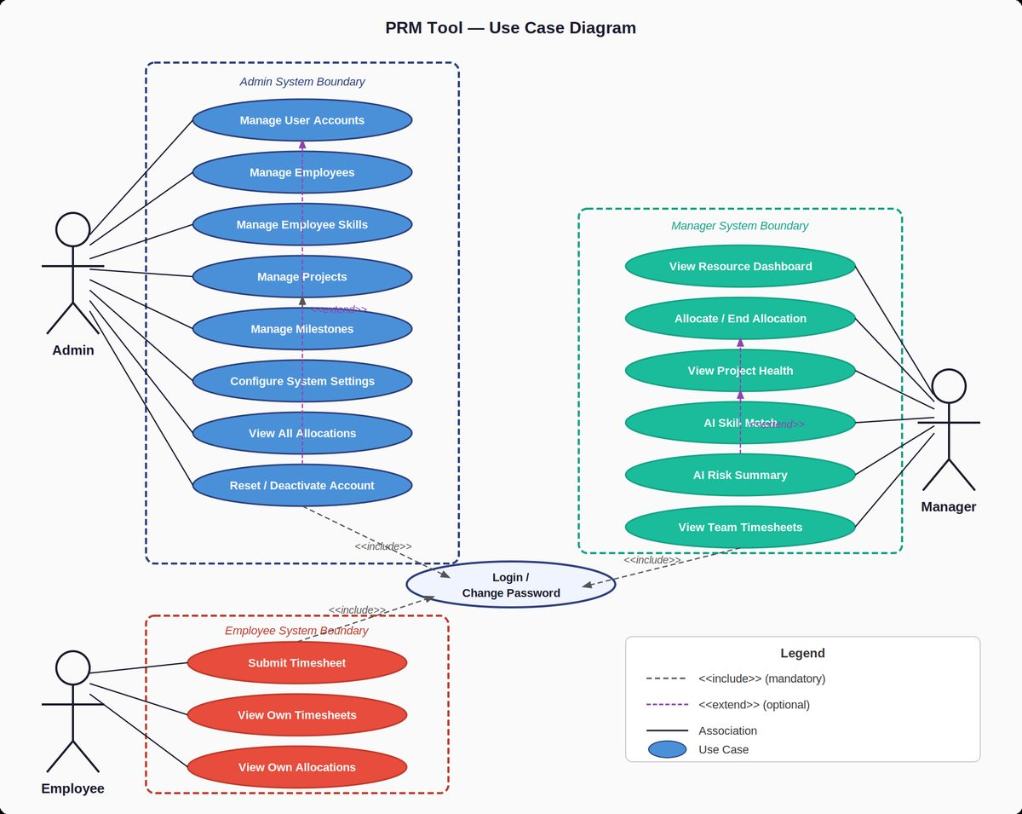
Figure 1 — PRM Tool Use Case Diagram

4. Sequence Diagrams
Three sequence diagrams are presented, covering the three primary workflows: Manager AI Skill Match and Allocate Resource, Employee Submit Timesheet, and Admin Create Employee and Project.

4.1 Manager: AI Skill Match & Allocate Resource
This is the core workflow. The manager logs in, retrieves their projects, types a natural language requirement, the server fetches candidates from MySQL, sends them to the LLM for ranking, presents the result, and the manager confirms. The allocation is saved to the database.
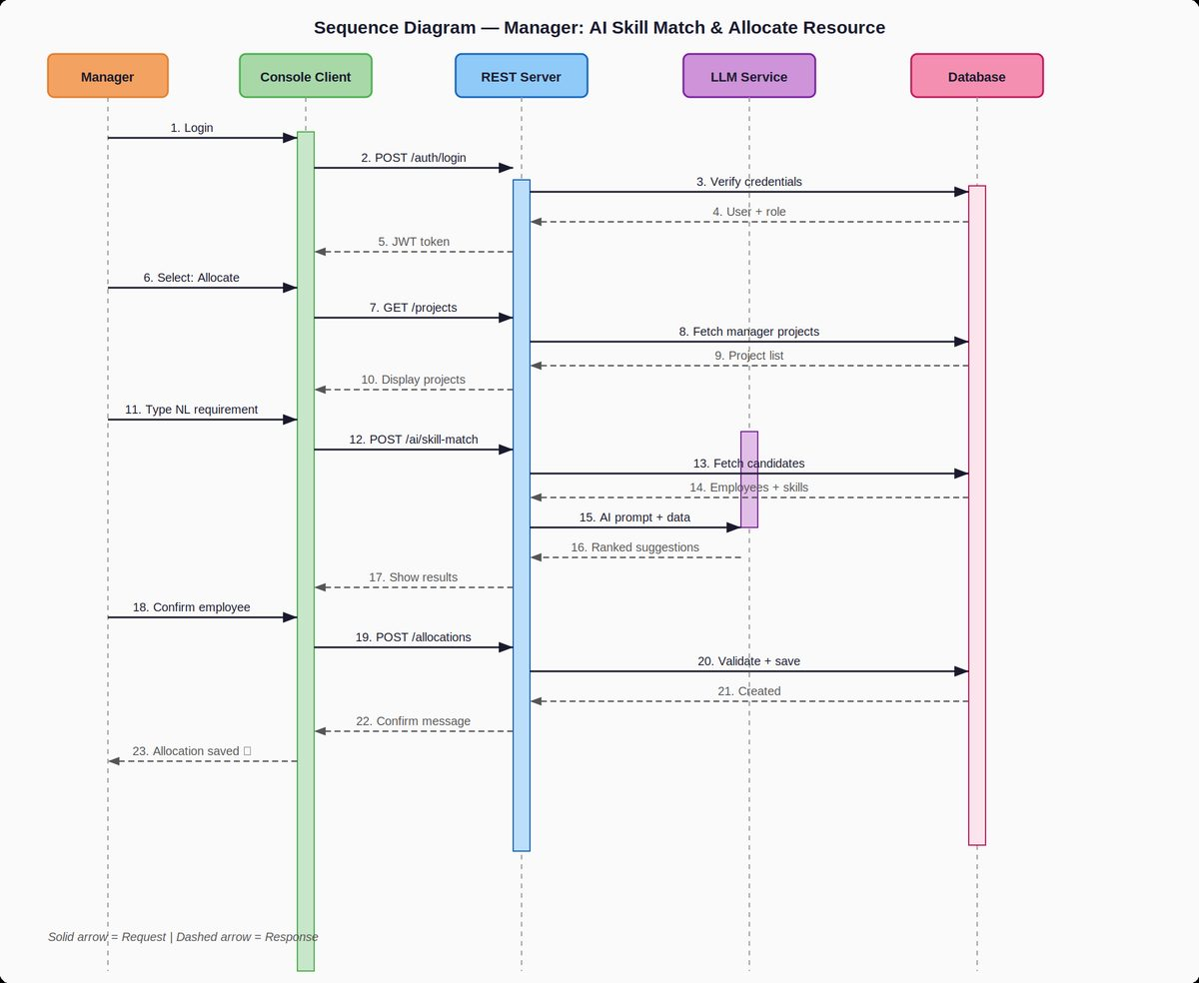
Figure 2 — Sequence Diagram: Manager AI Skill Match & Resource Allocation

4.2 Employee: Submit Timesheet
The employee logs in, navigates to Submit Timesheet. The client fetches active allocations for the current week, the employee enters hours and activity tags per project. The server validates against allocation rules (max hours, no future weeks, no duplicates) and saves the timesheet.
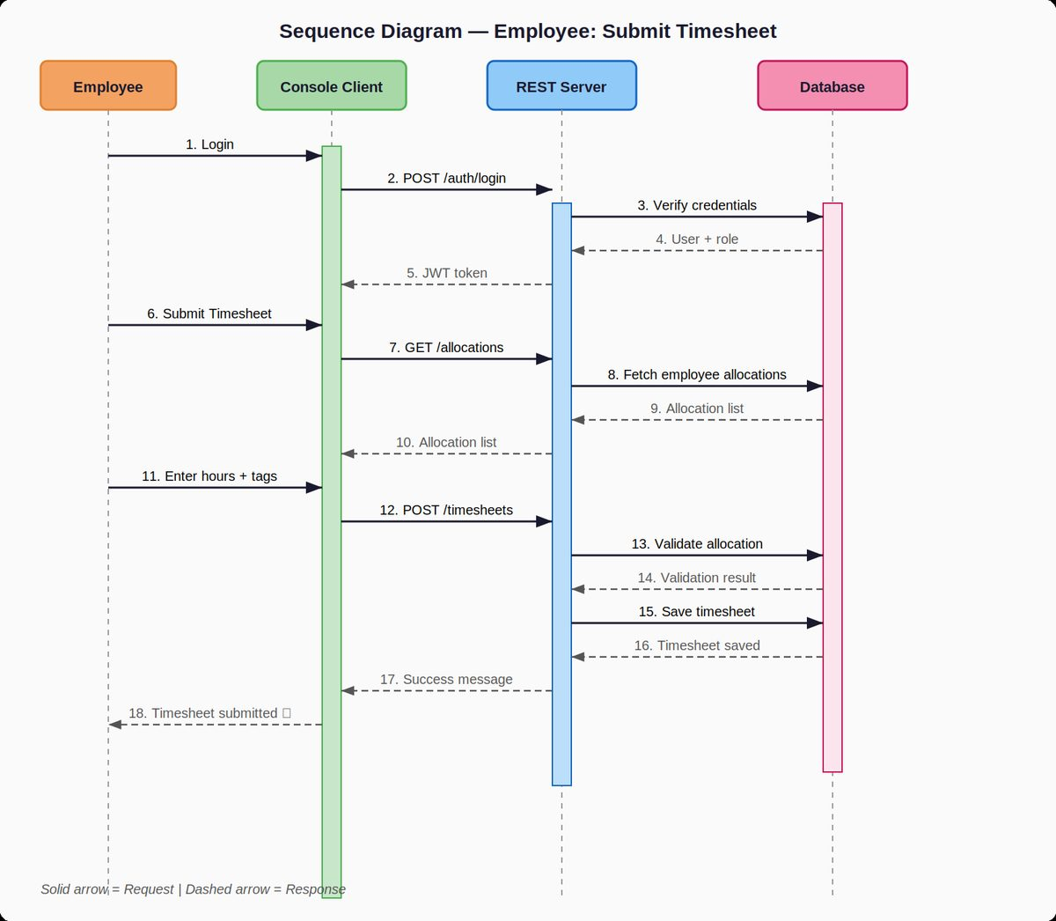
Figure 3 — Sequence Diagram: Employee Submit Timesheet

4.3 Admin: Create Employee & Project
The admin logs in, creates an employee (which triggers creation of both a User account and an Employee profile atomically), assigns skills, then creates a project. Each step involves a REST call to the server which persists the data in MySQL.
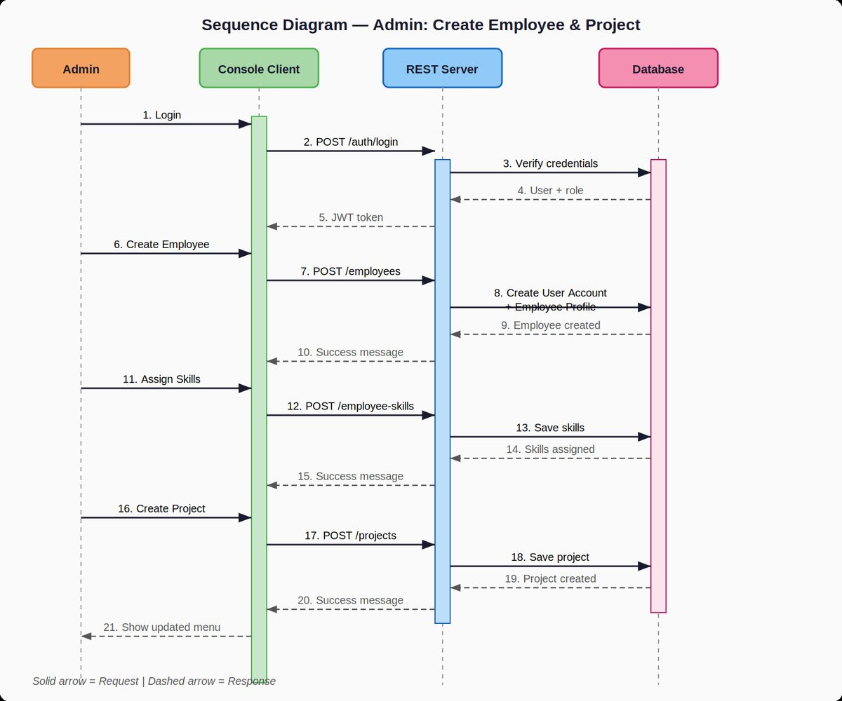
Figure 4 — Sequence Diagram: Admin Create Employee & Project

5. Class Diagram
The Class Diagram models the domain layer of the REST server. All classes are implemented in C++ with the design patterns described in Section 2.3. Key classes and their relationships are shown below.

5.1 Core Domain Classes
- User — Authentication entity. Holds role ENUM (ADMIN, MANAGER, EMPLOYEE), isActive flag, and forcePasswordChange flag set at account creation.
- Employee — Profile entity linked 1-to-1 with User. Tracks department, designation, and active status. Methods provide utilisation and allocation queries.
- Project — Tracks lifecycle from PLANNED to COMPLETED. Holds managerId FK. computeHealthStatus() is called by the background scheduler.
- Milestone — Belongs to a Project (1 to many). isOverdue() compares dueDate against current date.
- Allocation — Links Employee to Project with a utilisation percentage and date range. Business rule: sum of utilisation for an employee cannot exceed 100%.
- Timesheet — Weekly submission entity per employee. Contains multiple TimesheetEntry records. status is SUBMITTED or MISSED (set by scheduler).
- TimesheetEntry — One row per project per timesheet. Holds hours and is tagged with multiple ActivityTags.
- EmployeeSkill — Junction class between Employee and Skill, stores proficiency level (BEGINNER, INTERMEDIATE, ADVANCED).
- AIService — Stateless service class. Uses libcurl internally to call the configured LLM provider. Implements the Strategy pattern.
- SystemConfig — Singleton. Stores LLM API key, max weekly hours, scheduler interval. Loaded once from MySQL at startup.
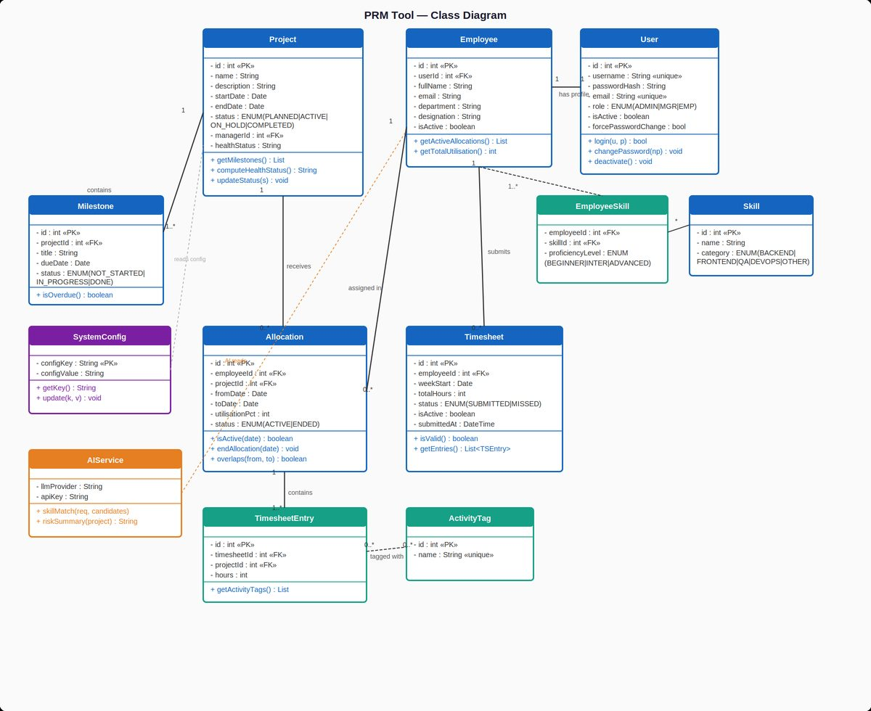
Figure 5 — PRM Tool Class Diagram

6. Entity Relationship (ER) Diagram
The ER Diagram shows the complete relational database schema for MySQL 8. Every entity has a surrogate integer primary key. Foreign keys enforce referential integrity. Junction tables handle many-to-many relationships.

6.1 Entity Descriptions
- USERS — Authentication table. role ENUM constrains valid values. is_active and force_password_change support account lifecycle management.
- EMPLOYEES — Profile table with FK to USERS (1-to-1). Separated from USERS to follow Single Responsibility; auth data and profile data are distinct concerns.
- SKILLS — Master list of skills, categorised by ENUM (BACKEND, FRONTEND, QA, DEVOPS, OTHER).
- EMPLOYEE_SKILLS — Junction table (employee_id, skill_id) with composite PK. Stores proficiency_level ENUM per combination.
- PROJECTS — Core project entity. health_status is updated by the background scheduler. manager_id FK points to USERS (a Manager role user).
- MILESTONES — Belongs to PROJECTS (1 to many). status ENUM tracks progress lifecycle.
- ALLOCATIONS — Links EMPLOYEES to PROJECTS with utilisation_pct and date range. status ENUM is ACTIVE or ENDED.
- TIMESHEETS — Weekly timesheet header per employee. Composite unique constraint on (employee_id, week_start) prevents duplicate submission.
- TIMESHEET_ENTRIES — One row per project per timesheet. Foreign keys to both TIMESHEETS and PROJECTS.
- ACTIVITY_TAGS — Master list of activity tag names (unique). Enables the AI Skill Matcher to correlate tag frequency with skill evidence.
- ENTRY_TAGS — Junction table linking TIMESHEET_ENTRIES to ACTIVITY_TAGS (many-to-many). PK is composite (entry_id, tag_id).
- SYSTEM_CONFIG — Key-value store for runtime configuration: LLM API key, max_weekly_hours, scheduler_interval_minutes.

6.2 Key Constraints & Business Rules
- Utilisation enforcement: Application-layer check on ALLOCATIONS ensures sum of utilisation_pct for an employee in overlapping date ranges does not exceed 100.
- Timesheet uniqueness: UNIQUE constraint on (employee_id, week_start) in TIMESHEETS prevents double submission.
- Referential integrity: All FKs are enforced with InnoDB engine. ON DELETE RESTRICT prevents orphaned records.
- Soft delete: Employees and Users use is_active flag rather than physical deletion to preserve audit trail.
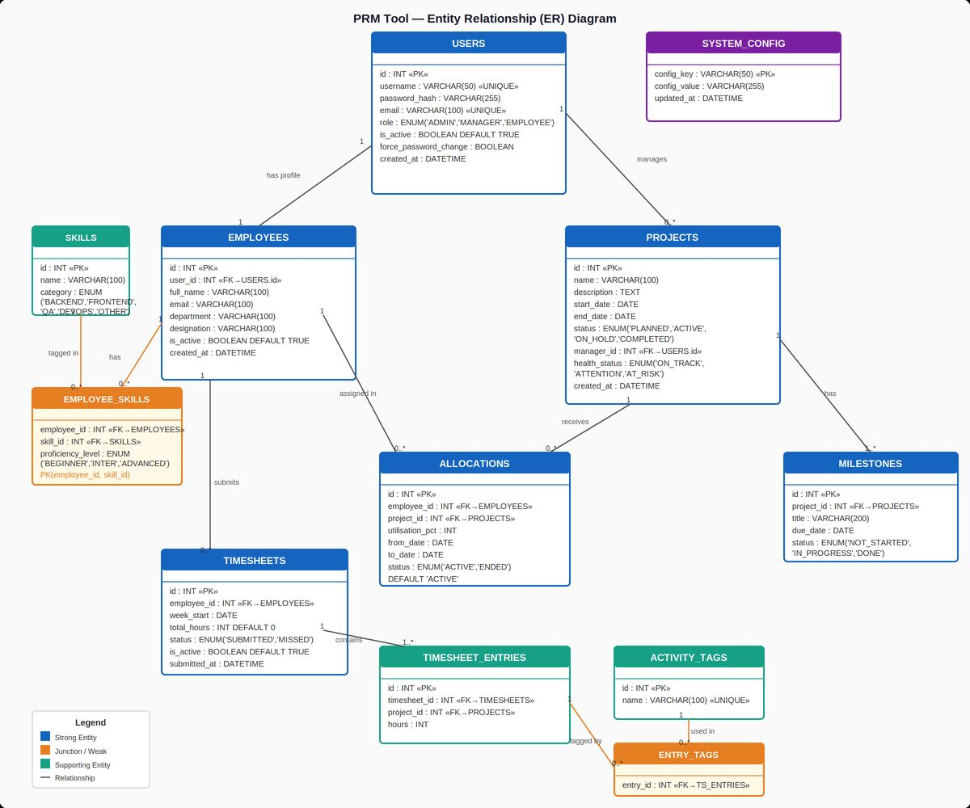
Figure 6 — PRM Tool ER Diagram

7. REST API Design (Summary)
All API endpoints are served by the Drogon HTTP server. JWT token (obtained from POST /auth/login) must be included in the Authorization: Bearer <token> header for all protected routes.
Method | Path | Role | Description
POST | /auth/login | All | Authenticate user, return JWT
PUT | /auth/change-password | All | Change own password
POST | /employees | Admin | Create employee + user account
GET | /employees | Admin/Manager | List all employees
PUT | /employees/:id | Admin | Update employee profile
POST | /employee-skills | Admin | Assign skill to employee
POST | /projects | Admin | Create new project
GET | /projects | Manager | List manager's projects
PUT | /projects/:id | Admin | Update project details
POST | /projects/:id/milestones | Admin | Add milestone to project
GET | /allocations | All | Get allocations (scoped by role)
POST | /allocations | Manager | Allocate employee to project
PUT | /allocations/:id/end | Manager | End an active allocation
POST | /timesheets | Employee | Submit weekly timesheet
GET | /timesheets | Employee/Manager | Get timesheets (scoped by role)
POST | /ai/skill-match | Manager | AI ranked resource suggestions
POST | /ai/risk-summary | Manager | AI plain-English risk summary
GET | /config | Admin | View system configuration
PUT | /config | Admin | Update system configuration

8. Design Principles & Clean Code

8.1 Design Principles Applied
- DRY (Don't Repeat Yourself) — Validation logic (hours cap, allocation overlap check) lives in one service method called from both the timesheet endpoint and the allocation endpoint. No duplication.
- Separation of Concerns — Controllers parse HTTP requests and return responses. Services hold business rules. Repositories perform data access. No layer reaches into another's concern.
- Fail Fast — Input validation is performed at the API boundary before any database call. Invalid requests are rejected immediately with a 400 status and descriptive error message.
- Law of Demeter — Service methods receive only the data they need, not entire entity graphs. Prevents tight coupling between unrelated modules.

8.2 Clean Code Practices
- Meaningful names — Functions are named for what they do: computeProjectHealthStatus(), endAllocationById(), validateTimesheetHours().
- Small focused functions — Each function does one thing. No function exceeds 30 lines. Helper methods are extracted when a block needs a comment to explain it.
- No magic numbers — Max weekly hours, scheduler interval, and JWT expiry are read from SystemConfig or named constants. No hardcoded literals in logic.
- No dead code — No commented-out code blocks or unused variables in the final codebase. All code paths are either active or removed.

8.3 Error Handling Strategy
- All REST endpoints return structured JSON error responses: { "error": "<code>", "message": "<detail>" }.
- Database errors are caught at the repository layer and translated to domain exceptions before bubbling up to the controller.
- libcurl failures (LLM API unreachable) return HTTP 503 with a graceful degradation message to the console client.

9. Background Scheduler
The Drogon framework provides a built-in asynchronous timer. At startup, the server registers two periodic tasks:
- Utilisation Recomputation — Runs at the configured scheduler_interval_minutes. Queries active allocations, sums utilisation per employee, and updates employee records.
- Project Health Flagging — After utilisation runs, checks each active project: if any milestone is overdue and no hours were logged in the last week, sets health_status to AT_RISK. If milestones are overdue but hours are being logged, sets ATTENTION. Otherwise ON_TRACK.
- Missed Timesheet Detection — On Monday mornings, creates MISSED timesheet records for employees who did not submit for the previous week and who had active allocations. These appear as warnings on the Employee dashboard.
The scheduler interval is configurable via the Admin screen and stored in SYSTEM_CONFIG (key: scheduler_interval_minutes). Default is 60 minutes.

10. Glossary
Term | Definition
PRM | Project and Resource Management Tool — the system described in this document
Drogon | High-performance asynchronous C++ HTTP framework used as the REST server
libcurl | C library for making HTTP requests; used to call the external LLM API
JWT | JSON Web Token — stateless auth token carrying user ID and role
LLM | Large Language Model — AI service (OpenAI/Anthropic) used for Skill Match and Risk Summary
Utilisation | Percentage of an employee's weekly capacity allocated to projects (max 100%)
Bench | An employee with 0% allocation — available for new project assignment
Activity Tag | A label applied by an employee to timesheet entries describing the type of work done
Health Status | Project-level indicator: ON_TRACK, ATTENTION, or AT_RISK — set by the background scheduler
SOLID | Five OOP design principles: Single Responsibility, Open/Closed, Liskov, Interface Segregation, Dependency Inversion

— End of Document —

