AI/ML LAB JOURNAL

Name: Yash Yogesh Mhatre

Roll: C25067

Div: B

MCAL22 Artificial Intelligence and Machine Learning Lab
INDEX
Sr. No | Artificial Intelligence Section | Date | CO | Sign
1. | Implementation of Logic programming using PROLOG DFS for water jug problem |  | CO1
2. | Implementation of Logic programming using PROLOG BFS for tic-tac-toe problem |  | CO1
3. | Implementation of Logic programming using PROLOG Hill-climbing to solve 8- Puzzle Problem. |  | CO1
4. | Introduction to Python Programming: Learn the different libraries - NumPy, Pandas, SciPy, Matplotlib, Scikit Learn. |  | CO2
5. | Implement Perceptron algorithm for OR operation |  | CO2
6. | Improve the prediction accuracy by estimating the weight values for the training data using stochastic gradient descent. (Perceptron) |  | CO2
7. | Implement Adaline algorithm for AND operation |  | CO2
Sr. No | Machine Learning Section | Date | CO | Sign
1. | Implementation of Features Extraction and Selection, Normalization, Transformation, Principal Components Analysis. |  | CO3
2. | Implementation of Logistic regression |  | CO4
3. | Implementation of Classifying data using Support Vector Machine (SVM)- Linear and Non-Linear SVM Classification |  | CO4
4. | Implement Elbow method for K means Clustering |  | CO4
5. | Implementation of Bagging Algorithm: Random Forest |  | CO4
6. | Implementation of Boosting Algorithms: AdaBoost, Stochastic Gradient Boosting, Voting Ensemble |  | CO4

Artificial Intelligence Section

- Implementation of Logic programming using PROLOG DFS for water jug problem

Code:

%Practical 1 on Water jug problem 20Apr26
%Define goal state
goal(state(2, _)). % 2 liters in jug A

%Define capacity
capacity(4, 3).

%Move rules

%fill jug A
move(state(X, Y), state(4, Y)) :-
X < 4.

%fill jug B
move(state(X, Y), state(X, 3)) :-
Y < 3.

%empty jug A
move(state(X, Y), state(0, Y)) :-
X > 0.

%empty jug B
move(state(X, Y), state(X, 0)) :-
Y > 0.

%pour A -> B
move(state(X, Y), state(X1, Y1)) :-
X > 0,
Y < 3,
Transfer is min(Y, 3 - Y),
X1 is X - Transfer,
Y1 is Y + Transfer.

%pour B -> A
move(state(X, Y), state(X1, Y1)) :-
Y > 0,
X < 4,
Transfer is min(Y, 4 - X),
Y1 is Y - Transfer,
X1 is X + Transfer.

% DFS algorithm
dfs(State, Visited, [State|Path]) :-
goal(State).

dfs(State, Visited, [State|Path]) :-
move(State, Next),
\+ member(Next, Visited),
dfs(Next, [Next|Visited], Path).

%Start predicate

To execute:

consult(‘D:/MCA/SEM_2/AIML/AIMLPracticals/YYM_AI_WaterJug.pl’).
solve(Path) :-
dfs(state(0, 0), [state(0, 0)], Path).

Output:

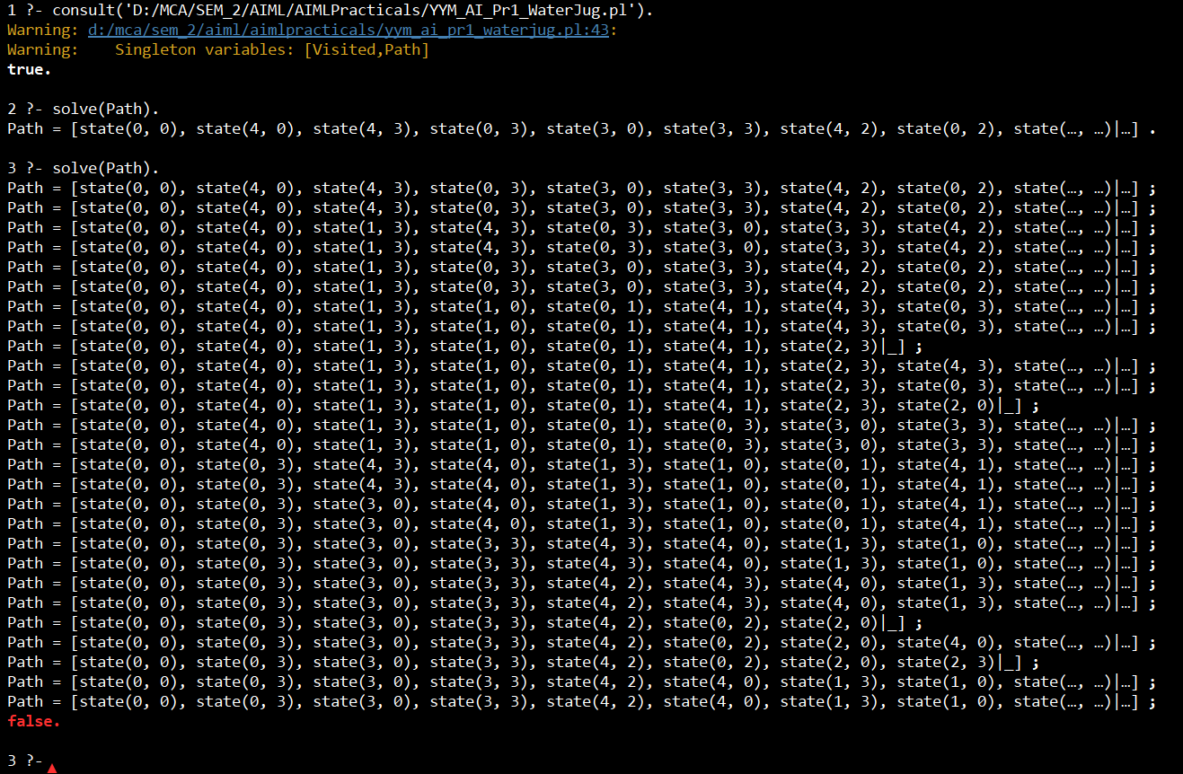

- Implementation of Logic programming using PROLOG BFS for tic-tac-toe problem

Code:

% --- Initial Board ------------------------------------------
initial([e, e, e,
e, e, e,
e, e, e]).

% --- Goal ---------------------------------------------------
% X wins
goal(Board) :-
win(Board, x).

% --- Winning Conditions -------------------------------------
win([P, P, P, _, _, _, _, _, _], P). % row 1
win([_, _, _, P, P, P, _, _, _], P). % row 2
win([_, _, _, _, _, _, P, P, P], P). % row 3
win([P, _, _, P, _, _, P, _, _], P). % col 1
win([_, P, _, _, P, _, _, P, _], P). % col 2
win([_, _, P, _, _, P, _, _, P], P). % col 3
win([P, _, _, _, P, _, _, _, P], P). % diagonal
win([_, _, P, _, P, _, P, _, _], P). % anti-diagonal

% --- Player Management --------------------------------------
next_player(x, o).
next_player(o, x).

% --- Move Generation ----------------------------------------
% Place Player's mark on any empty cell
move(Board, Player, NewBoard) :-
nth0(Index, Board, e),
replace(Board, Index, Player, NewBoard).

% --- List Utilities -----------------------------------------
% Replace element at Index with X
replace([_ | T], 0, X, [X | T]).
replace([H | T], I, X, [H | R]) :-
I > 0,
I1 is I - 1,
replace(T, I1, X, R).

% --- BFS Implementation -------------------------------------
% Base case: front of queue is a winning board
bfs([[Board | Path] | _], _, [Board | Path]) :-
goal(Board),
!.

% Recursive case: expand current board, append children to queue
bfs([[Board | Path] | Queue], Player, Solution) :-
findall(
[NextBoard, Board | Path],
move(Board, Player, NextBoard),
Children
),
append(Queue, Children, NewQueue),
next_player(Player, NextPlayer),
bfs(NewQueue, NextPlayer, Solution).

% --- Top-Level Solver ---------------------------------------
solve(Path) :-
initial(Board),
bfs([[Board]], x, RevPath),
reverse(RevPath, Path).

% --- Pretty Printing ----------------------------------------
print_board([A, B, C, D, E, F, G, H, I]) :-
format(" ~w | ~w | ~w~n", [A, B, C]),
format("---+---+---~n"),
format(" ~w | ~w | ~w~n", [D, E, F]),
format("---+---+---~n"),
format(" ~w | ~w | ~w~n~n", [G, H, I]).

print_solution([]).
print_solution([Board | Rest]) :-
print_board(Board),
print_solution(Rest).

AIML Practical 17 Apr 2026 Tic Tac Toe BFS
Software to execute:SWI Prolog
consolt('path with backward slash'). to set up
solve(Path),print_solution(Path)) to execute

Output:
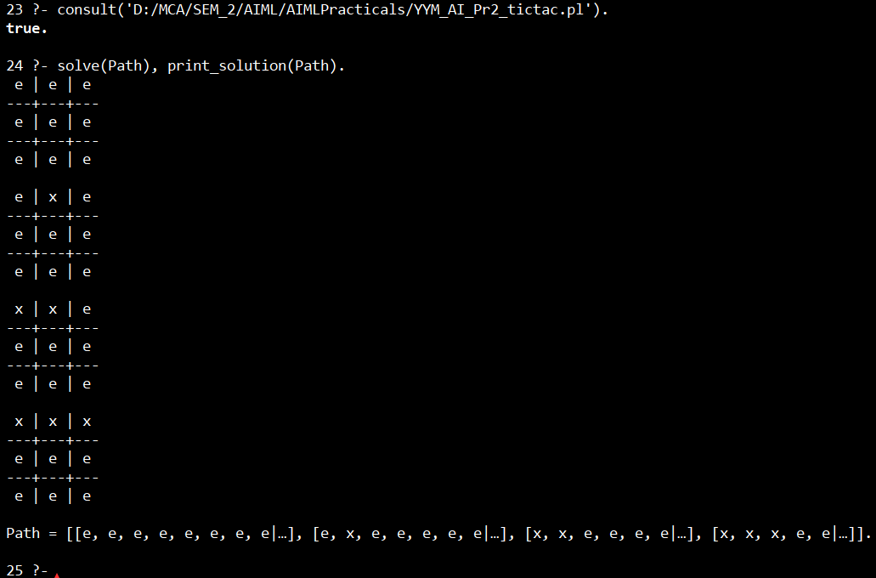

- Implementation of Logic programming using PROLOG Hill-climbing to solve 8- Puzzle Problem.

Code:
% --- Goal State ---------------------------------------------
goal([1, 2, 3,
4, 5, 6,
7, 8, 0]). % 0 represents blank

% --- Entry Point --------------------------------------------
solve(Start) :-
hill_climb(Start, []).

% --- Hill Climbing Algorithm --------------------------------
% Base case: goal reached
hill_climb(State, _) :-
goal(State),
write('Goal Reached:'), nl,
print_state(State).

% Recursive case: move to the best child
hill_climb(State, Visited) :-
get_children(State, Children),
exclude(member_of(Visited), Children, ValidChildren),
evaluate_children(ValidChildren, ScoredChildren),
sort(ScoredChildren, Sorted), % sort ascending by heuristic
Sorted = [[_, BestChild] | _], % pick best (lowest score)
write('Current State:'), nl,
print_state(State), nl,
hill_climb(BestChild, [State | Visited]).

% Stuck: no valid children to explore
hill_climb(State, _) :-
write('Stuck at local optimum:'), nl,
print_state(State).

% --- Membership Check ---------------------------------------
member_of(List, Element) :-
member(Element, List).

% --- Child Generation ---------------------------------------
get_children(State, Children) :-
findall(Child, move(State, Child), Children).

% --- Possible Moves -----------------------------------------
move(State, NewState) :- swap(State, 0, -3, NewState). % up
move(State, NewState) :- swap(State, 0, 3, NewState). % down
move(State, NewState) :- swap(State, 0, -1, NewState). % left
move(State, NewState) :- swap(State, 0, 1, NewState). % right

% --- Swap Positions -----------------------------------------
swap(State, Zero, Move, NewState) :-
nth0(Index, State, Zero),
NewIndex is Index + Move,
valid_move(Index, NewIndex),
nth0(NewIndex, State, Value),
set_element(State, Index, Value, Temp),
set_element(Temp, NewIndex, Zero, NewState).

% --- Valid Move Guard ---------------------------------------
valid_move(I, J) :-
J >= 0, J < 9,
\+ invalid_edge(I, J).

% Prevent wrap-around between rows
invalid_edge(2, 3).
invalid_edge(3, 2).
invalid_edge(5, 6).
invalid_edge(6, 5).

% --- List Element Replacement -------------------------------
set_element([_ | T], 0, X, [X | T]).
set_element([H | T], I, X, [H | R]) :-
I > 0,
I1 is I - 1,
set_element(T, I1, X, R).

% --- Heuristic: Misplaced Tiles -----------------------------
heuristic(State, H) :-
goal(Goal),
count_misplaced(State, Goal, H).

count_misplaced([], [], 0).
count_misplaced([0 | T1], [_ | T2], H) :- % skip blank tile
count_misplaced(T1, T2, H).
count_misplaced([H | T1], [H | T2], C) :- % tiles match
count_misplaced(T1, T2, C).
count_misplaced([H1 | T1], [H2 | T2], C) :- % tiles differ
H1 \= H2,
count_misplaced(T1, T2, C1),
C is C1 + 1.

% --- Evaluate Children --------------------------------------
evaluate_children([], []).
evaluate_children([State | Rest], [[H, State] | ScoredRest]) :-
heuristic(State, H),
evaluate_children(Rest, ScoredRest).

% --- Print State --------------------------------------------
print_state([A, B, C, D, E, F, G, H, I]) :-
write([A, B, C]), nl,
write([D, E, F]), nl,
write([G, H, I]), nl.

Output:

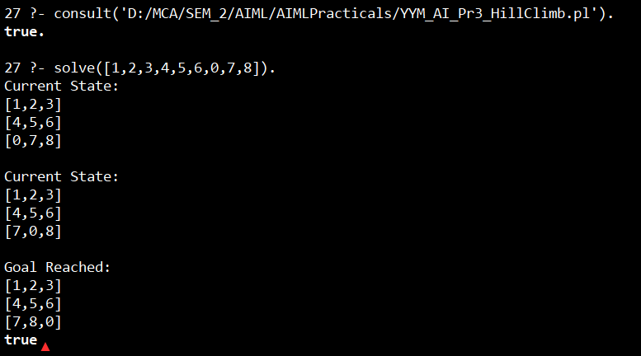

- Introduction to Python Programming: Learn the different libraries - NumPy, Pandas, SciPy, Matplotlib, Scikit Learn.

Code:
import numpy as np
import pandas as pd
from scipy import stats
import matplotlib.pyplot as plt
from sklearn.linear_model import LinearRegression
from sklearn.model_selection import train_test_split

# Step 1: Create / Load Dataset
data = {
'Hours': [1, 2, 3, 4, 5, 6, 7, 8, 9, 10],
'Marks': [10, 20, 30, 40, 50, 60, 70, 80, 90, 95]
}
df = pd.DataFrame(data)
print("Dataset:\n", df)

# ─────────────────────────────────────────────
# Step 2: NumPy Operations
# ─────────────────────────────────────────────
hours_array = np.array(df['Hours'])
marks_array = np.array(df['Marks'])

print("\nMean Marks (NumPy):", np.mean(marks_array))
print("Standard Deviation (NumPy):", np.std(marks_array))

# ─────────────────────────────────────────────
# Step 3: SciPy Statistical Analysis
# ─────────────────────────────────────────────
correlation, p_value = stats.pearsonr(hours_array, marks_array)
print("\nCorrelation (SciPy):", correlation)

# ─────────────────────────────────────────────
# Step 4: Data Visualization (Matplotlib)
# ─────────────────────────────────────────────
plt.scatter(df['Hours'], df['Marks'])
plt.title("Study Hours vs Marks")
plt.xlabel("Hours")
plt.ylabel("Marks")
plt.show()

# ─────────────────────────────────────────────
# Step 5: Machine Learning (Scikit-learn)
# ─────────────────────────────────────────────
X = df[['Hours']] # Independent variable
y = df['Marks'] # Dependent variable

# Split data
X_train, X_test, y_train, y_test = train_test_split(X, y, test_size=0.2)

# Train model
model = LinearRegression()
model.fit(X_train, y_train)

# Predict
predictions = model.predict(X_test)

print("\nPredicted Marks:", predictions)
print("Actual Marks:", list(y_test))

# Model Accuracy
score = model.score(X_test, y_test)
print("\nModel Accuracy:", score)

If error numpy ont found run :

!pip install numpy pandas scipy matplotlib scikit-learn

Output:
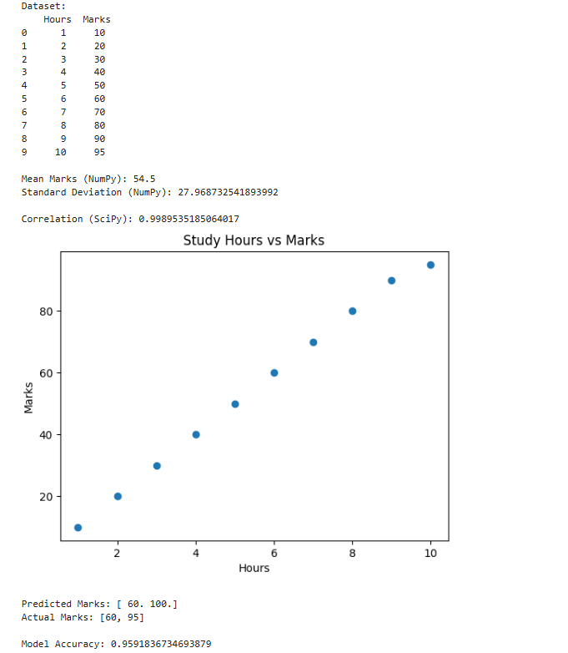

Q5. Implement Perceptron algorithm for OR operation

Code:
# Perceptron for OR operation

# Training data
inputs = [(0,0), (0,1), (1,0), (1,1)]
labels = [0, 1, 1, 1]

# Initialize weights and bias
w1, w2 = 0.0, 0.0
bias = 0.0
learning_rate = 0.1
epochs = 10

# Step activation function
def step(x):
return 1 if x >= 0 else 0

# Training loop
for _ in range(epochs):
for (x1, x2), label in zip(inputs, labels):
linear_output = w1*x1 + w2*x2 + bias
prediction = step(linear_output)
# Update rule
error = label - prediction
w1 += learning_rate * error * x1
w2 += learning_rate * error * x2
bias += learning_rate * error

# Testing
print("Trained weights:", w1, w2)
print("Bias:", bias)

for x1, x2 in inputs:
output = step(w1*x1 + w2*x2 + bias)
print(f"{x1} OR {x2} = {output}")

Output:

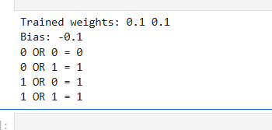

Q6. Improve the prediction accuracy by estimating the weight values for the training data using stochastic gradient descent. (Perceptron)

Code:
# Perceptron using Stochastic Gradient Descent (SGD)

import numpy as np

# Training dataset for AND gate
X = np.array([
[0, 0],
[0, 1],
[1, 0],
[1, 1]
])

# Target outputs
y = np.array([0, 0, 0, 1])

# Initialize weights and bias
weights = np.zeros(2)
bias = 0

# Learning rate
lr = 0.1

# Number of epochs
epochs = 10

# Activation function
def activation(z):
return 1 if z >= 0 else 0

# Training using SGD
for epoch in range(epochs):

print(f"\nEpoch {epoch + 1}")

for i in range(len(X)):

# Linear combination
z = np.dot(X[i], weights) + bias

# Prediction
y_pred = activation(z)

# Error
error = y[i] - y_pred

# Weight update
weights = weights + lr * error * X[i]

# Bias update
bias = bias + lr * error

print(f"Input: {X[i]}, Predicted: {y_pred}, Error: {error}")

print("\nFinal Weights:", weights)
print("Final Bias:", bias)

# Testing
print("\nTesting Perceptron")

for i in range(len(X)):
z = np.dot(X[i], weights) + bias
prediction = activation(z)

print(f"Input: {X[i]} -> Output: {prediction}")

Output:

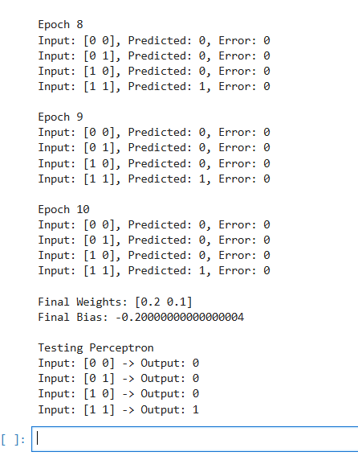
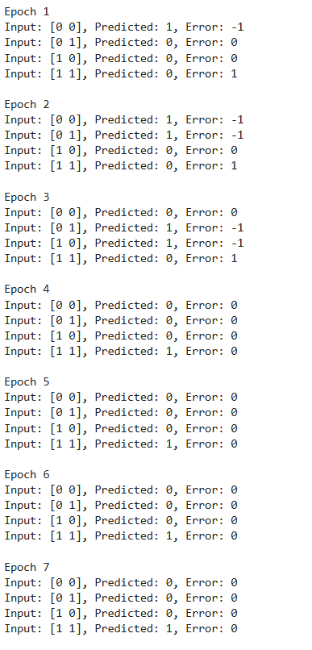

Q7. Implement Adaline algorithm for AND operation

Code:
import numpy as np

# ─────────────────────────────────────────────
# Input dataset for AND operation
# ─────────────────────────────────────────────
X = np.array([
[0, 0],
[0, 1],
[1, 0],
[1, 1]
])

# Target outputs
T = np.array([0, 0, 0, 1])

# ─────────────────────────────────────────────
# Initialize weights and bias
# ─────────────────────────────────────────────
w = np.zeros(2)
b = 0

# Learning rate
alpha = 0.1

# Number of epochs
epochs = 10

print("Initial Weights:", w)
print("Initial Bias:", b)

# ─────────────────────────────────────────────
# Training Process
# ─────────────────────────────────────────────
for epoch in range(epochs):

print("\nEpoch", epoch + 1)

for i in range(len(X)):

x = X[i]
target = T[i]

# Net input
yin = b + np.dot(w, x)

# Error
error = target - yin

# Weight update
w = w + alpha * error * x

# Bias update
b = b + alpha * error

print(f"Input: {x}, Target: {target}, Output: {yin:.2f}")
print("Updated Weights:", w)
print("Updated Bias:", round(b, 2))

# ─────────────────────────────────────────────
# Testing Phase
# ─────────────────────────────────────────────
print("\nTesting Adaline for AND Operation")

for i in range(len(X)):

yin = b + np.dot(w, X[i])

# Activation function
output = 1 if yin >= 0.5 else 0

print(f"Input: {X[i]} -> Output: {output}")

Output:

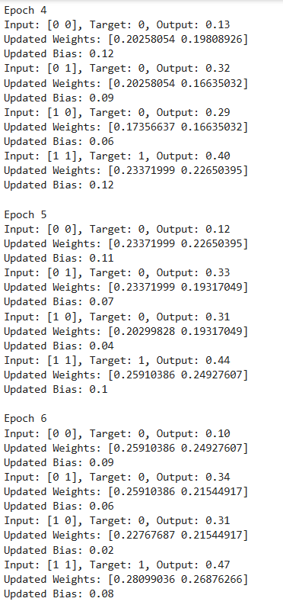
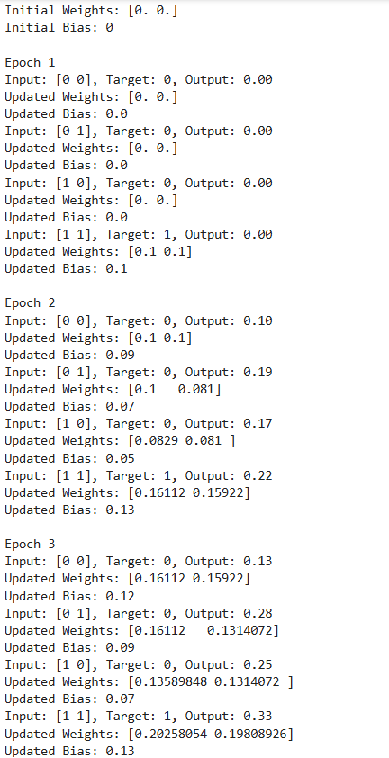

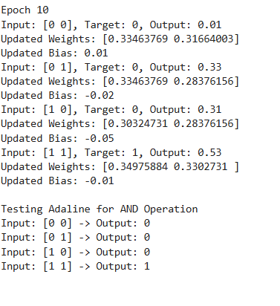
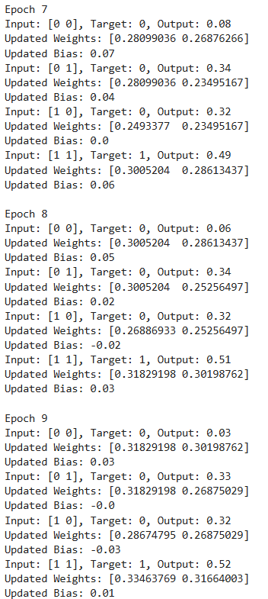

Machine Learning Section

Q1. Implementation of Features Extraction and Selection, Normalization, Transformation, Principal Components Analysis

In order to run this code you need heath_data.csv file for data
Contents of heath_data.csv
ID | Age | Height (cm) | Weight (kg) | Blood Pressure (BP) | Cholesterol Level | Diabetes | Physical Activity (hours/week) | Smoking Habit | Disease Risk Score
1 | 56 | 159 | 77 | 122 | High | 1 | 1 | 0 | 59
2 | 69 | 185 | 77 | 157 | Normal | 0 | 0.53 | 1 | 48
3 | 46 | 163 | 93 | 122 | Low | 1 | 9.59 | 0 | 42.05
4 | 32 | 180 | 79 | 103 | Normal | 1 | 8.47 | 0 | 78.47
5 | 60 | 197 | 111 | 110 | Normal | 1 | 3.55 | 1 | 63.94
6 | 25 | 164 | 111 | 137 | Normal | 0 | 9.57 | 1 | 80.5
7 | 78 | 157 | 50 | 109 | Normal | 1 | 6.77 | 0 | 90.32
8 | 38 | 163 | 76 | 97 | Low | 1 | 4.83 | 1 | 61.73
9 | 56 | 172 | 111 | 96 | Normal | 1 | 4.93 | 0 | 98.05
10 | 75 | 189 | 52 | 156 | Normal | 1 | 0.83 | 0 | 60.81
11 | 36 | 170 | 119 | 106 | High | 0 | 0.92 | 0 | 63.66
12 | 40 | 165 | 76 | 122 | Normal | 1 | 6.02 | 1 | 55.48
13 | 28 | 194 | 58 | 137 | High | 0 | 5.54 | 1 | 9.1
14 | 28 | 167 | 111 | 165 | Low | 0 | 2.13 | 1 | 72.64
15 | 41 | 196 | 86 | 148 | Low | 0 | 9.46 | 1 | 54.74
16 | 70 | 173 | 100 | 175 | Low | 0 | 7.81 | 1 | 45.09
17 | 53 | 175 | 93 | 111 | Low | 0 | 1.13 | 0 | 91.05
18 | 57 | 174 | 73 | 119 | High | 0 | 9.31 | 0 | 29.8
19 | 41 | 194 | 108 | 127 | Normal | 1 | 9.74 | 0 | 52.36
20 | 20 | 190 | 81 | 140 | Low | 0 | 9.96 | 0 | 69.76
21 | 39 | 178 | 101 | 143 | Normal | 0 | 0.56 | 1 | 79.65
22 | 70 | 164 | 111 | 97 | High | 0 | 7.37 | 0 | 45.93
23 | 19 | 194 | 107 | 116 | High | 1 | 5.46 | 1 | 84.21
24 | 41 | 150 | 101 | 116 | High | 1 | 7.06 | 0 | 76.89
25 | 61 | 174 | 61 | 110 | Low | 0 | 9.69 | 1 | 6.62
26 | 47 | 156 | 88 | 119 | Normal | 1 | 6.88 | 1 | 4.59
27 | 55 | 158 | 51 | 117 | Normal | 0 | 8.37 | 0 | 62.08
28 | 19 | 173 | 52 | 153 | Normal | 0 | 8.67 | 0 | 34.74
29 | 77 | 150 | 105 | 158 | High | 1 | 8.38 | 0 | 20.91
30 | 38 | 193 | 108 | 150 | Low | 0 | 4.26 | 0 | 57.96
31 | 50 | 157 | 51 | 137 | High | 1 | 2.23 | 1 | 34.16
32 | 29 | 173 | 51 | 108 | High | 1 | 3.97 | 0 | 53.73
33 | 75 | 160 | 103 | 93 | Normal | 0 | 8.92 | 0 | 46.01
34 | 39 | 166 | 50 | 124 | High | 0 | 1.47 | 1 | 58.48
35 | 78 | 157 | 68 | 153 | Normal | 1 | 5.13 | 0 | 40.03
36 | 61 | 184 | 51 | 138 | Low | 0 | 2.33 | 0 | 69.77
37 | 42 | 184 | 102 | 106 | Normal | 0 | 5.81 | 0 | 18.01
38 | 66 | 182 | 93 | 133 | Low | 0 | 8.63 | 0 | 69.65
39 | 44 | 154 | 81 | 119 | Normal | 1 | 8.8 | 0 | 41.17
40 | 76 | 191 | 119 | 135 | High | 1 | 2.37 | 1 | 87.43
41 | 59 | 188 | 81 | 95 | High | 0 | 9.08 | 0 | 51.52
42 | 45 | 190 | 117 | 126 | Low | 1 | 5.92 | 0 | 97.31
43 | 77 | 177 | 104 | 113 | Low | 1 | 3.5 | 0 | 60.19
44 | 33 | 156 | 105 | 135 | Low | 1 | 7.08 | 0 | 22.38
45 | 32 | 158 | 66 | 142 | Normal | 1 | 4.82 | 0 | 82.18
46 | 79 | 157 | 87 | 149 | Normal | 1 | 3.78 | 1 | 34.51
47 | 79 | 161 | 73 | 152 | Low | 0 | 7.05 | 0 | 34.76
48 | 64 | 183 | 118 | 174 | High | 0 | 2.49 | 1 | 3.18
49 | 79 | 182 | 119 | 121 | Normal | 0 | 3.3 | 1 | 54.87
50 | 68 | 197 | 60 | 176 | Normal | 1 | 4.34 | 0 | 53.44
51 | 61 | 172 | 65 | 122 | Normal | 1 | 2.54 | 0 | 35.6
52 | 72 | 173 | 108 | 156 | Low | 0 | 4.05 | 0 | 89.42
53 | 69 | 186 | 119 | 107 | Low | 1 | 5.71 | 0 | 12.87
54 | 74 | 184 | 52 | 114 | Low | 0 | 7.41 | 1 | 33.01
55 | 20 | 193 | 69 | 143 | Low | 0 | 7.67 | 0 | 32.16
56 | 54 | 189 | 108 | 147 | Low | 0 | 8.23 | 0 | 9.23
57 | 68 | 171 | 85 | 156 | High | 1 | 7.44 | 0 | 48.11
58 | 24 | 176 | 68 | 135 | High | 1 | 6.81 | 0 | 68.78
59 | 38 | 184 | 116 | 113 | Low | 0 | 2.38 | 0 | 51.17
60 | 26 | 150 | 68 | 121 | Normal | 0 | 4 | 0 | 15.7
61 | 56 | 184 | 69 | 136 | Low | 0 | 4.78 | 1 | 37.73
62 | 35 | 186 | 101 | 175 | High | 0 | 0.83 | 1 | 0.26
63 | 21 | 196 | 82 | 112 | High | 1 | 5.28 | 0 | 86.83
64 | 42 | 163 | 89 | 155 | Normal | 1 | 4.36 | 0 | 8.45
65 | 77 | 152 | 88 | 116 | High | 0 | 8.02 | 0 | 59.73
66 | 31 | 150 | 50 | 91 | Low | 0 | 9.78 | 1 | 98.63
67 | 67 | 154 | 60 | 179 | Normal | 1 | 5.56 | 0 | 53.66
68 | 75 | 175 | 106 | 106 | Low | 1 | 3.23 | 1 | 92.4
69 | 26 | 163 | 99 | 122 | Low | 0 | 0.43 | 0 | 23.61
70 | 43 | 188 | 72 | 98 | Normal | 0 | 9.25 | 0 | 76
71 | 70 | 176 | 80 | 132 | Low | 0 | 9.19 | 0 | 53.13
72 | 19 | 158 | 91 | 137 | High | 1 | 2.53 | 0 | 72.05
73 | 37 | 164 | 56 | 128 | Low | 1 | 6.95 | 1 | 6.23
74 | 45 | 164 | 65 | 131 | Normal | 1 | 0.75 | 1 | 14.77
75 | 64 | 175 | 109 | 115 | Normal | 0 | 1.66 | 0 | 13.31
76 | 77 | 191 | 51 | 139 | Normal | 0 | 2.17 | 0 | 68.72
77 | 24 | 162 | 50 | 114 | Low | 1 | 2.94 | 1 | 84.44
78 | 61 | 181 | 97 | 113 | Normal | 1 | 9.96 | 1 | 74.96
79 | 78 | 188 | 61 | 102 | Normal | 0 | 6.97 | 1 | 3.05
80 | 25 | 198 | 118 | 149 | Low | 1 | 3.84 | 1 | 86.72
81 | 64 | 181 | 86 | 96 | High | 1 | 7.37 | 0 | 35.41
82 | 52 | 153 | 81 | 146 | Low | 0 | 9.15 | 1 | 39.72
83 | 31 | 179 | 58 | 125 | Normal | 1 | 9.59 | 0 | 10.49
84 | 34 | 186 | 68 | 134 | Normal | 0 | 0.58 | 1 | 73.74
85 | 53 | 172 | 97 | 109 | Low | 0 | 3.95 | 1 | 18.23
86 | 67 | 188 | 52 | 154 | High | 0 | 1.07 | 1 | 56.4
87 | 57 | 194 | 69 | 97 | Normal | 0 | 3.36 | 1 | 84.07
88 | 21 | 164 | 73 | 105 | Normal | 0 | 1.7 | 1 | 8.92
89 | 19 | 192 | 103 | 103 | Normal | 0 | 6.47 | 0 | 53.53
90 | 79 | 178 | 82 | 165 | Low | 0 | 3.88 | 0 | 23.32
91 | 23 | 185 | 73 | 176 | Normal | 1 | 2.29 | 1 | 34.29
92 | 71 | 162 | 85 | 104 | High | 0 | 2.66 | 1 | 47.4
93 | 59 | 181 | 87 | 155 | Normal | 0 | 3.6 | 0 | 35.51
94 | 21 | 156 | 74 | 121 | Normal | 1 | 2.6 | 1 | 64.88
95 | 71 | 171 | 67 | 176 | High | 1 | 4.53 | 1 | 47.96
96 | 46 | 177 | 115 | 152 | Normal | 1 | 0.32 | 0 | 58.42
97 | 35 | 151 | 103 | 175 | Low | 0 | 2.8 | 1 | 73.68
98 | 43 | 191 | 84 | 140 | Low | 1 | 4.11 | 1 | 55.77
99 | 61 | 194 | 110 | 114 | Low | 0 | 6.03 | 0 | 58.65
100 | 51 | 155 | 90 | 147 | High | 0 | 2.71 | 0 | 56.45

Code:
import pandas as pd
import numpy as np
from sklearn.preprocessing import StandardScaler, MinMaxScaler, PowerTransformer, LabelEncoder
from sklearn.feature_selection import SelectKBest, f_classif, VarianceThreshold
from sklearn.decomposition import PCA

# Load the healthcare dataset
file_path = "health_dataset.csv"
df = pd.read_csv(file_path)

# Display first few rows
display(df.head())

# Identify non-numeric columns
categorical_columns = df.select_dtypes(include=['object']).columns
print("Categorical Columns:", categorical_columns)

# Convert categorical columns using Label Encoding
label_encoders = {}

for col in categorical_columns:
le = LabelEncoder()
df[col] = le.fit_transform(df[col])
label_encoders[col] = le

# Ensure all columns are numeric
df = df.apply(pd.to_numeric, errors='coerce') # Converts non-numeric values to NaN
df.fillna(0, inplace=True) # Replace NaNs with 0

# Separate features and target
target_column = 'Disease Risk Score'

if target_column not in df.columns:
raise ValueError("Target column not found in dataset")

X = df.drop(columns=[target_column])
y = df[target_column]

# Check for missing values in target and encode if necessary
if y.isnull().sum() > 0:
y.fillna(y.mode()[0], inplace=True) # Replace NaN with most frequent value

if y.dtype == 'object':
le = LabelEncoder()
y = le.fit_transform(y)

# Remove constant features
var_thresh = VarianceThreshold(threshold=0)
X = var_thresh.fit_transform(X)

# Feature Selection using ANOVA F-score
selector = SelectKBest(
score_func=f_classif,
k=min(8, X.shape[1]) # Ensure k does not exceed feature count
)

X_selected = selector.fit_transform(X, y)

print(X_selected)

selected_features = [
col
for col, keep in zip(
df.drop(columns=[target_column]).columns,
selector.get_support()
)
if keep
]

print("Selected Features:", selected_features)

# Normalization using Min-Max Scaling
scaler = MinMaxScaler()
X_normalized = scaler.fit_transform(X_selected)

# Transformation using Power Transform (Box-Cox or Yeo-Johnson)
power_transformer = PowerTransformer(method='yeo-johnson') # Use 'box-cox' if no negative values

X_transformed = power_transformer.fit_transform(X_normalized)

# Dimensionality Reduction using PCA
pca_components = min(5, X_transformed.shape[1]) # Ensure PCA components do not exceed feature count

pca = PCA(n_components=pca_components)

X_pca = pca.fit_transform(X_transformed)

print("Explained Variance Ratio:", pca.explained_variance_ratio_)

# Convert processed data back to DataFrame
processed_df = pd.DataFrame(
X_pca,
columns=[f'PC{i+1}' for i in range(X_pca.shape[1])]
)

processed_df['Disease Risk Score'] = y.reset_index(drop=True)

# Save processed dataset
processed_df.to_csv("processed_health_dataset.csv", index=False)

print("Processed dataset saved successfully.")

Output:
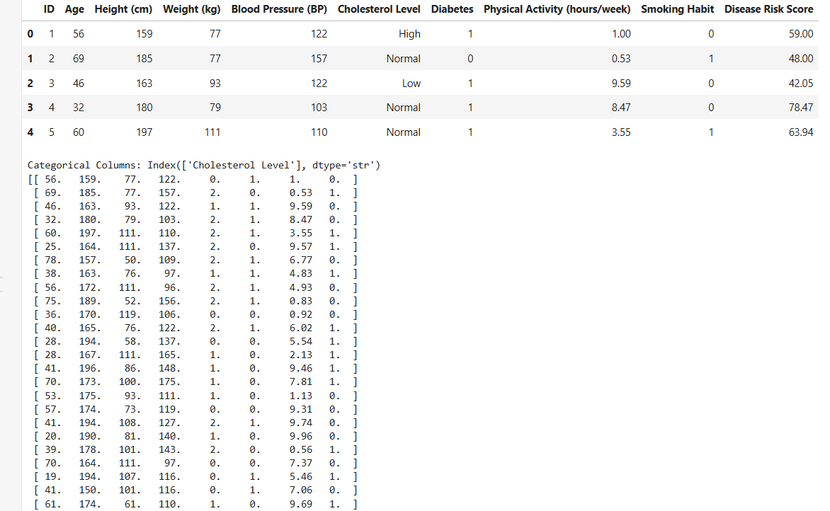

Q2. Implementation of Logistic regression

Code:
import numpy as np
from sklearn import datasets
iris = datasets.load_iris()
print(type(iris))
print(list(iris.keys()))
X = iris["data"][:,3:] # petal width
y = (iris["target"] == 2).astype(np.int64) # 1 if Iris-Virginica, else 0
from sklearn.linear_model import LogisticRegression
log_reg = LogisticRegression(solver="lbfgs", random_state=42)
log_reg.fit(X,y)
import matplotlib.pyplot as plt
X_new = np.linspace(0,3,1000).reshape(-1,1)
y_proba = log_reg.predict_proba(X_new)
plt.plot(X_new, y_proba[:,1],"g-")
plt.plot(X_new, y_proba[:,0], "b--")
plt.xlabel('Petal width (cm)')
plt.ylabel('Probability')
plt.legend(['Prob(Iris-Virginica)','Prob(Not Iris-Virginica)'])
print(log_reg.predict(X))
print(log_reg.coef_)
print(log_reg.intercept_)

Output:
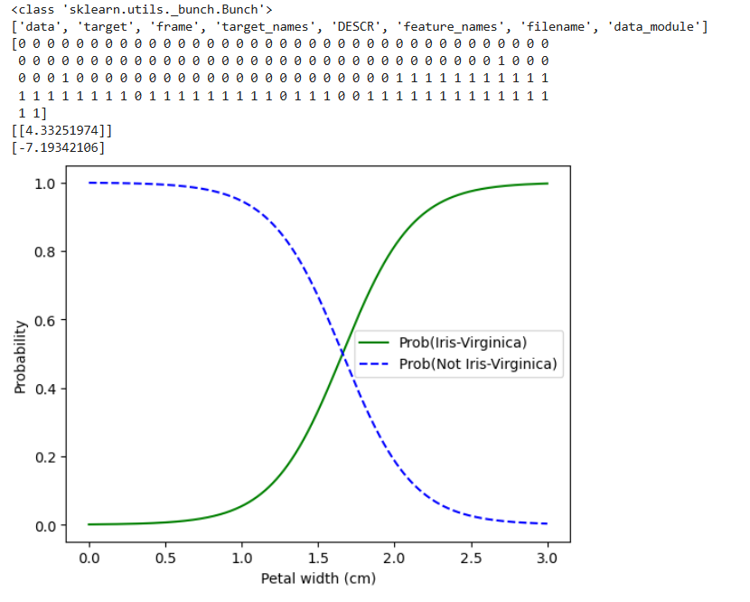

2. Logistic regression with multiple feature (Petal Width & Petal Height)

Code:
from sklearn.linear_model import LogisticRegression
X = iris["data"][:, (2, 3)] # petal length, petal width
y = (iris["target"] == 2).astype(np.int64)
log_reg2 = LogisticRegression(solver="lbfgs", C=10**10, random_state=42)
log_reg2.fit(X, y)
x0, x1 = np.meshgrid(
np.linspace(2.9, 7, 500).reshape(-1, 1),
np.linspace(0.8, 2.7, 200).reshape(-1, 1),
)
X_new = np.c_[x0.ravel(), x1.ravel()]
print(X_new.shape)
y_proba = log_reg2.predict_proba(X_new)
plt.figure(figsize=(10, 4))
plt.plot(X[y==0, 0], X[y==0, 1], "bs")
plt.plot(X[y==1, 0], X[y==1, 1], "g^")
zz = y_proba[:, 1].reshape(x0.shape)
contour = plt.contour(x0, x1, zz, cmap=plt.cm.brg)
left_right = np.array([2.9, 7])
boundary = -(log_reg2.coef_[0][0] * left_right + log_reg2.intercept_[0]) / log_reg2.coef_[0][1]
plt.clabel(contour, inline=1, fontsize=12)
plt.plot(left_right, boundary, "k--", linewidth=3)
plt.text(3.5, 1.5, "Not Iris virginica", fontsize=14, color="b", ha="center")
plt.text(6.5, 2.3, "Iris virginica", fontsize=14, color="g", ha="center")
plt.xlabel("Petal length", fontsize=14)
plt.ylabel("Petal width", fontsize=14)
plt.axis([2.9, 7, 0.8, 2.7])

Output:

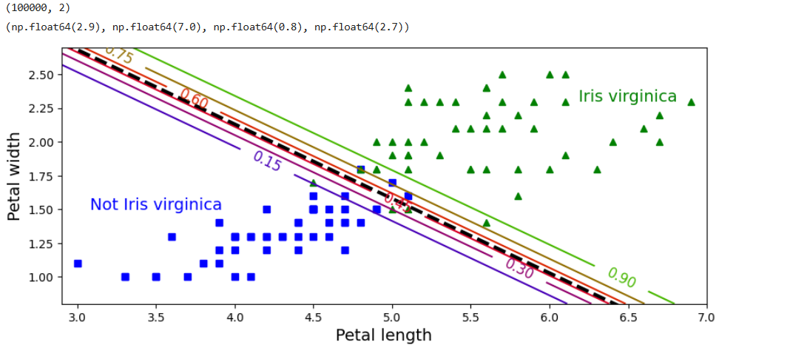

Q3. Implementation of Classifying data using Support Vector Machine (SVM)- Linear and Non-Linear SVM Classification

In order to run this code you need heath_data.csv file for data
Contents of heath_data.csv
ID | Age | Height (cm) | Weight (kg) | Blood Pressure (BP) | Cholesterol Level | Diabetes | Physical Activity (hours/week) | Smoking Habit | Disease Risk Score
1 | 56 | 159 | 77 | 122 | High | 1 | 1 | 0 | 59
2 | 69 | 185 | 77 | 157 | Normal | 0 | 0.53 | 1 | 48
3 | 46 | 163 | 93 | 122 | Low | 1 | 9.59 | 0 | 42.05
4 | 32 | 180 | 79 | 103 | Normal | 1 | 8.47 | 0 | 78.47
5 | 60 | 197 | 111 | 110 | Normal | 1 | 3.55 | 1 | 63.94
6 | 25 | 164 | 111 | 137 | Normal | 0 | 9.57 | 1 | 80.5
7 | 78 | 157 | 50 | 109 | Normal | 1 | 6.77 | 0 | 90.32
8 | 38 | 163 | 76 | 97 | Low | 1 | 4.83 | 1 | 61.73
9 | 56 | 172 | 111 | 96 | Normal | 1 | 4.93 | 0 | 98.05
10 | 75 | 189 | 52 | 156 | Normal | 1 | 0.83 | 0 | 60.81
11 | 36 | 170 | 119 | 106 | High | 0 | 0.92 | 0 | 63.66
12 | 40 | 165 | 76 | 122 | Normal | 1 | 6.02 | 1 | 55.48
13 | 28 | 194 | 58 | 137 | High | 0 | 5.54 | 1 | 9.1
14 | 28 | 167 | 111 | 165 | Low | 0 | 2.13 | 1 | 72.64
15 | 41 | 196 | 86 | 148 | Low | 0 | 9.46 | 1 | 54.74
16 | 70 | 173 | 100 | 175 | Low | 0 | 7.81 | 1 | 45.09
17 | 53 | 175 | 93 | 111 | Low | 0 | 1.13 | 0 | 91.05
18 | 57 | 174 | 73 | 119 | High | 0 | 9.31 | 0 | 29.8
19 | 41 | 194 | 108 | 127 | Normal | 1 | 9.74 | 0 | 52.36
20 | 20 | 190 | 81 | 140 | Low | 0 | 9.96 | 0 | 69.76
21 | 39 | 178 | 101 | 143 | Normal | 0 | 0.56 | 1 | 79.65
22 | 70 | 164 | 111 | 97 | High | 0 | 7.37 | 0 | 45.93
23 | 19 | 194 | 107 | 116 | High | 1 | 5.46 | 1 | 84.21
24 | 41 | 150 | 101 | 116 | High | 1 | 7.06 | 0 | 76.89
25 | 61 | 174 | 61 | 110 | Low | 0 | 9.69 | 1 | 6.62
26 | 47 | 156 | 88 | 119 | Normal | 1 | 6.88 | 1 | 4.59
27 | 55 | 158 | 51 | 117 | Normal | 0 | 8.37 | 0 | 62.08
28 | 19 | 173 | 52 | 153 | Normal | 0 | 8.67 | 0 | 34.74
29 | 77 | 150 | 105 | 158 | High | 1 | 8.38 | 0 | 20.91
30 | 38 | 193 | 108 | 150 | Low | 0 | 4.26 | 0 | 57.96
31 | 50 | 157 | 51 | 137 | High | 1 | 2.23 | 1 | 34.16
32 | 29 | 173 | 51 | 108 | High | 1 | 3.97 | 0 | 53.73
33 | 75 | 160 | 103 | 93 | Normal | 0 | 8.92 | 0 | 46.01
34 | 39 | 166 | 50 | 124 | High | 0 | 1.47 | 1 | 58.48
35 | 78 | 157 | 68 | 153 | Normal | 1 | 5.13 | 0 | 40.03
36 | 61 | 184 | 51 | 138 | Low | 0 | 2.33 | 0 | 69.77
37 | 42 | 184 | 102 | 106 | Normal | 0 | 5.81 | 0 | 18.01
38 | 66 | 182 | 93 | 133 | Low | 0 | 8.63 | 0 | 69.65
39 | 44 | 154 | 81 | 119 | Normal | 1 | 8.8 | 0 | 41.17
40 | 76 | 191 | 119 | 135 | High | 1 | 2.37 | 1 | 87.43
41 | 59 | 188 | 81 | 95 | High | 0 | 9.08 | 0 | 51.52
42 | 45 | 190 | 117 | 126 | Low | 1 | 5.92 | 0 | 97.31
43 | 77 | 177 | 104 | 113 | Low | 1 | 3.5 | 0 | 60.19
44 | 33 | 156 | 105 | 135 | Low | 1 | 7.08 | 0 | 22.38
45 | 32 | 158 | 66 | 142 | Normal | 1 | 4.82 | 0 | 82.18
46 | 79 | 157 | 87 | 149 | Normal | 1 | 3.78 | 1 | 34.51
47 | 79 | 161 | 73 | 152 | Low | 0 | 7.05 | 0 | 34.76
48 | 64 | 183 | 118 | 174 | High | 0 | 2.49 | 1 | 3.18
49 | 79 | 182 | 119 | 121 | Normal | 0 | 3.3 | 1 | 54.87
50 | 68 | 197 | 60 | 176 | Normal | 1 | 4.34 | 0 | 53.44
51 | 61 | 172 | 65 | 122 | Normal | 1 | 2.54 | 0 | 35.6
52 | 72 | 173 | 108 | 156 | Low | 0 | 4.05 | 0 | 89.42
53 | 69 | 186 | 119 | 107 | Low | 1 | 5.71 | 0 | 12.87
54 | 74 | 184 | 52 | 114 | Low | 0 | 7.41 | 1 | 33.01
55 | 20 | 193 | 69 | 143 | Low | 0 | 7.67 | 0 | 32.16
56 | 54 | 189 | 108 | 147 | Low | 0 | 8.23 | 0 | 9.23
57 | 68 | 171 | 85 | 156 | High | 1 | 7.44 | 0 | 48.11
58 | 24 | 176 | 68 | 135 | High | 1 | 6.81 | 0 | 68.78
59 | 38 | 184 | 116 | 113 | Low | 0 | 2.38 | 0 | 51.17
60 | 26 | 150 | 68 | 121 | Normal | 0 | 4 | 0 | 15.7
61 | 56 | 184 | 69 | 136 | Low | 0 | 4.78 | 1 | 37.73
62 | 35 | 186 | 101 | 175 | High | 0 | 0.83 | 1 | 0.26
63 | 21 | 196 | 82 | 112 | High | 1 | 5.28 | 0 | 86.83
64 | 42 | 163 | 89 | 155 | Normal | 1 | 4.36 | 0 | 8.45
65 | 77 | 152 | 88 | 116 | High | 0 | 8.02 | 0 | 59.73
66 | 31 | 150 | 50 | 91 | Low | 0 | 9.78 | 1 | 98.63
67 | 67 | 154 | 60 | 179 | Normal | 1 | 5.56 | 0 | 53.66
68 | 75 | 175 | 106 | 106 | Low | 1 | 3.23 | 1 | 92.4
69 | 26 | 163 | 99 | 122 | Low | 0 | 0.43 | 0 | 23.61
70 | 43 | 188 | 72 | 98 | Normal | 0 | 9.25 | 0 | 76
71 | 70 | 176 | 80 | 132 | Low | 0 | 9.19 | 0 | 53.13
72 | 19 | 158 | 91 | 137 | High | 1 | 2.53 | 0 | 72.05
73 | 37 | 164 | 56 | 128 | Low | 1 | 6.95 | 1 | 6.23
74 | 45 | 164 | 65 | 131 | Normal | 1 | 0.75 | 1 | 14.77
75 | 64 | 175 | 109 | 115 | Normal | 0 | 1.66 | 0 | 13.31
76 | 77 | 191 | 51 | 139 | Normal | 0 | 2.17 | 0 | 68.72
77 | 24 | 162 | 50 | 114 | Low | 1 | 2.94 | 1 | 84.44
78 | 61 | 181 | 97 | 113 | Normal | 1 | 9.96 | 1 | 74.96
79 | 78 | 188 | 61 | 102 | Normal | 0 | 6.97 | 1 | 3.05
80 | 25 | 198 | 118 | 149 | Low | 1 | 3.84 | 1 | 86.72
81 | 64 | 181 | 86 | 96 | High | 1 | 7.37 | 0 | 35.41
82 | 52 | 153 | 81 | 146 | Low | 0 | 9.15 | 1 | 39.72
83 | 31 | 179 | 58 | 125 | Normal | 1 | 9.59 | 0 | 10.49
84 | 34 | 186 | 68 | 134 | Normal | 0 | 0.58 | 1 | 73.74
85 | 53 | 172 | 97 | 109 | Low | 0 | 3.95 | 1 | 18.23
86 | 67 | 188 | 52 | 154 | High | 0 | 1.07 | 1 | 56.4
87 | 57 | 194 | 69 | 97 | Normal | 0 | 3.36 | 1 | 84.07
88 | 21 | 164 | 73 | 105 | Normal | 0 | 1.7 | 1 | 8.92
89 | 19 | 192 | 103 | 103 | Normal | 0 | 6.47 | 0 | 53.53
90 | 79 | 178 | 82 | 165 | Low | 0 | 3.88 | 0 | 23.32
91 | 23 | 185 | 73 | 176 | Normal | 1 | 2.29 | 1 | 34.29
92 | 71 | 162 | 85 | 104 | High | 0 | 2.66 | 1 | 47.4
93 | 59 | 181 | 87 | 155 | Normal | 0 | 3.6 | 0 | 35.51
94 | 21 | 156 | 74 | 121 | Normal | 1 | 2.6 | 1 | 64.88
95 | 71 | 171 | 67 | 176 | High | 1 | 4.53 | 1 | 47.96
96 | 46 | 177 | 115 | 152 | Normal | 1 | 0.32 | 0 | 58.42
97 | 35 | 151 | 103 | 175 | Low | 0 | 2.8 | 1 | 73.68
98 | 43 | 191 | 84 | 140 | Low | 1 | 4.11 | 1 | 55.77
99 | 61 | 194 | 110 | 114 | Low | 0 | 6.03 | 0 | 58.65
100 | 51 | 155 | 90 | 147 | High | 0 | 2.71 | 0 | 56.45

Code:

import pandas as pd
import numpy as np
from sklearn.preprocessing import StandardScaler, MinMaxScaler, PowerTransformer, LabelEncoder
from sklearn.feature_selection import SelectKBest, f_classif, VarianceThreshold
from sklearn.decomposition import PCA

# Load the healthcare dataset
file_path = "health_dataset.csv"
df = pd.read_csv(file_path)

# Display first few rows
display(df.head())

# Identify non-numeric columns
categorical_columns = df.select_dtypes(include=['object']).columns
print("Categorical Columns:", categorical_columns)

# Convert categorical columns using Label Encoding
label_encoders = {}

for col in categorical_columns:
le = LabelEncoder()
df[col] = le.fit_transform(df[col])
label_encoders[col] = le

# Ensure all columns are numeric
df = df.apply(pd.to_numeric, errors='coerce') # Converts non-numeric values to NaN
df.fillna(0, inplace=True) # Replace NaNs with 0

# Separate features and target
target_column = 'Disease Risk Score'

if target_column not in df.columns:
raise ValueError("Target column not found in dataset")

X = df.drop(columns=[target_column])
y = df[target_column]

# Check for missing values in target and encode if necessary
if y.isnull().sum() > 0:
y.fillna(y.mode()[0], inplace=True) # Replace NaN with most frequent value

if y.dtype == 'object':
le = LabelEncoder()
y = le.fit_transform(y)

# Remove constant features
var_thresh = VarianceThreshold(threshold=0)
X = var_thresh.fit_transform(X)

# Feature Selection using ANOVA F-score
selector = SelectKBest(
score_func=f_classif,
k=min(8, X.shape[1]) # Ensure k does not exceed feature count
)

X_selected = selector.fit_transform(X, y)

print(X_selected)

selected_features = [
col
for col, keep in zip(
df.drop(columns=[target_column]).columns,
selector.get_support()
)
if keep
]

print("Selected Features:", selected_features)

# Normalization using Min-Max Scaling
scaler = MinMaxScaler()
X_normalized = scaler.fit_transform(X_selected)

# Transformation using Power Transform (Box-Cox or Yeo-Johnson)
power_transformer = PowerTransformer(method='yeo-johnson') # Use 'box-cox' if no negative values

X_transformed = power_transformer.fit_transform(X_normalized)

# Dimensionality Reduction using PCA
pca_components = min(5, X_transformed.shape[1]) # Ensure PCA components do not exceed feature count

pca = PCA(n_components=pca_components)

X_pca = pca.fit_transform(X_transformed)

print("Explained Variance Ratio:", pca.explained_variance_ratio_)

# Convert processed data back to DataFrame
processed_df = pd.DataFrame(
X_pca,
columns=[f'PC{i+1}' for i in range(X_pca.shape[1])]
)

processed_df['Disease Risk Score'] = y.reset_index(drop=True)

# Save processed dataset
processed_df.to_csv("processed_health_dataset.csv", index=False)

print("Processed dataset saved successfully.")

Output:


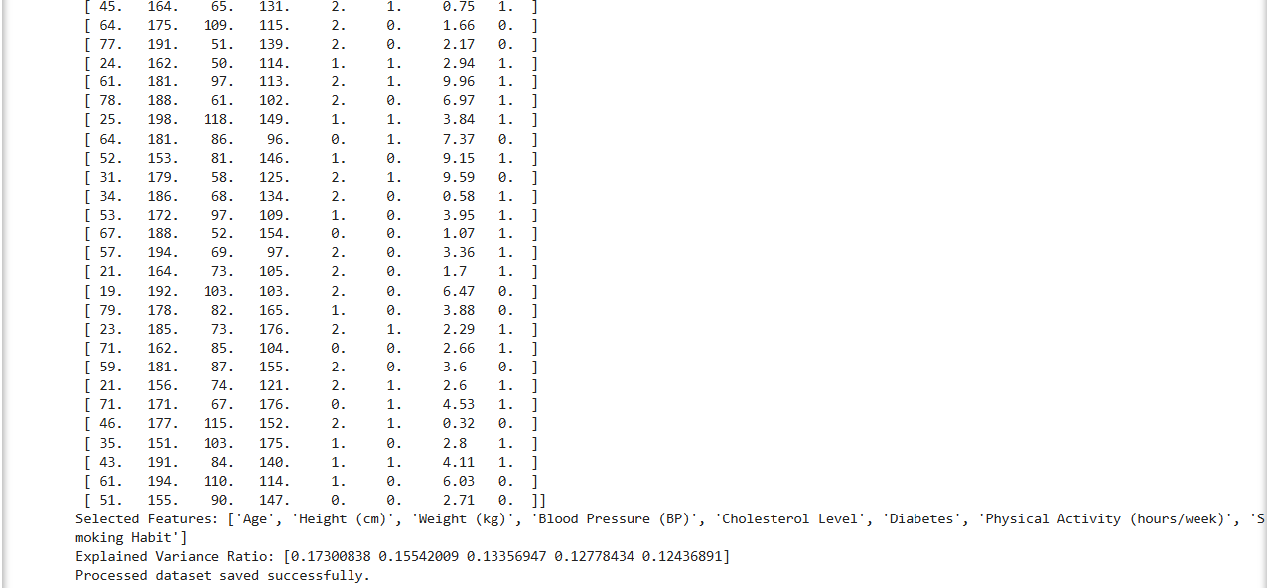

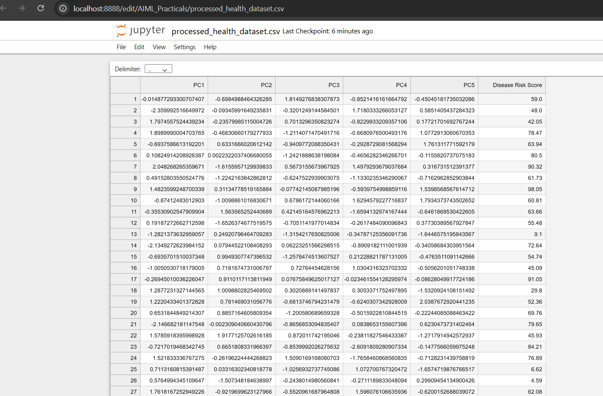

Q4. Implement Elbow method for K means Clustering

Code:
import pandas as pd
import numpy as np
import matplotlib.pyplot as plt
from sklearn.cluster import KMeans
# Load the dataset
df = pd.read_csv("clustering.csv")
# Display first few rows of the dataset
print(df.head())
# Drop missing values
df_cleaned = df.dropna()# Selecting numerical columns for clustering
numerical_cols = df_cleaned.select_dtypes(include=[np.number]).columns
print("Numerical columns used for clustering:", numerical_cols.tolist())
# Feature selection for clustering (Modify as needed)
X = df_cleaned[numerical_cols]
# Apply the Elbow Method
wcss = [] # Within-cluster sum of squares
for i in range(1, 11): # Trying different cluster numbers from 1 to 10
kmeans = KMeans(n_clusters=i, random_state=42, n_init=10)
kmeans.fit(X)
wcss.append(kmeans.inertia_)
# Plot the Elbow Method
plt.plot(range(1, 11), wcss, marker='o', linestyle='--')
plt.xlabel('Number of Clusters')
plt.ylabel('WCSS')
plt.title('Elbow Method for Optimal k')
plt.show()
# Choose optimal k (Modify based on the elbow plot observation)
k_optimal = 3 # Example choice, change based on your dataset
# Apply K-Means with the optimal number of clusters
kmeans = KMeans(n_clusters=k_optimal, random_state=42, n_init=10)
df_cleaned['Cluster'] = kmeans.fit_predict(X)
# Display clustered data
print(df_cleaned.head())
# Plot the clusters (for 2D visualization, choose two relevant features)
plt.scatter(df_cleaned[numerical_cols[0]], df_cleaned[numerical_cols[1]], c=df_cleaned['Cluster'],
cmap='viridis')
plt.xlabel(numerical_cols[0])
plt.ylabel(numerical_cols[1])
plt.title(f 'K-Means Clustering (k={k_optimal})')
plt.colorbar(label='Cluster')
plt.show()

Output:
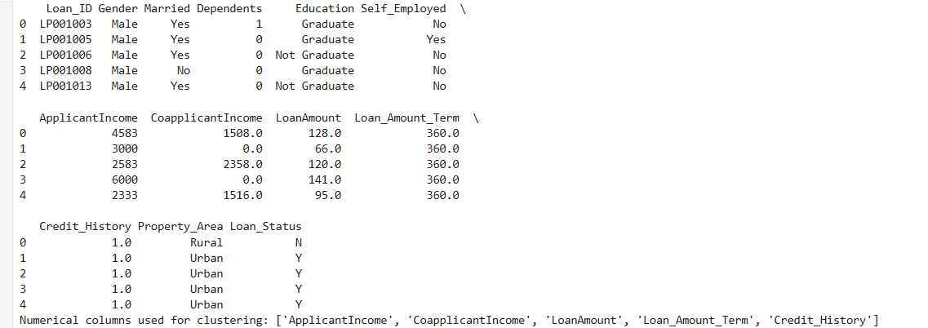
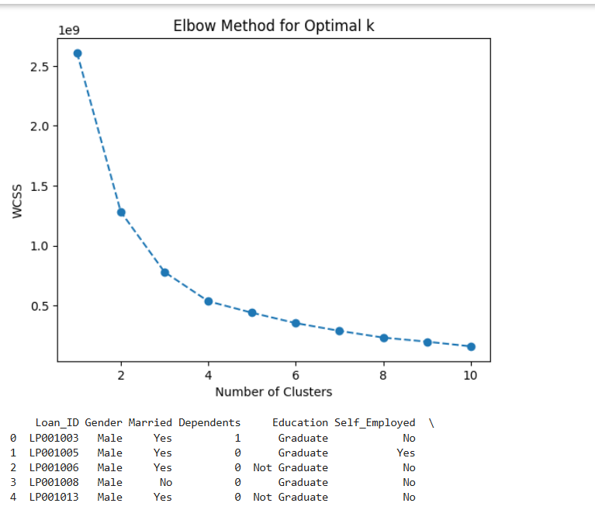
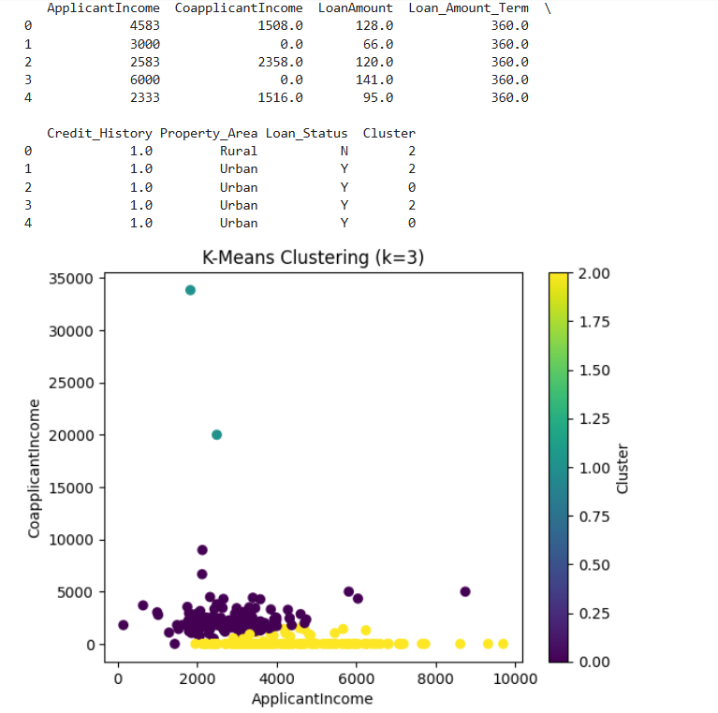

Q5. Implementation of Bagging Algorithm: Random Forest

Code
import numpy as np
import pandas as pd
import matplotlib.pyplot as plt
from sklearn.datasets import load_iris
from sklearn.model_selection import train_test_split
from sklearn.ensemble import RandomForestClassifier
from sklearn.metrics import accuracy_score,confusion_matrix
from sklearn.decomposition import PCA
# Load dataset
iris = load_iris()
X = iris.data
y = iris.target
# Split data into training and testing sets
X_train, X_test, y_train, y_test = train_test_split(X, y, test_size=0.2, random_state=42)
# Initialize and train the Random Forest Classifier
rf_classifier = RandomForestClassifier(n_estimators=100, random_state=42)
rf_classifier.fit(X_train, y_train)
# Make predictions
y_pred = rf_classifier.predict(X_test)
# Evaluate the model
cm=confusion_matrix(y_test, y_pred)
accuracy = accuracy_score(y_test, y_pred)
print(f'Accuracy of Random Forest Classifier: {accuracy * 100:.2f}%')
print("Confusion Matrix:\n", cm)

Output:
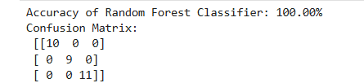

Q6. Implementation of Boosting Algorithms: AdaBoost, Stochastic Gradient Boosting, Voting Ensemble

Code:
import numpy as np
import pandas as pd
import matplotlib.pyplot as plt
from sklearn.datasets import load_iris
from sklearn.model_selection import train_test_split
from sklearn.ensemble import RandomForestClassifier
from sklearn.metrics import accuracy_score,confusion_matrix
from sklearn.decomposition import PCA
# Load dataset
iris = load_iris()
X = iris.data
y = iris.target
# Split data into training and testing sets
X_train, X_test, y_train, y_test = train_test_split(X, y, test_size=0.2, random_state=42)
# Initialize and train the Random Forest Classifier
rf_classifier = RandomForestClassifier(n_estimators=100, random_state=42)
rf_classifier.fit(X_train, y_train)
# Make predictions
y_pred = rf_classifier.predict(X_test)
# Evaluate the model
cm=confusion_matrix(y_test, y_pred)
accuracy = accuracy_score(y_test, y_pred)
print(f'Accuracy of Random Forest Classifier: {accuracy * 100:.2f}%')
print("Confusion Matrix:\n", cm)

Output:
