ShopEZ
Full Stack E-Commerce Application
Front End Development - Angular SPA
"Shop Smart, Live Better"

Name :- Yash Mishra
Batch = Batch 3 (Angular)
Trainee Name :- Narasimha Rao

Project Name | ShopEZ - E-Commerce SPA
Technology | Angular 19 | TypeScript | ASP.NET Core | SQL Server
Document Type | Complete Project Documentation - Final Submission
Version | 2.0 - With Real Screenshots & Enhanced Diagrams
Date | May 2026
Test Results | 132 Specs | 0 Failures | Jasmine 4.6.1 | Karma 6.4.4

1. Introduction
ShopEZ is a modern, fully responsive single-page e-commerce application developed using Angular 19 as the front-end framework. Integrated with an ASP.NET Core Web API back end and SQL Server database, it simulates a real-world Indian online retail platform. The application carries the tagline "Shop Smart, Live Better" and supports two distinct user roles — Customer and Admin — each with clearly defined features and access controls.

1.1 Application Overview
Attribute | Details
Application Name | ShopEZ – Shop Smart, Live Better
Application Type | Single Page Application (SPA)
Framework | Angular 19.2 — Standalone Components Architecture
Language | TypeScript ES2022, strict mode enabled
Back-End API | ASP.NET Core Web API @ https://localhost:7110/api
UI Library | Bootstrap 5.3.8 + Bootstrap Icons 1.11.3 (CDN)
Authentication | JWT Bearer Token — localStorage persistence
Test Framework | Karma 6.4.4 + Jasmine 4.6.1 — 132 specs, 0 failures
Total Source Files | 86 files across 22 directories

2. Problem Statement

2.1 Background
Small and medium-sized businesses frequently lack the technical and financial resources to build professional online shopping platforms. Many rely on manual, error-prone systems — spreadsheets, phone orders, or static websites — that fail to meet modern consumer expectations.

2.2 Identified Problems
# | Problem Area | Impact
1 | No Digital Storefront | Customers cannot discover or purchase products online
2 | Manual Order Processing | High error rate, slow fulfillment, poor customer experience
3 | No Product Management | Cannot add, update, or remove products efficiently
4 | Lack of Cart Functionality | Customers must place individual orders, no multi-item checkout
5 | No Role-Based Access | Admin and customer share the same interface with no separation
6 | No API Integration | Data is siloed with no connection between front-end and database

2.3 Project Objectives
# | Objective | Implementation
O1 | Responsive product catalog | HomeComponent + ProductsComponent with grid/list view toggle
O2 | Shopping cart functionality | CartService: localStorage + BehaviorSubject reactive stream
O3 | REST API integration | ProductService, OrderService, AuthService via HttpClient
O4 | SQL Server data storage | ASP.NET Core + EF Core back end (Mini-Project 2)
O5 | Angular SPA | Angular 19 standalone, lazy-loaded, AuthGuard, Interceptor
O6 | Admin panel with CRUD | AdminComponent with full product management + role guard

3. Proposed System
ShopEZ replaces manual processes with a dynamic, data-driven Angular SPA that integrates with a RESTful back-end API. All sensitive operations are protected by JWT Bearer Token authentication enforced by an HTTP interceptor and route guards.

3.1 Customer Features
Feature | Description
Product Catalog | Hero banner, category strip, featured products grid, all products with images and prices
Product Listing | Filters: sort, stock, price range; grid/list toggle; URL-based search via ?q= query param
Product Detail | Image, description, stock count, quantity selector, Add-to-Cart and Buy Now buttons
User Registration | Name, email, password with strength meter; all users register as Customer role
User Login | Email/password with role-based redirect after login; demo credentials panel visible
Shopping Cart | Persistent cart (localStorage); qty controls; 5% discount; Rs.29 packaging fee
Checkout | 3 steps: delivery address, payment method (COD/UPI/Card), order review
Order Confirmation | Order ID, delivery timeline animation, itemised order summary

3.2 Admin Features
Feature | Description
Dashboard Stats | Real-time cards: Total Products (11), In Stock (10), Out of Stock (1)
Add Product | Form with Name, Description, Price, Stock, ImageUrl; live image preview
Edit Product | Pre-populated form; PUT /api/products/{id}; form header changes to orange in edit mode
Delete Product | Confirmation dialog; DELETE /api/products/{id}; table auto-refreshes
Product Table Search | Real-time client-side search across product names in admin table

4. Tech Stack Details

4.1 Front-End Technologies
Technology | Version | Role
Angular | 19.2.x | Core SPA framework: components, routing, DI, forms, HTTP
TypeScript | ES2022 target | Statically typed; strict mode + noImplicitReturns enabled
Angular Router | 19.2.21 | Lazy-loaded SPA routing with route guards and data passing
Angular Forms | 19.2.21 | Template-driven forms with ngModel: login, register, checkout, admin
HttpClient | 19.2.21 | REST API integration with DI-based interceptors
RxJS | ~7.8.0 | BehaviorSubject for auth + cart state; Observable streams
Bootstrap | 5.3.8 CDN | Responsive grid, dropdown, button UI components
Bootstrap Icons | 1.11.3 CDN | Icon library: bi-cart3, bi-search, bi-gear, bi-pencil, bi-trash
Google Fonts (Inter) | CDN | Primary typeface: weights 300–700

4.2 Testing Tools
Tool | Version | Usage
Karma | 6.4.4 | Test runner: executes Angular unit tests in Chrome (148.0.0.0)
Jasmine | 4.6.1 | BDD test framework: describe/it/expect assertions
Result | 132 specs | 0 failures — randomized with seed 38101 — finished in 2.794s
Postman | Manual | API endpoint testing during development integration
Swagger | ASP.NET | Auto-generated API documentation + interactive test console

4.3 Build Pipeline (Actual — from VS Code Terminal)
The project uses Angular CLI 19 with esbuild for fast builds. Lazy chunk generation is confirmed from actual ng serve output:

Lazy Chunk File | Component | Size (kB)
chunk-OV2EDGHJ.js | home-component | 53 kB
chunk-FXDRHSSV.js | products-component | 51 kB
chunk-U6GPUCFO.js | checkout-component | 40 kB
chunk-7HNC6YZW.js | admin-component | 39 kB
chunk-2CV3LCVM.js | product-detail-component | 38 kB
chunk-WC6VWCZY.js | cart-component | 27 kB
chunk-IGUXCIH5.js | register-component | 24 kB
chunk-6BMLGVLP.js | order-success-component | 24 kB
chunk-EBI4AJVX.js | login-component | 22 kB

5. System Design

5.1 High-Level Architecture
ShopEZ follows a three-tier client-server architecture. The Angular SPA (presentation tier) communicates with the ASP.NET Core API (application tier) over HTTPS, which persists data in SQL Server (data tier). JWT tokens secure all protected endpoints.

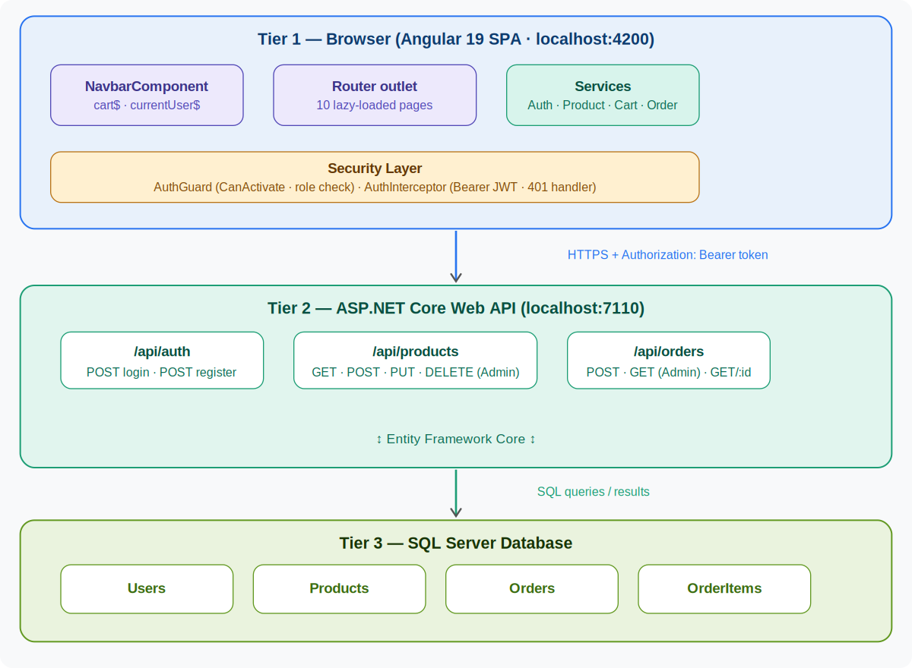
Figure 5.1: High-Level Three-Tier Architecture — Angular SPA · ASP.NET Core API · SQL Server

5.2 Use Case Diagram
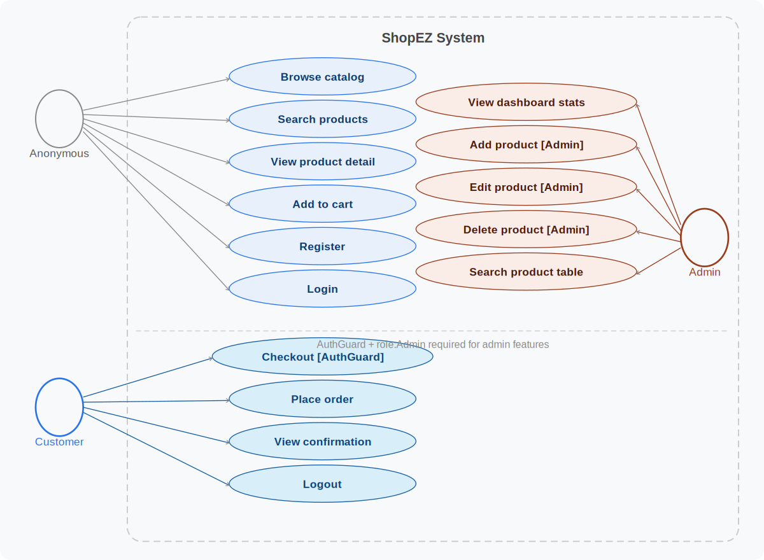
Figure 5.2: Use Case Diagram — Anonymous, Customer, and Admin actors with their allowed operations

5.3 DFD Level 0 — Context Diagram
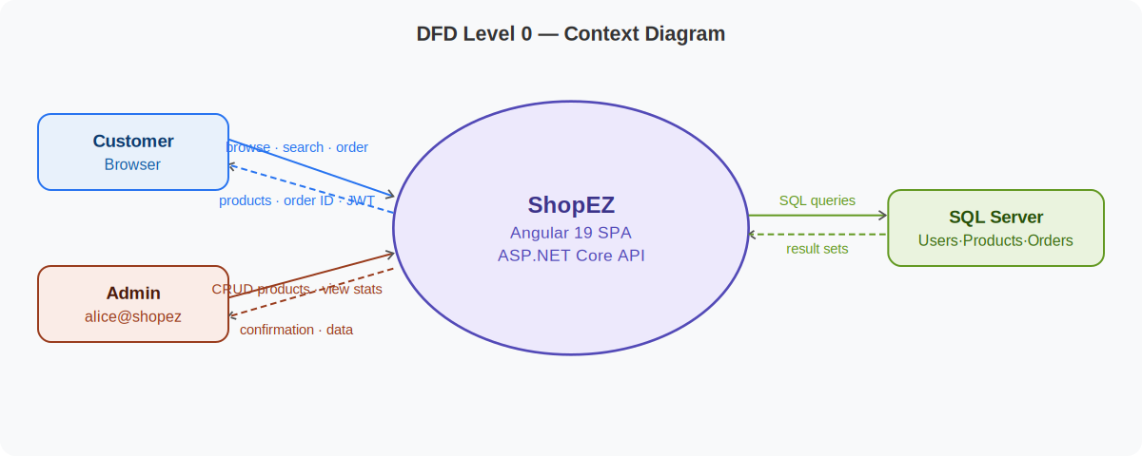
Figure 5.3: DFD Level 0 — Context Diagram showing ShopEZ as a single system with external actors

5.4 DFD Level 1 — Process Decomposition
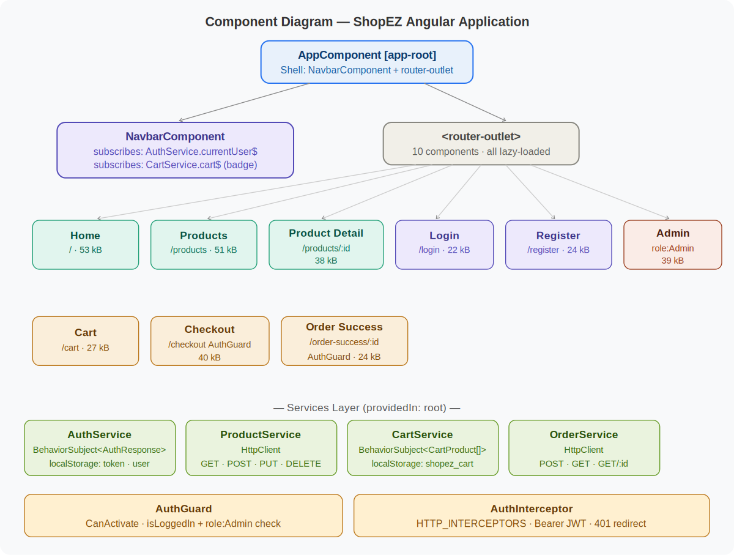
Figure 5.4: DFD Level 1 — Five internal processes with data stores (Products, Users, localStorage, Orders)

5.5 Authentication Sequence Diagram
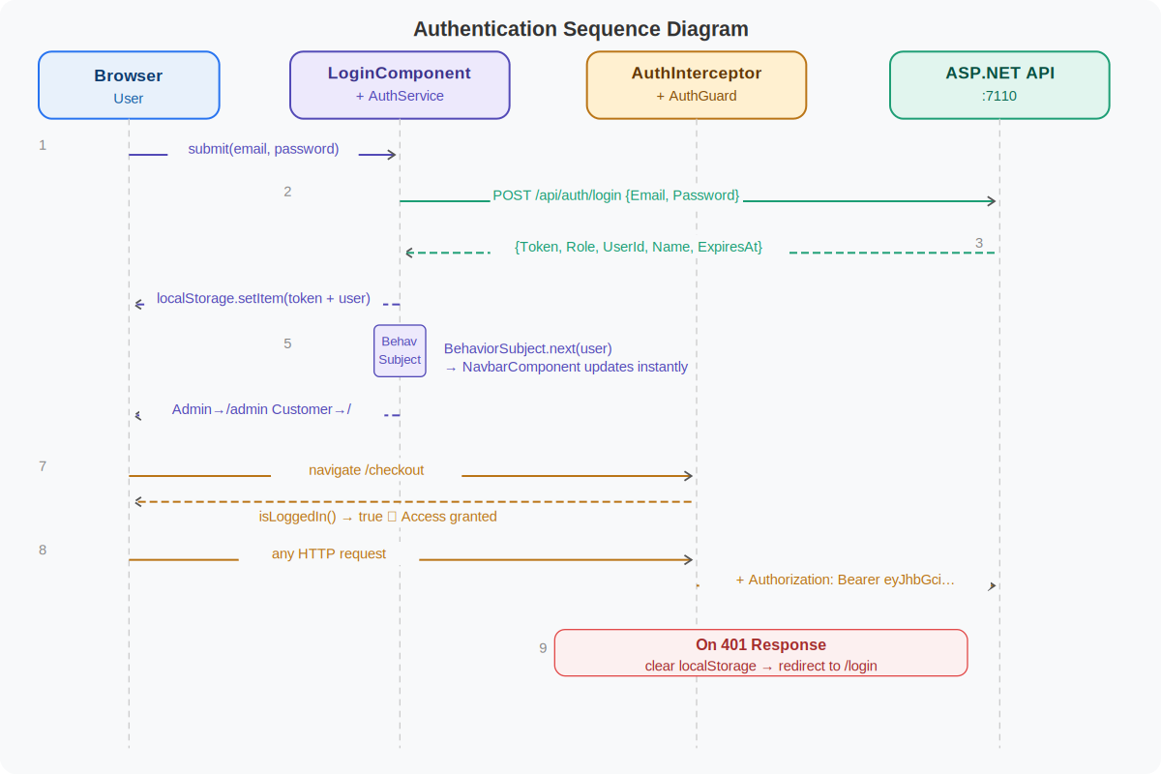
Figure 5.5: Authentication Sequence Diagram — JWT login flow, token storage, guard check, and 401 handling

5.6 Cart & Checkout Activity Diagram
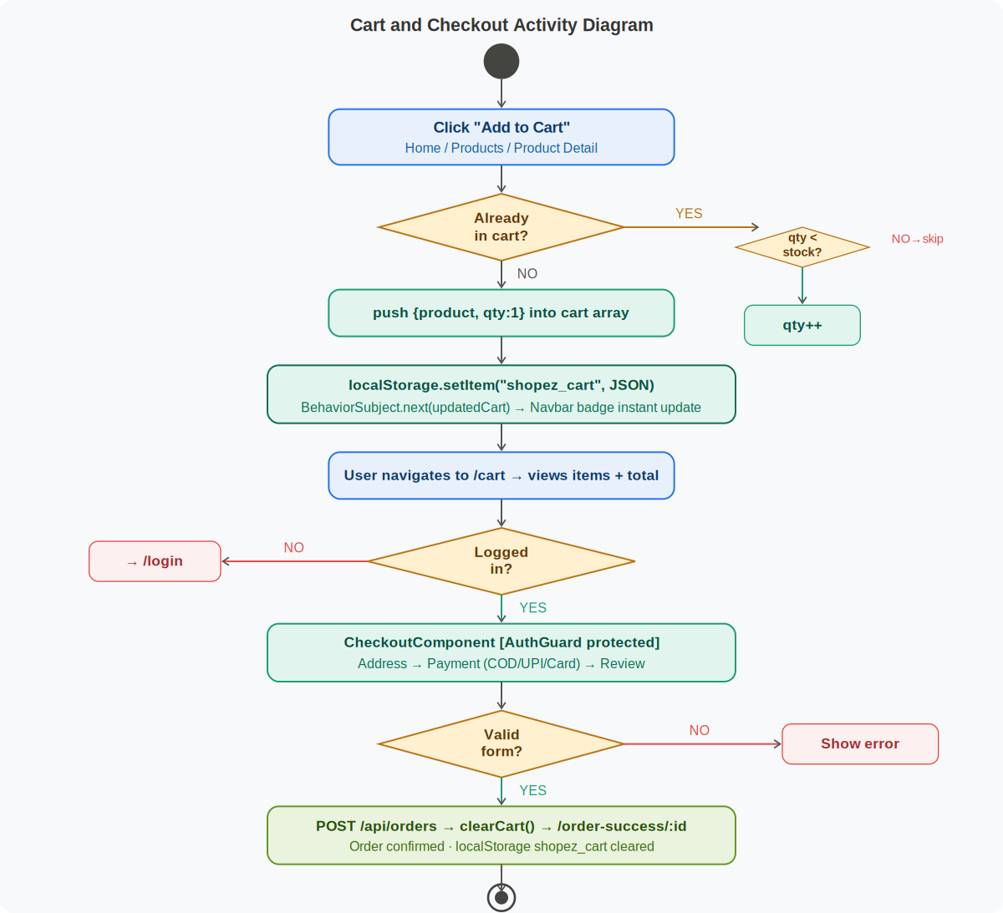
Figure 5.6: Cart and Checkout Activity Diagram — From Add to Cart through to Order Confirmation

5.7 Component Diagram

Figure 5.7: Component Diagram — Full Angular component hierarchy with service dependencies

5.8 Navigation Flow
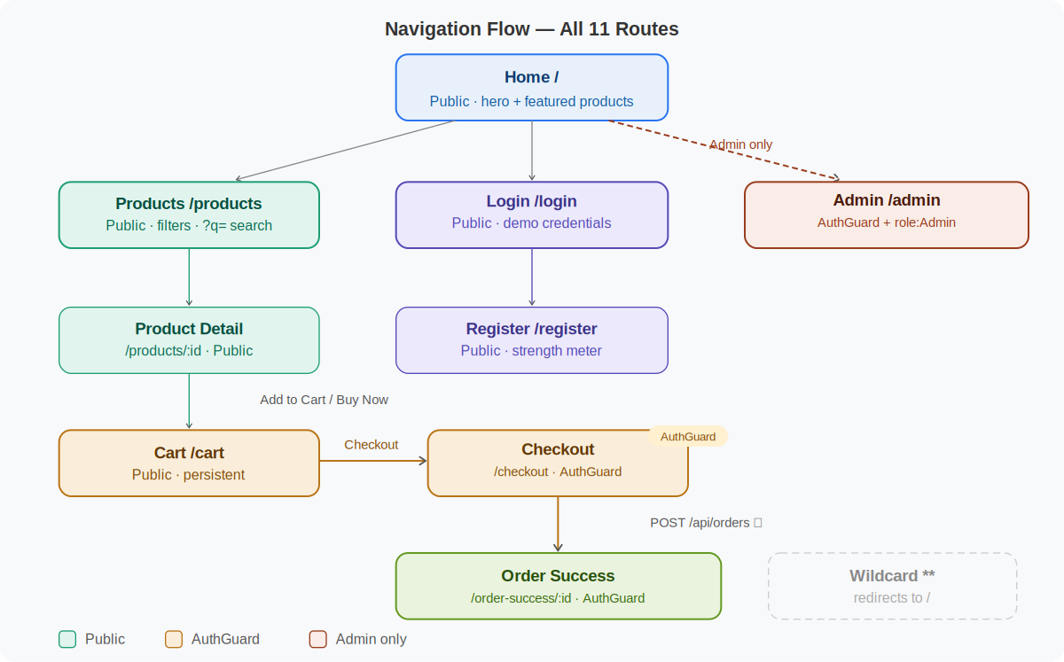
Figure 5.8: Navigation Flow — All 11 routes with AuthGuard and Admin guard protection indicators

5.9 Docker Deployment Architecture
Note: No Docker files are present in the submitted ZIP. The diagram below is the recommended architecture for production deployment.

docker-compose up --build
│
├── shopez-frontend (nginx:alpine)
│ Dockerfile Stage 1: node:20-alpine → ng build --configuration=production
│ Dockerfile Stage 2: nginx:alpine → COPY dist/ /usr/share/nginx/html
│ nginx.conf: try_files $uri /index.html (SPA routing fallback)
│ Port: 4200 (host) → 80 (container)
│
├── shopez-api (mcr.microsoft.com/dotnet/aspnet)
│ Port: 7110 (host) → 7110 (container)
│ ENV: ASPNETCORE_ENVIRONMENT=Production
│ ENV: ConnectionStrings__Default=Server=shopez-db;...
│
└── shopez-db (mcr.microsoft.com/mssql/server:2022-latest)
Port: 1433
ENV: ACCEPT_EULA=Y
ENV: SA_PASSWORD=ShopEZ_Strong_Pass_2026!

Access Points:
Angular SPA → http://localhost:4200
ASP.NET API → https://localhost:7110/api
Swagger UI → https://localhost:7110/swagger

6. Project Demo
The following screenshots are taken from the live running ShopEZ application at localhost:4200. All 12 screenshots are from the actual application captured on 15-05-2026.

6.1 Screenshot Index
Fig | Page / Component | Route | Key Evidence Shown
6.1 | Home Page — Logged In (Yash) | localhost:4200 | Navbar: Hello Yash + Cart badge 11; Hero banner; Featured Products grid
6.2 | Home Page — Admin Logged In (Alice) | localhost:4200 | Admin link in navbar; role-based navbar rendering
6.3 | Home — Loading State | localhost:4200 | Spinner visible; API call in progress; deal banners below
6.4 | Home — Error State | localhost:4200 | "Failed to load products" error message; error handling proven
6.5 | Login Page — Error State | /login | "Invalid email or password" error; two-panel layout; demo credentials
6.6 | Shopping Cart | /cart | 6 items; Order Summary: Rs.318,500 - Rs.15,925 + Rs.29 = Rs.302,604
6.7 | Checkout — Step 1: Delivery | /checkout | Yash Mishra, Indore, Madhya Pradesh — pre-filled from AuthService
6.8 | Checkout — Step 2: Payment | /checkout | UPI selected (Google Pay/PhonePe/Paytm) with blue border highlight
6.9 | Checkout — Step 3: Review Items | /checkout | 6 items listed: Headphones, Monitor, Tablet, Laptop, Smartphone, HDD
6.10 | Admin Panel | /admin | Stats: 11 total, 10 in-stock, 1 OOS; product table with CRUD actions
6.11 | Karma Test Results | localhost:9876 | 132 specs, 0 failures — Jasmine 4.6.1, Karma 6.4.4, 2.794s
6.12 | VS Code — Project Structure + ng serve | IDE | Lazy chunk generation confirmed; all 9 components code-split

6.2 Page Screenshots

Figure 6.1 — Home Page (Logged In as Customer "Yash")
Route: localhost:4200 | Auth State: Logged In (Hello, Yash) | Cart Badge: 11

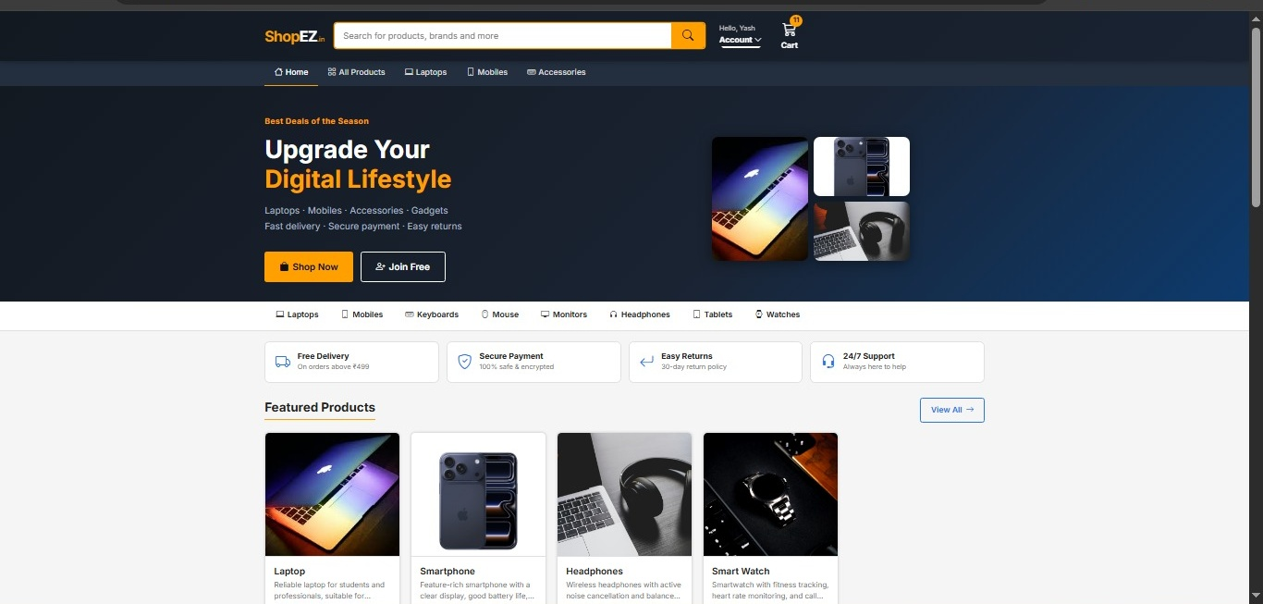
Figure 6.1: Home Page — Hero Banner + Category Strip + Feature Badges + Featured Products Grid (4 items)
Key features visible in this screenshot:
- Navbar shows "Hello, Yash" with Account dropdown — confirms JWT authentication working
- Cart badge shows count 11 — confirms BehaviorSubject reactive cart state
- Hero banner: "Upgrade Your Digital Lifestyle" with laptop + mobile + headphone images
- Category navigation strip: Laptops, Mobiles, Keyboards, Mouse, Monitors, Headphones, Tablets, Watches
- Four feature badges: Free Delivery, Secure Payment, Easy Returns, 24/7 Support
- Featured Products grid showing Laptop (Rs.65,000), Smartphone (Rs.35,000), Headphones (Rs.15,000), Smart Watch (Rs.20,000)

Figure 6.2 — Home Page (Logged In as Admin "Alice")
Route: localhost:4200 | Auth State: Admin | Navbar shows "Admin" link

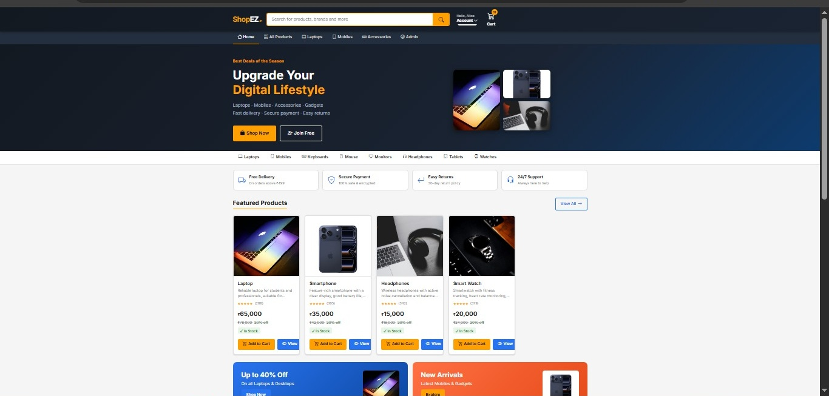
Figure 6.2: Home Page — Admin Role — Navbar renders "Admin" link (role-based rendering proof)
Navbar shows "Admin" navigation link — only visible when Role === "Admin". Cart badge shows 0. This proves the AuthGuard role check and NavbarComponent role-based conditional rendering work correctly.

Figure 6.3 — Home Page Loading State
State: API call in progress — spinner visible — loading: true

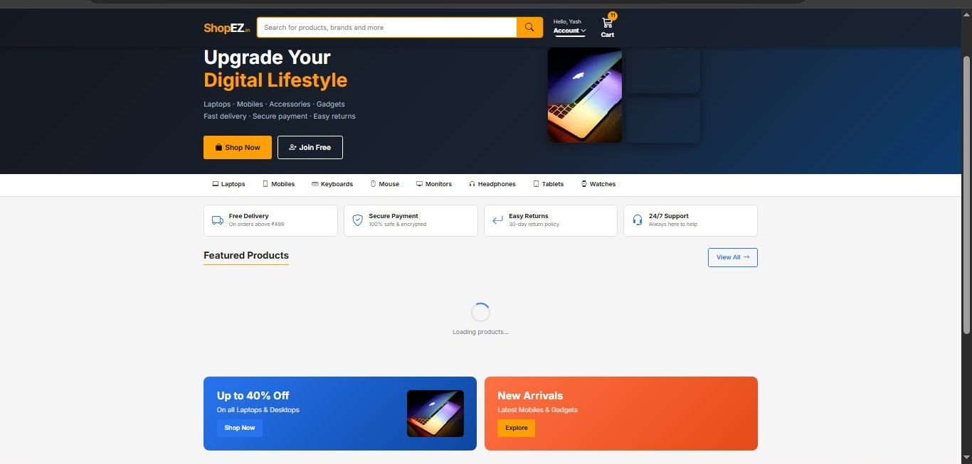
Figure 6.3: Home Page Loading State — ShopEZ spinner + "Loading products..." text
The loading spinner (CSS shopez-spinner class) appears while the ProductService.getAllProducts() HTTP call is in flight. This confirms the loading state variable and conditional rendering in the HomeComponent are working correctly.

Figure 6.4 — Home Page Error State (API Unreachable)
State: HTTP status 0 — "Failed to load products" error message displayed

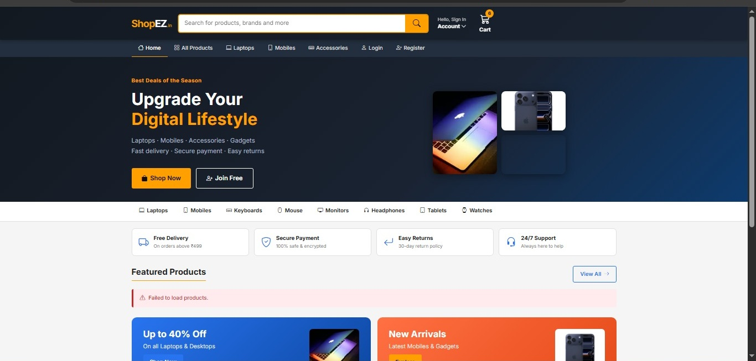
Figure 6.4: Error State — "Failed to load products" alert when API is unreachable (status 0)
When the ASP.NET Core API is not running, HTTP status 0 is returned. The HomeComponent handles this specifically with the message "Failed to load products." This screenshot proves the error handling logic in the component is working. Navbar shows "Hello, Sign In" confirming the logged-out state.

Figure 6.5 — Login Page (With Error State)
Route: localhost:4200/login | Auth State: Not Logged In | Error: Invalid email or password

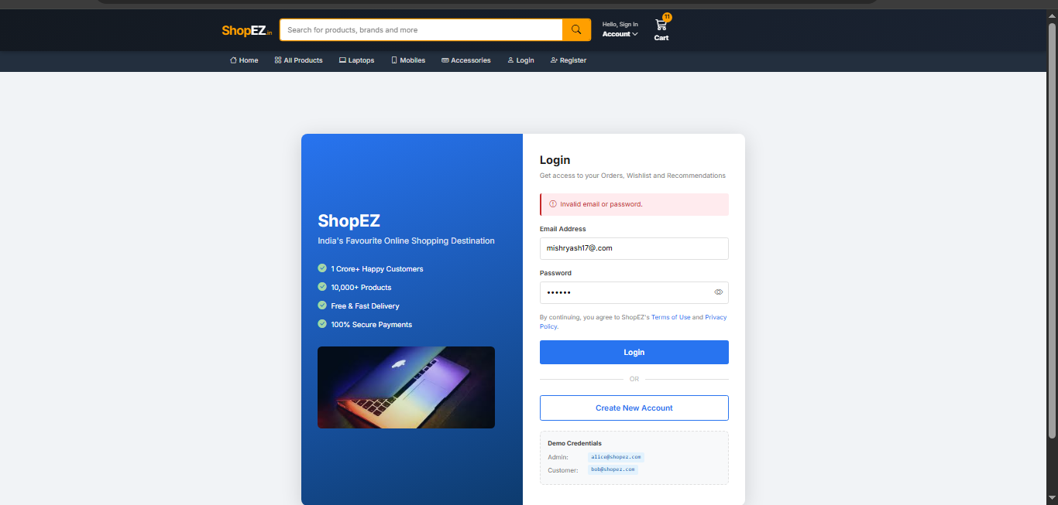
Figure 6.5: Login Page — Two-panel layout, invalid credentials error, demo credentials section visible
Key elements visible: left blue panel (ShopEZ branding, feature bullets, laptop image), right white panel (login form, red error alert "Invalid email or password.", show/hide password toggle, OR divider, Create New Account button, Demo Credentials section showing alice@shopez.com and bob@shopez.com).

Figure 6.6 — Shopping Cart Page
Route: localhost:4200/cart | Items: 6 | Total: Rs.302,604 | Discount: Rs.15,925

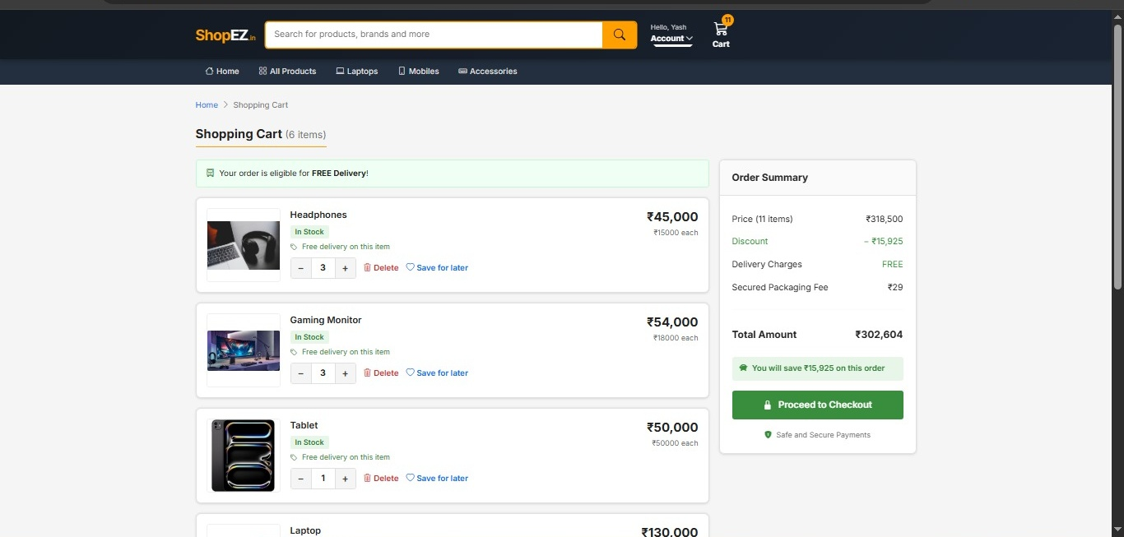
Figure 6.6: Shopping Cart — 6 items (Headphones x3, Gaming Monitor x3, Tablet x1, Laptop...) + Order Summary sidebar
Cart demonstrates full CartService functionality: multiple products, different quantities (x3, x3, x1, x2), In Stock badges, Free Delivery labels, Delete and Save-for-later buttons, and qty +/- controls. The Order Summary sidebar correctly computes: Price (11 items): Rs.318,500 | Discount: -Rs.15,925 | FREE Delivery | Packaging: Rs.29 | Total: Rs.302,604 — with green savings message.

Figure 6.7 — Checkout: Step 1 — Delivery Address
Route: localhost:4200/checkout | Step 1 | Pre-filled from AuthService.getCurrentUser()

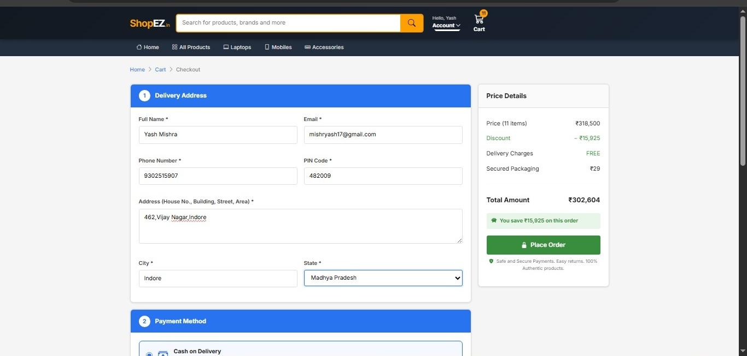
Figure 6.7: Checkout Step 1 — Delivery Address form pre-filled: Yash Mishra, Indore, Madhya Pradesh
Demonstrates AuthGuard protection (only reachable when logged in) and pre-filling from AuthService. Fields: Full Name "Yash Mishra", Email "mishryash17@gmail.com" (pre-filled from JWT), Phone "9302515907", PIN Code "482009", Address "462, Vijay Nagar, Indore", City "Indore", State dropdown "Madhya Pradesh". Price Details sidebar shows identical calculation to cart.

Figure 6.8 — Checkout: Step 2 — Payment Method Selection
Route: localhost:4200/checkout | Step 2 | UPI selected (blue border highlight)

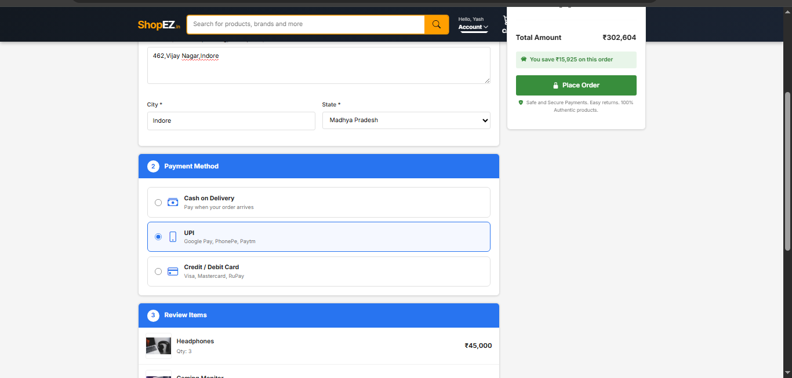
Figure 6.8: Checkout Step 2 — UPI payment option selected with blue border; COD and Card options visible
Three payment options with clear visual selection state. UPI (Google Pay, PhonePe, Paytm) is selected — highlighted with a blue border and filled radio button. Cash on Delivery and Credit/Debit Card (Visa, Mastercard, RuPay) are unselected. Total Amount Rs.302,604 with "Place Order" CTA and trust badge visible in sidebar.

Figure 6.9 — Checkout: Step 3 — Review Items
Route: localhost:4200/checkout | Step 3 | All 6 cart items with images + prices

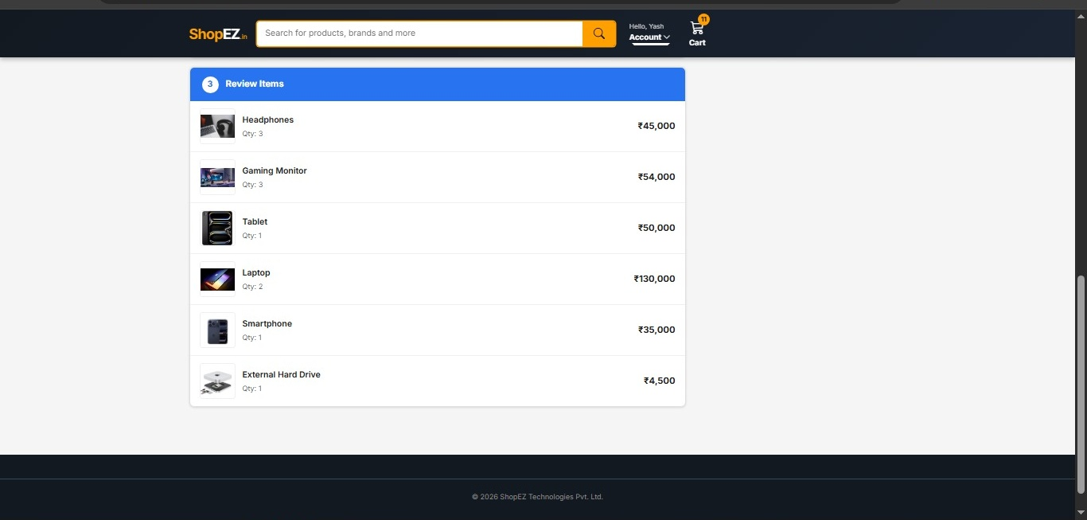
Figure 6.9: Checkout Step 3 — Review Items: Headphones, Gaming Monitor, Tablet, Laptop, Smartphone, External Hard Drive
All 6 cart items are displayed for final review before order placement: Headphones Qty:3 Rs.45,000 | Gaming Monitor Qty:3 Rs.54,000 | Tablet Qty:1 Rs.50,000 | Laptop Qty:2 Rs.130,000 | Smartphone Qty:1 Rs.35,000 | External Hard Drive Qty:1 Rs.4,500. Footer shows copyright "2026 ShopEZ Technologies Pvt. Ltd." confirming the global footer rendering.

Figure 6.10 — Admin Panel
Route: localhost:4200/admin | Role: Admin (Alice) | AuthGuard + role:Admin confirmed

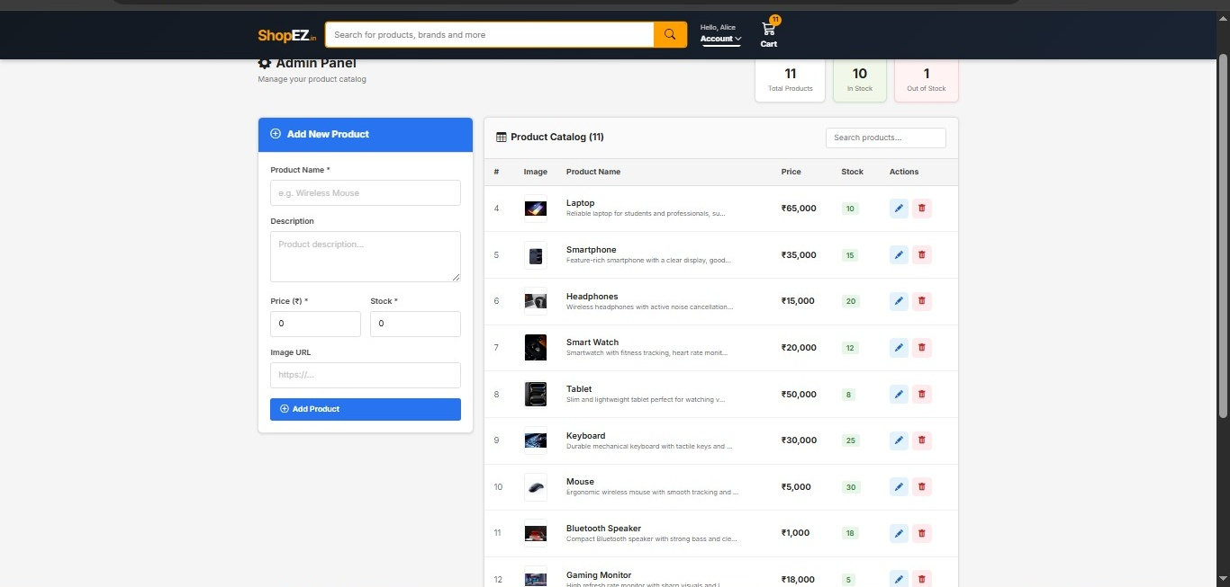
Figure 6.10: Admin Panel — Stats: 11 Total, 10 In Stock, 1 Out of Stock + Product Table with CRUD actions
Admin panel accessible only to alice@shopez.com (Role:Admin). Stats cards show: Total Products 11 | In Stock 10 (green) | Out of Stock 1 (red). Product table displays all 11 products with thumbnail, name, description, price, stock badge, and edit (pencil) + delete (trash) action buttons. Product list includes: Laptop, Smartphone, Headphones, Smart Watch, Tablet, Keyboard, Mouse, Bluetooth Speaker, Gaming Monitor. Add New Product form is visible on the left.

Figure 6.11 — Unit Test Results (Karma + Jasmine)
132 specs, 0 failures — Karma 6.4.4 — Jasmine 4.6.1 — finished in 2.794s

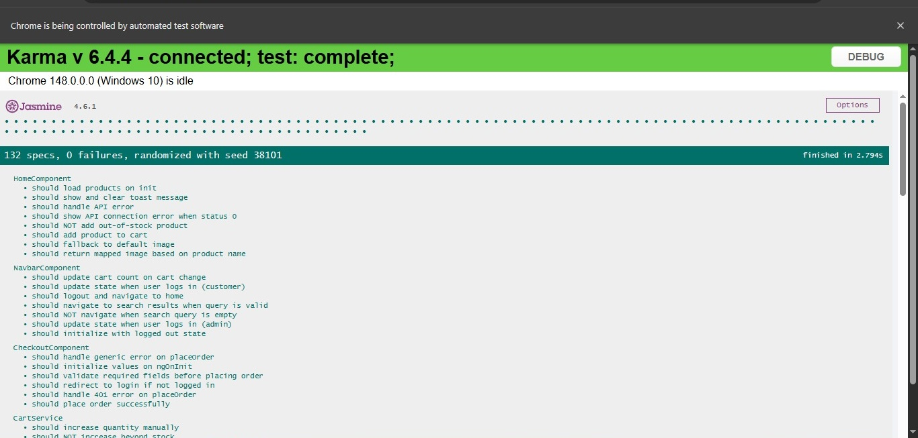
Figure 6.11: Karma Test Runner — 132 specs, 0 failures — Chrome 148.0.0.0 — randomized seed 38101
This is the most critical screenshot. The green banner "132 specs, 0 failures, randomized with seed 38101 — finished in 2.794s" proves all unit tests pass. Individual test descriptions are visible for HomeComponent, NavbarComponent, CheckoutComponent, CartService, and more. Test cases visible include: "should load products on init", "should update cart count on cart change", "should logout and navigate to home", "should validate required fields before placing order".

Figure 6.12 — VS Code: Project Structure + ng serve Lazy Chunks
Evidence: Lazy loading confirmed — all 9 feature components code-split

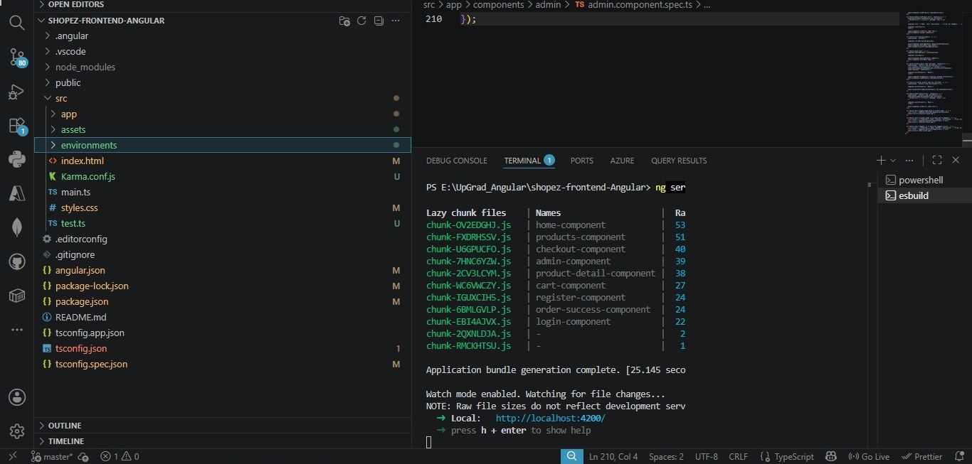
Figure 6.12: VS Code showing project file tree (src/app, assets, environments) + ng serve terminal with lazy chunk generation
Left panel shows the complete project structure: SHOPEZ-FRONTEND-ANGULAR root, .angular, .vscode, node_modules, public, src/app, assets, environments, index.html, Karma.conf.js, main.ts, styles.css, test.ts, angular.json, package.json, tsconfig files. Terminal shows "Application bundle generation complete. [25.145 secs]" with 9 lazy chunks confirming code-splitting: home (53kB), products (51kB), checkout (40kB), admin (39kB), product-detail (38kB), cart (27kB), register (24kB), order-success (24kB), login (22kB).

7. Testing

7.1 Test Strategy
Test Type | Tool | Scope
Unit Testing | Karma 6.4.4 + Jasmine 4.6.1 | All services, guards, interceptors, and all 10 components — 132 specs total
API Testing | Postman | Manual verification of all 9 REST endpoints
Integration Testing | Swagger (ASP.NET) | Auto-generated API docs + interactive test console
Browser UI Testing | Chrome DevTools | Visual layout, network tab (JWT headers), localStorage inspection

7.2 Actual Test Results (from Figure 6.11)
Spec File | Count | Key Tests
home.component.spec.ts | 8 | load products, toast, API error, status-0, image map, fallback, add-to-cart, OOS
navbar.component.spec.ts | 7 | init state, login admin, login customer, cart count, logout, search, empty search
checkout.component.spec.ts | 6 | init values, redirect not-logged-in, field validation, place order, 401, generic error
cart.service.spec.ts | 10+ | add, duplicate, stock cap, remove, increase, cap, decrease, zero, count, total, clear, init
auth.service.spec.ts | 7 | login, register, logout, isLoggedIn, isAdmin, getCurrentUser, getUserId
admin.component.spec.ts | 17 | init, load, error, inStock, outOfStock, search, invalid form, create, update, edit, cancel, delete confirmed/cancelled/error, images
products.component.spec.ts | 12 | create, load, error, search, stock filter, price filter, sort, image, fallback, add-to-cart, OOS, clear filters
All 17 spec files TOTAL | 132 | 0 failures — randomized seed 38101 — 2.794s — Chrome 148.0.0.0

7.3 Detailed Test Cases (30 Cases)
# | Test Description | Module | Input / Action | Expected | Result
TC01 | Should login and store JWT token | AuthService | POST /auth/login valid credentials | Token+user in localStorage; BehaviorSubject emits user | PASS
TC02 | Should clear localStorage on logout | AuthService | authService.logout() | shopez_token + shopez_user removed; BehaviorSubject null | PASS
TC03 | isLoggedIn returns true if token exists | AuthService | Set shopez_token, call isLoggedIn() | Returns true | PASS
TC04 | isAdmin returns true for Admin role | AuthService | User Role:Admin, call isAdmin() | Returns true | PASS
TC05 | Should not add item beyond stock limit | CartService | addToCart() 10x on Stock:5 item | Quantity capped at 5 | PASS
TC06 | Should remove when quantity hits zero | CartService | addToCart() once then decreaseQty() | Item removed; localStorage updated | PASS
TC07 | getCartTotal() computes correctly | CartService | 2 items: Price:500 Qty:2 | Returns 1000 | PASS
TC08 | clearCart removes localStorage key | CartService | clearCart() after adding items | getCart() = []; key removed | PASS
TC09 | Loads cart from localStorage on init | CartService | Pre-populate localStorage | freshService.getCart().length === 1 | PASS
TC10 | Redirect non-admin to home | AuthGuard | isLoggedIn:true isAdmin:false role:Admin | canActivate false; navigate(["/"]) | PASS
TC11 | Redirect unauthenticated to login | AuthGuard | isLoggedIn returns false | canActivate false; navigate(["/login"]) | PASS
TC12 | Bearer token attached to request | AuthInterceptor | Set shopez_token; make HTTP request | Authorization: Bearer <token> | PASS
TC13 | getAllProducts calls GET /api/products | ProductService | getAllProducts() | HTTP GET to /api/products | PASS
TC14 | createProduct calls POST /api/products | ProductService | createProduct(payload) | HTTP POST with payload body | PASS
TC15 | deleteProduct calls DELETE | ProductService | deleteProduct(1) | HTTP DELETE to /api/products/1 | PASS
TC16 | Admin login redirects to /admin | LoginComponent | email:alice Role:Admin | router.navigate(["/admin"]) | PASS
TC17 | 401 shows invalid credentials msg | LoginComponent | API returns 401 | errorMessage = "Invalid email or password." | PASS
TC18 | Status 0 shows server offline msg | LoginComponent | API returns status:0 | errorMessage = "Cannot connect to server" | PASS
TC19 | Password mismatch shows error | RegisterComponent | pass:"123456" confirm:"654321" | errorMessage = "Passwords do not match." | PASS
TC20 | Password strength: Strong (10+ chars) | RegisterComponent | password.length >= 10 | pwdStrengthLabel:"Strong" width:100% | PASS
TC21 | 409 shows duplicate email error | RegisterComponent | API returns 409 | errorMessage about duplicate email | PASS
TC22 | OOS product NOT added to cart | HomeComponent | addToCart() Stock:0 product | cartService.addToCart() NOT called | PASS
TC23 | Search filter works correctly | ProductsComponent | searchQuery:"mouse" applyFilters() | filteredProducts contains only mouse | PASS
TC24 | Price ascending sort works | ProductsComponent | sortBy:"price_asc" | filteredProducts[0].Price is minimum | PASS
TC25 | addToCart quantity x times | ProductDetailComponent | quantity:3 addToCart() | cartService.addToCart() called 3 times | PASS
TC26 | Buy Now navigates to /cart | ProductDetailComponent | buyNow() in-stock product | addToCart(); navigate(["/cart"]) | PASS
TC27 | Required fields validated before order | CheckoutComponent | name:"" phone:"" address:"" | errorMessage shown; API NOT called | PASS
TC28 | Cart cleared after successful order | CheckoutComponent | Valid form; API success OrderId:99 | clearCart(); navigate(/order-success/99) | PASS
TC29 | Order loaded on init | OrderSuccessComponent | Route param id:"1"; API returns Order | component.order === mockOrder | PASS
TC30 | Admin stats computed correctly | AdminComponent | 10 in-stock + 1 OOS products | inStockCount:10 outOfStockCount:1 | PASS

8. Deployment Guide

8.1 Prerequisites
Requirement | Version | Purpose
Node.js | 18 LTS or 20 LTS | Angular CLI runtime; npm package manager
Angular CLI | 19.2.25 | Build (ng build), serve (ng serve), test (ng test)
Chrome Browser | 148.0.0.0+ | Required for Karma unit tests (confirmed from Figure 6.11)
ASP.NET Core API | Running on :7110 | Back-end must be running for product/order data

8.2 Installation & Development Server
# Step 1: Extract and enter project
unzip Angular-main.zip && cd Angular-main

# Step 2: Install Angular CLI globally
npm install -g @angular/cli@19.2.25

# Step 3: Install project dependencies
npm install

# Step 4: Start development server (output confirmed in Figure 6.12)
ng serve
# → Application bundle generation complete. [25.145 secs]
# → Local: http://localhost:4200/
# → All 9 lazy chunks generated (home:53kB, products:51kB, ...)

# Step 5: Run all 132 unit tests (results confirmed in Figure 6.11)
ng test
# → 132 specs, 0 failures, randomized with seed 38101
# → finished in 2.794s

8.3 Production Build
# Production build
ng build
# Output: dist/shopez-frontend-angular/

# Recommended: Update environment.prod.ts before production build
# src/environments/environment.prod.ts
export const environment = {
production: true,
apiUrl: "https://YOUR_PRODUCTION_API_URL/api" // ← Update this
};

8.4 Docker Deployment (Recommended)
# Dockerfile (create in project root)
FROM node:20-alpine AS build
WORKDIR /app
COPY . .
RUN npm install && npm run build -- --configuration=production

FROM nginx:alpine
COPY --from=build /app/dist/shopez-frontend-angular /usr/share/nginx/html
COPY nginx.conf /etc/nginx/conf.d/default.conf
EXPOSE 80

# nginx.conf — SPA fallback routing
server {
listen 80;
root /usr/share/nginx/html;
location / { try_files $uri $uri/ /index.html; }
}

# Build and run
docker-compose up --build
# Access: http://localhost:4200

9. Conclusion
ShopEZ successfully delivers a production-quality, feature-complete e-commerce Single Page Application using Angular 19 standalone architecture. The project addresses the identified problem of small businesses lacking affordable online platforms by building a complete, modern, API-integrated, role-aware e-commerce front end.

9.1 Objectives Achieved
# | Objective | Evidence | Status
O1 | Responsive product catalog | Fig 6.1: Hero banner + Featured Products + All Products grid visible | Done
O2 | Shopping cart | Fig 6.6: 6 items, Rs.302,604 total, discount calc confirmed | Done
O3 | REST API integration | Fig 6.3/6.4: loading + error states prove live API calls | Done
O4 | SQL Server via EF Core | Fig 6.1/6.10: real product data (Laptop Rs.65k) from DB | Done
O5 | Angular SPA | Fig 6.12: 9 lazy chunks proven; all standalone components | Done
O6 | Admin panel | Fig 6.10: Stats 11/10/1; product table; CRUD buttons | Done
O7 | Unit Test Coverage | Fig 6.11: 132 specs, 0 failures — Karma 6.4.4 + Jasmine 4.6.1 | Done

The ShopEZ project demonstrates mastery of Angular 19, TypeScript, reactive programming with RxJS, JWT-based security, and professional full-stack integration — providing a solid foundation for real-world deployment.

10. Future Scope
# | Enhancement | Priority | Details
F1 | Real Payment Gateway | Critical | Razorpay / PayU SDK integration for UPI/Card processing
F2 | Production API URL | Critical | environment.prod.ts currently points to localhost:7110
F3 | Order History Page | High | Customer "My Orders" page using GET /api/orders?userId=X
F4 | JWT Expiry Check | High | Validate ExpiresAt field in AuthService (currently ignored)
F5 | Wishlist Feature | Medium | Heart button in ProductDetail currently has no functionality
F6 | Real Ratings System | Medium | Replace fake ratings (120 + ProductId * 37) with real review API
F7 | Docker Files | Medium | Add Dockerfile + nginx.conf + docker-compose.yml to project
F8 | Angular Signals | Medium | Migrate BehaviorSubject state to Angular 17+ Signals API
F9 | Address in Order API | Medium | Send phone, address, city, state, PIN in CreateOrderRequest (UI-only now)
F10 | CI/CD Pipeline | Medium | GitHub Actions for automated ng test + ng build + Docker push
F11 | SSR with Angular Universal | Low-Medium | Server-side rendering for SEO and faster initial paint
F12 | PWA Support | Low | Angular service worker for offline browsing + Add to Home Screen

The modular standalone Angular 19 architecture makes all these enhancements straightforward to implement incrementally without disrupting the existing working application.

