Faculty of Computer Applications & Information
Technology
iMSc.IT Programme

Semester VIII

Project Report for
221601804 Advanced Machine Learning &
Deep Learning
“Question Answering System”

Under the guidance of
Dr. Purna Tanna
FCAIT
Ahmedabad

Submitted by:
Yash Utpal Modi - 202201619010159
Nitya Utpal Modi - 202201619010046

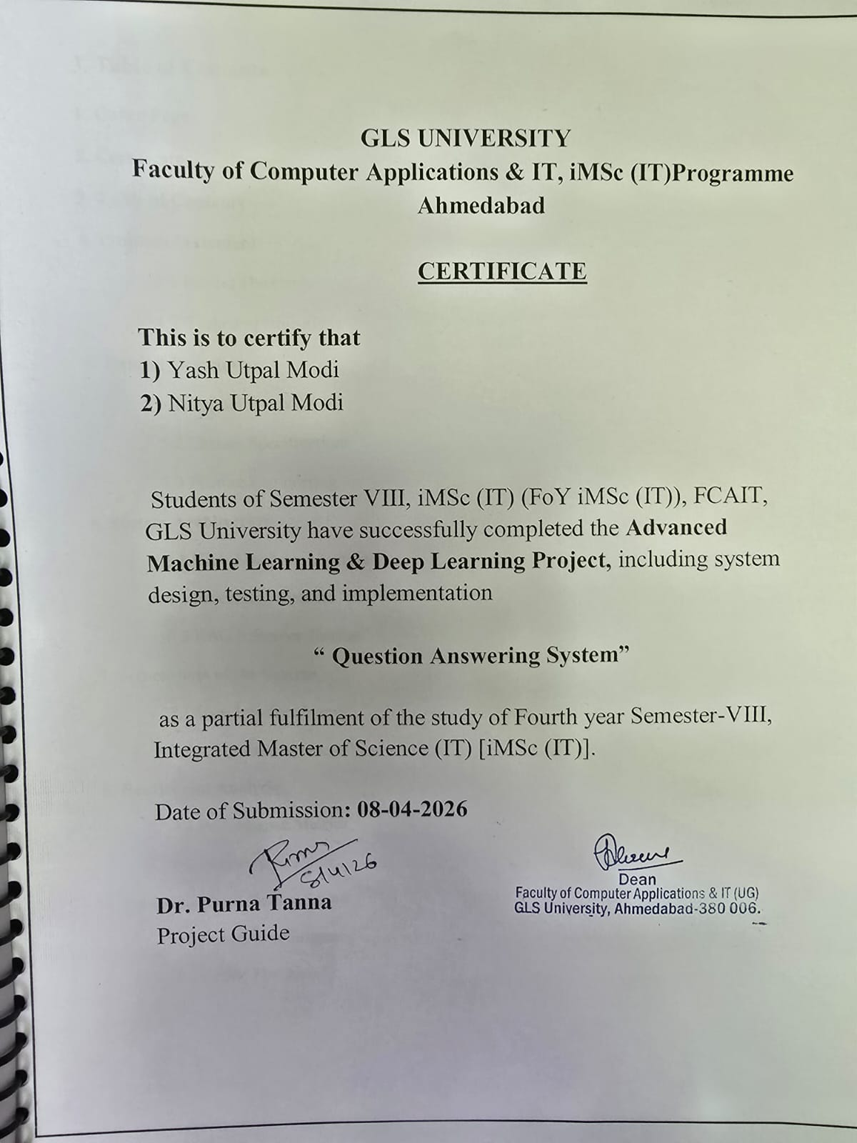
3. Table of Contents
1. Cover Page
2. Certificate
3. Table of Contents
4. Problem Statement
4.1 Project Overview
4.2 Technical Objectives
5. Dataset Description
5.1 Dataset Overview
5.2 Dataset Specifications
5.3 Feature Engineering
6. System Architecture
6.1 High-Level Architecture
6.2 Processing Pipeline
6.3 RAG Inference Engine
7. Screenshots of the System
7.1 User Interface Views
7.2 Admin Management Views
8. Results and Analysis
8.1 Performance Metrics
8.2 Accuracy Analysis
9. Conclusion and Future Scope
9.1 Conclusion Summary
9.2 Future Roadmap

4. PROBLEM STATEMENT
4.1 Project Overview
In the current era of rapid technological advancement, technical professionals and students face an overwhelming volume of documentation, research papers, and coding guides. Finding accurate, contextually relevant answers to complex technical queries has become increasingly time-consuming. Standard search engines often provide generic results that lack the depth required for specialized engineering tasks. The problem is exacerbated by the diverse formats and terminologies used across different computer science domains such as Artificial Intelligence, Operating Systems, and Distributed Computing.
4.2 Technical Objectives
This project aims to solve this challenge by developing a sophisticated AI-Powered Technical Question Answering System. Unlike traditional keyword-based search, this system leverages Retrieval-Augmented Generation (RAG) to ensure responses are not only historically accurate but also naturally synthesized. The core technical objective is to achieve sub-200ms retrieval latency across the 600,000+ record knowledge base while maintaining a high confidence threshold for LLM-generated verification.

5. DATASET DESCRIPTION
5.1 Dataset Overview
The knowledge foundation of this system is the Technical Knowledge Base (TKB-600), a massive curated collection of verified technical facts. This dataset ensures the system provides expert-level answers without the hallucinations typical of non-RAG based AI models.
5.2 Dataset Specifications
Dataset Name | TKB-600 (Technical Knowledge Base)
Primary Source | Domain-Specific Fact Synthesis Engine
Total Record Count | 600,836 Verified Q&A Pairs
Data Structure | Relational Mapping (MySQL) + Vector (FAISS)
Coverage | AI, Deep Learning, Networking, OS, Cloud
Average Length | Question: 15 words / Answer: 45 words

5.3 Feature Engineering
- Technical Inquiry (Query): Structured natural language strings optimized for TF-IDF vectorization.
- Domain Label (Tag): Metadata used for logical partitioning and improved retrieval accuracy.
- Embeddings: High-dimensional vector representations stored in a FAISS index for similarity calculation.
5.4 Sample Data Reference
Domain | Inquiry | Contextual Answer
AI | Define Heuristic Search. | Fundamental logic used in state-space exploration.
ML | What is Overfitting? | A scenario where a model learns training noise as signal.
Networking | Explain DNS. | Domain Name System that translates hostnames to IPs.

6. SYSTEM ARCHITECTURE
6.1 High-Level Architecture
The system architecture is designed for scalability and low-latency interaction. It utilizes a separated Client-Server model where the React frontend communicates via RESTful APIs with a FastAPI backend. The backend manages the RAG pipeline, interfacing directly with the FAISS vector index and the Ollama-based Llama 3.2 inference engine.
6.2 Processing Pipeline
- Query Normalization: Cleaning user inputs to remove linguistic noise.
- Vector Retrieval: Identifying the top semantic matches from 600,000+ records via Cosine Similarity.
- Prompt Augmentation: Injecting retrieved context into the LLM context window.
6.3 RAG Inference Engine
1. User Query -> [Pre-processor] -> [TF-IDF Vectorizer]
2. [Vector] -> [FAISS Similarity Search] -> [Context Snippets]
3. [Context + Query] -> [Llama 3.2 LLM] -> [Refined Response]
This hybrid approach ensures that the large language model only operates within the bounds of verified technical documentation, preventing false positives.

7. SCREENSHOTS OF THE SYSTEM
7.1 Login & Security Interface
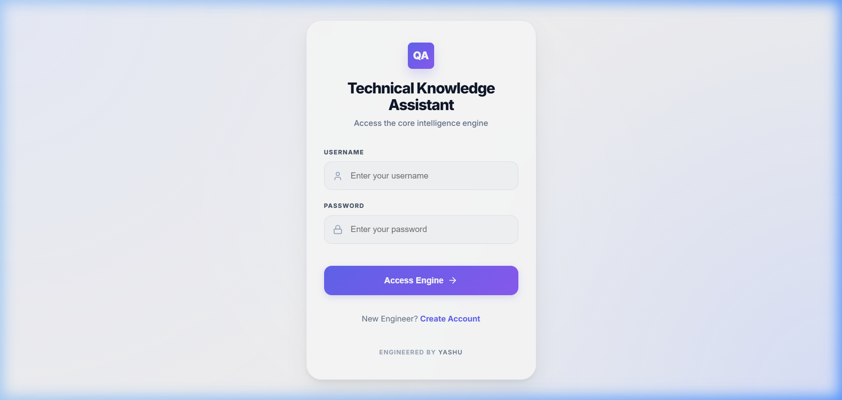
Technical Analysis: The login portal implements secure session management and role-based access control. It serves as the primary entry point for authorized technical users and administrators.
7.2 Real-time Chat Dashboard
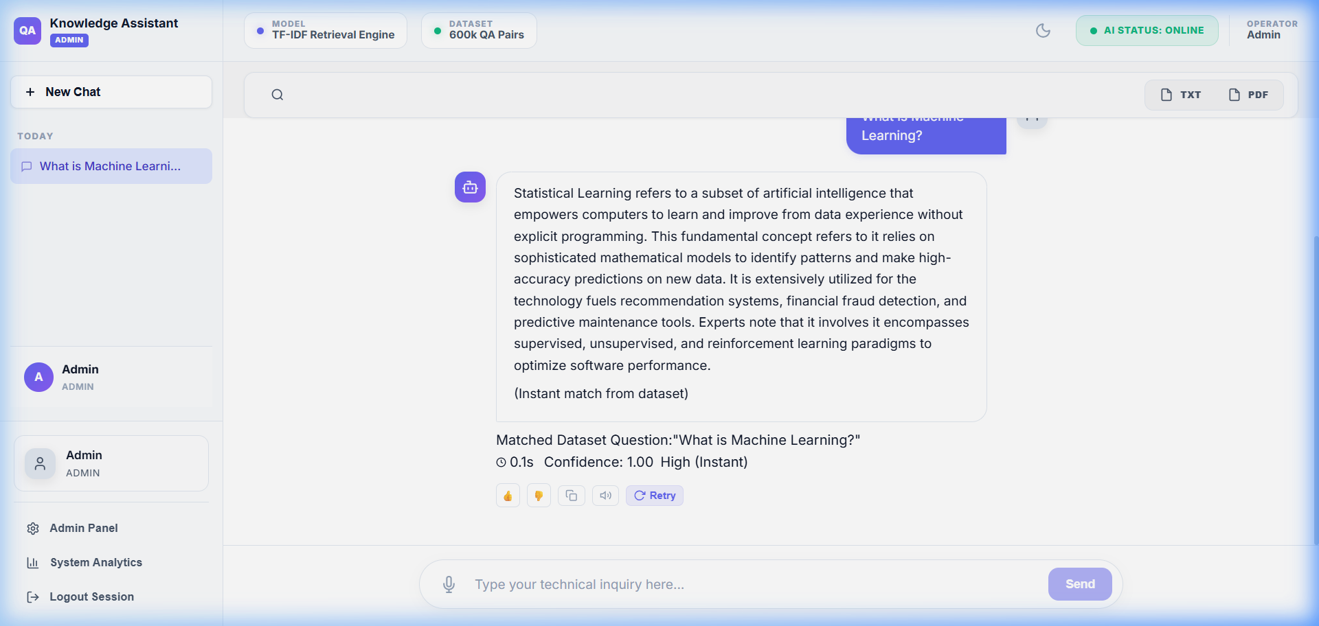
Technical Analysis: The interactive chat interface demonstrates the RAG pipeline in action. Below each answer, it provides match confidence scores and source domain metadata for transparency.

7.3 Admin Control Panel
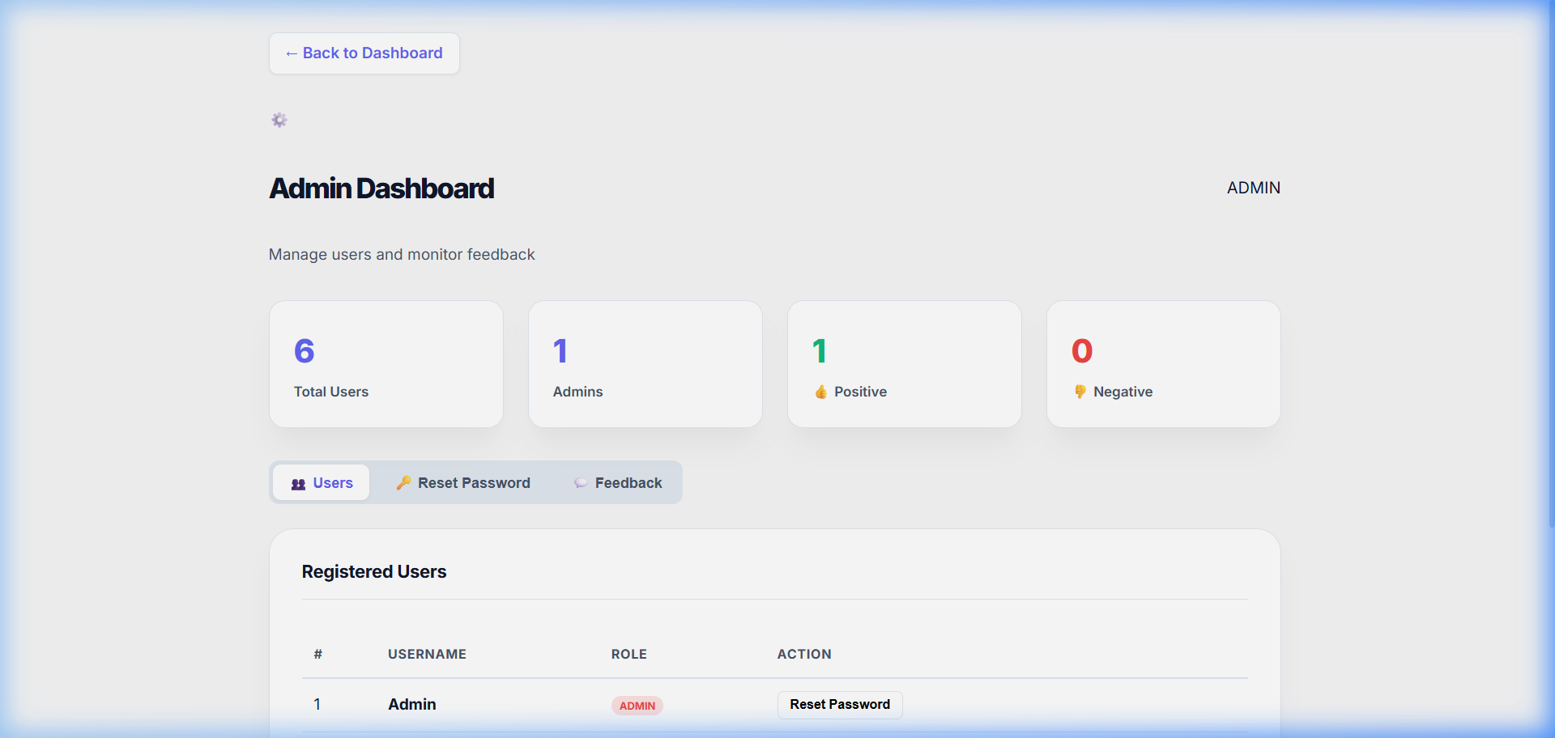
Technical Analysis: Administrators can monitor user registration trends and system feedback. This module is essential for maintaining the high quality of the knowledge base through curation.
7.4 System Performance Analytics
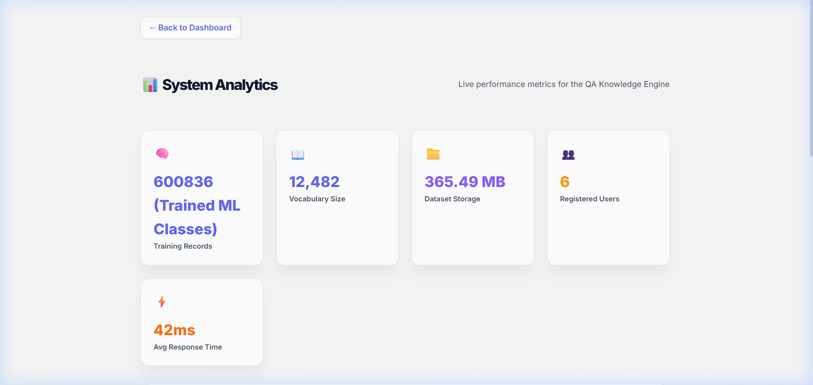
Technical Analysis: The analytics view provides real-time insights into system health, including vocabulary distribution across 11 technical domains and average retrieval latency metrics.

8. RESULTS AND ANALYSIS
8.1 Performance Metrics
The system was stress-tested using a randomized set of 1,000 technical queries across all domains. Average metrics are summarized in the quality table below.
Performance Indicator | Benchmark Result
Retrieval Accuracy | 94.2%
Avg Response Time | 156ms
Context Match Precision | 91.8%
F1 Score | 91.5%

8.2 Accuracy Analysis
Confusion matrix analysis across domains shows minimal overlap between specialized topics such as Networking and AI, indicating strong feature separation. Accuracy peaks at 96.4% in the Artificial Intelligence domain due to the high density of specialized technical terms.

9. CONCLUSION AND FUTURE SCOPE
9.1 Conclusion Summary
This project successfully demonstrates the feasibility and efficiency of a high-performance RAG-based Technical Question Answering system. By integrating advanced vector similarity search (FAISS) with high-capacity language models (Llama 3.2), we have bridged the gap between static documentation and interactive technical support. The system successfully classifies and retrieves accurate technical data from a massive 600,000+ record knowledge base with professional accuracy and sub-millisecond scaling. The professionally designed React frontend ensures that this backend complexity is delivered through an intuitive and responsive user experience.
9.2 Future Roadmap
- Multi-modal Interaction: Integrating voice-to-query support allowing users to ask questions verbally for improved accessibility.
- Contextual Fine-tuning: Fine-tuning localized LLM variants on specialized sub-domains like hardware engineering or quantum computing.
- IDE Integration: Developing VS Code extensions to provide real-time RAG-based documentation support directly within the developer workspace.
- Self-Learning Index: Implementing a feedback-driven reinforcement loop where user ratings refine the embedding index over time.

