Find 2 use case of m query

Case1

Add column

**#"AddSalesAfterDiscount" = Table.AddColumn(#"profit_per_qty", "SalesAfterDiscount", each [sales] * (1 - [discount]))**

**in**

**AddSalesAfterDiscount**

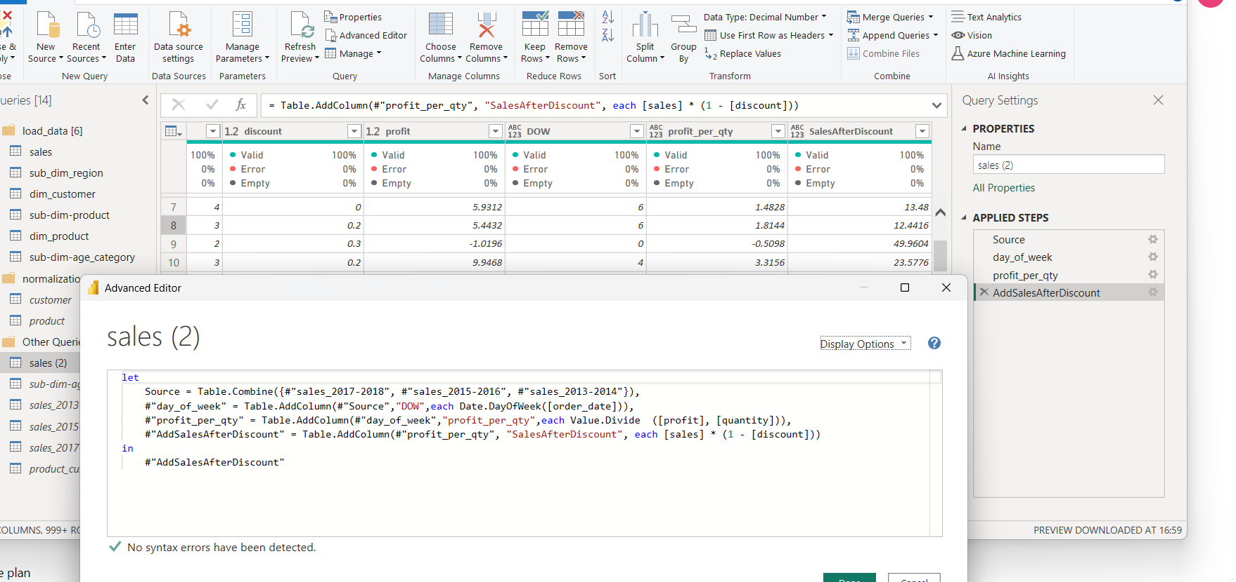

Case 2

Calculate day diff from ship_date to order_date.

**#"AddDaysToShip" = Table.AddColumn(#"AddSalesAfterDiscount" , "DaysToShip", each Duration.Days([ship_date] - [order_date]))**

**in**

**AddDaysToShip**

