SNS ASSIGNMENT:

* Yash Nagda (B20EE092)

Assignment Report

Results and Interpretations:

The plot of the data at the end is obtained as follows:

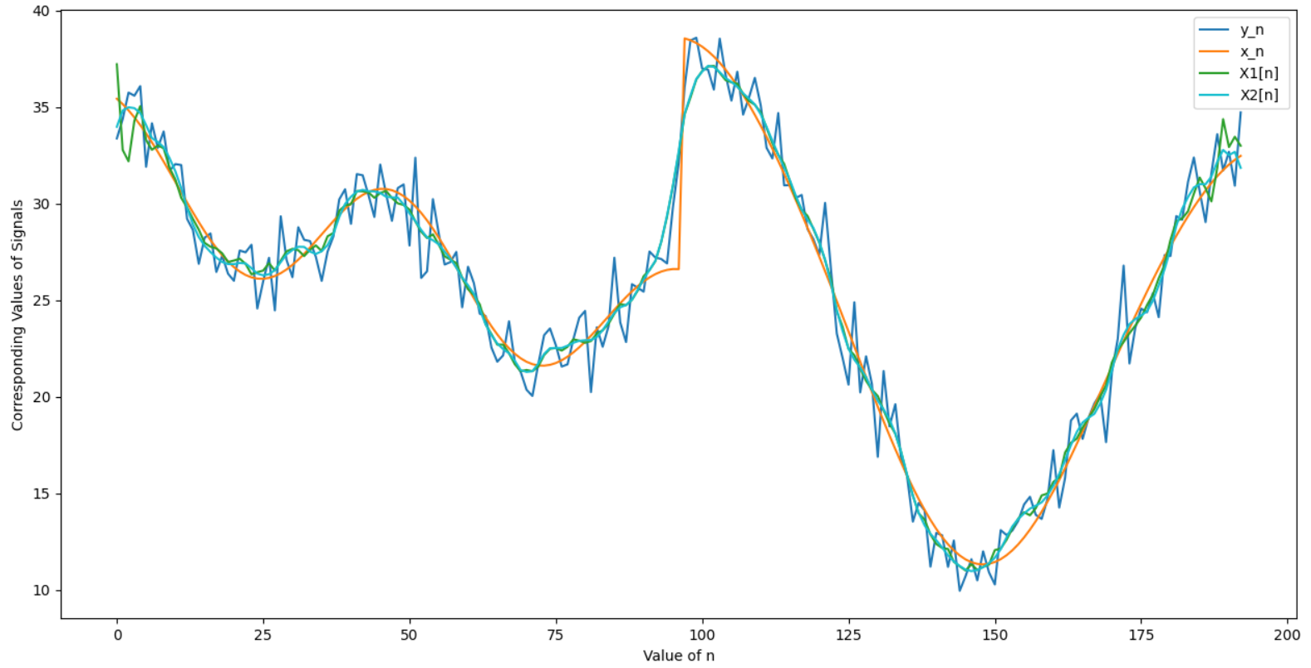

The Results obtained are as Follows:

|  |  |  |  |  |
| --- | --- | --- | --- | --- |
| Value of n | x[n] | y[n] | x1[n] | x2[n] |
| 0 | 35.4312 | 33.3735 | 37.2176 | 33.9793 |
| 1 | 35.1511 | 34.3744 | 32.7794 | 34.8234 |
| 2 | 34.8284 | 35.7514 | 32.1903 | 34.986 |
| 3 | 34.4656 | 35.5869 | 34.2903 | 34.9439 |
| 4 | 34.0656 | 36.0826 | 35.0457 | 34.6884 |
| 5 | 33.6319 | 31.9046 | 33.2878 | 34.0645 |
| 6 | 33.1689 | 34.1604 | 32.7865 | 33.3909 |
| 7 | 32.6809 | 32.8899 | 33.0079 | 33.1952 |
| 8 | 32.1733 | 33.7345 | 32.8679 | 32.9249 |
| 9 | 31.6515 | 31.7042 | 31.8549 | 32.3578 |
| 10 | 31.1213 | 32.0472 | 31.2433 | 31.6708 |
| 11 | 30.5888 | 31.9954 | 30.298 | 30.8114 |
| 12 | 30.0605 | 29.2099 | 29.8008 | 29.8009 |
| 13 | 29.5425 | 28.6328 | 29.2015 | 28.91 |
| 14 | 29.0412 | 26.879 | 28.6532 | 28.2637 |
| 15 | 28.5629 | 28.234 | 27.9644 | 27.8163 |
| Value of n | x[n] | y[n] | x1[n] | x2[n] |
| 16 | 28.1135 | 28.4533 | 27.7652 | 27.4909 |
| 17 | 27.6986 | 26.4562 | 27.6783 | 27.203 |
| 18 | 27.3234 | 27.2977 | 27.4236 | 26.9743 |
| 19 | 26.9924 | 26.3674 | 26.9732 | 26.8677 |
| 20 | 26.7097 | 26.0025 | 27.0495 | 26.865 |
| 21 | 26.4785 | 27.5698 | 27.1431 | 26.9212 |
| 22 | 26.3012 | 27.4753 | 26.8777 | 26.8972 |
| 23 | 26.1795 | 27.8671 | 26.3358 | 26.6559 |
| 24 | 26.1141 | 24.565 | 26.4442 | 26.3746 |
| 25 | 26.1046 | 25.9686 | 26.5285 | 26.2853 |
| 26 | 26.15 | 27.1948 | 26.9137 | 26.3423 |
| 27 | 26.2482 | 24.4673 | 26.5277 | 26.5523 |
| 28 | 26.3961 | 29.3415 | 27.0426 | 26.971 |
| 29 | 26.5898 | 27.0769 | 27.5268 | 27.3669 |
| 30 | 26.8247 | 26.1878 | 27.6544 | 27.5949 |
| 31 | 27.0953 | 28.7746 | 27.5866 | 27.762 |
| 32 | 27.3956 | 28.1229 | 27.2807 | 27.7557 |
| 33 | 27.7188 | 28.0572 | 27.6064 | 27.5152 |
| 34 | 28.058 | 27.2412 | 27.8341 | 27.3914 |
| 35 | 28.4056 | 25.9975 | 27.543 | 27.5326 |
| 36 | 28.7542 | 27.509 | 28.3036 | 27.8498 |
| 37 | 29.0961 | 28.3029 | 28.4796 | 28.4287 |
| 38 | 29.4237 | 30.2193 | 29.6365 | 29.3082 |
| 39 | 29.7297 | 30.7428 | 29.8939 | 29.9844 |
| 40 | 30.0071 | 28.9521 | 29.9693 | 30.3536 |
| 41 | 30.2495 | 31.5281 | 30.6491 | 30.6242 |
| 42 | 30.4508 | 31.4678 | 30.6348 | 30.7113 |
| 43 | 30.6061 | 30.4359 | 30.5794 | 30.6424 |
| 44 | 30.7107 | 29.3044 | 30.3004 | 30.6326 |
| 45 | 30.7613 | 32.0193 | 30.5452 | 30.5501 |
| 46 | 30.7553 | 30.4901 | 30.6561 | 30.3524 |
| 47 | 30.6912 | 29.1049 | 30.2904 | 30.3244 |
| 48 | 30.5684 | 30.8039 | 30.0119 | 30.3085 |
| 49 | 30.3875 | 30.9927 | 29.9279 | 29.9562 |
| 50 | 30.15 | 27.8288 | 29.6881 | 29.4859 |
| 51 | 29.8584 | 32.379 | 29.0753 | 29.0943 |
| 52 | 29.5162 | 26.1485 | 28.5479 | 28.6333 |
| 53 | 29.1278 | 26.4947 | 28.2157 | 28.2516 |
| 54 | 28.6985 | 30.2314 | 28.4077 | 28.1017 |
| 55 | 28.234 | 28.4439 | 27.8712 | 27.8855 |
| 56 | 27.7409 | 26.8432 | 27.2697 | 27.5051 |
| 57 | 27.2262 | 26.9707 | 27.094 | 27.1362 |
| 58 | 26.6971 | 27.4959 | 26.9182 | 26.6849 |
| 59 | 26.1613 | 24.6287 | 26.1534 | 26.1575 |
| 60 | 25.6264 | 26.7288 | 25.5666 | 25.7718 |
| Value of n | x[n] | y[n] | x1[n] | x2[n] |
| 61 | 25.0999 | 25.8782 | 25.2665 | 25.321 |
| 62 | 24.5893 | 24.299 | 24.7795 | 24.5458 |
| 63 | 24.1015 | 24.1763 | 23.7528 | 23.7467 |
| 64 | 23.6434 | 22.5418 | 23.2373 | 23.1804 |
| 65 | 23.2208 | 21.8105 | 22.6925 | 22.7514 |
| 66 | 22.8394 | 22.139 | 22.695 | 22.4615 |
| 67 | 22.5037 | 23.9021 | 22.2494 | 22.2449 |
| 68 | 22.2177 | 21.7907 | 21.677 | 21.8485 |
| 69 | 21.9843 | 21.2762 | 21.3187 | 21.3724 |
| 70 | 21.8056 | 20.3548 | 21.3839 | 21.2811 |
| 71 | 21.6829 | 20.0346 | 21.3161 | 21.3156 |
| 72 | 21.6163 | 21.6838 | 21.5645 | 21.7138 |
| 73 | 21.6051 | 23.1861 | 22.1578 | 22.2114 |
| 74 | 21.6477 | 23.5318 | 22.4747 | 22.5062 |
| 75 | 21.7418 | 22.666 | 22.5232 | 22.5194 |
| 76 | 21.8839 | 21.5566 | 22.385 | 22.5194 |
| 77 | 22.0702 | 21.6734 | 22.583 | 22.6401 |
| 78 | 22.296 | 22.9841 | 22.9719 | 22.7879 |
| 79 | 22.5562 | 24.09 | 22.8963 | 22.8926 |
| 80 | 22.8451 | 24.4396 | 22.7914 | 22.9204 |
| 81 | 23.1568 | 20.234 | 22.8794 | 22.9309 |
| 82 | 23.4851 | 23.5917 | 23.2694 | 23.0914 |
| 83 | 23.8236 | 22.5824 | 23.4359 | 23.4415 |
| 84 | 24.166 | 23.6432 | 23.7723 | 23.892 |
| 85 | 24.506 | 27.1993 | 24.2984 | 24.3406 |
| 86 | 24.8375 | 23.8468 | 24.7902 | 24.6243 |
| 87 | 25.1545 | 22.8253 | 24.7385 | 24.75 |
| 88 | 25.4517 | 25.8261 | 25.0147 | 25.0202 |
| 89 | 25.7238 | 25.6394 | 25.4972 | 25.5378 |
| 90 | 25.9663 | 25.4367 | 26.2392 | 26.0812 |
| 91 | 26.1749 | 27.5169 | 26.5528 | 26.5639 |
| 92 | 26.3462 | 27.208 | 27.0173 | 27.0325 |
| 93 | 26.4771 | 27.1316 | 28.0072 | 28.0213 |
| 94 | 26.5652 | 26.8982 | 29.3199 | 29.3822 |
| 95 | 26.6086 | 29.8031 | 30.9036 | 30.9252 |
| 96 | 26.606 | 32.1206 | 32.6226 | 32.7319 |
| 97 | 38.5567 | 36.0268 | 34.622 | 34.6469 |
| 98 | 38.4605 | 38.4469 | 35.4913 | 35.5993 |
| 99 | 38.3174 | 38.5914 | 36.4313 | 36.4542 |
| 100 | 38.1283 | 36.9945 | 36.8636 | 36.8388 |
| 101 | 37.8941 | 36.938 | 37.1031 | 37.1305 |
| 102 | 37.6161 | 35.9048 | 37.1303 | 37.0782 |
| 103 | 37.2959 | 38.5436 | 36.775 | 36.8068 |
| 104 | 36.9352 | 36.6695 | 36.397 | 36.5027 |
| 105 | 36.5361 | 35.3315 | 36.2798 | 36.3007 |
| Value of n | x[n] | y[n] | x1[n] | x2[n] |
| 106 | 36.1006 | 36.8311 | 36.213 | 36.0508 |
| 107 | 35.6306 | 34.6094 | 35.6781 | 35.7098 |
| 108 | 35.1284 | 35.4921 | 35.3189 | 35.4346 |
| 109 | 34.5959 | 36.5117 | 35.1172 | 35.1347 |
| 110 | 34.0352 | 35.0932 | 34.7233 | 34.6274 |
| 111 | 33.4482 | 32.8906 | 33.9294 | 33.9689 |
| 112 | 32.8367 | 32.3367 | 33.1277 | 33.2544 |
| 113 | 32.2025 | 34.6908 | 32.527 | 32.5346 |
| 114 | 31.5472 | 30.946 | 32.0574 | 31.8754 |
| 115 | 30.8724 | 30.9531 | 31.1489 | 31.1964 |
| 116 | 30.1795 | 30.2894 | 30.2769 | 30.4084 |
| 117 | 29.4701 | 30.4487 | 29.6781 | 29.683 |
| 118 | 28.7456 | 28.6813 | 29.3596 | 29.1713 |
| 119 | 28.0073 | 28.1587 | 28.687 | 28.7321 |
| 120 | 27.2567 | 27.3395 | 27.9852 | 28.0179 |
| 121 | 26.4954 | 30.0342 | 27.0586 | 27.1025 |
| 122 | 25.725 | 26.6117 | 26.0706 | 25.8645 |
| 123 | 24.9471 | 23.2711 | 24.4303 | 24.4729 |
| 124 | 24.1638 | 21.9894 | 23.6056 | 23.3886 |
| 125 | 23.3771 | 20.6231 | 22.4772 | 22.4878 |
| 126 | 22.5892 | 24.8874 | 22.1406 | 21.9127 |
| 127 | 21.8027 | 20.2186 | 21.455 | 21.5027 |
| 128 | 21.0201 | 22.0887 | 20.8234 | 21.0064 |
| 129 | 20.2445 | 20.6506 | 20.3585 | 20.3618 |
| 130 | 19.4788 | 16.8824 | 20.0316 | 19.7888 |
| 131 | 18.7264 | 21.329 | 19.2919 | 19.3383 |
| 132 | 17.9907 | 18.4568 | 18.6168 | 18.8145 |
| 133 | 17.2752 | 19.6091 | 18.0764 | 18.0879 |
| 134 | 16.5838 | 16.7748 | 17.1251 | 17.1213 |
| 135 | 15.92 | 15.8912 | 15.9348 | 15.9685 |
| 136 | 15.2876 | 13.5269 | 14.876 | 14.8576 |
| 137 | 14.6904 | 14.4964 | 13.953 | 13.9772 |
| 138 | 14.1319 | 14.107 | 13.6269 | 13.3315 |
| 139 | 13.6156 | 11.1923 | 12.865 | 12.8896 |
| 140 | 13.1448 | 12.9435 | 12.3677 | 12.5629 |
| 141 | 12.7226 | 12.8151 | 12.161 | 12.1905 |
| 142 | 12.3517 | 11.1801 | 12.1085 | 11.7806 |
| 143 | 12.0345 | 12.5462 | 11.4426 | 11.4618 |
| 144 | 11.773 | 9.9419 | 11.2131 | 11.2254 |
| 145 | 11.5689 | 10.7015 | 10.9958 | 11.0365 |
| 146 | 11.4232 | 11.5785 | 11.3177 | 10.9629 |
| 147 | 11.3368 | 10.4833 | 11.0233 | 11.0224 |
| 148 | 11.3098 | 11.9865 | 11.1842 | 11.1647 |
| 149 | 11.3421 | 10.9006 | 11.3013 | 11.3706 |
| 150 | 11.4329 | 10.2717 | 12.0507 | 11.656 |
| Value of n | x[n] | y[n] | x1[n] | x2[n] |
| 151 | 11.581 | 13.0854 | 12.1296 | 12.0965 |
| 152 | 11.7848 | 12.8299 | 12.5832 | 12.7076 |
| 153 | 12.0423 | 13.0692 | 13.184 | 13.2841 |
| 154 | 12.3511 | 13.5663 | 13.6799 | 13.6655 |
| 155 | 12.7084 | 14.418 | 14.0128 | 13.9522 |
| 156 | 13.1112 | 14.8122 | 13.8547 | 14.1997 |
| 157 | 13.5562 | 13.875 | 14.2234 | 14.3515 |
| 158 | 14.0399 | 13.6661 | 14.8845 | 14.5276 |
| 159 | 14.5587 | 14.6942 | 14.9816 | 14.8856 |
| 160 | 15.1089 | 17.2264 | 15.5809 | 15.3876 |
| 161 | 15.6868 | 14.2535 | 15.8157 | 15.9936 |
| 162 | 16.2886 | 15.7885 | 17.1039 | 16.7202 |
| 163 | 16.9106 | 18.766 | 17.6092 | 17.4852 |
| 164 | 17.5492 | 19.1203 | 17.8276 | 18.1684 |
| 165 | 18.2011 | 17.814 | 18.4026 | 18.6607 |
| 166 | 18.8629 | 18.899 | 18.8769 | 18.9082 |
| 167 | 19.5315 | 19.6421 | 19.3599 | 19.1098 |
| 168 | 20.2041 | 20.1386 | 20.0015 | 19.6396 |
| 169 | 20.878 | 17.6416 | 20.5843 | 20.3536 |
| 170 | 21.5506 | 21.2573 | 21.7692 | 21.371 |
| 171 | 22.2198 | 22.9984 | 22.4336 | 22.4569 |
| 172 | 22.8834 | 26.7884 | 22.8339 | 23.1964 |
| 173 | 23.5395 | 21.7178 | 23.283 | 23.7583 |
| 174 | 24.1865 | 23.567 | 23.6813 | 24.0218 |
| 175 | 24.8226 | 24.5613 | 24.1049 | 24.2025 |
| 176 | 25.4464 | 24.3632 | 24.7456 | 24.4277 |
| 177 | 26.0563 | 25.3569 | 25.2777 | 24.9644 |
| 178 | 26.651 | 24.1146 | 26.1289 | 25.7572 |
| 179 | 27.2291 | 27.3306 | 26.8206 | 26.599 |
| 180 | 27.789 | 27.286 | 28.1087 | 27.6453 |
| 181 | 28.3294 | 29.3543 | 29.0986 | 28.839 |
| 182 | 28.8485 | 29.1628 | 29.2214 | 29.7267 |
| 183 | 29.3448 | 31.1193 | 29.6016 | 30.3371 |
| 184 | 29.8166 | 32.3875 | 30.5091 | 30.8364 |
| 185 | 30.2619 | 30.6265 | 31.3493 | 31.0035 |
| 186 | 30.6789 | 29.0392 | 30.7907 | 31.0029 |
| 187 | 31.0656 | 31.5744 | 30.1143 | 31.3967 |
| 188 | 31.4198 | 33.5967 | 31.858 | 32.1694 |
| 189 | 31.7396 | 31.7135 | 34.3726 | 32.779 |
| 190 | 32.0228 | 32.6819 | 32.9268 | 32.5095 |
| 191 | 32.2673 | 30.926 | 33.4612 | 32.6796 |
| 192 | 32.4714 | 34.7257 | 32.9956 | 31.8497 |

MSE Formula: $\frac{\sum_{k=0}^{192}{}{\left(w\left[k\right]-x\left[k\right]\right)}^{2}}{193}$

Based on the above formula, errors were calculated for w[n]=y[n] (Original Error), w[n] = x1[n] and w[n] = x2[n].

Where, x1[n] = First Denoise then Deblur and x2[n] = First Deblur then Denoise.

The original MSE for y[n] was 2.0611474113471493.

The MSE in x1[n] is 0.8595060172538854.

The MSE excluding 3 start terms and 4 end terms in x1[n] is 0.7562301936559138.

The MSE in x2[n] is 0.785699310673575.

The MSE excluding 3 start terms and 4 end terms in x2[n] is 0.7931505208064514.

General Points:

The Given y[n] had two problems in it, it was blurred using the h[n] given, and some noise was added to it. To remove them, we needed a deblur filter and a denoising filter.

Blurring corresponds to acting of a low pass filter. So in order to deblur, we needed a high pass filter which would not change low frequencies by much and allows high frequencies to pass by increasing their magnitude in a considerable way.

As noise is a composition of random high frequency components, in order to denoise we need to apply a low pass filter. Low pass filter attenuates the high frequency components and allows low frequency components to pass without much attenuation. Since Denoise is a Low pass filter, it would add some blur to the signal.

Now when we denoise, the signal's noise decreases, but the quantity of blur increases due to the use of a low pass filter. When we then apply a deblurring filter (i.e. a high pass filter), the blur added due to noise may also get eliminated. Hence we see that the signal has less MSE when we first denoise then deblur(x1[n]), as opposed to first deblur then denoise(x2[n]). In the second approach of x2[n], the blur added by a low pass filter used for denoise may remain in the signal.

We see that for all values of n, however, our system outcome suggests otherwise, that is error when first denoised is greater than when first deblurred. To understand this change, we observed the graphs of the signals obtained and found an abnormality. In the graphs, at few start terms and end terms, we were able to observe some high frequency components in starting values of x1[n]. When we excluded the first 3 and last 4 entries, our system gave results as expected, i.e. error when denoised first is less than error when deblurred first. We think this happens due to some high frequency of noise getting added, or we are unable to remove some noise component from the system. The few starting and end terms deviate to having some larger frequency components when denoised first. This may also happen due to high pass filters acting when deblurred in the final step in case of x1[n].

At the Start:

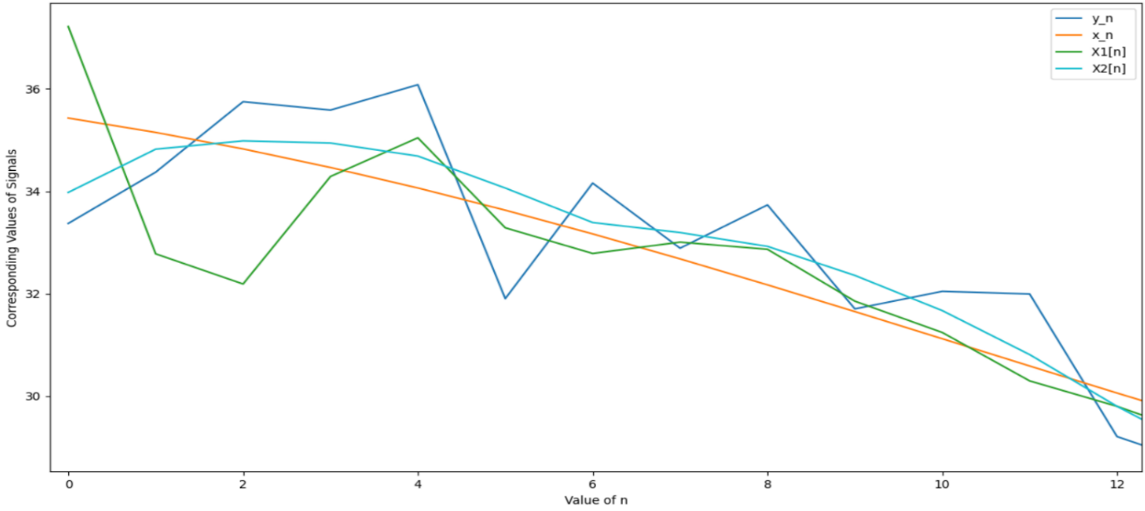

At the End:

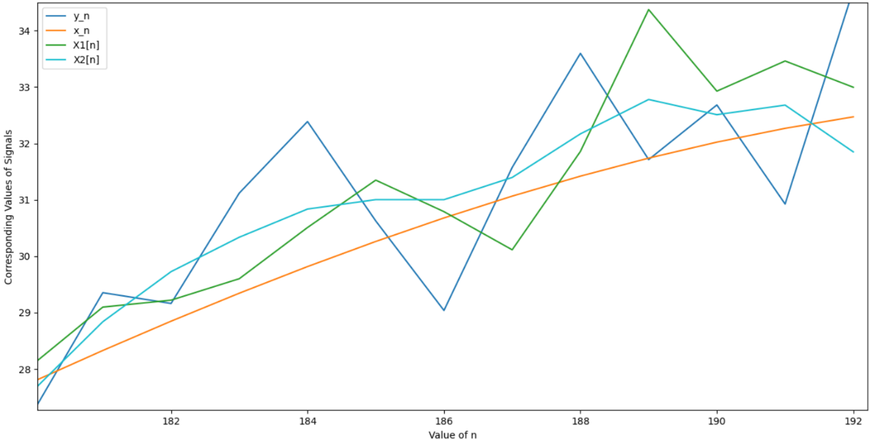

(From above we see that as we reach the start and end points of the signal, there is a sudden rise in values of x1[n].)

In order to curb this noise, we tried to deploy an analysis function. This function would detect a rapid change in values of a signal at a given point, say k, by taking the average of nearby components, and comparing it with the value of a signal at the given point k. If the value is too high or too low, it would change the value at the given point in a range of average value of nearby points and a factor would be added/subtracted in it. The factor is added to the average if the value at the point is too high, and it is subtracted otherwise. This maintains the overall shape of the curve, while reducing the kinks in it. This function suppresses the high/low kinks in the graph to a somewhat smoother function.

While denoising, first we calculated the average value of the signal. This average was then appended in the list of signal values, in start as values corresponding to n = -1, -2, ... - length (denoise impulse response)/2 and end as n= 193, 194, … 192 + length (denoise impulse response)/2. This helped us to reduce abnormalities getting added at the starting and at end few values, if we take these values to be 0 for convolving with low pass filter impulse response. Since the Low pass filter is taking average of nearby values, taking these values to be 0 would lead to smaller values at the end points of the signal. Since we record temperature by the sensor, and due to physical limits of sensor to store data, we only get a windowed version of original x’[n] (n in range (-∞, ∞) as x[n] given, with the window range of 0 ≤ n ≤ 192. Hence we can say temperature can’t abruptly drop to 0 beyond the range of n given. Since average/mean value indicates the central point of whole data, the average/mean value would be closest to the actual temperature at the given points, whose information is unknown to us.

Reasons for selecting impulse response of low pass filter:

h[n] = $\frac{1}{10}$ [1,1,2,2,2,1,1]   (For Denoising Low pass filter)

(The middle value corresponds to the value at n=0)

From the plot of Fourier transform of Y, we observed noise getting added after Ώ = 1 rad/s, as we were able to see a random sudden increase in oscillations of Ϝ(Y). So we needed a filter which could suppress these oscillations. As seen in figure, the low pass filter suppressed the angular frequencies in the range of (1 rad/s, 2 rad/s). The filter approached the value of 0 near 1.5 rad/s. But after 2 rad/s, the sinc like function again started to rise to high values. Using these values would make noise frequencies significant in these regions, so we made the value of low pass filter 0 for angular frequencies > 2rad/s.

Deblur Function:

Blurring refers to Low Pass filter. Since Deblur corresponds to inverse of Blur, it would mean Deblur is a high pass filter. So for high frequencies, Deblur function will give high values. Deblur function is the inverse impulse response of the blurring impulse response given in question. We made the value of deblur function Frequency response as 0 beyond angular frequency 1.5 rad/s, firstly due to increasing noise and secondly, the value of high pass filter overshoot to very high values. This made even a small amount of noise if present, getting amplified to large values. For very small values of blur frequency response, python script considered it to be 0 and hence was unable to calculate 1/0 forms of value, giving errors.

Fourier Domain graphs of y[n], Low Pass filter for Denoising, Inverse System impulse response for Blur i.e. Deblur.

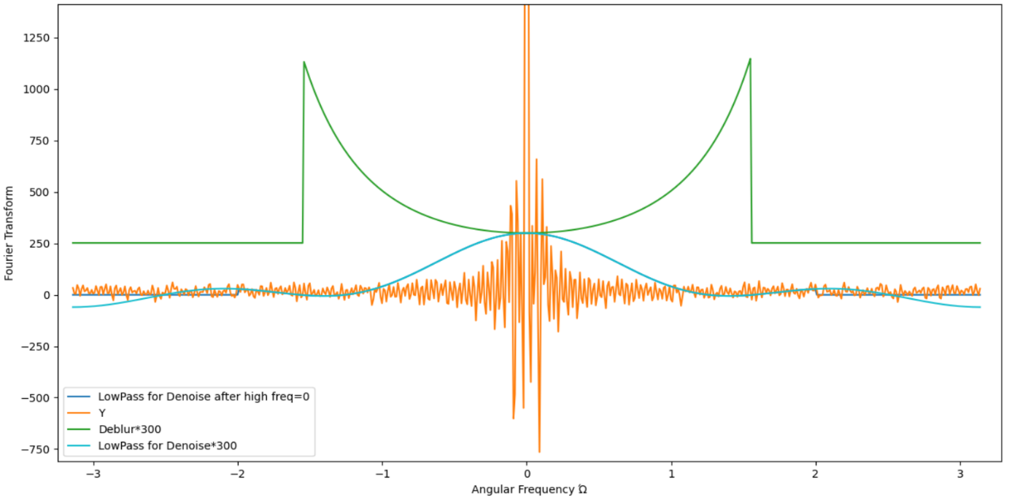

The values of Deblurring and Denoising impulse responses are multiplied by 300 to visualize graphs in comparison to y[n] frequencies.