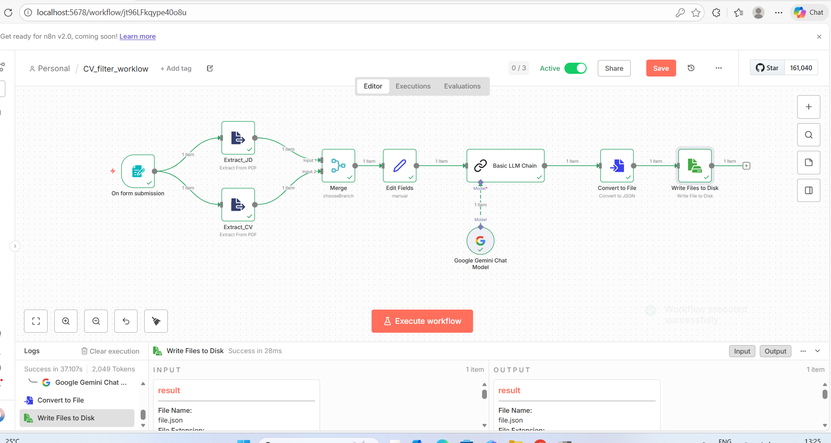

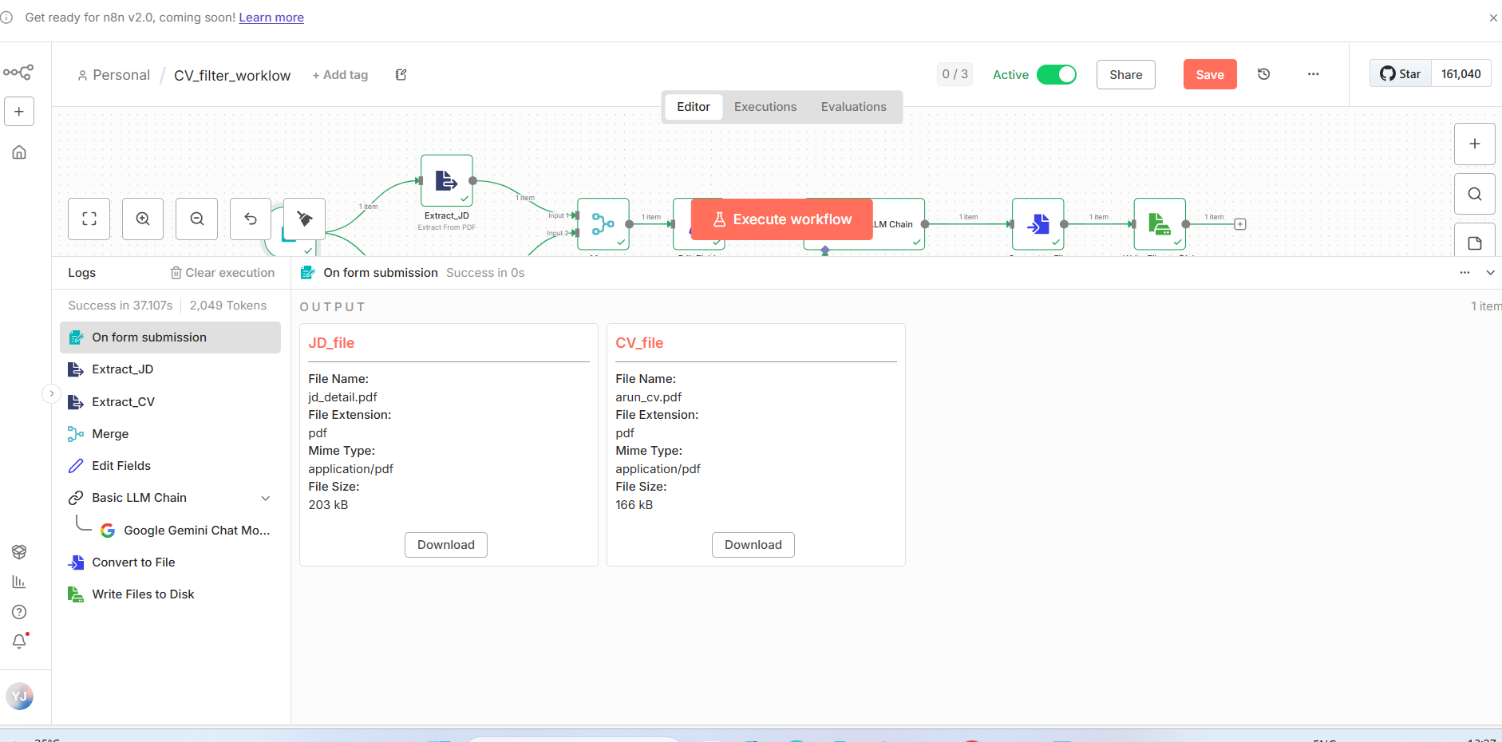

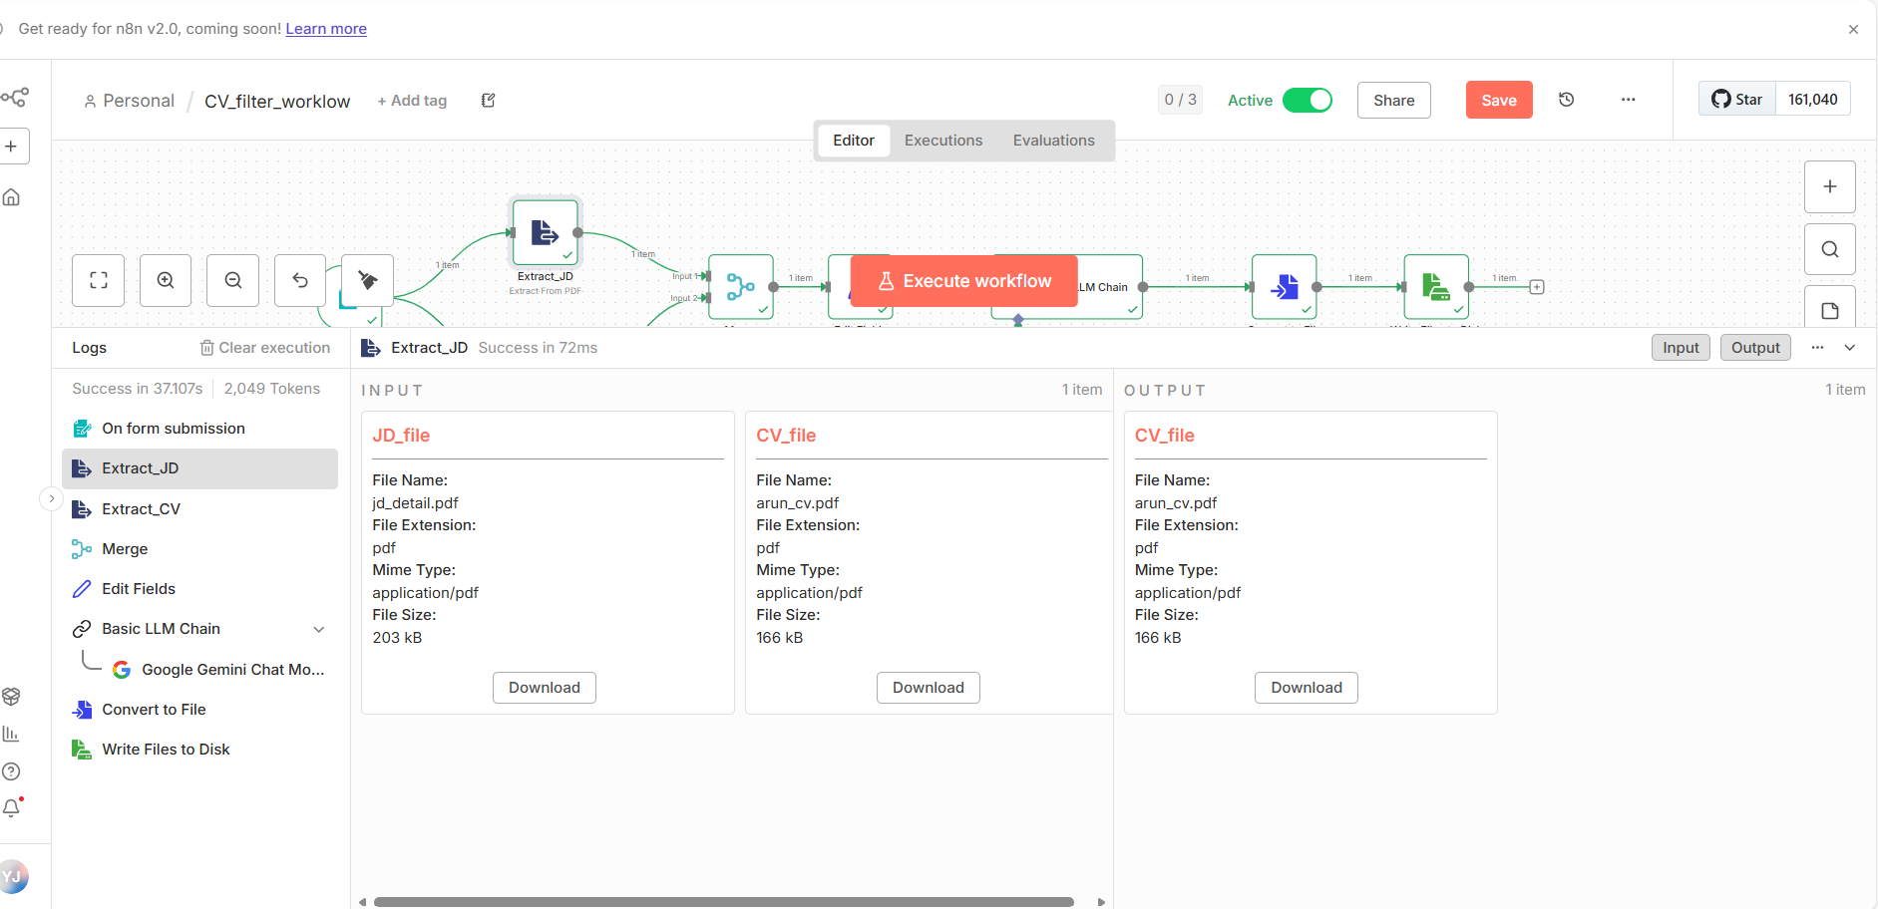

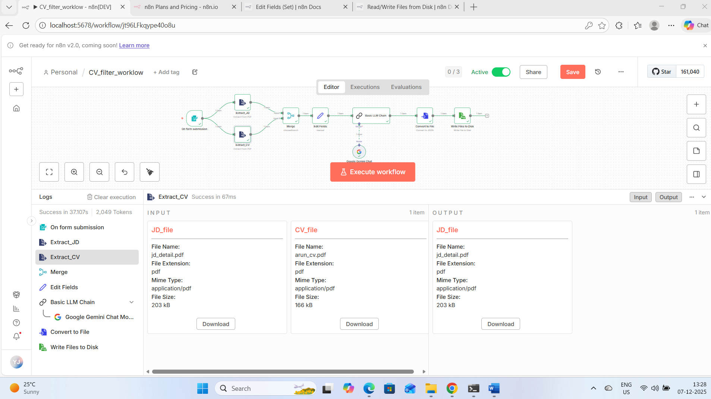

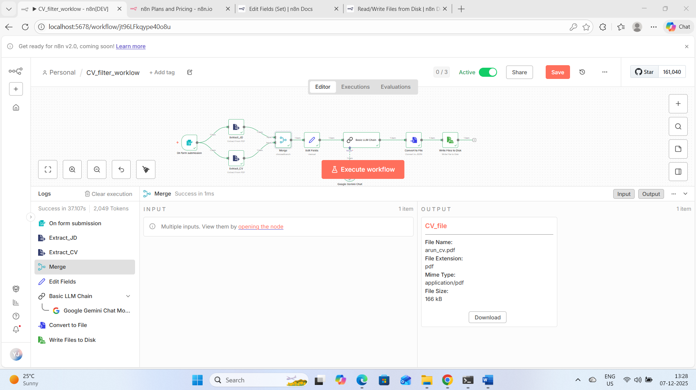

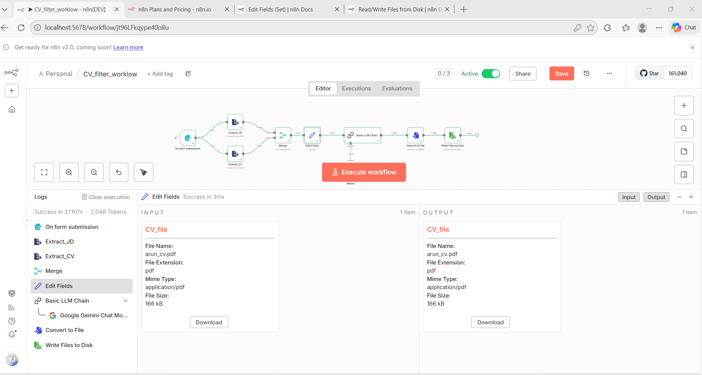

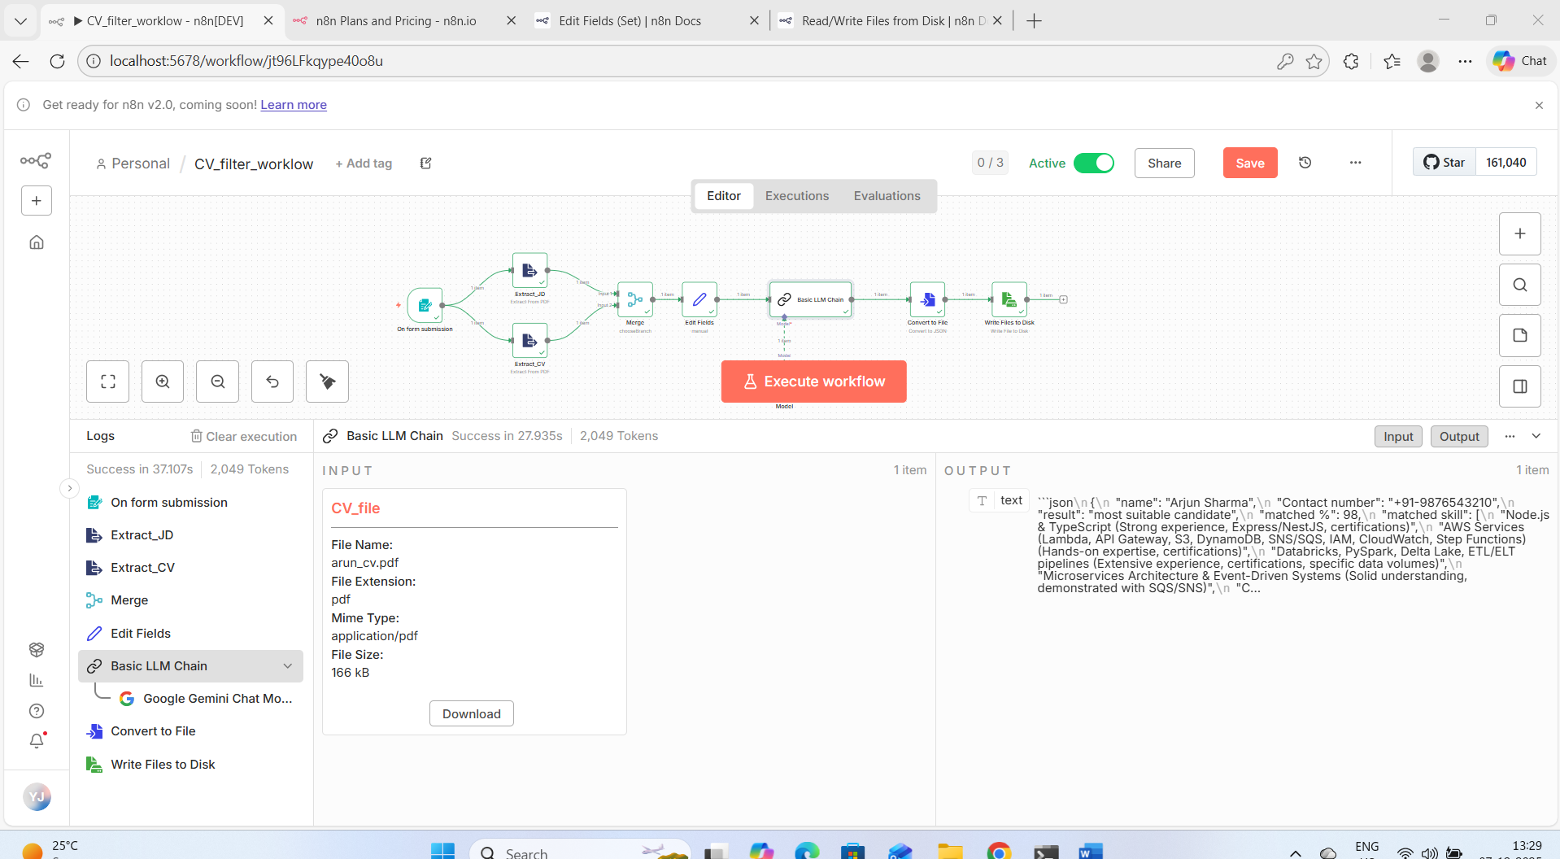

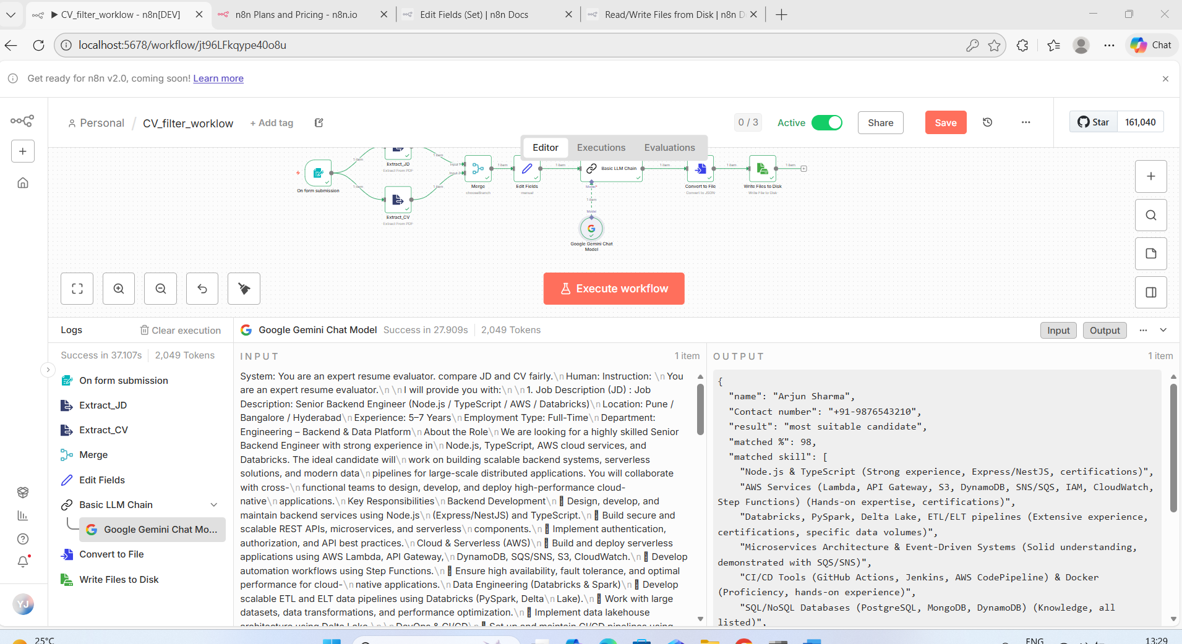

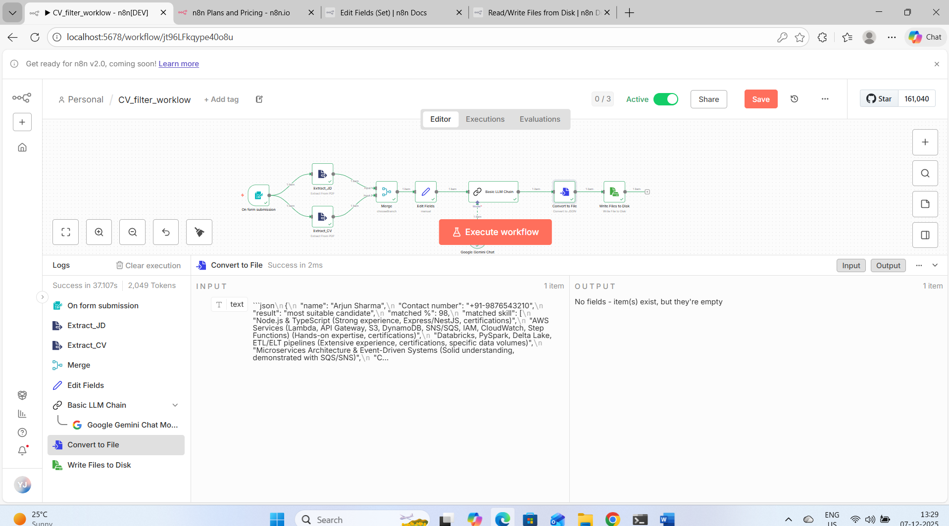

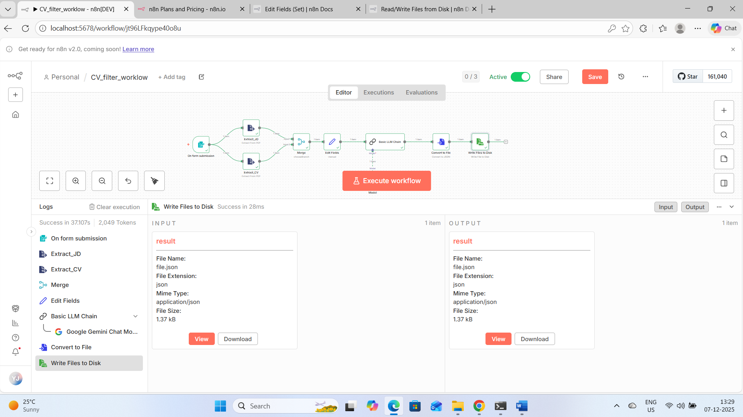

Prompt given to LLM:
Instruction:
You are an expert resume evaluator.
I will provide you with:
1. Job Description (JD) : {{ $json.jd_text }}
2. Candidate Resume : {{ $json.cv_text }}
Your task:
- Compare the resume against the JD.
- Identify skill match, experience match, technology match, and role responsibilities match.
- Calculate a match percentage (0–100%) based on how closely the resume aligns with the JD.
- Then give the final result using the following rules:
If matched % >= 80:
result : most suitable candidate
matched % : <percentage>
If matched % >= 60 and < 80:
result : suitable candidate
matched % : <percentage>
If matched % < 60:
result : not suitable candidate
matched % : <percentage>

Output Format: need json as output (Strictly follow this):
name : <candidate name>
Contact number: <candidate contact number>
result : <result_text>
matched % : <percentage>
matched skill: <list of skill from grater to lower matched percentage>
Final Output:
[{"text":"```json\n{\n \"name\": \"Arjun Sharma\",\n \"Contact number\": \"+91-9876543210\",\n \"result\": \"most suitable candidate\",\n \"matched %\": 98,\n \"matched skill\": [\n \"Node.js & TypeScript (Strong experience, Express/NestJS, certifications)\",\n \"AWS Services (Lambda, API Gateway, S3, DynamoDB, SNS/SQS, IAM, CloudWatch, Step Functions) (Hands-on expertise, certifications)\",\n \"Databricks, PySpark, Delta Lake, ETL/ELT pipelines (Extensive experience, certifications, specific data volumes)\",\n \"Microservices Architecture & Event-Driven Systems (Solid understanding, demonstrated with SQS/SNS)\",\n \"CI/CD Tools (GitHub Actions, Jenkins, AWS CodePipeline) & Docker (Proficiency, hands-on experience)\",\n \"SQL/NoSQL Databases (PostgreSQL, MongoDB, DynamoDB) (Knowledge, all listed)\",\n \"Debugging, Problem-Solving, and Performance Optimization (Strong skills, demonstrated in experience)\",\n \"Collaborative Responsibilities (Cross-functional teams, Agile ceremonies, Code review participation)\",\n \"API Security & JWT/OAuth (Experience with JWT for authentication/authorization)\",\n \"Python (Basic knowledge, used for ETL scripts)\",\n \"Terraform (Basic familiarity, listed as good to have)\",\n \"Kafka or other streaming technologies (Basic familiarity, listed as good to have)\"\n ]\n}\n```"}]
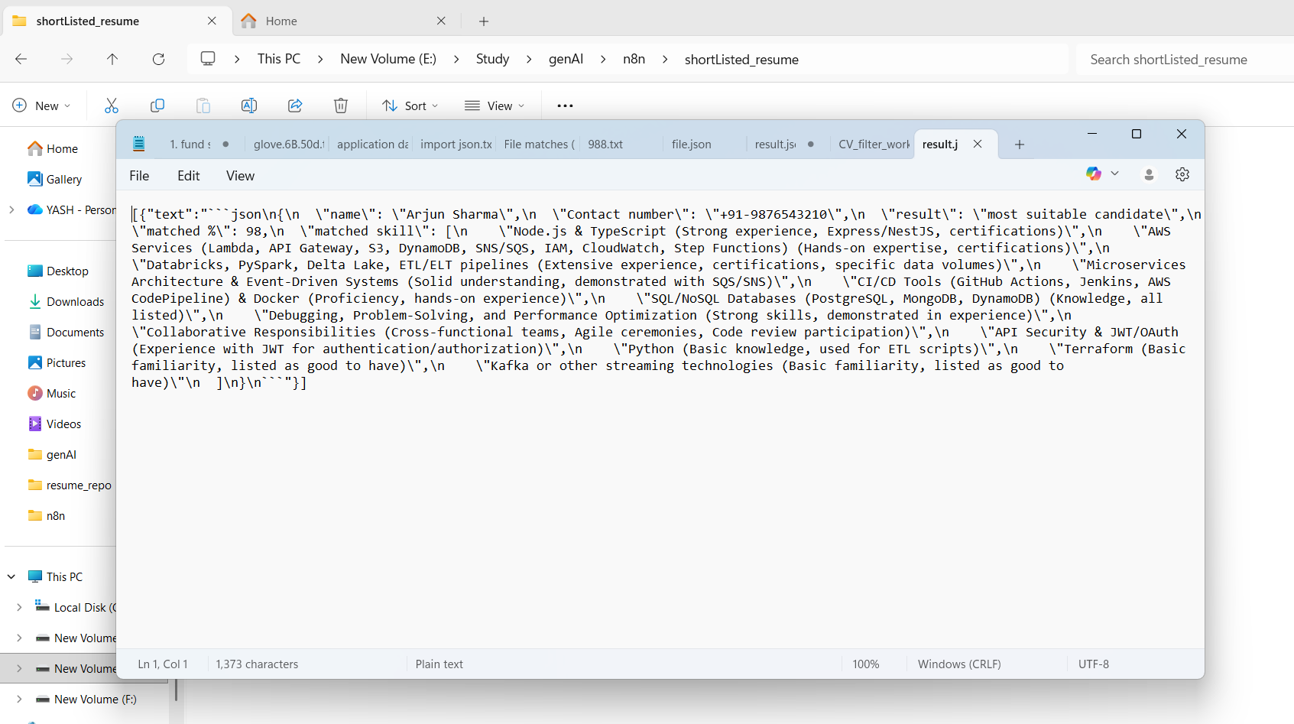

Url of workflow:
http://localhost:5678/form/362cbd41-1e86-4694-8666-ae7f09d0a3d5
